Supplement Fig. 1 Flowchart of the study cohort. MIMIC-IV, Medical Information Mart for Intensive Care IV; ICU, Intensive Care Unit.

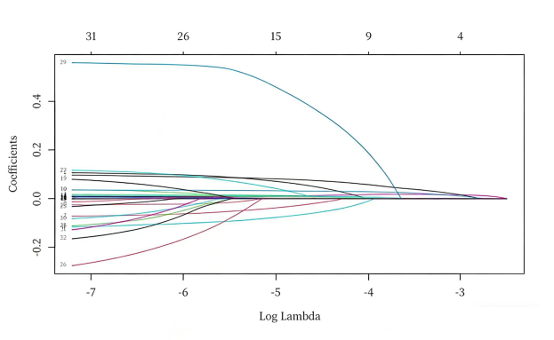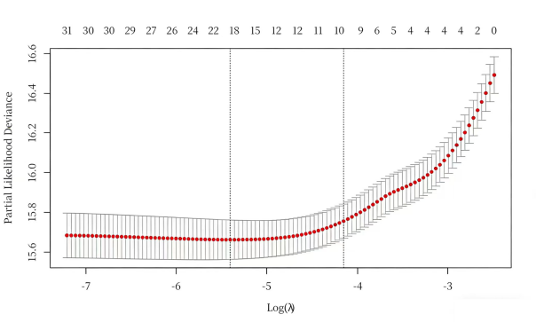
Supplementary Fig. 2 Covariate selection using LASSO regression: coefficient paths and optimal lambda value

Supplementary Fig. 3 Kaplan-Meier survival analysis curves for all-cause mortality in patients with diabetes. Kaplan-Meier curves and cumulative incidence of 28-day (A) and 90-day (B) all-cause mortality stratified by HGI in patients with diabetes.

Supplementary Fig. 4 Kaplan-Meier survival analysis curves for all-cause mortality in patients without diabetes. Kaplan-Meier curves and cumulative incidence of 28-day (A) and 90-day (B) all-cause mortality stratified by HGI in patients without diabetes.

