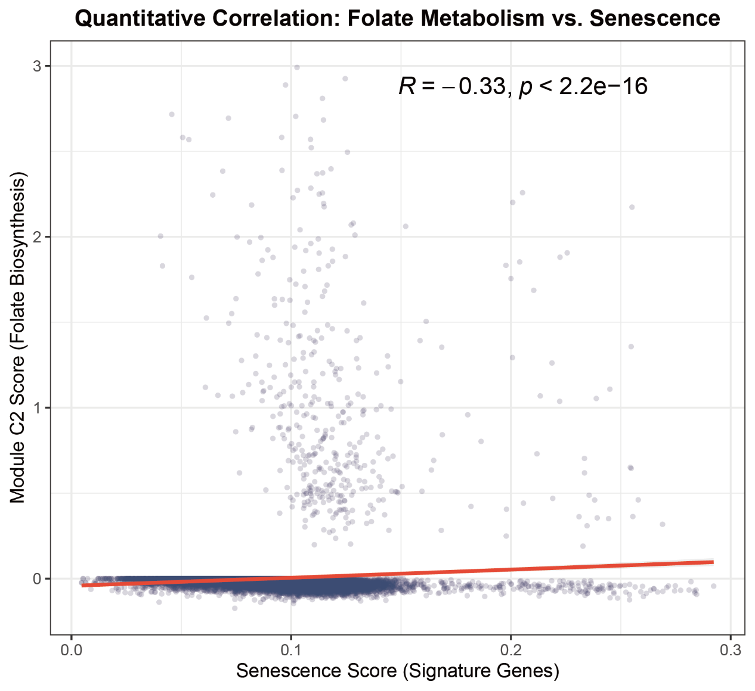
Supplementary Figure S1. Quantitative correlation between folate metabolism and cellular senescence at the single-cell level.
Scatter plot illustrating the Spearman’s rank correlation between the Module C2 (Folate Biosynthesis) activity score and the Senescence Score (calculated using established senescence-associated signature genes). Each dot represents an individual cell from the human NPC scRNA-seq dataset. The red line indicates the linear regression fit. A significant negative correlation ($R=-0.33$
$p<2.2×{10}^{-16}$) was observed, demonstrating that the transcriptional decline of folate biosynthetic capacity is quantitatively and intrinsically coupled with the biological progression of NPC senescence, extending beyond mere visual proximity on the UMAP.

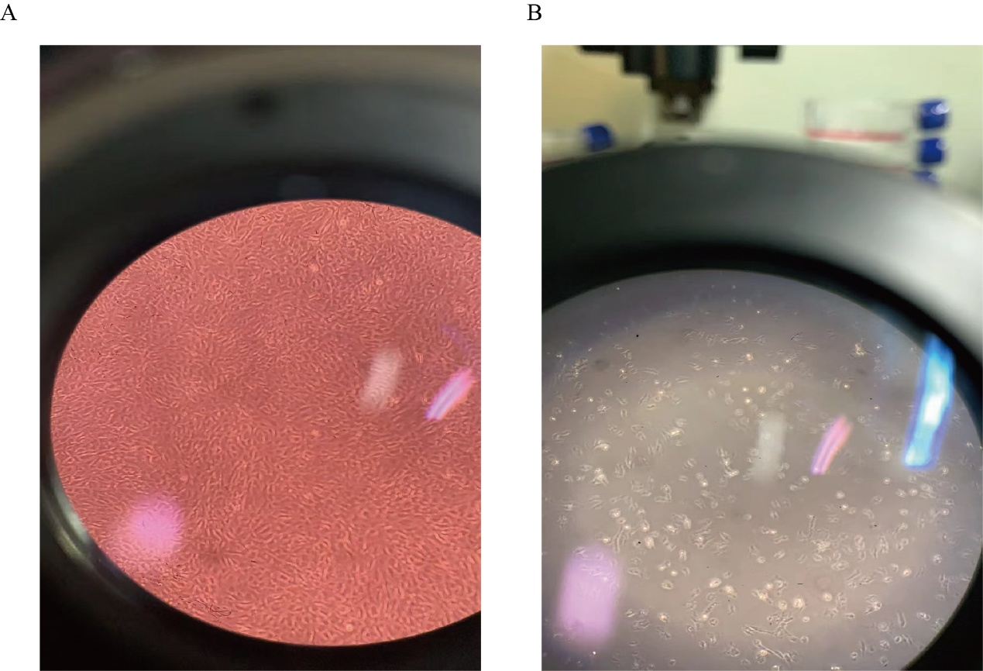
Supplementary Figure S2. Representative brightfield images showing morphological alterations in NPCs under acute oxidative stress.
(A) Control group NPCs displaying a high-confluence monolayer with characteristic spindle-shaped and well-extended morphology. (B) NPCs treated with TBHP. Distinct morphological hallmarks of stress-induced damage are evident, including significant cellular shrinkage, cell rounding, and a marked reduction in cell density compared to the control group. These visual observations provide qualitative confirmation of the growth arrest and morphological transition identified in our multi-omics analysis.

