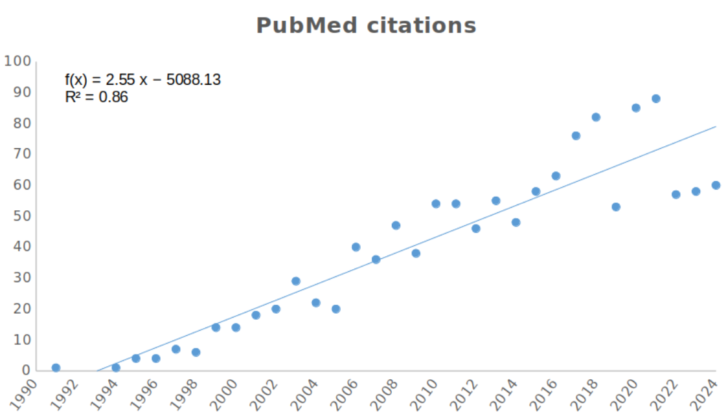Supplementary Figure 1. Trend in PubMed-indexed publications on AFM applied to cell biology since the mid-1990s. The bibliographic search was performed using the query string: "(atomic force microscopy) OR (AFM) AND (cell)", with filters applied to include only the following publication types: Full Text, Books and Documents, Clinical Trial, Meta-Analysis, Randomized Controlled Trial, Review, and Systematic Review. The results illustrate the growing scientific interest in applying Atomic Force Microscopy to cellular studies over time.

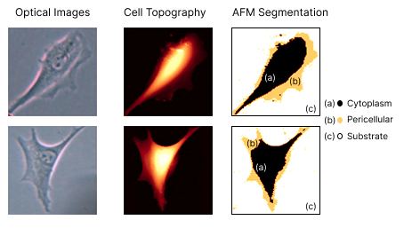Supplementary Figure 2. Cell topography–based segmentation. The figure is organized into two rows and three columns: the columns correspond, respectively, to the optical image, cell topography, and AFM-derived segmentation, while the rows represent the individual cells analyzed. In the segmentation column, the regions are delineated as follows: (a) Cytoplasm, (b) Pericellular region, and (c) Substrate, segmented by AFM. The substrate was defined to pixels with height values below 100 nm, accompanied by probe indentation < 200 nm and Young’s Modulus > 150 kPa. Within the cellular region, pixels with height values between 100 nm and 650 nm were classified as pericellular.
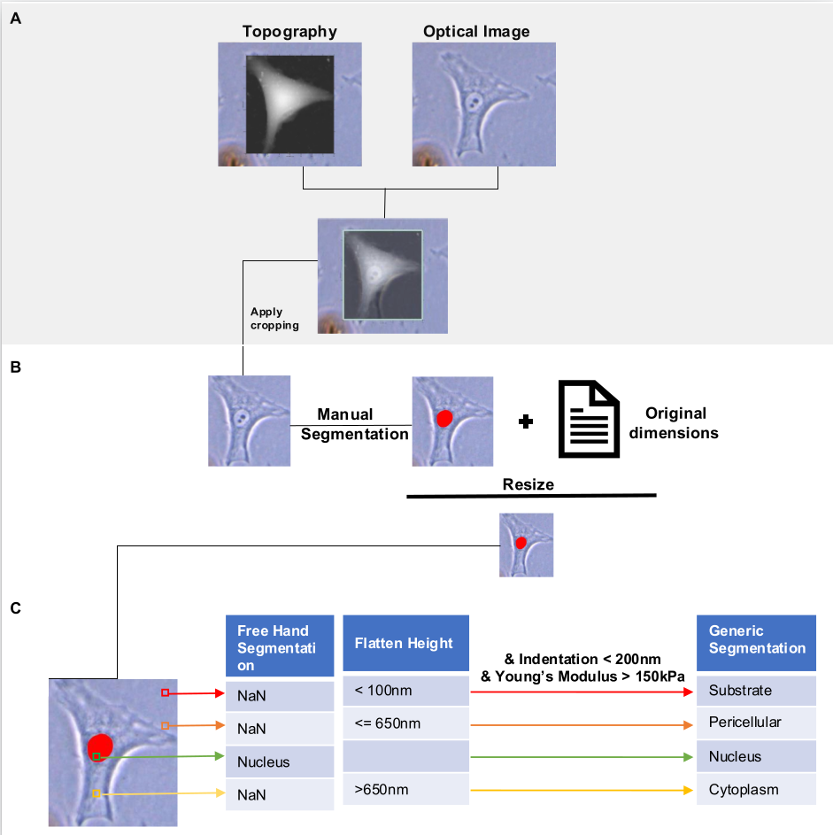Supplementary Figure 3. Workflow for image preprocessing for cellular region classification. (A) Superimposition of topography image, and optical image data to define the region of interest for cropping. (B) Application of the defined crop to the optical image, followed by manual segmentation of the nucleus (red). The segmented image was then resized using the original dimensional information extracted from AFM metadata stored in an auxiliary text file. (C) Classification of cellular regions by scanning the resized image from bottom to top and left to right. The nucleus was identified based on red-labeled pixels from manual annotation, while non-nuclear regions were defined by their surface height in the AFM topography profile.
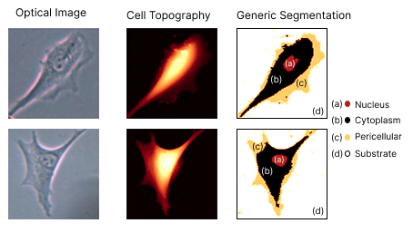Supplementary Figure 4. AFM-based segmentation paired with manual nuclear delineation. The figure is organized into two rows and three columns: the columns correspond to the optical image, cell topography, and the combined segmentation (AFM and manual), while the rows represent the individual cells from which the data were obtained. In the segmentation column, the regions are delineated as follows: (a) Nucleus manually segmented; (b–d) Cytoplasm, Pericellular region, and Substrate, respectively, segmented by AFM.

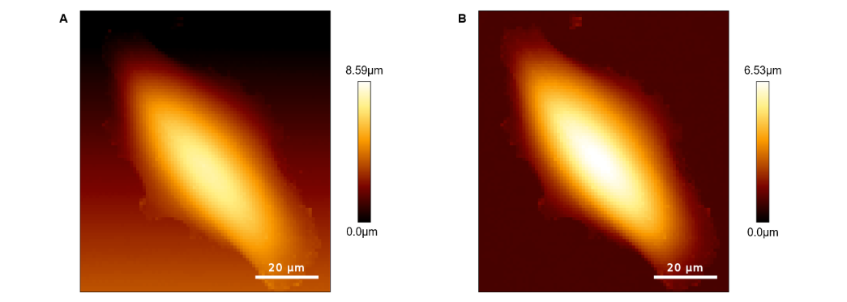Supplementary Figure 5. Processing of AFM topography image. (A) Raw topography data acquired with AFM scanners as reference and (B) Image processing using the JPK Data Processing software, where the Plane Fit function was applied to set the substrate as the reference plane, and the Median Filter function was used to remove image artifacts (“spikes”). The processed height information for each pixel was stored in the AFM data file (.tsv) under the column named “Flatten_Height.”.
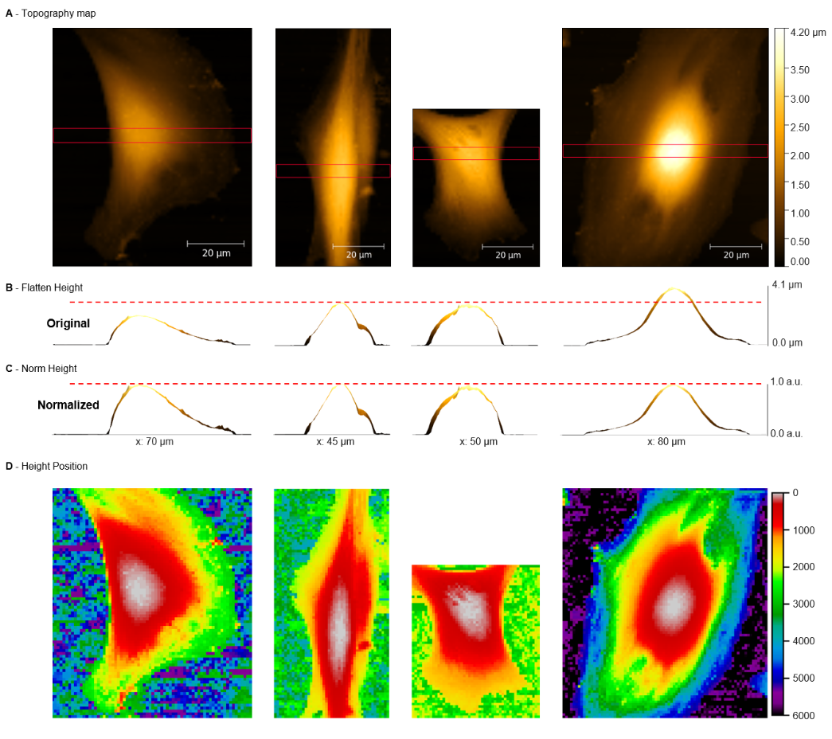Supplementary Figure 6. Flatten_Height-derived parameters for normalization across cells. (A) Four representative AFM topography images, with the red area indicating the region from which the corresponding (B) Flatten_Height profiles were extracted. (C) Norm_Height, obtained by normalizing Flatten_Height values between 0.0 and 1.0 for each cell using the minMaxScaler function from scikit-learn. (D) Height_Position, representing the ranked order of pixel Flatten_Height from highest to lowest within each individual cell.

Supplementary Table 1. Selected AFM Features and Their Normalized Importance Scores for nuclear segmentation. Importance values were obtained by combining the outputs of XGBoost and Logistic Regression models. Each feature corresponds to specific AFM-derived property as indicated in the table.
Feature Name | Normalized Importance | Property
Norm_Height | 0.24 | Height
Flatten_Height | 0.22 | Height
Indentation_F80% | 0.17 | Indentation
MaxPosition_F1500pN | 0.17 | Indentation
Ajuste_X_CP_YM | 0.06 | Elasticity (for Contact Point Adjustment)
MaxPosition_F3000pN | 0.03 | Indentation
Height_Position | 0.01 | Height

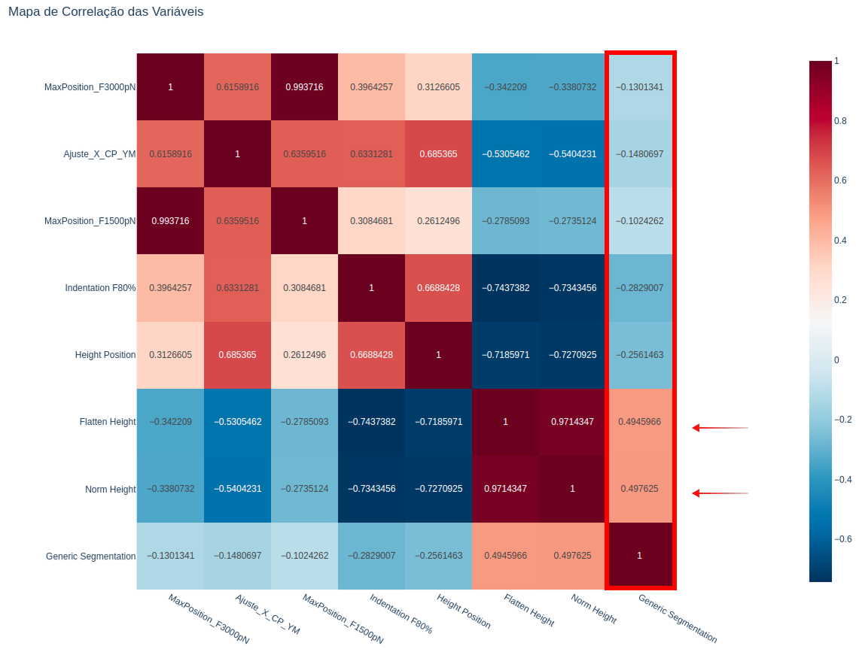Supplementary Figure 7. Correlation map of AFM features selected for nuclear segmentation. The highlighted column displays the correlation of each feature with the target Generic Segmentation. Arrows indicate the features showing the strongest correlation with the target, highlighting those most relevant for distinguishing nuclear regions.

Supplementary Table 2. Performance of different erosion Kernel sizes for CHS-Based nucleus localization in the AFM training dataset (N = 234 images). Kernel sizes up to 15 were tested to optimize nucleus inclusion within CHS-defined regions. K = 15 fully encompassing nuclei in 96.15% of images while maintaining segmentation precision.
Kernel Size (K) | Image Count (Nucleus Fully Included) | Percentage (%)
5 | 0/234 | 0.0
10 | 180 / 234 | 76.92
11 | 197 / 234 | 84.19
12 | 211 / 234 | 90.17
13 | 217 / 234 | 92.74
14 | 223 / 234 | 95.30
15 | 225 / 234 | 96.15

Supplementary Table 3. Channel-wise contrast-to-noise ratio (CNR) of RGB images. The blue channel shows the highest contrast compared to the red and green channels.
Channel | CNR (mean ± SD)
Red | 0.38 ± 0.24
Green | 0.39 ± 0.23
Blue | 0.45 ± 0.28

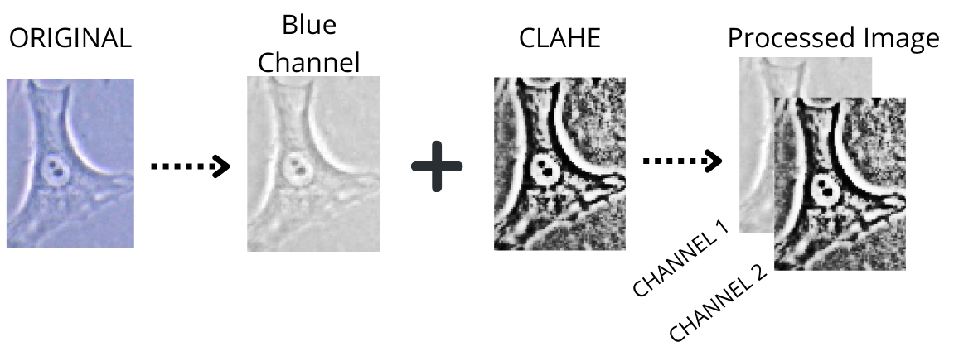Supplementary Figure 8. Optical image preprocessing workflow. The figure illustrates the preprocessing steps applied to optical microscopy images starting with the original optical image, followed by extraction of the blue channel and application of adaptive histogram equalization (CLAHE) to enhance contrast. The final two-channel processed image was generated by combining the blue channel with the equalized result.

Supplementary Table 4. Performance evaluation of AFMap-UNet based on Cross-Validation
 |  | AFMap-UNet
Metrics  Folds |  | Precision | Recall | Dice | loss
1 |  | 0.99 | 0.98 | 0.94 | 0.01
2 |  | 0.97 | 0.97 | 0.95 | 0.01
3 |  | 1.00 | 0.93 | 0.91 | 0.05
4 |  | 0.99 | 0.94 | 0.93 | 0.02
5 |  | 0.97 | 0.97 | 0.95 | 0.01
6 |  | 0.97 | 0.97 | 0.95 | 0.01
7 |  | 0.98 | 0.97 | 0.95 | 0.01
8 |  | 0.98 | 0.97 | 0.96 | 0.01
9 |  | 0.99 | 0.97 | 0.95 | 0.01
10 |  | 0.97 | 0.98 | 0.96 | 0.01

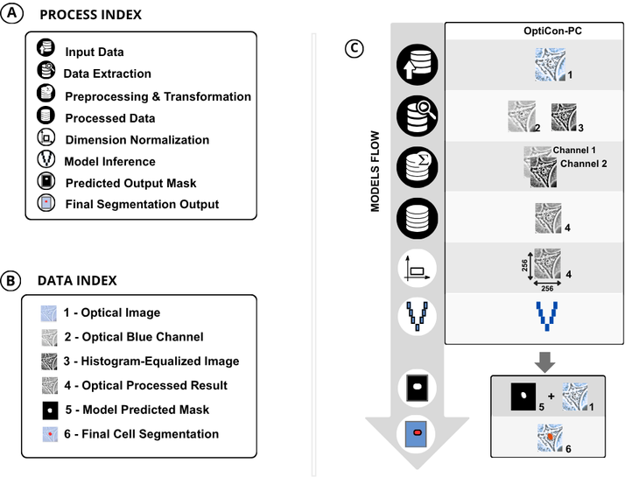Supplementary Figure 9. Overview of the general Opticon-PC pipeline workflows for nucleus segmentation. (A) Process Index summarizes the processing steps applied across U-Net–based model. (B) Data Index specifies input data used in the processing stage and their corresponding identifiers. (C) Schematic representation of the workflows for Opticon-PC model.
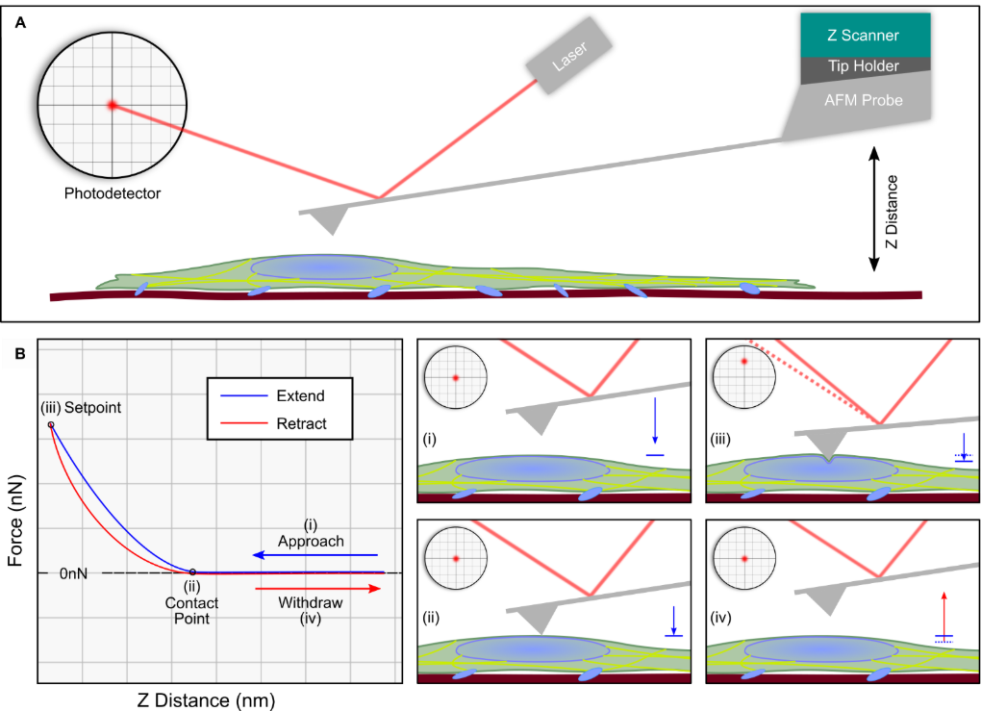Supplementary Figure 10. (A) Schematic representation of the AFM instrument structure. (B) Representation of a typical force–distance (FD) curve, highlighting the main phases of tip–sample interaction: (i) approach of the probe toward the surface, (ii) contact point, (iii) indentation up to the maximum force defined by the setpoint, and (iv) retraction.

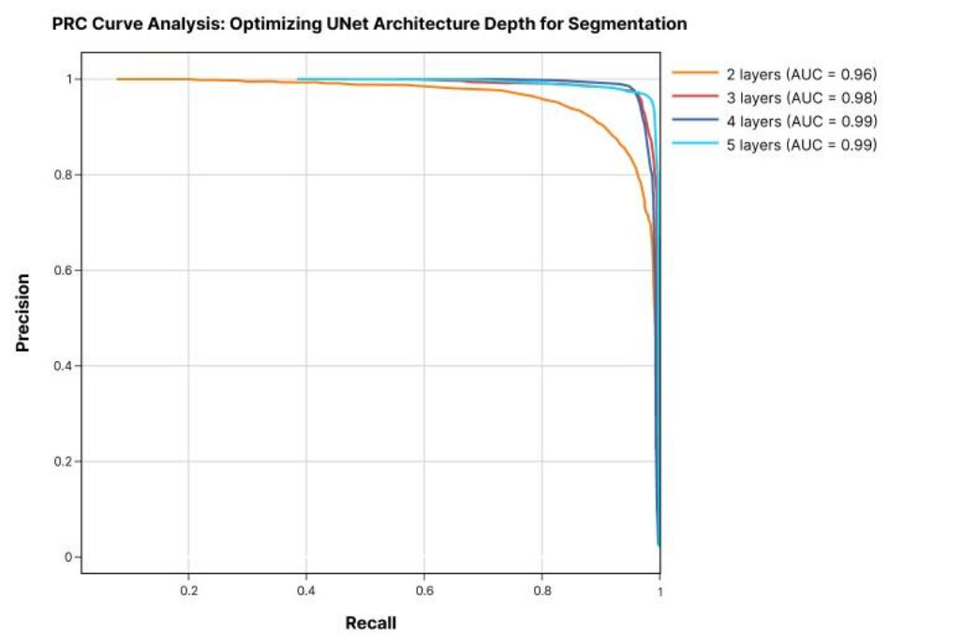
Supplementary Figure 11. Performance evaluation of U-Net architectures with varying depths. Precision–recall curves (PRC) depict the performance of U-Net models trained with different numbers of layers. Both the 4-layer and 5-layer architectures achieved superior performance compared to shallower variants. However, the 4-layer configuration provided a more favorable balance, yielding higher PRC values while requiring substantially less training time than the 5-layer model. Consequently, the 4-layer U-Net was selected as the optimal architecture for this study.

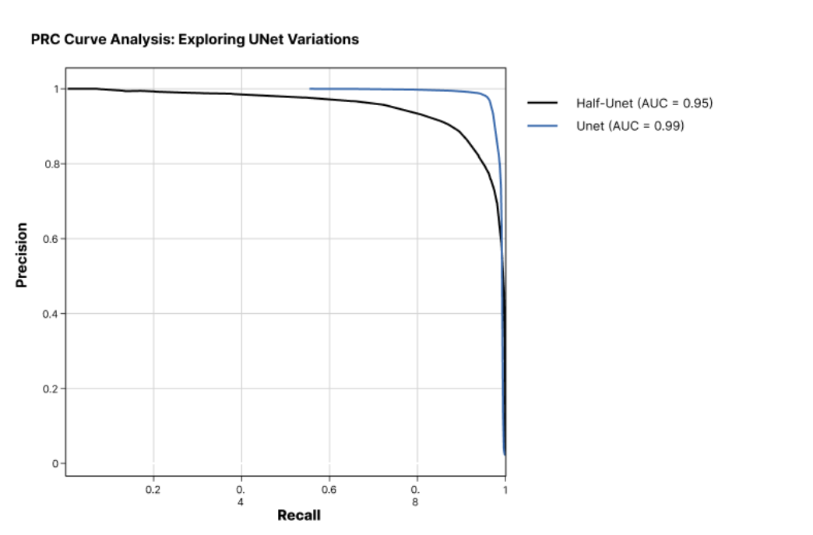
Supplementary Figure 12. Performance evaluation of Half-U-Net and the standard U-Net architectural variations with 4 convolutional layers. Precision–recall curves showing that standard U-Net provided the best balance between segmentation accuracy and computational complexity and was therefore selected as the optimal architecture for subsequent analyses.

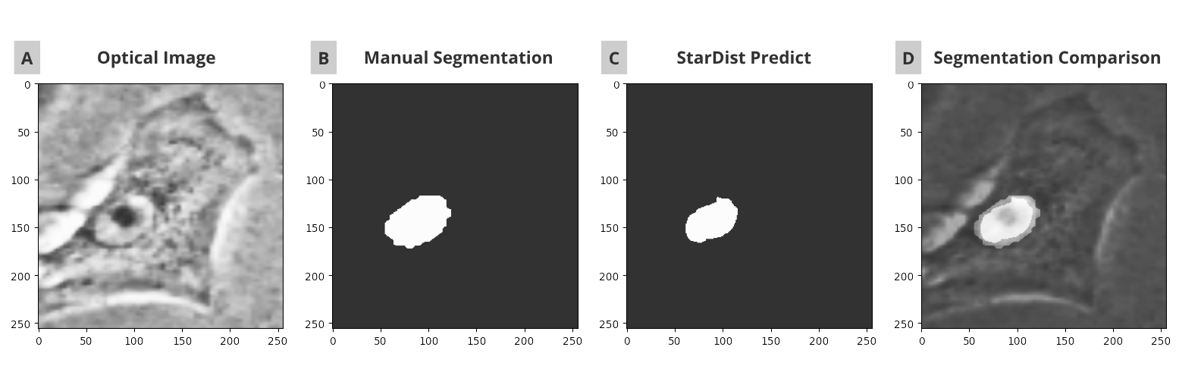Supplementary Figure 13. Comparison of manual and StarDist segmentation applied to the same optical image. (A) Original optical image. (B) Manual annotation of the nucleus. (C) Segmentation results obtained using the fine-tuned StarDist model. (D) Overlay of the manual annotation and StarDist segmentation on the original image.

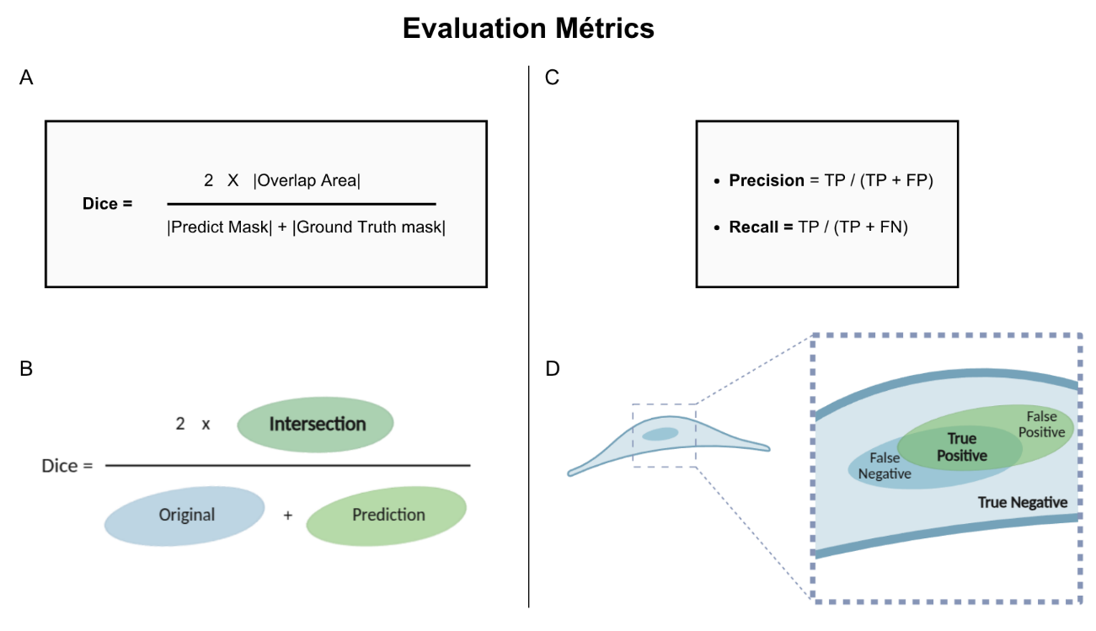Supplementary Figure 14. Quantitative metrics for segmentation performance. (A) Formula of the Dice similarity coefficient, which measures spatial overlap between predicted masks and ground-truth annotations. (B) Schematic representation illustrating how Dice evaluates agreement between segmentation outputs. (C) Formulas of precision and recall, defined in terms of true positives (TP), false positives (FP), and false negatives (FN). (D) Didactic schema depicting how precision and recall operate in practice, highlighting their roles in quantifying false detections and missed objects.

Supplementary Table 5. List of analytical features extracted from force–distance curves obtained by AFM measurements. Features are grouped according to their respective information classes and accompanied by detailed descriptions. The units of measurement include meter (m), Pascal (Pa), and Newton (N).
Class | Feature | Unit | Description
Position
 | X Position | m | Position of each pixel in the map along the X scanner
 | Y Position | m | Position of each pixel in the map along the Y scanner
Curve Adjustment |  |  | The function used to fit and extract Young’s Modulus was applied for FD axis adjustment and Contact Point determination.
 | Ajuste_X_CP_YM | Pa | Young’s Modulus measured from the fitting function during Contact Point adjustment using the full force–distance curve
 | Ajuste_X_CP_RRMS | N | Residual RMS measured on the function during the Contact Point adjustment using the full force–distance curve
 | Ajuste_Y_CP_YM | Pa | Young's Modulus measured from the function during the Contact Point adjustment using maximum force up to 500 pN
 | Ajuste_Y_CP_RRMS | N | Residual RMS measured on the function during the Contact Point adjustment using maximum force up to 500 pN
Topography
 | Ajuste_X_CP_CP | m | Contact Point measured by Young's Modulus fitting curve
 | Height 10% | m | Height in z scanner when reaching 10% of the setpoint of the FD curve
 | Height 5% | m | Height in z scanner when reaching 5% of the setpoint of the FD curve
 | Flatten Height | m | Contact Point image treated to make the substrate the reference plan
 | Height Position | a.u. | Flatten Height feature ranked by the highest pixels
 | Height by Max | m | Flatten Height feature inverted (highest pixel starts in zero height)
 | Norm Height | a.u. | Flatten Height normalized between 0 and 1
Stiffness
 | YM_Fmax0100pN | Pa | Young’s Modulus fitted using a maximum force of 100 pN
 | YM_Fmax0200pN | Pa | Young’s Modulus fitted using a maximum force of 200 pN
 | YM_Fmax0300pN | Pa | Young’s Modulus fitted using a maximum force of 300 pN
 | YM_Fmax0400pN | Pa | Young’s Modulus fitted using a maximum force of 400 pN
 | YM_Fmax0500pN | Pa | Young’s Modulus fitted using a maximum force of 500 pN
 | YM_Fmax0600pN | Pa | Young’s Modulus fitted using a maximum force of 600 pN
 | YM_Fmax0800pN | Pa | Young’s Modulus fitted using a maximum force of 800 pN
 | YM_Fmax1000pN | Pa | Young’s Modulus fitted using a maximum force of 1000 pN
 | YM_Fmax1200pN | Pa | Young’s Modulus fitted using a maximum force of 1200 pN
 | YM_Fmax1500pN | Pa | Young’s Modulus fitted using a maximum force of 1500 pN
 | MaxPosition_F0500pN | m | Indentation of the probe on the sample when reaching 500 pN of force
 | MaxPosition_F1000pN | m | Indentation of the probe on the sample when reaching 1000 pN of force
 | MaxPosition_F1500pN | m | Indentation of the probe on the sample when reaching 1500 pN of force
 | MaxPosition_F3000pN | m | Indentation of the probe on the sample when reaching the maximum force in the FD curve
 | Indentation F80% | m | Indentation of the probe before removal reduces the probe's contribution to a force of 80% of the selected setpoint.
References and adjustment quality
 | Ajuste_X_CP_RRMS | N | Residual RMS of the YM fitting
 | Ajuste_Y_CP_RRMS | N | Residual RMS of the YM fitting
 | RMS_Fmax0100pN | N | Residual RMS of the YM fitting
 | RMS_Fmax0200pN | N | Residual RMS of the YM fitting
 | RMS_Fmax0300pN | N | Residual RMS of the YM fitting
 | RMS_Fmax0400pN | N | Residual RMS of the YM fitting
 | RMS_Fmax0500pN | N | Residual RMS of the YM fitting
 | RMS_Fmax0600pN | N | Residual RMS of the YM fitting
 | RMS_Fmax0800pN | N | Residual RMS of the YM fitting
 | RMS_Fmax1000pN | N | Residual RMS of the YM fitting
 | RMS_Fmax1200pN | N | Residual RMS of the YM fitting
 | RMS_Fmax1500pN | N | Residual RMS of the YM fitting
 | MinForce_F0500pN | N | Reference of minimum and maximum points in the FD curve to measure the indentation at 500pN
 | minPosition_F0500pN | m
 | MaxForce_F0500pN | N
 | MinForce_F1000pN | N | Reference of minimum and maximum points in the FD curve to measure the indentation at 1000pN
 | minPosition_F1000pN | m
 | MaxForce_F1000pN | N
 | MinForce_F1500pN | N | Reference of minimum and maximum points in the FD curve to measure the indentation at 1500pN
 | minPosition_F1500pN | m
 | MaxForce_F1500pN | N
 | MinForce_F3000pN | N | Reference of minimum and maximum points in the FD curve to measure the indentation at the maximum force
 | minPosition_F3000pN | m
 | MaxForce_F3000pN | N

