Supplementary Information for

Impact of Antarctic radar on Southern Hemisphere atmospheric river reanalysis and forecast

Kazutoshi Sato^{1,2,3}, Jun Inoue^{1,2,3}, Akira Yamazaki³, Yoshihiro Tomikawa^{1,2,4}, Kaoru Sato⁵

¹National Institute of Polar Research, Tachikawa, Tokyo 190-8518, Japan
²SOKENDAI (The Graduate University for Advanced Studies), Hayama, Kanagawa, 240-0193, Japan
³Application Laboratory, Japan Agency for Marine-Earth Science and Technology, Yokohama, Kanagawa 236-0001, Japan
⁴Polar Environment Data Science Center, Joint Support-Center for Data Science Research, Research Organization of Information and Systems, Tachikawa, Tokyo 190-8518, Japan
⁵Department of Earth and Planetary Science, The University of Tokyo, Tokyo 113-0033, Japan

Corresponding author: Kazutoshi Sato (sato.kazutoshi@nipr.ac.jp)

Including:
Supplementary Figs. 1–3.
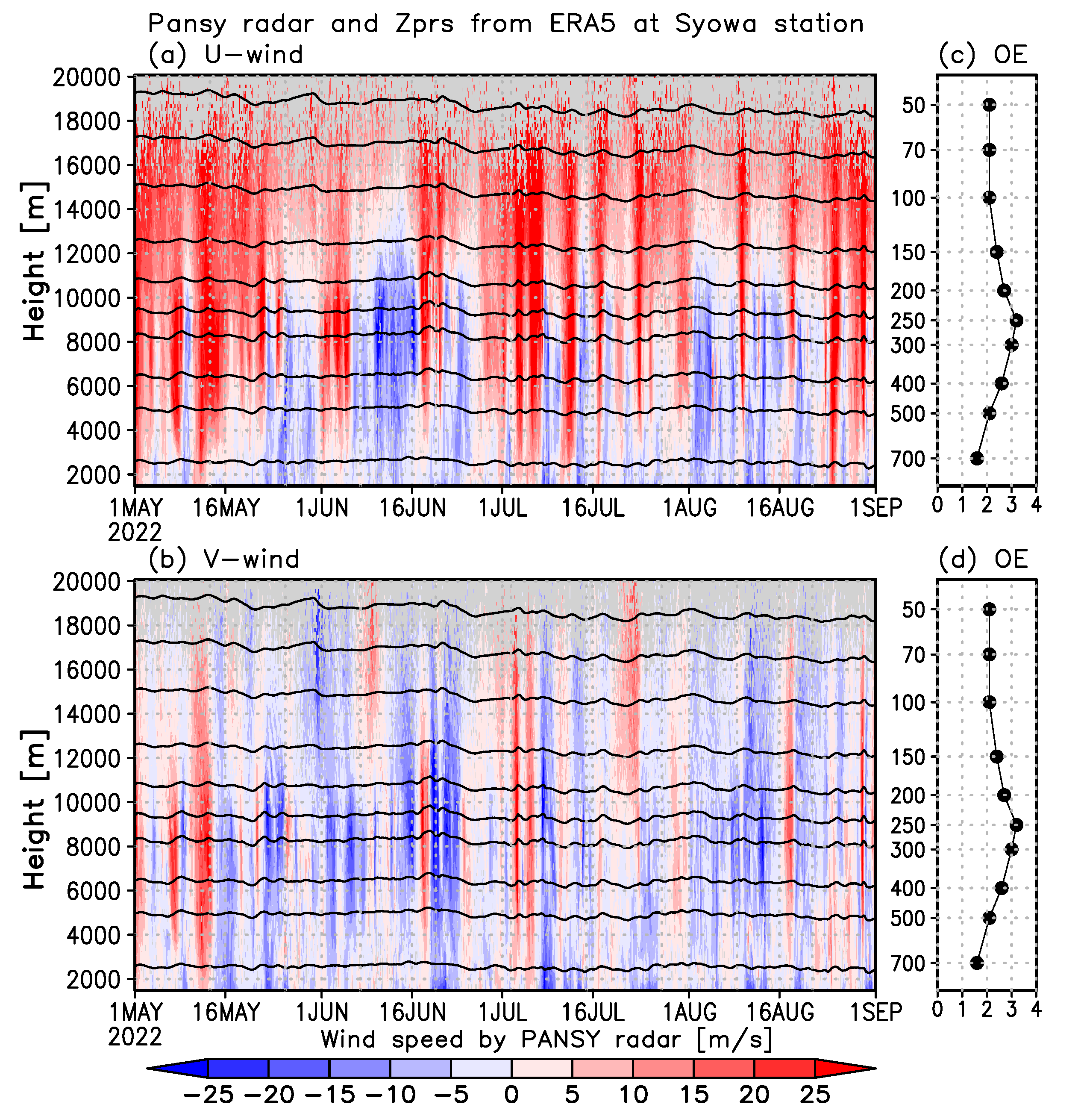
Supplementary Fig. 1: PANSY data at the Japanese Antarctic Syowa Station.
Time–height [m] cross sections of the a zonal and b meridional wind speed [m/s] from PANSY located at the Japanese Syowa Station in Antarctica. Grey shading indicates a lack of PANSY data. Black contours show the geopotential height from ERA5 at standard isobaric surfaces (700, 500, 400, 300, 250, 200, 150, 100, 70, and 50 hPa) for data assimilation. Vertical profile of the observation error of the c zonal and d meridional wind speed [m/s] with respect to PANSY in the PREPBUFR Global Observation dataset.
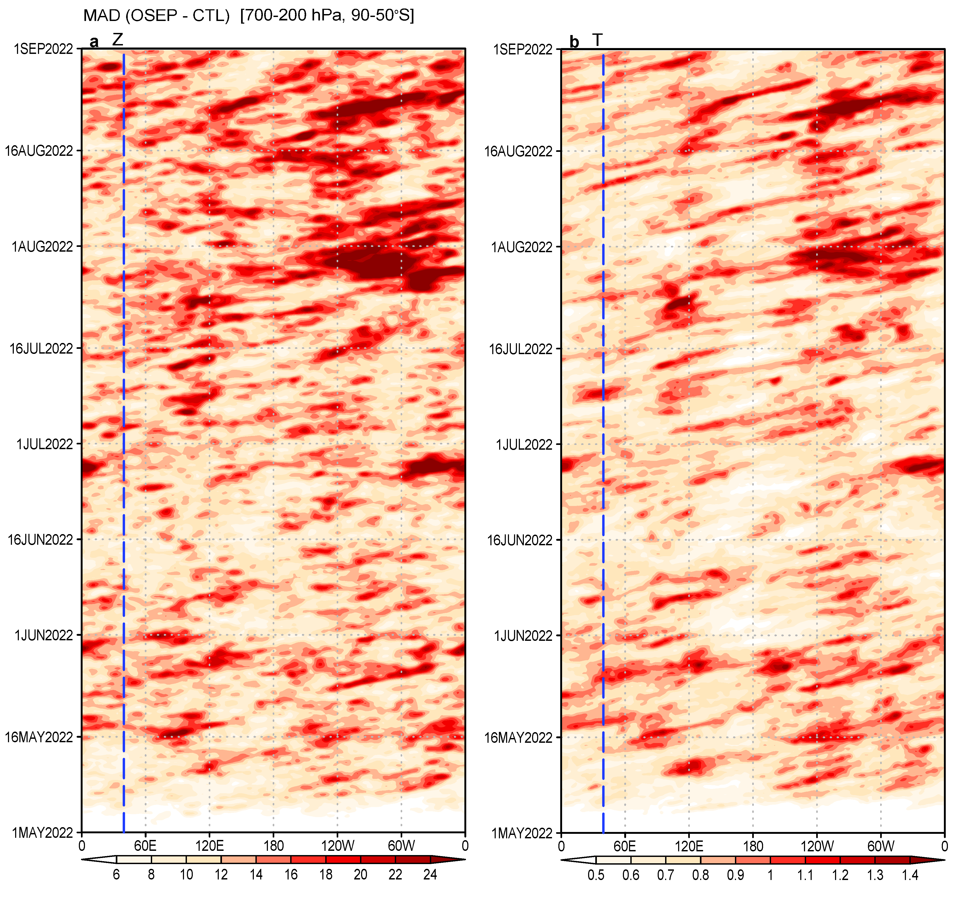Supplementary Fig. 2: Impact of PANSY observations on the initial field for forecasts.
Hovmöller diagrams of the mean absolute difference (MAD) of the a geopotential height (Z) [m] and b temperature (T) [°C] between OSEP and CTL, vertically averaged over 700-200 hPa and spatially averaged over 90–50° S. The blue dashed line shows the latitude of the Japanese Syowa Station.
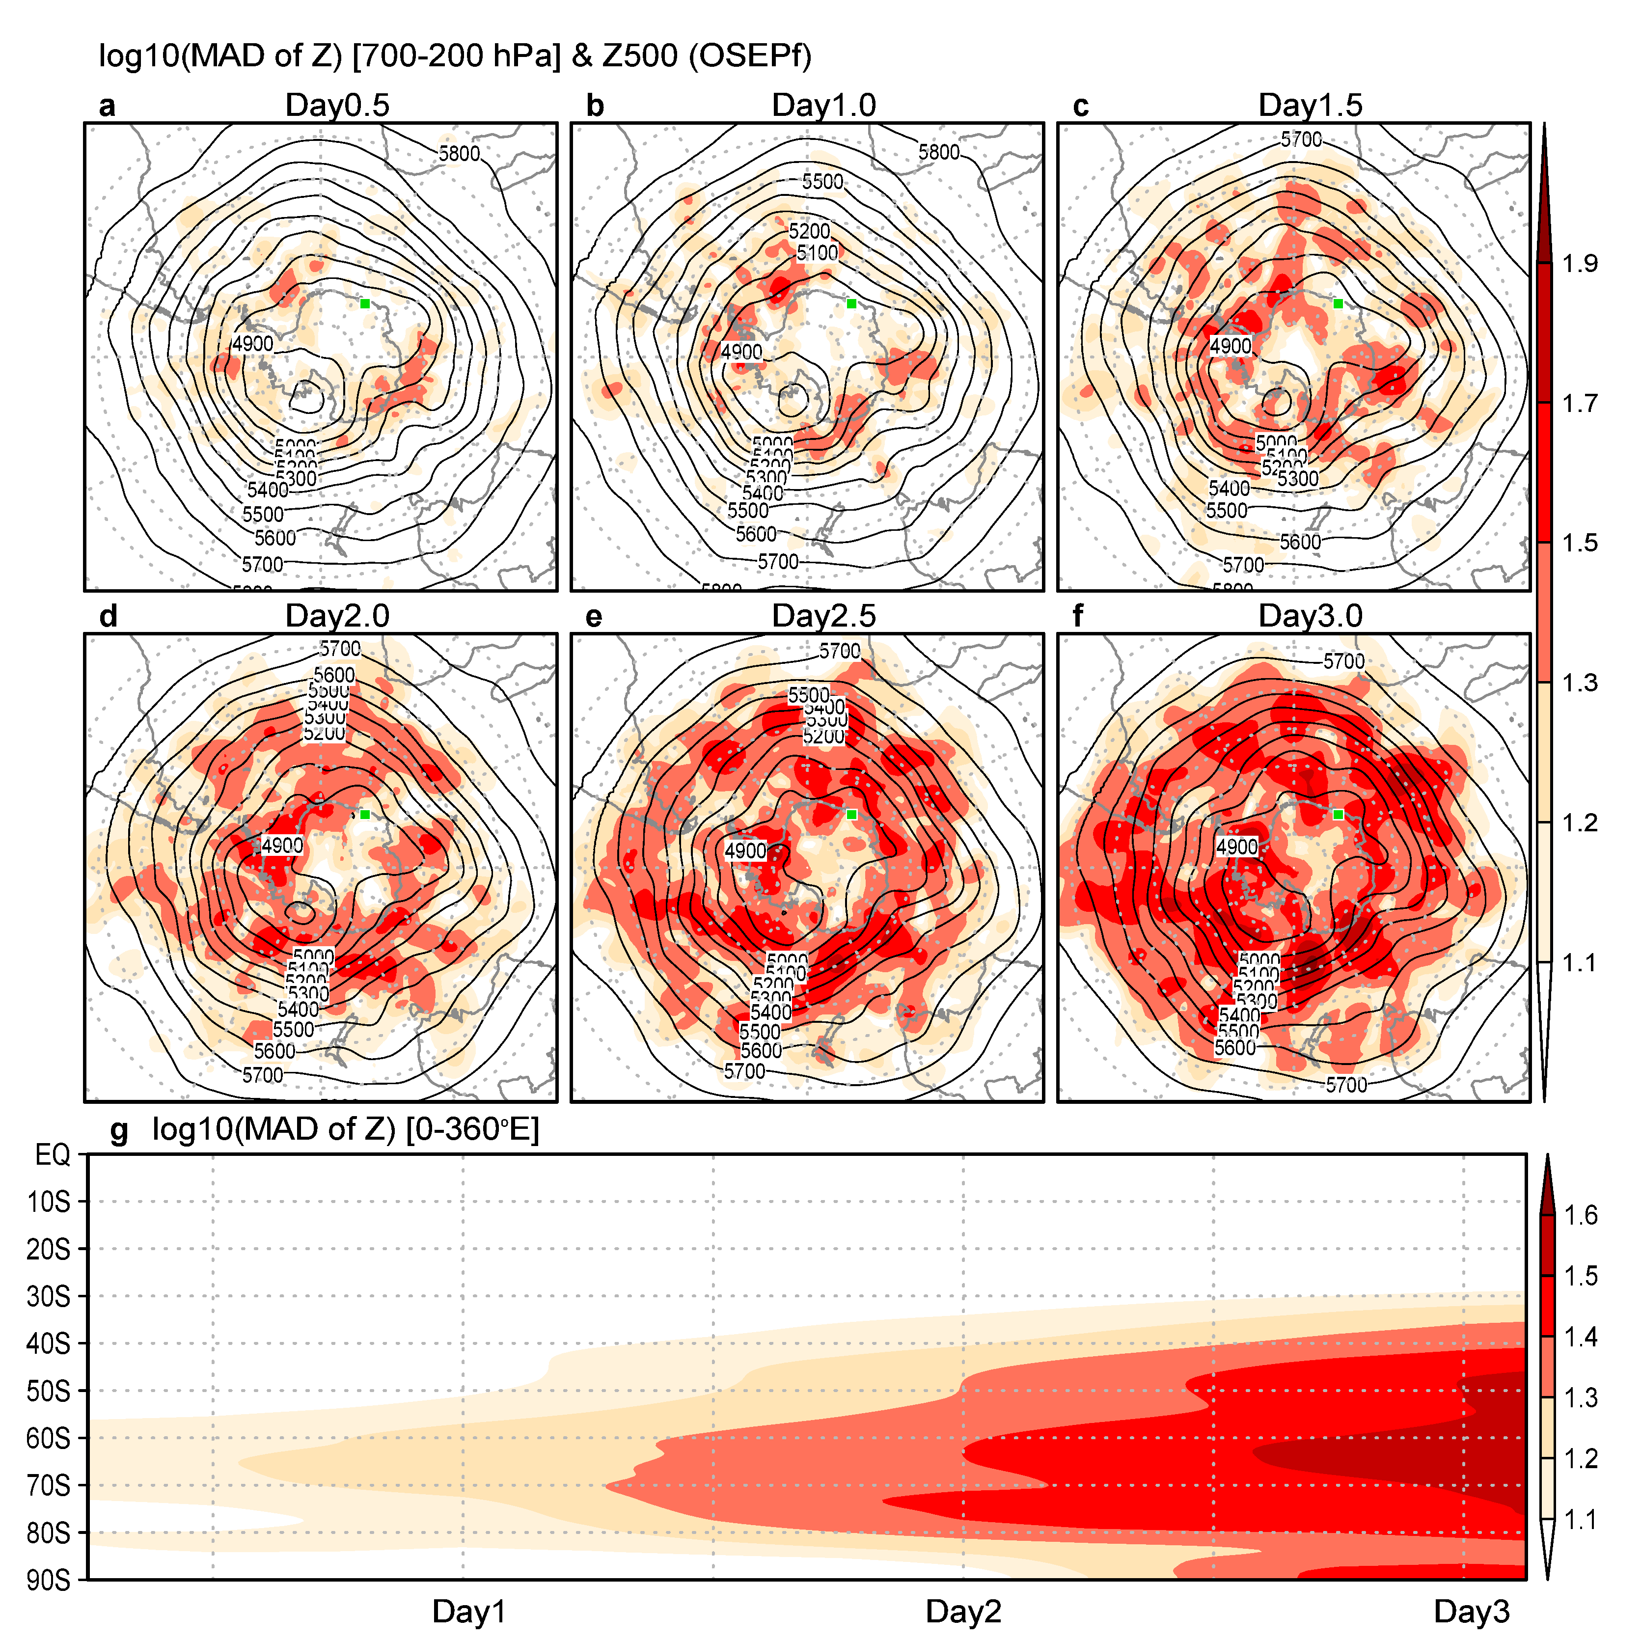Supplementary Fig. 3: Widespread impact of PANSY observations over the Southern Hemisphere.
Mean absolute difference (MAD) of the predicted geopotential height (Z) [m] between OSEPf and CTLf, averaged between 700 hPa and 200 hPa with Z at 500 hPa (Z500) (contours) [m] from OSEPf on forecast days a 0.5, b 1.0, c 1.5, d 2.0, e 2.5, and f 3.0. The green square indicates the Japanese Syowa Station. g Latitude–forecast time cross section of the MAE of Z between 700 hPa and 200 hPa averaged over 0–360° E. These results are averaged over the seven AR cases.

