The supplementary figures present the observed monthly malaria incidence data (blue points) together with the fitted nonlinear response curves (solid line) and corresponding 95% confidence intervals (shaded band). Displaying the observed data alongside the fitted models enables visual assessment of the agreement between the observed malaria incidence and the fitted nonlinear functions, thereby improving transparency regarding model adequacy and the underlying exposure–response relationships.

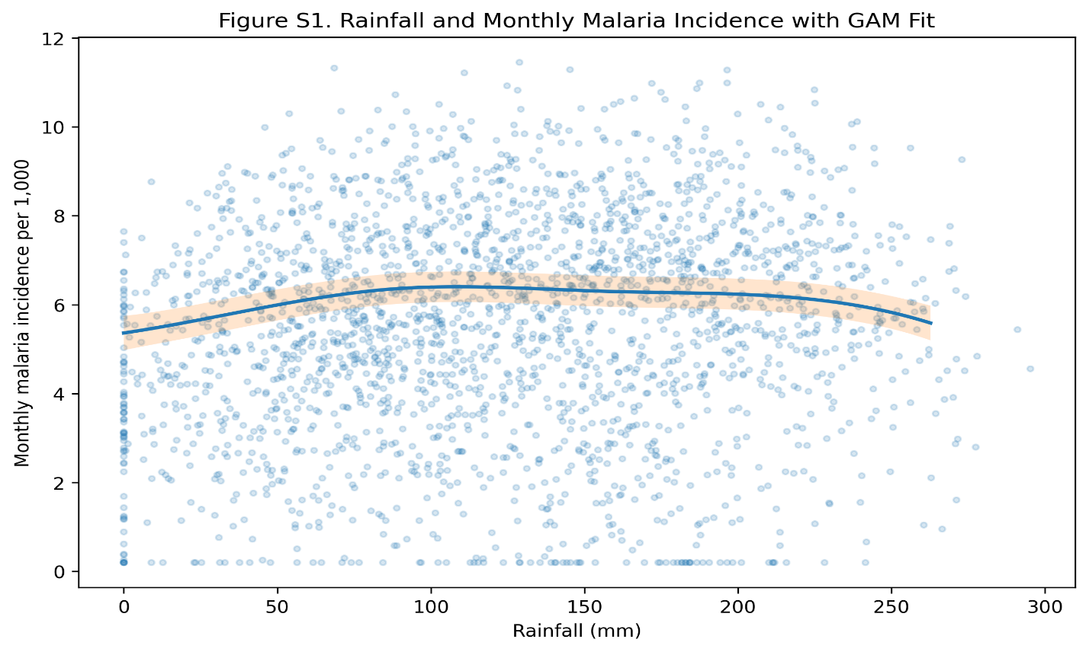
Figure S1. Rainfall and Monthly Malaria Incidence with GAM Fit

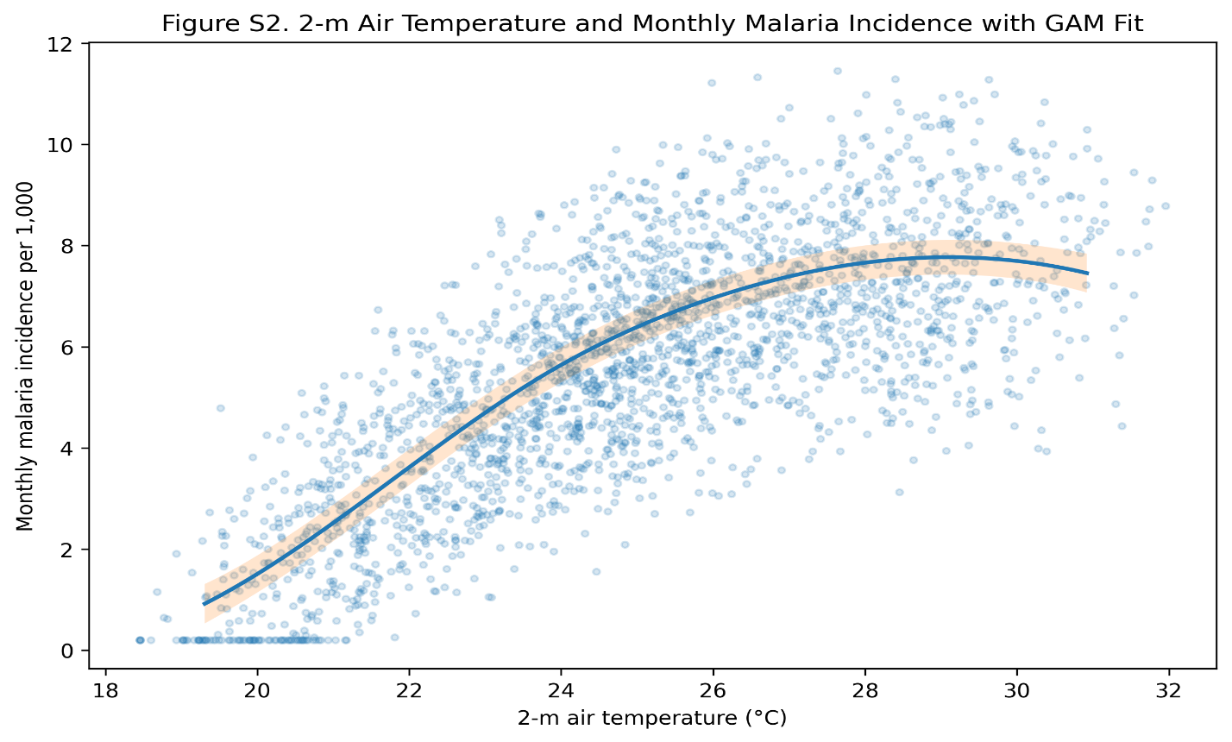Figure S2. 2-m Air Temperature and Monthly Malaria Incidence with GAM Fit

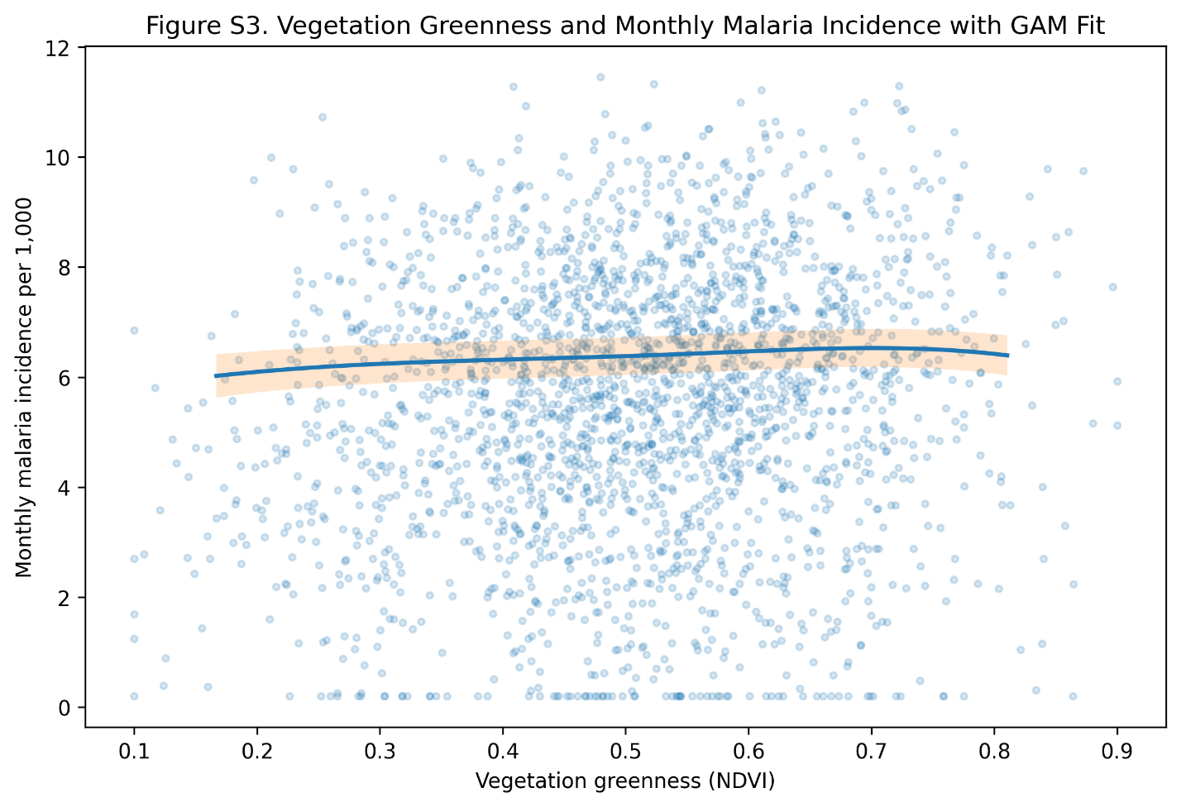
Figure S3. Vegetation Greenness and Monthly Malaria Incidence with GAM fit

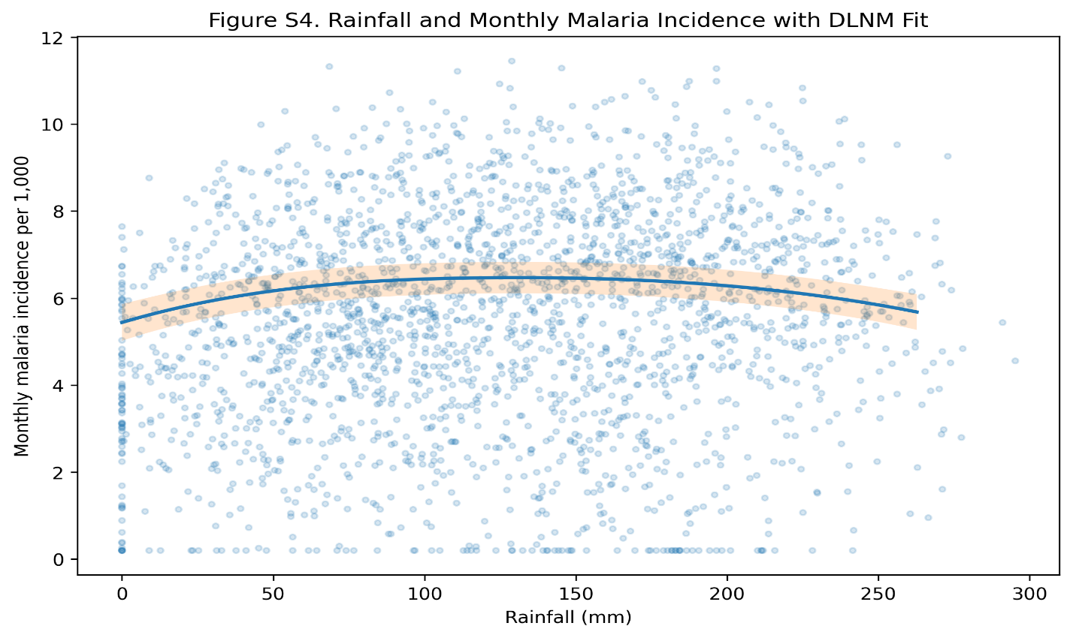Figure S4. Rainfall and Monthly Malaria Incidence with DLNM Fit

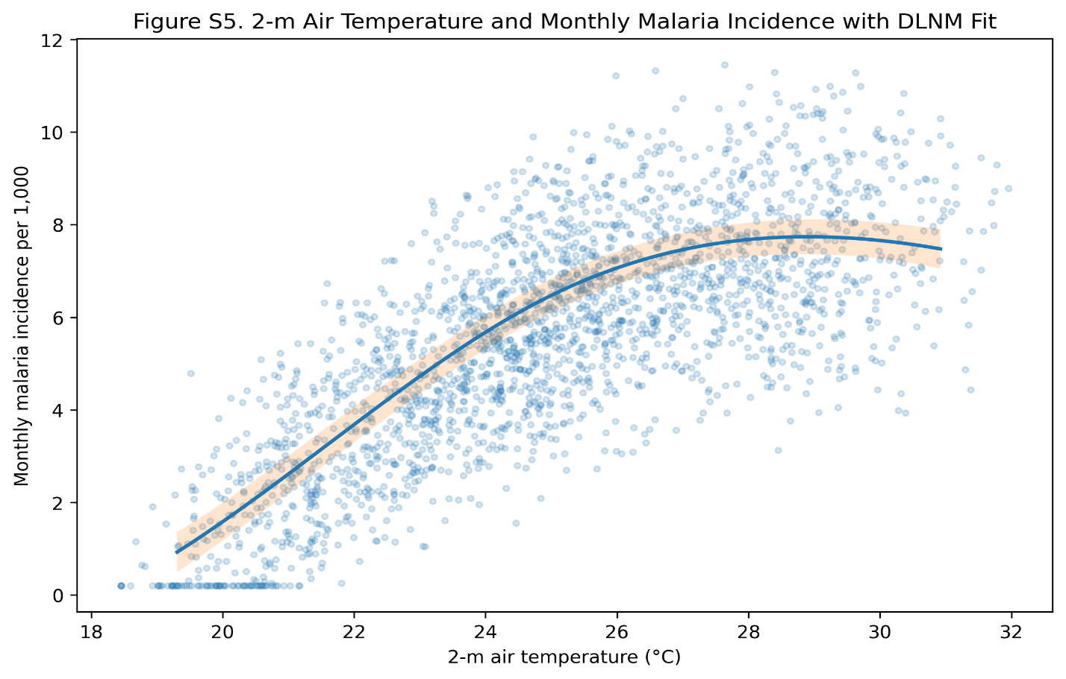
Figure S5. 2-m Air Temperature and Monthly Malaria Incidence with DLNM Fit
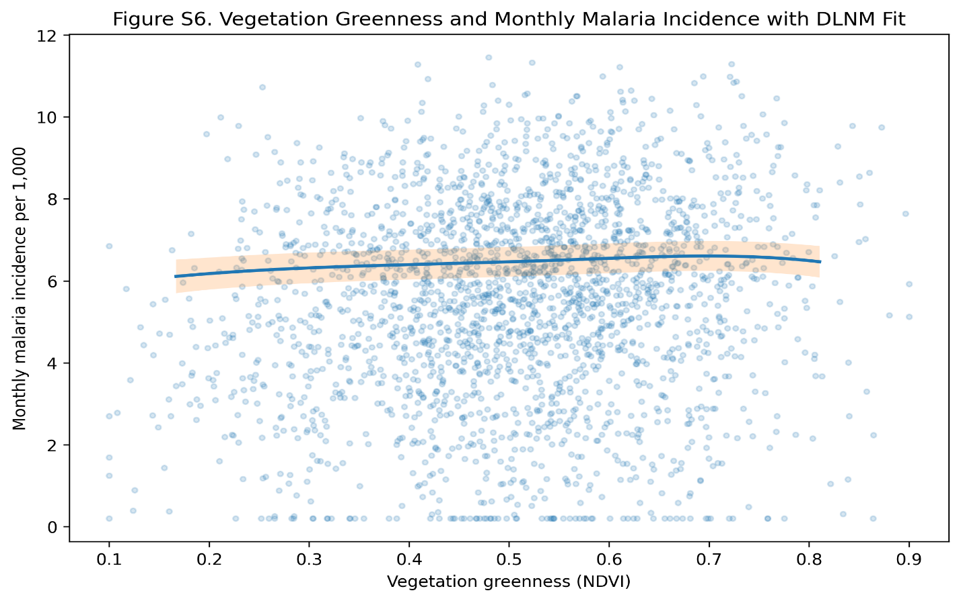Figure S6. Vegetation Greenness and Monthly Malaria Incidence with DLNM fit

Figures S1–S6 present the observed monthly malaria incidence data together with the fitted nonlinear relationships estimated from the Generalised Additive Model (GAM) and the Distributed Lag Nonlinear Model (DLNM). The superimposed fitted curves provide a visual assessment of model fit relative to the observed data while illustrating the nonlinear exposure–response relationships identified in the regression analyses. The fitted curves closely follow the central tendency of the observed data, indicating that the nonlinear models capture the principal climatic patterns associated with malaria incidence while appropriately reflecting the variability inherent in ecological surveillance data.
Figure S1. Rainfall and Monthly Malaria Incidence with GAM Fit.
The fitted GAM curve indicates a nonlinear rainfall–malaria relationship characterised by an initial increase in malaria incidence with increasing rainfall, followed by a gradual plateau and slight decline at higher rainfall levels. This pattern is consistent with threshold behaviour whereby moderate rainfall promotes mosquito breeding habitats, whereas excessive rainfall may reduce larval survival through flushing of breeding sites.
Figure S2. 2-m Air Temperature and Monthly Malaria Incidence with GAM Fit.
The GAM fit demonstrates a strong nonlinear positive relationship between air temperature and malaria incidence. Malaria incidence increases steadily across the observed temperature range before approaching a plateau at higher temperatures, reflecting the biological limits of mosquito survival and parasite development under increasingly warm conditions.
Figure S3. Vegetation Greenness and Monthly Malaria Incidence with GAM Fit.
The relationship between vegetation greenness (NDVI) and malaria incidence is characterised by a gradual increase followed by a mild saturation effect. This pattern suggests that greater vegetation cover and environmental moisture enhance habitat suitability for malaria vectors, although additional increases in vegetation produce diminishing marginal effects on transmission.
Figure S4. Rainfall and Monthly Malaria Incidence with DLNM Fit.
The DLNM fitted curve exhibits a rainfall–malaria relationship that is highly consistent with the corresponding GAM results, indicating that the nonlinear association remains robust after accounting for distributed lag effects. The similarity between the two models indicates that rainfall exerts both immediate and short-term delayed influences on malaria transmission, while the distributed lag specification explicitly accommodates the temporal persistence of these effects across successive months.
Figure S5. 2-m Air Temperature and Monthly Malaria Incidence with DLNM Fit.
The DLNM confirms the strong positive nonlinear association between temperature and malaria incidence while incorporating delayed climatic effects. The fitted curve closely resembles the GAM response, indicating that temperature influences malaria transmission through both contemporaneous and short-term lagged biological processes.
Figure S6. Vegetation Greenness and Monthly Malaria Incidence with DLNM Fit.
The DLNM reproduces the nonlinear vegetation–malaria relationship observed in the GAM analysis, with malaria incidence increasing gradually across the NDVI range before approaching saturation. The consistency between both modelling approaches provides additional evidence that vegetation greenness remains an important ecological predictor of malaria transmission after accounting for lagged climatic effects.

