Chitosan-Quinoxaline Schiff Base/Hydroxyapatite Composite as a Promising Biomaterial for Bone Regeneration: Synthesis, Characterization, and In Vitro Evaluation
Supplementary data
Sup. Table 1. Nitrogen content and degree of substitution (DS) for Schiff base derivatives (d1–d4) synthesized with varying B6 ratios.
Sample Code | Nitrogen Content (%) | Degree of Substitution (DS)
d1 | 6.41% | 0.67
d2 | 5.96% | 0.64
d3 | 5.7% | 0.62
d4 | 5.21% | 0.59

Sup. Table 2. Crystallinity index (CI) values of chitosan and its Schiff base derivatives.
Sample | CI (%)
Chitosan | 67
d1 | 48.5
d2 | 53
d3 | 56.7
d4 | 59.5

Sup. Table 3. XRD-derived crystallite size data for HAp composites (dH0–dH4).
Sample | 2θ (°) | FWHM (°2θ) | Crystallite size D (nm) | Average crystallite size (nm)
dH0 | 25.88 | 0.44 | 18.49 | 9.97
dH0 | 32.06 | 1.47 | 5.64 | 9.97
dH0 | 28.47 | 1.08 | 7.56 | 9.97
dH0 | 33.99 | 0.89 | 9.28 | 9.97
dH0 | 39.67 | 1.16 | 7.30 | 9.97
dH0 | 46.72 | 0.75 | 11.56 | 9.97
dH0 | 49.67 | 1.55 | 5.66 | 9.97
dH0 | 53.19 | 0.32 | 27.79 | 9.97
dH1 | 25.87 | 0.44 | 18.69 | 18.21
dH1 | 28.32 | 0.38 | 21.80 | 18.21
dH1 | 32.11 | 1.70 | 4.85 | 18.21
dH1 | 40.50 | 0.36 | 23.64 | 18.21
dH1 | 46.66 | 1.13 | 7.68 | 18.21
dH1 | 53.23 | 0.27 | 32.56 | 18.21
dH1 | 49.67 | 2.05 | 4.27 | 18.21
dH2 | 25.88 | 0.69 | 11.82 | 12.90
dH2 | 28.32 | 0.37 | 21.94 | 12.90
dH2 | 31.91 | 1.46 | 5.65 | 12.90
dH2 | 33.40 | 1.53 | 5.41 | 12.90
dH2 | 40.51 | 0.32 | 26.76 | 12.90
dH2 | 46.98 | 1.48 | 5.84 | 12.90
dH2 | 49.94 | 2.01 | 4.36 | 12.90
dH2 | 53.28 | 0.30 | 29.23 | 12.90
dH3 | 25.87 | 0.46 | 17.62 | 14.37
dH3 | 28.36 | 0.48 | 17.19 | 14.37
dH3 | 32.00 | 1.34 | 6.15 | 14.37
dH3 | 33.45 | 1.75 | 4.73 | 14.37
dH3 | 40.54 | 0.28 | 30.79 | 14.37
dH3 | 46.68 | 0.89 | 9.74 | 14.37
dH3 | 49.66 | 2.27 | 3.85 | 14.37
dH4 | 25.83 | 0.74 | 11.05 | 10.89
dH4 | 28.34 | 0.77 | 10.70 | 10.89
dH4 | 31.95 | 1.69 | 4.90 | 10.89
dH4 | 33.82 | 1.31 | 6.32 | 10.89
dH4 | 40.50 | 0.28 | 30.12 | 10.89
dH4 | 48.98 | 3.85 | 2.27 | 10.89

Sup. Table 4. Crystallographic parameters of HAp–chitosan Schiff base composites.
Sample | Crystal system | a (Å) | b (Å) | c (Å) | α (°) | β (°) | γ (°) | Unit cell volume (Å³) | Z | RIR
dH0 | Hexagonal | 3.8911 | 3.8911 | 13.1863 | 90 | 90 | 120 | 172.90 | 2 | 3.25
dH1 | Hexagonal | 3.8911 | 3.8911 | 13.1863 | 90 | 90 | 120 | 172.90 | 2 | 3.25
dH2 | Hexagonal | 3.6290 | 3.6290 | 5.8900 | 90 | 90 | 120 | 67.18 | 1 | 1.93
dH3 | Hexagonal | 3.8911 | 3.8911 | 13.1863 | 90 | 90 | 120 | 172.90 | 2 | 3.25
dH4 | Hexagonal | 3.8911 | 3.8911 | 13.1863 | 90 | 90 | 120 | 172.90 | 2 | 3.25
Sup. Table 5. Binding energies and chemical assignments of XPS core-level peaks for samples d2, dH0, and dH2.
Sample | Element | Core level | Binding energy (eV) | Peak assignment
d2 | C | C1s | 285.37 | C–C / C–H
d2 | C | C1s | 286.74 | C–O / C–N
d2 | C | C1s | 287.95 | C=N / C=O (Schiff base)
d2 | N | N1s | 397.28 | Imine nitrogen (C=N)
d2 | N | N1s | 400.19 | Free amine nitrogen
d2 | N | N1s | 402.99 | Protonated nitrogen
d2 | O | O1s | 531.63 | Carbonyl / sulfonyl oxygen
d2 | O | O1s | 532.60 | Ether / hydroxyl oxygen
d2 | S | S2p | 163.41–164.50 | Sulfonated quinoxaline sulfur
dH0 | C | C1s | 285.52 | C–C / C–H
dH0 | C | C1s | 286.00–286.61 | C–O / C–N
dH0 | N | N1s | 400.01–400.55 | Amine nitrogen
dH0 | O | O1s | 531.86 | Phosphate oxygen (PO₄³⁻)
dH0 | Ca | Ca2p | 345.88 / 349.62 | Ca²⁺ in hydroxyapatite
dH0 | P | P2p | 130.78 / 131.55 | Phosphate (PO₄³⁻)
dH2 | C | C1s | 285.64 | C–C / C–H
dH2 | C | C1s | 286.55 | C–O / C–N
dH2 | N | N1s | 400.00 | Amine nitrogen
dH2 | N | N1s | 401.49 | Imine nitrogen (retained Schiff base)
dH2 | O | O1s | 531.00 | Phosphate oxygen
dH2 | O | O1s | 529.32 | Ca–O coordinated oxygen
dH2 | Ca | Ca2p | 345.90 / 349.57 | Ca²⁺ in hydroxyapatite
dH2 | P | P2p | 130.76 / 131.51 | Phosphate (PO₄³⁻)
dH2 | S | S2p | 163.22 / 166.99 | Sulfonated quinoxaline sulfur
Sup. Table 6. Elemental composition (At% and Wt%) and Ca/P ratio of hydroxyapatite composites (dH0–dH4) as determined by EDX analysis.
Sample | C |  | N |  | O |  | P |  | Ca |  | S |  | Cl |  | K |  | Ca/P  ratio
Sample | At% | Wt% | At% | Wt% | At% | Wt% | At% | Wt% | At% | Wt% | At% | Wt% | At% | Wt% | At% | Wt% | Ca/P  ratio
dH0 | 10.73 | 8.93 | 6.8 | 6.12 | 8.41 | 7.32 | 27.75 | 23.88 | 43.6 | 48.21 | _ | _ | 2.26 | 2.75 | 3.45 | 2.79 | 1.57
dH1 | 11.2 | 9.45 | 6.5 | 5.86 | 8.25 | 7.19 | 27.12 | 23.33 | 41.7 | 46.21 | 1.45 | 1.31 | 3.02 | 2.89 | 4.76 | 3.89 | 1.54
dH2 | 6.34 | 5.45 | 4.25 | 3.88 | 6.58 | 5.72 | 30.25 | 26.11 | 47.75 | 51.28 | 0.94 | 0.86 | 3.12 | 2.91 | 4.77 | 3.92 | 1.58
dH3 | 8.21 | 7.12 | 5.12 | 4.71 | 6.98 | 6.07 | 29.5 | 25.44 | 46.3 | 49.89 | 1.02 | 0.94 | 2.65 | 2.53 | 3.92 | 3.24 | 1.57
dH4 | 9.65 | 8.43 | 6.21 | 5.72 | 7.45 | 6.48 | 28.75 | 24.78 | 44.8 | 48.36 | 1.23 | 1.12 | 3.87 | 3.64 | 5.04 | 4.15 | 1.56

Sup. Table 7. In vitro study for determining time-kill kinetics of dH2-treated Bacillus cereus, Staphylococcus aureus, and Candida albicans with their untreated controls.
Incubation period (h) | Human pathogens treated with dH2-formula
Incubation period (h) | Bacillus cereus |  |  | Staphylococcus aureus |  |  | Candida albicans
Incubation period (h) | Cell viability (log₁₀CFU/ml±SD) |  | Percentage of reduction in growth | Cell viability (log₁₀CFU/ml±SD) |  | Percentage of reduction in growth | Cell viability (log₁₀CFU/ml±SD) |  | Percentage of reduction in growth
Incubation period (h) | Untreated | Treated | (%±SD) | Untreated | Treated | (%±SD) | Untreated | Treated | (%±SD)
12 | 5.36±0.35 | 2.36±0.36 | 55.97±0.14 | 2.71±0.35 | 2.31±1.25 | 14.76±0.14 | 4.31±2.11 | 3.52±0.98 | 18.32±0.94
24 | 7.94±1.23 | 1.12±1.25 | 85.89±0.42 | 5.63±1.22 | 1.32±0.88 | 76.55±0.41 | 5.63±0.24 | 1.14±0.02 | 79.75±0.13
36 | 8.02±0.65 | 1.04±0.98 | 87.03±2.41 | 6.24±0.87 | 1.02±0.04 | 83.65±0.38 | 6.24±0.47 | 0.97±0.03 | 84.45±0.51
48 | 8.45±1.52 | 0.96±0.21 | 88.63±0.90 | 7.22±0.33 | 0.97±0.21 | 86.56±0.50 | 7.11±1.24 | 0.54±0.11 | 92.40±0.63
60 | 8.41±2.54 | 0.52±0.14 | 93.81±0.68 | 7.03±2.05 | 0.63±0.05 | 91.03±0.84 | 6.98±0.98 | 0.42±0.09 | 92.53±0.11
Sup. Table 8. Cell viability percentages of Vero cells after exposure to different concentrations of the dH2 composite, evaluated using the MTT assay.
ID | ug/ml | O.D |  |  | Mean O.D | ±SE | Viability % | Toxicity % | IC50  ± SD
Vero | -------- | 0.761 | 0.794 | 0.788 | 0.781 | 0.010149 | 100 | 0 | ug
dH2 | 1000 | 0.018 | 0.019 | 0.015 | 0.017333 | 0.001202 | 2.219376867 | 97.78062313 | 344.99 ± 2.55
dH2 | 500 | 0.115 | 0.139 | 0.126 | 0.126667 | 0.006936 | 16.21852326 | 83.78147674 | 344.99 ± 2.55
dH2 | 250 | 0.537 | 0.531 | 0.568 | 0.545333 | 0.011465 | 69.82501067 | 30.17498933 | 344.99 ± 2.55
dH2 | 125 | 0.769 | 0.773 | 0.785 | 0.775667 | 0.004807 | 99.31711481 | 0.68288519 | 344.99 ± 2.55
dH2 | 62.5 | 0.783 | 0.762 | 0.769 | 0.771333 | 0.006173 | 98.76227059 | 1.237729407 | 344.99 ± 2.55
dH2 | 31.25 | 0.77 | 0.79 | 0.782 | 0.780667 | 0.005812 | 99.95731968 | 0.042680324 | 344.99 ± 2.55

Sup. Table 9. Cell viability (%), optical density, and IC₅₀ values of MG-63 osteoblast-like cells treated with dH2 at different concentrations (31.25–1000 µg/mL
ID | ug/ml | O.D |  |  | Mean O.D | ±SE | Viability % | Toxicity % | IC50  ± SD
MG63 | -------- | 0.688 | 0.691 | 0.685 | 0.688 | 0.001732 | 100 | 0 | ug
dH2 | 1000 | 0.02 | 0.019 | 0.022 | 0.020333 | 0.000882 | 2.955426357 | 97.04457364 | 156.62 ± 1.63
dH2 | 500 | 0.02 | 0.02 | 0.021 | 0.020333 | 0.000333 | 2.955426357 | 97.04457364 | 156.62 ± 1.63
dH2 | 250 | 0.094 | 0.108 | 0.1 | 0.100667 | 0.004055 | 14.63178295 | 85.36821705 | 156.62 ± 1.63
dH2 | 125 | 0.354 | 0.369 | 0.363 | 0.362 | 0.004359 | 52.61627907 | 47.38372093 | 156.62 ± 1.63
dH2 | 62.5 | 0.662 | 0.668 | 0.675 | 0.668333 | 0.003756 | 97.14147287 | 2.858527132 | 156.62 ± 1.63
dH2 | 31.25 | 0.685 | 0.689 | 0.69 | 0.688 | 0.001528 | 100 | 0 | 156.62 ± 1.63

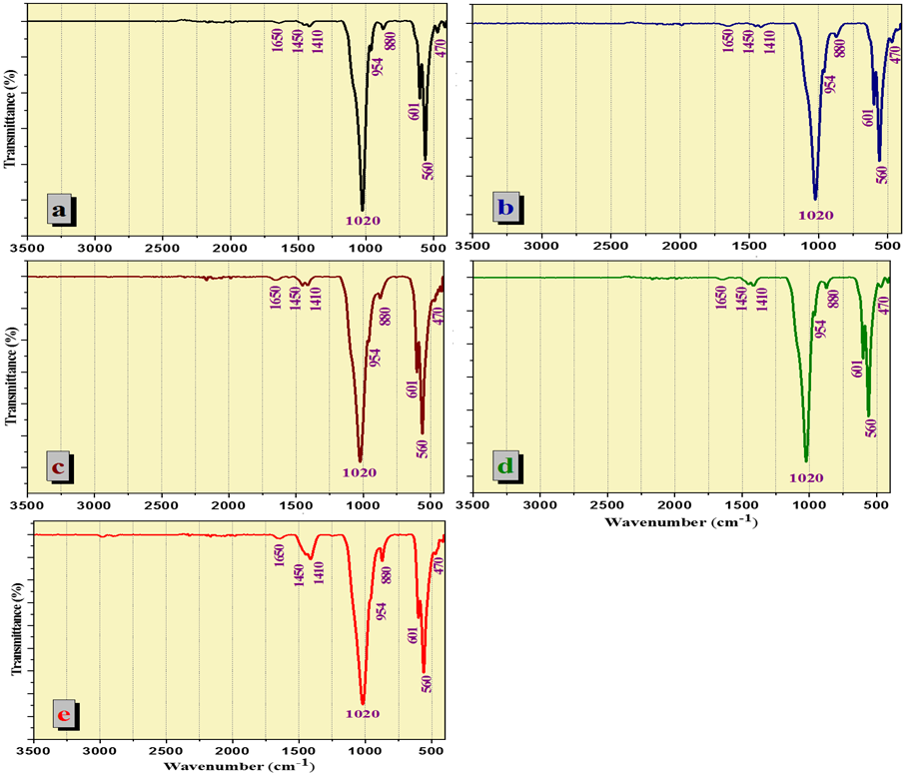
Sup. Figure 1. FTIR spectra of (a) dH0 sample, (b) dH1 sample, (c) dH2 sample, (d) dH3 sample and (e) dH4 sample.

a
b
c
Sup. Figure 2. High-resolution C1s XPS spectra of (a) d2, (b) dH0, and (c) dH2.
a
b
c
Sup. Figure 3. High-resolution N1s XPS spectra of (a) d2, (b) dH0, and (c) dH2.
a
b
c
Sup. Figure 4. High-resolution O1s XPS spectra of (a) d2, (b) dH0, and (c) dH2.
a
b
Sup. Figure 5. High-resolution Ca2p XPS spectra of (a) dH0 and (b) dH2.
a
b
Sup. Figure 6. High-resolution P2p XPS spectra of (a) dH0 and (b) dH2.

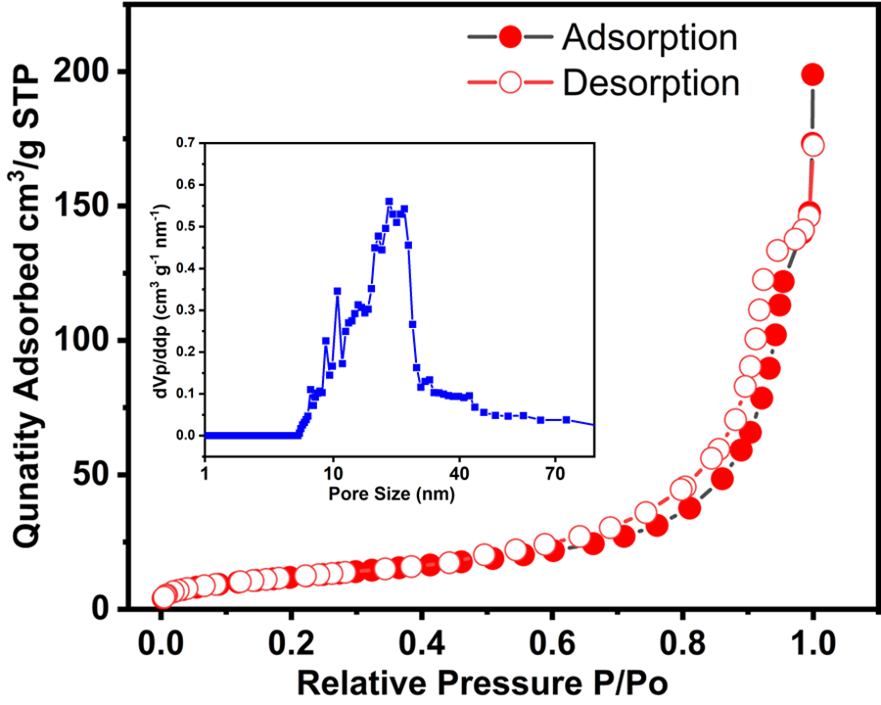
Sup. Figure 7. N₂ adsorption-desorption allowing surface area calculation via BET method and Pore size distribution curve for dh2 sample.

