Supplementary Material
Competing Tropical and Extra-tropical Processes Drive Zonal Asymmetries in Hadley Circulation Expansion
U Anjana*¹, Karanam Kishore Kumar¹
¹ Space Physics Laboratory, Vikram Sarabhai Space Centre, ISRO, Trivandrum, Kerala, India

Corresponding author: U Anjana, anjanasplvssc@gmail.com

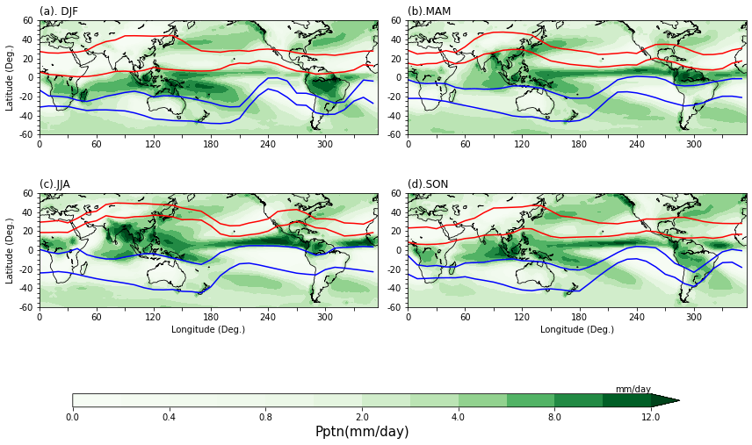

Figure S1: Zonally resolved HC boundaries and GPCP precipitation distribution: Four decades (1979-2021) of climatology of precipitation along with the HC ascending and descending region boundaries for (a) DJF, (b) MAM, (c) JJA and (d) SON. Red curves represent the ascending and descending region edges in NH and blue curves represent the same in SH. The HC ascending region boundaries encompass the wet regime and the descending region the dry regime thus ensuring the robustness of method employed for deriving the HC boundaries using ZR-MSF.

(a) NH-Correlations
(b) SH-Correlations

Figure S2: Co-variability of latitude of EDJ and HC descending boundaries: The correlation coefficients (r) between the HC descending region edge latitudes and latitude of EDJ in (a) NH and (b) SH as a function of month and longitude. The correlation denotes the extent to which extra-tropical eddy activity can control descending region boundaries of HC. The stipples indicate the correlations significant at 95% level.

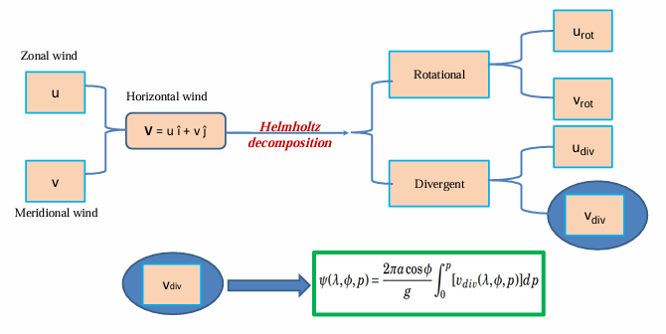

Figure S3: Schematic of methodology adopted for estimating ZR-MSF: The zonal (u) and meridional winds (v) together forming horizontal winds are subjected to Helmholtz decomposition, which provide zonal and meridional components of rotational and divergent winds. The divergent component of meridional wind is used to compute the ZR-MSF (ψ), a function of latitude-$λ$, longitude-φ and pressure level-p as given in the equation.

