misoTar: A novel approach for predicting miRNA and isomiR targets
Rony Chowdhury Ripan¹, Xiaoman Li², Haiyan Hu¹

- Department of Computer Science, University of Central Florida, Orlando, FL, 32816, USA
- Burnett School of Biomedical Science, College of Medicine, University of Central Florida, Orlando, FL, 32816, USA

Supplementary
Table S1: The number of positive miRNA/isomiR-mRNA interactions across six datasets before and after deduplication.
Dataset name | # of positive miRNA/isomiR-mRNA interactions
 | Before deduplication | After deduplication
CLASH | 48092 | 37803
CLEAR-CLIP | 7260 | 5731
qCLASH | 1709166 | 1396274
eCLIP | 1630579 | 1328453
Kozar et al. | 461566 | 368567
Fields et al. | 262631 | 194053

Table S2: Five-fold cross-validation results of misoTar on 80% training data
Folds | Accuracy | F1 | Precision | Recall | AUROC
1 | 0.875 | 0.874 | 0.879 | 0.868 | 0.949
2 | 0.927 | 0.927 | 0.922 | 0.933 | 0.978
3 | 0.948 | 0.949 | 0.939 | 0.958 | 0.989
4 | 0.932 | 0.933 | 0.925 | 0.941 | 0.983
5 | 0.840 | 0.819 | 0.939 | 0.727 | 0.939
Avg. | 0.904 | 0.900 | 0.921 | 0.885 | 0.968

Table S3: Comparison of the six datasets with respect to cell types and experimental protocols.
Dataset Name | Cell Type | Experimental Protocol
CLASH | HEK293 | CLASH
CLEAR-CLIP | Hepatoma cells | CLEAR-CLIP
qCLASH | Endothelial cells | qCLASH
eCLIP | HEK293T | Chimeric eCLIP
Kozar et al. | Melanoma cells | qCLASH
Fields et al. | HCT116 colorectal cancer cells | AGO-qCLASH

Table S4: Performance comparison between misoTar with the four external tools in the miRNA-mRNA test subset and isomiR-mRNA test subset of the 20% test data.
Datasets | Models | Accuracy | F1 | Precision | Recall | AUROC
miRNA-mRNA | misoTar | 0.921 | 0.920 | 0.932 | 0.908 | 0.968
miRNA-mRNA | TargetScan | 0.499 | 0.488 | 0.499 | 0.476 | NA
miRNA-mRNA | Mimosa | 0.535 | 0.657 | 0.521 | 0.890 | 0.568
miRNA-mRNA | TEC-miTarget | 0.511 | 0.349 | 0.522 | 0.262 | 0.523
miRNA-mRNA | DMISO | 0.571 | 0.666 | 0.546 | 0.854 | 0.613
isomiR-mRNA | misoTar | 0.925 | 0.924 | 0.939 | 0.909 | 0.972
isomiR-mRNA | TargetScan | 0.500 | 0.503 | 0.500 | 0.506 | NA
isomiR-mRNA | Mimosa | 0.534 | 0.664 | 0.519 | 0.918 | 0.561
isomiR-mRNA | TEC-miTarget | 0.511 | 0.348 | 0.522 | 0.261 | 0.519
isomiR-mRNA | DMISO | 0.575 | 0.672 | 0.547 | 0.871 | 0.623

Table S5: Performance comparison between misoTar with the four external tools in the ten miRAW test datasets.
Datasets | Models | Accuracy | F1 | Precision | Recall | AUROC | Time Cost
Test 1 | misoTar | 0.828 | 0.820 | 0.858 | 0.785 | 0.825 | 28s
Test 1 | TargetScan | 0.525 | 0.461 | 0.532 | 0.407 | NA | 7 min 45s*
Test 1 | Mimosa | 0.751 | 0.787 | 0.687 | 0.922 | 0.817 | 10 min
Test 1 | TEC-miTarget | 0.433 | 0.400 | 0.420 | 0.377 | 0.388 | 15 min 10s
Test 1 | DMISO | 0.476 | 0.599 | 0.485 | 0.784 | 0.439 | 55s*
Test 2 | misoTar | 0.823 | 0.814 | 0.857 | 0.776 | 0.824 | 32s
Test 2 | TargetScan | 0.496 | 0.410 | 0.495 | 0.350 | NA | 7 min 20s*
Test 2 | Mimosa | 0.756 | 0.793 | 0.690 | 0.932 | 0.833 | 10 min 20s
Test 2 | TEC-miTarget | 0.424 | 0.384 | 0.413 | 0.359 | 0.388 | 15 min 25s
Test 2 | DMISO | 0.471 | 0.594 | 0.482 | 0.774 | 0.427 | 1 min*
Test 3 | misoTar | 0.826 | 0.818 | 0.858 | 0.781 | 0.819 | 29s
Test 3 | TargetScan | 0.511 | 0.437 | 0.515 | 0.379 | NA | 8 min 15s*
Test 3 | Mimosa | 0.760 | 0.797 | 0.691 | 0.940 | 0.829 | 10 min 30s
Test 3 | TEC-miTarget | 0.438 | 0.409 | 0.432 | 0.388 | 0.403 | 15 min 5s
Test 3 | DMISO | 0.479 | 0.604 | 0.488 | 0.792 | 0.448 | 58s*
Test 4 | misoTar | 0.806 | 0.793 | 0.851 | 0.743 | 0.813 | 31s
Test 4 | TargetScan | 0.500 | 0.417 | 0.500 | 0.358 | NA | 8 min*
Test 4 | Mimosa | 0.742 | 0.778 | 0.683 | 0.903 | 0.804 | 10 min 25s
Test 4 | TEC-miTarget | 0.431 | 0.395 | 0.421 | 0.372 | 0.386 | 15 min 15s
Test 4 | DMISO | 0.473 | 0.596 | 0.483 | 0.777 | 0.447 | 1 min 2s*
Test 5 | misoTar | 0.814 | 0.803 | 0.854 | 0.757 | 0.813 | 30s
Test 5 | TargetScan | 0.515 | 0.444 | 0.519 | 0.387 | NA | 7 min 50s*
Test 5 | Mimosa | 0.762 | 0.798 | 0.692 | 0.943 | 0.837 | 10 min 35s
Test 5 | TEC-miTarget | 0.436 | 0.405 | 0.429 | 0.383 | 0.404 | 15 min 40s
Test 5 | DMISO | 0.468 | 0.591 | 0.480 | 0.768 | 0.429 | 1 min 1s*
Test 6 | misoTar | 0.840 | 0.835 | 0.862 | 0.810 | 0.845 | 28s
Test 6 | TargetScan | 0.517 | 0.448 | 0.523 | 0.392 | NA | 8 min 5s*
Test 6 | Mimosa | 0.755 | 0.792 | 0.689 | 0.931 | 0.825 | 10 min 20s
Test 6 | TEC-miTarget | 0.434 | 0.402 | 0.426 | 0.379 | 0.395 | 15 min 10s
Test 6 | DMISO | 0.471 | 0.594 | 0.482 | 0.774 | 0.428 | 59s*
Test 7 | misoTar | 0.827 | 0.819 | 0.858 | 0.783 | 0.829 | 32s
Test 7 | TargetScan | 0.509 | 0.434 | 0.512 | 0.376 | NA | 7 min 55s*
Test 7 | Mimosa | 0.754 | 0.790 | 0.688 | 0.927 | 0.820 | 10 min 30s
Test 7 | TEC-miTarget | 0.455 | 0.436 | 0.452 | 0.422 | 0.412 | 15 min 25s
Test 7 | DMISO | 0.475 | 0.599 | 0.485 | 0.783 | 0.448 | 57s*
Test 8 | misoTar | 0.824 | 0.815 | 0.857 | 0.777 | 0.819 | 29s
Test 8 | TargetScan | 0.505 | 0.427 | 0.507 | 0.368 | NA | 8 min 20s*
Test 8 | Mimosa | 0.765 | 0.801 | 0.693 | 0.949 | 0.830 | 10 min 40s
Test 8 | TEC-miTarget | 0.428 | 0.390 | 0.418 | 0.367 | 0.383 | 15 min 10s
Test 8 | DMISO | 0.481 | 0.605 | 0.488 | 0.794 | 0.438 | 1 min 3s*
Test 9 | misoTar | 0.827 | 0.819 | 0.858 | 0.783 | 0.822 | 30s
Test 9 | TargetScan | 0.526 | 0.464 | 0.534 | 0.411 | NA | 8 min 10s*
Test 9 | Mimosa | 0.762 | 0.798 | 0.692 | 0.943 | 0.838 | 10 min 25s
Test 9 | TEC-miTarget | 0.423 | 0.383 | 0.412 | 0.358 | 0.381 | 15 min 20s
Test 9 | DMISO | 0.465 | 0.588 | 0.478 | 0.763 | 0.444 | 1 min*
Test 10 | misoTar | 0.835 | 0.829 | 0.861 | 0.799 | 0.845 | 31s
Test 10 | TargetScan | 0.504 | 0.424 | 0.505 | 0.365 | NA | 8 min*
Test 10 | Mimosa | 0.761 | 0.798 | 0.692 | 0.942 | 0.823 | 10 min 15s
Test 10 | TEC-miTarget | 0.429 | 0.394 | 0.420 | 0.370 | 0.387 | 15 min
Test 10 | DMISO | 0.467 | 0.590 | 0.480 | 0.766 | 0.440 | 1 min 5s*
* Indicates CPU-run time; unmarked values indicate GPU-run time.
Table S6: Recall comparison among different existing prediction tools in the miRTarBase and miRecords datasets.
 | miRTarBase |  | miRecords
Models | Recall | Time Cost | Recall | Time Cost
misoTar | 0.834 | 13 min | 0.771 | 41s
TargetScan | 0.368 | 40 min* | 0.324 | 1 min 12 s*
Mimosa | 0.825 | 1 h 18 min | 0.760 | 2 min 10 s
TEC-miTarget | 0.448 | 4 h 15 min | 0.409 | 7 min 40s
DMISO | 0.743 | 15 min 13s* | 0.774 | 1 min 46s*
* Indicates CPU-run time; unmarked values indicate GPU-run time.
Table S7: Recall comparison among different existing prediction tools in the strongly supported and CLIP-derived subsets of miRTarBase data.
Models | Strongly supported subset | CLIP-derived subset
misoTar | 0.882 | 0.816
TargetScan | 0.483 | 0.363
Mimosa | 0.760 | 0.826
TEC-miTarget | 0.425 | 0.449
DMISO | 0.848 | NA*
* DMISO was excluded from evaluation on the CLIP-derived subset due to potential train–test leakage, as DMISO was trained on CLASH data and the CLIP-derived subset contains CLASH-derived interactions

Table S8: Comparison among different tokenization techniques.
Tokenization  techniques | Models | Accuracy | F1 | Precision | Recall | AUROC | Time Cost
WordPiece | misoTar | 0.922 | 0.921 | 0.934 | 0.908 | 0.969 | 8 h 38 min
K-mer(6) | DNABERT | 0.926 | 0.924 | 0.946 | 0.903 | 0.972 | 17 h 28 min
Byte Pair Encoding (BPE) | DNABERT2 | 0.928 | 0.927 | 0.943 | 0.911 | 0.974 | 4 h 35 min

Table S9: Five-fold cross-validation results of DNABERT2 and DNABERT on 20% test data
Models | Folds | Accuracy | F1 | Precision | Recall | AUROC
DNABERT2 | 1 | 0.500 | 0.670 | 0.500 | 1.000 | 0.500
DNABERT2 | 2 | 0.500 | 0.670 | 0.500 | 1.000 | 0.500
DNABERT2 | 3 | 0.928 | 0.927 | 0.943 | 0.911 | 0.974
DNABERT2 | 4 | 0.927 | 0.926 | 0.941 | 0.912 | 0.973
DNABERT2 | 5 | 0.500 | 0.670 | 0.500 | 1.000 | 0.500
DNABERT | 1 | 0.915 | 0.914 | 0.922 | 0.907 | 0.965
DNABERT | 2 | 0.919 | 0.917 | 0.937 | 0.898 | 0.968
DNABERT | 3 | 0.926 | 0.924 | 0.946 | 0.903 | 0.972
DNABERT | 4 | 0.928 | 0.926 | 0.943 | 0.911 | 0.973
DNABERT | 5 | 0.927 | 0.925 | 0.946 | 0.906 | 0.973

Table S10: The effect of misoTar’s model size on prediction performance
Hyperparameters |  |  | Evaluation Metrics
#L | #H | #A | Accuracy | F1 | Precision | Recall | AUROC
2 | 128 | 2 | 0.792 | 0.792 | 0.793 | 0.791 | 0.875
4 | 256 | 4 | 0.898 | 0.895 | 0.921 | 0.869 | 0.955
4 | 512 | 8 | 0.914 | 0.911 | 0.941 | 0.882 | 0.965
8 | 512 | 8 | 0.918 | 0.916 | 0.941 | 0.891 | 0.967
12 | 768 | 12 | 0.922 | 0.921 | 0.934 | 0.908 | 0.969

Table S11: The effect of hyperparameters on misoTar’s prediction performance
Hyperparameters |  |  | Evaluation Metrics
Epoch | Batch Size | Learning  Rate | Accuracy | F1 | Precision | Recall | AUROC
2 | 64 | 5e-5 | 0.918 | 0.917 | 0.933 | 0.901 | 0.967
3 | 64 | 5e-5 | 0.922 | 0.921 | 0.934 | 0.908 | 0.969
4 | 64 | 5e-5 | 0.919 | 0.918 | 0.931 | 0.907 | 0.968
3 | 32 | 5e-5 | 0.500 | 0.667 | 0.500 | 0.999 | 0.500
3 | 64 | 2e-5 | 0.921 | 0.919 | 0.944 | 0.894 | 0.969

Table S12: miRNA/isomiR count for important and crucial positions.
miRNA position index | #of miRNAs (important positions) | #of miRNAs  (crucial positions)
1 | 1218 | 539
2 | 1361 | 666
3 | 1418 | 814
4 | 1459 | 910
5 | 1501 | 920
6 | 1486 | 839
7 | 1359 | 676
8 | 1243 | 622
9 | 1118 | 605
10 | 1148 | 588
11 | 1178 | 614
12 | 1160 | 625
13 | 1222 | 653
14 | 1135 | 623
15 | 1123 | 613
16 | 1105 | 610
17 | 1060 | 523
18 | 976 | 499
19 | 880 | 464
20 | 787 | 426
21 | 684 | 354
22 | 459 | 243
23 | 170 | 85
24 | 14 | 14
25 | 7 | 3
26 | 4 | 6
27 | 7 | 5
28 | 7 | 5

Table S13: 21 middle region only user miRNA/isomiRs
hsa-miR-17-3p(ACTGCAGTGAAGGCACCTGTAG)⁺,
hsa-miR-17-5p(CAAAGTGATTACAGTGCAGGTAG),
hsa-miR-17-5p(CAAAGTGCTTACACTGCAGGTAG),
hsa-miR-186-5p(CAAAGAACTCTCCTTTTGGGCT),
hsa-miR-18a-3p(TGCCCTAAGTGCTCCTTCTGG),
hsa-miR-18a-5p(GCATCTAGTGCAGATAG),
hsa-miR-18a-5p(TAAGGTGCATCCAGTGCAGATAG),
hsa-miR-1972(AGGCCAGGCACAGTGGCTCA),
hsa-miR-19a-3p(CAAATCTATGCAAAACTGA),
hsa-miR-19b-3p(TGCAAATCCATGCAAAACTG),
hsa-miR-20a-5p(GTGCTTATAGTGCAGGTA),
hsa-miR-25-3p(ATTGCACTTGTCCCGGTTTG),
hsa-miR-361-3p*,
hsa-miR-374c-5p,
hsa-miR-4787-3p(ATGCGCCGCCCACTGCCCCGCGC),
hsa-miR-484(CAGGCTCAGTCCCCTCCCGAT),
hsa-miR-548a-3p,
hsa-miR-5585-3p(CTGAGTAGCTGGGACTATAGGT),
hsa-miR-5585-3p(GAGTAGCTGGGACTACAG),
hsa-miR-5689(CACACACCTGTAGTCCCAG),
hsa-miR-93-5p(GTGCTGTTCGTGCAGGTAG)
+ are isomiRs, * are miRNAs

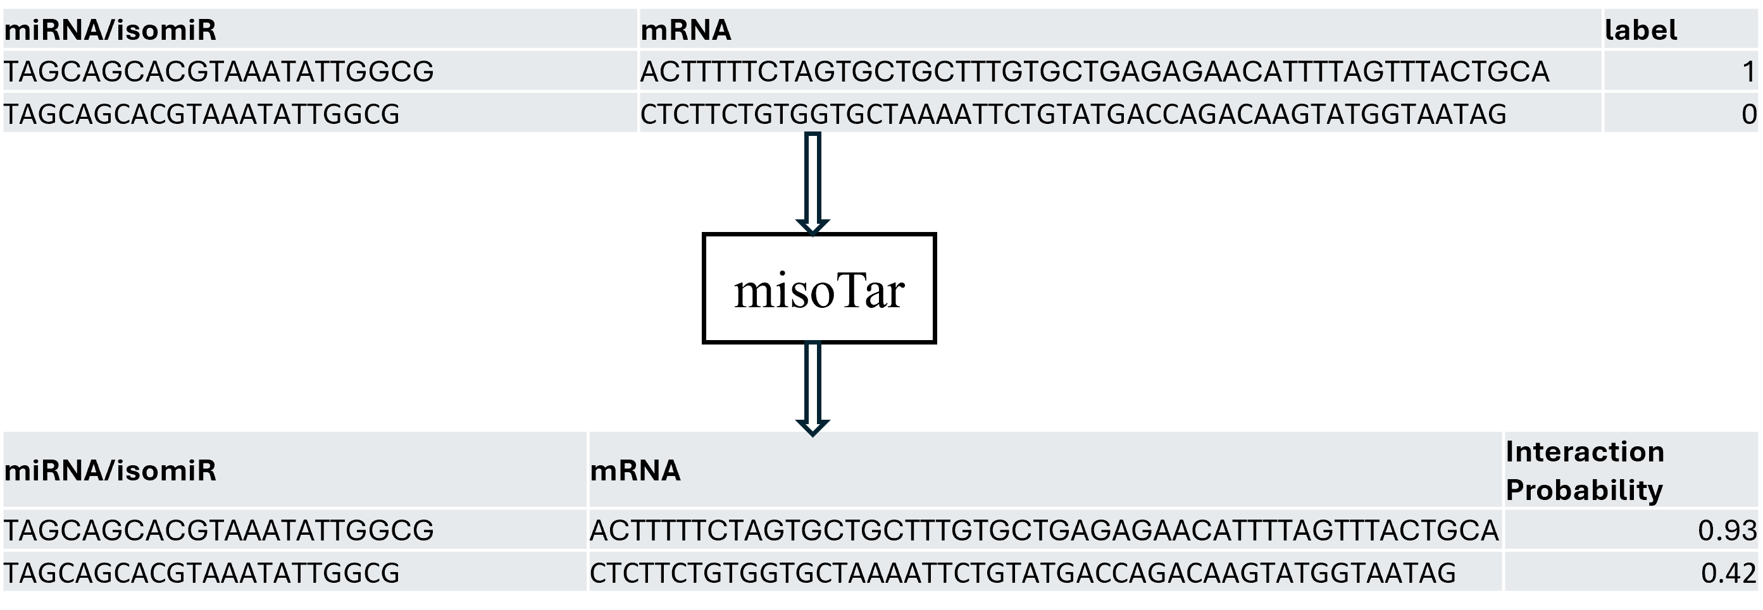
Fig S1: A schematic example of misoTar’s input (miRNA/isomiR and mRNA sequences) and output.
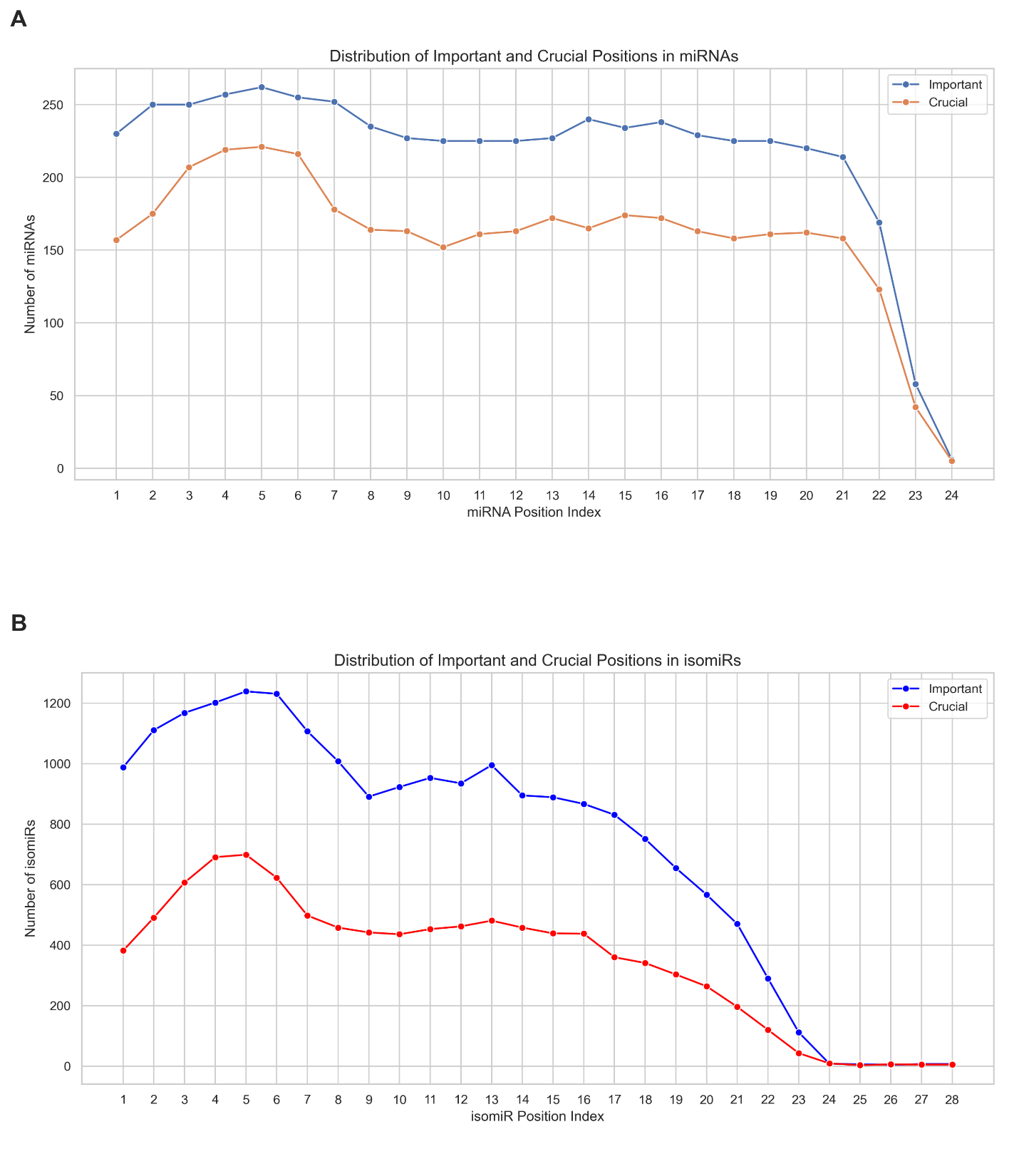Fig S2: A) Distribution of important and crucial positions in miRNAs. B) Distribution of important and crucial positions in isomiRs.

