Supplement 1
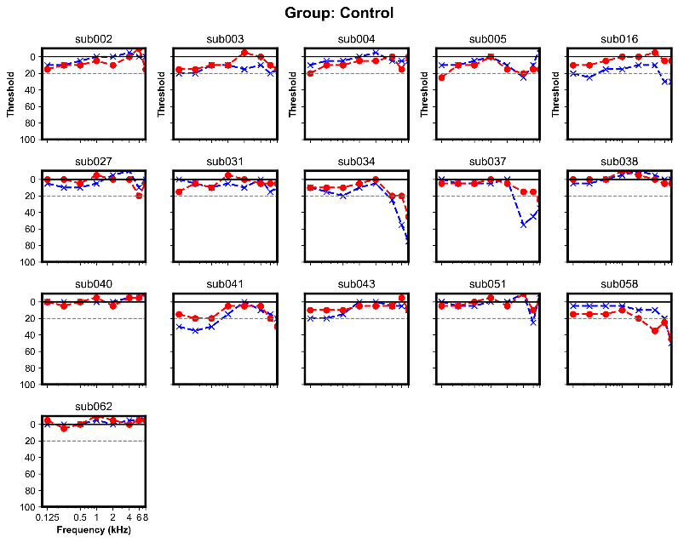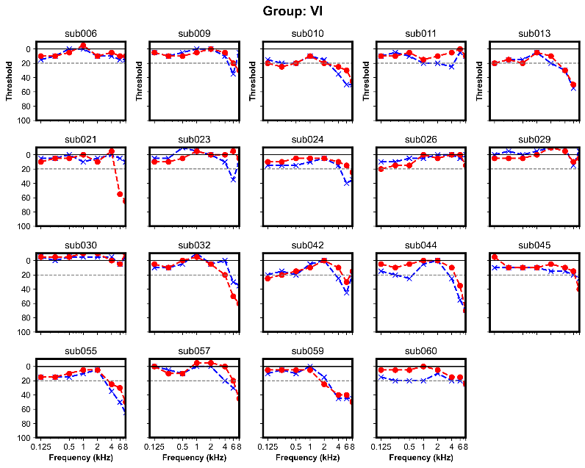
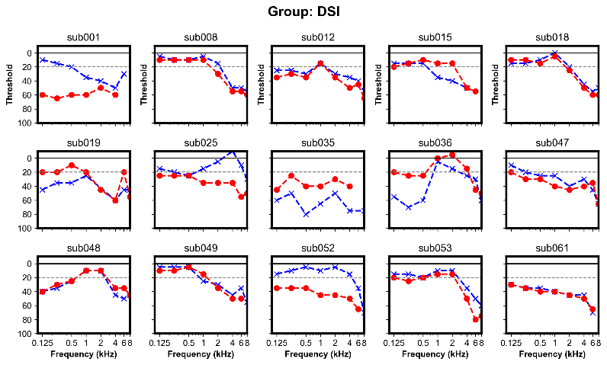

Supplementary Figure 1. The hearing test audiograms for control, vision loss (VL) and dual sensory loss (DSL) groups.

