Unveiling GSPT1 as a crucial prognostic biomarker and therapeutic vulnerability in breast cancer
Huafei Wang¹, Chenxi Li¹, Zhu Zhu¹, Xinwei Liu², Shan Jiang², Li Wang¹, Yijuan Liu¹, Hanlin Fu^{3*}, Ruixia Guo^{3*}
Institution: ¹Department of Biological Sample Bank, The First Affiliated Hospital of Zhengzhou University, Zhengzhou, Henan 450052. ²Department of Breast Surgery, The First Affiliated Hospital of Zhengzhou University, Zhengzhou, Henan 450052. ³Department of Obstetrics and Gynecology, The First Affiliated Hospital of Zhengzhou University, Zhengzhou, Henan 450052.
Corresponding author: Ruixia Guo, grxcdxzzu@163.com; Hanlin Fu, fuhanlin@zzu.edu.cn
Supplemental Figure 1
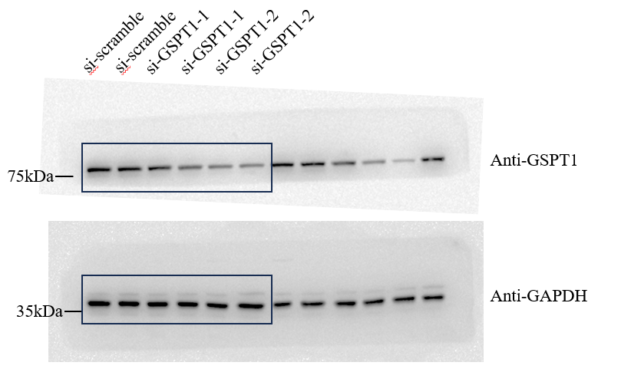
Supplemental Figure 1. GSPT1 protein levels were determined in cells using western blot analysis

