Pairwise comparison matrix developed based on expert opinion for AHP, FAHP, ANP, and DEMTAEL is given below:
Factors |  | I | II | III | IV | V | VI | VII | VIII | IX | X | XI | XII | AHP Weight (%) | ANP Weight (%) | FAHP  Weight  (%) | DEMTEL  Weight  (%) | CR (%)
I |  | 1 | 4 | 7 | 7 | 4 | 5 | 2 | 6 | 1 | 6 | 5 | 7 | 22.1 | 23.6 | 22.2 | 19.58 | 4.2
II |  | 1/4 | 1 | 5 | 5 | 2 | 3 | 1/3 | 4 | 1/3 | 2 | 4 | 5 | 10.4 | 10.1 | 10 | 10.71 | 4.2
III |  | 1/7 | 1/5 | 1 | 1 | 1/3 | 1/3 | 1/7 | 1 | 1/7 | 1 | 1/3 | 1 | 2.4 | 2.2 | 2.64 | 3.46 | 4.2
IV |  | 1/7 | 1/5 | 1 | 1 | 1/3 | 1/3 | 1/7 | 1 | 1/6 | 1 | 1/3 | 1 | 2.4 | 2.1 | 2.57 | 3.99 | 4.2
V |  | 1/4 | 1/2 | 3 | 3 | 1 | 2 | 1/3 | 3 | 1/3 | 4 | 3 | 4 | 7.9 | 8.3 | 8.05 | 12.35 | 4.2
VI |  | 1/5 | 1/3 | 3 | 3 | 1/2 | 1 | 1/3 | 3 | 1/3 | 3 | 3 | 3 | 6.6 | 6.7 | 6.52 | 8.57 | 4.2
VII |  | 1/2 | 3 | 7 | 7 | 3 | 3 | 1 | 5 | 1 | 6 | 5 | 6 | 17.2 | 16.3 | 18 | 12.20 | 4.2
VIII |  | 1/6 | 1/4 | 1 | 1 | 1/3 | 1/3 | 1/5 | 1 | 1/6 | 1 | 1 | 1 | 2.8 | 2.5 | 2.93 | 4.13 | 4.2
IX |  | 1 | 3 | 7 | 6 | 3 | 3 | 1 | 6 | 1 | 7 | 5 | 7 | 18.7 | 19.9 | 18.2 | 12.64 | 4.2
X |  | 1/6 | 1/2 | 1 | 1 | 1/4 | 1/3 | 1/6 | 1 | 1/7 | 1 | 1/2 | 1 | 2.7 | 2.1 | 2.68 | 5.37 | 4.2
XI |  | 1/5 | 1/4 | 3 | 3 | 1/3 | 1/3 | 1/5 | 1 | 1/5 | 2 | 1 | 3 | 4.4 | 4.0 | 4 | 4.71 | 4.2
XII |  | 1/7 | 1/5 | 1 | 1 | 1/4 | 1/3 | 1/6 | 1 | 1/7 | 1 | 1/3 | 1 | 2.4 | 2.2 | 2.21 | 2.29 | 4.2
 | I = Elevation, II = Slope, III = Aspect, IV = Curvature, V = Drainage density, VI = TWI, VII = Rainfall, VIII = NDVI, IX = Distance from river, X = TPI, XI = LULC, XII = SPI
 | Subclasses | Sub-classes |  |  |  |  |  |  |  |  |  | CR (%) | AHP Weight (%) |  | ANP Weight (%) |  | FAHP  Weight (%) | DEMTEL  Weight  (%)
Elevation (m) | Subclasses | I | II | III | IV | V | VI | VII | VIII | IX | X
 | I | 1 | 3 | 5 | 7 | 9 |  |  |  |  |  | 8.35 |  | 50.3 | 52.2 | 49.99 |  | 43.86
 | II | 1/3 | 1 | 3 | 5 | 7 |  |  |  |  |  |  |  | 26.0 | 24.4 | 26.8 |  | 29.60
 | III | 1/5 | 1/3 | 1 | 3 | 5 |  |  |  |  |  |  |  | 13.4 | 12.4 | 13.26 |  | 12.75
 | IV | 1/7 | 1/5 | 1/3 | 1 | 3 |  |  |  |  |  |  |  | 6.8 | 7.2 | 6.52 |  | 6.90
 | V | 1/9 | 1/7 | 1/5 | 1/3 | 1 |  |  |  |  |  |  |  | 3.5 | 3.8 | 3.42 |  | 6.90
I = -26 to 5, II = 5 to 7.5, III = 7.5 to 10, IV = 10 to 12.5, V = 12.5 to 37
Slope (Degree) |  | I | II | III | IV | V | VI | VII | VIII | IX | X
 | I | 1 | 3 | 4 | 5 | 7 |  |  |  |  |  | 6.02 |  | 47.4 | 50.1 | 46.84 |  | 43.86
 | II | 1/3 | 1 | 2 | 4 | 6 |  |  |  |  |  |  |  | 24.7 | 22.5 | 24.87 |  | 29.60
 | III | 1/4 | 1/2 | 1 | 2 | 5 |  |  |  |  |  |  |  | 15.0 | 16.3 | 15.48 |  | 12.75
 | IV | 1/5 | 1/4 | 1/2 | 1 | 3 |  |  |  |  |  |  |  | 8.7 | 7.7 | 8.85 |  | 6.90
 | V | 1/7 | 1/6 | 1/5 | 1/3 | 1 |  |  |  |  |  |  |  | 4.1 | 3.4 | 3.96 |  | 6.90
I = 0 to 1, II = 1 to 2, III = 2 to 3, IV = 3 to 4, V = 4 to 25.85
Curvature |  | I | II | III | IV | V | VI | VII | VIII | IX | X
 | I | 1 | 2 | 4 | 6 | 8 |  |  |  |  |  | 2.86 |  | 46.6 | 48.7 | 45.45 |  | 40.93
 | II | 1/2 | 1 | 2 | 4 | 6 |  |  |  |  |  |  |  | 26.6 | 25.3 | 27.42 |  | 32.01
 | III | 1/4 | 1/2 | 1 | 2 | 4 |  |  |  |  |  |  |  | 14.2 | 14.0 | 14.71 |  | 15.20
 | IV | 1/6 | 1/4 | 1/2 | 1 | 3 |  |  |  |  |  |  |  | 8.4 | 9.1 | 8.43 |  | 5.92
 | V | 1/8 | 1/6 | 1/4 | 1/3 | 1 |  |  |  |  |  |  |  | 4.1 | 2.9 | 4 |  | 5.92
I = -4 to -0.3, II = -0.3 to -0.15, III = -0.15 to 0.05, IV = 0.05 to 0.15, V = 0.15 to 7.44
Drainage density |  | I | II | III | IV | V | VI | VII | VIII | IX | X
 | I | 1 | 3 | 5 | 6 | 7 |  |  |  |  |  | 7.7 |  | 49.5 | 52.0 | 49.57 |  | 45.27
 | II | 1/3 | 1 | 3 | 4 | 5 |  |  |  |  |  |  |  | 24.8 | 22.8 | 25.42 |  | 26.58
 | III | 1/5 | 1/3 | 1 | 3 | 4 |  |  |  |  |  |  |  | 14.0 | 14.2 | 13.43 |  | 15.80
 | IV | 1/6 | 1/4 | 1/3 | 1 | 2 |  |  |  |  |  |  |  | 7.0 | 6.5 | 6.9 |  | 6.17
 | V | 1/7 | 1/5 | 1/4 | 1/2 | 1 |  |  |  |  |  |  |  | 4.7 | 4.5 | 4.69 |  | 6.17
I = 1.4 to 25, II = 25 to 35, III = 35 to 40, IV = 40 to 45, V = 45 to 52.73
TWI |  | I | II | III | IV | V | VI | VII | VIII | IX | X
 | I | 1 | 1/2 | 1/3 | 1/5 | 1/7 |  |  |  |  |  | 1.59 |  | 5.1 | 2.9 | 5.21 |  | 5.89
 | II | 2 | 1 | 1/2 | 1/4 | 1/6 |  |  |  |  |  |  |  | 7.9 | 9.0 | 7.99 |  | 5.89
 | III | 3 | 2 | 1 | 1/2 | 1/4 |  |  |  |  |  |  |  | 13.8 | 14.1 | 14.28 |  | 9.04
 | IV | 5 | 4 | 2 | 1 | 1/2 |  |  |  |  |  |  |  | 26.5 | 25.2 | 27.15 |  | 39.04
 | V | 7 | 6 | 4 | 2 | 1 |  |  |  |  |  |  |  | 46.7 | 48.8 | 45.37 |  | 40.13
I = 3.86 to 7, II = 7 to 8.5, III = 8.5 to 9.5, IV = 9.5 to 11, V = 11 to 36.5
Rainfall  (mm) |  | I | II | III | IV | V | VI | VII | VIII | IX | X
 | I | 1 | 1/2 | 1/3 | 1/4 | 1/6 |  |  |  |  |  | 3.26 |  | 5.7 | 3.4 | 5.83 |  | 6.67
 | II | 2 | 1 | 1/2 | 1/3 | 1/5 |  |  |  |  |  |  |  | 8.9 | 9.2 | 9.16 |  | 6.67
 | III | 3 | 2 | 1 | 1/2 | 1/4 |  |  |  |  |  |  |  | 14.3 | 14.0 | 14.71 |  | 6.67
 | IV | 4 | 3 | 2 | 1 | 1/3 |  |  |  |  |  |  |  | 22.7 | 22.5 | 22.79 |  | 36.19
 | V | 6 | 5 | 4 | 3 | 1 |  |  |  |  |  |  |  | 48.5 | 50.9 | 47.51 |  | 43.80
I = 1750 to 1800, II = 1800 to 1850, III = 1850 to 1900, IV = 1900 to 1950, V = 1950 to 2040
NDVI |  | I | II | III | IV | V | VI | VII | VIII | IX | X
 | I | 1 | 2 | 4 | 6 | 8 |  |  |  |  |  | 1.56 |  | 46.8 | 48.6 | 45.53 |  | 43.86
 | II | 1/2 | 1 | 2 | 4 | 6 |  |  |  |  |  |  |  | 26.8 | 25.4 | 27.47 |  | 29.60
 | III | 1/4 | 1/2 | 1 | 2 | 4 |  |  |  |  |  |  |  | 14.4 | 14.0 | 14.74 |  | 12.75
 | IV | 1/6 | 1/4 | 1/2 | 1 | 2 |  |  |  |  |  |  |  | 7.6 | 9.1 | 7.81 |  | 6.90
 | V | 1/8 | 1/6 | 1/4 | 1/2 | 1 |  |  |  |  |  |  |  | 4.4 | 2.9 | 4.45 |  | 6.90
I = -0.094 to 0.15, II = 0.15 to 0.2, III = 0.2 to 0.25, IV = 0.25 to 0.3, V = 0.3 to 0.476
Distance from River (m) |  | I | II | III | IV | V | VI | VII | VIII | IX | X
 | I | 1 | 3 | 5 | 6 | 8 |  |  |  |  |  | 5.16 |  | 50.4 | 52.1 | 50.05 |  | 44.01
 | II | 1/3 | 1 | 3 | 4 | 6 |  |  |  |  |  |  |  | 25.7 | 24.5 | 25.91 |  | 29.40
 | III | 1/5 | 1/3 | 1 | 2 | 4 |  |  |  |  |  |  |  | 12.4 | 12.3 | 12.18 |  | 14.70
 | IV | 1/6 | 1/4 | 1/2 | 1 | 2 |  |  |  |  |  |  |  | 7.3 | 7.3 | 7.54 |  | 5.94
 | V | 1/8 | 1/6 | 1/4 | 1/2 | 1 |  |  |  |  |  |  |  | 4.3 | 3.8 | 4.31 |  | 5.94
I = 0 to 250, II= 250 to 500, III = 500 to 1000, IV = 1000 to 1500, V = 1500 to 2460.17
TPI |  | I | II | III | IV | V | VI | VII | VIII | IX | X
 | I | 1 | 3 | 5 | 7 | 8 |  |  |  |  |  | 9.28 |  | 49.7 | 52.2 | 49.8 |  | 44.01
 | II | 1/3 | 1 | 3 | 5 | 7 |  |  |  |  |  |  |  | 26.2 | 22.6 | 26.9 |  | 29.40
 | III | 1/5 | 1/3 | 1 | 3 | 5 |  |  |  |  |  |  |  | 13.6 | 14.1 | 13.3 |  | 14.70
 | IV | 1/7 | 1/5 | 1/3 | 1 | 3 |  |  |  |  |  |  |  | 6.9 | 6.6 | 6.5 |  | 5.94
 | V | 1/8 | 1/7 | 1/5 | 1/3 | 1 |  |  |  |  |  |  |  | 3.7 | 4.5 | 3.5 |  | 5.94
I = -37.25 to -3, II = -3 to -1, III = -1 to 0.5, IV = 0.5 to 2.5, V = 2.5 to 39.1174
Aspect |  | I | II | III | IV | V | VI | VII | VIII | IX | X
 | I | 1 | 1/4 | 1/3 | 1 | 2 | 3 | 4 | 3 | 3 | 2 | 5.29 |  | 12.2 | 12.0 | 12.17 |  | 8.10
 | II | 4 | 1 | 2 | 2 | 3 | 4 | 5 | 4 | 3 | 2 |  |  | 22.9 | 23.1 | 22.2 |  | 18.48
 | III | 3 | 1/2 | 1 | 2 | 3 | 3 | 4 | 3 | 3 | 3 |  |  | 18.2 | 18.1 | 18.5 |  | 14.99
 | IV | 1 | 1/2 | 1/2 | 1 | 2 | 3 | 3 | 3 | 2 | 1 |  |  | 11.6 | 11.7 | 12.03 |  | 11.39
 | V | 1/2 | 1/3 | 1/3 | 1/2 | 1 | 2 | 3 | 2 | 2 | 1 |  |  | 8.1 | 8.4 | 8.66 |  | 8.10
 | VI | 1/3 | 1/4 | 1/3 | 1/3 | 1/2 | 1 | 2 | 1 | 1 | 1 |  |  | 5.2 | 4.9 | 5.62 |  | 6.82
 | VII | 1/4 | 1/5 | 1/4 | 1/3 | 1/3 | 1/2 | 1 | 1 | 1 | 1 |  |  | 4.1 | 4.0 | 4.23 |  | 9.16
 | VIII | 1/3 | 1/4 | 1/3 | 1/3 | 1/2 | 1 | 1 | 1 | 2 | 2 |  |  | 6.0 | 6.1 | 5.55 |  | 8.10
 | IX | 1/3 | 1/3 | 1/3 | 1/2 | 1/2 | 1 | 1 | 1/2 | 1 | 2 |  |  | 5.6 | 5.5 | 5.4 |  | 8.10
 | X | 1/2 | 1/2 | 1/3 | 1 | 1 | 1 | 1 | 1/2 | 1/2 | 1 |  |  | 6.1 | 6.2 | 5.64 |  | 6.77
I = Flat (-1), II = North (0-22.5), III = Northeast (22.5-67.5), IV = East (67.5-112.5), V = Southeast (112.5-157.5), VI = South (157.5-202.5), VII = Southwest (202.5-247.5), VIII = West (247.5-292.5), IX = Northwest (292.5-337.5), X = North (337.5-357.782196)
LULC |  | I | II | III | IV | V | VI | VII | VIII | IX | X
 | I | 1 | 2 | 1 | 4 | 1/2 |  |  |  |  |  | 2.89 |  | 22.3 | 24.4 | 23.9 |  | 28.62
 | II | 1/2 | 1 | 1 | 3 | 1/3 |  |  |  |  |  |  |  | 14.7 | 13.3 | 16.02 |  | 11.62
 | III | 1 | 1 | 1 | 3 | 1/3 |  |  |  |  |  |  |  | 16.9 | 17.2 | 15.34 |  | 11.62
 | IV | 1/4 | 1/3 | 1/3 | 1 | 1/4 |  |  |  |  |  |  |  | 6.4 | 6.2 | 6.32 |  | 6.75
 | V | 2 | 3 | 3 | 4 | 1 |  |  |  |  |  |  |  | 39.7 | 38.9 | 38.43 |  | 41.38
I = Agri. Land, II = Bare Soil, III = Built area, IV = Vegetation, V = Water
SPI |  | I | II | III | IV | V | VI | VII | VIII | IX | X
 | I | 1 | 1/2 | 1/4 | 1/6 | 1/8 |  |  |  |  |  | 1.75 |  | 4.5 | 5.2 | 4.51 |  | 6.06
 | II | 2 | 1 | 1/2 | 1/4 | 1/5 |  |  |  |  |  |  |  | 8.0 | 7.5 | 8.23 |  | 6.06
 | III | 4 | 2 | 1 | 1/2 | 1/4 |  |  |  |  |  |  |  | 14.6 | 15.0 | 14.93 |  | 9.47
 | IV | 6 | 4 | 2 | 1 | 1/2 |  |  |  |  |  |  |  | 27.2 | 25.3 | 27.83 |  | 37.88
 | V | 8 | 5 | 4 | 2 | 1 |  |  |  |  |  |  |  | 45.8 | 47.0 | 44.51 |  | 40.52
I = 0 to 6500, II= 6500 to 30000, III = 30000 to 65000, IV = 65000 to 140000, V = 140000 to 327824

Network diagram generated from the DEMATEL method.
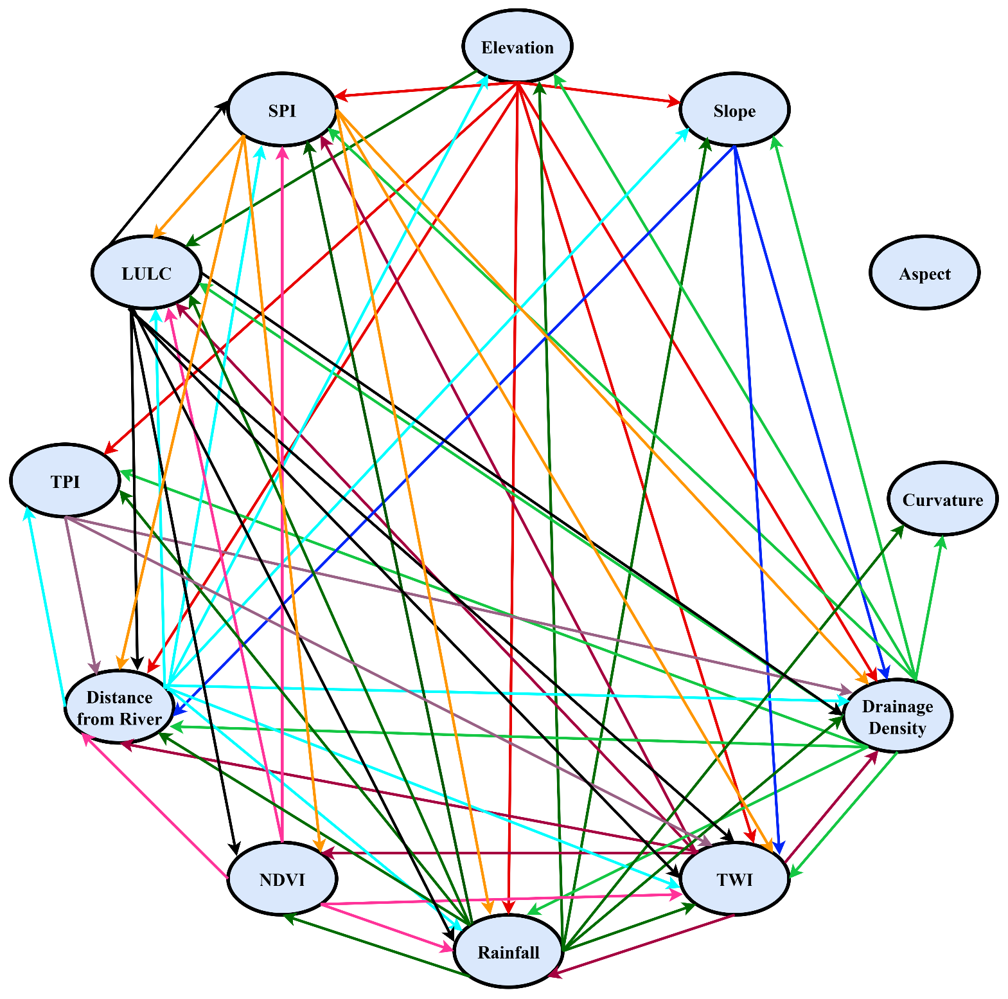

Outputs of the sensitivity analysis incorporating correlation and RMSE values are demonstrated below:
Method | Correlation | RMSE
AHP | 0.908575 | 0.083865
FAHP | 1 | 0
ANP | 0.838937 | 0.127756
DEMATEL | 0.789463 | 0.168659
TOPSIS | 0.53704 | 0.29942
VIKOR | 0.408128 | 0.311469
EDAS | 0.142727 | 0.358739
Entropy | 0.802491 | 0.146181

