Supplementary Table and Figures

Table S1. Associations (partial correlations) between (adjusted) mean pre-to-post session change on VAS measures and levels of intervention immersion, post-session SSQ score and (adjusted) pre-to-post session change on the SSQ for VR Headset (VR) and Video intervention participants.
 | Stress | Anxious | Sad | Calm | Happy
 | r (CI) | r (CI) | r (CI) | r (CI) | r (CI)
VR participants
Immersion | 0.42**  (0.07,0.70) | 0.52***  (0.21,0.74) | 0.29*  (0.04,0.52) | 0.64***  (0.49,0.78) | 0.50*** (0.26,0.71)
SSQ total (post-session) | -0.13  (-0.41,0.20) | -0.05  (-0.37,0.31) | -0.05  (-0.35,0.19) | -0.07  (-0.36,0.38) | -0.01  (-0.37,0.38)
SSQ change (adjusted) | -0.13  (-0.37,0.11) | -0.09  (0.15,-0.37) | -0.14  (-0.38,0.05) | -0.19  (-0.46,0.13) | -0.19  (-0.47,0.07)
Video participants
Immersion | 0.48**  (0.18,0.68) | 0.27  (0.01,0.48) | 0.09  (-0.27,0.39) | 0.43** (0.12,0.68) | 0.17  (-0.20,0.54)
SSQ total (post-session) | -0.27  (-0.53,0.06) | -0.01  (-0.29,0.28) | -0.06  (-0.39,0.24) | -0.08  (-0.38,0.28) | 0.13  (-0.20,0.43)
SSQ change (adjusted) | -0.33*  (-0.57,-0.06) | -0.12  (-0.37,0.17) | -0.16  (0.15,-0.45) | -0.18  (-0.48,0.17) | -0.08  (-0.43,0.24)
Note: Mean pre-to-post-session change on VAS measures were adjusted for pre-session scores. SSQ = Simulator sickness questionnaire; pre-to-post session change on the SSQ was adjusted for pre-session score. *p < 0.05, **p < 0.01, ***p < 0.001.

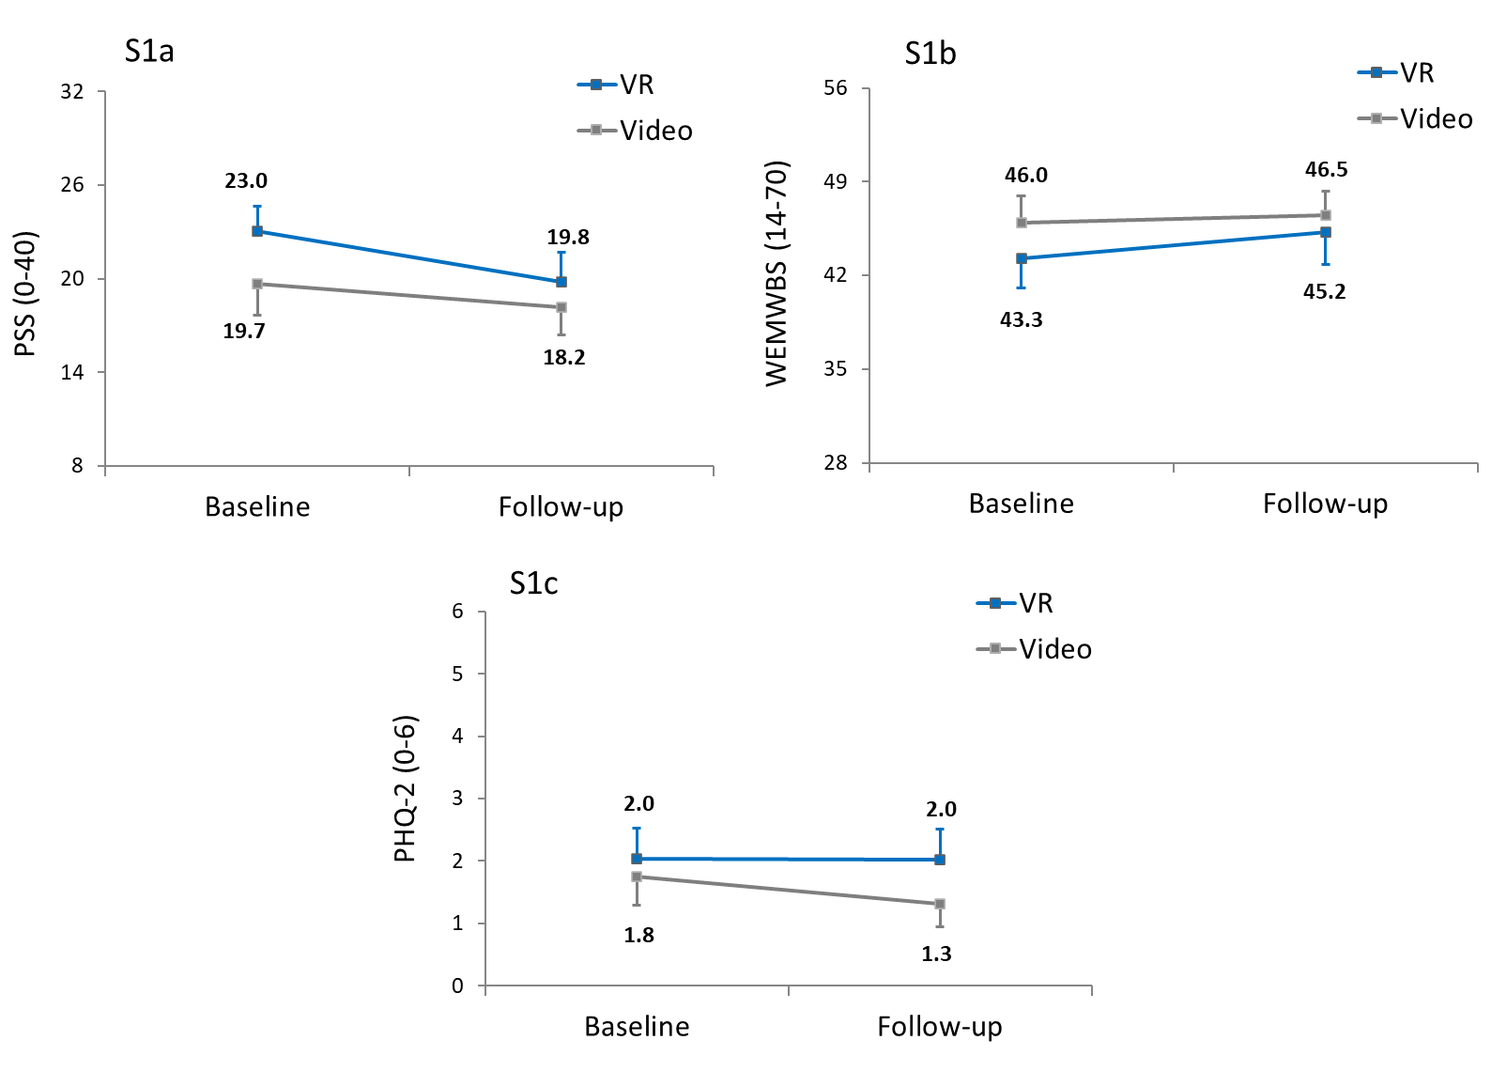
Figures S1a-S1c. Perceived stress, wellbeing and mood scores at baseline and follow-up for (VR) and Video intervention participants (per-protocol approach; S1a = Perceived Stress Scale (PSS); S1b = Warwick-Edinburgh Mental Wellbeing Scale (WEMWBS); S1c = Patient Health Questionnaire-2 (PHQ-2)). Value labels represent mean values. Error bars are 95% confidence intervals.

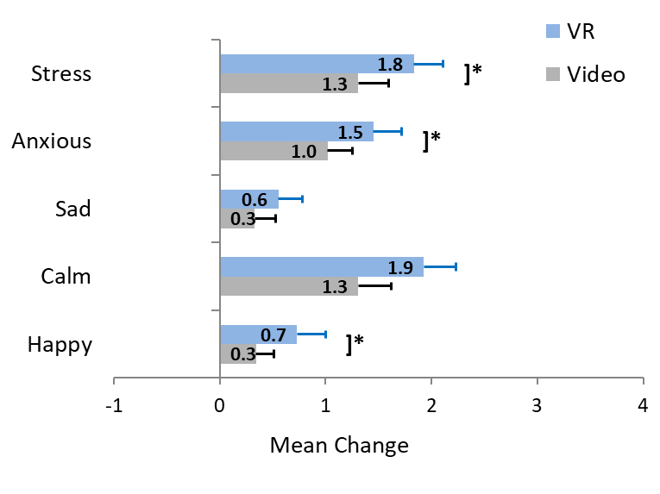

Figure S2. Adjusted pre-to-post session mean change scores over the study for VR Headset (VR) and Video intervention study participants (per-protocol approach). Value labels represent mean values. Error bars are 95% confidence intervals. Asterisks indicate significant differences between study conditions: *p < 0.05, **p < 0.01, ***p < 0.001.

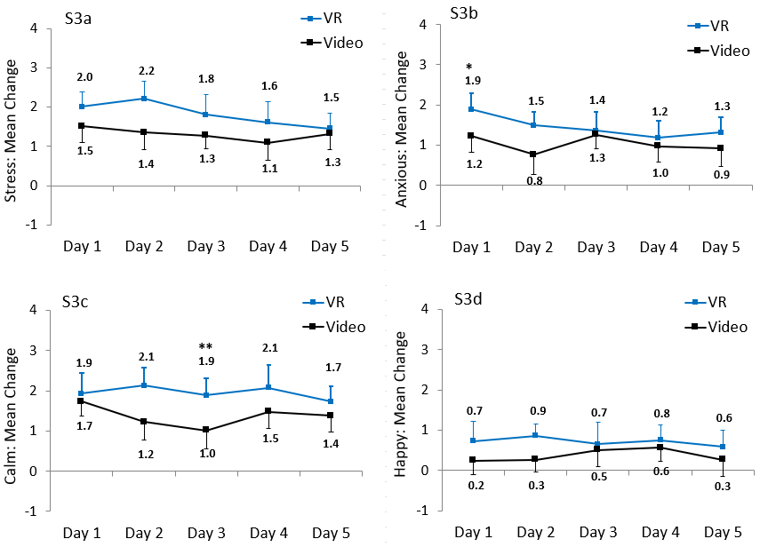
Figure S3a-3d. Adjusted pre-to-post session mean (CI) change scores over the study for VR Headset (VR) and Video intervention study participants according to session (per-protocol approach; S3a = Stress; S3b = Anxious; S3c = Calm; S3d = Happy). Value labels represent mean values. Error bars are 95% confidence intervals. Asterisks indicate significant differences between study conditions: *p < 0.05, **p < 0.01, ***p < 0.001.

