Supplementary file
Table S1. Descriptive statistics of animals, trial duration, age, and feeder visits by feed efficiency trial
FET¹ | N² | DOT³ | Year of birth | Age⁴ ± SD⁵ | Feeder visits ± SD⁵
1 | 64 | 81 | 2012 | 281 ± 25 | 8137 ± 2003
2 | 63 | 81 | 2012 | 289 ± 24 | 7621 ± 1601
3 | 60 | 96 | 2013 | 291 ± 20 | 5637 ± 1092
4 | 61 | 95 | 2014 | 277 ±26 | 5768 ± 933
5 | 73 | 110 | 2015 | 268 ± 25 | 8970 ± 1374
6 | 70 | 62 | 2016 | 274 ± 24 | 4467 ± 810
7 | 57 | 75 | 2017 | 257 ±26 | 6368 ± 1472
8 | 72 | 81 | 2017 | 351 ± 26 | 5496 ± 1148
9 | 32 | 81 | 2018 | 246 ± 33 | 6196 ± 1141
10 | 28 | 81 | 2018 | 254 ± 29 | 6170 ± 919
11 | 30 | 81 | 2018 | 335 ± 20 | 4397 ± 881
12 | 32 | 81 | 2018 | 325 ± 27 | 4717 ± 932
13 | 44 | 81 | 2019 | 240 ± 23 | 5240 ± 1102
14 | 42 | 81 | 2019 | 238 ± 24 | 5080 ± 1179
15 | 35 | 67 | 2019 | 314 ± 24 | 3670 ± 869
16 | 34 | 67 | 2019 | 310 ± 28 | 4029 ± 1132
17 | 36 | 88 | 2020 | 249 ± 23 | 7427 ± 1269
18 | 39 | 88 | 2020 | 247± 22 | 8523 ±1579
19 | 51 | 75 | 2020 | 336 ± 25 | 5365 ±1123
20 | 50 | 75 | 2020 | 339 ± 24 | 4837 ±1022
21 | 39 | 81 | 2021 | 242 ± 21 | 9274 ±2203
22 | 40 | 81 | 2021 | 246 ± 23 | 9006 ± 1551
23 | 39 | 71 | 2021 | 317 ± 25 | 5065 ± 957
24 | 39 | 71 | 2021 | 319 ± 22 | 4168 ± 1043
25 | 23 | 82 | 2022 | 243 ± 38 | 7840 ± 1189
26 | 24 | 82 | 2022 | 241 ± 31 | 8862 ± 1326
27 | 35 | 68 | 2022 | 337 ± 31 | 6063 ± 1402
28 | 35 | 68 | 2022 | 336 ± 37 | 6202 ±1089
29 | 31 | 82 | 2023 | 256 ± 35 | 7368 ± 1522
30 | 31 | 82 | 2023 | 251 ± 39 | 7426 ± 1519
31 | 30 | 76 | 2023 | 345 ± 35 | 4456 ± 1103
32 | 28 | 76 | 2023 | 350 ± 32 | 4323 ± 963
¹Feed efficiency trial; ²number of animals per trial; ³days on trial; ⁴ age at beginning of the trial; ⁵standard deviation

Table S2. Spearman rank correlations of Social Network Analysis (SNA) metrics for feeder replacement intervals from 5 to 65 s, using the 25-s interval as the reference
Trait | 5 | 10 | 15 | 20 | 25 | 30 | 35 | 40 | 45 | 50 | 55 | 60 | 65
Betweenness | 0.792 | 0.948 | 0.977 | 0.990 | 1 | 0.993 | 0.989 | 0.986 | 0.985 | 0.983 | 0.980 | 0.980 | 0.977
Closeness | 0.884 | 0.978 | 0.994 | 0.999 | 1 | 0.999 | 0.998 | 0.997 | 0.996 | 0.995 | 0.994 | 0.993 | 0.992
Clustering | 0.909 | 0.988 | 0.997 | 0.999 | 1 | 0.999 | 0.999 | 0.998 | 0.998 | 0.998 | 0.997 | 0.997 | 0.996
Degree | 0.872 | 0.968 | 0.986 | 0.994 | 1 | 0.995 | 0.993 | 0.990 | 0.988 | 0.987 | 0.985 | 0.984 | 0.983

Fig S1. Cumulative distribution of inter-visit intervals between feeder replacement events.

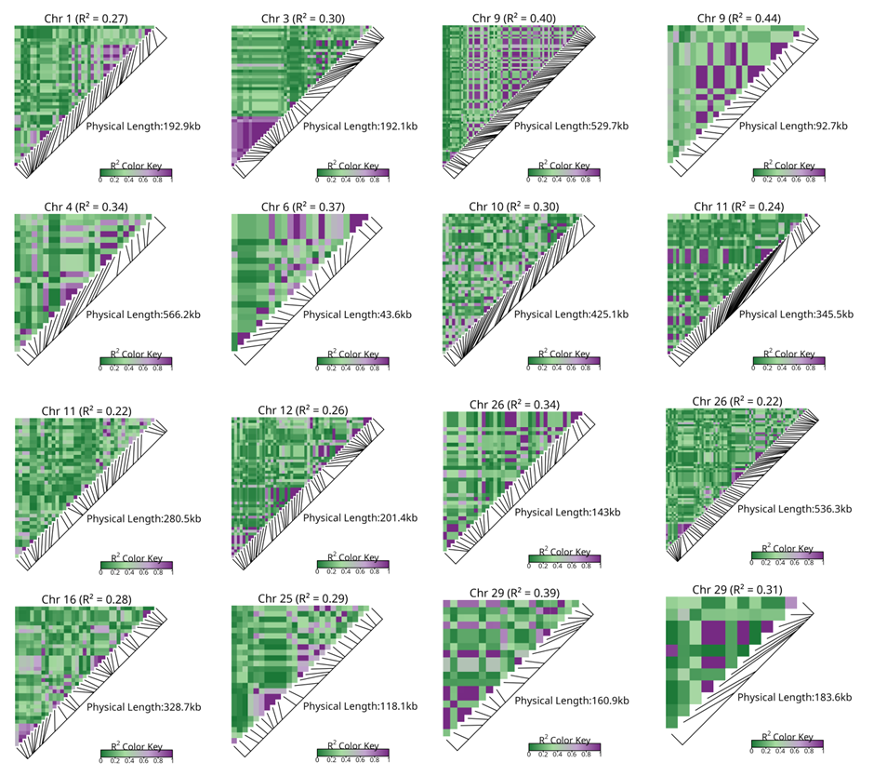
Fig. S2. Linkage disequilibrium (LD) patterns across genomic windows explaining >1% of the additive genetic variance for the betweenness centrality trait in Nellore cattle. Each panel shows a triangular heatmap of pairwise LD (r²) among SNPs within the corresponding window chromosome. The mean r² for each region is reported in the panel header, and the physical length of the window (kb) is indicated within each panel.

Fig S3. Linkage disequilibrium (LD) patterns across genomic windows explaining >1% of the additive genetic variance for the closeness centrality trait in Nellore cattle. Each panel shows a triangular heatmap of pairwise LD (r²) among SNPs within the corresponding window chromosome. The mean r² for each region is reported in the panel header, and the physical length of the window (kb) is indicated within each panel.
Fig S4. Linkage disequilibrium (LD) patterns across genomic windows explaining >1% of the additive genetic variance for the clustering coefficient trait in Nellore cattle. Each panel shows a triangular heatmap of pairwise LD (r²) among SNPs within the corresponding window chromosome. The mean r² for each region is reported in the panel header, and the physical length of the window (kb) is indicated within each panel.

Fig S5. Linkage disequilibrium (LD) patterns across genomic windows explaining >1% of the additive genetic variance for the degree centrality trait in Nellore cattle. Each panel shows a triangular heatmap of pairwise LD (r²) among SNPs within the corresponding window chromosome. The mean r² for each region is reported in the panel header, and the physical length of the window (kb) is indicated within each panel.

