Supplemental materials for

Structural basis of condensate formation of VAPB protein

Kyoko Furuita^{1,2}, Mayu Enomoto-Kusano³, Wataru Togawa³, Rion Komuro³, Kengo Nakayama³, Naohiro Kobayashi⁴, Takashi S. Kodama¹, Yohei Miyanoiri¹, Toshimichi Fujiwara¹, Chojiro Kojima^{1,3}

¹ Institute for Protein Research, The University of Osaka, 3-2 Yamadaoka, Suita, Osaka 565-0871, Japan.
² Institute for Chemical Research, Kyoto University, Gokasho, Uji, Kyoto 611-0011, Japan.
³ Graduate School of Engineering Science, Yokohama National University, Tokiwadai 79-5, Hodogaya-ku, Yokohama 240-8501, Japan.
⁴ RIKEN Center for Integrative Medical Sciences, Yokohama, Japan
Supplementary Information Contents
Table S1
Figures S1–S23
NOE upper distance restraints  Intraresidual (|i-j| = 0)  Sequential (|i-j| = 1)  Medium-range (1 < |i-j| < 5)  Long-range (≤ |i-j|)  Total  Dihedral angle restraints  φ  ψ  Total  AMBER GB energies (kcal/ mol)  Total  Restraints  Maximum violations  Distance (Å)  Angle (°)  RMSD (5-125) (Å)  Backbone heavy atoms  All atoms  Ramachandran analysis (5-125) (%)  Most favored regions  Additional allowed region  Generously allowed regions  Disallowed regions | 487  673  237  857  2254  95  96  191  -5071 ± 13  15 ±1  0.250  0.821  0.76 ±0.16  1.21 ±0.15  87.3  10.6  1.1  1.0
Table S1. Structural statistics for VAPB_{MSP}.

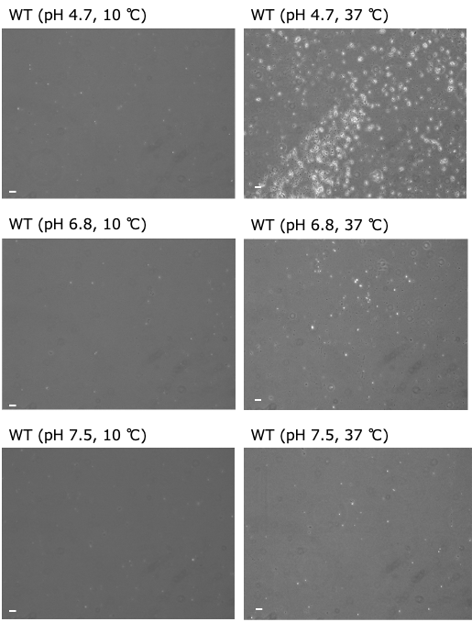
Figure S1. Full-screen view of VAPB_{MSP} WT microscope images at pH 4.7 (top two panels), pH 6.8 (middle two panels), pH 7.5 (bottom two panels), 10 °C (left three panels), and 37 °C (right three panels). Scale bar = 10 μm.
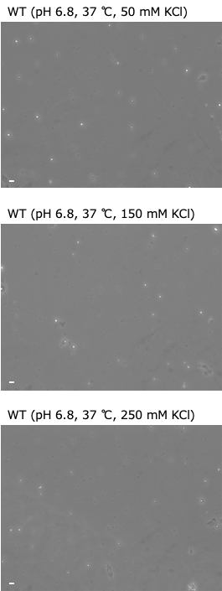
Figure S2. Full-screen view of VAPB_{MSP} WT microscope images at pH 6.8 and 37 °C in the presence of 50 mM KCl (top), 150mM KCl (middle), and 250 mM KCl (bottom). Scale bar = 10 μm.
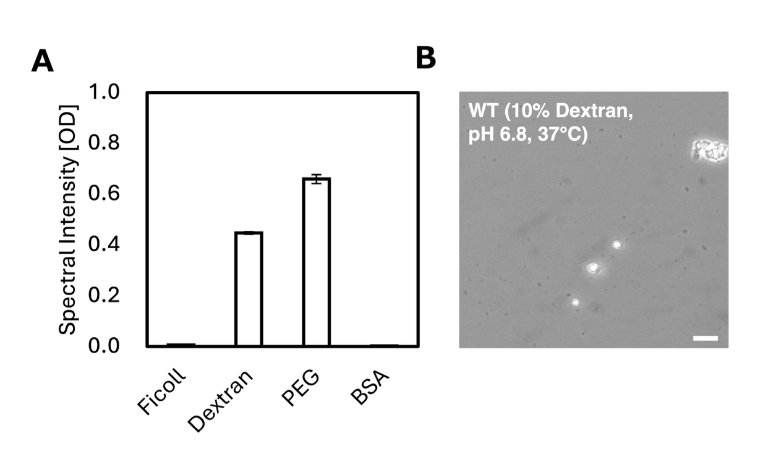
Figure S3. Condensate formation of VAPB_{MSP} WT in the presence of 7.5% ficoll, 10% dextran, 15% polyethylene glycol (PEG), and bovine serum albumin (BSA). Scale bar = 10 μm. (A) Macromolecular crowder dependence of optical density (OD) values at 660 nm for 50 μM protein at pH 6.8 and 37 °C. (B) Microscopic images of VAPB_{MSP} WT condensates in the presence of 10% dextran for 50 μM protein at pH 6.8 and 37 °C.
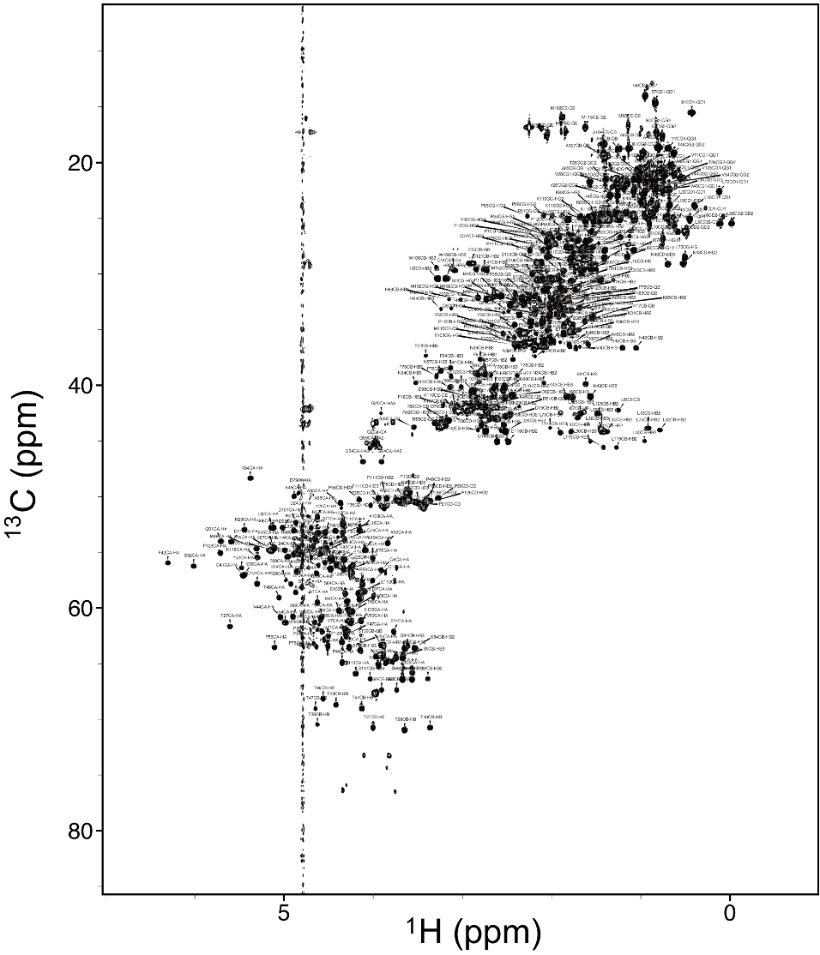
Figure S4. ¹H–¹³C HSQC spectrum of VAPB_{MSP} with resonance assignments. Assignments are completed for 100% of C_{α}, 97% of H_{α}, and 92.6% of side-chain resonances.
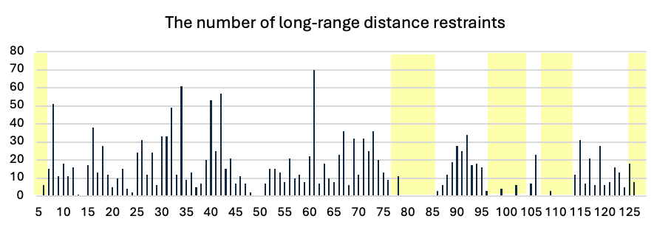
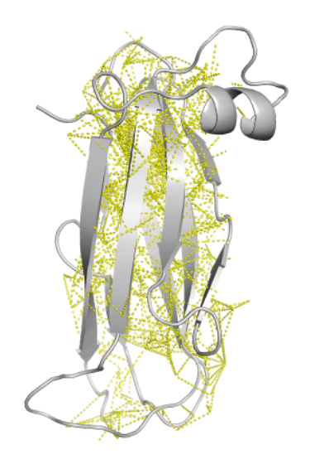
Figure S5. The long-range NOEs used for the structure determination. (A) Plot showing the number of long-range NOEs per residue. Regions with poor convergence (RMSD > 0.6 Å) are highlighted in yellow. (B) The long-range NOEs are depicted in yellow dotted lines on the lowest-energy structure. (C) The long-range NOEs are shown in ¹³C-edited NOESY strip plots for L8 H_{δ1} and Q91 H_{α}. Assignments for the long-range NOE cross-peaks are given on the right side of each strip plot.
A
B
C
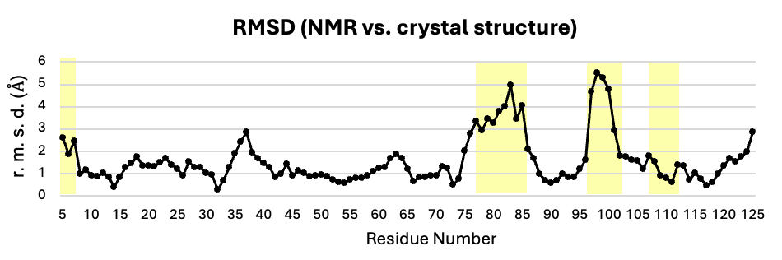
Figure S6. C^{α} RMSD for each residue in the lowest-energy NMR structure of VAPB compared to the crystal structure (PDB ID: 3IKK, chain A). Regions with poor convergence (RMSD > 0.6 Å) are highlighted in yellow.
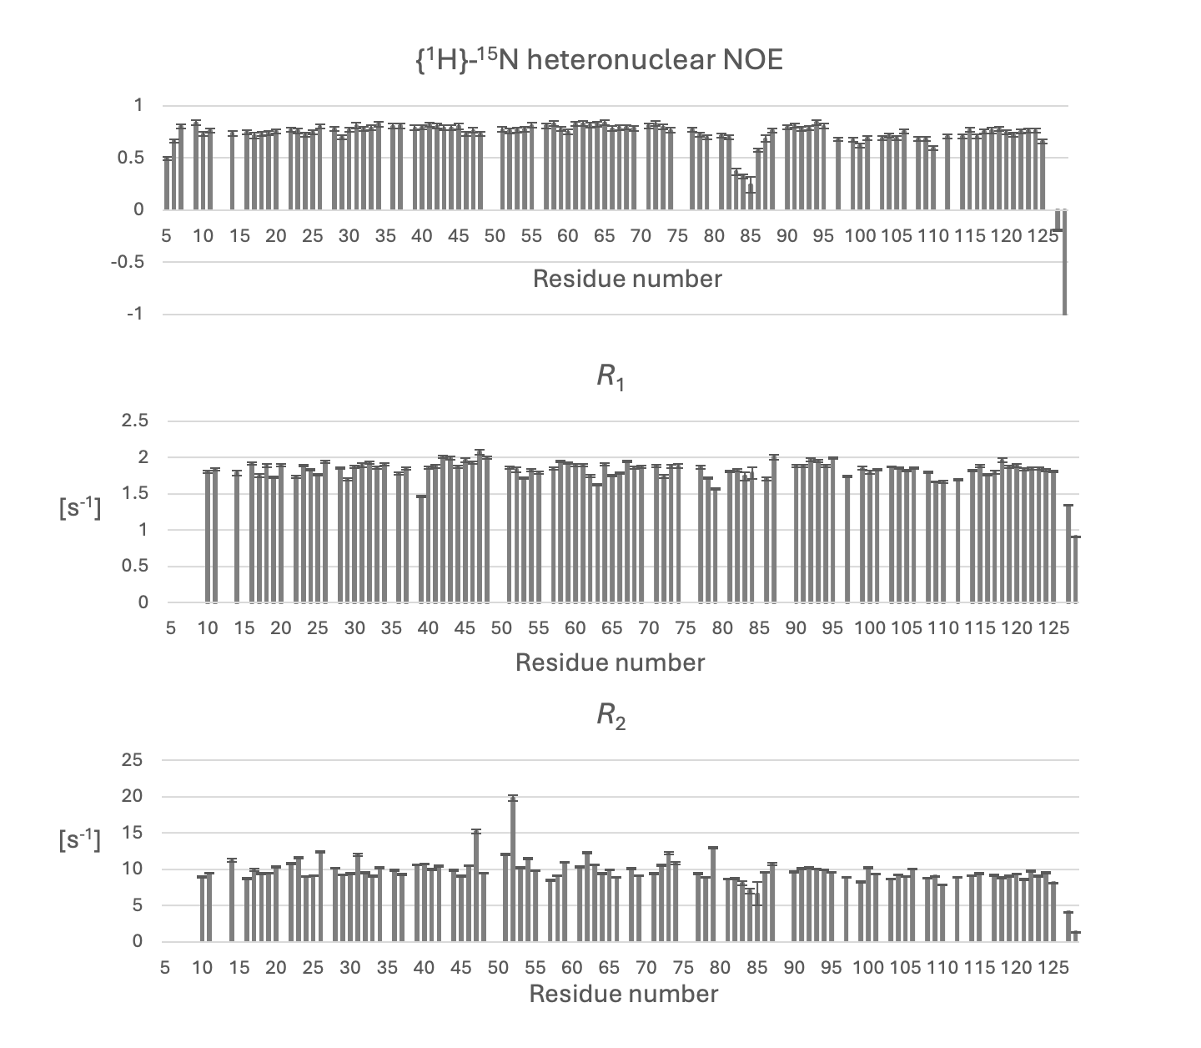
Figure S7. The {¹H}-¹⁵N heteronuclear NOE values, the longitudinal relaxation rate (R₁) and the transverse relaxation rate (R₂) of VAPB_{MSP} measured at pH 6.8 and 30 °C on a 500 MHz NMR spectrometer. The error bars for the heteronuclear NOEs were determined by Monte Carlo simulations. The R₁ and R₂ error bars were estimated from the covariance matrix of the fitted parameters.
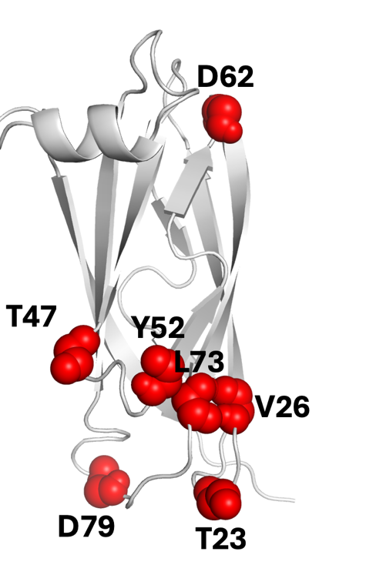
Figure S8. Residues with detectable Rex values. The backbone atoms of residues exhibiting R_{ex} are shown as spheres on the lowest-energy structure of VAPB_{MSP}.
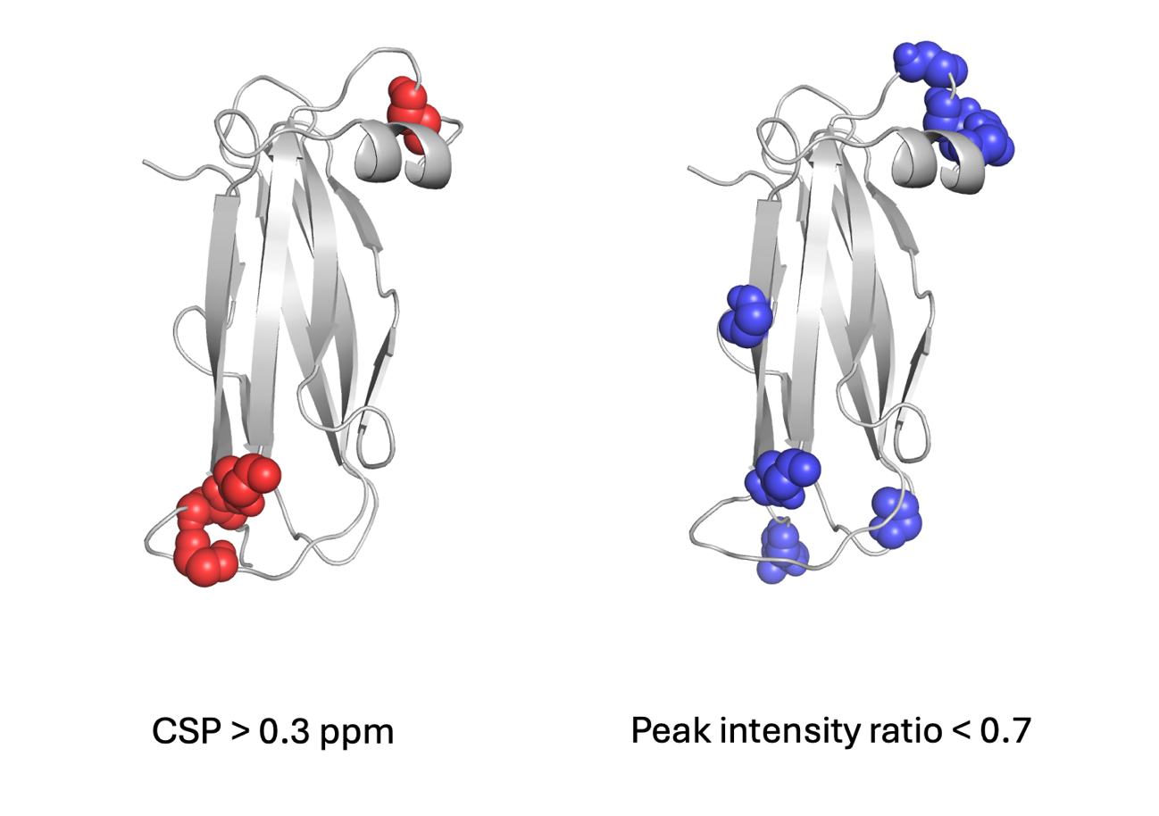
Figure S9. Residues showing large changes in peak position (left) and peak intensity (right) in the ¹H–¹⁵N HSQC spectra at pH 6.8 between 10 °C and 37 °C. In the left panel, residues with Δδ(HN) > 0.3 ppm are represented using a sphere model. In the right panel, residues with a peak intensity ratio (37 °C / 10 °C) < 0.7 are shown using a sphere model. Δδ(HN) values were calculated as: $∆δ\left(HN\right)= \sqrt{{(∆δH)}^{2}+ {(\frac{∆δN}{5})}^{2}}$.

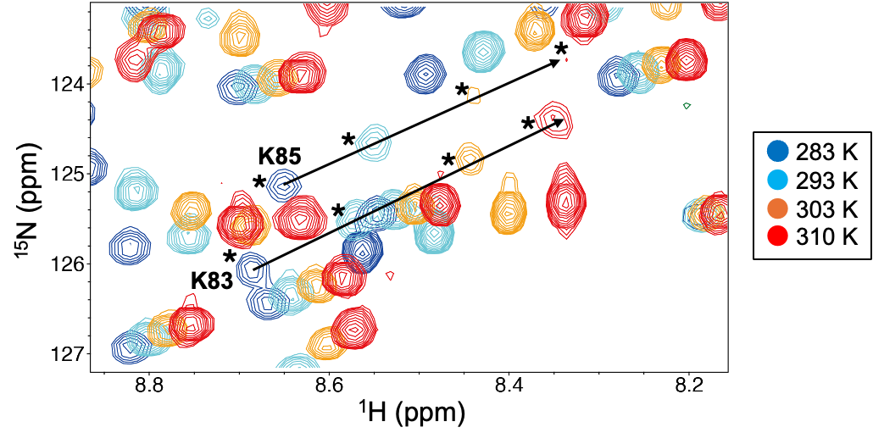
Figure S10. Expanded view of the region containing K83 and K85 from the overlaid ¹H–¹⁵N HSQC spectra of VAPB_{MSP} recorded at various temperatures. Blue, 10 °C; cyan, 20 °C; orange, 30 °C; red, 37 °C. Asterisks indicate the peak positions of K83 or K85 at each temperature.
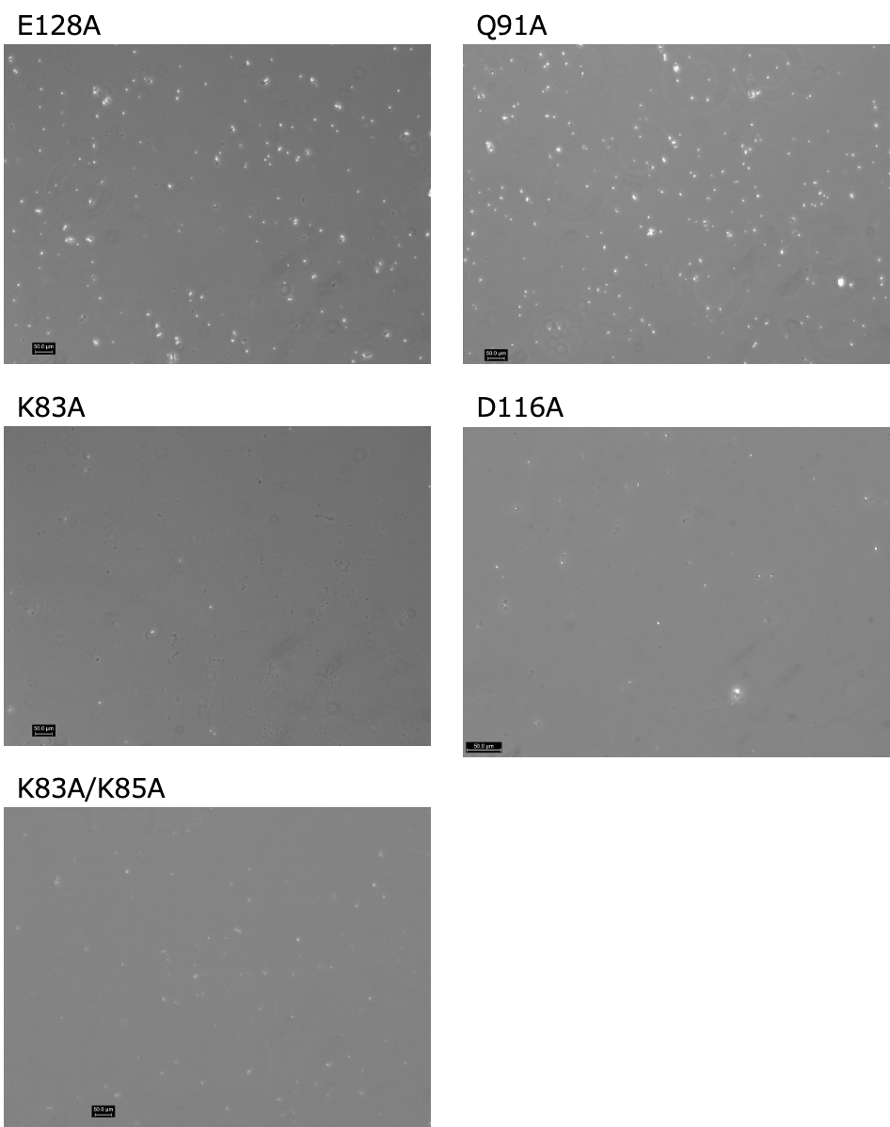
Figure S11. Full-screen view of VAPB_{MSP} E128A, K83A, K83A/K85A, Q91A, and D116A microscope images at pH 6.8 and 37 °C. Scale bar = 50 μm.
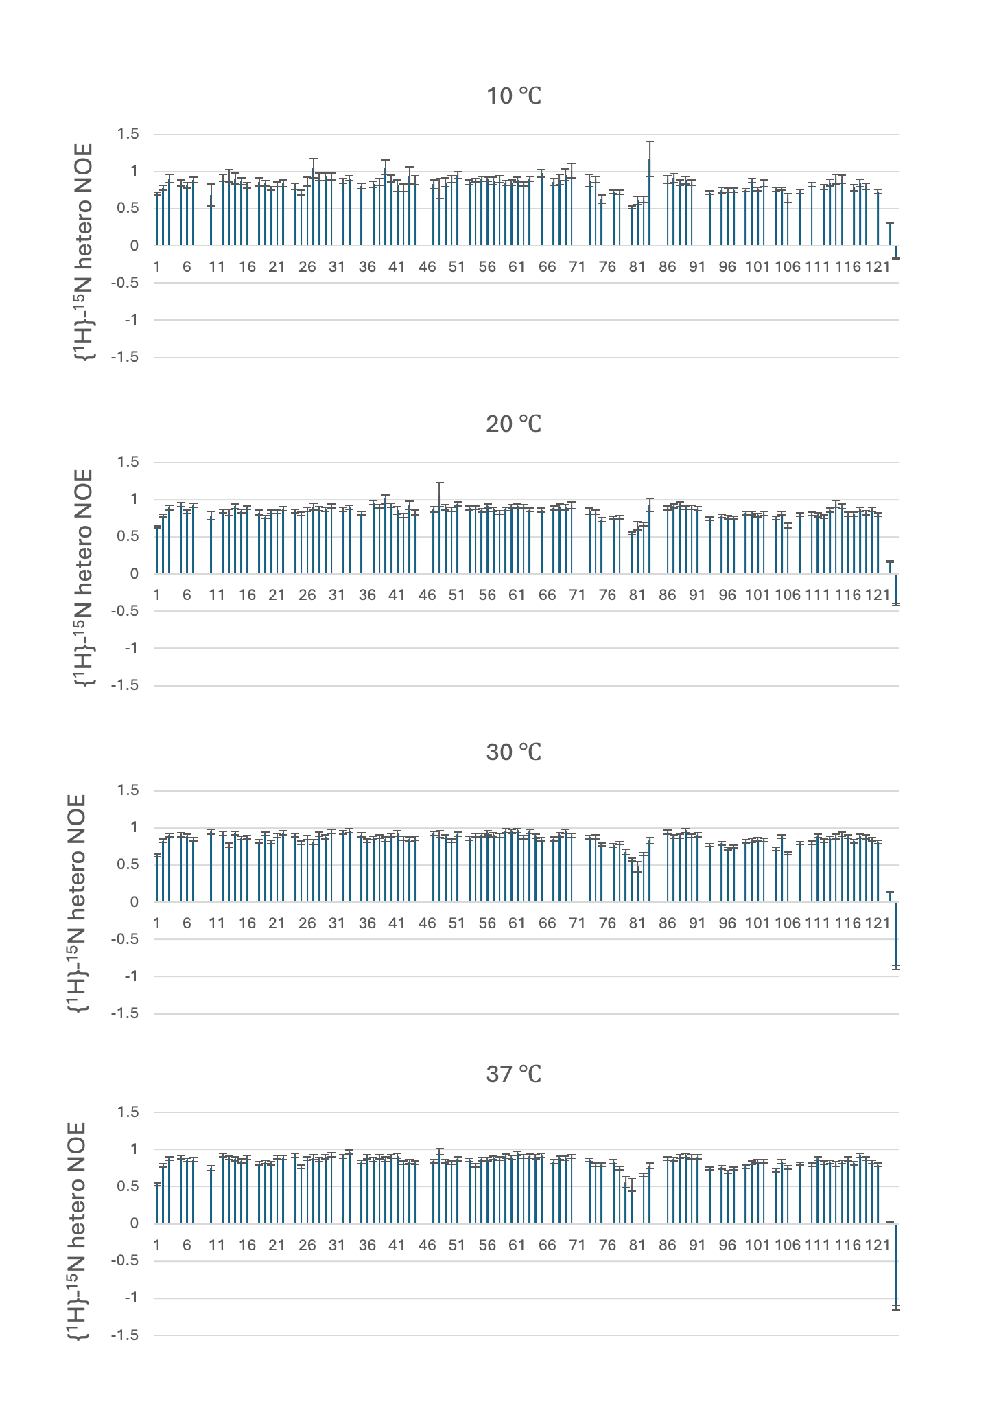
Figure S12. {¹H}-¹⁵N heteronuclear NOE values measured at pH 6.8 and temperatures of 10, 20, 30, and 37 °C.
Figure S13. Assignment of Chemical Shifts for H^{ε21} and H^{ε22} in Q91. (Left) Strip plots of the ¹⁵N-edited NOESY spectrum of VAPB_{MSP} showing the H^{ε21} and H^{ε22} region of Q91. (Right) An enlarged view of the three-dimensional structure of VAPB_{MSP}. Q91 and L114 are shown as stick models. The side-chain amide group of Q91 was identified based on the NOE cross-peaks with L114, and the assignment of H^{ε21} or H^{ε22} was determined from their chemical shifts.
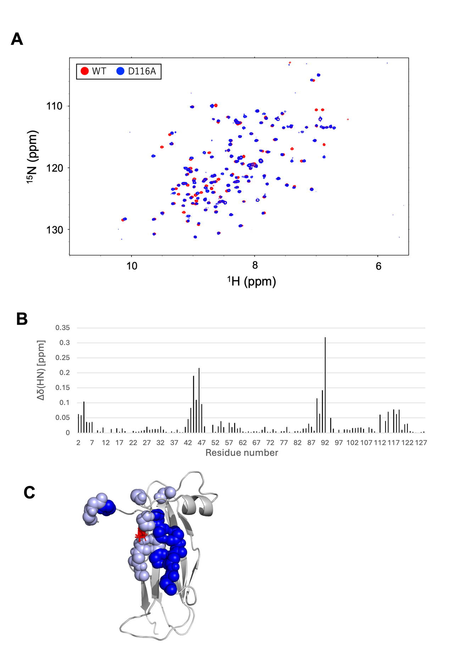Figure S14. (A) Superimposed ¹H–¹⁵N HSQC spectra measured at pH 6.8 and 20 °C of WT VAPB_{MSP} and the D116A mutant. (B) Backbone amide chemical shift perturbations (CSPs) (Δδ(NH)) between the WT and the D116A mutant. (C) Solution structure of VAPB_{MSP} with residues that exhibited large CSPs, where residues with Δδ(NH) > 0.10 ppm are colored blue, and residues with 0.05 ≤ Δδ(NH) ≤ 0.10 ppm are colored light blue. Δδ(HN) values were calculated as: $∆δ\left(HN\right)= \sqrt{{(∆δH)}^{2}+ {(\frac{∆δN}{5})}^{2}}$. D116 is shown by the red stick model.
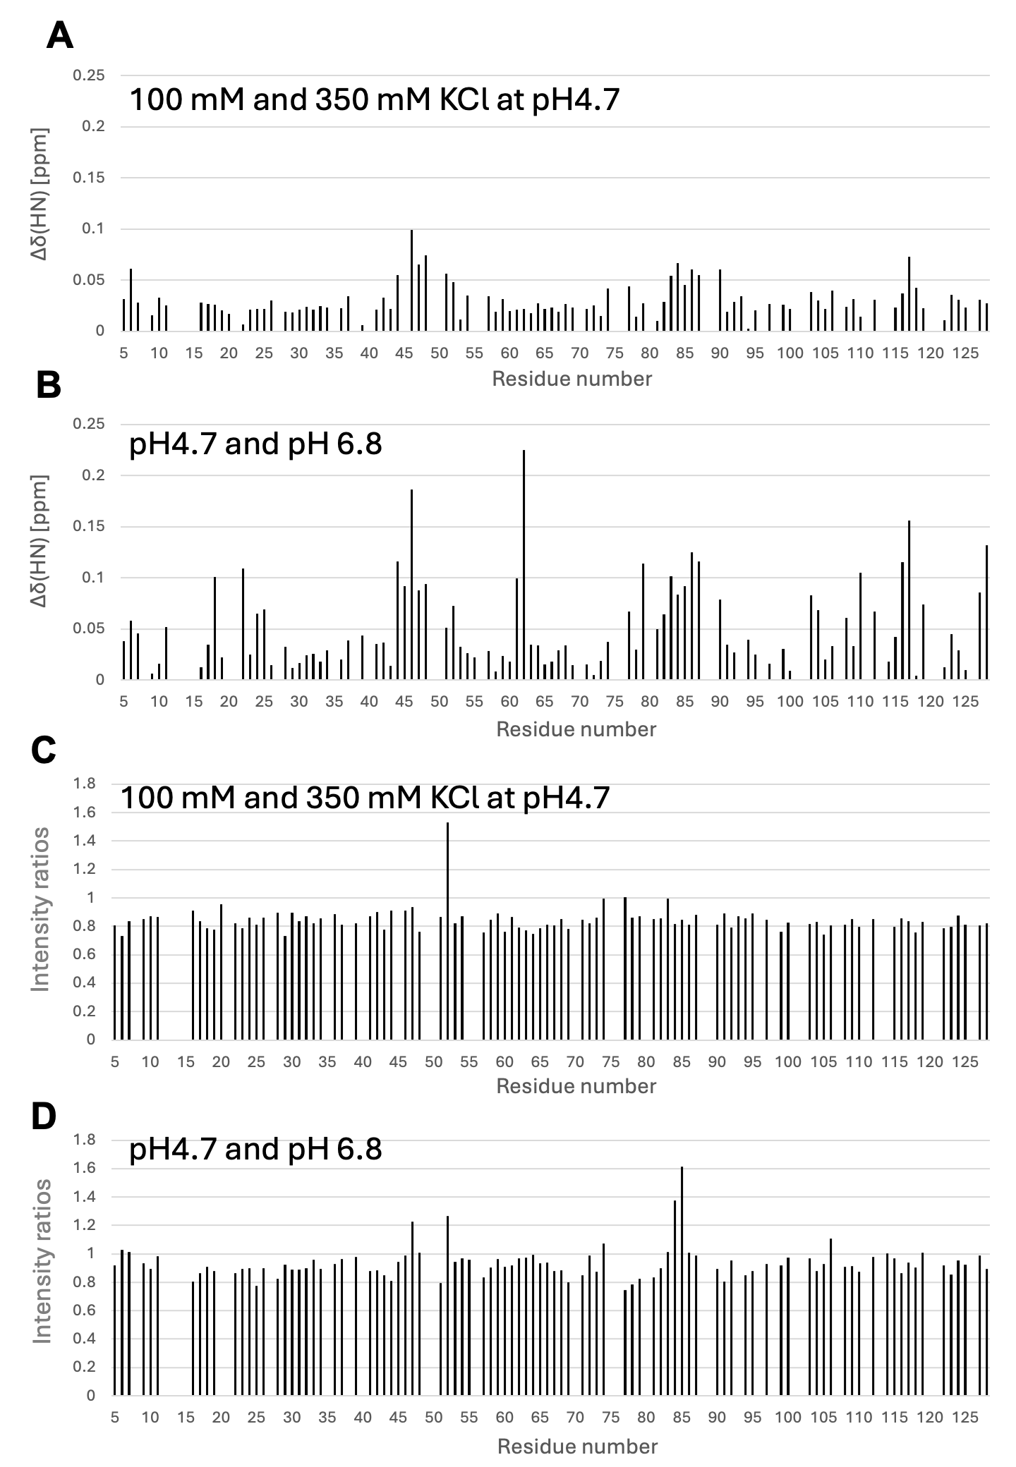Figure S15. (A) CSPs of backbone amide groups (Δδ(HN)) induced by different KCl concentrations (100 mM and 350 mM) at pH 4.7 and 20 °C. (B) CSPs caused by pH change (pH 4.7 vs. pH 6.8) and 20 °C in the presence of 100 mM KCl. (C) Relative peak intensities in the presence of 350 mM KCl compared to those in the presence of 100 mM KCl at pH 4.7 and 20 °C. (D) Relative peak intensities at pH 4.7 compared with those at pH 6.8 at 20 °C in the presence of 100 mM KCl. Δδ(HN) values were calculated as: $∆δ\left(HN\right)= \sqrt{{(∆δH)}^{2}+ {(\frac{∆δN}{5})}^{2}}$.

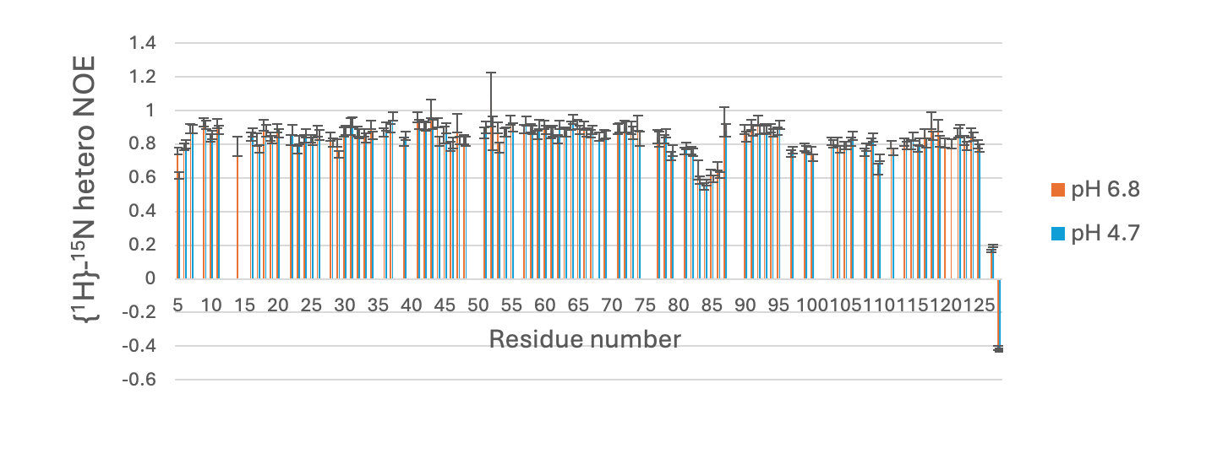
Figure S16. {¹H}-¹⁵N heteronuclear NOE values of VAPB_{MSP} measured at pH 4.7 (light blue) and pH 6.8 (orange) at 20 °C. The error bars represent standard deviations estimated by Monte Carlo simulations based on spectral noise levels.
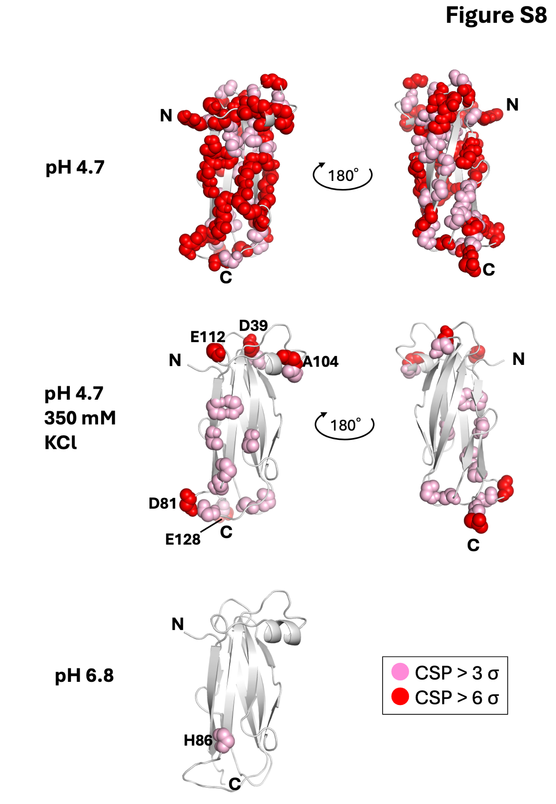
Figure S17. The residues showed significant concentration-dependent CSPs. NMR measurements were performed at 20 °C under the following solvent conditions: (A) Potassium acetate buffer (pH 4.7), 100 mM KCl, and 1 mM DTT; (B) Potassium acetate buffer (pH 4.7), 350 mM KCl, and 1 mM DTT; and (C) Phosphate buffer (pH 6.8), 100 mM KCl, and 1 mM DTT. CSPs were evaluated based on standard deviations (σ), which were determined by Monte Carlo simulations using the spectral noise level¹. Residues with CSP values greater than 6σ are shown in red, and residues with CSP values between 3σ and 6σ are shown in pink.
A
B
C
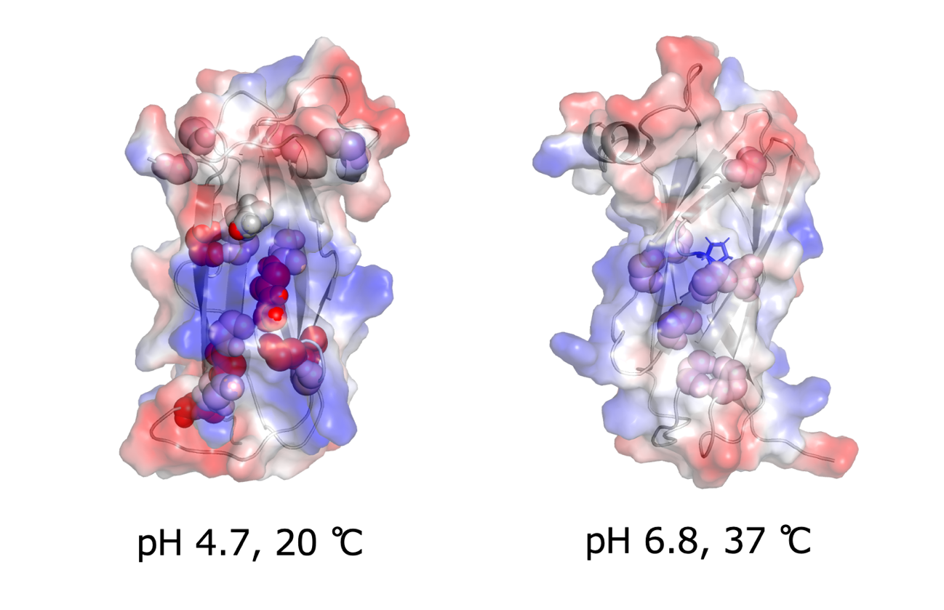
Figure S18. Surface electrostatic potential of VAPB. In the left figure, residues with concentration-dependent CSP exceeding 0.01 ppm at pH 4.7 and 20°C are shown by spheres. In the right, residues with concentration-dependent CSP exceeding 2.5 σ at pH 6.8 and 37 °C are shown by spheres.
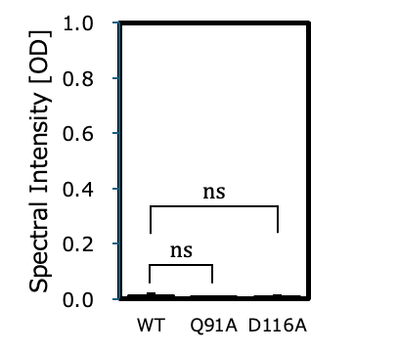
Figure S19. OD values at 660 nm of VAPB_{MSP} WT, Q91A, and D116A mutants at pH 6.8 and 20 °C. ns: not significant.
WT,Q91A,D116A (pH6.8, 20°C)
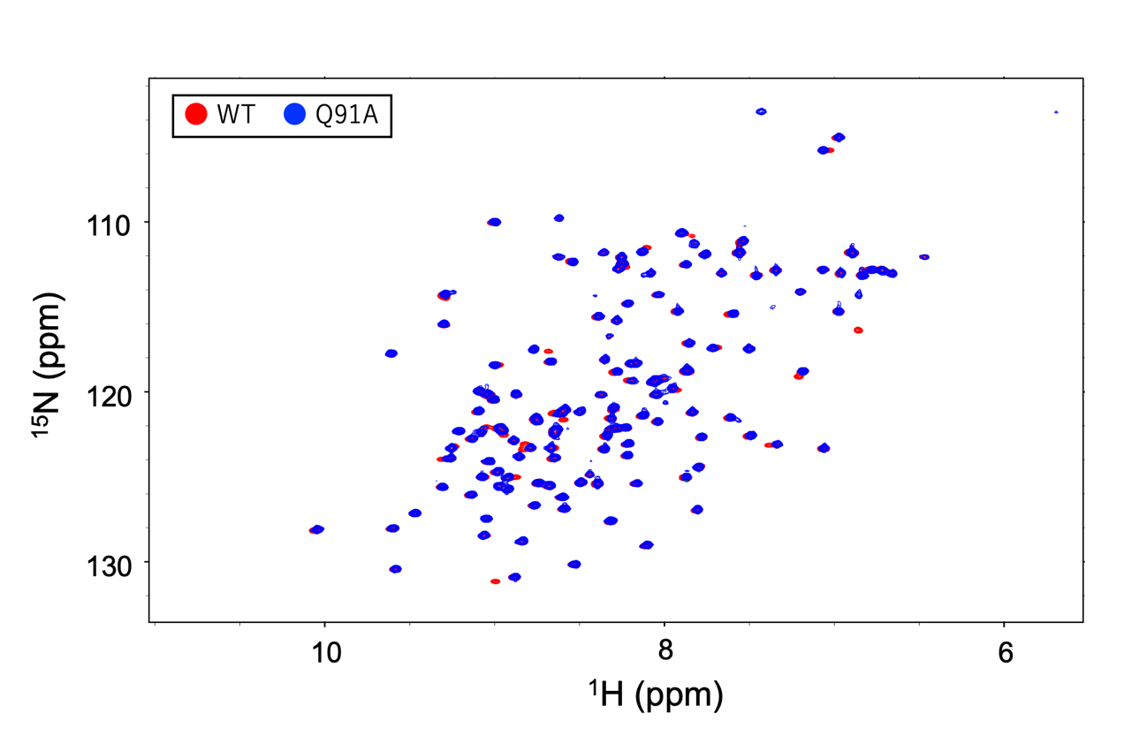Figure S20. Superimposed ¹H–¹⁵N HSQC spectra measured at pH 6.8 and 30 °C of WT VAPB_{MSP} and the Q91A mutant.

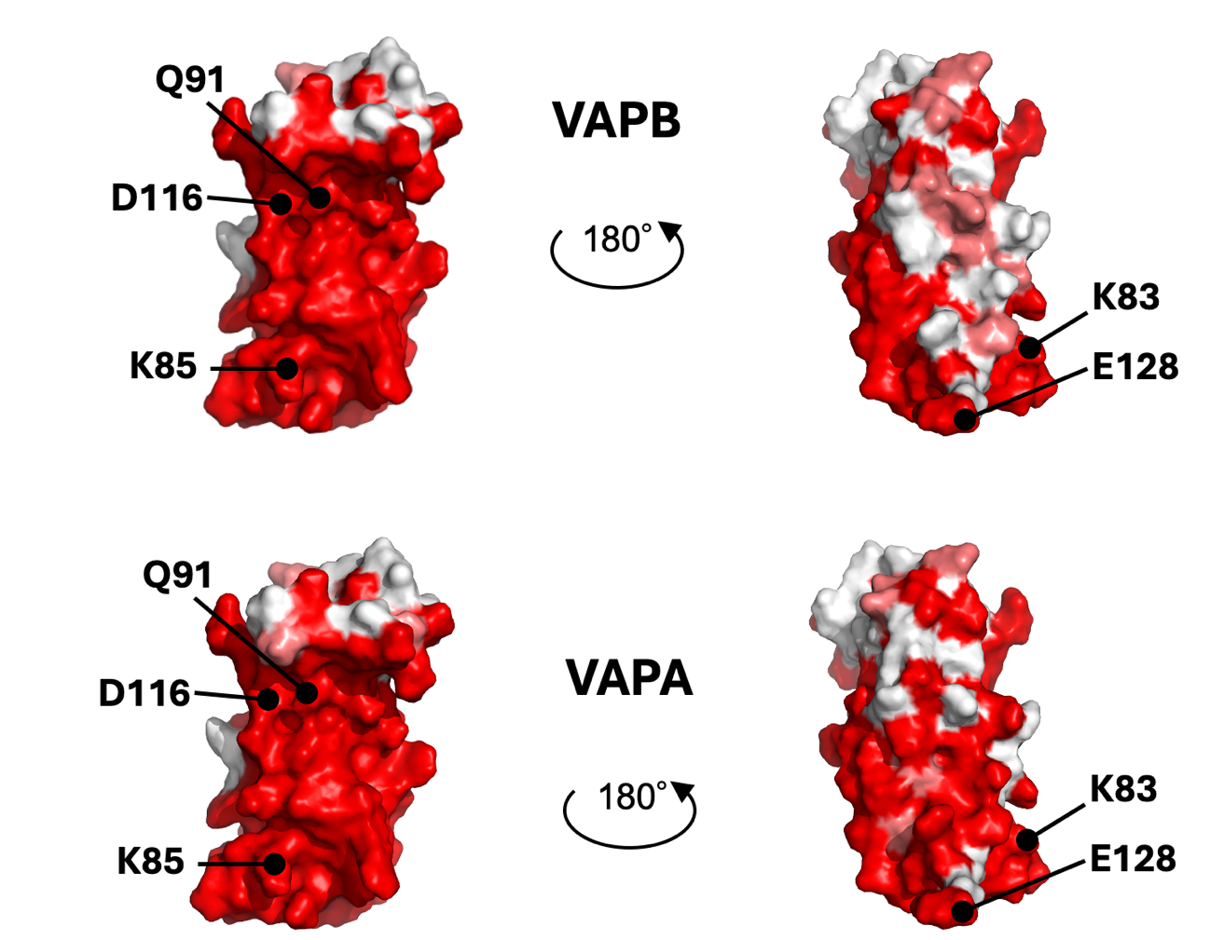
Figure S21. Amino acid conservation in the MSP domains of VAPB and VAPA. In the surface representation of the lowest-energy structure of VAPB_{MSP}, residues with <80% conservation are shown in white, whereas those with 80–100% conservation are colored using a white-to-red gradient.
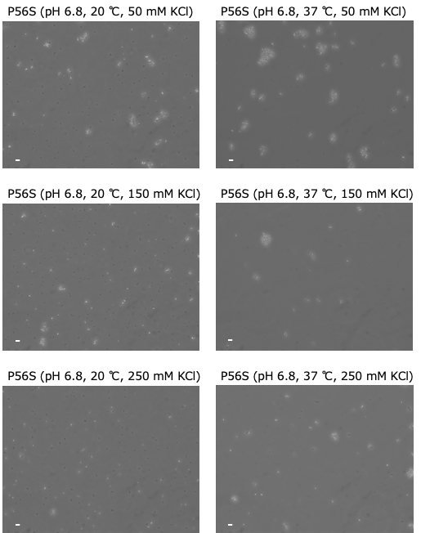
Figure S22. Full-screen view of VAPB_{MSP} P56S microscope images at pH 6.8 (all panels), 20 °C (left three panels), and 37 °C (right three panels) in the presence of 50 mM KCl (top two panels), 150 mM KCl (middle two panels), and 250 mM KCl (bottom two panels). Scale bar = 10 μm.
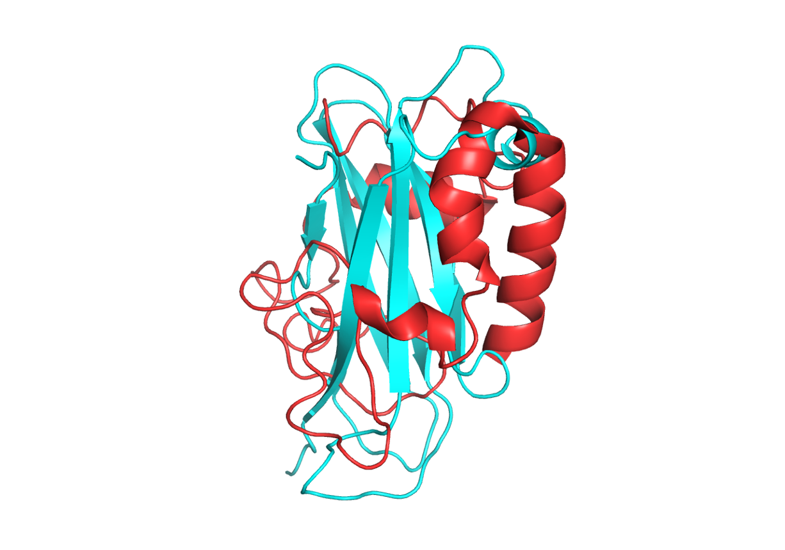
Figure S23. Overlay of the lowest-energy structures of VAPB_{MSP} WT (cyan) and the VAPB P56S MSP domain in a DPC micelle (PDB ID: 2MDK, red). The 2MDK structure differs substantially from the WT structure. As shown in this study, the backbone amide chemical shifts of our P56S sample differ markedly from those reported for the 2MDK sample (BMRB Entry 19489). These significant differences in chemical shifts most likely arise from the distinct sample compositions and measurement conditions. They also suggest that the three-dimensional structures of the two P56S samples differ substantially. The 2MDK sample was prepared in 20 mM DPC in water (pH 4) and measured at 40 °C. In contrast, our P56S sample was prepared in a buffer containing 50 mM potassium phosphate (pH 6.8), 100 mM KCl, and 1 mM DTT, and measured at 20 °C. Therefore, we concluded that the P56S structure under our measurement conditions is closer to the WT structure (see main text) and differs from that reported in 2MDK.
References
1. Furuita, K. & Kojima, C. Improved analysis of NMR chemical shift perturbations through an error estimation method. Biophys. Chem. 310, 107255 (2024).

