Additional File 2: Detailed list and definitions of the 40 anatomical landmarks detected by the markerless motion capture system.
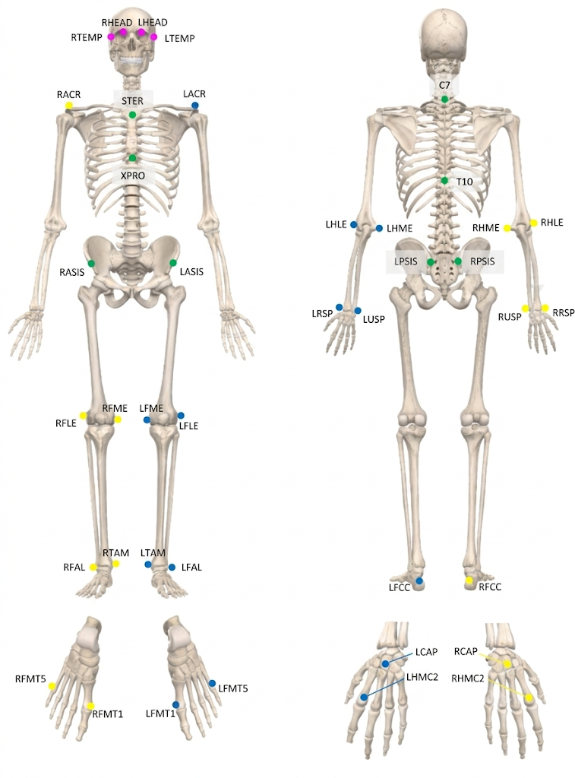
List of anatomical keypoints
Segment | Keypoint Abbreviation | Anatomical Landmark / Definition
Head | RHEAD / LHEAD | Right / Left Head
Head | RTEMP / LTEMP | Right / Left Temple
Torso | RACR / LACR | Right / Left Acromion Process
Torso | STER | Sternum
Torso | XPRO | Xiphoid Process
Torso | C7 | 7th Cervical Vertebra
Torso | T10 | 10th Thoracic Vertebra
Pelvis | RASIS / LASIS | Right / Left Anterior Superior Iliac Spine
Pelvis | RPSIS / LPSIS | Right / Left Posterior Superior Iliac Spine
Upper Arms  & Elbows | RHLE / LHLE | Right / Left Lateral Epicondyle of the Humerus
Upper Arms  & Elbows | RHME / LHME | Right / Left Medial Epicondyle of the Humerus
Forearms, Wrists & Hands | RRSP / LRSP | Right / Left Radial Styloid Process
Forearms, Wrists & Hands | RUSP / LUSP | Right / Left Ulnar Styloid Process
Forearms, Wrists & Hands | RCAP / LCAP | Right / Left Capitate Bone
Forearms, Wrists & Hands | RHMC2 / LHMC2 | Right / Left Second Metacarpal
Legs & Knees | RFLE / LFLE | Right / Left Lateral Epicondyle of the Femur
Legs & Knees | RFME / LFME | Right / Left Medial Epicondyle of the Femur
Ankles & Feet | RFAL / LFAL | Right / Left Lateral Malleolus
Ankles & Feet | RTAM / LTAM | Right / Left Medial Malleolus
Ankles & Feet | RFCC / LFCC | Right / Left Posterior Calcaneus (Heel)
Ankles & Feet | RFMT1 / LFMT1 | Right / Left First Metatarsal Bone
Ankles & Feet | RFMT5 / LFMT5 | Right / Left Fifth Metatarsal Bone

