Supplementary Material
Title: Machine Learning-Based Analysis of Risk Factors and Construction of a Predictive Model for Hyperuricemia in Chinese Health Examination Population
Journal: Scientific Reports
List of Supplementary Items:
Figs. 1.
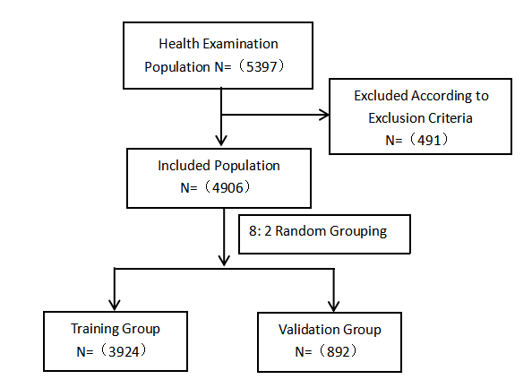
Based on the inclusion and exclusion criteria for the participants, the final analysis sample was formed

Figs. 2.
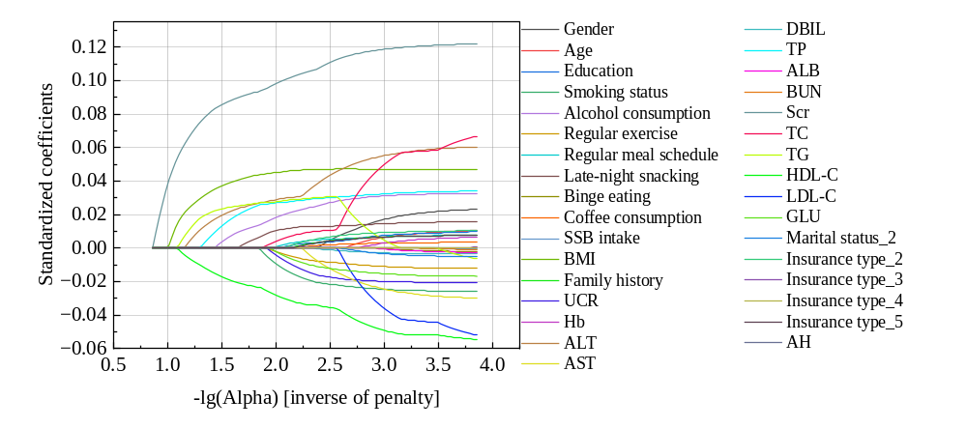
Legend of coefficient paths: candidate variables in LASSO regression
Figs. 3.
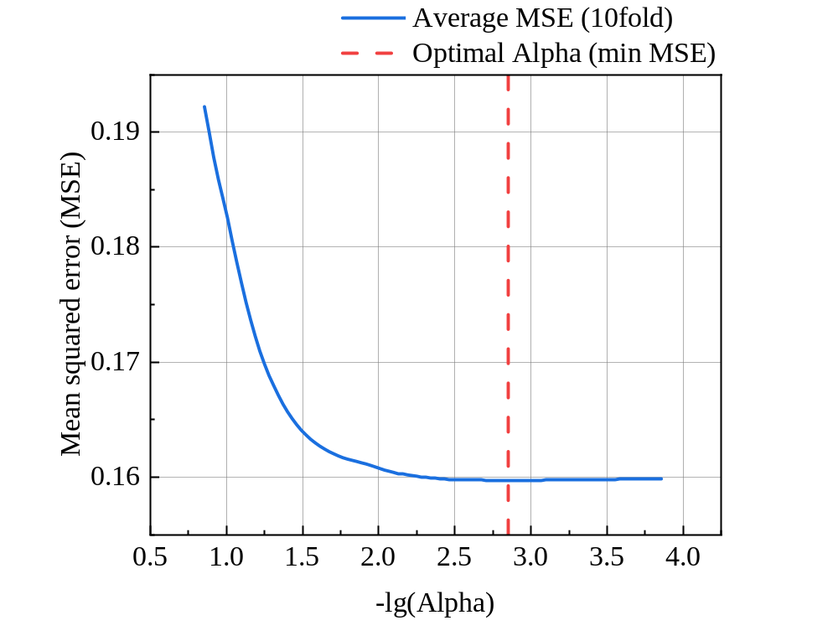Cross-validation error curve for LASSO regression (10‑fold)
Supplementary Table S1. Univariate analysis of incidence and sociodemographic characteristics of HUA.
Table S1 Univariate analysis of incidence and sociodemographic characteristics of HUA
Variable | Category | Total(n=4906) | Non-onset group(n=2971) | Onset group(n=1935) | χ² | P-value
Gender | Male | 2971(60.56) | 1924(64.76) | 1047(54.11) | 335.23 | 0.000
 | Female | 1935(38.44) | 1707(35.24) | 228(11.79)
Age (years) | ≤18 | 18(0.37) | 9(0.25) | 9(0.71) | 7.903 | 0.162
 | 19-30 | 581(11.84) | 421(11.59) | 160(12.55)
 | 31-40 | 1233(25.13) | 909(25.03) | 324(25.41)
 | 41-50 | 1329(27.09) | 995(27.40) | 334(26.20)
 | 51-60 | 1319(26.89) | 972(26.77) | 347(27.22)
 | ≥61 | 426(8.68) | 325(8.95) | 101(7.92)
Education | Junior high or below | 700(14.27) | 553(15.23) | 147(11.53) | 13.020 | 0.011
 | Senior high | 645(13.15) | 485(13.36) | 160(12.55)
 | Technical school | 337(6.87) | 247(6.80) | 90(7.06)
 | Bachelor's degree | 2610(53.20) | 1908(52.55) | 702(55.06)
 | Postgraduate | 614(12.52) | 438(12.06) | 176(13.80)
Marital status | Unmarried | 511(10.42) | 373(10.27) | 138(10.82) | 0.307 | 0.580
 | Married | 4395(89.58) | 3258(89.73) | 1137(89.18)
Insurance type | Urban Employee Basic Medical | 3016(61.48) | 2220(61.14) | 796(62.43) | 2.436 | 0.656
 | Urban Resident Basic Medical | 833(16.98) | 611(16.83) | 222(17.41)
 | New Rural Cooperative Medical | 769(15.67) | 585(16.11) | 184(14.43)
 | Other | 153(3.12) | 116(3.19) | 37(2.90)
 | None | 135(2.75) | 99(2.73) | 36(2.82)

Table S2 Univariate analysis of the incidence of HUA and health-related behaviors
Variable | Category | Total (n=4906) | Non-onset group (n=2971) | Onset group (n=1935) | χ²/t-value | P-value
Smoking status | Non-smoker | 3633(74.05) | 2770(76.29) | 863(67.69) | 36.332 | 0.000
 | Smoker | 1273(25.95) | 861(23.71) | 412(32.31) | 36.332 | 0.000
Alcohol consumption | Non-drinker | 3255(66.35) | 2575(70.92) | 680(53.33) | 130.674 | 0.000
 | Drinker | 1651(33.65) | 1056(29.08) | 595(46.67) | 130.674 | 0.000
Regular exercise | No | 1789(36.47) | 1285(35.39) | 504(39.53) | 6.980 | 0.008
 | Yes | 3117(63.53) | 2346(64.61) | 771(60.47) | 6.980 | 0.008
Regular meal schedule | Regular | 3276(66.78) | 2470(68.03) | 806(63.22) | 10.322 | 0.006
 | Irregular | 1286(26.21) | 921(25.36) | 365(28.63) | 10.322 | 0.006
 | Skipping | 344(7.01) | 240(6.61) | 104(8.16) | 10.322 | 0.006
Late-night snacking | None | 3034(61.84) | 2335(64.31) | 699(54.82) | 40.020 | 0.000
 | Occasional (≤3/week) | 1679(34.22) | 1174(32.33) | 505(39.61) | 40.020 | 0.000
 | Frequent (>3/week) | 193(3.93) | 122(3.36) | 71(5.57) | 40.020 | 0.000
Binge eating | Absent | 4533(92.40) | 3378(93.03) | 1155(90.59) | 8.024 | 0.005
 | Present | 373(7.60) | 253(6.97) | 120(9.41) | 8.024 | 0.005
Coffee consumption | Non-consumer | 3425(69.81) | 2579(71.03) | 846(66.35) | 18.929 | 0.000
 | Occasional (1-3/month) | 1185(24.15) | 824(22.69) | 361(28.31) | 18.929 | 0.000
 | Regular (1-6/week) | 213(4.34) | 159(4.38) | 54(4.24) | 18.929 | 0.000
 | Daily (≥1/day) | 83(1.69) | 69(1.90) | 14(1.10) | 18.929 | 0.000
SSB intake | Non-consumer | 2492(50.79) | 1914(52.71) | 578(45.33) | 31.945 | 0.000
 | Occasional (1-3/month) | 2107(42.95) | 1521(41.89) | 586(45.96) | 31.945 | 0.000
 | Regular (1-6/week) | 283(5.77) | 178(4.90) | 105(8.24) | 31.945 | 0.000
 | Daily (≥1/day) | 24(0.49) | 18(0.50) | 6(0.47) | 31.945 | 0.000
SSB=Sugar-sweetened beverage; Frequency definitions adapted from NHANES dietary guidelines

Supplementary Table S3. Univariate analysis of the incidence of HUA and physical examination status.
Table S3 Univariate analysis of the incidence of HUA and physical examination status
Variable | Total (n=4906) | Non-onset group (n=2971) | Onset group (n=1935) | Statistics | P-value
BMI classification |  |  |  | 317.266 | <0.001
Underweight (<18.5 kg/m²) | 134(2.73) | 123(3.39) | 11(0.86)
Normal (18.5-24.9 kg/m²) | 2731(55.67) | 2258(62.19) | 473(37.10)
Overweight (25.0-29.9 kg/m²) | 1715(34.96) | 1079(29.72) | 636(49.88)
Obese (≥30 kg/m²) | 326(6.64) | 171(4.71) | 155(12.16)
Hypertension |  |  |  | 21.905 | <0.001
No | 4248(86.59) | 3193(87.94) | 1055(82.75)
Yes | 658(13.41) | 438(12.06) | 220(17.25)
Family history |  |  |  | 1.642 | 0.200
Negative | 1778(36.24) | 1297(35.72) | 481(37.73)
Positive | 3128(63.76) | 2334(64.28) | 794(62.27)
Metabolic parameters
UCR (μmol/24h) | 14535.67±8142.03 | 14048.79±8290.25 | 15922.26±7536.92 | -7.436 | <0.001
Hb | 146.32±16.24 | 143.96±16.48 | 153.05±13.43 | -19.548 | <0.001
ALT (U/L) | 27.46±21.79 | 24.78±19.19 | 35.11±26.43 | -12.830 | <0.001
AST (U/L) | 24.78±11.28 | 23.92±11.01 | 27.23±11.67 | -8.858 | <0.001
DBIL (μmol/L) | 3.92±1.90 | 3.90±1.64 | 3.98±2.49 | -1.138 | 0.255
TP (g/L) | 73.70±4.37 | 73.28±4.30 | 74.90±4.37 | -11.498 | <0.001
ALB (g/L) | 46.66±2.80 | 46.44±2.80 | 47.30±2.71 | -9.503 | <0.001
BUN (mmol/L) | 4.89±1.25 | 4.82±1.23 | 5.09±1.29 | -6.598 | <0.001
Scr (μmol/L) | 72.27±16.39 | 69.23±15.03 | 80.92±17.01 | -21.734 | <0.001
TCl (mmol/L) | 5.04±1.00 | 4.98±0.96 | 5.21±1.08 | -6.843 | <0.001
TG (mmol/L) | 1.96±2.17 | 1.68±1.75 | 2.78±2.90 | -12.738 | <0.001
HDL-C (mmol/L) | 1.29±0.29 | 1.33±0.29 | 1.17±0.24 | 19.061 | <0.001
LDL-C (mmol/L) | 2.88±0.83 | 2.88±0.81 | 2.87±0.86 | 0.483 | 0.629
GLU (mmol/L) | 5.54±1.31 | 5.51±1.36 | 5.62±1.15 | -2.538 | 0.011

Note:
BMI, body mass index; UCR, urinary creatinine; Hb, hemoglobin; ALT, alanine aminotransferase; AST, aspartate aminotransferase; DBIL, direct bilirubin; TP, total protein; ALB, albumin; BUN, blood urea nitrogen; Scr, serum creatinine; TC, total cholesterol; TG, triglycerides; HDL‑C, high‑density lipoprotein cholesterol; LDL‑C, low‑density lipoprotein cholesterol; GLU, glucose.
Table S4 LASSO Regression Feature Selection Result Table
Feature | Coefficient
Scr | 0.117
ALT | 0.053
BMI | 0.047
HDL-C | -0.046
TC | 0.041
TP | 0.032
Alcohol consumption | 0.031
LDL-C | -0.028
Smoking status | -0.024
AST | -0.022
UCR | -0.019
GLU | -0.015
Gender | 0.015
Late-night snacking | 0.014
TG | 0.011
Regular exercise | -0.010
Insurance type_2（medical insurance for urban residents） | 0.009
Education | 0.007
Regular meal schedule | 0.006
Family history | 0.006
Insurance type_5(Uninsured) | 0.006
Age | 0.005
Coffee consumption | 0.003
DBIL | -0.003
Marital status_2(Married) | -0.002
Hb | 0.002

