Supplementary Information
SiO₂ Nanoparticle Morphology and Aggregation State Modulate Plant Antioxidant Responses Under Abiotic Stress: A Systematic Review and Meta-Analysis

Emilaine da Rocha Prado^{1*}, Renato de Mello Prado², Reginaldo de Oliveira¹, Carlos Vital Gonzalez-Porras¹, Lara Yassuko Nakamura¹, Priscila Lupino Gratão¹
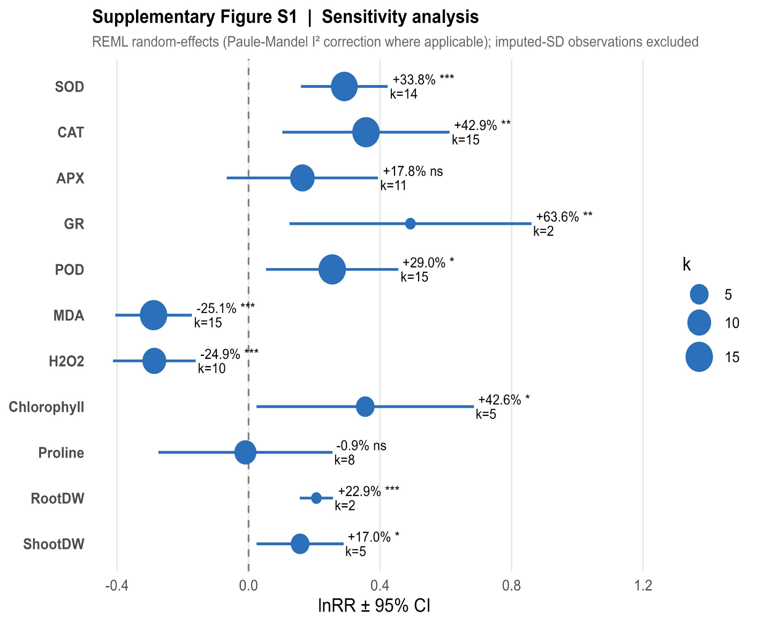
Supplementary Figure S1 | Sensitivity analysis – exclusion of SD-imputed observations. Pooled lnRR ± 95% CI computed after excluding all observations for which SD was imputed (46.3% of total), re-fitted with REML random-effects; Paule-Mandel I² correction†. Results are directionally consistent with the primary analysis for all variables. APX lost statistical significance under this stricter subset (k = 11, ns), and GR, though nominally significant, is supported by only k = 2 non-imputed observations; both should be interpreted cautiously pending additional non-imputed data.

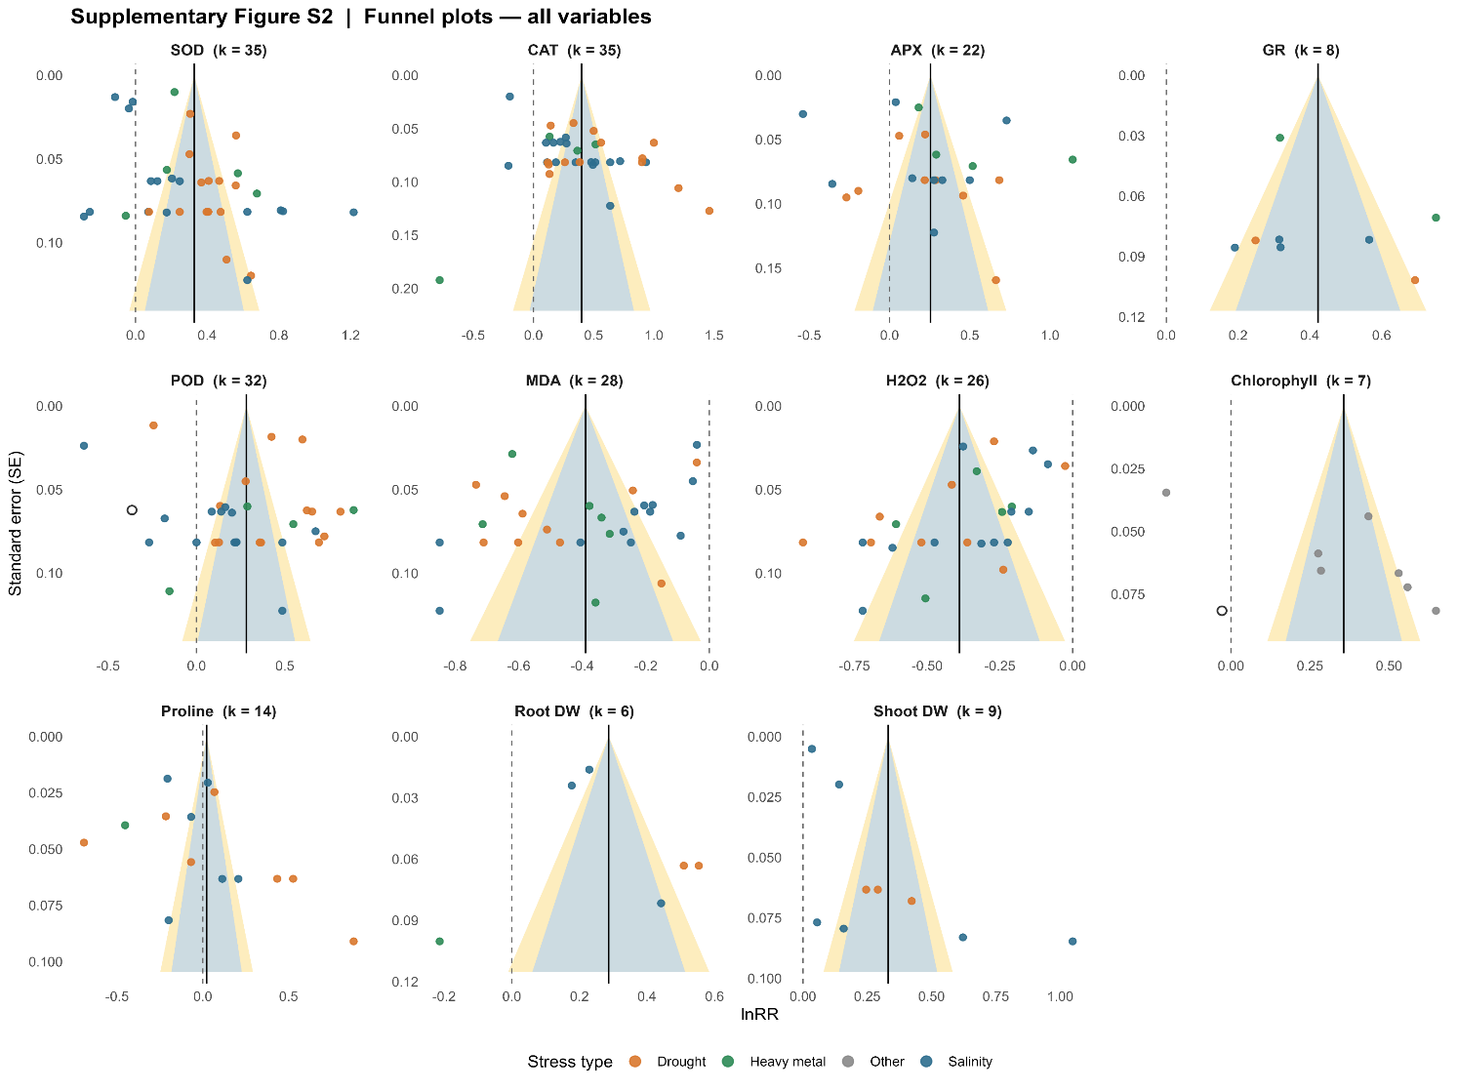
Supplementary Figure S2 | Funnel plots for all response variables. Each panel shows individual lnRR vs standard error (SE). The vertical solid line indicates the pooled REML lnRR; the dashed line indicates lnRR = 0. Blue shading = pseudo-95% CI; yellow shading = pseudo-99% CI contours. Open circles (○) indicate studies imputed by Duval-Tweedie trim-and-fill. Egger’s weighted regression p-value annotated per panel (red = significant asymmetry, p < 0.05).

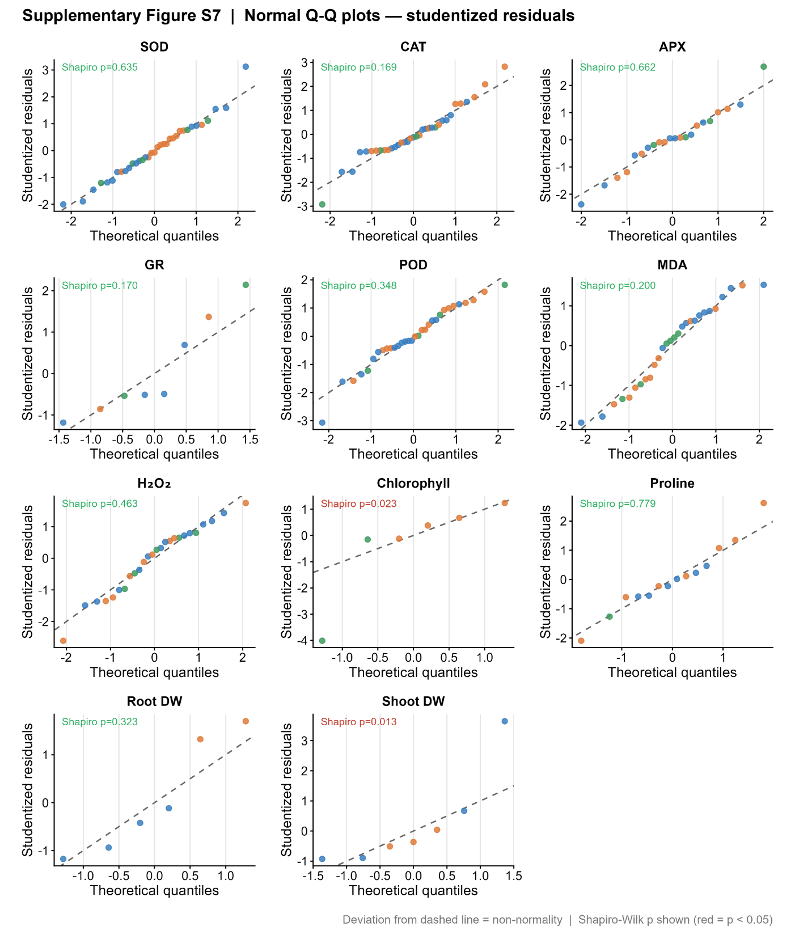
Supplementary Figure S3 | Normal Q-Q plots of studentized residuals for all response variables. Deviation from the dashed line indicates departure from normality. Shapiro-Wilk p-values are annotated per panel (red = p < 0.05, indicating significant departure). The majority of variables show adequate normality of residuals, supporting the validity of REML random-effects estimation

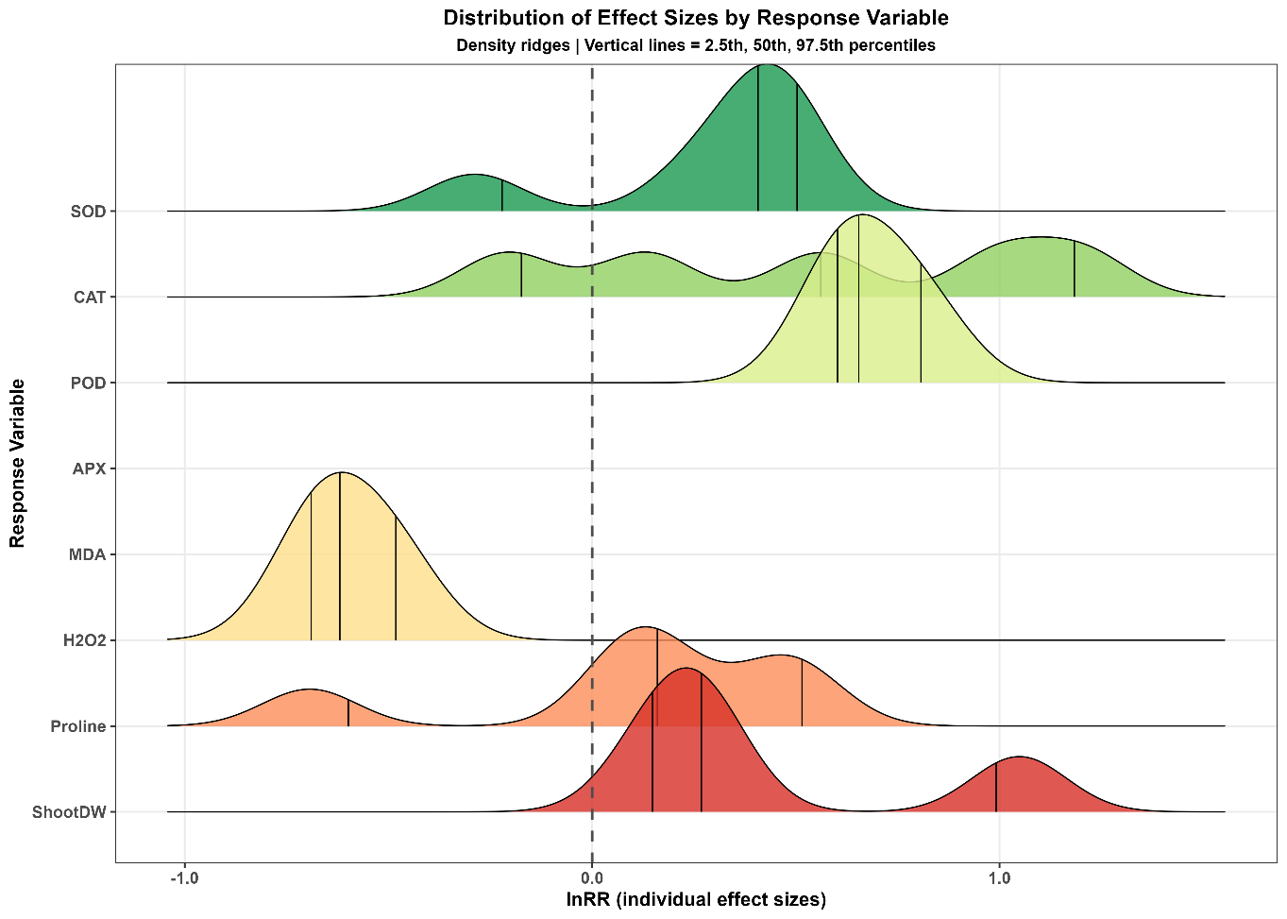
Supplementary Figure S4 | Distribution of individual effect sizes by response variable. Kernel density estimates of all individual lnRR values per variable. Vertical lines indicate 2.5th, 50th, and 97.5th percentiles. Dashed vertical line at lnRR = 0. Antioxidant enzymes (green) peak consistently above zero; oxidative markers (yellow-orange: MDA, H₂O₂) peak below zero, reflecting protective SiO₂ NP effects. Growth/osmolyte variables (red) show bimodal distributions consistent with stress-type heterogeneity.
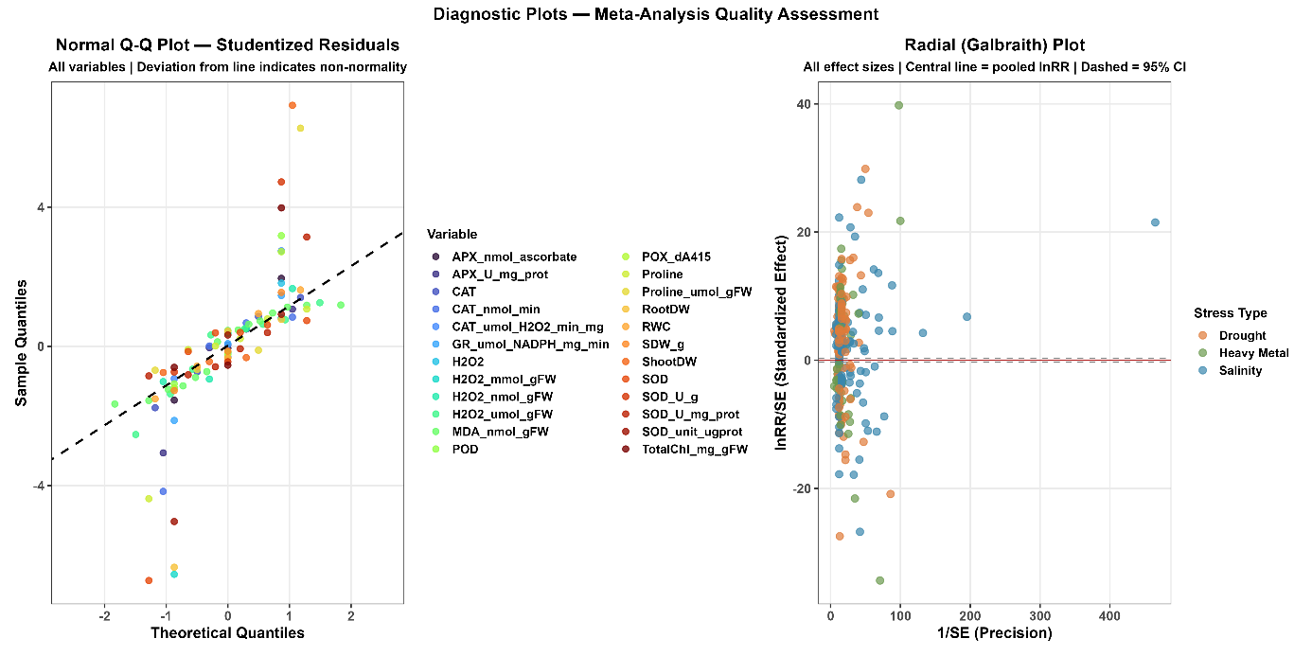
Supplementary Figure S5 | Diagnostic plots for meta-analysis quality assessment. Left: Normal Q-Q plot of studentized residuals across all effect sizes and variables; deviation from the dashed line indicates departure from normality. Right: Radial (Galbraith) plot showing standardized effect size (lnRR/SE) versus precision (1/SE) for all 313 observations, stratified by stress type (drought = orange; heavy metal = green; salinity = blue); the central diagonal line represents the pooled REML lnRR and the horizontal dashed lines indicate the ±1.96 bounds. Stars denote outliers (|z| > 3).

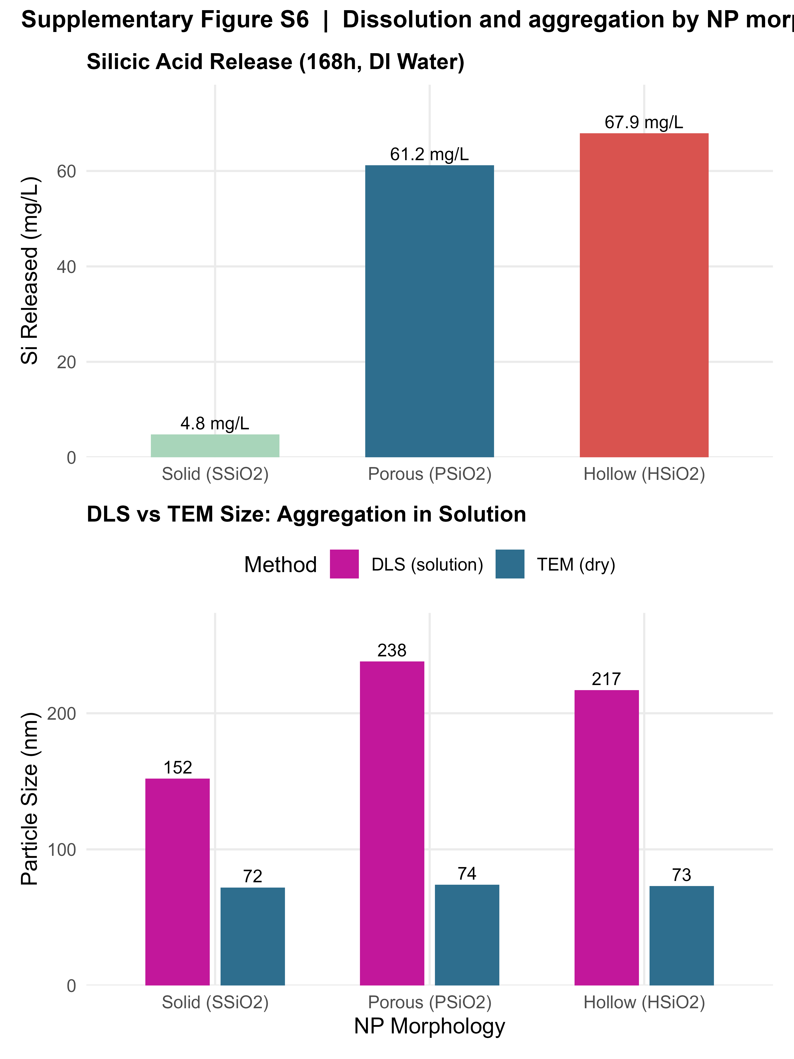
Supplementary Figure S6 | Dissolution and aggregation by NP morphology. Top: cumulative silicic acid release (mg L⁻¹) after 168 h in deionised water for solid (SSiO₂), porous (PSiO₂), and hollow (HSiO₂) NPs; hollow releases ~14-fold more Si than solid. Bottom: DLS hydrodynamic vs TEM primary particle size for each morphology, confirming aggregation in all preparations (DLS/TEM ratio > 2 for all three). Data from Wang et al.⁷ (J. Agric. Food Chem. 2025). Split out from the main-text Figure 4 morphology comparison for clarity.

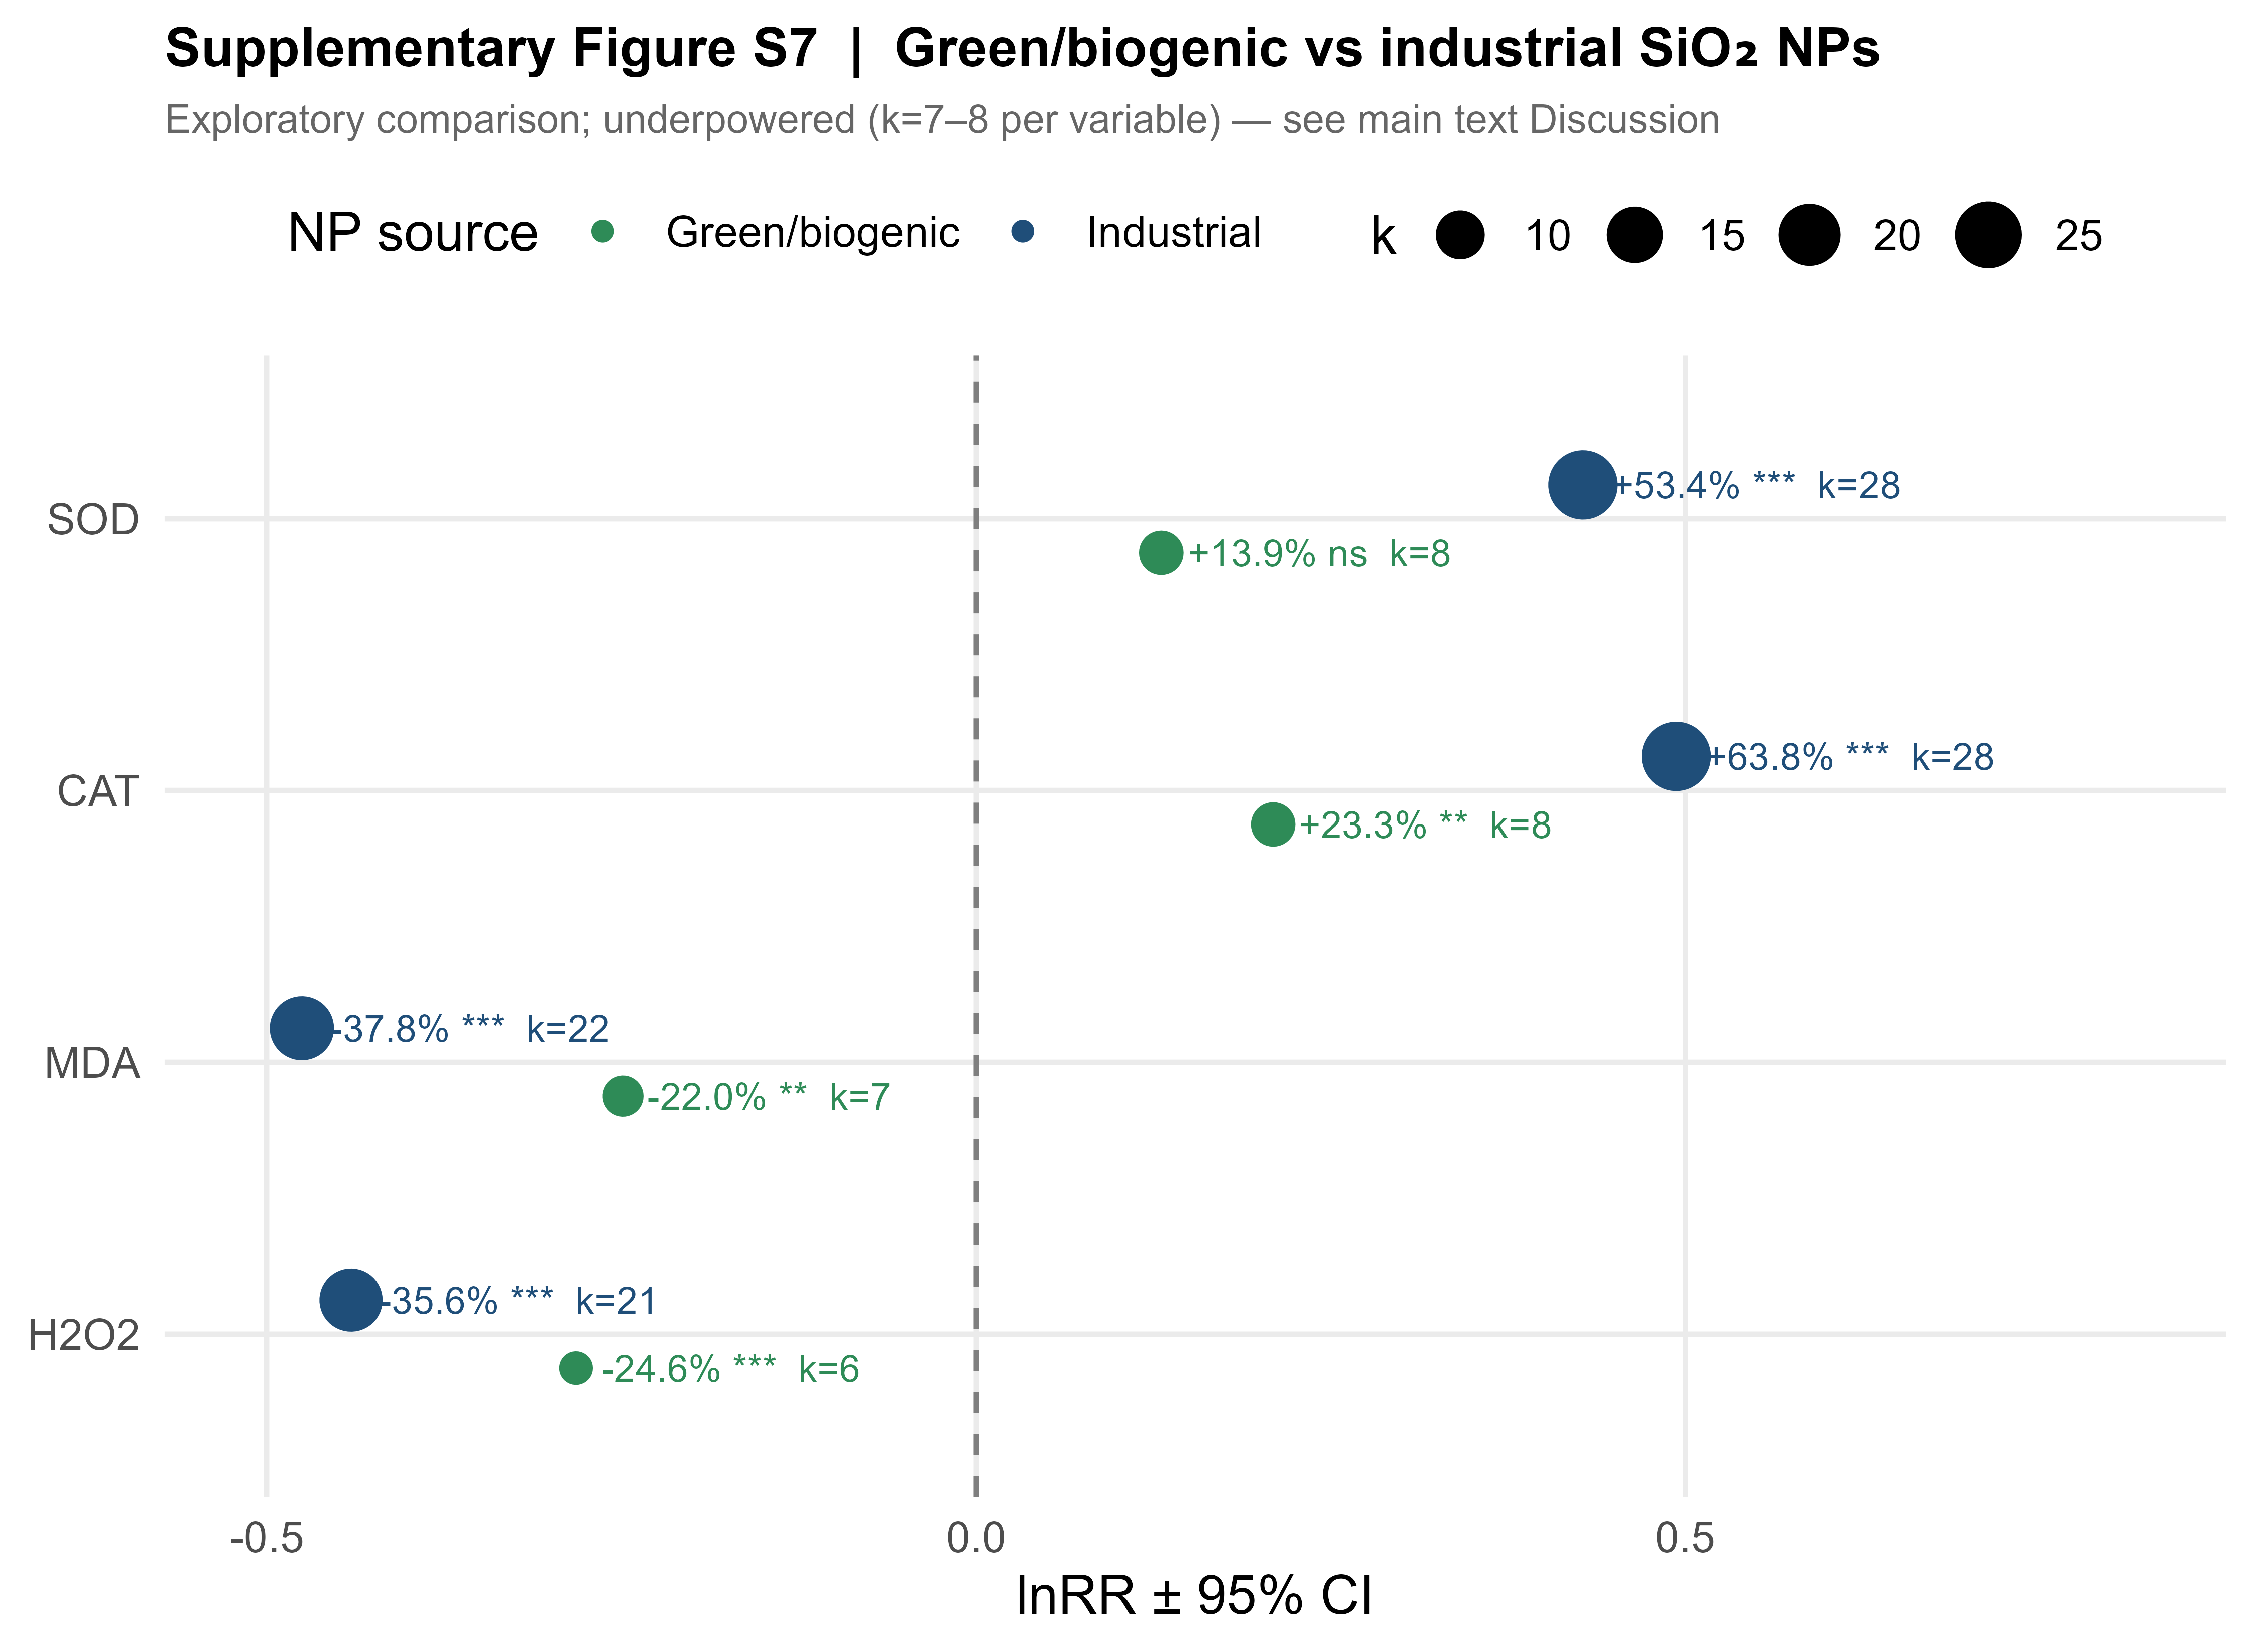
Supplementary Figure S7 | Green/biogenic vs industrial SiO₂ NPs. Pooled lnRR ± 95% CI per response variable for green/biogenic (rice husk extract, plant extract-derived; k = 7–8 per variable) versus industrial SiO₂ NPs. The omnibus moderator test was non-significant for all variables (Q_M = 1.82, df = 1, p = 0.18), which should be interpreted as insufficient statistical power to detect moderate differences rather than as established equivalence between synthesis routes. Split out from the main-text Figure 7 heatmap as an exploratory, underpowered secondary comparison (see Discussion).

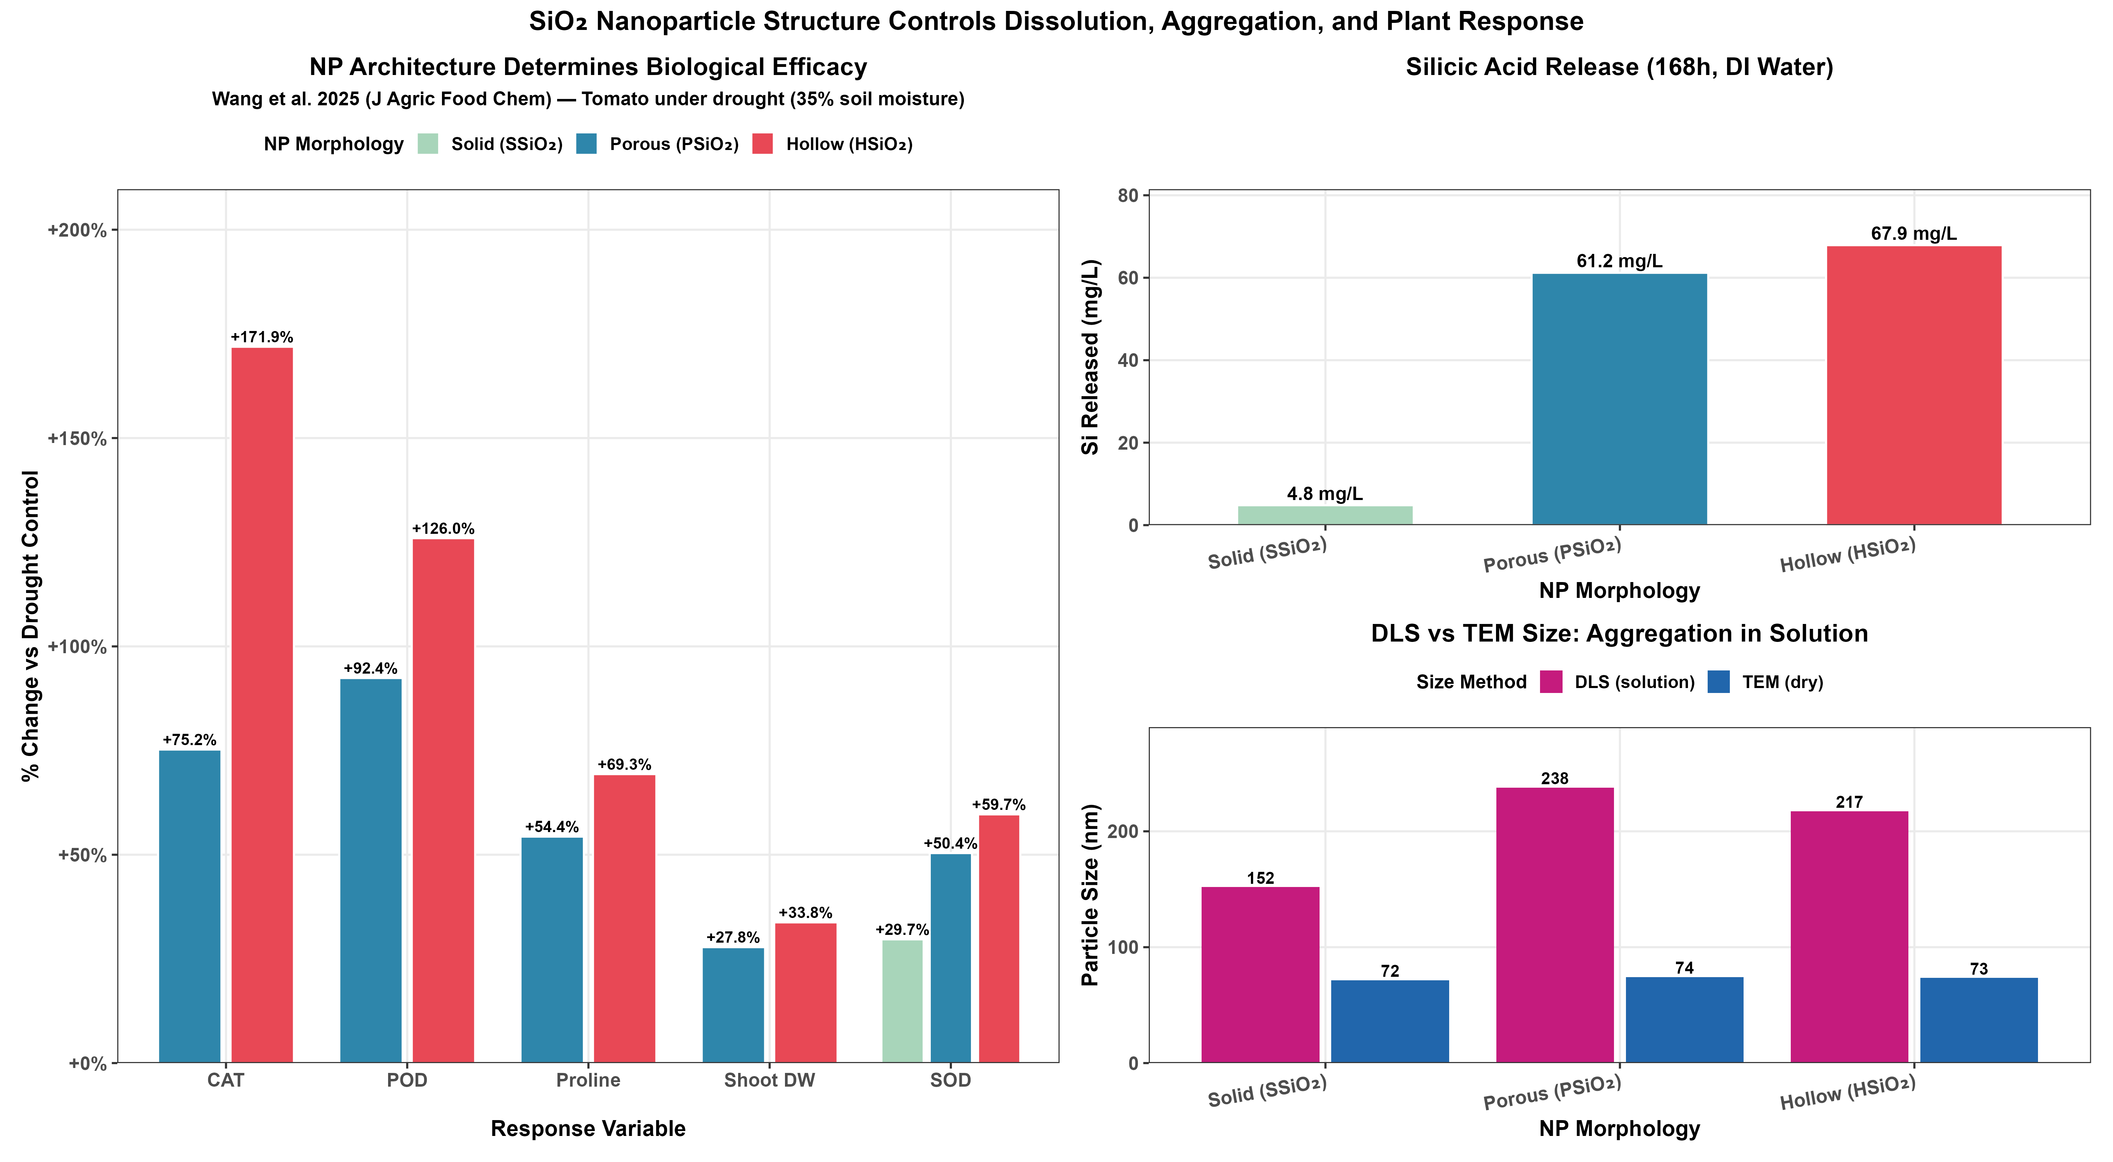
Supplementary Figure S8 | Composite view of nanoparticle structure, dissolution, and plant response. Combined reference figure showing, in one panel, the morphology comparison (main-text Figure 4), the silicic acid dissolution kinetics, and the DLS-vs-TEM aggregation data (Supplementary Figure S6) together, for readers who wish to see the full structure-dissolution-efficacy relationship in a single view. Data from Wang et al.⁷ (J. Agric. Food Chem. 2025).

