Supplementary Methods: Assessment of children’s mental state reasoning (Experiment 2).

In Experiment 2 we used an established measure of mental state reasoning, in the expectation that children’s scores might contribute to explaining variation in performance on the main task, potentially shedding light on the developmental changes responsible for any differences found between age groups.
The mental state reasoning task was completed by all children prior to their completion of the main grid search task. Our goal was to evaluate relatively advanced capacities for mental state reasoning in our study population (aged between five and ten years old). We opted for the ‘Yoni task’ which is designed to evaluate reasoning about second-order as well as first-order mental states. This task also had the advantages of being quick and easy to administer (fitting within the time that children were permitted to be absent from their classroom), and straightforward to score.
In previous studies this task has mainly been used to assess mental state reasoning in adult populations, particularly to evaluate neurodivergent or older populations, whose cognitive impairments may affect performance in socio-cognitive reasoning. Although studies with adult populations typically use a combination of accuracy and reaction time to score the Yoni task, we used only response accuracy. Representation of first-order mental states is widely agreed to be in place by the age of five, but children’s understanding of second-order mental states (involving representation of, for example, beliefs about beliefs) appears to develop later, with significant advances in performance found between the ages of six and ten years old. We therefore expected to see significant differences in accuracy between our age groups, with the oldest children performing best, particularly on items assessing reasoning about second-order mental state.
The stimuli that we used were adapted in several ways from the original Yoni task stimuli. Firstly, we renamed the main protagonist of the task based on informal feedback about the relative familiarity of names. On this basis, the central character of our task was therefore named ‘Yanny’, rather than Yoni. We also reduced the number of trials (due to testing time limitations), whilst retaining all essential elements of the original task and ensuring that there was at least one of each trial type. In addition, the task stimuli were re-created from scratch to reduce ambiguities about gaze direction present in the original task stimuli. In other respects, the task was the same. All trials showed a yellow character (Yanny) in the middle of the screen, surrounded by four different images, positioned in the four corners of the screen. At the top of the screen there was an incomplete sentence, describing Yanny’s relationship with the other trial stimuli. The trials were organised into two separate blocks, testing for first- and second-order mental state reasoning. Examples of task stimuli are shown in Fig. S5, including examples of each of the different judgement types (physical, cognitive and affective) in both the first- and second-order blocks. There were 34 trials in total (12 first-order and 22 second-order).
The task was run using PsychoPy v1.84.2, on either a Microsoft Surface tablet, or a Lenovo Yoga 520 touchscreen laptop in tablet mode, both using Windows 10. An experimenter read aloud the sentence shown at the top of the screen and asked the child to select which of the four corner images would correctly complete the sentence. Once the child had made their selection, the next trial was shown.
As noted above, we had included this test in the expectation that it might help to elucidate the developmental advances that were responsible for any differences in performance between age groups on the main task. However, upon analysis of the results of the mental state reasoning task, it became clear that the children’s scores could not be used for the intended purpose. There were several reasons why we came to this conclusion.
Firstly, ceiling effects were evident in children’s response accuracy, with all trial types showing accuracy of >70% for all age groups, and the majority >85% (see Table S8 and Fig. S6). These high accuracies limited to potential sensitivity of the measure to detect relatively subtle differences in ability. As previously noted, the Yoni task is generally scored by using a combination of accuracy and reaction time data, so it is possible that inclusion of reaction time data might have produced a more sensitive measure.
Nonetheless, analysis of the accuracy data did identify some significant differences between trial types and age groups. However, the effects found were not consistent with the trends we would have expected if these test items were truly tapping into children’s well-documented age-related advances in explicit understanding of first- and second-order mental states, including the relative difficultly of second-, compared to first-order reasoning.
Perhaps most strikingly, performance was better overall for second-order, compared with first-order, items (see Table S9 and Fig. S7), in direct conflict with our expectations. Furthermore, age group differences showed no obvious linear progression (see Table S8b in particular). Overall accuracy was higher in the 7- to 8-year-olds and 9- to 10-year olds, compared with the 5- to 6-year-olds, but there was no significant difference in overall accuracy between the 7- to 8-year-olds and the 9- to 10-year-olds (see results of GLMM in Table S9). In addition, although there was a significant interaction with stage between the 5- to 6-year-old and 7- to 8-year-old groups (with the older group showing a greater improvement on second-order items, relative to their performance on first-order items, compared with the relative differences in performance between the two stages in the younger group), there was no such interaction effect when comparing the 5- to 6-year-old group with the 9- to 10-year-old group. Furthermore, in light of fact that the overall differences between first- and second-order items were in the non-predicted direction, even the one significant interaction between age and stage did not reflect an expected pattern of results in a straightforward way.
Finally, there was also no overall effect of judgement type (see Table S9). In theory, physical judgements should have been easiest, as these would not require mental state representation at all, but this was not the case. Furthermore, the trends in performance between judgement types were different for the first-order stage, compared with second-order (see Figure S7).
Since the task scores did not appear to reveal age-related advances in understanding of mental states we decided that the measure had little value in our interpretation of age-related differences in performance on the main task (e.g., as a potential mediator or moderator of effects of age).

Supplementary Figure S1 | Survival analysis of grids yet to be solved by any participant in chain across all three conditions.
a. Kaplan-Meier survival plot of the number of learner generations taken for adult participants (Experiment 1) to achieve maximum score (score = 27, all three 3×3 targets found) on any given grid, for all three conditions. Shaded areas show confidence intervals.
b. Total count of grids as yet unsolved by any participant in chain following completion of each learner generation.

a

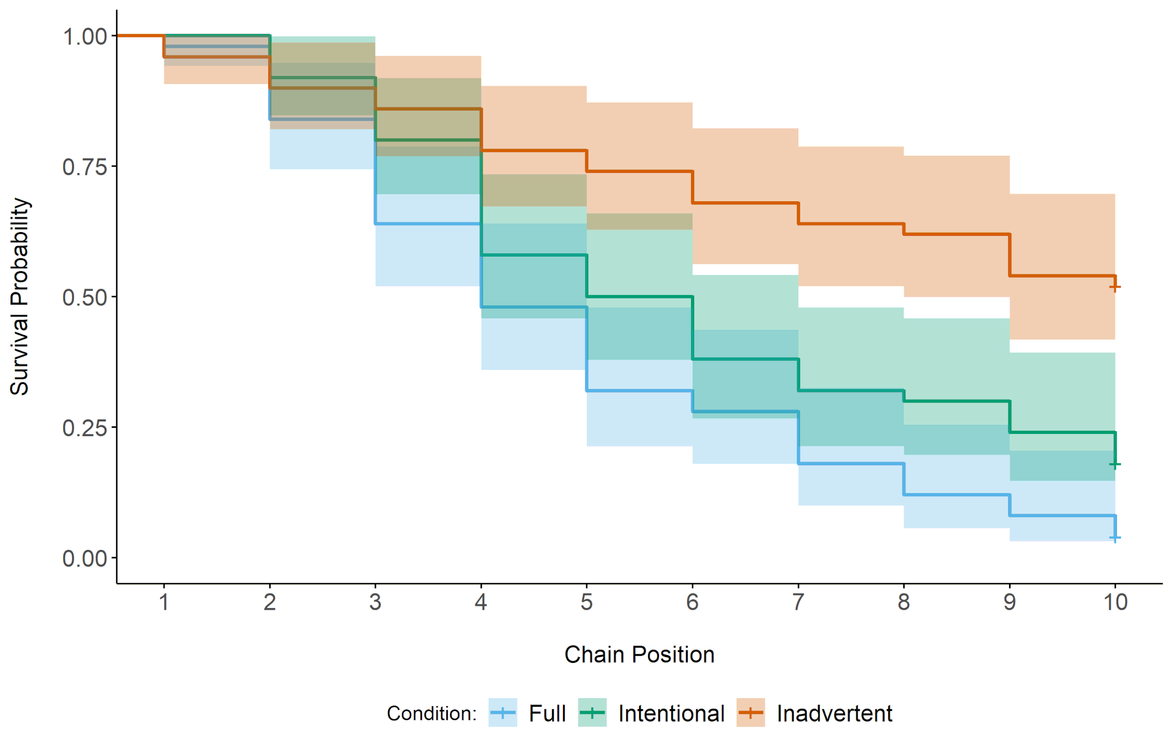

b

Chain position | 0 | 1 | 2 | 3 | 4 | 5 | 6 | 7 | 8 | 9 | 10
Full | 50 | 49 | 42 | 32 | 24 | 16 | 14 | 9 | 9 | 4 | 2
Intentional | 50 | 50 | 46 | 40 | 29 | 25 | 19 | 16 | 15 | 12 | 9
Inadvertent | 50 | 48 | 45 | 43 | 39 | 37 | 34 | 32 | 32 | 27 | 26

Supplementary Figure S2 | Proportion of hits transmitted, relative to the proportion available, in the Intentional condition in Experiment 1 (adults).

Participants selected a disproportionate number of hits for transmission. Across all grids completed in the Intentional condition, the mean percentage of hits available for transmission was 63.7% but the mean percentage of hits within the transmission selection was higher at 81.4%. Compared with information about miss locations, information about hit locations was strategically more useful to cultural offspring. Most obviously, using information about a hit (by selecting the same grid square) guaranteed that the cultural offspring could add a point to their score, whereas using information about a miss (by avoiding it and searching elsewhere) only very slightly increased the probability of scoring a point, relative to no information. In addition, the predictable clustering of target grid squares meant that knowing the location of one target grid square narrowed down the potential locations of others that were part of the same target. Data have been jittered for greater visibility of individual points. Shaded areas represent +/- 1 standard error.

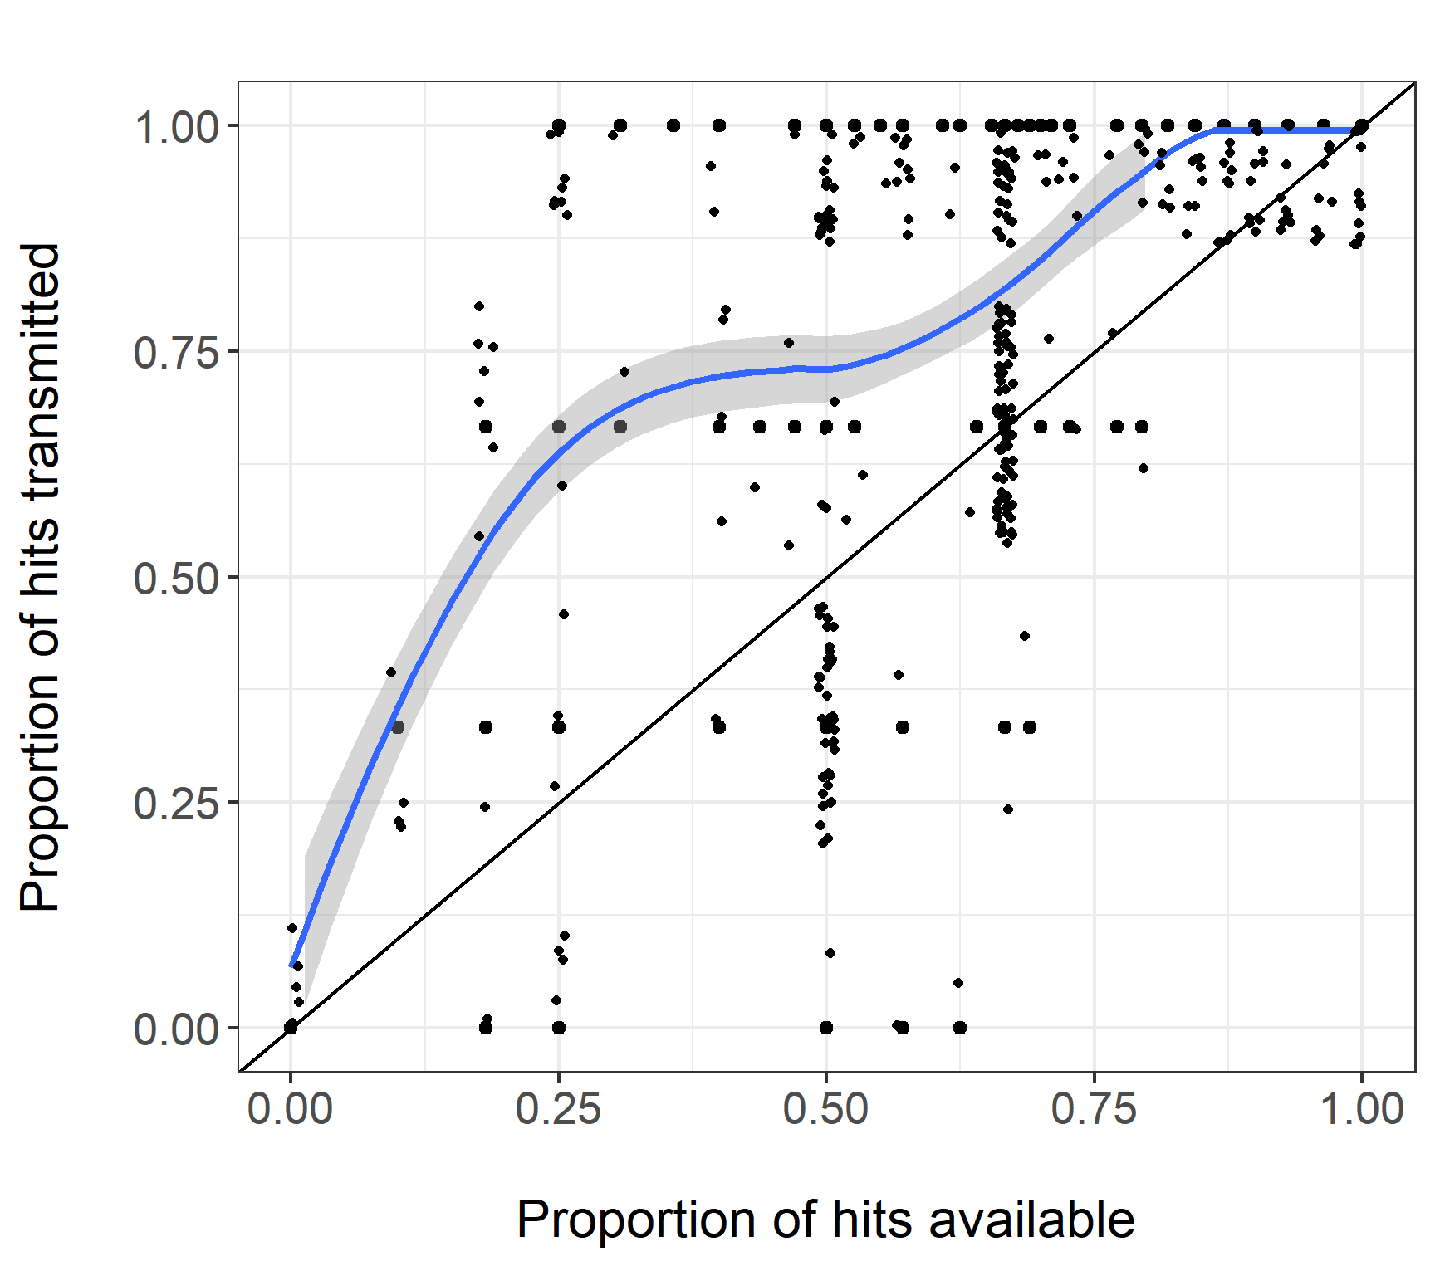
Supplementary Figure S3 | Proportion of hits transmitted, relative to the proportion available, in the Intentional condition in Experiment 2 (children).

Participants in all age groups selected a disproportionate number of hits for transmission. Across all grids completed in the Intentional condition, the mean percentages of hits available for transmission were: 32.2% (age 5-6); 43.3% (age 7-8); and 59.1% (age 9-10). The mean percentages of hits within the transmission selections were higher at 54.7% (age 5-6); 57.6% (age 7-8); and 76.0% (age 9-10). Data have been jittered for greater visibility of individual points. Shaded areas represent +/- 1 standard error.

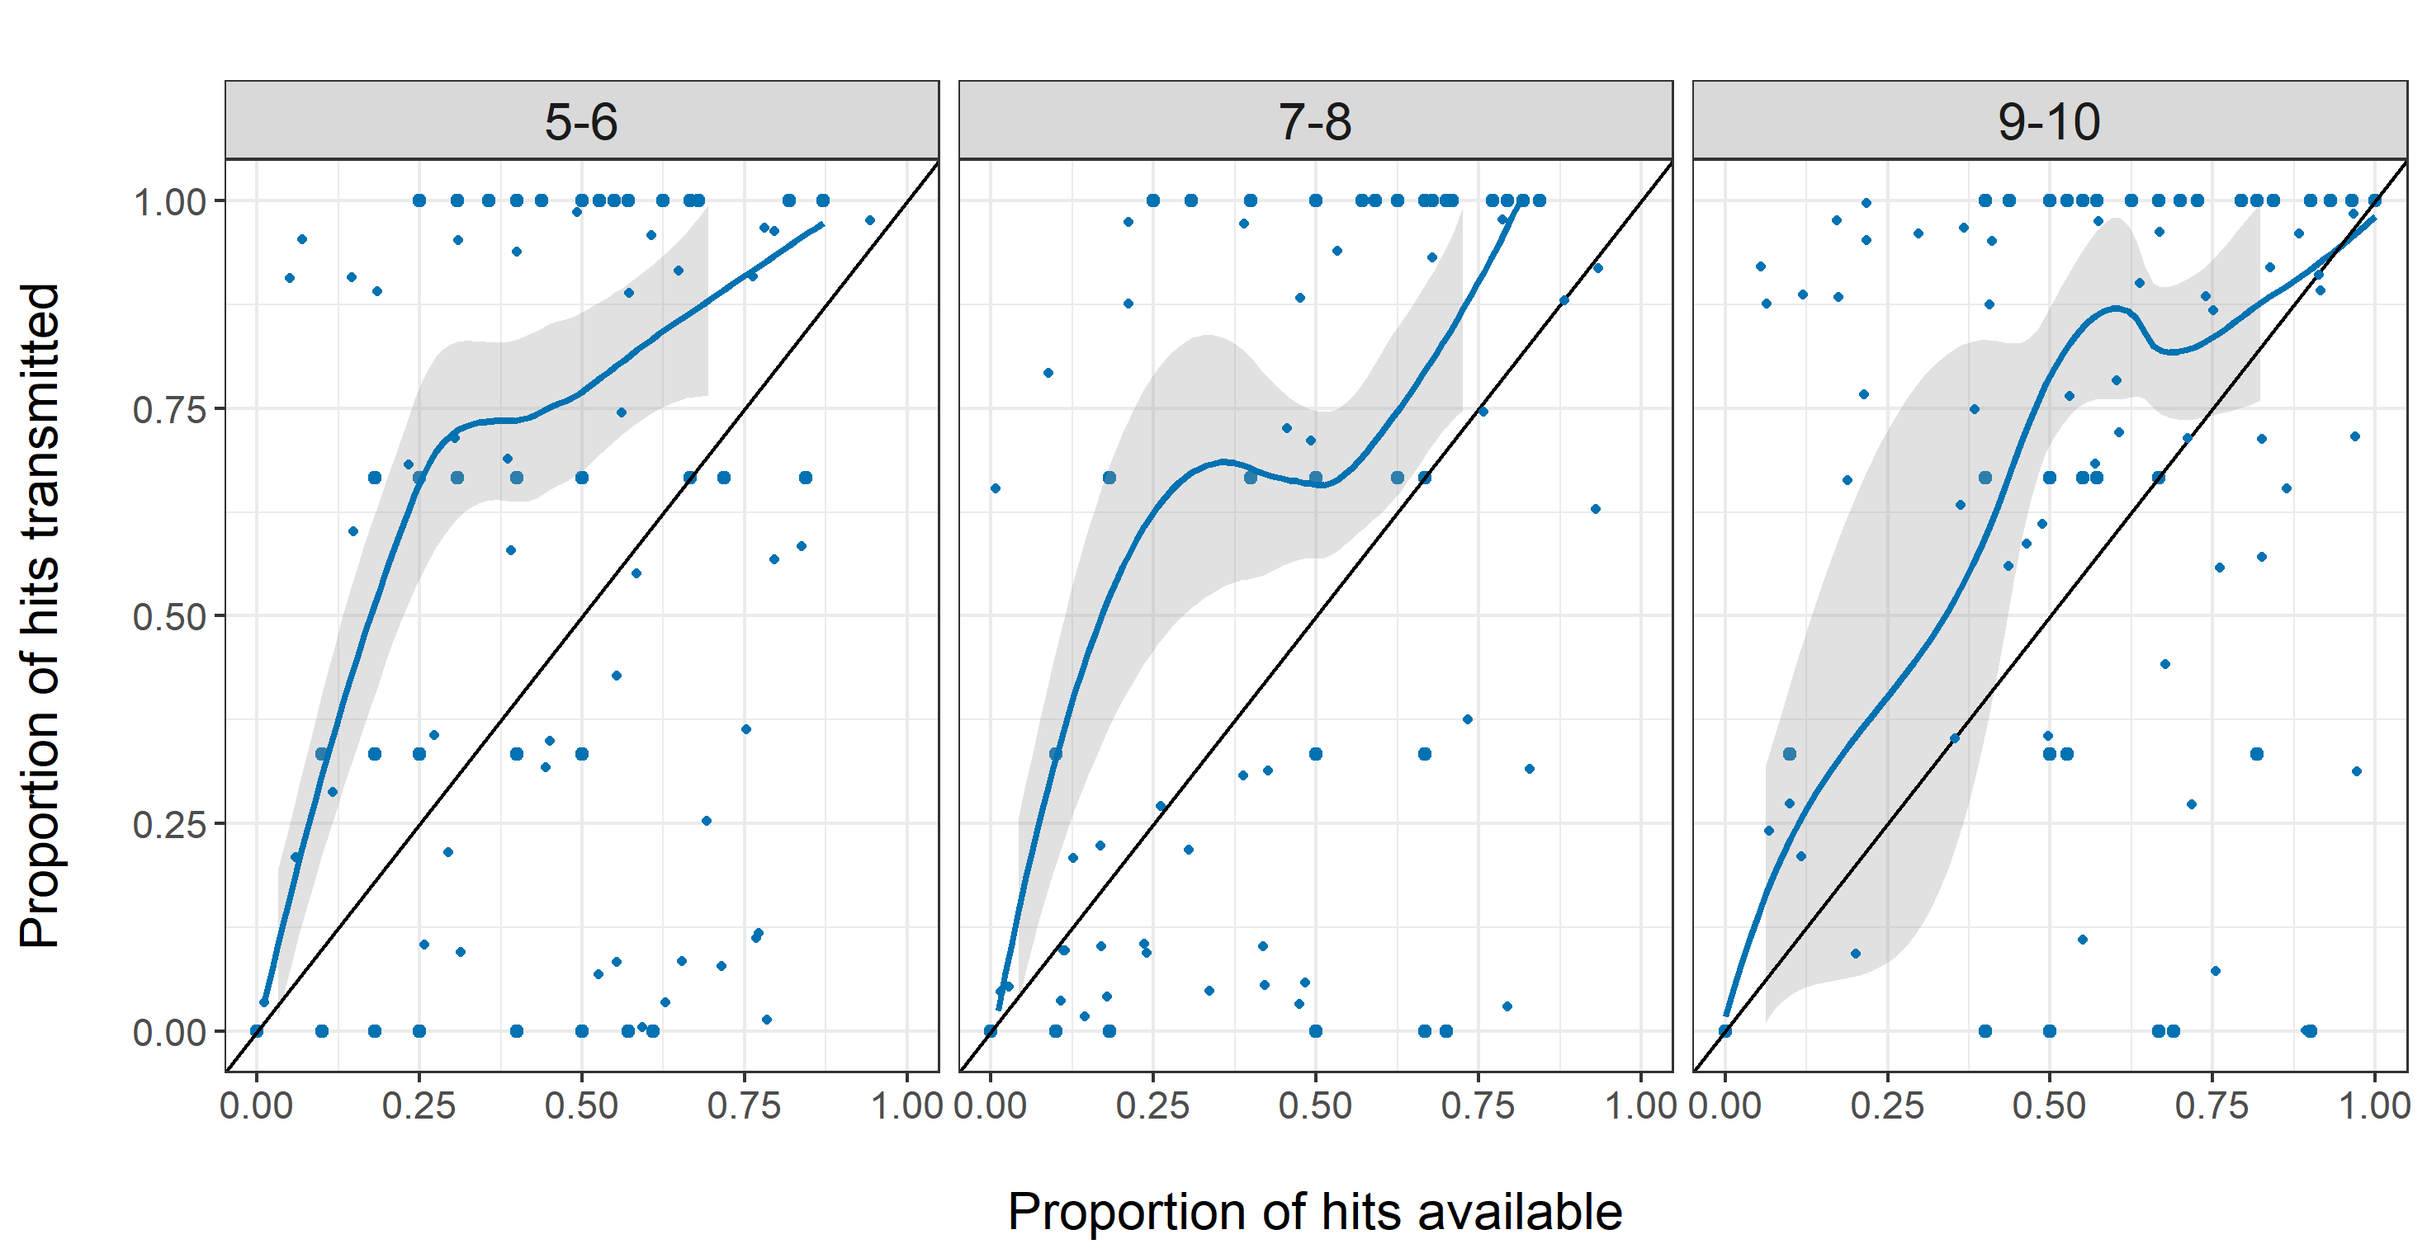
Supplementary Figure S4 | Children’s understanding check quiz (Experiment 2)

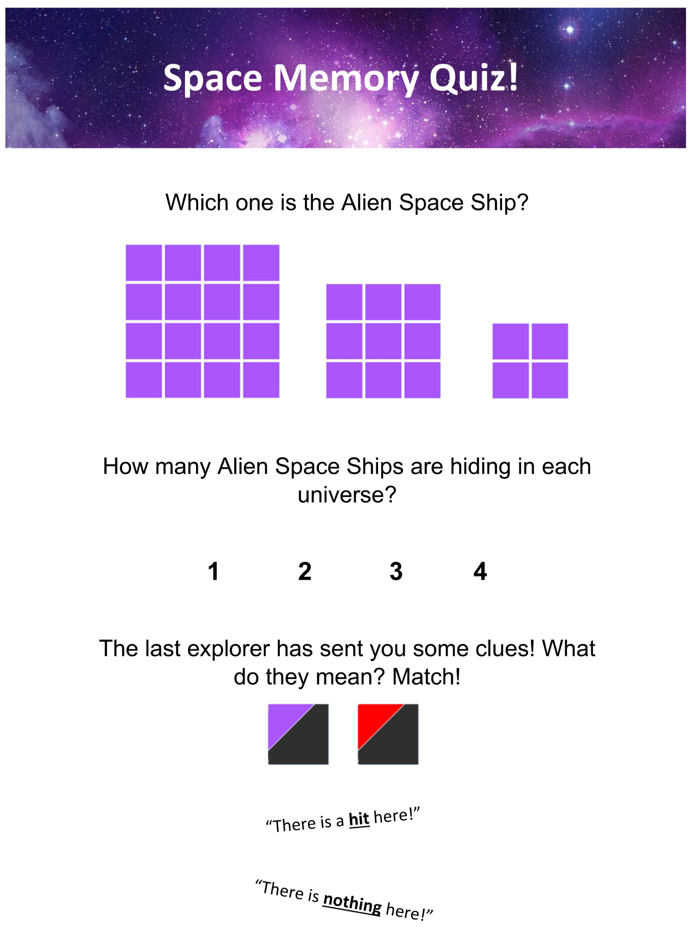
Supplementary Figure S5 | Examples of stimuli used in assessment of children’s reasoning about mental states (Experiment 2)
Task stimuli assessed reasoning about cognitive and affective mental states (thoughts and feelings), and physical relationships (proximity and similarity), in both first- and second-order associations (i.e., involving only Yanny’s relationship to objects, or Yanny’s relationship with objects identifiable only by ascertaining others’ associations with those objects).

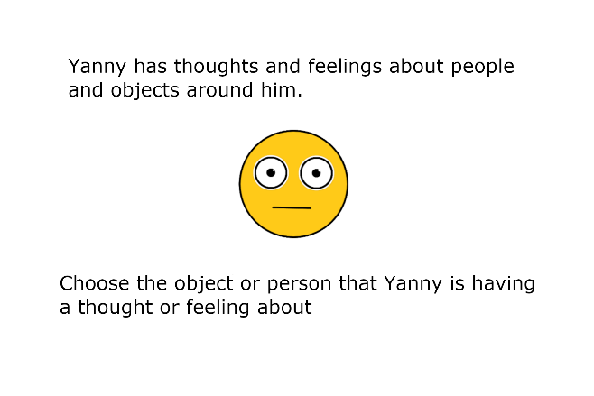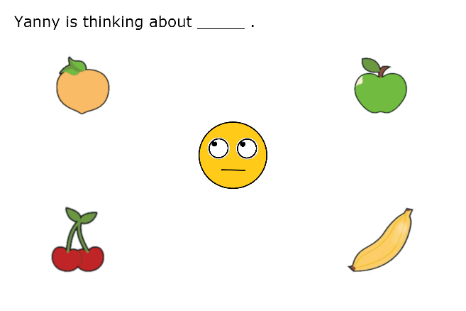

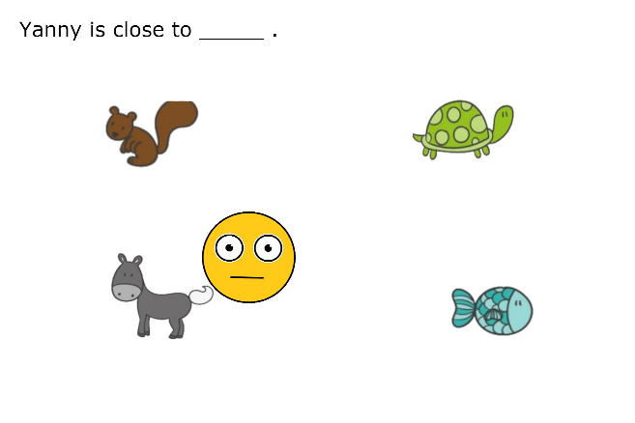

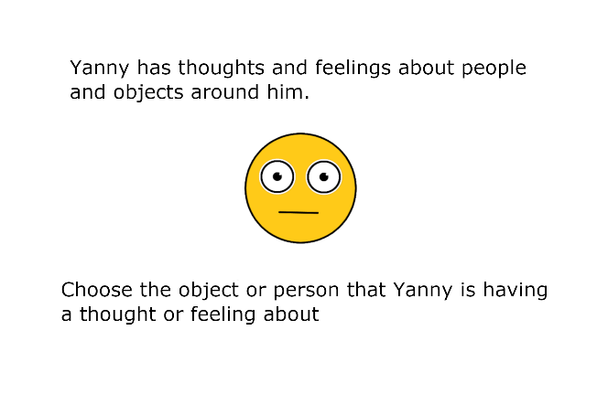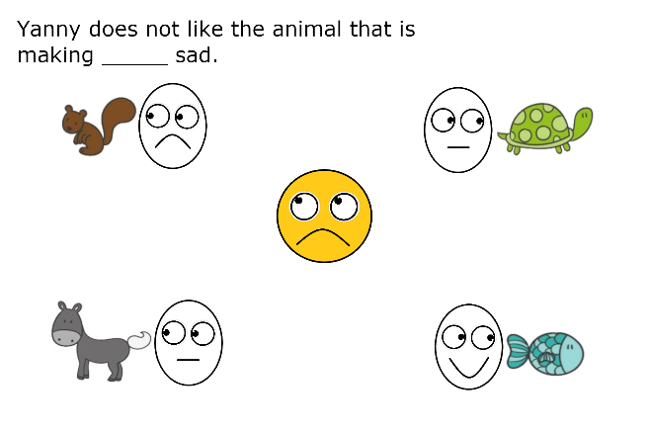

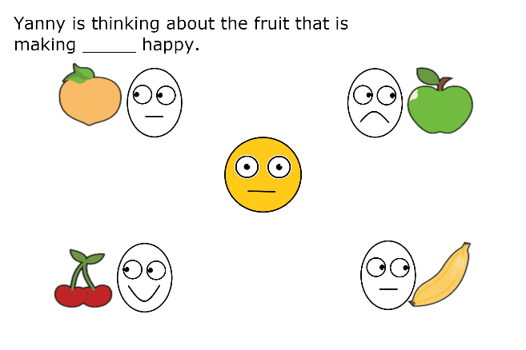
Supplementary Figure S6 | Total participants correct (out of 75 in each age group) by individual trial in assessment of children’s mental state reasoning (Experiment 2).

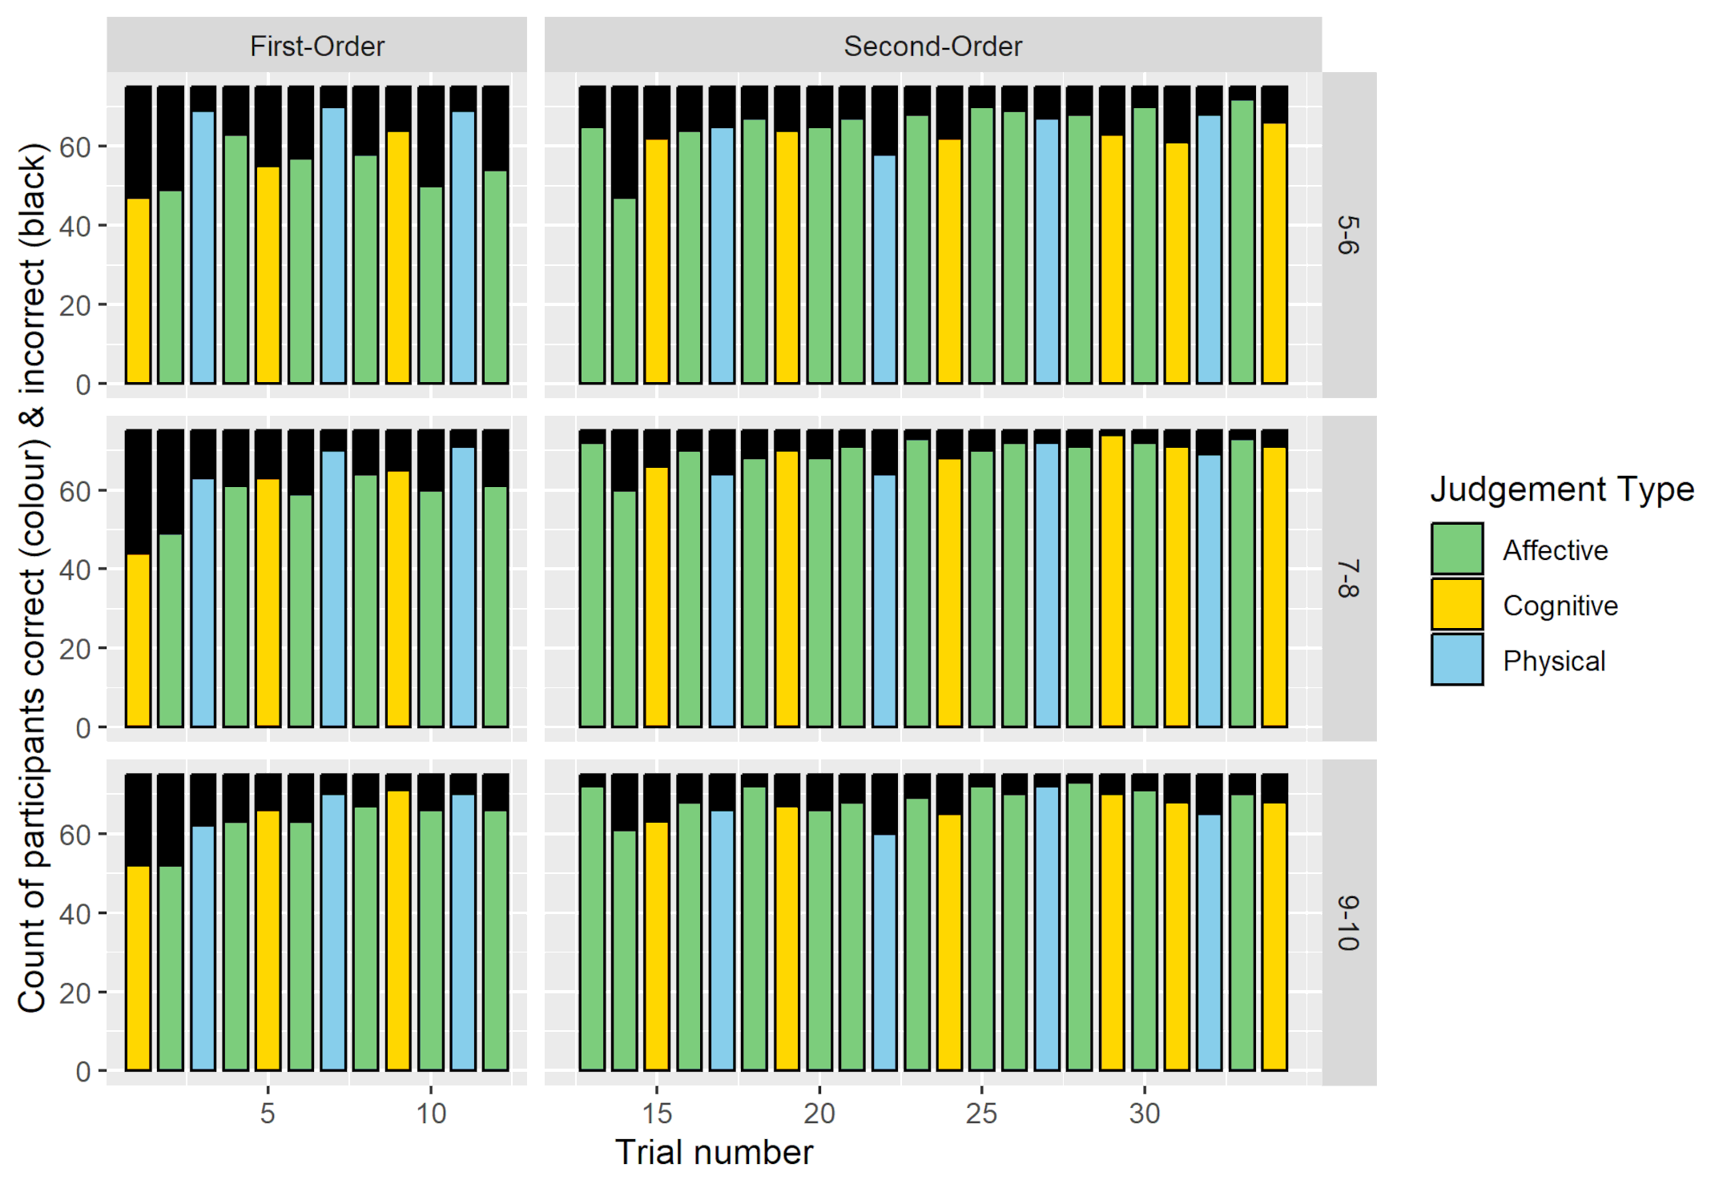

Supplementary Figure S7 | Median proportion correct in assessment of children’s mental state reasoning (Experiment 2), for all three age groups, for first- and second-order test items involving affective, cognitive and physical judgements.
Median shown as heavier black line. Ends of boxes indicate interquartile range and ends of whiskers indicate full range.

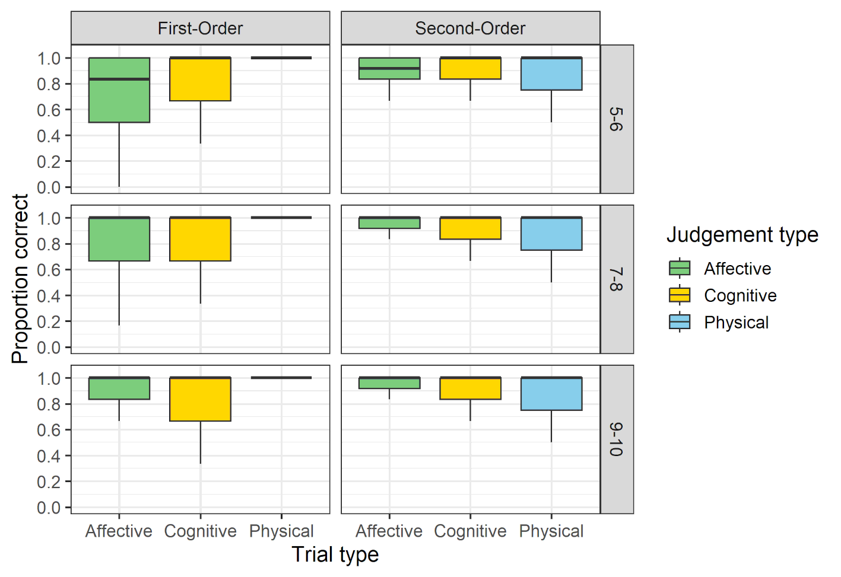

Supplementary Table S1 | Linear model and post-hoc test outputs for adult participants (Experiment 1) for total task score (a) and search attempts remaining (b).

a

GLMM comparing effects on Total Score of Full and Inadvertent conditions against Intentional, including interactions with chain position (random intercept for chain included)
 | Estimate | Std. Error | t value | p value
Intercept | 170.720 | 8.518 | 20.042 | <.0001
Condition Full | 22.580 | 11.510 | 1.962 | 0.0518
Condition Inadvertent | -40.620 | 11.510 | -3.529 | 0.0006
Chain position | 116.388 | 28.337 | 4.107 | <.0001
Condition Full : Chain position | -21.661 | 40.074 | -0.541 | 0.5897
Condition Inadvertent : Chain position | -71.673 | 40.074 | -1.789 | 0.0759

emmeans analysis for pairwise comparisons between all conditions (tukey adjustment)
 | Estimate | Std. Error | df | t value | p value
Intentional - Full | -22.6 | 11.5 | 140 | -1.962 | 0.1256
Intentional - Inadvertent | 40.6 | 11.5 | 140 | 3.529 | 0.0016
Full - Inadvertent | 63.2 | 11.5 | 140 | 5.491 | <.0001

emtrends analysis to compare between conditions for interactions with chain position
 | Estimate | Std. Error | df | t value | p value
Intentional - Full | 21.7 | 40.1 | 140 | 0.541 | 0.8515
Intentional - Inadvertent | 71.7 | 40.1 | 140 | 1.789 | 0.1772
Full - Inadvertent | 50.0 | 40.1 | 140 | 1.248 | 0.4271

b

GLMM comparing effects on Total Search Attempts Remaining of Full and Inadvertent against Intentional, including interactions with chain position (random intercept for chain included)
 | Estimate | Std. Error | t value | p value
Intercept | 22.780 | 3.486 | 6.535 | <.0001
Condition Full | 14.380 | 3.917 | 3.671 | 0.0003
Condition Inadvertent | -19.720 | 3.917 | -5.035 | <.0001
Chain position | 50.970 | 9.642 | 5.286 | <.0001
Condition Full : Chain position | 2.218 | 13.636 | 0.163 | 0.8710
Condition Inadvertent : Chain position | -48.145 | 13.636 | -3.531 | 0.0005

emmeans analysis for pairwise comparisons between all conditions (tukey adjustment)
 | Estimate | Std. Error | df | t value | p value
Intentional - Full | -14.4 | 3.92 | 140 | -3.671 | 0.0010
Intentional - Inadvertent | 19.7 | 3.92 | 140 | 5.035 | <.0001
Full - Inadvertent | 34.1 | 3.92 | 140 | 8.706 | <.0001

emtrends analysis to compare between conditions for interactions with chain position
 | Estimate | Std. Error | df | t value | p value
Intentional - Full | -2.22 | 13.6 | 140 | -0.163 | 0.9855
Intentional - Inadvertent | 48.15 | 13.6 | 140 | 3.531 | 0.0016
Full - Inadvertent | 50.36 | 13.6 | 140 | 3.693 | 0.0009

Supplementary Table S2 | Counts and percentages of particular target segments (corners, sides, centre) transmitted in Experiment 1 (adults), by condition.
This analysis includes data only from targets within which all nine segments were potentially available for transmission (i.e. the target had been fully revealed by the cultural parent). Out of a potential 1,500 targets presented to participants across all chains in each condition, the numbers of such fully revealed targets in each of the different conditions were as follows: Full condition, n = 1,085; Intentional condition, n = 805, Inadvertent condition n = 652. In the Intentional condition, cultural parents showed a strong preference for transmitting the centre segment of the 3×3 targets. Inadvertent and Full conditions are also shown for comparison. Chi-Square results, testing against an assumption of a flat distribution, are reported for the Intentional and Inadvertent conditions. Follow-up Binomial tests are reported for the Intentional condition only, for each individual segment position, again against an assumption of no selection bias. Binomial tests which remained significant using an adjusted alpha criterion of p ≤ 0.006 (0.05/9) corrected for multiple comparisons are marked with an asterisk (*), and the direction of the bias is indicated with up/down arrows. Values relating specifically to the central segment are in bold.

 |  |  | Full | Inadvertent |  | Intentional
Count of full targets revealed |  |  | 1085 | 652 |  | 805 |  | Percentage of all segments selected for transmission | Binomial test against expected proportion of 921/9 (11.11%)
Total segments transmitted (not transmitted in parentheses) |  |  | 9765 (0) | 717 (5151) |  | 921 (6324) |  | Percentage of all segments selected for transmission
Count of fully-revealed targets in which particular segment positions were transmitted (not transmitted in parentheses) |  | top left | 1085 (0) | 73 (579) | Chi² = 7.331  df = 8  p = .501 | 154 (651) | Chi² = 2378  df = 8  p < .001 | 16.72% | < 0.001 * | ↑
 |  | top centre | 1085 (0) | 81 (571) | Chi² = 7.331  df = 8  p = .501 | 32 (773) | Chi² = 2378  df = 8  p < .001 | 3.47% | < 0.001 * | ↓
 |  | top right | 1085 (0) | 77 (575) | Chi² = 7.331  df = 8  p = .501 | 33 (772) | Chi² = 2378  df = 8  p < .001 | 3.58% | < 0.001 * | ↓
 |  | centre left | 1085 (0) | 96 (556) | Chi² = 7.331  df = 8  p = .501 | 37 (768) | Chi² = 2378  df = 8  p < .001 | 4.02% | < 0.001 * | ↓
 |  | centre centre | 1085 (0) | 90 (562) | Chi² = 7.331  df = 8  p = .501 | 554 (251) | Chi² = 2378  df = 8  p < .001 | 60.15% | < 0.001 * | ↑
 |  | centre right | 1085 (0) | 71 (581) | Chi² = 7.331  df = 8  p = .501 | 20 (785) | Chi² = 2378  df = 8  p < .001 | 2.17% | < 0.001 * | ↓
 |  | bottom left | 1085 (0) | 74 (578) | Chi² = 7.331  df = 8  p = .501 | 28 (777) | Chi² = 2378  df = 8  p < .001 | 3.04% | < 0.001 * | ↓
 |  | bottom centre | 1085 (0) | 82 (570) | Chi² = 7.331  df = 8  p = .501 | 19 (786) | Chi² = 2378  df = 8  p < .001 | 2.06% | < 0.001 * | ↓
 |  | bottom right | 1085 (0) | 73 (579) | Chi² = 7.331  df = 8  p = .501 | 44 (761) | Chi² = 2378  df = 8  p < .001 | 4.78% | < 0.001 * | ↓

Supplementary Table S3 | Linear model and post-hoc test outputs for 5- to 6-year-old children (Experiment 2) for total task score (a) and search attempts remaining (b).

a

GLM comparing effects on Total Score of Full and Inadvertent conditions against Intentional, including interactions with chain position (no random effects included as random intercept was removed due to singular fit error)
 | Estimate | Std. Error | t value | p value
Intercept | 33.240 | 3.943 | 8.430 | <.0001
Condition Full | 3.560 | 5.576 | 0.638 | 0.5255
Condition Inadvertent | -7.540 | 5.914 | -1.275 | 0.2070
Chain position | 34.700 | 13.940 | 2.489 | 0.0154
Condition Full : Chain position | 14.800 | 19.715 | 0.751 | 0.4556
Condition Inadvertent : Chain position | -16.825 | 20.911 | -0.805 | 0.4240

emmeans analysis for pairwise comparisons between all conditions (tukey adjustment)
 | Estimate | Std. Error | df | t value | p value
Intentional - Full | -3.56 | 5.58 | 64 | -0.638 | 0.7995
Intentional - Inadvertent | 7.54 | 5.91 | 64 | 1.275 | 0.4145
Full - Inadvertent | 11.10 | 5.91 | 64 | 1.877 | 0.1537

emtrends analysis to compare between conditions for interactions with chain position
 | Estimate | Std. Error | df | t value | p value
Intentional - Full | -14.8 | 19.7 | 64 | -0.751 | 0.7343
Intentional - Inadvertent | 16.8 | 20.9 | 64 | 0.805 | 0.7015
Full - Inadvertent | 31.6 | 20.9 | 64 | 1.512 | 0.2919

b

GLMM comparing effects on Total Search Attempts Remaining of Full and Inadvertent against Intentional, including interactions with chain position (random intercept for chain included)
 | Estimate | Std. Error | t value | p value
Intercept | 0.4800 | 0.3863 | 1.243 | 0.229
Condition Full | 0.4800 | 0.5184 | 0.926 | 0.358
Condition Inadvertent | -0.4126 | 0.5526 | -0.747 | 0.458
Chain position | 1.8000 | 1.2960 | 1.389 | 0.170
Condition Full : Chain position | 1.9000 | 1.8328 | 1.037 | 0.304
Condition Inadvertent : Chain position | -2.0500 | 1.9440 | -1.055 | 0.296

emmeans analysis for pairwise comparisons between all conditions (tukey adjustment)
 | Estimate | Std. Error | df | t value | p value
Intentional - Full | -0.480 | 0.518 | 60.1 | -0.926 | 0.6262
Intentional - Inadvertent | 0.413 | 0.560 | 63.2 | 0.736 | 0.7431
Full - Inadvertent | 0.893 | 0.560 | 63.2 | 1.592 | 0.2563

emtrends analysis to compare between conditions for interactions with chain position
 | Estimate | Std. Error | df | t value | p value
Intentional - Full | -1.90 | 1.83 | 60.1 | -1.037 | 0.5569
Intentional - Inadvertent | 2.05 | 1.94 | 60.1 | 1.055 | 0.5458
Full - Inadvertent | 3.95 | 1.94 | 60.1 | 2.032 | 0.1134

Supplementary Table S4 | Linear model and post-hoc test outputs for 7- to 8-year-old children (Experiment 2) for total task score (a) and search attempts remaining (b).

a

GLM comparing effects on Total Score of Full and Inadvertent conditions against Intentional, including interactions with chain position (no random effects included as random intercept was removed due to singular fit error)
 | Estimate | Std. Error | t value | p value
Intercept | 49.200 | 4.218 | 11.664 | <.0001
Condition Full | 16.720 | 5.965 | 2.803 | 0.0066
Condition Inadvertent | 3.520 | 5.965 | 0.590 | 0.5571
Chain position | 29.600 | 14.914 | 1.985 | 0.0511
Condition Full : Chain position | 79.100 | 21.091 | 3.750 | 0.0004
Condition Inadvertent : Chain position | -6.600 | 21.091 | -0.313 | 0.7553

emmeans analysis for pairwise comparisons between all conditions (tukey adjustment)
 | Estimate | Std. Error | df | t value | p value
Intentional - Full | -16.72 | 5.97 | 69 | -2.803 | 0.0178
Intentional - Inadvertent | -3.52 | 5.97 | 69 | -0.590 | 0.8259
Full - Inadvertent | 13.20 | 5.97 | 69 | 2.213 | 0.0761

emtrends analysis to compare between conditions for interactions with chain position
contrast | Estimate | Std. Error | df | t value | p value
Intentional - Full | -79.1 | 21.1 | 69 | -3.750 | 0.0010
Intentional - Inadvertent | 6.6 | 21.1 | 69 | 0.313 | 0.9475
Full - Inadvertent | 85.7 | 21.1 | 69 | 4.063 | 0.0004

b

GLMM comparing effects on Total Search Attempts Remaining of Full and Inadvertent against Intentional, including interactions with chain position (random intercept for chain included)
 | Estimate | Std. Error | t value | p value
Intercept | 0.4800 | 0.7290 | 0.658 | 0.521
Condition Full | 9.2800 | 0.8688 | 10.681 | <.0001
Condition Inadvertent | 0.1600 | 0.8688 | 0.184 | 0.854
Chain position | 0.5000 | 2.1720 | 0.230 | 0.819
Condition Full : Chain position | 25.9000 | 3.0717 | 8.432 | <.0001
Condition Inadvertent : Chain position | -1.7000 | 3.0717 | -0.553 | 0.582

emmeans analysis for pairwise comparisons between all conditions (tukey adjustment)
 | Estimate | Std. Error | df | t value | p value
Intentional - Full | -9.28 | 0.869 | 65 | -10.681 | <.0001
Intentional - Inadvertent | -0.16 | 0.869 | 65 | -0.184 | 0.9815
Full - Inadvertent | 9.12 | 0.869 | 65 | 10.497 | <.0001

emtrends analysis to compare between conditions for interactions with chain position
 | Estimate | Std. Error | df | t value | p value
Intentional – Full | -25.9 | 3.07 | 65 | -8.432 | <.0001
Intentional – Inadvertent | 1.7 | 3.07 | 65 | 0.553 | 0.8451
Full - Inadvertent | 27.6 | 3.07 | 65 | 8.985 | <.0001

Supplementary Table S5 | Linear model and post-hoc test outputs for 9- to 10-year-old children (Experiment 2) for total task score (a) and search attempts remaining (b).

a

GLMM comparing effects on Total Score of Full and Inadvertent conditions against Intentional, including interactions with chain position (random intercept for chain included)
 | Estimate | Std. Error | t value | p value
Intercept | 74.960 | 3.333 | 22.492 | <.0001
Condition Full | -1.560 | 3.783 | -0.412 | 0.6814
Condition Inadvertent | -23.920 | 3.783 | -6.323 | <.0001
Chain position | 61.900 | 9.457 | 6.545 | <.0001
Condition Full : Chain position | 45.100 | 13.375 | 3.372 | 0.0013
Condition Inadvertent : Chain position | -6.500 | 13.375 | -0.486 | 0.6286

emmeans analysis for pairwise comparisons between all conditions (tukey adjustment)
 | Estimate | Std. Error | df | t value | p value
Intentional - Full | 1.56 | 3.78 | 65 | 0.412 | 0.9107
Intentional - Inadvertent | 23.92 | 3.78 | 65 | 6.323 | <.0001
Full - Inadvertent | 22.36 | 3.78 | 65 | 5.911 | <.0001

emtrends analysis to compare between conditions for interactions with chain position
 | Estimate | Std. Error | df | t value | p value
Intentional - Full | -45.1 | 13.4 | 65 | -3.372 | 0.0036
Intentional - Inadvertent | 6.5 | 13.4 | 65 | 0.486 | 0.8782
Full - Inadvertent | 51.6 | 13.4 | 65 | 3.858 | 0.0008

b

GLMM comparing effects on Total Search Attempts Remaining of Full and Inadvertent against Intentional, including interactions with chain position (random intercept for chain included)
 | Estimate | Std. Error | t value | p value
Intercept | 4.8800 | 0.9324 | 5.234 | 0.0003
Condition Full | 2.3200 | 1.0017 | 2.316 | 0.0237
Condition Inadvertent | -4.8000 | 1.0017 | -4.792 | <.0001
Chain position | 13.9000 | 2.5042 | 5.551 | <.0001
Condition Full : Chain position | 11.5000 | 3.5414 | 3.247 | 0.0018
Condition Inadvertent : Chain position | -13.7000 | 3.5414 | -3.869 | 0.0003

emmeans analysis for pairwise comparisons between all conditions (tukey adjustment)
 | Estimate | Std. Error | df | t value | p value
Intentional - Full | -2.32 | 1 | 65 | -2.316 | 0.0606
Intentional - Inadvertent | 4.80 | 1 | 65 | 4.792 | <.0001
Full - Inadvertent | 7.12 | 1 | 65 | 7.108 | <.0001

emtrends analysis to compare between conditions for interactions with chain position
 | Estimate | Std. Error | df | t value | p value
Intentional - Full | -11.5 | 3.54 | 65 | -3.247 | 0.0052
Intentional - Inadvertent | 13.7 | 3.54 | 65 | 3.869 | 0.0007
Full - Inadvertent | 25.2 | 3.54 | 65 | 7.116 | <.0001

Supplementary Table S6 | Counts and percentages of particular target segments (corners, sides, centre) transmitted in Experiment 2 (children), by condition and age group.
This analysis includes data only from targets within which all nine segments were potentially available for transmission (i.e. the target had been fully revealed by the cultural parent). For groups and conditions with no exclusions, a total of 375 targets were presented to participants across all chains in each condition for each age group (totals were lower for those with exclusions, as per the values reported below). The numbers of fully-revealed targets in each of the different conditions were as follows: 5&6 Full, n = 83/375; 5&6 Intentional, n = 59/360; 5&6 Inadvertent, n = 32/285; 7&8 Full, n = 175/375; 7&8 Intentional, n = 124/375; 7&8 Inadvertent, n = 126/375; 9&10 Full, n = 194/375; 9&10 Intentional, n = 198/375; 9&10 Inadvertent, n = 127/375. In the Intentional condition, cultural parents from all age groups showed a preference for transmitting the centre segment of the 3×3 targets. The strength of this bias increased with age. Inadvertent and Full conditions are also shown for comparison. Chi-Square results, testing against an assumption of a flat distribution, are reported for the Intentional and Inadvertent conditions. Follow-up Binomial tests are reported for the Intentional condition only, for each individual segment position, again against an assumption of no selection bias. Binomial tests which remained significant using an adjusted alpha criterion of p ≤ 0.006 (0.05/9) corrected for multiple comparisons are marked with an asterisk (*), and the direction of the bias is indicated with up/down arrows. Values relating specifically to the central segment are in bold.

 |  |  |  | Full | Inadvertent |  | Intentional
5-6 years | Count of full targets revealed |  |  | 83 | 32 |  | 59 |  | Percentage of all segments selected for transmission | Binomial test against expected proportion of 97/9 (11.11%)
5-6 years | Total segments transmitted (not transmitted in parentheses) |  |  | 747 (0) | 42 (246) |  | 97 (434) |  | Percentage of all segments selected for transmission
5-6 years | Count of fully-revealed targets in which particular segment positions were transmitted (not transmitted in parentheses) |  | top left | 83 (0) | 6 (26) | Chi² = 6.429  df = 8  p = 0.599 | 15 (44) | Chi² = 21.30  df = 8  p = 0.006 | 15.46% | 0.193
5-6 years |  |  | top centre | 83 (0) | 1 (31) | Chi² = 6.429  df = 8  p = 0.599 | 14 (45) | Chi² = 21.30  df = 8  p = 0.006 | 14.43% | 0.330
5-6 years |  |  | top right | 83 (0) | 4 (28) | Chi² = 6.429  df = 8  p = 0.599 | 13 (46) | Chi² = 21.30  df = 8  p = 0.006 | 13.40% | 0.422
5-6 years |  |  | centre left | 83 (0) | 5 (27) | Chi² = 6.429  df = 8  p = 0.599 | 3 (56) | Chi² = 21.30  df = 8  p = 0.006 | 3.09% | 0.009
5-6 years |  |  | centre centre | 83 (0) | 5 (27) | Chi² = 6.429  df = 8  p = 0.599 | 20 (39) | Chi² = 21.30  df = 8  p = 0.006 | 20.62% | 0.006 * | ↑
5-6 years |  |  | centre right | 83 (0) | 8 (24) | Chi² = 6.429  df = 8  p = 0.599 | 7 (52) | Chi² = 21.30  df = 8  p = 0.006 | 7.22% | 0.260
5-6 years |  |  | bottom left | 83 (0) | 3 (29) | Chi² = 6.429  df = 8  p = 0.599 | 5 (54) | Chi² = 21.30  df = 8  p = 0.006 | 5.15% | 0.073
5-6 years |  |  | bottom centre | 83 (0) | 5 (27) | Chi² = 6.429  df = 8  p = 0.599 | 9 (50) | Chi² = 21.30  df = 8  p = 0.006 | 9.28% | 0.746
5-6 years |  |  | bottom right | 83 (0) | 5 (27) | Chi² = 6.429  df = 8  p = 0.599 | 11 (48) | Chi² = 21.30  df = 8  p = 0.006 | 11.34% | 0.872
 |  |  |  | Full | Inadvertent |  | Intentional
7-8 years | Count of full targets revealed |  |  | 175 | 126 |  | 124 |  | Percentage of all segments selected for transmission | Binomial test against expected proportion of 174/9 (11.11%)
7-8 years | Total segments transmitted (not transmitted in parentheses) |  |  | 1575 (0) | 146 (988) |  | 174 (942) |  | Percentage of all segments selected for transmission
7-8 years | Count of fully-revealed targets in which particular segment positions were transmitted (not transmitted in parentheses) |  | top left | 175 (0) | 18 (108) | Chi² = 1.452  df = 8  p = 0.994 | 24 (100) | Chi² = 41.59  df = 8  p < 0.001 | 13.79% | 0.276
7-8 years |  |  | top centre | 175 (0) | 16 (110) | Chi² = 1.452  df = 8  p = 0.994 | 18 (106) | Chi² = 41.59  df = 8  p < 0.001 | 10.34% | 0.904
7-8 years |  |  | top right | 175 (0) | 17 (109) | Chi² = 1.452  df = 8  p = 0.994 | 21 (103) | Chi² = 41.59  df = 8  p < 0.001 | 12.07% | 0.631
7-8 years |  |  | centre left | 175 (0) | 15 (111) | Chi² = 1.452  df = 8  p = 0.994 | 15 (109) | Chi² = 41.59  df = 8  p < 0.001 | 8.62% | 0.336
7-8 years |  |  | centre centre | 175 (0) | 14 (112) | Chi² = 1.452  df = 8  p = 0.994 | 42 (82) | Chi² = 41.59  df = 8  p < 0.001 | 24.14% | < 0.001 * | ↑
7-8 years |  |  | centre right | 175 (0) | 14 (112) | Chi² = 1.452  df = 8  p = 0.994 | 14 (110) | Chi² = 41.59  df = 8  p < 0.001 | 8.05% | 0.228
7-8 years |  |  | bottom left | 175 (0) | 19 (107) | Chi² = 1.452  df = 8  p = 0.994 | 16 (108) | Chi² = 41.59  df = 8  p < 0.001 | 9.20% | 0.471
7-8 years |  |  | bottom centre | 175 (0) | 17 (109) | Chi² = 1.452  df = 8  p = 0.994 | 5 (119) | Chi² = 41.59  df = 8  p < 0.001 | 2.87% | < 0.001 * | ↓
7-8 years |  |  | bottom right | 175 (0) | 16 (110) | Chi² = 1.452  df = 8  p = 0.994 | 19 (105) | Chi² = 41.59  df = 8  p < 0.001 | 10.92% | 1.000
 |  |  |  | Full | Inadvertent |  | Intentional
9-10 years | Count of full targets revealed |  |  | 194 | 127 |  | 198 |  | Percentage of all segments selected for transmission | Binomial test against expected proportion of 263/9 (11.11%)
9-10 years | Total segments transmitted (not transmitted in parentheses) |  |  | 1746 (0) | 142 (1001) |  | 263 (1519) |  | Percentage of all segments selected for transmission
9-10 years | Count of fully-revealed targets in which particular segment positions were transmitted (not transmitted in parentheses) |  | top left | 194 (0) | 11 (116) | Chi² = 8.845  df = 8  p = 0.356 | 43 (155) | Chi² = 172.9  df = 8  p < 0.001 | 16.35% | 0.010
9-10 years |  |  | top centre | 194 (0) | 19 (108) | Chi² = 8.845  df = 8  p = 0.356 | 19 (179) | Chi² = 172.9  df = 8  p < 0.001 | 7.22% | 0.049
9-10 years |  |  | top right | 194 (0) | 17 (110) | Chi² = 8.845  df = 8  p = 0.356 | 35 (163) | Chi² = 172.9  df = 8  p < 0.001 | 13.31% | 0.279
9-10 years |  |  | centre left | 194 (0) | 23 (104) | Chi² = 8.845  df = 8  p = 0.356 | 4 (194) | Chi² = 172.9  df = 8  p < 0.001 | 1.52% | < 0.001 * | ↓
9-10 years |  |  | centre centre | 194 (0) | 11 (116) | Chi² = 8.845  df = 8  p = 0.356 | 88 (110) | Chi² = 172.9  df = 8  p < 0.001 | 33.46% | < 0.001 * | ↑
9-10 years |  |  | centre right | 194 (0) | 17 (110) | Chi² = 8.845  df = 8  p = 0.356 | 11 (187) | Chi² = 172.9  df = 8  p < 0.001 | 4.18% | < 0.001 * | ↓
9-10 years |  |  | bottom left | 194 (0) | 15 (112) | Chi² = 8.845  df = 8  p = 0.356 | 21 (177) | Chi² = 172.9  df = 8  p < 0.001 | 7.98% | 0.116
9-10 years |  |  | bottom centre | 194 (0) | 18 (109) | Chi² = 8.845  df = 8  p = 0.356 | 14 (184) | Chi² = 172.9  df = 8  p < 0.001 | 5.32% | 0.002 * | ↓
9-10 years |  |  | bottom right | 194 (0) | 11 (116) | Chi² = 8.845  df = 8  p = 0.356 | 28 (170) | Chi² = 172.9  df = 8  p < 0.001 | 10.65% | 0.922

Supplementary Table S7. | Age summary statistics (years:months) for age group categories (Experiment 2: Children)

Age Category | Minimum | Maximum | Mean | Median
5- to 6-year-olds | 5:0 | 6:11 | 6:1 | 6:1
7- to 8-year-olds | 7:0 | 8:11 | 7:11 | 7:11
9- to 10-year-olds | 9:0 | 10:11 | 9:11 | 9:11

Supplementary Table S8 | Mean proportion correct in assessment of children’s mental state reasoning (Experiment 2), for all three age groups, for first- and second-order test items involving affective, cognitive and physical judgements.
Shading is used to show groups/conditions in which highest (pale gold) and lowest (darkest gold) performances would be expected, if results were in line with existing theory and evidence regarding the development of children’s understanding of mental states. Table S8a is aggregated by group and trial properties. Table S8b displays the same information, but ordered by mean proportion correct, from high to low. Note that no strong trends for high/low performance are apparent either amongst age groups or amongst judgement types. Only stage shows a consistent trend, but this was in the direction opposite to that expected (performances higher for second-order, compared with first-order trials).

a

Age | Stage | Judgement Type | n | mean | median | sd | min | max
9&10 | First-Order | Physical | 75 | 0.90 | 1.00 | 0.23 | 0.00 | 1.00
9&10 | First-Order | Affective | 75 | 0.84 | 1.00 | 0.23 | 0.17 | 1.00
9&10 | First-Order | Cognitive | 75 | 0.84 | 1.00 | 0.24 | 0.00 | 1.00
9&10 | Second-Order | Physical | 75 | 0.88 | 1.00 | 0.22 | 0.25 | 1.00
9&10 | Second-Order | Affective | 75 | 0.92 | 1.00 | 0.12 | 0.25 | 1.00
9&10 | Second-Order | Cognitive | 75 | 0.89 | 1.00 | 0.21 | 0.00 | 1.00
7&8 | First-Order | Physical | 75 | 0.91 | 1.00 | 0.20 | 0.00 | 1.00
7&8 | First-Order | Affective | 75 | 0.79 | 1.00 | 0.29 | 0.00 | 1.00
7&8 | First-Order | Cognitive | 75 | 0.76 | 1.00 | 0.32 | 0.00 | 1.00
7&8 | Second-Order | Physical | 75 | 0.90 | 1.00 | 0.18 | 0.25 | 1.00
7&8 | Second-Order | Affective | 75 | 0.93 | 1.00 | 0.10 | 0.50 | 1.00
7&8 | Second-Order | Cognitive | 75 | 0.93 | 1.00 | 0.13 | 0.33 | 1.00
5&6 | First-Order | Physical | 75 | 0.92 | 1.00 | 0.19 | 0.00 | 1.00
5&6 | First-Order | Affective | 75 | 0.74 | 0.83 | 0.30 | 0.00 | 1.00
5&6 | First-Order | Cognitive | 75 | 0.74 | 1.00 | 0.33 | 0.00 | 1.00
5&6 | Second-Order | Physical | 75 | 0.86 | 1.00 | 0.19 | 0.25 | 1.00
5&6 | Second-Order | Affective | 75 | 0.88 | 0.92 | 0.15 | 0.25 | 1.00
5&6 | Second-Order | Cognitive | 75 | 0.84 | 1.00 | 0.25 | 0.00 | 1.00

b

Age | Stage | Judgement Type | n | mean | median | sd | min | max
7&8 | Second-Order | Affective | 75 | 0.93 | 1.00 | 0.10 | 0.50 | 1.00
7&8 | Second-Order | Cognitive | 75 | 0.93 | 1.00 | 0.13 | 0.33 | 1.00
9&10 | Second-Order | Affective | 75 | 0.92 | 1.00 | 0.12 | 0.25 | 1.00
5&6 | First-Order | Physical | 75 | 0.92 | 1.00 | 0.19 | 0.00 | 1.00
7&8 | First-Order | Physical | 75 | 0.91 | 1.00 | 0.20 | 0.00 | 1.00
9&10 | First-Order | Physical | 75 | 0.90 | 1.00 | 0.23 | 0.00 | 1.00
7&8 | Second-Order | Physical | 75 | 0.90 | 1.00 | 0.18 | 0.25 | 1.00
9&10 | Second-Order | Cognitive | 75 | 0.89 | 1.00 | 0.21 | 0.00 | 1.00
5&6 | Second-Order | Affective | 75 | 0.88 | 0.92 | 0.15 | 0.25 | 1.00
9&10 | Second-Order | Physical | 75 | 0.88 | 1.00 | 0.22 | 0.25 | 1.00
5&6 | Second-Order | Physical | 75 | 0.86 | 1.00 | 0.19 | 0.25 | 1.00
9&10 | First-Order | Cognitive | 75 | 0.84 | 1.00 | 0.24 | 0.00 | 1.00
5&6 | Second-Order | Cognitive | 75 | 0.84 | 1.00 | 0.25 | 0.00 | 1.00
9&10 | First-Order | Affective | 75 | 0.84 | 1.00 | 0.23 | 0.17 | 1.00
7&8 | First-Order | Affective | 75 | 0.79 | 1.00 | 0.29 | 0.00 | 1.00
7&8 | First-Order | Cognitive | 75 | 0.76 | 1.00 | 0.32 | 0.00 | 1.00
5&6 | First-Order | Cognitive | 75 | 0.74 | 1.00 | 0.33 | 0.00 | 1.00
5&6 | First-Order | Affective | 75 | 0.74 | 0.83 | 0.30 | 0.00 | 1.00

Supplementary Table S9 | Linear model and post-hoc test outputs for assessment of children’s mental state reasoning (Experiment 2)

GLMM comparing effects of age group (age 5-6 used as reference), judgement type (affective judgements used as reference) and stage (first-order used as reference), including interactions between age and stage. Random intercepts were included in the model for both participant and trial, although random slopes were omitted due to model convergence failure.
 | Estimate | Std. Error | z value | p value
Intercept | 1.6672 | 0.2469 | 6.751 | 1.46e-11
age_cat7-8 | 0.2361 | 0.2210 | 1.068 | 0.28530
age_cat9-10 | 0.5584 | 0.2244 | 2.488 | 0.01284
stageSecond-Order | 0.6818 | 0.2342 | 2.912 | 0.00359
stim_genCognitive | -0.2426 | 0.2453 | -0.989 | 0.32260
stim_genPhysical | 0.2057 | 0.2703 | 0.761 | 0.44678
age_cat7-8:stageSecond-Order | 0.5660 | 0.1795 | 3.153 | 0.00162
age_cat9-10:stageSecond-Order | -0.1085 | 0.1783 | -0.608 | 0.54310

emmeans analysis for pairwise comparisons between age groups (tukey adjustment)
 | Estimate | Std. Error | z value | p value
(5-6) - (7-8) | -0.5191 | 0.202 | -2.567 | 0.0277
(5-6) - (9-10) | -0.5042 | 0.201 | -2.503 | 0.0330
(7-8) - (9-10) | 0.0149 | 0.205 | 0.073 | 0.9971

emmeans analysis for pairwise comparisons between judgement types (tukey adjustment)
 | Estimate | Std. Error | z value | p value
Affective – Cognitive | 0.243 | 0.245 | 0.989 | 0.5837
Affective – Physical | -0.206 | 0.270 | -0.761 | 0.7271
Cognitive – Physical | -0.448 | 0.304 | -1.474 | 0.3037

