Supplementary Materials
Preliminary analyses were conducted to identify covariates, using one-way ANOVAs for nominal demographic variables and correlations for continuous variables. One-way ANOVAs were conducted with all baseline dependent variables (MASQ-AD, PWSQ, PCL-5, CERQ-Positive Reframing, CFI-Alternatives, CFI-Control, GSE, PANAS-Negative Affect, Brief COPE-Positive Reframing, 2-back space task RT, 2-back letter task RT) and the nominal demographic variables (cohort, academic year, sex, ethnicity) as factors. Of note, not all measures collected (i.e., Brief COPE, GSE, executive functioning tasks) were included for the purposes of this manuscript, but were informative for baseline assessments (i.e., assessing baseline levels of ER and/or cognitive functioning). A one-way ANOVA revealed a significant effect of cohort on positive reframing (Brief COPE): F(7, 39) = 3.637, p = 0.004, η_{p}² = 0.395. Bonferroni post hoc comparisons revealed significant differences between the Spring 2023 and Fall 2019, Spring 2020, and Fall 2020 cohorts, such that participants in the Spring 2023 cohort reported higher baseline positive reframing (M = 7.00, SD = 1.73) than those in the Fall 2019 (M = 2.43, SD = 1.13), Spring 2020 (M = 2.57, SD = 2.70), and Fall 2020 (M = 2.78, SD = 2.05) cohorts. All other interactions were nonsignificant. Pearson’s correlations were conducted between age and all baseline dependent variables. Results revealed that age was significantly correlated with PCL-5 (r = 0.306, p = 0.036), performance on the 2-back space executive functioning task (r = 0.296, p = 0.046), and performance on the 2-back letter executive functioning task (r = 0.439, p = 0.003). All other correlations with age were nonsignificant.
Importantly, if cohort and age were not included in our behavioral analyses as covariates, this impacted the intervention results. Specifically, without covariates, the Time x Group interaction for CFI-Control within the subset of behavioral data (n = 39; high distress participants excluded) was significant: F(1, 37) = 4.902, p = 0.003, η_{p}² = 0.117, which was inconsistent with the reported results. Post hoc comparisons remained consistent with the reported results, such that there were significant pre- to post-training increases in the experimental (M_{pre} = 28.40, M_{post} = 32.60, p = 0.003, η_{p}² = 0.214), but not the control group (M_{pre} = 31.53, M_{post} = 31.53, p = 1.000, η_{p}² < 0.001). Overall, the inclusion of the covariates of cohort and age provided a more conservative assessment of intervention effects.
 | Experimental (N = 28) |  |  | Control (N = 19)
Demographics | n | % |  | n | %
Biological Sex
Female | 24 | 85.7 % |  | 16 | 84.2 %
Male | 4 | 14.3 % |  | 3 | 15.8 %
Ethnicity
Asian/Pacific Islander | 12 | 42.9 % |  | 8 | 42.1 %
White | 11 | 39.3 % |  | 5 | 26.3 %
Hispanic | 5 | 17.9 % |  | 3 | 15.8 %
Black | 0 | 0 % |  | 1 | 5.3 %
Multiracial | 0 | 0 % |  | 2 | 10.5 %
 | M | SD |  | M | SD
Age | 20.21 | 1.13 |  | 20.00 | 1.16

Table S1. Demographic data for the experimental group (cognitive-emotional training) and control group (waitlist). Data represented here reflects the full behavioral dataset (N = 47). M, Mean; SD, Standard Deviation.

 | Experimental  Mean (SD) | Control  Mean (SD) | df | t | p | Cohen’s d
MASQ-AD | 20.25 (4.90) | 17.89 (5.09) | 36.70 | -1.47 | 0.15 | -0.47
PSWQ | 30.35 (7.03) | 27.05 (5.96) | 36.54 | -1.58 | 0.12 | -0.50
PCL-5 | 21.20 (12.83) | 26.84 (16.42) | 34.08 | 1.19 | 0.24 | 0.38
Table S2. Group Comparisons of Screening Measure Scores at Baseline. MASQ-AD, Mood and Anxiety Symptom Questionnaire (Anhedonic Depression); PSWQ, Penn State Worry Questionnaire; PCL-5, PTSD Checklist for DSM-5. *p < 0.05
 | Experimental  Mean (SD) | Control  Mean (SD) | df | t | p | Cohen’s d
PANAS (Negative) | 30.20 (8.94) | 28.42 (7.56) | 36.53 | -0.67 | 0.51 | -0.21
PANAS (Positive) | 37.65 (10.37) | 36.63 (11.13) | 36.45 | -0.30 | 0.77 | -0.09
CERQ (Positive Refocusing) | 4.25 (2.05) | 5.68 (2.03) | 36.93 | 2.20 | 0.03* | 0.70
CERQ (Positive Reappraisal) | 7.25 (1.74) | 8.26 (1.76) | 36.86 | 1.81 | 0.08 | 0.58
CFI (Control) | 28.40 (8.90) | 31.53 (6.96) | 35.72 | -1.23 | 0.23 | 0.39
CFI (Alternatives) | 75.35 (8.29) | 70.79 (10.98) | 33.48 | -1.46 | 0.15 | -0.47
Table S3. Group Comparisons of Neuropsychological Measure Scores at Baseline. PANAS, Positive and Negative Affective Schedule; CERQ, Cognitive Emotion Regulation Questionnaire; CFI, Cognitive Flexibility Index. *p < 0.05
 | MASQ (AD) | PSWQ | PCL-5
MASQ (AD) | 1.00 | 0.20 | 0.18
PSWQ | 0.20 | 1.00 | -0.20
PCL-5 | 0.18 | -0.20 | 1.00
Table S4. Correlations Between Screening Measures at Baseline. Pairwise Pearson correlations among scores across the screening measures at baseline. MASQ-AD, Mood and Anxiety Symptom Questionnaire (Anhedonic Depression); PSWQ, Penn State Worry Questionnaire; PCL-5, PTSD Checklist for DSM-5.

 | PANAS (Negative Affect) | PANAS (Positive Affect) | CERQ (Positive Refocusing) | CERQ (Positive Reappraisal) | CFI (Control Subscale) | CFI (Alternatives Subscale)
PANAS (Negative Affect) | 1.00 | 0.10 | -0.07 | -0.13 | -0.42* | -0.11
PANAS (Positive Affect) | 0.10 | 1.00 | 0.32 | 0.40* | 0.25 | 0.21
CERQ (Positive Refocusing) | -0.07 | 0.32 | 1.00 | 0.50* | 0.03 | 0.05
CERQ (Positive Reappraisal) | -0.13 | 0.40* | 0.50* | 1.00 | 0.41* | 0.37
CFI (Control Subscale) | -0.42* | 0.25 | 0.03 | 0.41* | 1.00 | 0.35
CFI (Alternatives Subscale) | -0.11 | 0.21 | 0.05 | 0.37 | 0.35 | 1.00
Table S5. Correlations Between Measures of Interest at Baseline. Pairwise Pearson correlations among scores across measures of interest at baseline. P-values were corrected for multiple comparisons using the false discovery rate procedure. PANAS, Positive and Negative Affective Schedule; CERQ, Cognitive Emotion Regulation Questionnaire; CFI, Cognitive Flexibility Index. *p < 0.05
 | Experimental  (N = 28) | Control  (N = 19)
 | Pre | Post | Pre |  | Post | Range | df | F | p | η_{p}²
Measures: | M (SD) | M (SD) | M (SD) |  | M (SD)
PANAS-Neg  PANAS-Pos. | 32.11(10.28)  37.04 (10.02) | 26.54 (8.02)  32.32(11.73) | 28.42 (7.56)  36.63(11.13) |  | 28.95 (8.54)  34.89(13.36) | [15, 57]  [13, 59] | (1, 37)  (1, 43) | 6.81  1.72 | .013*  0.197 | .155  0.002
CERQ-Pos Refoc  CERQ-Pos Reappr | 4.43 (2.03)  7.11(1.75) | 5.79 (1.75)  7.61 (1.34) | 5.68 (2.03)  8.26 (1.75) |  | 5.37 (2.09)  7.58 (2.09) | [2, 10]  [3, 10] | (1, 37)  (1,43) | 6.26  5.74 | .017*  0.21* | .145  0.118
CFI-Cont | 27.25 (9.36) | 30.68 (9.03) | 31.53 (6.96) |  | 31.53 (6.93) | [11, 48] | (1, 37) | 3.16 | .084 | .079
CFI-Alt | 74.14 (9.58) | 75.29 (9.17) | 70.79 (10.98) |  | 72.42 (9.61) | [42, 91] | (1, 37) | .438 | .512 | .012
Table S6. Group comparisons of means (M), standard deviations (SD), ranges, F values (F), and partial eta-squared effect sizes (η_{p}²) for the main self-report and neuropsychological measures. PANAS-Neg, Positive and Negative Affective Schedule (Negative Affect); PANAS-Pos, Positive and Negative Affective Schedule (Positive Affect); CERQ-Pos Refoc, Cognitive Emotion Regulation Questionnaire (Positive Refocusing); CERQ-Pos Reappr, Cognitive Emotion Regulation Questionnaire (Positive Reappraisal); CFI-Alt, Cognitive Flexibility Inventory (Generating Alternatives); CFI-Ctrl, Cognitive Flexibility Inventory (Perceived Control).
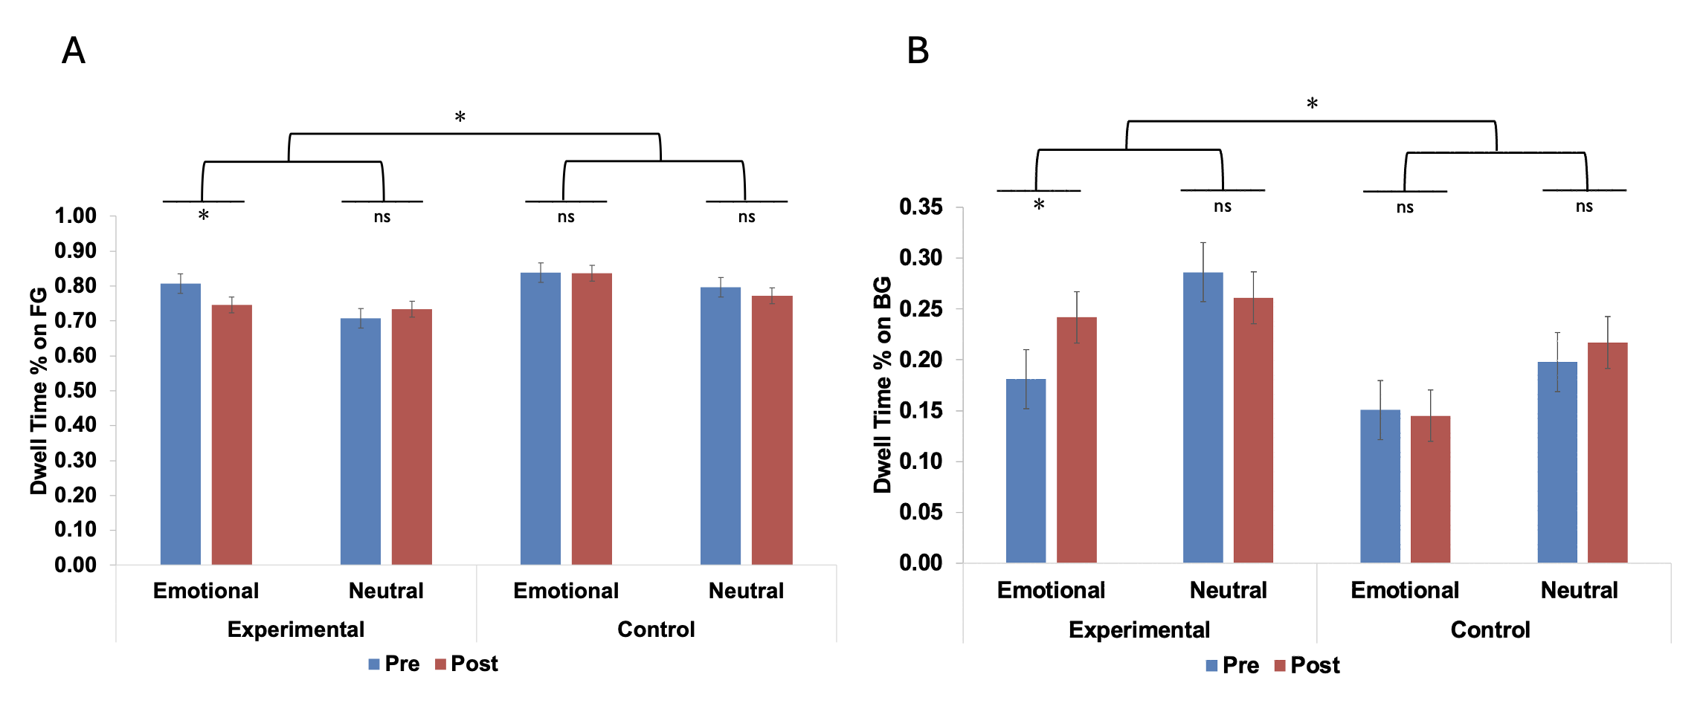
Figure S1. Training-Related Changes in Eye-Tracking Gaze Behavior. (A) The experimental group showed significant pre- to post-test decreases in dwell time (%) directed toward the foregrounds of emotionally negative images. (B) Corresponding increases in dwell time (%) directed toward the backgrounds of emotional images were also observed in the experimental group. p < 0.05 (two-tailed); ns, non-significant; FG, image foreground; BG, image background. Error bars represent standard errors of the mean.

