Supplementary material
Table S1. STROBE Statement—Checklist of items that should be included in reports of cross-sectional studies 2
Table S2. Description of the PSQI components 4
Table S3. Details and measurement of covariates 5
Table S4. Test of parallel lines of the PSQI components 6
Table S5. Correlations between SNA, global sleep quality, sleep duration, depressive symptoms, and main covariables 7
Table S6. Mediating effects of PSQI sleep components on the relationship between SNA and depressive symptoms 8
Figure S1. STROBE Flow Diagram. 9
Figure S2. Directed Acyclic Graph (DAG). 10

Table S1. STROBE Statement—Checklist of items that should be included in reports of cross-sectional studies
 | Item No | Recommendation | Page no
Title and abstract | 1 | (a) Indicate the study’s design with a commonly used term in the title or the abstract | 1
Title and abstract | 1 | (b) Provide in the abstract an informative and balanced summary of what was done and what was found | 1
Introduction
Background/rationale | 2 | Explain the scientific background and rationale for the investigation being reported | 1-2
Objectives | 3 | State specific objectives, including any prespecified hypotheses | 2
Methods
Study design | 4 | Present key elements of study design early in the paper | 2
Setting | 5 | Describe the setting, locations, and relevant dates, including periods of recruitment, exposure, follow-up, and data collection | 2
Participants | 6 | (a) Give the eligibility criteria, and the sources and methods of selection of participants | 2
Variables | 7 | Clearly define all outcomes, exposures, predictors, potential confounders, and effect modifiers. Give diagnostic criteria, if applicable | 2-3, Tables S2, S3
Data sources/ measurement | 8* | For each variable of interest, give sources of data and details of methods of assessment (measurement). Describe comparability of assessment methods if there is more than one group | 2-3, Tables S2, S3
Bias | 9 | Describe any efforts to address potential sources of bias | 2-3, Figure S2
Study size | 10 | Explain how the study size was arrived at | 2
Quantitative variables | 11 | Explain how quantitative variables were handled in the analyses. If applicable, describe which groupings were chosen and why | 2-3, Table S4
Statistical methods | 12 | (a) Describe all statistical methods, including those used to control for confounding | 3
Statistical methods | 12 | (b) Describe any methods used to examine subgroups and interactions | 3
Statistical methods | 12 | (c) Explain how missing data were addressed | Na
Statistical methods | 12 | (d) If applicable, describe analytical methods taking account of sampling strategy | 2-3
Statistical methods | 12 | (e) Describe any sensitivity analyses | 3
Results
Participants | 13* | (a) Report numbers of individuals at each stage of study—eg numbers potentially eligible, examined for eligibility, confirmed eligible, included in the study, completing follow-up, and analysed | Figure S1
Participants | 13* | (b) Give reasons for non-participation at each stage | Na
Participants | 13* | (c) Consider use of a flow diagram | Figure S1
Descriptive data | 14* | (a) Give characteristics of study participants (eg demographic, clinical, social) and information on exposures and potential confounders | 5/Table 1/Figure 1
Descriptive data | 14* | (b) Indicate number of participants with missing data for each variable of interest | Figure S1
Outcome data | 15* | Report numbers of outcome events or summary measures | 5-8/Tables 2, 3/Figure 1/ Figure 2
Main results | 16 | (a) Give unadjusted estimates and, if applicable, confounder-adjusted estimates and their precision (eg, 95% confidence interval). Make clear which confounders were adjusted for and why they were included | 5-8/ Figure 2, Tables 2, 3, S5, S6
Main results | 16 | (b) Report category boundaries when continuous variables were categorized | Table 1/Tables S2, S3
Main results | 16 | (c) If relevant, consider translating estimates of relative risk into absolute risk for a meaningful time period | Na
Other analyses | 17 | Report other analyses done—eg analyses of subgroups and interactions, and sensitivity analyses | Tables S4, S5, S6
Discussion
Key results | 18 | Summarise key results with reference to study objectives | 8
Limitations | 19 | Discuss limitations of the study, taking into account sources of potential bias or imprecision. Discuss both direction and magnitude of any potential bias | 9
Interpretation | 20 | Give a cautious overall interpretation of results considering objectives, limitations, multiplicity of analyses, results from similar studies, and other relevant evidence | 8-9
Generalisability | 21 | Discuss the generalisability (external validity) of the study results | 8-10
Other information
Funding | 22 | Give the source of funding and the role of the funders for the present study and, if applicable, for the original study on which the present article is based | 12
*Give information separately for exposed and unexposed groups.
Note: Page numbers in the "Page no" column refer to the pages of the published article, counting the title page as page 1. An Explanation and Elaboration article discusses each checklist item and gives methodological background and published examples of transparent reporting. The STROBE checklist is best used in conjunction with this article (freely available on the Web sites of PLoS Medicine at http://www.plosmedicine.org/, Annals of Internal Medicine at http://www.annals.org/, and Epidemiology at http://www.epidem.com/). Information on the STROBE Initiative is available at www.strobe-statement.org.

Table S2. Description of the PSQI components
Component | Description | PSQI Question(s)
(1) Subjective sleep quality | Assesses the individual’s subjective perception of their sleep quality. | Q6: During the past month, how would you rate your sleep quality overall?
(2) Sleep latency | Measures the time it takes for an individual to fall asleep after going to bed. | Q2: During the past month, how long (in minutes) does it usually take you to fall asleep each night?  Q5a: Cannot get to sleep within 30 minutes
(3) Sleep duration | Refers to the total number of hours slept per night. | Q4: During the past month, how many hours of actual sleep did you get at night?
(4) Habitual sleep efficiency | Calculates the percentage of time spent asleep relative to the total time spent in bed: [Q4 / (Q3 − Q1)] × 100 | Q1: During the past month, what time have you usually gone to bed at night?  Q3: During the past month, what time have you usually gotten up in the morning?  Q4: During the past month, how many hours of actual sleep did you get at night?
(5) Sleep disturbances | Assesses the frequency of nighttime disturbances such as awakenings, nocturia, or physical discomfort. | Q5b–5j: During the past month, how often have you had trouble sleeping because you…  (b) Wake up in the middle of the night or early morning  (c) Have to get up to use the bathroom  (d) Cannot breathe comfortably  (e) Cough or snore loudly  (f) Feel too cold  (g) Feel too hot  (h) Had bad dreams  (i) Have pain  (j) Other reason(s)
(6) Use of sleep medication | Examines the frequency of use of pharmacological sleep aids. | Q7: During the past month, how often have you taken medicine to help you sleep (prescribed or “over the counter”)?
(7) Daytime dysfunction | Evaluates impairments in daytime functioning due to inadequate sleep, including excessive daytime sleepiness and reduced motivation. | Q8: During the past month, how often have you had trouble staying awake while driving, eating meals, or engaging in social activity?  Q9: During the past month, how much of a problem has it been for you to keep up enough enthusiasm to get things done?
Each component is scored 0–3, with higher scores indicating more problems. The seven components are summed to obtain an overall PSQI score (range 0–21), where higher scores indicate poorer sleep quality.

Table S3. Details and measurement of covariates
Category | Variable | Assessment Method | Descriptive Analysis
Sociodemographic | Age | Self-reported | Continuous (years)
 | Sex | Self-reported | Male (coded as 0)  Female (coded as 1)
 | Maternal education attainment | Self-reported | Primary education  Higher education  University education
 | Living conditions | Self-reported | Living with parents  Living in another situation
Anthropometric | Body mass index | Calculated as weight (kg) / height² (m²) (World Health Organization, 2016)ª | Continuous (kg/m²)
Lifestyle | Mediterranean diet adherence | Mediterranean Diet Adherence Screener (Schröder et al., 2011)^{b} | Low adherence (<9)  Good adherence (≥9)
 | Physical activity level | International Physical Activity Questionnaire (Roman-Viñas et al., 2010)^{c} | Low: Does not meet criteria for higher levels.  Moderate: ≥20 min vigorous activity ≥3 days/week OR ≥30 min moderate/walking ≥5 days/week OR ≥600 MET-min/week.  High: ≥3 days vigorous activity totaling ≥1500 MET-min/week OR any combination ≥3000 MET-min/week.
 | Risk of problematic alcohol use | Alcohol, Smoking and Substance Involvement Screening Test (Tiburcio Sainz et al., 2016)^{d} | Low risk (≤10)  Moderate–high risk (>10)
 | Risk of problematic tobacco use | Alcohol, Smoking and Substance Involvement Screening Test (Tiburcio Sainz et al., 2016)^{d} | Low risk (≤3)  Moderate–high risk (>3)
 | Daily screen time | Self-reported, calculated as ([Approximate weekday screen time*5 + approximate weekend screen time*2]/7) | Continuous (hours)
ª World Health Organization. (2016). Body Mass Index (BMI). https://www.who.int/data/gho/data/themes/topics/topic-details/GHO/body-mass-index
^{b} Schröder, H., Fitó, M., Estruch, R., Martínez-González, M. A., Corella, D., Salas-Salvadó, J., Lamuela-Raventós, R., Ros, E., Salaverría, I., Fiol, M., Lapetra, J., Vinyoles, E., Gómez-Gracia, E., Lahoz, C., Serra-Majem, L., Pintó, X., Ruiz-Gutierrez, V., & Covas, M.-I. (2011). A short screener is valid for assessing Mediterranean diet adherence among older Spanish men and women. The Journal of Nutrition, 141(6), 1140–1145. https://doi.org/10.3945/jn.110.135566
^{c} Roman-Viñas, B., Serra-Majem, L., Hagströmer, M., Ribas-Barba, L., Sjöström, M., & Segura-Cardona, R. (2010). International physical activity questionnaire: Reliability and validity in a Spanish population. European Journal of Sport Science. 2010;10(5):297–304. https://doi.org/10.1080/17461390903426667
^{d} Tiburcio Sainz, M., Rosete-Mohedano, M. G., Natera Rey, G., Martínez Vélez, N. A., Carreño García, S., & Pérez Cisneros, D. (2016). Validity and Reliability of the Alcohol, Smoking, and Substance Involvement Screening Test (ASSIST) in University Students. Adicciones, 28(1), 19–27. https://doi.org/10.20882/adicciones.786

Table S4. Test of parallel lines of the PSQI components
PSQI component | -2LL (Null) | -2LL (General) | χ² (df) | p-value
Subjective sleep quality | 788.085 | 739.426 | 48.66 (58) | 0.804
Sleep latency | 984.506 | 921.493 | 63.01 (58) | 0.304
Sleep duration | 939.817 | 880.894 | 58.92 (58) | 0.442
Habitual sleep efficiency | 161.003 | 151.539 | 9.46 (29) | 1.000
Sleep disturbances | 748.052 | 705.847 | 42.21 (29) | 0.054
Use of sleep medication | 505.604 | 496.542 | 9.06 (26) | 0.999
Daytime dysfunction | 899.723 | 883.145 | 16.58 (26) | 0.921
The null hypothesis for the test of parallel lines states that the location parameters (slope coefficients) are equivalent across all response categories for each ordinal variable. All ordinal regression models were adjusted for the covariates included in the mediation analyses. Non-significant results (p-value > 0.05) indicate that the proportional odds assumption was not violated for any PSQI component. Consequently, these variables were considered suitable for treatment as continuous variables in subsequent mediation analyses. LL = Log Likelihood.

Table S5. Correlations between SNA, global sleep quality, sleep duration, depressive symptoms, and main covariables
 | BDI-II | SNA | PSQI | AGE | SEX | MEA | LIV | BMI | DIET | PA | ALC | TOB | DST
BDI-II | 1 | 0.278** | 0.465** | –0.042 | –0.218** | 0.060 | 0.099* | 0.118* | –0.264** | –0.203** | 0.129** | 0.205** | 0.297**
SNA |  | 1 | 0.154** | –0.107* | –0.153** | 0.110* | 0.106* | –0.125* | –0.197** | –0.047 | 0.189** | 0.033 | 0.202**
PSQI |  |  | 1 | 0.074 | –0.123* | 0.013 | 0.130** | 0.043 | –0.209** | –0.090 | 0.136** | 0.143** | 0.139**
AGE |  |  |  | 1 | 0.011 | –0.062 | 0.139** | 0.084 | 0.048 | 0.075 | 0.057 | –0.034 | 0.002
SEX |  |  |  |  | 1 | –0.104* | –0.148** | 0.138** | 0.069 | 0.308** | 0.090 | –0.039 | –0.171**
MEA |  |  |  |  |  | 1 | 0.036 | 0.068 | 0.024 | 0.069 | 0.085 | 0.065 | 0.028
LIV |  |  |  |  |  |  | 1 | –0.048 | –0.079 | –0.011 | 0.111* | 0.079 | 0.079
BMI |  |  |  |  |  |  |  | 1 | 0.085 | 0.052 | 0.009 | 0.045 | 0.088
DIET |  |  |  |  |  |  |  |  | 1 | 0.217** | –0.103* | –0.065 | –0.210**
PA |  |  |  |  |  |  |  |  |  | 1 | –0.005 | 0.020 | –0.112*
ALC |  |  |  |  |  |  |  |  |  |  | 1 | 0.537** | 0.088
TOB |  |  |  |  |  |  |  |  |  |  |  | 1 | 0.100*
DST |  |  |  |  |  |  |  |  |  |  |  |  | 1
Data are presented as Spearman’s correlation coefficient (ρ). * p-value < 0.05 is statistically significant. ** p-value < 0.001 is statistically significant. Abbreviations: ALC, Risk of problematic alcohol use; BDI-II, Beck Depression Inventory-II; BMI, Body Mass Index; DST, Daily Screen Time; DIET, Mediterranean Diet Adherence; LIV, Living Condition; MEA, Maternal Education Attainment; PA, Physical Activity; PSQI, Pittsburgh Sleep Quality Index; SNA, Social Network Addiction; TOB, Risk of problematic tobacco use.
Table S6. Mediating effects of PSQI sleep components on the relationship between SNA and depressive symptoms
Mediator | Model | Path a  (SNA→Sleep) | Path b (Sleep→Dep) | Path c' (SNA→Dep) | Total Effect (SNA→Dep) | Indirect Effect (95% CI) | % of total effect
Global sleep quality (PSQI total score) | Unadjusted | 0.089* | 1.167** | 0.437** | 0.582** | 0.104*  (0.030 to 0.177) | 17.9
Global sleep quality (PSQI total score) | Adjusted | 0.089* | 1.167** | 0.333* | 0.437** | 0.104*  (0.027 to 0.184) | 23.9
Subjective sleep quality | Unadjusted | 0.026* | 3.606** | 0.485** | 0.582** | 0.096*  (0.042 to 0.150) | 16.5
Subjective sleep quality | Adjusted | 0.012 | 3.606** | 0.394** | 0.437** | 0.042 (-0.010 to 0.095) | 9.6
Sleep onset latency | Unadjusted | 0.030** | 2.336** | 0.513** | 0.582** | 0.069*  (0.024 to 0.114) | 11.9
Sleep onset latency | Adjusted | 0.022* | 1.979** | 0.392** | 0.437** | 0.044*  (0.006 to 0.082) | 10.1
Use of sleep medication | Unadjusted | 0.023** | 2.948** | 0.515** | 0.582** | 0.067*  (0.025 to 0.110) | 11.5
Use of sleep medication | Adjusted | 0.018* | 2.700** | 0.387** | 0.437** | 0.049*  (0.011 to 0.088) | 11.3
Daytime dysfunction | Unadjusted | 0.037** | 4.758** | 0.405** | 0.582** | 0.177**  (0.101 to 0.253) | 30.4
Daytime dysfunction | Adjusted | 0.032** | 4.225** | 0.301** | 0.437** | 0.136**  (0.068 to 0.204) | 31.2
Mediators examined include global sleep quality and its components in adjusted and unadjusted model (higher scores indicate poor outcomes). Indirect effects are reported with 95% bias-corrected percentile confidence intervals (CIs) based on 5,000 bootstrap resamples and are considered significant if the CI excludes zero. Adjusted models include covariates such as age, sex, maternal education, living condition, body mass index, diet quality, physical activity, risk of problematic alcohol use, risk of problematic tobacco use, and daily screen time. Bolded values with asterisks denote significant pathways, where *p-value < 0.05 and **p-value < 0.001.

Identification
Inclusion

Participants screened
(n = 862)
Missing data (n = 29):
Maternal education (n =12)
Living situation (n = 2)
Mediterranean diet (n = 7)
Daily screen time (n = 8)

Included in the study
(n = 775)
Participant excluded (n = 87):
Aged > 30 (n = 7)
Individuals with repeated measurements in 2023 and 2025 (n = 80)

Analyzed
(n = 746)
Analysis

Figure S1. STROBE Flow Diagram.

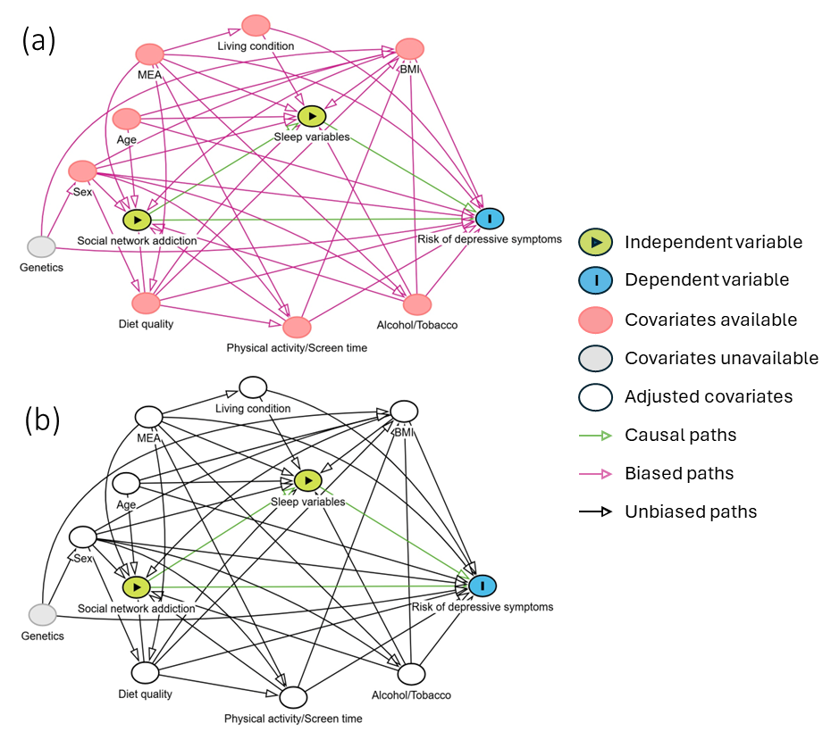
Figure S2. Directed Acyclic Graph (DAG). The DAG represents the causal relationships supporting the study association between social network addiction and depressive symptoms, where (a) indicates the DAG without adjustment for covariates and (b) indicates the DAG after adjustment for the covariates indicated in the minimal sufficient adjustment set of confounders.

