Supplementary Figure and Figure Legend
for

Selection of Stable Reference Genes for Accurate RT-qPCR Analysis in Canine MSCs Across Tissues, Replicative Stages, and Differentiation States

Chan-Hee Jo^{1#}, Chae-Yeon Hong^{1#}, Sang-Yun Lee^{1,2}, Eun-Yeong Bok³, Young-Bum Son⁴, Won-Jae Lee⁵, Seong-Ju Oh¹, Tae-Seok Kim¹, Seo-Yoon Kang¹, Sanghyeon Park¹, Sung-Lim Lee^{1,6*}, Yong-ho Choe^{1,7*}

¹College of Veterinary Medicine, Gyeongsang National University, Jinju 52828, Korea
²Department of Biology Education, Korea National University of Education, Cheongju 28173, Republic of Korea
³National Institute of Animal Science, Rural Development Administration, Wanju, 55365, Republic of Korea
⁴College of Veterinary Medicine, Chonnam National University, Gwangju 500-757, Republic of Korea
⁵College of Veterinary Medicine, Kyungpook National University, Daegu 41566, Republic of Korea
⁶Research Institute of Life Sciences, Gyeongsang National University, Jinju 52828, Republic of Korea
⁷Institute of Animal Medicine, Gyeongsang National University, Jinju 52828, Republic of Korea

#These authors contributed equally to this work.

*Corresponding authors:
Yong-ho Choe, PhD, DVM
College of Veterinary Medicine, Gyeongsang National University, Jinju 52828, Republic of Korea
Tel: +82-55-772-2347; E-mail: yhchoe@gnu.ac.kr

Sung-Lim Lee, PhD, DVM
College of Veterinary Medicine, Gyeongsang National University, Jinju 52828, Republic of Korea
Tel: +82-55-772-2360; E-mail: sllee@gnu.ac.kr
Supplementary Figure and Figure Legend
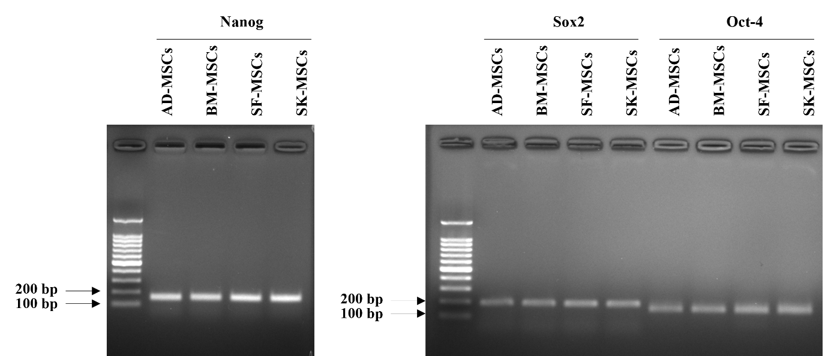
Figure S1. Full-length, uncropped gel image corresponding to Figure 1C. The full-length and uncropped gel image used for Figure 1C is provided.

