Supplementary Materials 2
- Behavioral Performance
Standard congruency effects were observed on the Flanker task, with participants being slower (b = 32.53, SE = 1.34, p < .001) and less accurate (b = -15.11, SE = .78, p < .001) on incongruent trials (see Tables S7-S8). Participants were also faster on error trials than correct trials (b = -54.32, SE = 2.28, p < .001) (see Table S9).
All models included the EEG visit as an effects-coded predictor to account for practice effects. For each of these models, we also examined whether EEG Visit interacted with our effects of interest. While the main effects remained, there was no interaction. EEG Visit was entered as an effects-coded predictor, but not included in the table for brevity. However, we report the results of the omnibus test for EEG Visit in the note of all our tables.
Table S7. Model Estimates of Congruency on Reaction Time on the Flanker Task
Fixed Effect | Estimate | Standard Error | t | p
Intercept | 422.95 | 4.07 | 104.00 | <.001
Congruency | 32.53 | 1.34 | 24.23 | <.001
Variance Components | Variance | Standard Deviation
Intercept | 2052.5 | 45.30
Residual | 357.9 | 18.92
Note. EEG Visit was a significant predictor of reaction time (F(3, 665.53) = 20.56, p < .001). Congruency was dummy-coded with congruent trials as the reference.
Table S8. Model Estimates of Congruency on the Number of Correct Responses on the Flanker Task
Fixed Effect | Estimate | Standard Error | t | p
Intercept | 222.42 | 1.37 | 162.81 | <.001
Congruency | -15.11 | .78 | -19.45 | <.001
Variance Components | Variance | Standard Deviation
Intercept | 203.1 | 14.25
Residual | 119.7 | 10.94
Note. EEG Visit was entered as an effects-coded predictor of accuracy (F(3, 675.10) = 24.30, p < .001). Congruency was dummy-coded with congruent trials as the reference.

Table S9. Model Estimates of Reaction Time on Correct and Incorrect Trials on the Flanker Task.
Fixed Effect | Estimate | Standard Error | t | p
Intercept | 443.16 | 4.46 | 99.38 | <.001
Accuracy (Errors vs. Correct) | -54.32 | 2.28 | -23.79 | <.001
Variance Components | Variance | Standard Deviation
Intercept | 2250 | 47.43
Residual | 1035 | 32.17
Note. EEG Visit was not significant predictor of reaction time (F(3, 675.93) = .86, p = .46). Accuracy was dummy-coded with correct trials as the reference.

- Event Related Potentials (ERP) Analyses
We conducted a multilevel model with accuracy (errors vs. corrects) as a random slope nested within participants to account for between-person variability between the ERN-CRN difference. Fixed effects included accuracy and EEG Visit. As a check, we first conducted a model that allowed accuracy and EEG visit to interact to examine whether there were significant differences between the ERN and CRN across visits. The results of that model revealed that there were main effects of accuracy and EEG Visit, but they did not interact (F(3, 559.48) = .22, p = .88). We therefore report on the model with accuracy and EEG Visit as main effects without their interaction.
We observed the standard contrast between the ERN and CRN, with error trials showing a more negative amplitude (b = -3.36, SE = .26, p < .001). There was also a main effect of EEG Visit (p < .001), revealing that the first visit (M = -2.38, SE = .22) was significantly more negative than the second (M = -1.88 , SE = .22) , third (M = - 1.64, SE = .22) , and fourth (M = -1.36 SE = .22) visits. However, visits 2, 3, and 4 did not differ from each other (p’s> .11). Notably, the random effects of this model offer meaningful insight into our findings. Individuals in our sample demonstrated between-person variability in performance monitoring amplitudes (τ₀₀= 3.74), while individuals varied substantially in their ERN vs CRN difference (τ₁₁ = 6.79). These findings indicate that a notable proportion of the variance consists of between-person variability in the ERN and CRN.
Table S10. Model Estimates of Amplitude on Correct and Incorrect Trials on the Flanker Task.
Fixed Effect | Estimate | Standard Error | t | p
Intercept | -.13 | .19 | -.69 | .49
Accuracy (Errors vs. Correct) | -3.36 | .26 | -12.91 | <.001
Variance Components | Variance | Standard Deviation | Correlation
Intercept | 3.74 | 1.94 | -.23
Accuracy | 6.79 | 2.61
Residual | 2.92 | 1.71
Note. EEG Visit was a significant predictor of amplitude (F(3, 546.82) = 11.31, p < .001). Accuracy was dummy-coded with correct trials as the reference.

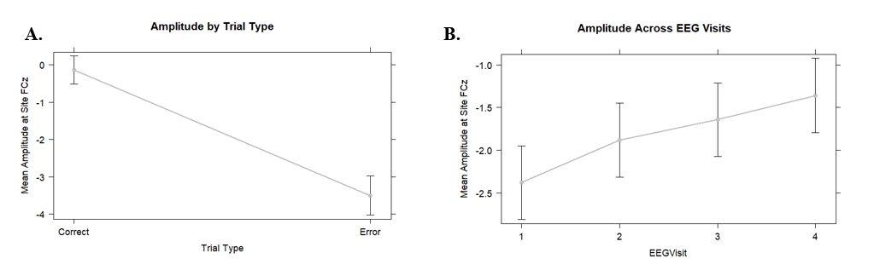
Figure S4. Effects of Accuracy EEG Visit. A. Accuracy Effects. Error trials elicited more negative amplitudes than correct trials. B. EEG Visit Effects. Amplitudes were significantly more negative on the first EEG Visit than visits two, three and four.
- ERN Residual (ERN_{resid}) Analyses
To assess whether our findings were associated with shared variance for the CRN, we tested three different models. Our results remained robust across tests. We believe these tests eliminate the concern that the effects are due to shared variance from the CRN, as they appear to be between-person and ERN-specific.
First, we entered Accuracy (Errors vs. Corrects) to examine where our effects emerged while including correct trials in the model. Indeed, our results mirrored our effects on the raw ERN and CRN, such that there was a significant interaction between accuracy x progesterone x PSWQ (p = .004). However, there was no interaction between accuracy x estradiol x PSWQ (p = .12). Simple slope analyses revealed that PSWQ was associated with a more negative amplitude on error trials for those with higher average progesterone levels (b = -.14, SE = .04, p < .01), while the effects were in the opposite direction for those with lower progesterone levels on error trials (b = .08, SE = .04, p < .03) . No simple slopes reached significance on correct trials (p’s > .16). We also observed a main effect of progesterone in this model, revealing that higher levels of progesterone were associated with a smaller amplitude (b = .006, SE = .003, p = .04).
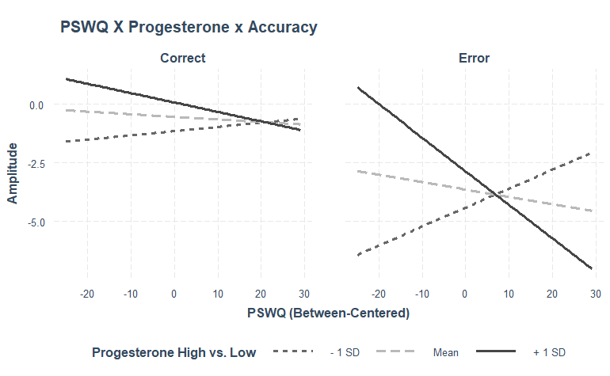
Figure S5. Worry, Progesterone, and Accuracy Interaction. Higher worry was associated with a more negative ERN on error trials for those with higher progesterone levels. No significant simple slopes were observed on correct trials.

Second, we ran a model examining effects on the ERN, while controlling for within-person CRN and between-person CRN. Our results also remained, such that there was a significant interaction between worry and progesterone (p = .0004) and PSWQ x estradiol (p = .02). Simple slope analyses revealed that worry was associated with a larger ERN for those with high progesterone levels (b = -.12, SE = .04, p < .01) and the reverse was true for those with lower progesterone levels (b = .07, SE = .03, p = .04). In addition, the association between the worry and a larger ERN was present for those with lower estradiol levels (b = -.09, SE = .03, p = .01), and not significant for those with higher levels (b = .04, SE = .04, p = .35). It is important to note however, that in our main analyses, the Johnson Neyman analyses revealed that significant effects for the association between worry and the ERN were observed when estradiol levels were 2.10 SD above the mean.
Lastly, to more closely examine this reviewer’s point we conducted a linear regression with the residuals extracted between people. To do so, we ran a model where we entered the average between-person CRN as a predictor of the average ERN. We extracted the residuals from this model to serve as the dependent variable of our main model, entering averaged worry, estradiol and progesterone as predictors. Our models showed that there was a significant interaction between worry and progesterone (p < .001) and worry and estradiol (p = .02). Simple slopes revealed that more worry was associated with a larger ERN for those with higher progesterone levels (b = -.13, SE = .04, p < .01) and the reverse was true for those with lower progesterone levels (b = .07, SE = .03, p = .04). Results for estradiol revealed more worry was associated with a larger ERN when estradiol levels were low (b = -.09, SE = .03, p = .01), but there was no association when estradiol was high (b = .04, SE = .04, p = .32).
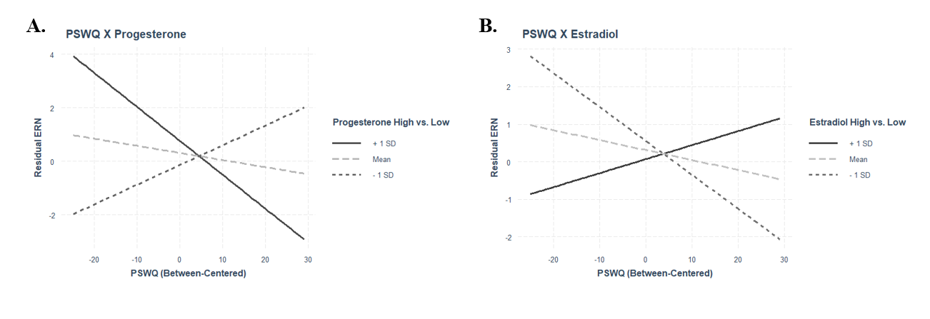
Figure S6. Interaction Effects from Linear Models on ERN_{resid.} A. Interaction between Progesterone and Penn State Worry Questionnaire (PSWQ). Higher PSWQ levels were associated with a larger ERN_{resid} for those with higher levels of progesterone (+1 standard deviation [SD] above the mean). B. Interaction between Estradiol and PSWQ. Higher PSWQ levels were associated with a larger ERN_{resid} for those with lower levels of estradiol (-1 SD below the mean).
Anxious Arousal and Generalized Anxiety Disorder Diagnoses
We also examined whether effects were similar for anxious arousal, which would imply our findings are not worry-specific. Our findings revealed no significant effects for within-person or between-person anxious arousal (see Table S12). Our results remained unchanged when controlling for levels of anxious arousal, such that we observed a significant interaction between worry and progesterone (p < .001) and worry and estradiol (p < .001).
Table S12. Model Estimates of the Error-Related Negativity for Anxious Arousal, Estradiol and Progesterone
 | Between-Centered Model |  |  |  | Within-Centered Model
Fixed Effect | Estimate | SE | t | p | Estimate | SE | t | p
Intercept | -3.15 | .34 | -9.27 | <. 001 | -3.55 | 2.73 | -13.00 | <.001
MASQ-AA | -.07 | .05 | -1.58 | .12 | -.04 | .03 | -1.24 | .22
Estradiol Levels | -.21 | .65 | -.33 | .74 | -.19 | .28 | -.70 | .94
Progesterone Levels | .005 | .004 | 1.20 | .23 | .001 | .002 | .74 | .46
MASQ-AA x Estradiol Levels | .03 | .08 | .44 | .66 | -.12 | .11 | -1.05 | .30
MASQ-AA x Progesterone Levels | -.0006 | .0006 | -1.04 | .30 | .0001 | .0004 | .27 | .79
Estradiol Levels x Progesterone Levels | -.008 | .005 | -1.55 | .13 | .003 | .003 | 1.13 | .26
MASQ-AA x Estradiol Levels x Progesterone Levels | .0002 | .0006 | .43 | .67 | .0004 | .0006 | .62 | .54
Variance Components
Intercept | 7.67 | 2.77 |  |  | 8.56 | 2.93
Residual | 4.50 | 2.12 |  |  | 4.68 | 2.16
*Note. EEG Visit was included as an effects-coded predictor in all models. For the ERN, there was a significant effect of EEG Visit (p =.004).
We also tested a model for Generalized Anxiety Disorder, based on the clinical interviews conducted at the end of the study. Our sample included 7 people who met criteria for current GAD (i.e., at the time of the interview) and 11 who met criteria for lifetime GAD. There were two people who had missing data for GAD diagnosis that were excluded from this analysis, resulting in a final sample of 130 people. Those with current GAD had significantly higher scores on the PSWQ (M = 52.5, SE = 4.9) compared to those without (M = 40.4, SE = 1.13). Given the unbalanced groups, we did not run a model examining the interaction between GAD diagnosis and estradiol and progesterone to predict the ERN. However, we re-examined our between-centered model while controlling for GAD diagnosis and found that our results remained unchanged.

