Supplementary information

Supplementary Table S1. The comparison of attribution of network between Ecz and Nor.
* q < 0.05
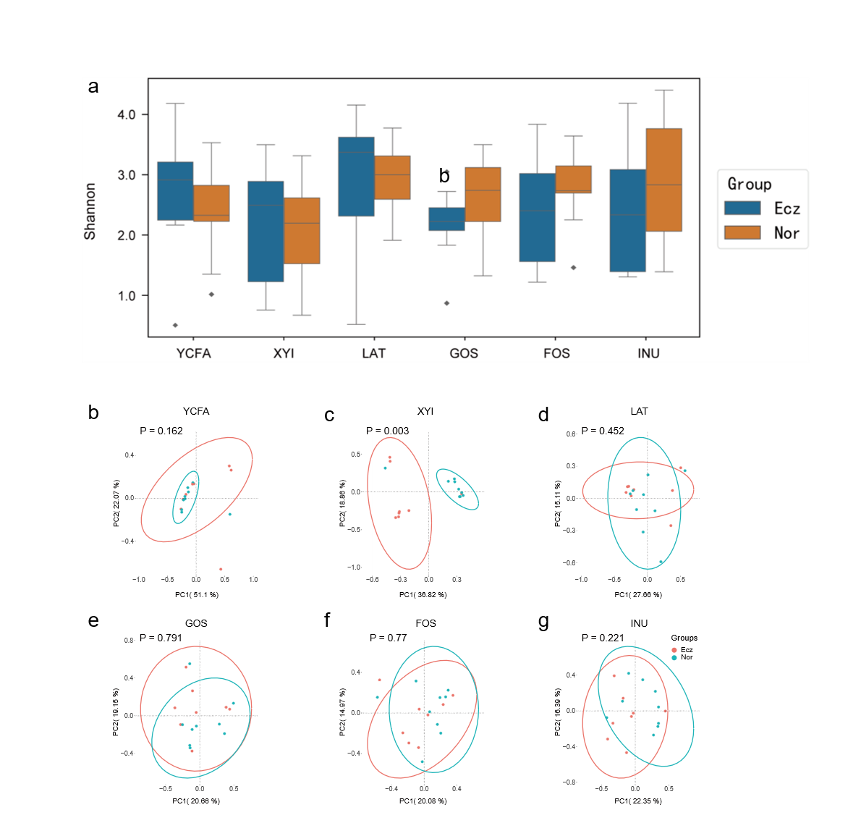
Supplementary Fig. S1 Comparison of α-diversity and β-diversity in fermentation broths’ microbiota between Ecz and Nor.
a: Box plots of the Shannon index of each fermentation broth showed no statistical significance. YCFA: the basic medium without carbon source; the medium containing YCFA and sole carbon source of xylitol (XYI), lactose (LAT), GOS, FOS, and inulin (INU). Data in box plots are presented as medians and interquartile ranges, whiskers: 1.5x interquartile, points: outliers, and statistical analysis was performed using the Mann-Whitney test. b: PCoA of fermentation broths’ microbiota based on the Bray-Curtis distance matrix. Adonis is used to calculate the p-value.

Supplementary Fig. S2 Comparison of top 20 species in fermentation broths’ microbiota between Ecz and Nor.
The stacked column chart of top 20 species in each broth. YCFA: the basic medium without carbon source; the medium containing YCFA and sole carbon source of xylitol (XYI), lactose (LAT), galactooligosaccharides (GOS), fructooligosaccharides (FOS), and inulin (INU).

Supplementary Fig. S3 Comparison of relative abundance at phylum level after fermentation.
a: Pie chart at phylum level between Ecz and Nor after fermentations. Bacteroidota are highlighted; b: Box plot of phylum Bacteroidota in YCFA; c: Box plot of phylum Firmicutes in XYI ; d: Box plot of phylum Firmicutes in LAT. YCFA: the basic medium without carbon source; the medium containing YCFA and sole carbon source of xylitol (XYI), lactose (LAT). Data in box plots are presented as: box, medians with interquartile ranges; whiskers: min to max; points: all data. Statistical analysis was performed using Mann-Whitney test and p < 0.2 was shown.

Supplementary Fig. S4 Taxa with the same intergroup variation trends between Ecz and Nor in feces and their broths.
a: Boxplot of class Clostridia in feces; b: Pie chart of class level in feces and broths, Clostridia is highlighted and its statistical difference between two groups was calculated using Mann-Whitney test, and the significant difference was shown in LAT; c: Boxplot of genus Clostridium_sensu_stricto_1 in feces; d: Heatmap of Clostridium_sensu_stricto_1 in feces and broths, with an increased trend in Nor group; e: Boxplot of genus Bacteroides in feces; f: Heatmap of genus Bacteroides in feces and broths, with an increased trend in Ecz group. Data in boxplot are presented as medians with interquartile ranges and analyzed using Mann-Whitney test, and p < 0.2 was shown.

Supplementary Fig. S5 Comparison of relative abundance of Lactobacillus in feces and after XYI fermentation.
a: The relative abundance of each species of Lactobacillus in feces, of which the sum showed no significant difference between Ecz and Nor (upper right panel); b: The relative abundance of each species of Lactobacillus in xylitol (XYI) broth, of which the sum was significantly higher in Ecz compared to Nor (upper right panel); c: Nor-enriched Lactobacillus and Ecz-enriched Lactobacillus were compared in their total relative abundance between two groups in feces; d: Nor-enriched Lactobacillus and Ecz-enriched Lactobacillus were compared in their total relative abundance between two groups in XYI broth. Only the top 60 species were analyzed. Data in interleaved bar are presented as mean and SEM. Data in scatter plot with bar are presented as medians with interquartile ranges. Mann-Whitney test was used for statistical analysis, and p < 0.1 is shown.

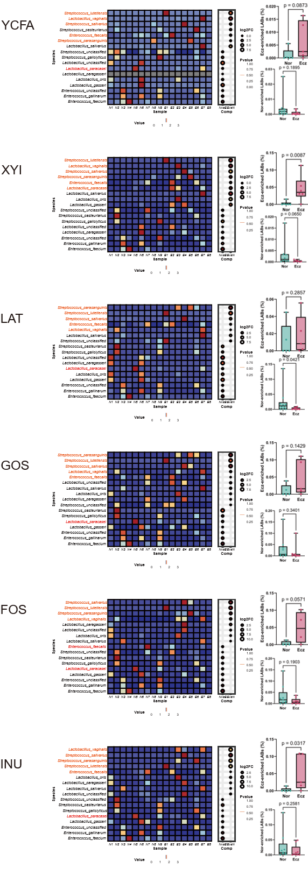
Supplementary Fig. S6 Comparison of LABs in fermentation broths between Ecz and Nor.
Left panel: Heatmap of relative abundance of LABs in each broth. Species belonging to faecal Ecz-enriched LABs are shown in red. Right upper panel: Box plot of the total relative abundance of faecal Ecz-enriched LABs which were still divided into the Ecz-enriched cluster (shown in left panel). Right lower panel: Box plot of the total relative abundance of Nor-enriched LABs in the left panel. YCFA: the basic medium without carbon source; the medium containing YCFA and sole carbon source of xylitol (XYI), lactose (LAT), galactooligosaccharides (GOS), fructooligosaccharides (FOS), and inulin (INU). Data in box plots are presented as: box, medians with interquartile ranges; whiskers: min to max; points: all data. Mann-Whitney test was used for statistical analysis.

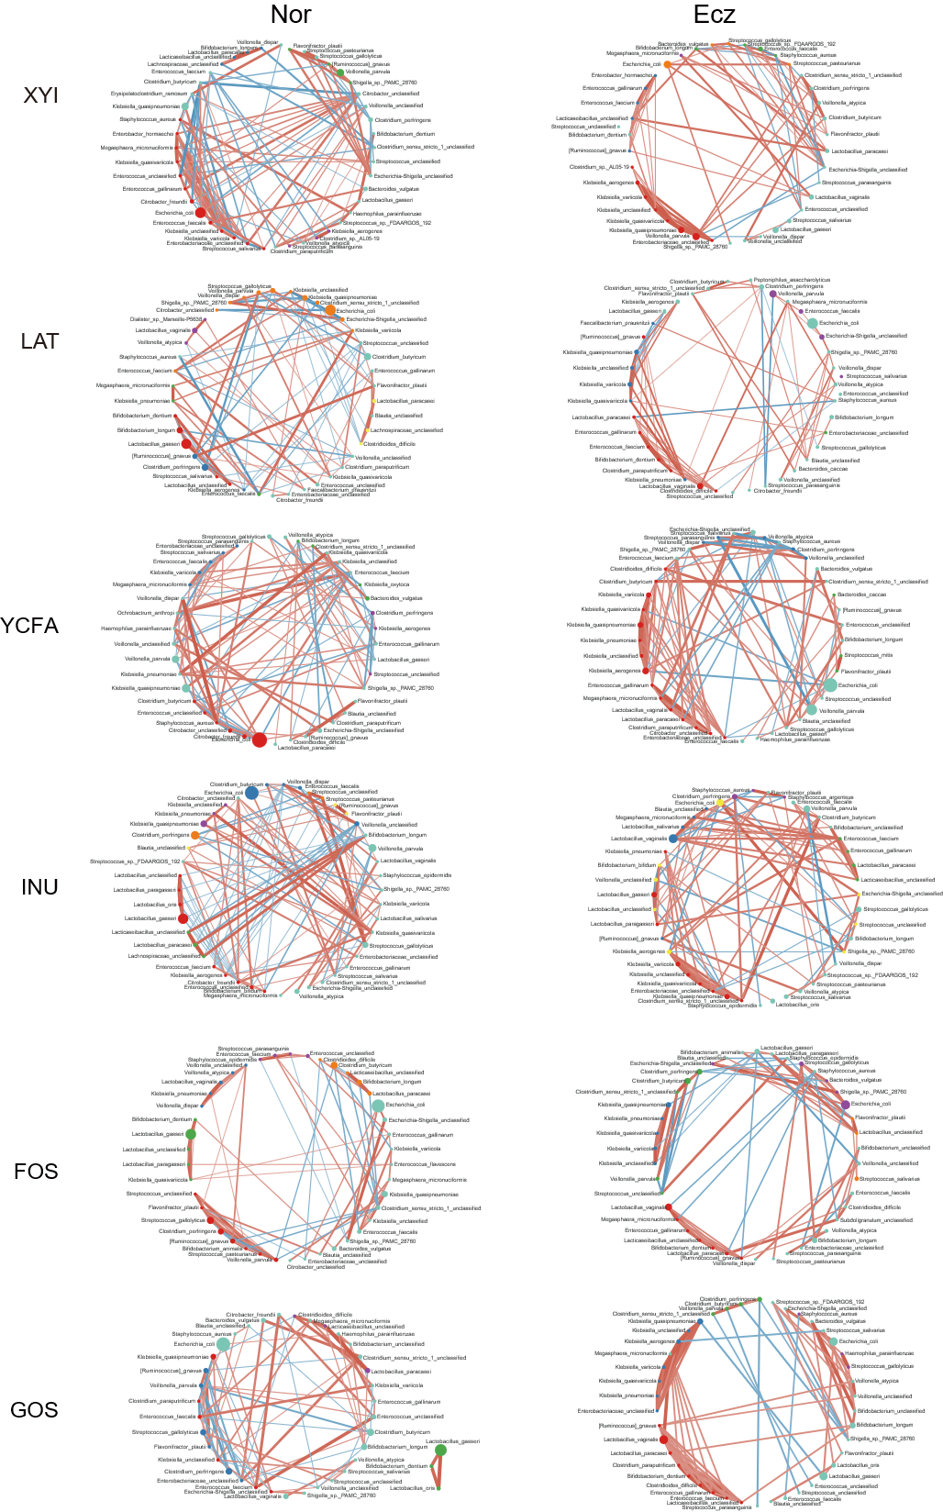
Supplementary Fig. S7 The co-occurrence network diagrams of fermentation broths’ microbiota in Nor and Ecz.
The network diagrams were drawn using Cytoscape. The relative abundance of nodes (species) is represented by size, and clusters (modules) are distinguished by color. Red edges indicate positive correlations, while blue edges indicate negative correlations. YCFA: the basic medium without carbon source; the medium containing YCFA and sole carbon source of xylitol (XYI), lactose (LAT), galactooligosaccharides (GOS), fructooligosaccharides (FOS), and inulin (INU).

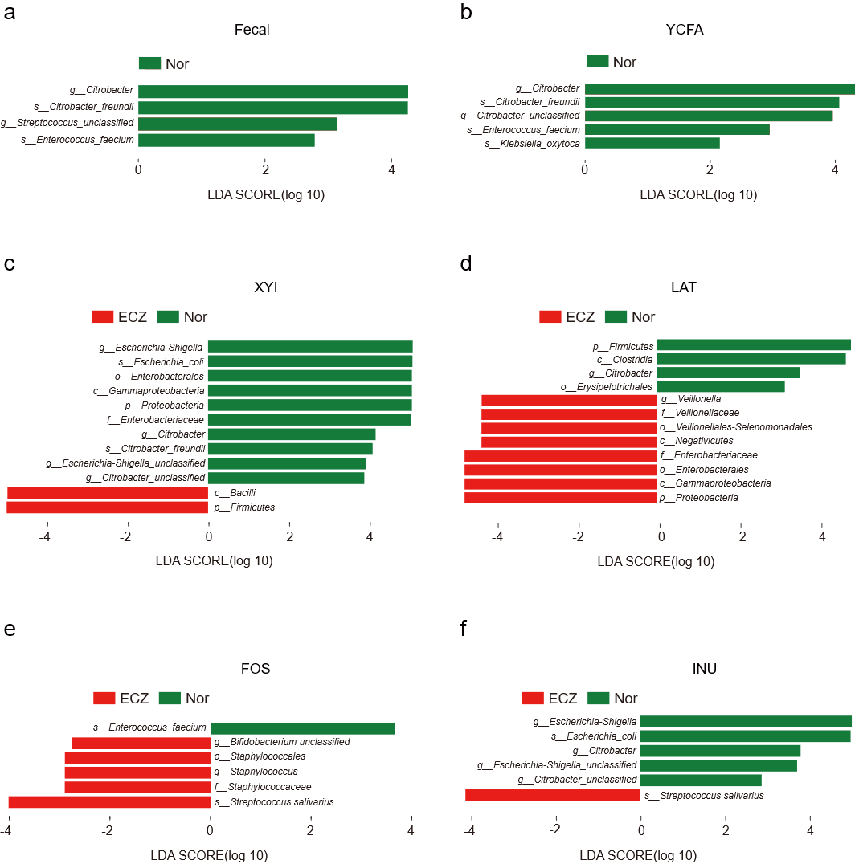
Supplementary Fig. S8. LEfSe analysis comparing the microbiota between Nor and Ecz in fecal samples and five fermentation broths.
Comparisons were performed separately for fecal samples (a) and for microbiota cultured in YCFA (b), XYI (c), LAT (d), FOS (e) and INU (f). Taxa detected in at least 10 samples and with a relative abundance greater than 0.01% were included in the LEfSe analysis. Differentially abundant taxa were identified using an LDA score greater than 2 and a p value less than 0.05.

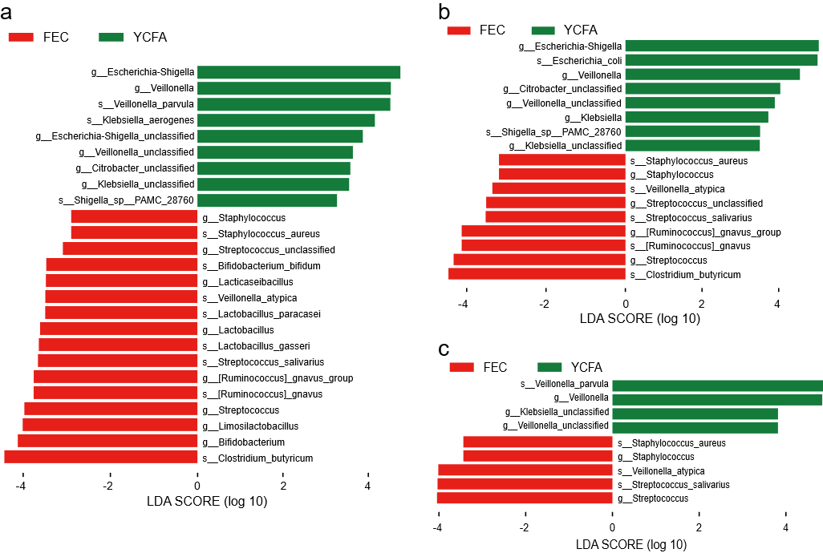
Supplementary Fig. S9. LEfSe analysis comparing the fecal microbiota with the microbiota cultured in YCFA.
Results are shown for the combined Nor and Ecz groups (a), the Nor group alone (b), and the Ecz group alone (c).
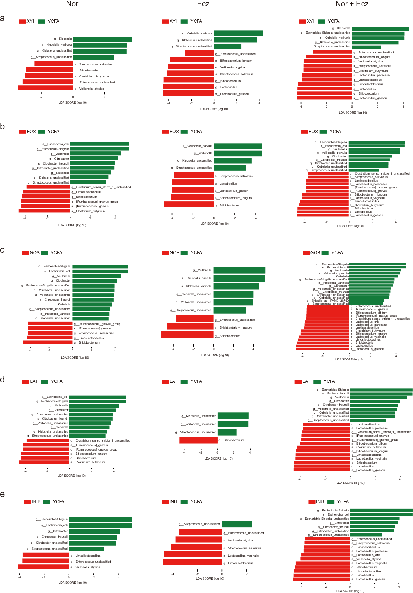
Supplementary Fig. S10. Effects of different carbohydrates on the gut microbiota after in vitro fermentation.
LEfSe analysis comparing the microbiota cultured in YCFA with those cultured in XYI (a), FOS (b), GOS (c), LAT (d), and INU (e). Results are presented separately for the Nor group (left panels), the Ecz group (middle panels), and the combined Nor and Ecz groups (right panels).

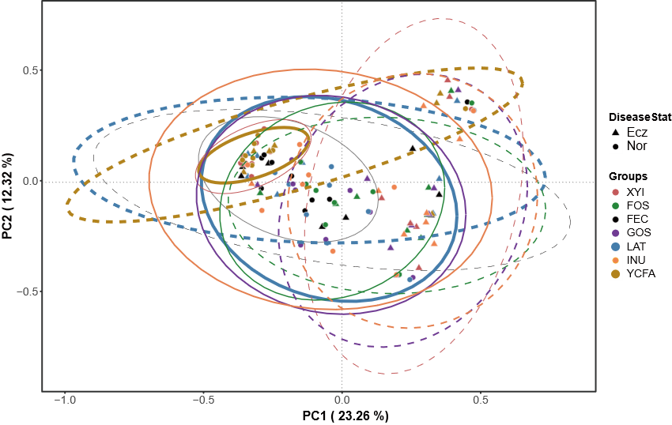
Supplementary Fig. S11 Superimposed PCoA of faeces and all fermentation broths.
●: Nor, ▲: Ecz; solid line: Nor, dashed line: Ecz.

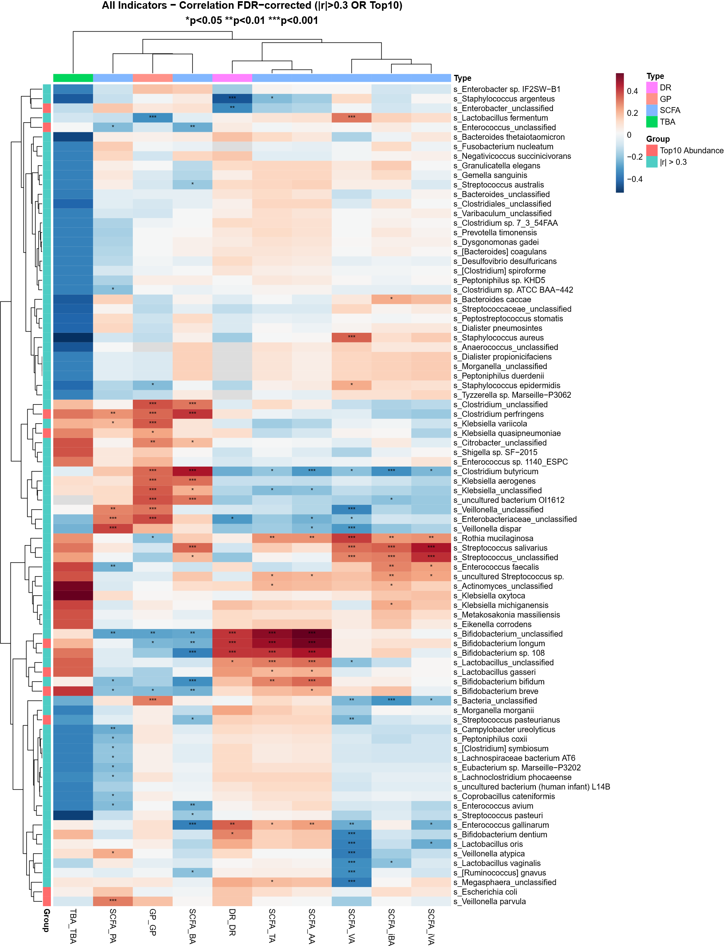
Supplementary Fig. S12. Heatmap of Spearman correlations between bacterial species and metabolic parameters.
Spearman’s rank correlation analysis was performed between bacterial species and metabolic parameters. The heatmap shows the top 10 species with absolute correlation coefficients greater than 0.3. TA, total short-chain fatty acids; AA, acetate; PA, propionate; BA, butyrate; iBA, isobutyrate; VA, valerate; iVA, isovalerate; TBA, total bile acids; GP, gas production; DR, degradation rate. Statistical significance is indicated as follows: *: p < 0.05, **: p < 0.01, and ***: p < 0.001.

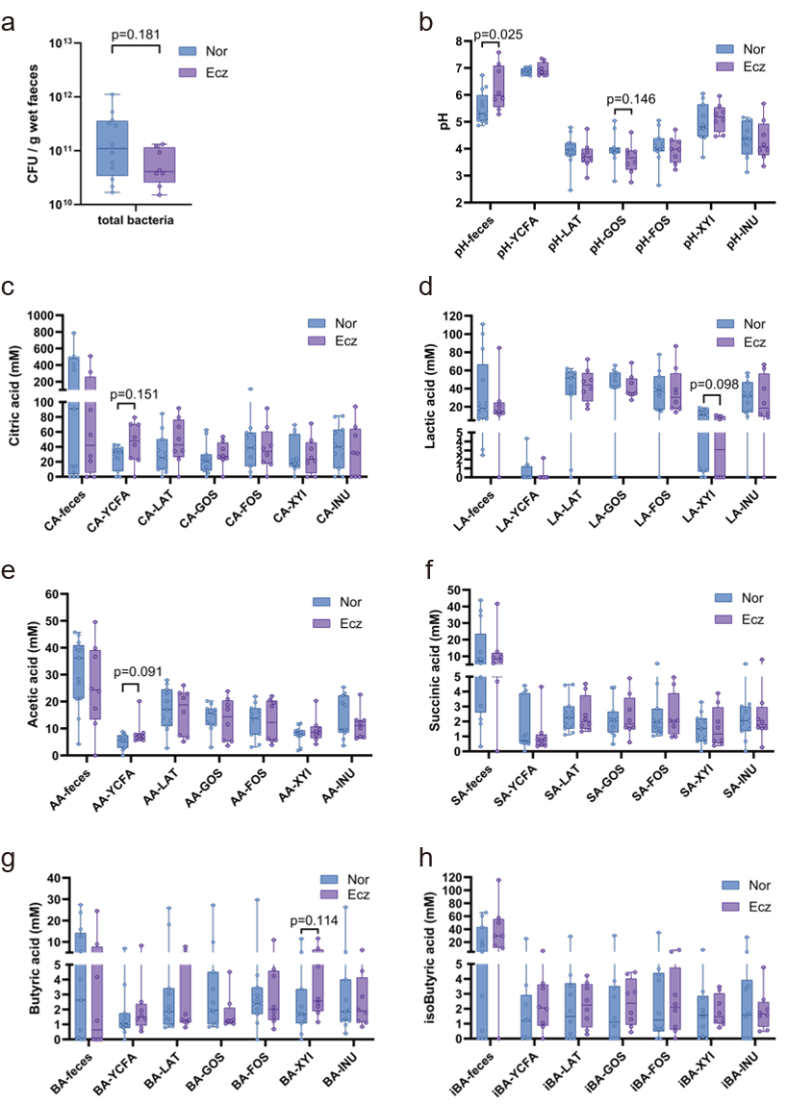
Supplementary Fig. S13 New measurement of total bacteria counts, pH and organic acids in newly collected samples.
The fresh faeces of newly recruited participants (Nor: n = 13, Ecz: n = 8) were subjected to in vitro fermentation under medium of YCFA, LAT, GOS, FOS, XYI and INU. Total bacterial counts (a) were determined by qPCR using universal primers derived from 16S rRNA gene. pH (b) was detected by pH meter and organic acids were measured by HPLC, including citric acid (c), lactic acid (d), acetic acid (e), succinic acid (f), butyric acid (g), isobutyric acid (h). p < 0.2 is shown.

