Supplementary Information

Supplementary Table 1. Mass loss of hydrothermally modified Douglas fir wood

Temperature | Time (h) | Mass loss (%)
Control | - | -
140°C | 0.5 | 0.86±0.10
140°C | 1 | 1.21±0.05
140°C | 2 | 1.60±0.05
160°C | 0.5 | 2.26±0.18
160°C | 1 | 2.45±0.13
160°C | 2 | 5.33±0.51
180°C | 0.5 | 10.20±0.44
180°C | 1 | 11.53±0.78
180°C | 2 | 19.61±0.31

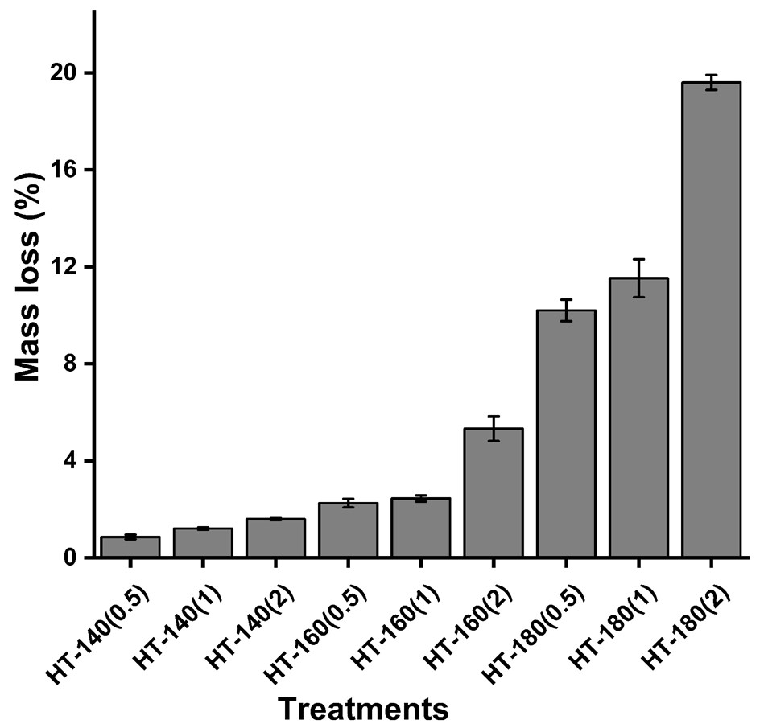
Mass loss of hydrothermally modified Douglas fir wood

Supplementary Table 2. Volumetric swelling (%) of control and hydrothermally modified Douglas fir wood

Temperature | Time (h) | Volumetric swelling (%)
Control | - | 14.46±0.24
140°C | 0.5 | 12.20±0.47
140°C | 1 | 11.86±0.83
140°C | 2 | 11.68±0.61
160°C | 0.5 | 10.80±0.29
160°C | 1 | 10.29±1.12
160°C | 2 | 10.20±0.33
180°C | 0.5 | 10.49±0.39
180°C | 1 | 9.89±0.47
180°C | 2 | 9.63±0.43

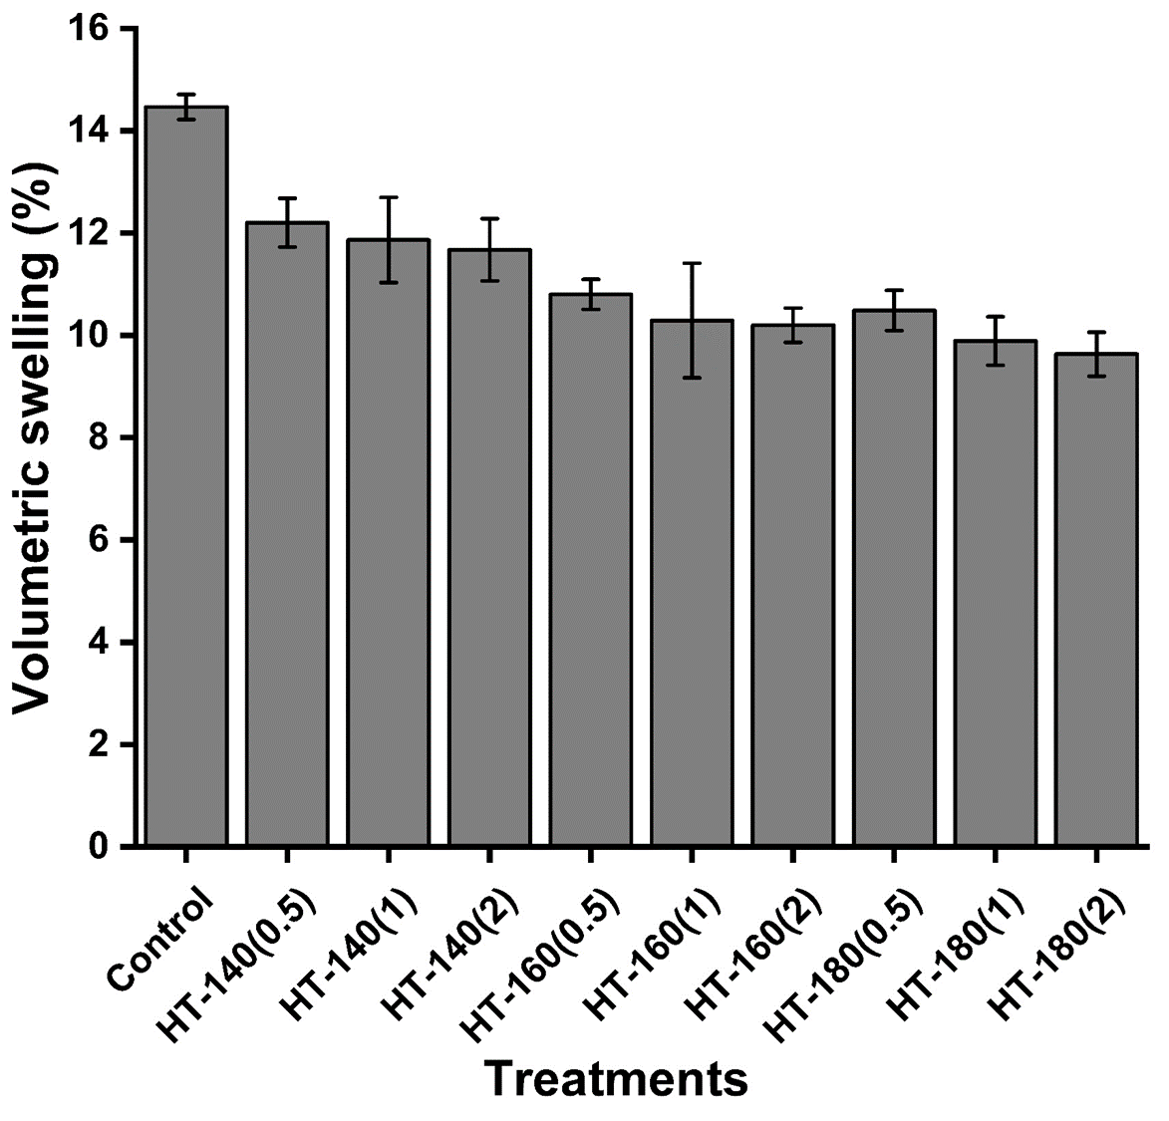
Volumetric swelling (%) of control and hydrothermally modified Douglas fir wood

Supplementary Table 3. MOE and MOR of control and hydrothermally modified Douglas fir wood

Temperature | Time (h) | MOE (GPa) | MOR (MPa)
Control | - | 9.5667±0.95 | 86.4733±6.56
140°C | 0.5 | 8.77±0.69 | 81.92±2.67
140°C | 1 | 8.20±0.63 | 76.44±10.25
140°C | 2 | 7.75±0.50 | 71.12±8.27
160°C | 0.5 | 7.08±1.30 | 62.10±4.58
160°C | 1 | 6.55±1.24 | 54.03±6.41
160°C | 2 | 5.07±0.77 | 47.78±5.58
180°C | 0.5 | 5.22±0.30 | 30.14±3.33
180°C | 1 | 5.01±1.64 | 24.95±5.04
180°C | 2 | 3.65±0.62 | 15.70±1.65

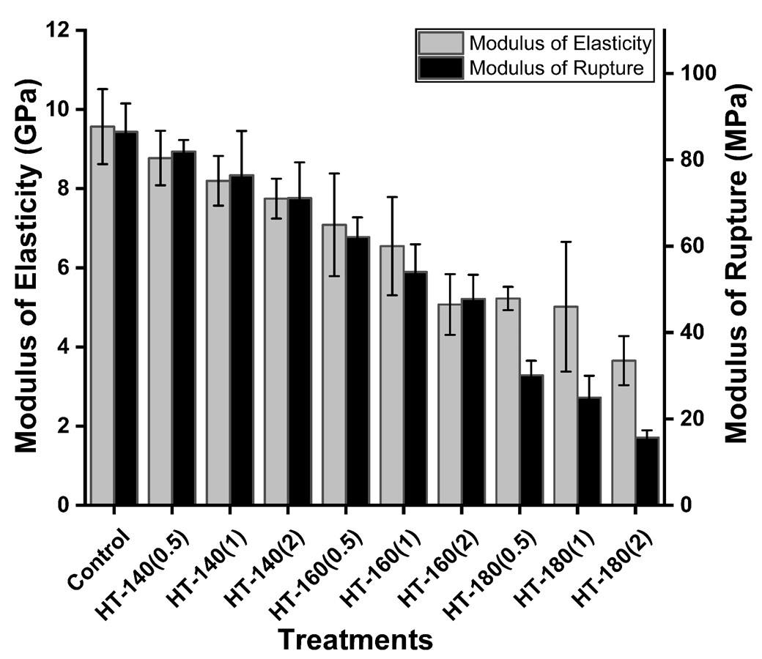
MOE and MOR of control and hydrothermally modified Douglas fir wood

Supplementary Table 4. DMOE of control and hydrothermally modified Douglas fir wood
Temperature | Time (h) | DMOE (GPa)
Control | - | 18.30±1.61
140°C | 0.5 | 18.00±1.72
140°C | 1 | 17.51±1.94
140°C | 2 | 17.65±1.77
160°C | 0.5 | 14.07±3.53
160°C | 1 | 13.84±4.84
160°C | 2 | 10.88±1.29
180°C | 0.5 | 13.86±2.78
180°C | 1 | 12.16±3.55
180°C | 2 | 7.49±1.51

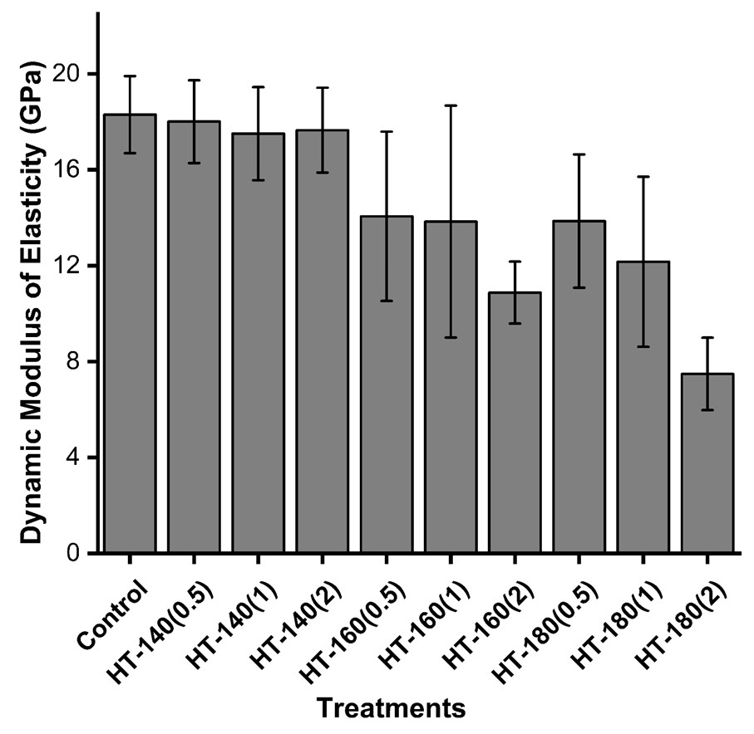
DMOE of control and hydrothermally modified Douglas fir wood
Supplementary Table 5. Surface hardness of control and hydrothermally modified Douglas fir wood

Temperature | Time (h) | Hardness (N)
Control | - | 2650.50±235.31
140°C | 0.5 | 2454.04±199.71
140°C | 1 | 2304.59±274.07
140°C | 2 | 2093.90±89.17
160°C | 0.5 | 1957.70±236.70
160°C | 1 | 1897.58±320.31
160°C | 2 | 1669.43±221.16
180°C | 0.5 | 1308.98±115.62
180°C | 1 | 986.13±86.43
180°C | 2 | 826.76±136.87

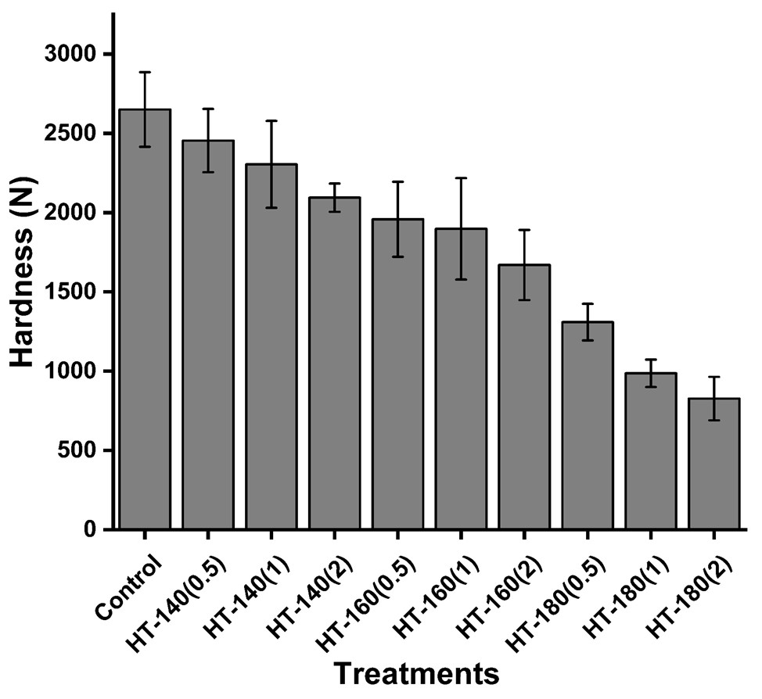
Surface hardness of control and hydrothermally modified Douglas fir wood

