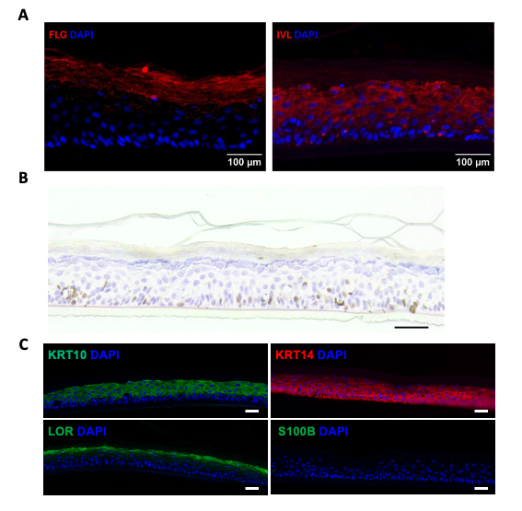
Figure S1. Representative images showing marker protein expression in PmtHEE detected by immunofluorescence (IF, upper panels) (A) and immunohistochemistry (IHC, middle panel) (B). FLG (upper left), IVL (upper right), and MKI67 (middle) were analyzed to visualize their spatial distribution within the tissue. Cell nuclei were counterstained with DAPI. Scale bars: 100 µm (IF) and 50 µm (IHC). (C) Immunofluorescence analysis of KRT10, KRT14, LOR, and S100B expression in the HEE model without melanocytes. Nuclei are counterstained with DAPI (blue). Scale bar, 50 µm.

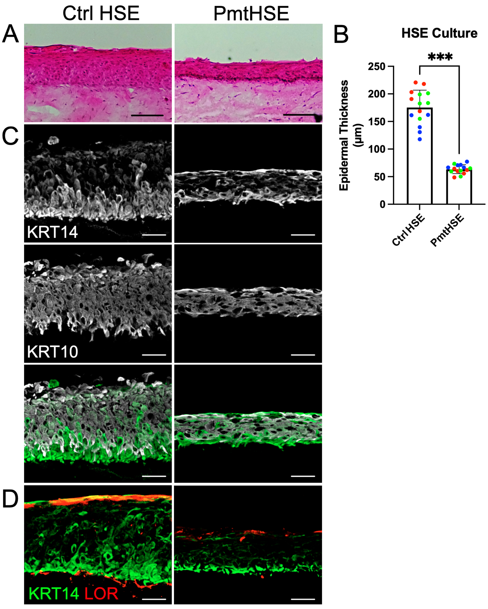
Figure S2. (A) Haematoxylin and eosin (H&E) staining of control HSE without melanocytes (left) and PmtHSE (right). (B) Quantification of epidermal thickness from HSE cultures. Significance determined by unpaired two-tailed t test (***, P < 0.001). (C) Immunofluorescence of KRT14 (upper), KRT10 (middle), and a merged image (bottom). (D) Immunoflurescence of KRT14 and LOR. Scale bars: 100 µm (H&E) and 50 µm (IF).
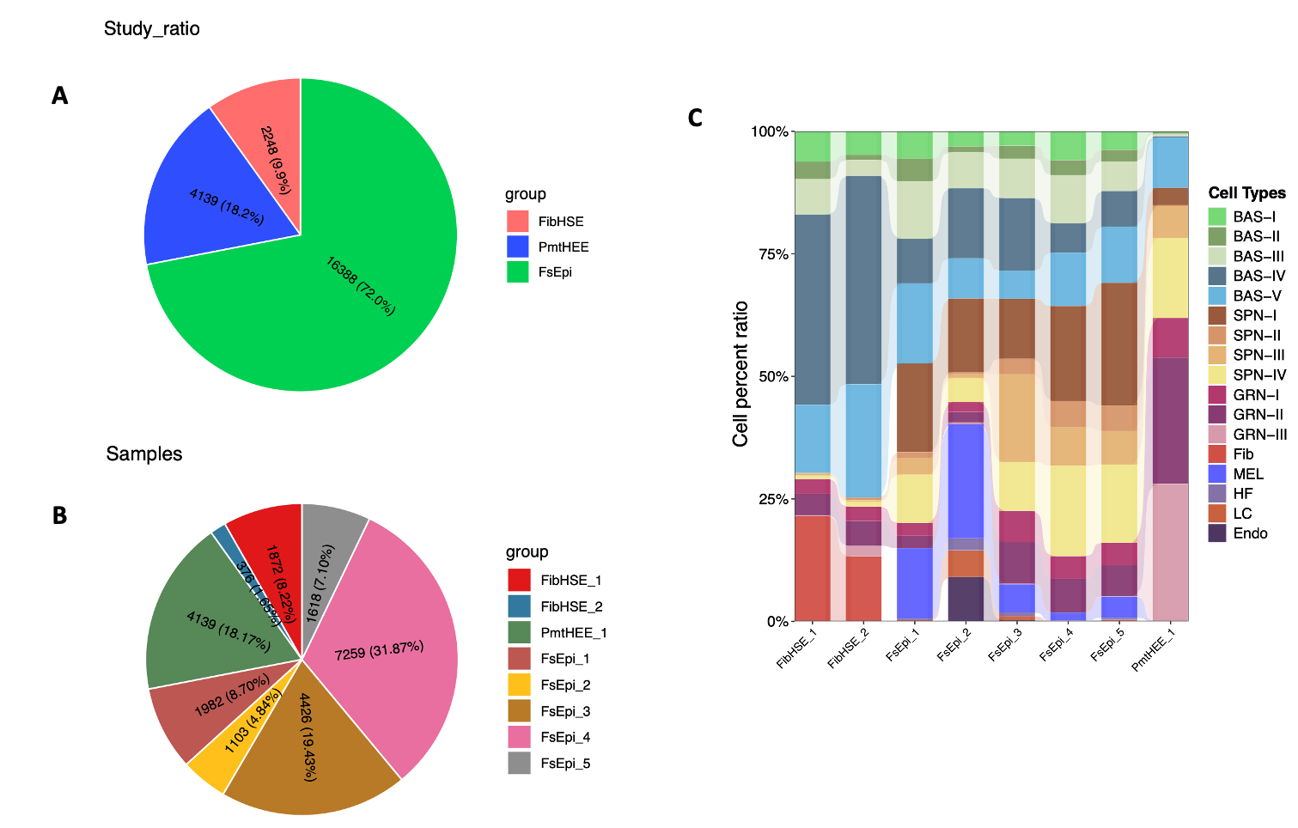
Figure S3. (A, B) Pie charts illustrating the composition of scRNA-seq datasets. (C) Bar plot showing the proportion of annotated cell types and keratinocyte cell states across individual samples, corresponding to Figure 3B.

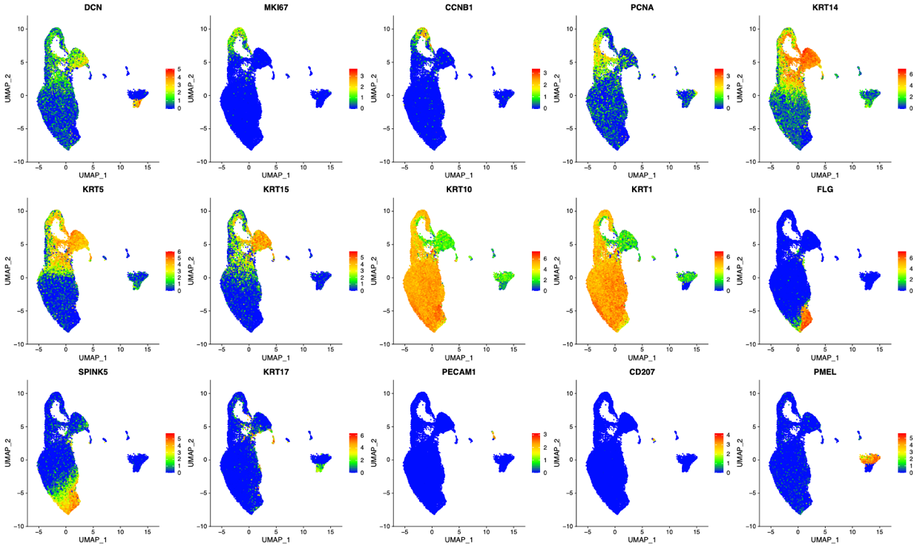
Figure S4. Feature plots showing the expression of canonical skin marker genes across cell populations within the integrated Seurat object.
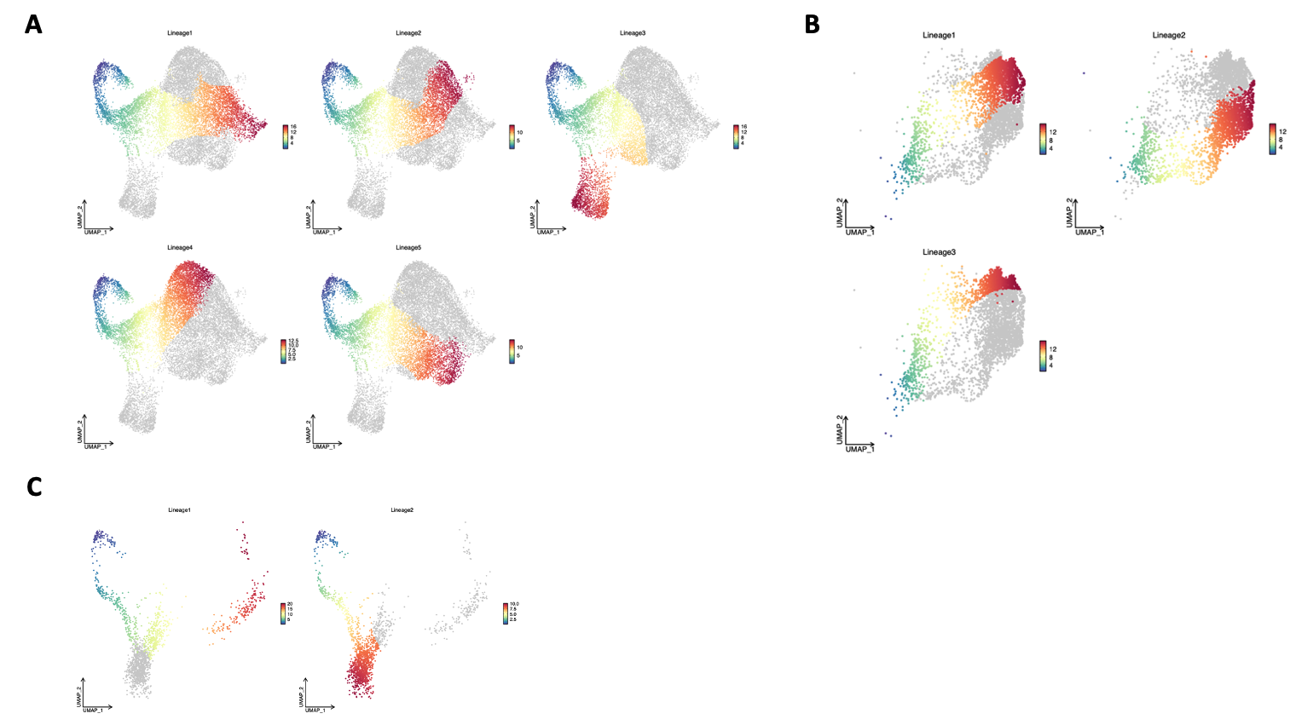
Figure S5. Pseudotime inference plots showing stable estimates of the underlying cell-level pseudotime variable for each lineage. Panels display results for (A) FsEpi, (B) PmtHEE, and (C) FibHSE models.

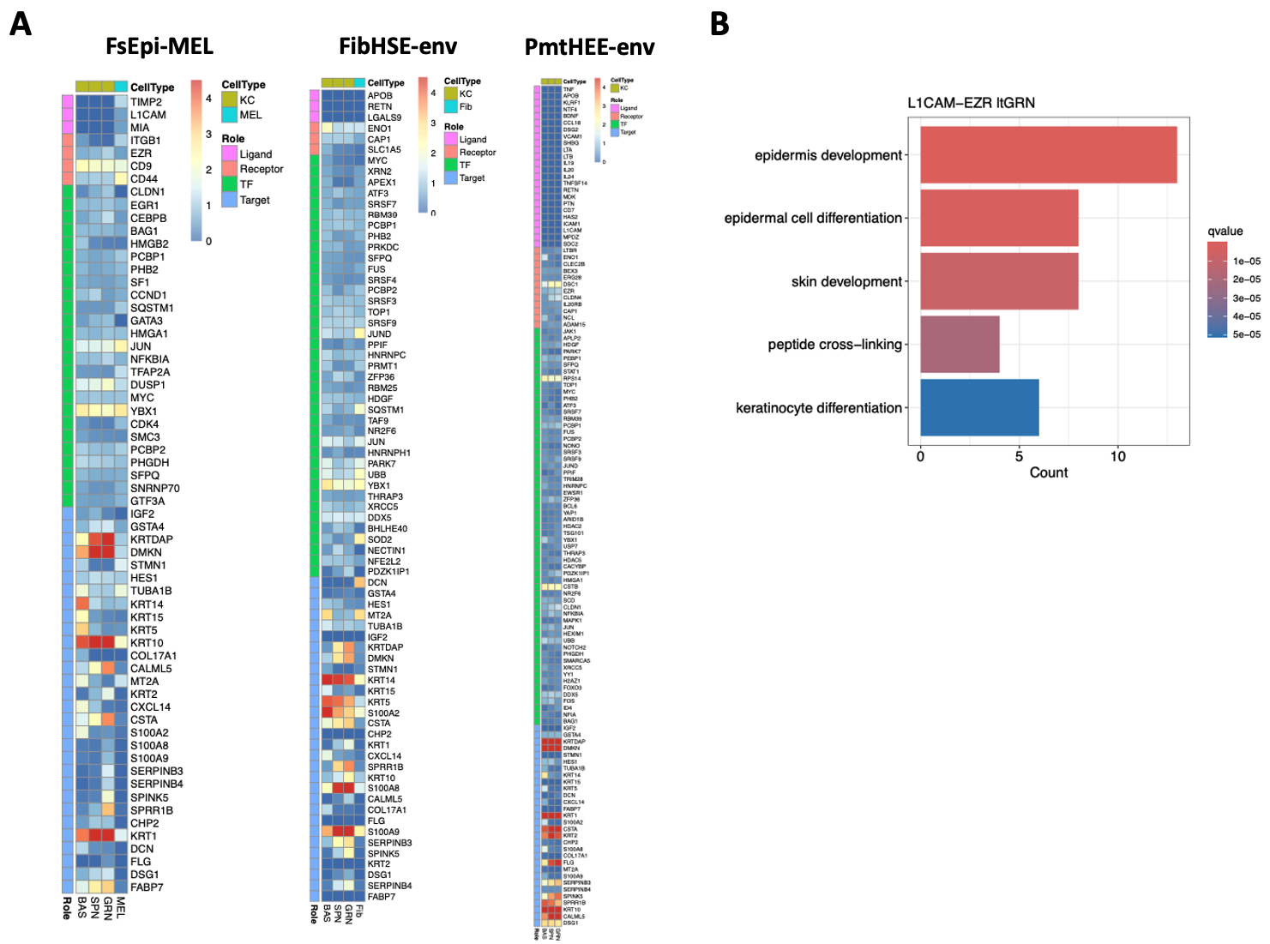
Figure S6. (A) Heatmap showing the expression levels of components from predicted exSigNets derived from selected sources under FsEpi, FibHSE, and PmtHEE conditions. (B) Functional enrichment analysis of biological processes for the shared L1CAM-EZR-driven exSigNet.

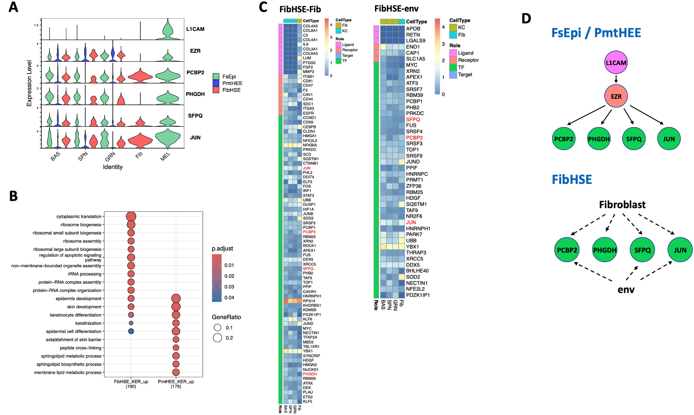
Figure S7. Alternative exSigNets targeting keratinocytes identified in the FibHSE model. (A) Violin plot showing the expression of ligand-receptor-transcription factor components from the shared L1CAM-EZR-driven exSigNet, predicted between FsEpi and PmtHEE. The FibHSE model is now included to enable comprehensive comparison across all conditions. (B) Functional enrichment analysis of biological processes in keratinocytes from FibHSE and PmtHEE. (C) Heatmap showing the expression levels of components within the fibroblast- and environment-specific exSigNets identified in the FibHSE model. Due to substantial overlap of target genes with those in Figure 6C, only ligand-receptor-transcription factor components are presented here. Transcription factors shared with the FsEpi/PmtHEE-derived L1CAM-EZR-driven exSigNet are highlighted in red. 'FibHSE_Fib' represents ligands derived from fibroblasts in the FibHSE model; 'FibHSE_env' refers to ligands from the external environment in the FibHSE model. Keratinocytes were used as the target cells in all analyses. (D) Schematic illustrating the origin of alternative exSigNets in the FibHSE model that bypass the L1CAM-EZR-driven exSigNet, in contrast to the melanocyte-to-keratinocyte signaling observed in FsEpi and PmtHEE.

