Supplemental Table 1: Association Between Cancer Type and Anxiety Based on Chi-Square Test
Cancer type | Prevalence of anxiety, GAD ≥ 10
Cancer type | n (row%) | p-value
Head & neck (n=16) | 6 (37.50) | 0.791
Lung (n=51) | 8 (15.69) | 0.003
Breast (n=101) | 44 (43.56) | 0.022
Hepatobiliary (n=16) | 10 (62.50) | 0.028
Gastrointestinal (n=48) | 24 (50.00) | 0.014
Prostate (n=8) | 2 (25.00) | 0.721
Kidney and urinary tract (n=25) | 12 (48.00) | 0.135
Colorectal (n=50) | 18 (36.00) | 0.767
Ovary and Endometrial (n=23) | 2 (8.70) | 0.691
Cervical (n=12) | 2 (16.67) | 0.234
Lymphoma (n=46) | 6 (13.04) | 0.001
Leukemia (n=20) | 8 (40.00) | 0.631

Supplemental Table 2: Association Between Cancer Type and Depression Based on Chi-Square Test
Cancer type | Prevalence of depression, PHQ-9 ≥ 10
Cancer type | n (col%) | p-value
Head & neck (n=16) | 8 (50.00) | 0.618
Lung (n=51) | 12 (23.53 | 0.002
Breast (n=101) | 58 (57.43) | 0.001
Hepatobiliary (n=16) | 12 (75.00) | 0.018
Gastrointestinal (n=48) | 24 (50.00) | 0.353
Prostate (n=8) | 4 (50.00) | 0.734
Kidney and urinary tract (n=25) | 10 (40.00) | 0.836
Colorectal (n=50) | 24 (48.00) | 0.518
Ovary and Endometrial (n=23) | 8 (34.78) | 0.398
Cervical (n=12) | 4 (33.33) | 0.563
Lymphoma (n=46) | 10 (21.74) | 0.001
Leukemia (n=20) | 8 (40.00) | 0.82

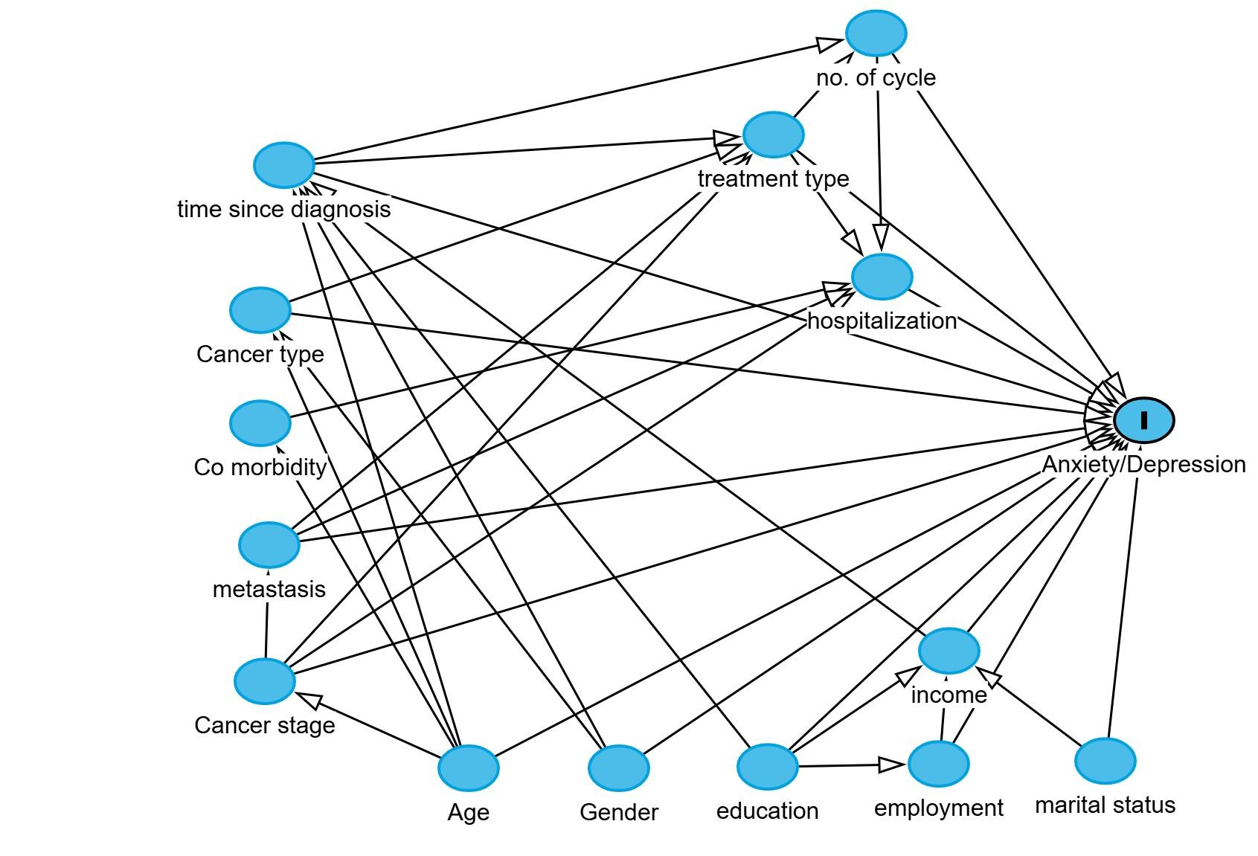
Supplementary Figure 1. Simplified directed acyclic graph illustrating the principal causal assumptions used to guide confounder selection. The figure is intended to summarize the key relationships considered during model development and does not depict every possible causal pathway or adjustment decision.

