Supplementary material
Scientific Reports

Combined effect of Al₂O₃ microparticle-enhanced cultivation (MPEC) and inoculation strategy on Streptomyces rimosus

Anna Ścigaczewska ª*, Tomasz Boruta^{b}, Marcin Bizukojć^{c}, Weronika Grzesiak^{d}
*corresponding author: anna.kowalska.1@p.lodz.pl
Lodz University of Technology, Faculty of Process and Environmental Engineering,
^{a,b,c,d} Department of Bioprocess Engineering, ul. Wolczanska 213, 93-005 Lodz, Poland

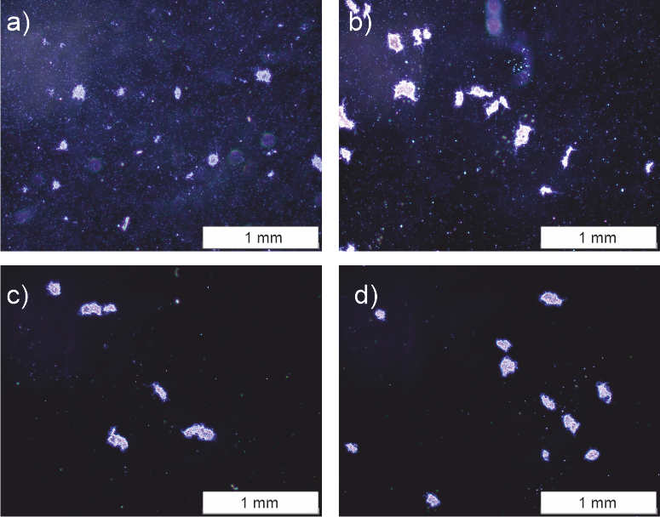
Suppl. Fig. 1 Representative microscopic images of S. rimosus morphological objects formed in a spore-inoculated bioreactor cultivation without Al₂O₃ addition (control) at a) 24 h, b) 48 h, c) 72 h, d) 96 h.
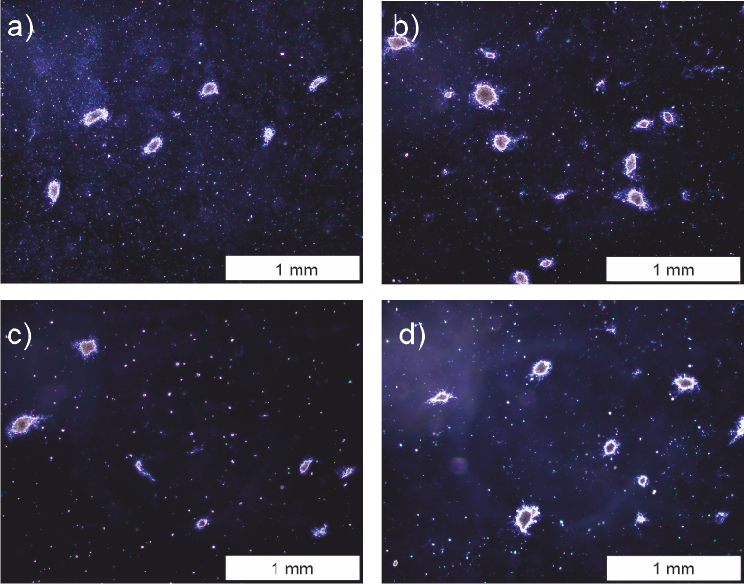
Suppl. Fig. 2 Representative microscopic images of S. rimosus morphological objects formed in a spore-inoculated bioreactor cultivation with 5 g L⁻¹ Al₂O₃ addition (MPEC) at a) 24 h, b) 48 h, c) 72 h, d) 96 h.

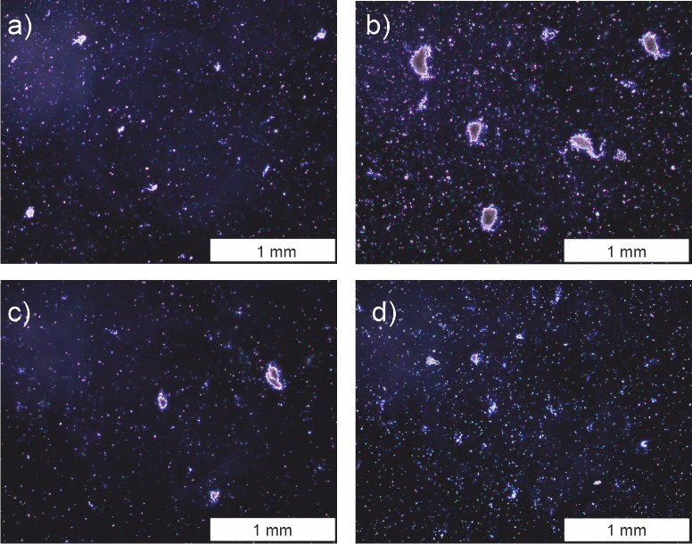
Suppl. Fig. 3 Representative microscopic images of S. rimosus morphological objects formed in a spore-inoculated bioreactor cultivation with 10 g L⁻¹ Al₂O₃ addition (MPEC) at a) 24 h, b) 48 h, c) 72 h, d) 96 h.

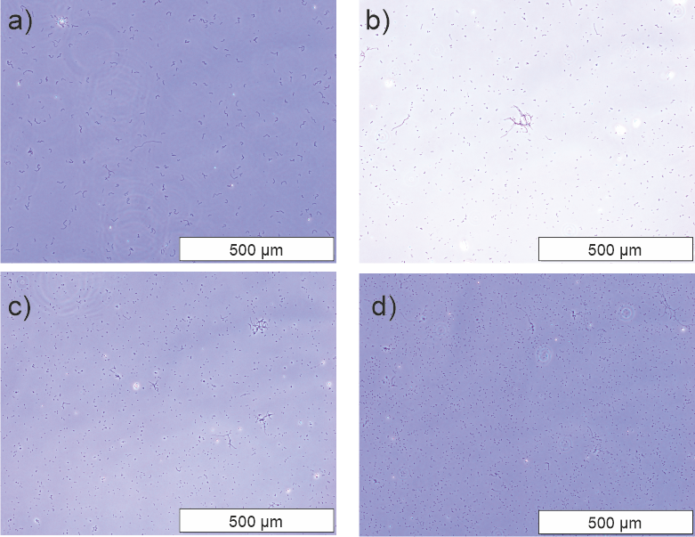
Suppl. Fig. 4 Representative microscopic images of S. rimosus morphological objects formed in a spore-inoculated bioreactor cultivation with 15 g L⁻¹ Al₂O₃ addition (MPEC) at a) 24 h, b) 48 h, c) 72 h, d) 96 h.

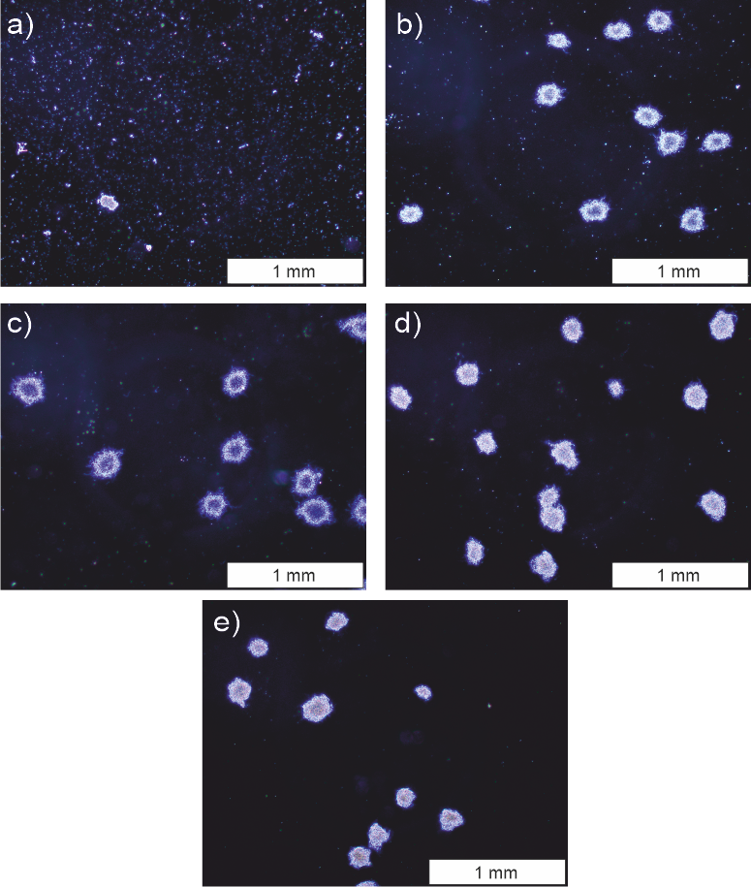
Suppl. Fig. 5 Representative microscopic images of S. rimosus morphological objects formed in a preculture-inoculated bioreactor cultivation without Al₂O₃ addition (control) at a) 0 h, b) 24 h, c) 48 h, d) 72 h, e) 96 h.

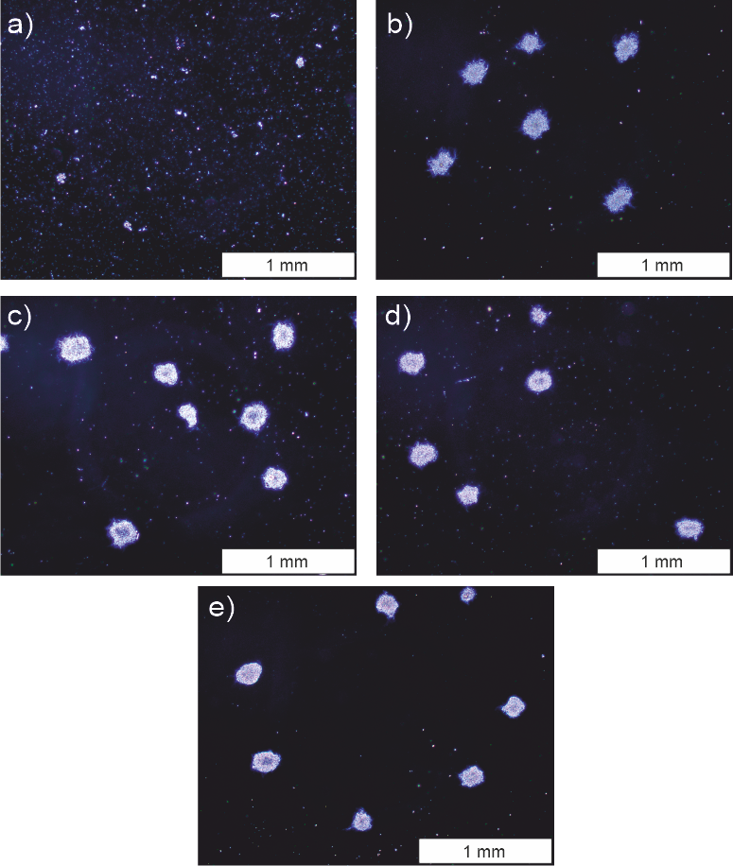
Suppl. Fig. 6 Representative microscopic images of S. rimosus morphological objects formed in a preculture-inoculated bioreactor cultivation with 5 g L⁻¹ Al₂O₃ addition (MPEC) at a) 0 h, b) 24 h, c) 48 h, d) 72 h, e) 96 h.

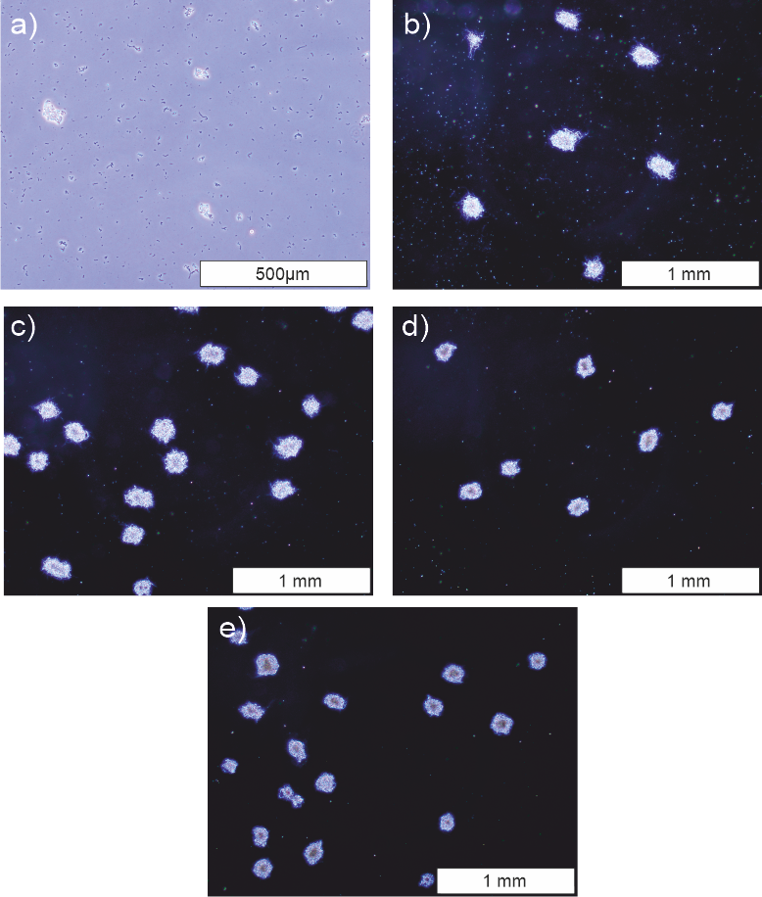
Suppl. Fig. 7 Representative microscopic images of S. rimosus morphological objects formed in a preculture-inoculated bioreactor cultivation with 10 g L⁻¹ Al₂O₃ addition (MPEC) at a) 0 h, b) 24 h, c) 48 h, d) 72 h, e) 96 h.

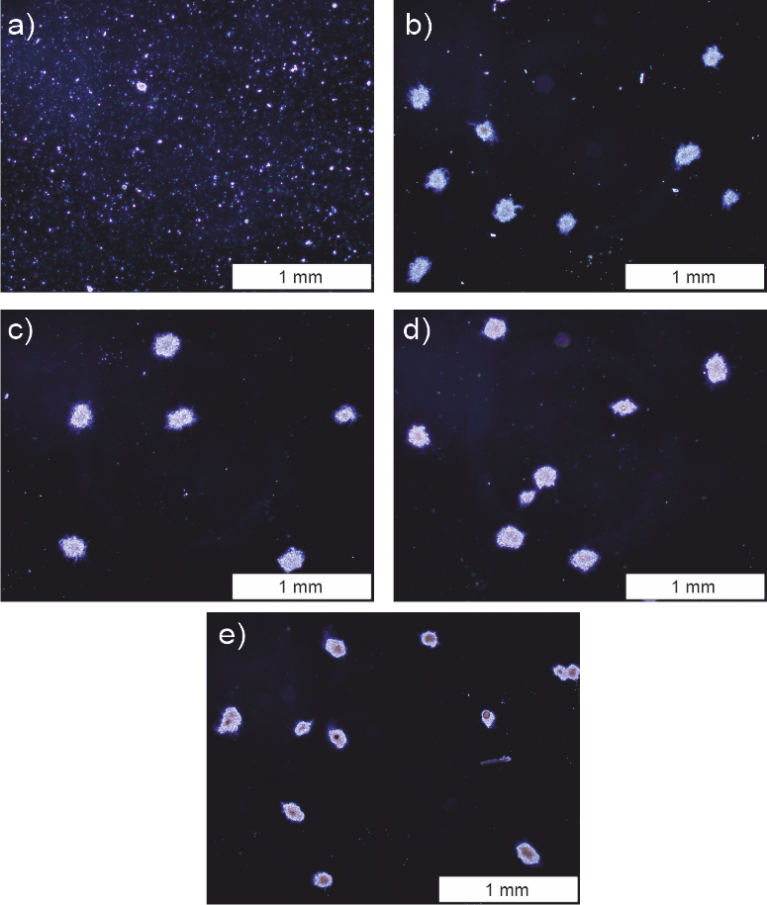
Suppl. Fig. 8 Representative microscopic images of S. rimosus morphological objects formed in a preculture-inoculated bioreactor cultivation with 15 g L⁻¹ Al₂O₃ addition (MPEC) at a) 0 h, b) 24 h, c) 48 h, d) 72 h, e) 96 h.

Suppl. Fig. 9 Changes of morphological parameters in relation to the overall process time:
a) projected area in the spore-inoculated cultivations, b) projected area in the preculture-inoculated cultivations, c) morphology number in the spore-inoculated cultivations, d) morphology number in the preculture-inoculated cultivations, e) roughness in the spore-inoculated cultivations, f) roughness in the preculture-inoculated cultivations. Error bars represent confidence bands calculated from three independent replications. As the values of the morphological parameters differed to the high extent, the ranges of y-axis are not the same in the panels for better visualization of the data.

Suppl. Fig. 10 Time profiles of pH during S. rimosus cultivation in a) spore-inoculated and b) preculture-inoculated conducted in a bioreactor supplemented with different concentrations of Al₂O₃

Suppl. Fig. 11 Time profiles of S. rimosus dry biomass concentration in a) spore-inoculated and b) preculture-inoculated cultivations conducted in bioreactors. Error bars represent confidence bands calculated from three independent replicates.

Suppl. Fig. 12 Biomass-normalised temporal changes of the concentrations of a) oxytetracycline in the spore-inoculated cultivations and b) oxytetracycline in the preculture-inoculated cultivations; temporal changes of the LC–MS peak areas of c) ADOTC in the spore-inoculated cultivations and d) ADOTC in the preculture-inoculated cultivations. Error bars represent confidence bands calculated from three independent replications. As the signals of metabolites differed to the high extent, the ranges of y-axis are not the same in the panels for better visualization of the data.

Suppl. Fig. 13 Biomass-normalised temporal changes of the concentrations of a) enaminomycin B in the spore-inoculated cultivations, b) enaminomycin B in the preculture-inoculated cultivations, c) spinoxazine A in the spore-inoculated cultivations, d) spinoxazine A in the preculture-inoculated cultivations, e) lorneic acid J in the spore-inoculated cultivations, f) lorneic acid J in the preculture-inoculated cultivations. Error bars represent confidence bands calculated from three independent replications. As the signals of metabolites differed to the high extent, the ranges of y-axis are not the same in the panels for better visualization of the data.

Suppl. Fig. 14 Biomass-normalised temporal changes of the concentrations of a) rimocidin in the spore-inoculated cultivations, b) rimocidin in the preculture-inoculated cultivations, c) rimocidin CE-108 in the spore-inoculated cultivations, d) rimocidin CE-108 in the preculture-inoculated cultivations. Error bars represent confidence bands calculated from three independent replications. As the signals of metabolites differed to the high extent, the ranges of y-axis are not the same in the panels for better visualization of the data.

Suppl. Fig. 15 Biomass-normalised temporal changes of the concentrations of a) milbemycin A₃ in the spore-inoculated cultivations, b) milbemycin A₃ in the preculture-inoculated cultivations, c) milbemycin β₁₁ in the spore-inoculated cultivations, d) milbemycin β₁₁ in the preculture-inoculated cultivations. Error bars represent confidence bands calculated from three independent replications.

