Supplementary information for
Investigating a Devonian vertebrate assemblage with synchrotron microtomography of coprolites
Arnaud Rebillard*, Vincent Dupret, Pavel Beznosov, Per Erik Ahlberg
*Arnaud Rebillard
Email: Arnaud.rebillard@mfn.berlin

This PDF file includes:
Fig. S1 to S11
Legends for Movies S1 to S4

Other supporting materials for this manuscript include the following:
Movies S1 to S4
Supp file 1

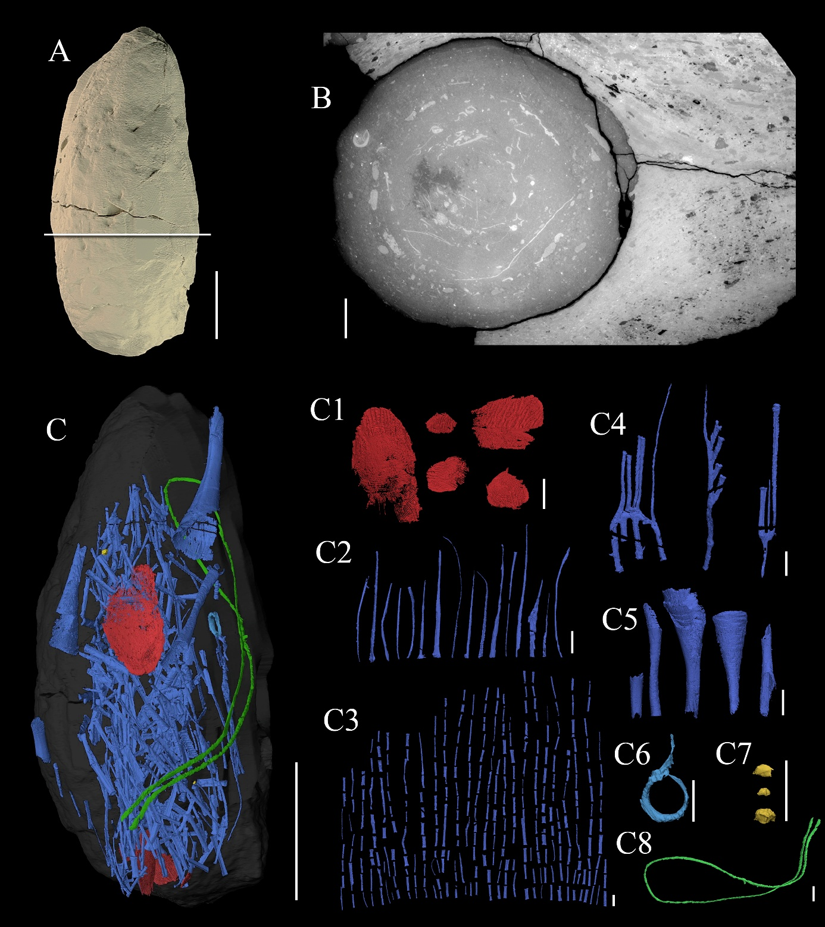
Fig. S1: Digital 3D rendering of coprolite #IGKSC 324/19 and its content (Sula fossil site, Nenets Autonomous Okrug, Arkhangelsk Region, RF, Kumushka Formation, Givetian-Frasnian transition beds). A: Sula2 sample coprolite modeled in 3D. B: tomogram displaying a transverse section along the plane shown in (A) showing the inclusions spirally organized. C: organization of the content in-situ; C1: porolepiform (incl holoptychiid) scale fragments. C2–C5: fleurantiid-like dipnoan. C2: elongated lepidotrichia. C3: short lepidotrichia. C4: lepidotrichia attached to a common base. C5: supraneural fragments. C6: possible poorly preserved dipnoan vertebra. C7: acanthodian scales. C8: vascular plant remain. Scale bars: 5 mm (A, K), 1 mm (B–J).

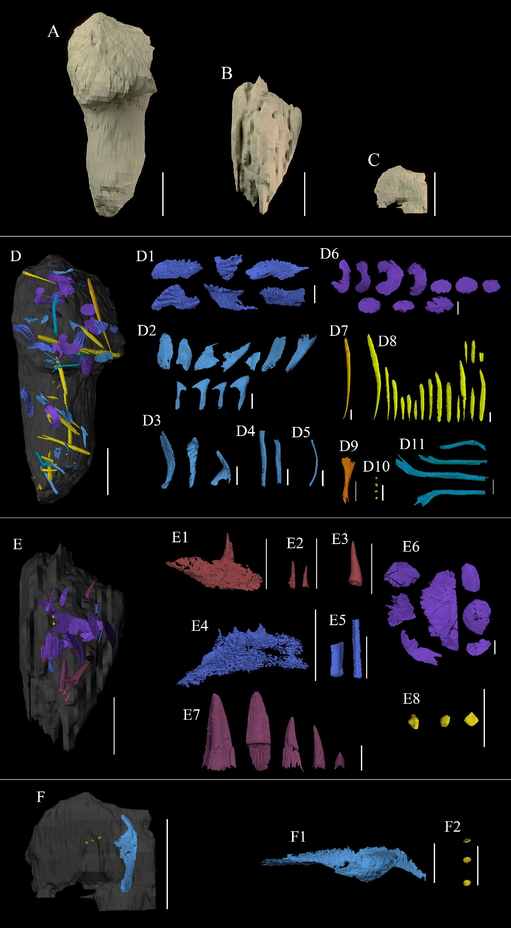
Fig. S2: Digital 3D rendering of coprolites #IGKSC 324/59A, #IGKSC 324/59B and #IGKSC 324/59C and their content (Sula fossil site, Nenets Autonomous Okrug, Arkhangelsk Region, RF, Kumushka Formation, Givetian-Frasnian transition beds). Coprolite A (A), coprolite B (B) and coprolite C (C). D: organization of the content in-situ in coprolite A D1: fleurantiid-like dipnoan prearticular toothplates. D2: dipnoan skull bones. D3: possible dipnoan shoulder girdle elements. D4: dipnoan cranial ribs. D5: dipnoan pleural rib. D6: osteichthyan scale fragments. D7 : diplacanthiform acanthodian fin spines D8: acanthodian fin spines. D9: acanthodid acanthodian scapulocoracoid. D10: acanthodian scales. D11: Dipnoan rib. E organization of the content in-situ in coprolite B. E1: holoptychiid porolepiform coronoid teeth. E2: holoptychiid porolepiform marginal teeth; E3: holoptychiid porolepiform parasymphysial tooth. E4– E5: fleurantiid-like dipnoan remains. E4: prearticular toothplate. E5: lepidotrichia. E6: osteichthyan scales. E7: sarcopterygian fangs E8: acanthodian scales; F: organization of the content in-situ in coprolite C; F1: possible dipnoan clavicle. F2: acanthodian scales. Scale bars: 5 mm (A, E, G, I), 1 mm (D, F, H)

Fig. S3: Digital 3D rendering of coprolite #IGKSC 324/25b (A) and its content (B) (Sula fossil site, Nenets Autonomous Okrug, Arkhangelsk Region, RF, Kumushka Formation, Givetian-Frasnian transition beds). C: fleurantiid-like dipnoan lepidotrichia. D: fleurantiid-like dipnoan tooth plate. E: dipnoan cranial rib. F: osteichthyan infraorbital bone. G: Possible acanthodian fin spine. Scale bars: 5 mm (A,B), 1 mm (C–H).

Fig. S4: Digital 3D rendering of coprolites #IGKSC 324/31A and #IGKSC 324/31B (A,D) and the organization of the content in situ (B,E) (Sula fossil site, Nenets Autonomous Okrug, Arkhangelsk Region, RF, Kumushka Formation, Givetian-Frasnian transition beds). C1: possible dipnoan unidentified element.. C2: possible dipnoan clavicle.. C3: osteichthyan lepidotrichia. C4: acanthodian scales. F1: fleurantiid-like dipnoan supraneural shafts. F2: fleurantiid-like dipnoan lepidotrichium. Scale bars: 0.5 cm (A–E), 1 mm (C,F).

Fig. S5: Digital 3D rendering of a fragmentary Eusthenopteron-like tristichopterid snout found within specimen #IGKSC 324/25b, but outside the coprolite (Sula fossil site, Nenets Autonomous Okrug, Arkhangelsk Region, RF, Kumushka Formation, Givetian-Frasnian transition beds); in lateral (A,C) and occlusal (B,D) views. E: cropped tomogram of the bone along the plane shown in (A). Abbreviations: f1: fang1. f2: fang2. f3: fang3. pm: premaxilla. vo: vomer. Scale bars: 1 mm.

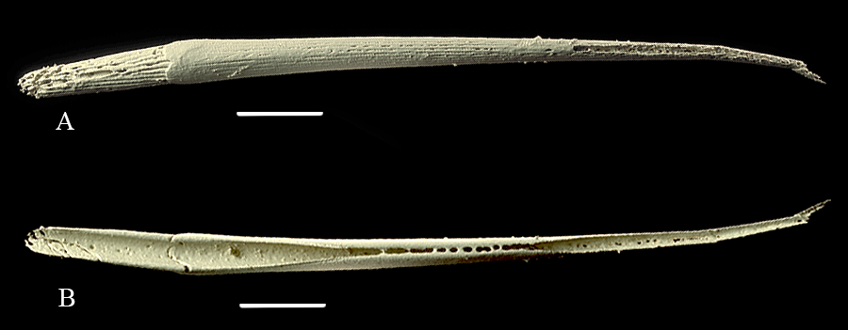
Fig. S6: Digital 3D rendering of a diplacanthiform acanthodian fin spine found in coprolite #IGKSC 324/59A (Sula fossil site, Nenets Autonomous Okrug, Arkhangelsk Region, RF, Kumushka Formation, Givetian-Frasnian transition beds) in lateral (A) and posterior (B) views. Scale bars: 1 mm.

Fig. S7: Digital 3D rendering of the fleurantiid-like dipnoan prearticular tooth plates found in coprolite #IGKSC 324/59A (Sula fossil site, Nenets Autonomous Okrug, Arkhangelsk Region, RF, Kumushka Formation, Givetian-Frasnian transition beds); in medial (A1– C1), lateral (A2– C2) and occlusal (A3– C3) views. Scale bars: 1 mm

Fig. S8: Digital 3D rendering of the fleurantiid-like dipnoan tooth plates displaying radiating rows found in coprolite #IGKSC 324/59A (Sula fossil site, Nenets Autonomous Okrug, Arkhangelsk Region, RF, Kumushka Formation, Givetian-Frasnian transition beds), in occlusal view. Scale bars: 1 mm.

Fig. S9: Digital 3D rendering of the fleurantiidae-like dipnoan supraneural fragments found in coprolite #IGKSC 324/19 (Sula fossil site, Nenets Autonomous Okrug, Arkhangelsk Region, RF, Kumushka Formation, Givetian-Frasnian transition beds). A,B,C: supraneural fragments. D,E: supraneurals shaft. Scale bar: 1 mm.

Fig. S10: Digital 3D rendering of a preserved plant remain in coprolite #IGKSC 324/19 (Sula fossil site, Nenets Autonomous Okrug, Arkhangelsk Region, RF, Kumushka Formation, Givetian-Frasnian transition beds. Scale bars: 1 mm.

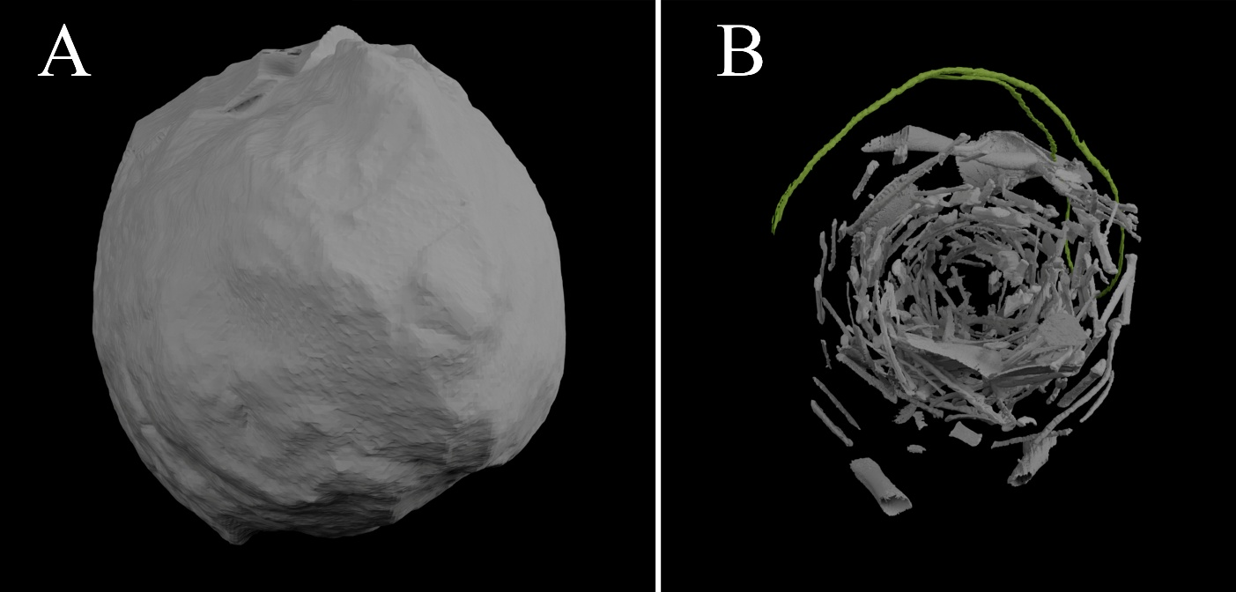
Fig. S11: Coprolite #IGKSC 324/19 in top view with (A) and without (B) the coprolitic matrix. This figure shows how the plant remain is closely bending along the internal surface.

Other supporting files:
Movie S1: Animation of coprolite #IGKSC 324/19, rotating about its vertical axis. The embedding coprolitic matrix disappears to reveal the three-dimensionally reconstructed inclusions. Scale bar: 5 mm
Movie S2: Animation of coprolites #IGKSC 324/59A, B and C, rotating about their vertical axis. The embedding coprolitic matrix disappears to reveal the three-dimensionally reconstructed inclusions. Note that acanthodian scales were not all segmented due to their high abundance (see main manuscript). Scale bar: 5 mm
Movie S3: Animation of coprolite #IGKSC 324/25b, rotating about its vertical axis. The embedding coprolitic matrix disappears to reveal the three-dimensionally reconstructed inclusions. Scale bar: 5 mm
Movie S4: Animation of coprolite #IGKSC 324/31A and B, rotating about their vertical axis. The embedding coprolitic matrix disappears to reveal the three-dimensionally reconstructed inclusions. Scale bar: 5 mm
Supp file 1: Powerpoint file including EDS results and corresponding SEM snapshots

