Association of Trajectories and Cumulative Exposure of Modified Cardiometabolic Index with Cardiovascular Disease in Middle and Older Adults

Legends:

Table S1 VIFs for covariates in Cox regression models of CVD in CHARLS and ELSA databases.
Table S2 P-values for tests of the proportional hazards hypothesis and covariates in Cox regression models of CVD in the CHARLS and ELSA databases.
Table S3 Goodness of fit for the group-based trajectory model.
Table S4 The detailed participants baseline characteristics in CHARLS and ELSA.
Table S5 Association between modified cardiometabolic index and incident heart disease and stroke in CHARLS and ELSA databases.
Table S6 The population attribution fraction for the modified cardiometabolic index.
Table S7 Association between cumulative modified cardiometabolic index and risk of cardiovascular disease, heart disease and stroke in CHARLS and ELSA datasets.
Table S8 Net reclassification improvement (NRI) and integrated discrimination improvement (IDI) of the cumulative cardiac metabolic index for cardiovascular disease, compared with cumulative TyG.
Table S9 Sensitivity analysis conducted on a complete dataset with no missing values.
Table S10 Sensitivity analysis following the exclusion of the diabetic diagnosis as a covariate from the full model.

Figure S1 The design procedure for this study. There was a total of two biomarker tests in CHARLS and three in ELSA.
Figure S2 Method for calculating cumulative MCMI values. The blue area under the curve representing as cumulative cardiometabolic index, which is expressed as the mean of the two measurements (A1 and A2) multiplied by the scale of the interval: (MCMI1st + MCMI2nd)/2 × time (Time1st – Time2nd).
Figure S3 The proportion of missing value in CHARLS and ELSA datasets.
Figure S4 The relationship between the sum of squared errors (SSE) and the number of clusters (k) in K-means clustering. The “elbow point”—the inflection point where the rate of decrease in the SSE value suddenly drops—indicates the optimal number of clusters (k).
Figure S5 The dose-response relationship between cumulative modified cardiometabolic index and the risk of incident heart disease (A, B) and stroke (C, D) in CHARLS (A, C) and ELSA (B, D). The analysis was conducted using a 4-node restricted cubic spline model, which accounted for the nonlinearity of cumulative MCMI, adjusting for all covariates, and using 12.5% as the reference value.
Figure S6 Association between modified cardiometabolic index and risk of incident cardiovascular disease in each subgroup population, using Cox model adjusted for all covariates in both CHARLS and ELSA.

Table S1 VIFs for covariates in Cox regression models of CVD in CHARLS and ELSA databases.
Variables | VIF in CHARLS | VIF in ELSA
Class 2 | 1.722 | 1.441
Class 3 | 2.403 | 1.677
Age | 1.287 | 1.130
Sex | 1.532 | 1.259
BMI | 2.382 | 1.564
Education level | 1.150 | 1.079
Marital status | 1.070 | 1.072
Smoking status | 2.091 | 1.045
Drinking status | 1.358 | 1.019
Diabetes | 1.044 | 1.141
SBP | 2.624 | 1.855
DBP | 2.546 | 1.866
CRP | 1.007 | 1.033
CHO | 3.053 | 2.737
LDL-C | 3.027 | 2.532
Notes: SBP=systolic blood pressure, DBP=diastolic blood pressure, CRP=C-reactive protein, CHO=total cholesterol, LDL-C=low-density lipoprotein cholesterol.

Table S2 P-values for tests of the proportional hazards hypothesis and covariates in Cox regression models of CVD in the CHARLS and ELSA databases.
Variables | P-value in CHARLS | P-value in ELSA
Class | 0.86 | 0.41
Age | 0.09 | 0.50
Sex | 0.37 | 0.31
BMI | 0.46 | 0.84
Education level | 0.19 | 0.79
Marital status | 0.35 | 0.61
Smoking status | 0.56 | 0.25
Drinking status | 0.93 | 0.32
Diabetes | 0.96 | 0.61
SBP | 0.87 | 0.13
DBP | 0.29 | 0.64
CRP | 0.90 | 0.55
CHO | 0.15 | 0.67
LDL-C | 0.15 | 0.70
Global test | 0.57 | 0.47
Notes: SBP=systolic blood pressure, DBP=diastolic blood pressure, CRP=C-reactive protein, CHO=total cholesterol, LDL-C=low-density lipoprotein cholesterol.

Table S3 Goodness of fit for the group-based trajectory model.
k | LL | Entropy | AIC | BIC | %class 1 (avePP)* | %class 2 (avePP)* | %class 3 (avePP)* | %class 4 (avePP)*
1 | -10757.88 | 1.00 | 21521.76 | 21539.47 | 100.0% (1.00)
2 | -9610.38 | 0.78 | 19232.75 | 19268.17 | 68.7% (0.95) | 31.3% (0.91)
3 | -9217.32 | 0.79 | 18452.64 | 18505.77 | 51.4% (0.92) | 41.9% (0.88) | 6.7% (0.91)
4 | -9063.86 | 0.73 | 18151.72 | 18222.56 | 46.6% (0.82) | 25.0% (0.87) | 24.2% (0.84) | 4.3% (0.90)
Notes: *%class (avePP) denotes the proportion of members assigned to this class and the average posterior probability. BIC = Bayesian information criterion; AIC: Akaike’ s Information Criterion; LL: log-likelihood; avePP: Average Predicted Probability.

Table S4 The detailed participants baseline characteristics in CHARLS and ELSA.
Characteristics | CHARLS (N = 4,324) |  |  |  |  | ELSA (N = 2,707)
Characteristics | Class 1 (stable low-level, N = 1,606) | Class 2 (moderate-level, N = 1,845) | Class 3 (high-level, N = 873) | P value |  | Class 1 (stable low-level, N = 1,392) | Class 2 (moderate-level, N = 1,134) | Class 3 (high-level, N = 181 | P value
Age, n (%) |  |  |  | 0.202 |  |  |  |  | 0.004
< 60 | 909 (56.60) | 1098 (59.51) | 515 (58.99) |  |  | 649 (46.62) | 454 (40.04) | 81 (44.75)
≥ 60 | 697 (43.40) | 747 (40.49) | 358 (41.01) |  |  | 743 (53.38) | 680 (59.96) | 100 (55.25)
Sex, n (%) |  |  |  | <0.001 |  |  |  |  | <0.001
Male | 963 (59.96) | 770 (41.73) | 265 (30.36) |  |  | 507 (36.42) | 545 (48.06) | 94 (51.93)
Female | 643 (40.04) | 1075 (58.27) | 608 (69.64) |  |  | 885 (63.58) | 589 (51.94) | 87 (48.07)
BMI, Kg/m² | 20.79 (19.33, 22.33) | 23.71 (22.07, 25.59) | 27.06 (24.89, 28.93) | <0.001 |  | 25.24 (23.00, 27.29) | 28.64 (26.42, 31.77) | 32.69 (30.17, 36.83) | <0.001
Education, n (%) |  |  |  | 0.290 |  |  |  |  | <0.001
Lower | 1129 (70.30) | 1277 (69.21) | 630 (72.16) |  |  | 772 (55.46) | 733 (64.64) | 123 (67.96)
Higher | 477 (29.70) | 568 (30.79) | 243 (27.84) |  |  | 620 (44.54) | 401 (35.36) | 58 (32.04)
Marital status, n (%) |  |  |  | 0.918 |  |  |  |  | 0.078
Married | 1453 (90.47) | 1670 (90.51) | 794 (90.95) |  |  | 1081 (77.66) | 837 (73.81) | 136 (75.14)
Others | 153 (9.53) | 175 (9.49) | 79 (9.05) |  |  | 311 (22.34) | 297 (26.19) | 45 (24.86)
Smoking, n (%) |  |  |  | <0.001 |  |  |  |  | <0.001
No | 804 (50.06) | 1228 (66.56) | 640 (73.31) |  |  | 616 (44.25) | 451 (39.77) | 51 (28.18)
Yes | 802 (49.94) | 617 (33.44) | 233 (26.69) |  |  | 776 (55.75) | 683 (60.23) | 130 (71.82)
Drinking, n (%) |  |  |  | <0.001 |  |  |  |  | 0.015
No | 922 (57.41) | 1272 (68.94) | 639 (73.20) |  |  | 69 (4.96) | 80 (7.05) | 17 (9.39)
Yes | 684 (42.59) | 573 (31.06) | 234 (26.80) |  |  | 1323 (95.04) | 1054 (92.95) | 164 (90.61)
Diabetes, n (%) |  |  |  | <0.001 |  |  |  |  | <0.001
No | 1573 (97.95) | 1783 (96.64) | 779 (89.23) |  |  | 1383 (99.35) | 1093 (96.38) | 160 (88.40)
Yes | 33 (2.05) | 62 (3.36) | 94 (10.77) |  |  | 9 (0.65) | 41 (3.62) | 21 (11.60)
SBP, mmHg | 121.00 (110.33, 133.67) | 127.33 (114.67, 141.00) | 133.33 (121.00, 148.33) | <0.001 |  | 128.50 (118.00, 140.62) | 132.50 (123.50, 145.00) | 137.50 (127.00, 148.50) | <0.001
DBP, mmHg | 71.00 (64.33, 79.00) | 75.00 (68.00, 83.00) | 78.33 (71.67, 87.00) | <0.001 |  | 74.50 (68.00, 82.00) | 77.00 (70.00, 83.00) | 77.00 (70.00, 85.00) | <0.001
CHO, mmol/L | 3.20 (2.84, 3.60) | 3.37 (2.96, 3.79) | 3.46 (3.03, 3.93) | <0.001 |  | 6.10 (5.50, 6.80) | 6.20 (5.40, 6.90) | 6.30 (5.40, 7.00) | 0.718
CRP, mg/L | 0.69 (0.42, 1.48) | 1.02 (0.57, 1.98) | 1.44 (0.80, 2.77) | <0.001 |  | 1.30 (0.60, 2.60) | 2.45 (1.30, 4.70) | 4.00 (2.30, 5.90) | <0.001
LDL-C, mmol/L | 2.80 (2.33, 3.31) | 3.08 (2.56, 3.70) | 2.92 (2.26, 3.59) | <0.001 |  | 3.80 (3.20, 4.40) | 3.90 (3.20, 4.40) | 3.80 (3.17, 4.40) | 0.652
MCMI 1 | 2.37 (2.17, 2.57) | 3.02 (2.81, 3.24) | 3.89 (3.62, 4.20) | <0.001 |  | 2.66 (2.32, 2.98) | 3.42 (3.09, 3.78) | 4.22 (3.83, 4.74) | <0.001
MCMI 2 | 2.41 (2.22, 2.60) | 3.11 (2.90, 3.34) | 3.86 (3.61, 4.16) | <0.001 |  | 2.69 (2.37, 3.02) | 3.54 (3.21, 3.87) | 4.61 (4.22, 4.94) | <0.001
MCMI 3 | - | - | - | - |  | 2.77 (2.42, 3.11) | 4.23 (3.71, 4.76) | 5.87 (5.53, 6.30) | <0.001
Cumulative MCMI | 9.65 (8.94, 10.30) | 12.22 (11.56, 13.03) | 15.48 (14.66, 16.37) | <0.001 |  | 16.56 (14.76, 18.11) | 22.33 (20.71, 23.98) | 29.41 (28.12, 31.00) | <0.001
CVD, n (%)
No | 1385 (86.24) | 1450 (78.59) | 662 (75.83) | <0.001 |  | 1311 (94.18) | 1035 (91.27) | 161 (88.95) | 0.003
Yes | 221 (13.76) | 395 (21.41) | 211 (24.17) |  |  | 81 (5.82) | 99 (8.73) | 20 (11.05)
Heart disease, n (%)
No | 1447 (90.21) | 1567 (85.44) | 732 (84.04) | <0.001 |  | 1343 (96.48) | 1082 (95.41) | 164 (90.61) | 0.001
Yes | 157 (9.79) | 267 (14.56) | 139 (15.96) |  |  | 49 (3.52) | 52 (4.59) | 17 (9.39)
Stroke, n (%)
No | 1525 (94.96) | 1679 (91.05) | 773 (88.75) | <0.001 |  | 1358 (97.56) | 1085 (95.68) | 178 (98.34) | 0.013
Yes | 81 (5.04) | 165 (8.95) | 98 (11.25) |  |  | 34 (2.44) | 49 (4.32) | 3 (1.66)

Table S5 Association between modified cardiometabolic index and incident heart disease and stroke in CHARLS and ELSA databases.
Event | Group | Model 1 |  | Model 2 |  | Model 3
Event | Group | HR (95% CI) | P value | HR (95% CI) | P value | HR (95% CI) | P value
Heart disease
CHARLS (n = 4,309)
 | Class 1 | Ref |  | Ref |  | Ref
 | Class 2 | 1.53 (1.25, 1.86) | <0.001 | 1.47 (1.20, 1.79) | <0.001 | 1.36 (1.11, 1.67) | 0.003
 | Class 3 | 1.70 (1.35, 2.13) | <0.001 | 1.58 (1.25, 2.00) | <0.001 | 1.33 (1.04, 1.70) | 0.024
ELSA (n = 2,707)
 | Class 1 | Ref |  | Ref |  | Ref
 | Class 2 | 1.34 (0.90, 1.97) | 0.146 | 1.13 (0.76, 1.76) | 0.572 | 1.12 (0.72, 1.74) | 0.624
 | Class 3 | 2.81 (1.62, 4.88) | <0.001 | 1.40 (1.11, 4.29) | 0.024 | 2.10 (1.03, 4.26) | 0.041
Stroke
CHARLS (n = 4,321)
 | Class 1 | Ref |  | Ref |  | Ref
 | Class 2 | 1.81 (1.39, 2.36) | <0.001 | 1.81 (1.36, 2.40) | <0.001 | 1.63 (1.22, 2.17) | 0.001
 | Class 3 | 2.32 (1.73, 3.11) | <0.001 | 2.17 (1.52, 3.11) | <0.001 | 1.78 (1.22, 2.60) | 0.003
ELSA (n = 2,707)
 | Class 1 | Ref |  | Ref |  | Ref
 | Class 2 | 1.82 (1.17, 2.81) | 0.008 | 2.10 (1.28, 3.46) | 0.004 | 2.04 (1.24, 3.36) | 0.005
 | Class 3 | 0.68 (0.21, 2.22) | 0.526 | 1.05 (0.29, 3.74) | 0.942 | 1.79 (0.27, 3.58) | 0.979
Notes: Model 1, crude model. Model 2, adjusted for age, sex, body mass index, education, marital status, smoking status, and drinking status. Model 2, adjusted for age, sex, BMI, education, marital status, smoking status, drinking status, diabetes, systolic blood pressure, diastolic blood pressure, C-reactive protein, total cholesterol, and low-density lipoprotein cholesterol.

Table S6 The population attribution fraction for the modified cardiometabolic index.
Cluster | PAF | 95% CI | P value
CHARLS (n = 4,324)
Class 2 and Class 3 vs. Class 1 | 17.10% | 8.57% - 25.64% | <0.001
Class 3 vs. Class 2 and Class 1 | 0.51% | -3.07% - 4.13% | 0.804
ELSA (n = 2,707)
Class 2 and Class 3 vs. Class 1 | 18.86% | 5.05% - 32.57% | 0.013
Class 3 vs. Class 2 and Class 1 | 2.67% | -1.66% - 7.05% | 0.225
Notes: Adjusting age, sex, BMI, education, marital status, smoking status, drinking status, diabetes, systolic blood pressure, diastolic blood pressure, C-reactive protein, total cholesterol, and low-density lipoprotein cholesterol.
Table S7 Association between cumulative modified cardiometabolic index and risk of cardiovascular disease, heart disease and stroke in CHARLS and ELSA datasets.
Event | Model 1 |  | Model 2 |  | Model 3
Event | HR (95% CI) | P value | HR (95% CI) | P value | HR (95% CI) | P value
Cardiovascular disease
CHARLS | 1.11 (1.08, 1.14) | <0.001 | 1.09 (1.05, 1.13) | <0.001 | 1.07 (1.03, 1.11) | <0.001
ELSA | 1.06 (1.03, 1.09) | <0.001 | 1.07 (1.04, 1.10) | <0.001 | 1.06 (1.03, 1.09) | <0.001
Heart disease
CHARLS | 1.09 (1.06, 1.13) | <0.001 | 1.08 (1.05, 1.12) | <0.001 | 1.05 (1.02, 1.09) | 0.004
ELSA | 1.07 (1.04, 1.11) | <0.001 | 1.07 (1.03, 1.11) | <0.001 | 1.07 (1.03, 1.11) | 0.001
Stroke
CHARLS | 1.15 (1.11, 1.20) | <0.001 | 1.16 (1.10, 1.22) | <0.001 | 1.13 (1.07, 1.20) | <0.001
ELSA | 1.03 (0.99, 1.07) | 0.180 | 1.06 (1.01, 1.11) | 0.015 | 1.05 (1.01, 1.10) | 0.027
Notes: Model 1, crude model. Model 2, adjusted for age, sex, body mass index, education, marital status, smoking status, and drinking status. Model 2, adjusted for age, sex, BMI, education, marital status, smoking status, drinking status, diabetes, systolic blood pressure, diastolic blood pressure, C-reactive protein, total cholesterol, and low-density lipoprotein cholesterol.

Table S8 Net reclassification improvement (NRI) and integrated discrimination improvement (IDI) of the cumulative cardiac metabolic index for cardiovascular disease, compared with cumulative TyG.
Datasets | NRI |  | IDI
Datasets | NRI (95% CI) | P value | IDI (95% CI) | P value
CHARLS | 0.113 (0.061, 0.163) | <0.001 | 0.009 (0.004, 0.016) | <0.001
ELSA | 0.140 (0.030, 0.250) | 0.028 | 0.006 (0.001, 0.018) | 0.004
Notes: Adjusting age, sex, BMI, education, marital status, smoking status, drinking status, diabetes, systolic blood pressure, diastolic blood pressure, C-reactive protein, total cholesterol, and low-density lipoprotein cholesterol.

Table S9 Sensitivity analysis conducted on a complete dataset with no missing values.
Cluster | Model 1 |  | Model 2 |  | Model 3
Cluster | HR (95% CI) | P value | HR (95% CI) | P value | HR (95% CI) | P value
CHARLS (n = 3,068)
Class 1 (stable low-level) | Reference |  | Reference |  | Reference
Class 2 (moderate-level) | 1.53 (1.27, 1.85) | <0.001 | 1.47 (1.18, 1.78) | <0.001 | 1.32 (1.07, 1.63) | 0.010
Class 3 (high-level) | 1.81 (1.45, 2.26) | <0.001 | 1.58 (1.20, 2.09) | 0.001 | 1.37 (1.03, 1.83) | 0.030
ELSA (n = 2,312)
Class 1 (stable low-level) | Reference |  | Reference |  | Reference
Class 2 (moderate-level) | 1.55 (1.12, 2.14) | 0.009 | 1.53 (1.06, 2.22) | 0.023 | 1.50 (1.04, 2.17) | 0.032
Class 3 (high-level) | 1.90 (1.03, 3.50) | 0.041 | 2.17 (1.07, 4,38) | 0.031 | 2.18 (1.05, 4.50) | 0.036
Notes: Model 1, crude model. Model 2, adjusted for age, sex, body mass index, education, marital status, smoking status, and drinking status. Model 3, adjusted for age, sex, BMI, education, marital status, smoking status, drinking status, diabetes, systolic blood pressure, diastolic blood pressure, C-reactive protein, total cholesterol, and low-density lipoprotein cholesterol.

Table S10 Sensitivity analysis following the exclusion of the diabetic diagnosis as a covariate from the full model.
Cluster | Model 1 |  | Model 2 |  | Model 3
Cluster | HR (95% CI) | P value | HR (95% CI) | P value | HR (95% CI) | P value
CHARLS (n = 4,324)
Class 1 (stable low-level) | Reference |  | Reference |  | Reference
Class 2 (moderate-level) | 1.63 (1.38, 1.92) | <0.001 | 1.50 (1.25, 1.78) | <0.001 | 1.38 (1.15, 1.65) | <0.001
Class 3 (high-level) | 1.88 (1.55, 2.27) | <0.001 | 1.55 (1.23, 1.94) | <0.001 | 1.40 (1.10, 1.79) | 0.006
ELSA (n = 2,707)
Class 1 (stable low-level) | Reference |  | Reference |  | Reference
Class 2 (moderate-level) | 1.55 (1.16, 2.08) | 0.003 | 1.49 (1.07, 2.07) | 0.019 | 1.48 (1.06, 2.06) | 0.021
Class 3 (high-level) | 2.00 (1.22, 3.25) | 0.006 | 2.04 (1.15, 3.63) | 0.015 | 2.11 (1.17, 3.80) | 0.013
Notes: Model 1, crude model. Model 2, adjusted for age, sex, body mass index, education, marital status, smoking status, and drinking status. Model 3, adjusted for age, sex, BMI, education, marital status, smoking status, drinking status, systolic blood pressure, diastolic blood pressure, C-reactive protein, total cholesterol, and low-density lipoprotein cholesterol.

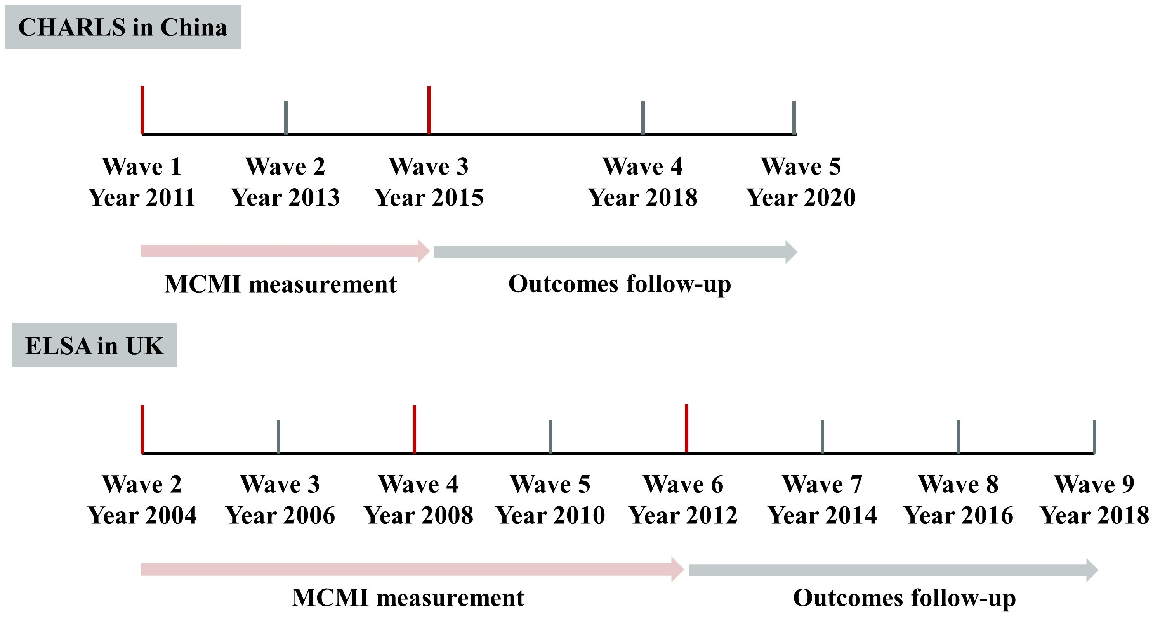
Figure S1 The design procedure for this study. There was a total of two biomarker tests in CHARLS and three in ELSA.

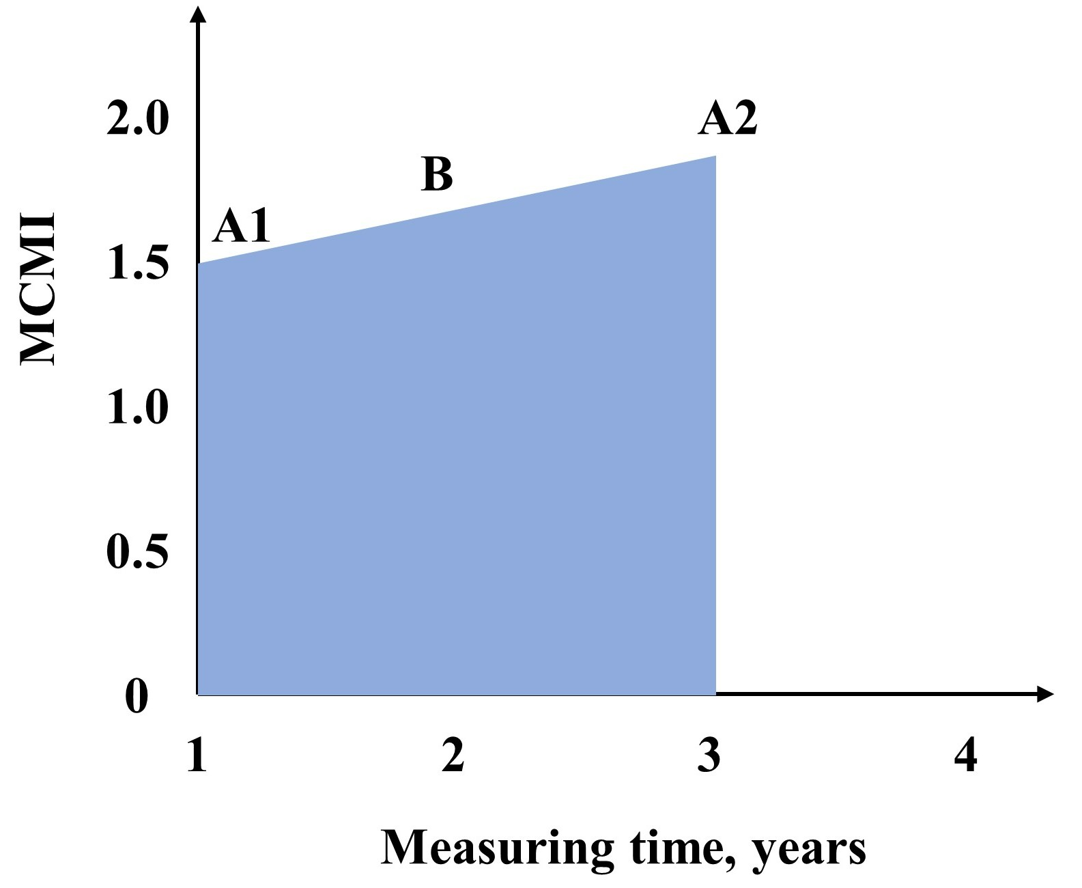
Figure S2 Method for calculating cumulative values. The blue area under the curve representing as cumulative cardiometabolic index, which is expressed as the mean of the two measurements (A1 and A2) multiplied by the scale of the interval: $cumMCMI=\sum_{i=1}^{n}{{MCMI}_{i}/n}×∆t_{i,n}$, $cumTyG=\sum_{i=1}^{n}{{TyG}_{i}/n}×∆t_{i,n}$
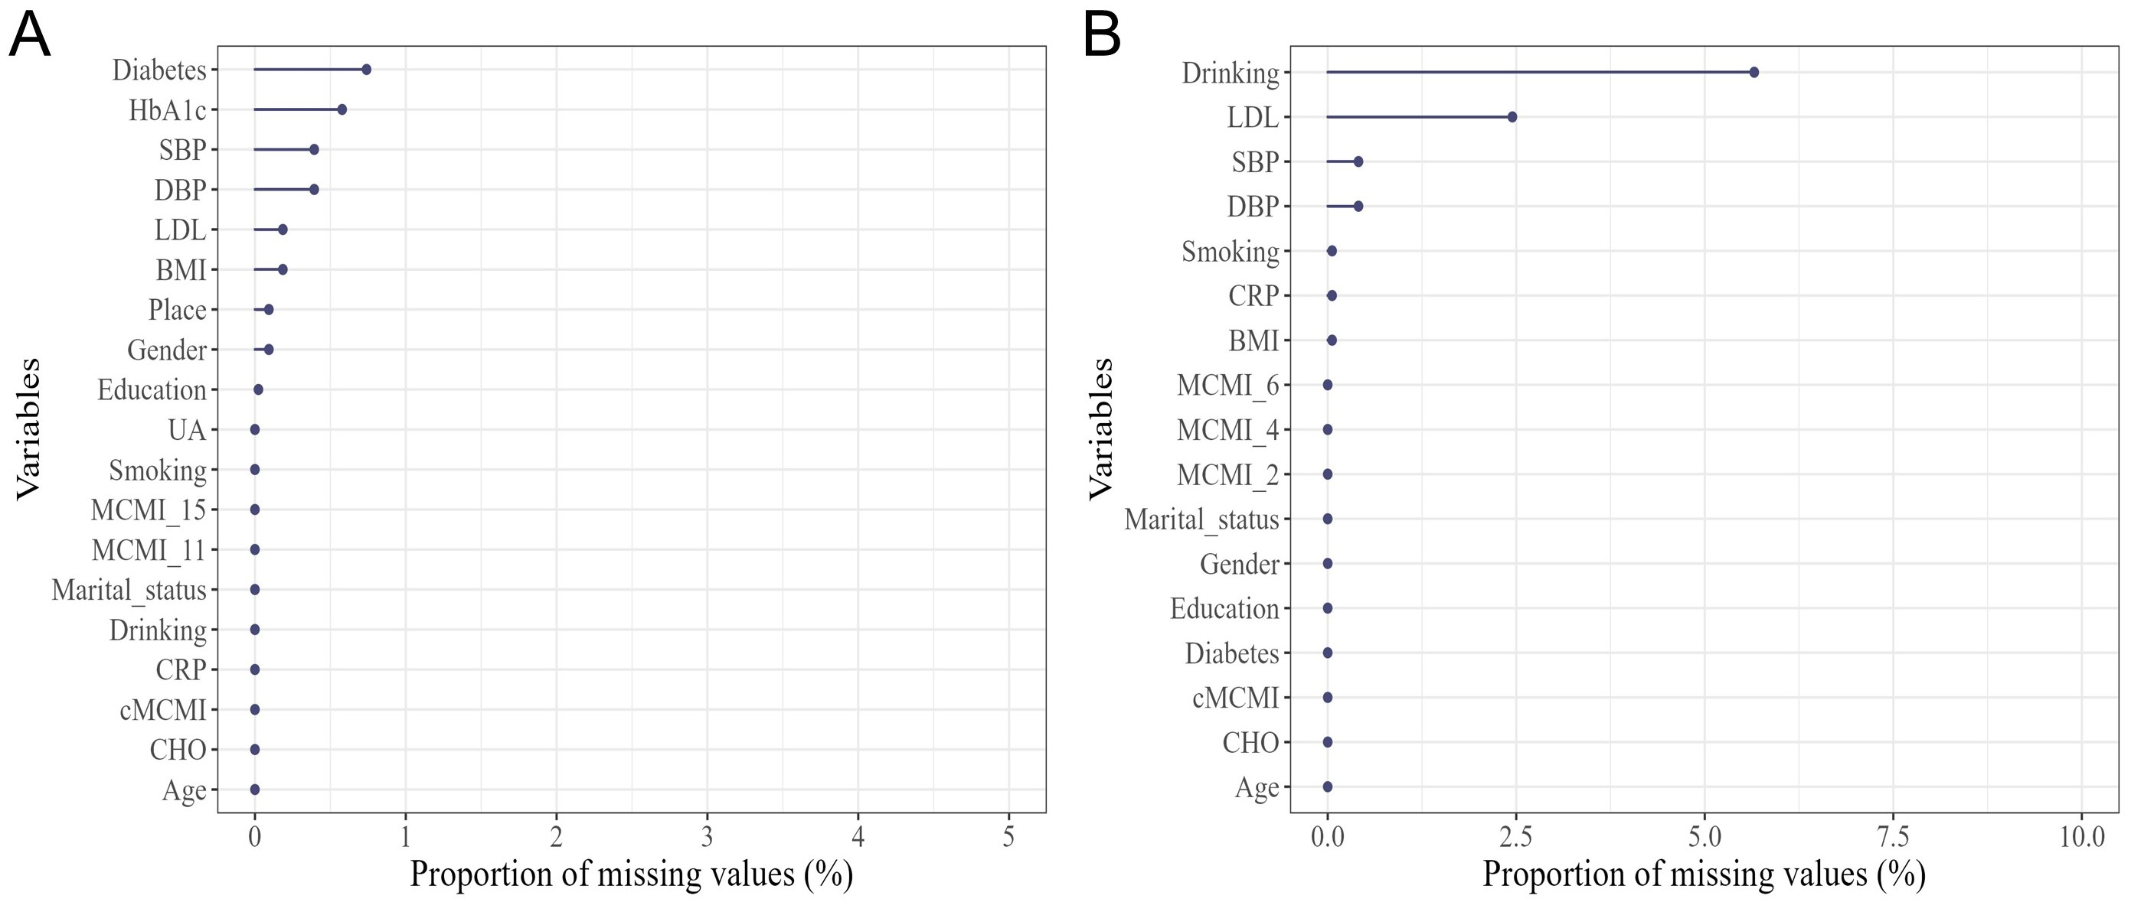
Figure S3 The proportion of missing value in CHARLS and ELSA datasets.
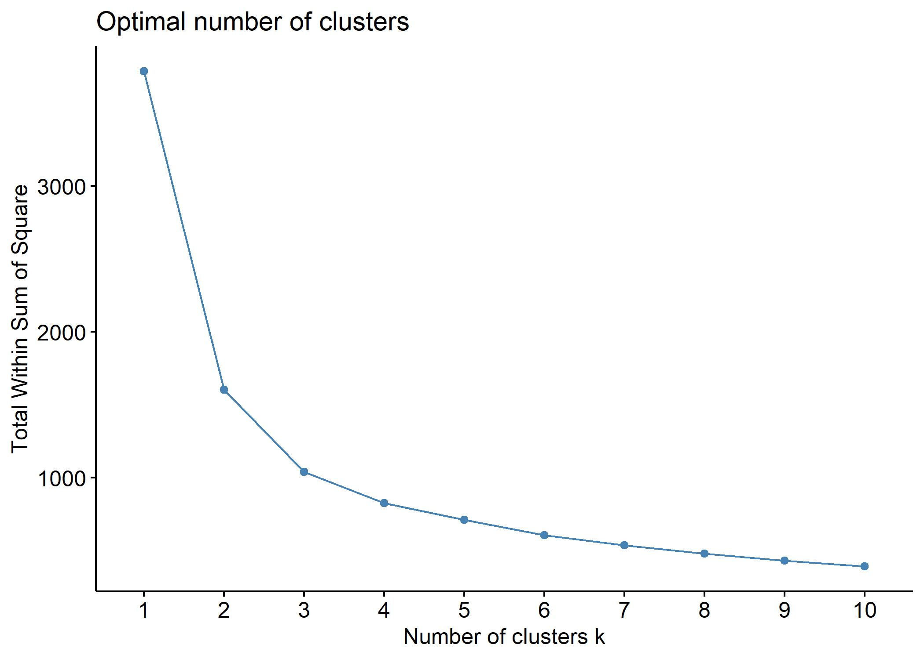
Figure S4 The relationship between the sum of squared errors (SSE) and the number of clusters (k) in K-means clustering. The “elbow point”—the inflection point where the rate of decrease in the SSE value suddenly drops—indicates the optimal number of clusters (k).

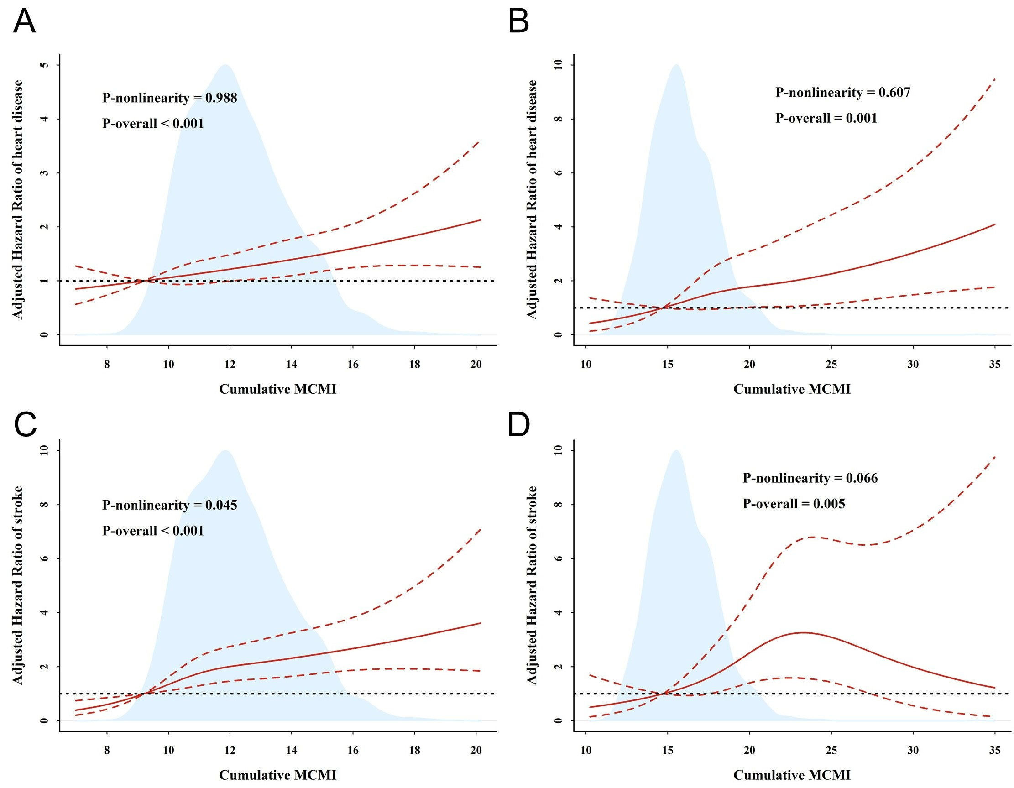
Figure S5 The dose-response relationship between cumulative modified cardiometabolic index and the risk of incident heart disease (A, B) and stroke (C, D) in CHARLS (A, C) and ELSA (B, D). The analysis was conducted using a 4-node restricted cubic spline model, which accounted for the nonlinearity of cumulative MCMI, adjusting for all covariates, and using 12.5% as the reference value.

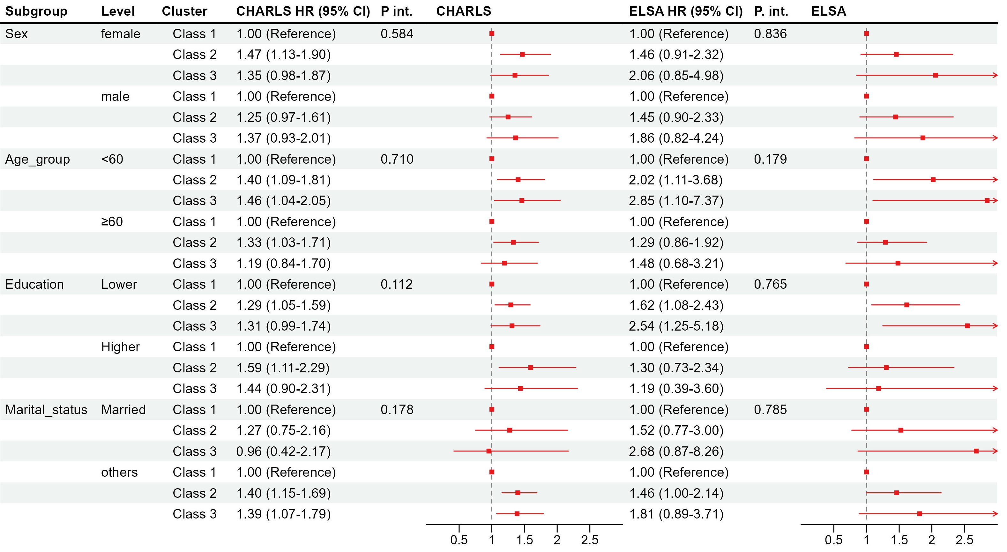
Figure S6 Association between modified cardiometabolic index and risk of incident cardiovascular disease in each subgroup population, using Cox model adjusted for all covariates in both CHARLS and ELSA. P.int. = P for interaction.

