Similar systemic but differential vaginal soluble mediator levels in injectable contraceptive users and impact of study site and STI prevalence
Alexis J. Bick^{1,#}, Chanel Avenant^{1,#}, Sigcinile Dlamini¹, Johnson Mosoko Moliki¹, Natalie Dicks¹, Elizna Maasdorp², Léanie Kleynhans^{3,4}, Jenni Smit⁵, G. Justus Hofmeyr^{6,7,8}, Charles Morrison⁹, Yu Hsin Tang, Pai-Lien Chen¹⁰, Janet P. Hapgood^{1,11,*, #}
¹Department of Molecular and Cell Biology, University of Cape Town, Cape Town, South Africa
²DSI-NRF Centre of Excellence for Biomedical Tuberculosis Research, Division of Immunology, Faculty of Medicine and Health Sciences, Stellenbosch University, Cape Town, South Africa; School for Data Science and Computational Thinking, Stellenbosch University, Cape Town, South Africa; Centre for Bioinformatics and Computational Biology, Stellenbosch University, Cape Town, South Africa
³Mater Research Institute - The University of Queensland, Translational Research Institute, Brisbane, Australia
⁴DSI-NRF Centre of Excellence for Biomedical Tuberculosis Research, South African Medical Research Council Centre for Tuberculosis Research, Division of Molecular Biology and Human Genetics, Faculty of Medicine and Health Sciences, Stellenbosch University, Cape Town, South Africa
⁵Wits MatCH Research Unit (MRU), Faculty of Health Sciences, Department of Obstetrics and Gynaecology, University of the Witwatersrand, Durban, South Africa
⁶Effective Care Research Unit, Eastern Cape Department of Health / Universities of the Witwatersrand and Fort Hare, East London, South Africa
⁷Walter Sisulu University, East London, South Africa
⁸Department of Obstetrics and Gynecology, University of Botswana, Gaborone, Botswana
⁹Independent Consultant, Chapel Hill, North Carolina, USA
¹⁰Family Health International (FHI) 360, Durham, North Carolina, USA
¹¹Institute of Infectious Disease and Molecular Medicine, University of Cape Town, Cape Town, South Africa

SUPPLEMENTARY DATA
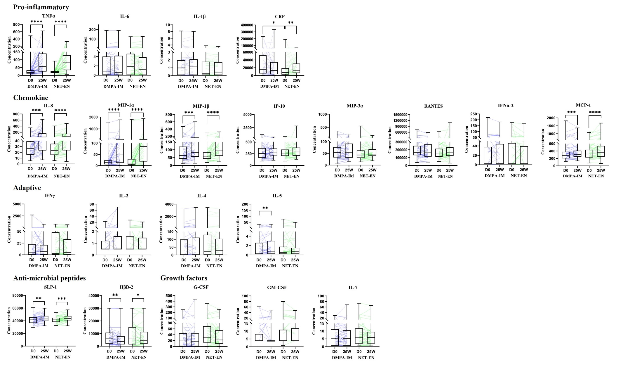
Fig. S1. Effects of injectable contraceptives on systemic soluble mediators at baseline (D0) and 25 weeks (25W). Boxplots represent median concentrations of 21 soluble mediators measured in serum at D0 and 25W following contraceptive initiation in women randomized to DMPA-IM (blue, n = 49) or NET-EN (green, n = 44) from the Durban site (Table S1). Concentration is represented as pg/mL for all soluble mediators apart from CRP which is represented as ng/mL. Boxes indicate interquartile range and error bars indicate range. Each coloured line represents one woman and immune mediator changes over time. *Within-group comparisons (D0 to 25W) were calculated using Wilcoxon paired signed-rank tests. #Between-group comparisons (DMPA-IM D0 vs NET-EN D0 and DMPA-IM 25W vs NET-EN 25W) were calculated using Mann-Whitney tests. Significance is indicated as **** p<0.0001, *** p<0.001, ** p<0.01, * or # p<0.05. Note that IFN-α2, IL-2, IL-4, GM-CSF had >50% of their levels below the limit of detection (LOD) and required imputation at one or both time points in serum, and thus these results should be interpreted with caution. TNF-α: tumor necrosis factor α, IL: interleukin, CRP: C-reactive protein, MIP: macrophage inflammatory protein, IP-10: interferon gamma-induced protein 10, RANTES: regulated on activation, normal T cell expressed and secreted, IFN: interferon, MCP-1: monocyte chemoattractant protein 1, SLPI: secretory leukocyte protease inhibitor, HβD-2: human beta-defensin 2, G-CSF: granulocyte-colony stimulating factor, GM-CSF: granulocyte-macrophage colony-stimulating factor.

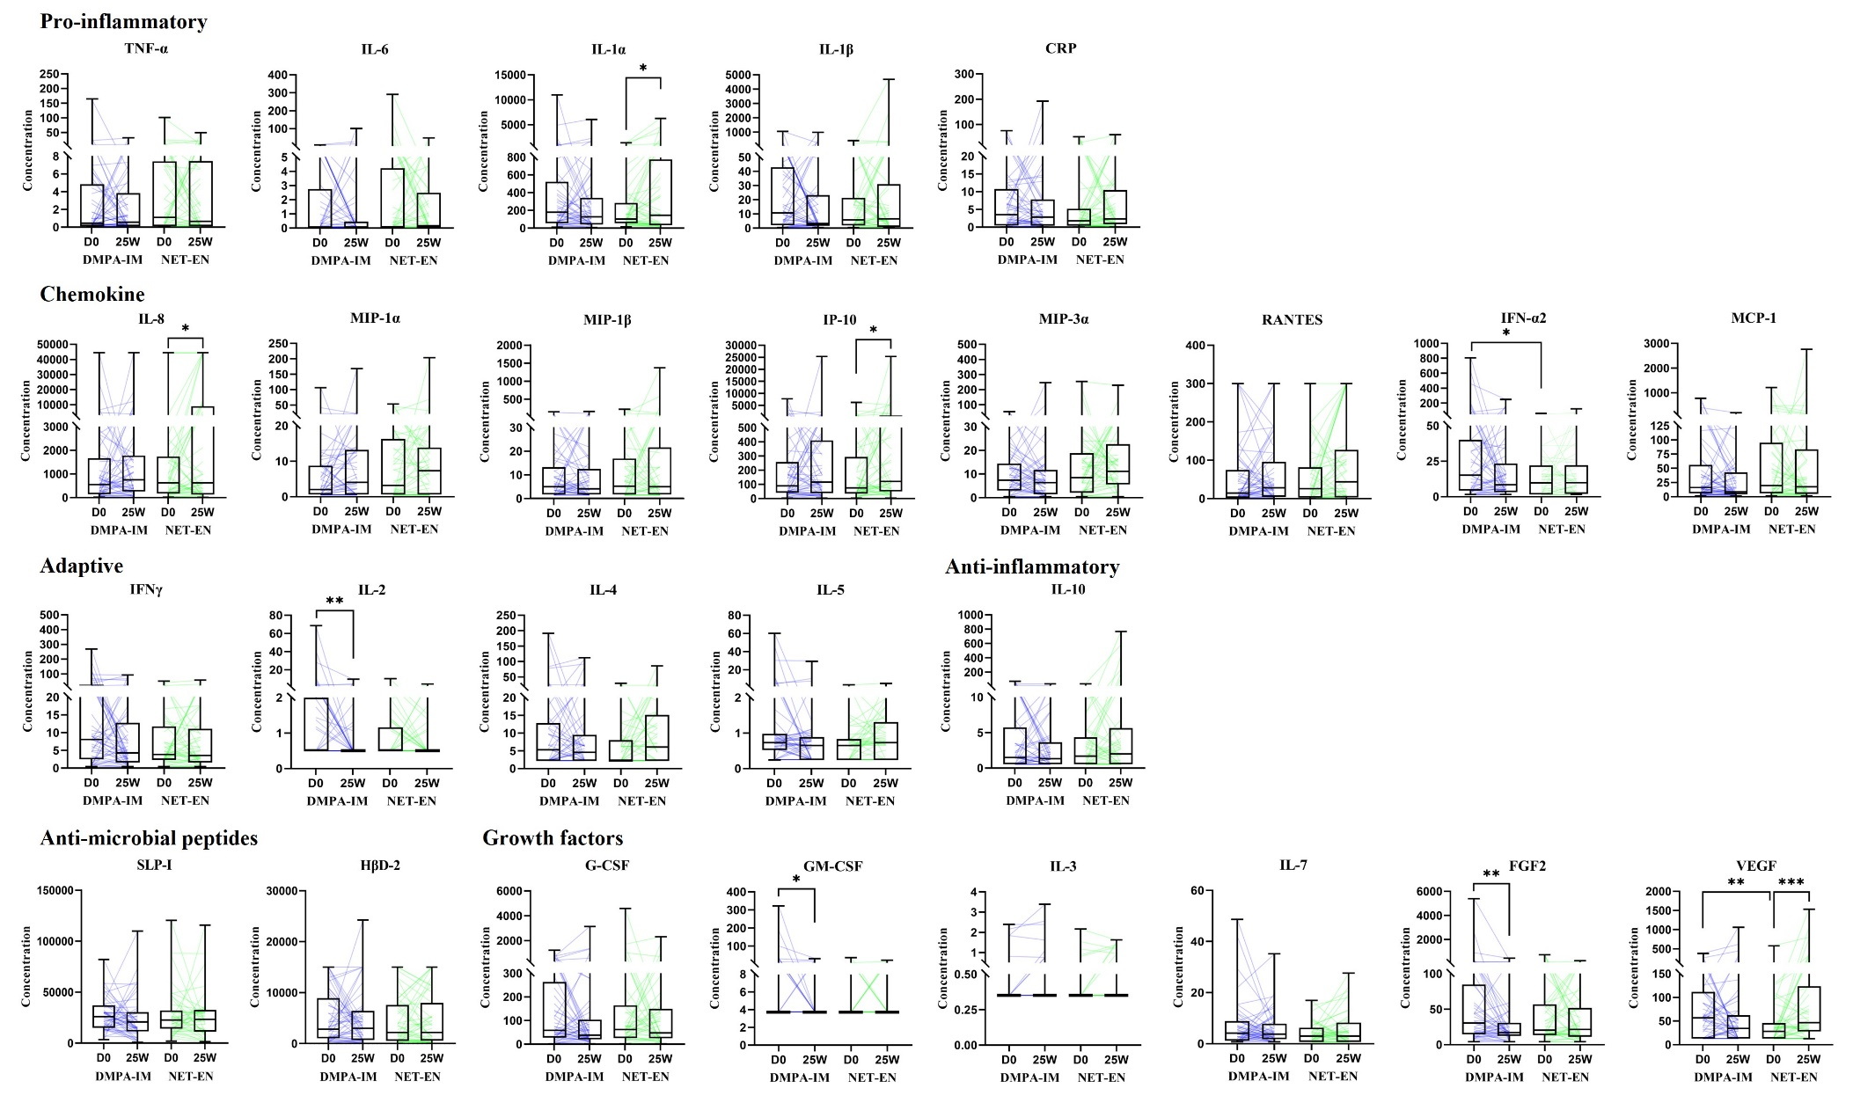
Fig. S2. Effects of injectable contraceptives on vaginal soluble mediators at baseline (D0) and 25 weeks (25W). Boxplots represent median concentrations of 26 vaginal soluble mediators at D0 and 25W following contraceptive initiation in women randomized to DMPA-IM (blue, n = 49) or NET-EN (green, n = 44) from the Durban site (Table S2). Concentration is represented as pg/mL for all soluble mediators apart from CRP and RANTES which are represented as ng/mL. Boxes indicate interquartile range and error bars indicate range. Each coloured line represents one woman and immune mediator changes over time. *Within-group comparisons (D0 to 25W) were calculated using Wilcoxon paired signed-rank tests. #Between-group comparisons (DMPA-IM D0 vs NET-EN D0 and DMPA-IM 25W vs NET-EN 25W) were calculated using Mann-Whitney tests. Significance is indicated as **** p<0.0001, *** p<0.001, ** or ## p<0.01, * or # p<0.05. Note that >50% of the values for GM-CSF, IL-2, IL-3, IL-4 and IL-6 were below the LOD and required imputation and thus should be interpreted cautiously. TNF-α: tumor necrosis factor α, IL: interleukin, CRP: C-reactive protein, MIP: macrophage inflammatory protein, IP-10: interferon gamma-induced protein 10, RANTES: regulated on activation, normal T cell expressed and secreted, IFN: interferon, MCP-1: monocyte chemoattractant protein 1, SLPI: secretory leukocyte protease inhibitor, HβD-2: human beta-defensin 2, G-CSF: granulocyte-colony stimulating factor, GM-CSF: granulocyte-macrophage colony-stimulating factor, FGF2: fibroblast growth factor 2, VEGF: vascular endothelial growth factor.

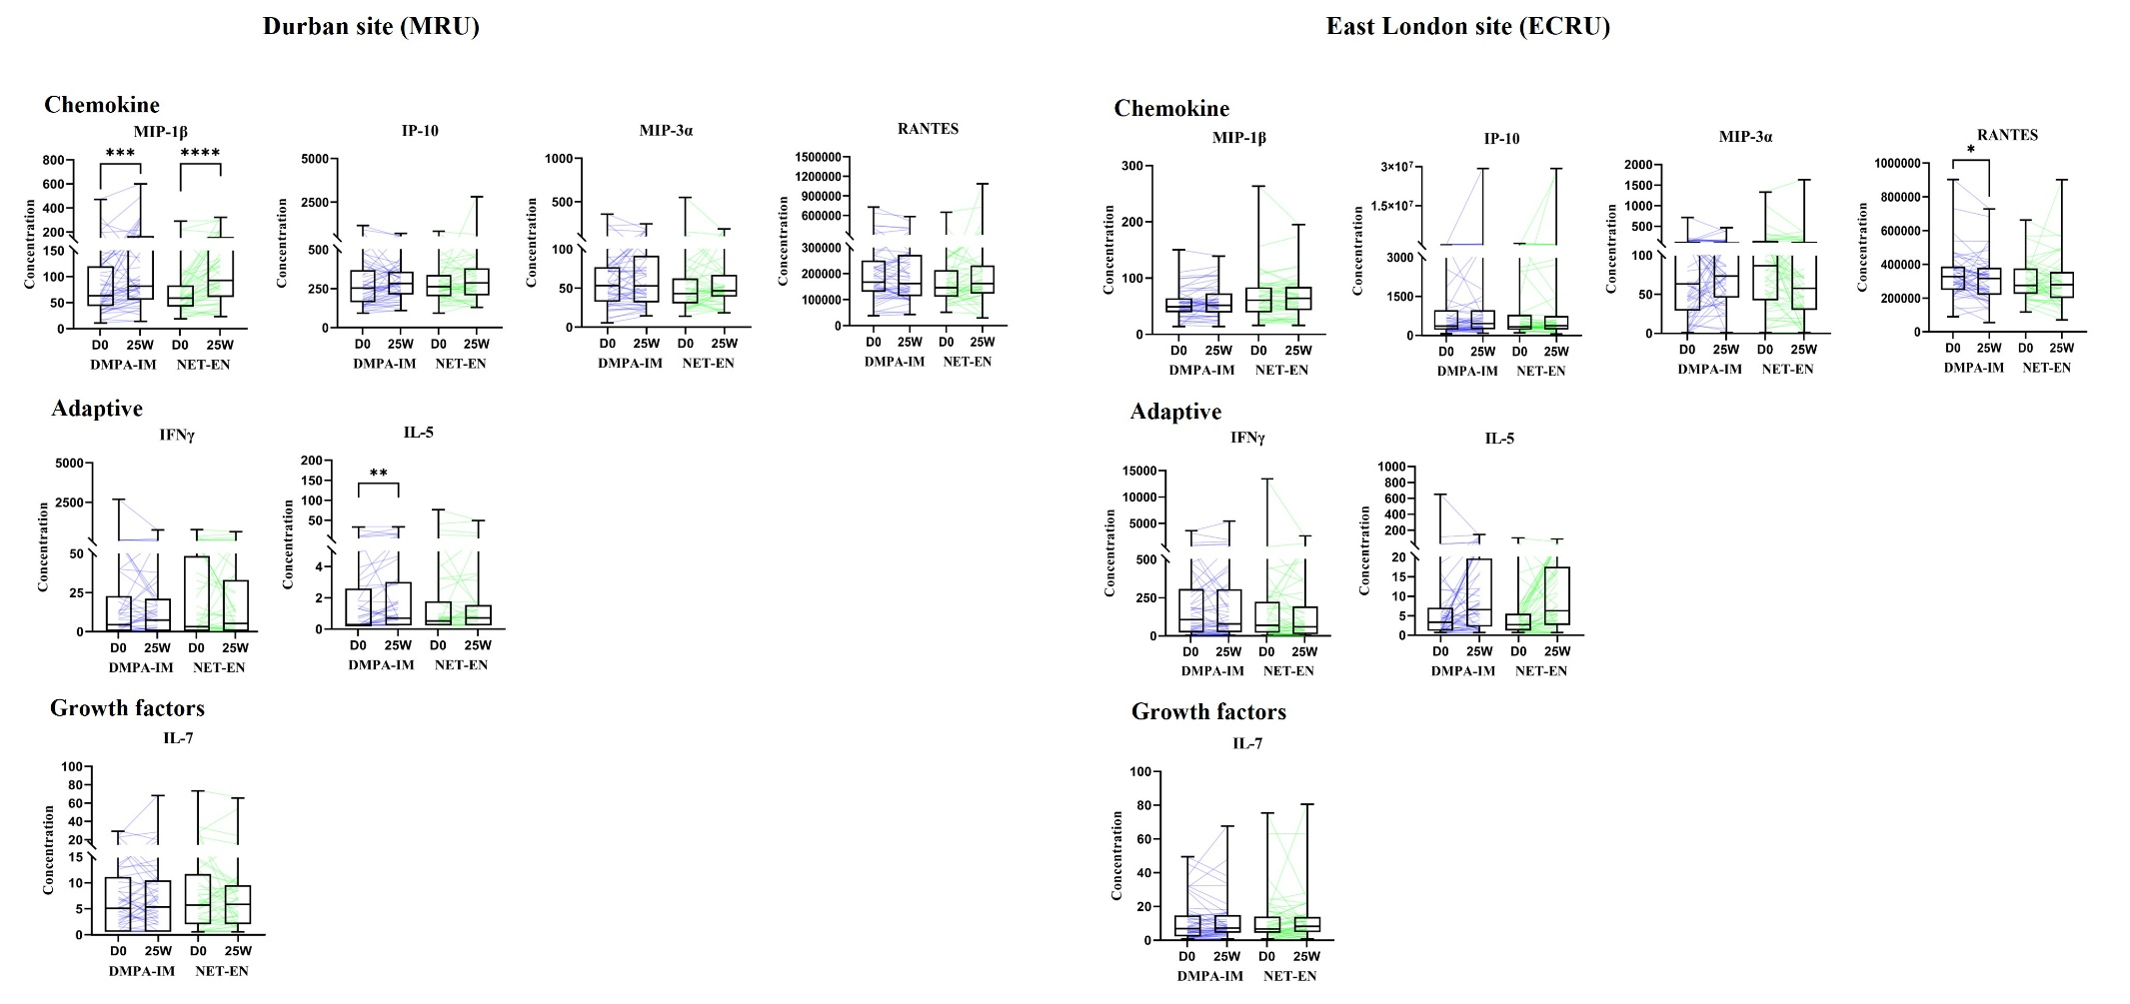
Fig. S3. Study site comparison of serum soluble mediators. Boxplots represent median concentrations of seven serum soluble mediators at D0 and 25W following contraceptive initiation in women randomized to DMPA-IM (blue, n = 42-50) or NET-EN (green, n = 35-50) at the Durban site (MRU, Table S1) and the East London site (ECRU, Table S3). Concentration is represented as pg/mL for all soluble mediators shown. Boxes indicate interquartile range and error bars indicate range. Each coloured line represents one woman and immune mediator changes over time. *Within-group comparisons (D0 to 25W) were calculated using Wilcoxon paired signed-rank tests. #Between-group comparisons (DMPA-IM D0 vs NET-EN D0 and DMPA-IM 25W vs NET-EN 25W) were calculated using Mann-Whitney tests. Significance is indicated as **** p<0.0001, *** p<0.001, ** or ## p<0.01, * or # p<0.05. TNF-α: tumor necrosis factor α, IL: interleukin, CRP: C-reactive protein, MIP: macrophage inflammatory protein, IP-10: interferon gamma-induced protein 10, RANTES: regulated on activation, normal T cell expressed and secreted, IFN: interferon, MCP-1: monocyte chemoattractant protein 1, SLPI: secretory leukocyte protease inhibitor, HβD-2: human beta-defensin 2, G-CSF: granulocyte-colony stimulating factor, GM-CSF: granulocyte-macrophage colony-stimulating factor, FGF2: fibroblast growth factor 2, VEGF: vascular endothelial growth factor.
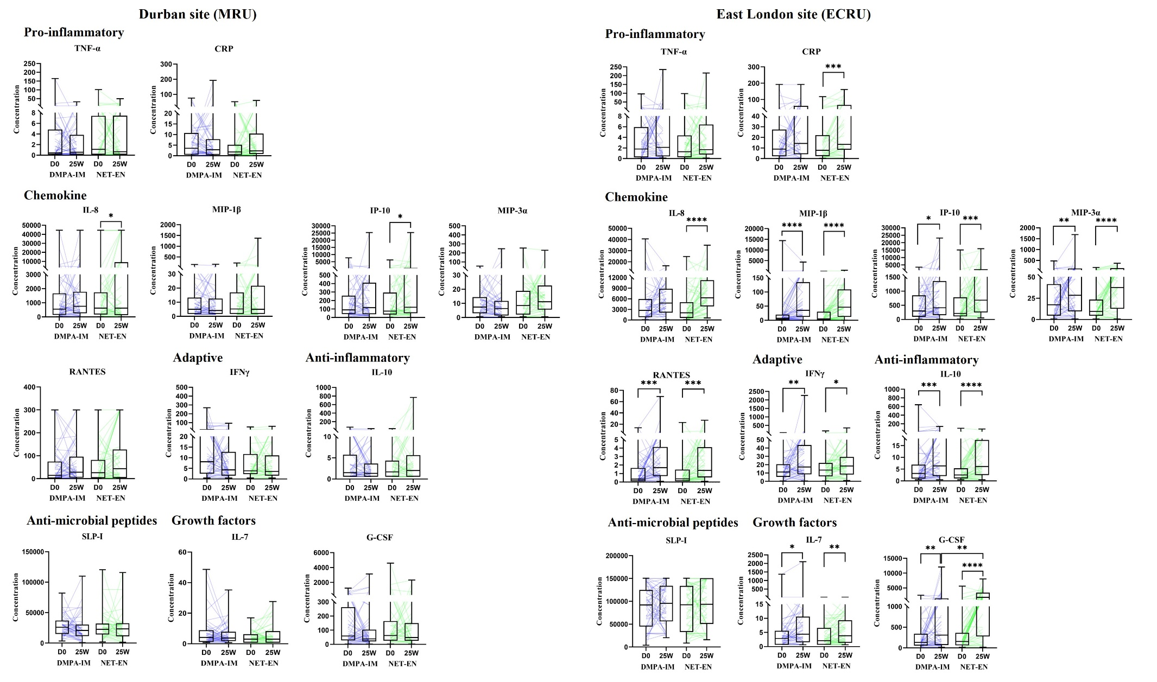
Fig. S4. Study site comparison of vaginal soluble mediators. Boxplots represent median concentrations of 12 vaginal soluble mediators at D0 and 25W following contraceptive initiation in women randomized to DMPA-IM (blue, n = 42-50) or NET-EN (green, n = 35-50) at the Durban site (MRU, Table S2) and the East London site (ECRU, Table S4). Concentration is represented as pg/mL for all soluble mediators apart from CRP and RANTES which are represented as ng/mL. Boxes indicate interquartile range and error bars indicate range. Each coloured line represents one woman and immune mediator changes over time. *Within-group comparisons (D0 to 25W) were calculated using Wilcoxon paired signed-rank tests. #Between-group comparisons (DMPA-IM D0 vs NET-EN D0 and DMPA-IM 25W vs NET-EN 25W) were calculated using Mann-Whitney tests. Significance is indicated as **** p<0.0001, *** p<0.001, ** or ## p<0.01, * or # p<0.05. TNF-α: tumor necrosis factor α, IL: interleukin, CRP: C-reactive protein, MIP: macrophage inflammatory protein, IP-10: interferon gamma-induced protein 10, RANTES: regulated on activation, normal T cell expressed and secreted, IFN: interferon, MCP-1: monocyte chemoattractant protein 1, SLPI: secretory leukocyte protease inhibitor, HβD-2: human beta-defensin 2, G-CSF: granulocyte-colony stimulating factor, GM-CSF: granulocyte-macrophage colony-stimulating factor, FGF2: fibroblast growth factor 2, VEGF: vascular endothelial growth factor.

