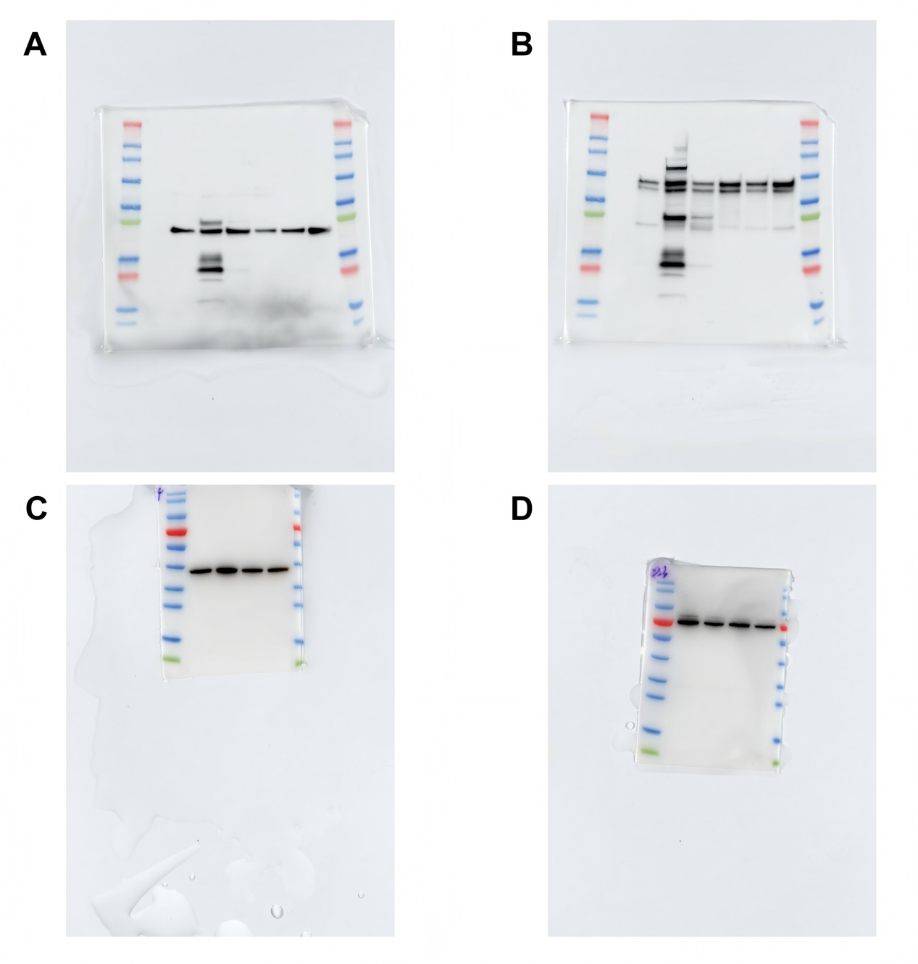

Supplementary Figure 4. uncropped PVDF membranes of western blot experiments.
- β-Actin, in various BC cells. From left to right, the names of the lanes are MCF-7, ZR-75-30, SKBR-3, BT-474, MDA-MB468 and MDA-MB453.
- MTDH, in BC cells. From left to right, the names of the lanes are MCF-7, ZR-75-30, SKBR-3, BT-474, MDA-MB468 and MDA-MB453.
- GAPDH，showed in the WB verification results of the lentivirus transfection experiment. From left to right, the names of the lanes are sh-NC, sh-MTDH-158, sh-MTDH-159 and sh-MTDH-160.
- MTDH, showed in the WB verification results of the lentivirus transfection experiment. From left to right, the names of the lanes are sh-NC, sh-MTDH-158, sh-MTDH-159 and sh-MTDH-160.

