The relationship between stress and sleep quality: An intensive longitudinal study

Supplementary Materials

Table S1
Between-Person Bivariate Correlations for Stress and Sleep Quality Indicators
 | Daily Stress | Mean Momentary Stress | AddHRVr | Subjective Sleep Quality | Sleep Onset Latency | Wake After Sleep Onset | Sleep Efficiency | Total Sleep Time
Daily Stress
Mean Momentary Stress | 0.45***
AddHRVr | 0.09* | 0.10*
Subjective Sleep Quality | -0.41*** | -0.26*** | 0.08*
Sleep Onset Latency | -0.05 | 0.12** | -0.12** | 0.14***
Wake After Sleep Onset | -0.12*** | -0.09* | 0.17*** | 0.18*** | -0.16***
Sleep Efficiency | -0.12** | -0.01 | 0.17*** | 0.23*** | 0.52*** | 0.80***
Total Sleep Time | -0.11** | -0.16*** | 0.11** | 0.17*** | 0.07* | 0.61*** | 0.64***
Note. Bivariate Spearman correlations at the between-person level between stress and sleep quality measures. AddHRVr = additional heart rate variability reductions adjusted for physical activity (Rominger & Schwerdtfeger et al., 2022). For this table, sleep onset latency and wake after sleep onset were recoded, so higher values are indicative of better sleep quality, *p < .05; **p < .01; ***p < .001.

Table S2
Descriptive Comparison of Different Operationalizations of Nocturnal Timeframes
Objective Sleep Quality Indicator | Mean | SD | Min | Max | Missing
Sleep Onset Latency in Minutes
Self-reported Nocturnal Timeframe | 20.45 | 28.60 | 0 | 254 | 24.66%
Fixed Nocturnal Timeframe | 119.20 | 90.05 | 0 | 609 | 18.06%
Accelerometry-Based Nocturnal Timeframe | 20.68 | 22.85 | 0 | 158 | 18.19%
Wake After Sleep Onset in Minutes
Self-reported Nocturnal Timeframe | 29.77 | 39.85 | 0 | 508 | 19.25%
Fixed Nocturnal Timeframe | 56.10 | 74.96 | 0 | 482 | 18.06%
Accelerometry-Based Nocturnal Timeframe | 22.89 | 27.10 | 0 | 167 | 23.32%
Sleep Efficiency in Percentage
Self-reported Nocturnal Timeframe | 87.60 | 10.35 | 32.50 | 100 | 24.66%
Fixed Nocturnal Timeframe | 53.91 | 12.34 | 0.14 | 85.02 | 18.06%
Accelerometry-Based Nocturnal Timeframe | 87.45 | 9.60 | 11.11 | 100 | 18.19%
Total Sleep Time in Hours
Self-reported Nocturnal Timeframe | 7.27 | 1.41 | 1.97 | 13.82 | 24.66%
Fixed Nocturnal Timeframe | 7.46 | 1.70 | 0.02 | 11.92 | 18.06%
Accelerometry-Based Nocturnal Timeframe | 7.07 | 1.75 | 0.02 | 14.55 | 18.19%
Note. Descriptive statistics are presented for the observed, unimputed values of four objective sleep indicators across three different operationalizations of nocturnal timeframes: self-reported, fixed (10 p.m. to noon), and accelerometry-based. Only participants with at least four days of valid data per indicator were included. Missingness reflects the percentage of days with unavailable data within each operationalization.
Table S3
Model Results for Different Nocturnal Timeframes
 | Self-Reported Timeframe | Fixed Timeframe | Accelerometry-Based Timeframe
Variables | Coefficient [95% CrI] | Coefficient [95% CrI] | Coefficient [95% CrI]
Stress → Sleep Quality
Sleep Onset Latency
Daily Stress
Within-person | 0.01 [-0.04, 0.05] | 0.76 [-1.17, 2.61] | 0.00 [-0.02, 0.03]
Between-person | 0.02 [-0.01, 0.06] | 1.92 [0.19, 3.69] | 0.02 [-0.01, 0.05]
Mean Momentary Stress
Within-person | -0.01 [-0.05, 0.04] | 2.03 [-0.27, 4.28] | 0.01 [-0.02, 0.05]
Between-person | -0.02 [-0.06, 0.02] | 1.35 [-0.62, 3.35] | -0.01 [-0.04, 0.02]
AddHRVr
Within-person | 0.00 [-0.03, 0.03] | -0.20 [-1.47, 1.11] | -0.01 [-0.02, 0.01]
Between-person | 0.01 [-0.02, 0.04] | -0.63 [-2.22, 0.91] | -0.01 [-0.03, 0.01]
Wake After Sleep Onset
Daily Stress
Within-person | -0.01 [-0.05, 0.02] | -0.00 [-0.04, 0.04] | -0.02 [-0.06, 0.01]
Between-person | 0.01 [-0.02, 0.04] | 0.02 [-0.02, 0.05] | 0.02 [-0.01, 0.06]
Mean Momentary Stress
Within-person | -0.01 [-0.06, 0.03] | 0.01 [-0.04, 0.06] | 0.01 [-0.04, 0.05]
Between-person | 0.01 [-0.02, 0.05] | 0.02 [-0.01, 0.06] | 0.01 [-0.02, 0.05]
AddHRVr
Within-person | -0.00 [-0.02, 0.02] | 0.00 [-0.02, 0.03] | 0.02 [-0.00, 0.04]
Between-person | -0.01 [-0.04, 0.01] | -0.01 [-0.04, 0.01] | -0.02 [-0.04, 0.01]
Sleep Efficiency
Daily Stress
Within-person | -0.02 [-0.24, 0.20] | -0.12 [-0.38, 0.15] | -0.07 [-0.23, 0.09]
Between-person | -0.15 [-0.42, 0.13] | -0.09 [-0.37, 0.20] | -0.06 [-0.22, 0.09]
Mean Momentary Stress
Within-person | 0.07 [-0.14, 0.28] | -0.15 [-0.47, 0.18] | -0.03 [-0.23, 0.18]
Between-person | -0.10 [-0.43, 0.22] | -0.09 [-0.40, 0.22] | 0.00 [-0.18, 0.19]
AddHRVr
Within-person | -0.02 [-0.13, 0.09] | -0.11 [-0.27, 0.06] | -0.05 [-0.16, 0.05]
Between-person | 0.18 [-0.02, 0.39] | 0.22 [-0.02, 0.45] | 0.11 [-0.02, 0.23]
Total Sleep Time
Daily Stress
Within-person | -0.67 [-2.78, 1.43] | -0.96 [-3.10, 1.26] | 0.24 [-1.91, 2.45]
Between-person | -2.31 [-4.68, 0.05] | -0.80 [-3.31, 1.65] | -0.33 [-3.12, 2.46]
Mean Momentary Stress
Within-person | -1.03 [-3.54, 1.45] | -1.30 [-4.06, 1.38] | -0.68 [-3.45, 2.11]
Between-person | -1.40 [-3.88, 1.06] | -0.76 [-3.43, 1.83] | 0.11 [-3.51, 3.76]
AddHRVr
Within-person | -0.39 [-1.67, 0.86] | -0.90 [-2.35, 0.50] | -1.01 [-2.51, 0.49]
Between-person | 1.59 [-0.24, 3.48] | 1.82 [-0.11, 3.73] | 1.82 [-0.53, 4.22]
Sleep Quality → Stress
Sleep Onset Latency
Daily Stress
Within-person | 0.01 [-0.02, 0.04] | -0.00 [-0.01, 0.01] | -0.00 [-0.04, 0.03]
Between-person | 0.01 [-0.04, 0.05] | 0.01 [-0.01, 0.02] | 0.01 [-0.06, 0.07]
Mean Momentary Stress
Within-person | 0.01 [-0.02, 0.04] | -0.01 [-0.02, -0.01] | -0.02 [-0.04, 0.01]
Between-person | -0.03 [-0.08, 0.01] | 0.00 [-0.01, 0.01] | -0.01 [-0.06, 0.03]
AddHRVr
Within-person | 0.02 [-0.03, 0.06] | -0.01 [-0.02, 0.00] | -0.02 [-0.07, 0.03]
Between-person | 0.00 [-0.07, 0.08] | -0.01 [-0.02, 0.01] | -0.03 [-0.13, 0.06]
Wake After Sleep Onset
Daily Stress
Within-person | -0.01 [-0.04, 0.02] | 0.00 [-0.01, 0.02] | -0.01 [-0.05, 0.02]
Between-person | 0.01 [-0.02, 0.04] | 0.01 [-0.01, 0.03] | 0.01 [-0.02, 0.04]
Mean Momentary Stress
Within-person | 0.01 [-0.01, 0.02] | 0.00 [-0.01, 0.01] | 0.00 [-0.02, 0.03]
Between-person | 0.01 [-0.02, 0.04] | 0.00 [-0.01, 0.02] | -0.01 [-0.04, 0.02]
AddHRVr
Within-person | 0.00 [-0.03, 0.03] | 0.00 [-0.01, 0.02] | -0.00 [-0.05, 0.04]
Between-person | -0.03 [-0.08, 0.02] | -0.01 [-0.04, 0.01] | -0.02 [-0.06, 0.03]
Sleep Efficiency
Daily Stress
Within-person | -0.06 [-0.16, 0.04] | 0.01 [-0.05, 0.07] | 0.00 [-0.09, 0.10]
Between-person | -0.01 [-0.11, 0.08] | -0.07 [-0.20, 0.06] | -0.04 [-0.14, 0.05]
Mean Momentary Stress
Within-person | -0.06 [-0.14, 0.01] | -0.00 [-0.05, 0.04] | -0.00 [-0.06, 0.06]
Between-person | -0.01 [-0.08, 0.07] | -0.02 [-0.13, 0.08] | 0.04 [-0.05, 0.13]
AddHRVr
Within-person | 0.06 [-0.06, 0.20] | 0.04 [-0.04, 0.12] | 0.08 [-0.03, 0.21]
Between-person | 0.15 [-0.02, 0.32] | 0.12 [-0.04, 0.28] | 0.06 [-0.09, 0.21]
Total Sleep Time
Daily Stress
Within-person | -0.00 [-0.01, 0.01] | 0.00 [-0.01, 0.01] | -0.00 [-0.01, 0.01]
Between-person | -0.01 [-0.03, -0.00] | -0.01 [-0.02, 0.01] | -0.00 [-0.02, 0.01]
Mean Momentary Stress
Within-person | -0.00 [-0.01, 0.01] | -0.00 [-0.01, 0.01] | -0.00 [-0.01, 0.00]
Between-person | -0.00 [-0.02, 0.01] | 0.002 [-0.01, 0.01] | 0.00 [-0.01, 0.01]
AddHRVr
Within-person | -0.00 [-0.01, 0.01] | 0.01 [-0.01, 0.02] | 0.00 [-0.01, 0.01]
Between-person | 0.02 [-0.01, 0.04] | 0.01 [-0.01, 0.03] | 0.01 [-0.00, 0.02]
Note. CrI = credible interval, AddHRVr = additional heart rate variability reductions, for bold numbers the credible interval did not include zero. Sleep onset latency and wake after sleep onset were estimated using negative binomial models with a log link. Coefficients are reported on the log scale; positive coefficients indicate longer sleep onset latency or wake after sleep onset, and negative coefficients indicate shorter sleep onset latency or wake after sleep onset.
Figure S1
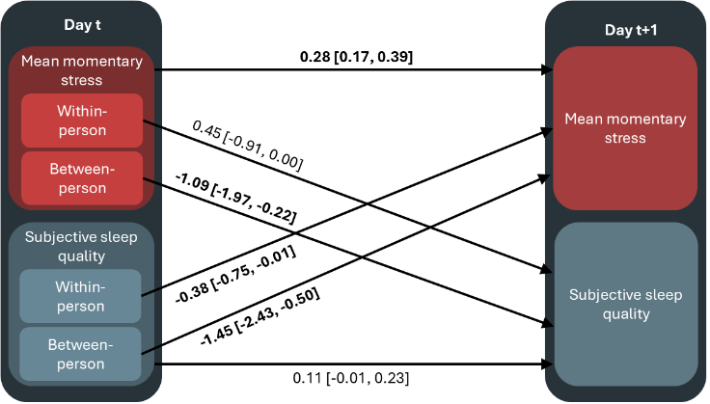
Sensitivity Analysis for Stress and Subjective Sleep Quality Including Complete-Case Analysis
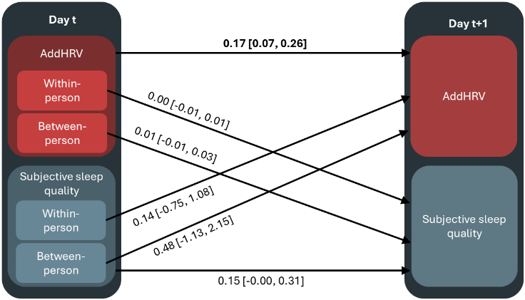
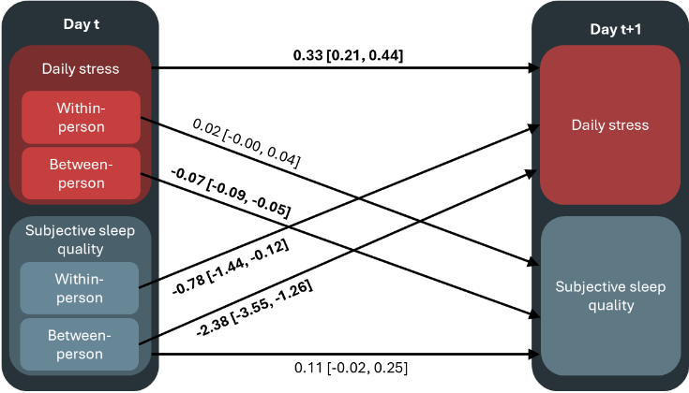
A B
C
Note. Panel A shows associations for daily stress (N = 100; k = 378 observations), panel B for mean momentary stress (N = 102; k = 503 observations), and panel C for additional heart rate variability reductions (AddHRVr; N = 83; k = 347 observations). Concerning random effects, participants showed variability in average subjective sleep quality (SD = 0.15 for the daily stress model, SD = 0.35 for the mean momentary stress model, and SD = 0.31 for the AddHRVr model), daily perceived stress (SD = 1.96 on a 0–40 scale), mean momentary stress (SD = 0.91 on a 0–40 scale), and AddHRVr (SD = 1.66). Day-level changes in these variables varied across individuals (SD = 0.34 for daily stress, SD = 0.52 for mean momentary stress, and SD = 0.83 for AddHRVr) but not for subjective sleep quality. Standard deviations of participant-specific slopes showed variability in how subjective sleep quality predicted next-day stress (SD = 0.74 for daily stress, SD = 0.34 for mean momentary stress, and SD = 0.64 for AddHRVr) but not for how prior stress predicted subsequent subjective sleep quality.

Figure S2
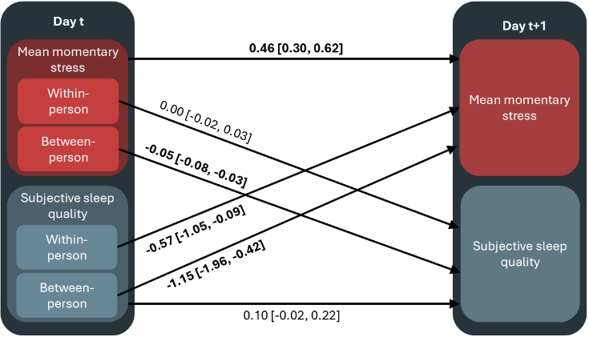
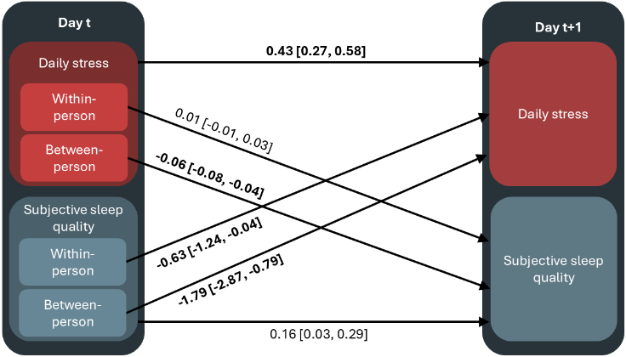
Sensitivity Analysis for Stress and Subjective Sleep Quality Including Covariates
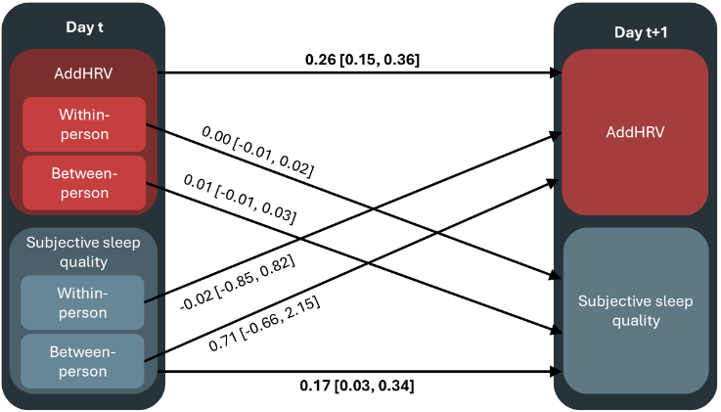
A B
C
Note. Panel A shows associations for daily stress (N = 99; k = 452 observations), panel B for mean momentary stress (N = 100; k = 457 observations), and panel C for additional heart rate variability reductions (AddHRVr; N = 84; k = 376 observations). Concerning random effects, participants showed variability in average subjective sleep quality (SD = 0.19–0.38 across models), daily perceived stress (SD = 1.35 on a 0–40 scale), mean momentary stress (SD = 1.39 on a 0–40 scale), and AddHRVr (SD = 1.13). Day-level changes in these variables varied across individuals (SD = 0.28 for daily stress, SD = 0.18 for mean momentary stress, and SD = 0.69 for AddHRVr) but not for subjective sleep quality. Standard deviations of participant-specific slopes showed variability in how subjective sleep quality predicted next-day stress (SD = 0.48 for daily stress, SD = 0.82 for mean momentary stress, SD = 0.64 for AddHRVr) but not for how prior stress predicted subsequent subjective sleep quality.

Table S4
Model Results for Sensitivity Analyses
 | Self-Reported Timeframe Main Analysis | Self-Reported Timeframe Complete-Case Analysis | Self-Reported Timeframe Including Covariates
Variables | Coefficient [95% CrI] | Coefficient [95% CrI] | Coefficient [95% CrI]
Stress → Sleep Quality
Sleep Onset Latency
Daily Stress
Within-person | 0.01 [-0.04, 0.05] | 0.01 [-0.03, 0.05] | 0.01 [-0.04, 0.05]
Between-person | 0.02 [-0.01, 0.06] | 0.01 [-0.02, 0.05] | 0.03 [-0.01, 0.06]
Mean Momentary Stress
Within-person | -0.01 [-0.05, 0.04] | 0.01 [-0.03, 0.05] | -0.00 [-0.06, 0.05]
Between-person | -0.02 [-0.06, 0.02] | -0.01 [-0.03, 0.05] | -0.04 [-0.05, 0.02]
AddHRVr
Within-person | 0.00 [-0.03, 0.03] | -0.00 [-0.03, 0.02] | 0.00 [-0.03, 0.03]
Between-person | 0.01 [-0.02, 0.04] | 0.01 [-0.02, 0.04] | 0.01 [-0.02, 0.04]
Wake After Sleep Onset
Daily Stress
Within-person | -0.01 [-0.05, 0.02] | -0.02 [-0.06, 0.02] | -0.01 [-0.05, 0.02]
Between-person | 0.01 [-0.02, 0.04] | 0.01 [-0.02, 0.05] | 0.01 [-0.02, 0.05]
Mean Momentary Stress
Within-person | -0.01 [-0.06, 0.03] | -0.02 [-0.06, 0.02] | -0.01 [-0.05, 0.04]
Between-person | 0.01 [-0.02, 0.05] | 0.02 [-0.02, 0.06] | 0.01 [-0.02, 0.05]
AddHRVr
Within-person | -0.00 [-0.02, 0.02] | 0.01 [-0.01, 0.03] | -0.00 [-0.03, 0.04]
Between-person | -0.01 [-0.04, 0.01] | -0.03 [-0.06, 0.00] | -0.03 [-0.08, 0.02]
Sleep Efficiency
Daily Stress
Within-person | -0.02 [-0.24, 0.20] | 0.00 [-0.23, 0.23] | -0.01 [-0.24, 0.23]
Between-person | -0.15 [-0.42, 0.13] | -0.05 [-0.39, 0.30] | -0.17 [-0.45, 0.11]
Mean Momentary Stress
Within-person | 0.07 [-0.14, 0.28] | 0.04 [-0.15, 0.23] | 0.05 [-0.17, 0.27]
Between-person | -0.10 [-0.43, 0.22] | 0.06 [-0.33, 0.44] | -0.12 [-0.43, 0.17]
AddHRVr
Within-person | -0.02 [-0.13, 0.09] | -0.09 [-0.19, 0.02] | -0.02 [-0.13, 0.10]
Between-person | 0.18 [-0.02, 0.39] | 0.17 [-0.04, 0.41] | 0.18 [-0.02, 0.39]
Total Sleep Time
Daily Stress
Within-person | -0.67 [-2.78, 1.43] | -0.31 [-2.66, 2.11] | -0.84 [-3.11, 1.45]
Between-person | -2.31 [-4.68, 0.05] | -1.23 [-3.52, 1.02] | -1.72 [-4.33, 0.76]
Mean Momentary Stress
Within-person | -1.03 [-3.54, 1.45] | -0.45 [-2.49, 1.54] | -1.38 [-4.02, 1.20]
Between-person | -1.40 [-3.88, 1.06] | -1.83 [-4.49, 0.74] | -1.53 [-3.98, 0.77]
AddHRVr
Within-person | -0.39 [-1.67, 0.86] | -0.46 [-1.90, 0.93] | -0.29 [-1.67, 1.06]
Between-person | 1.59 [-0.24, 3.48] | 1.30 [-0.33, 3.01] | 1.48 [-0.36, 3.39]
Sleep Quality → Stress
Sleep Onset Latency
Daily Stress
Within-person | 0.01 [-0.02, 0.04] | 0.02 [-0.00, 0.05] | 0.01 [-0.03, 0.04]
Between-person | 0.01 [-0.04, 0.05] | -0.01 [-0.06, 0.03] | 0.01 [-0.04, 0.06]
Mean Momentary Stress
Within-person | 0.01 [-0.02, 0.04] | 0.01 [-0.01, 0.04] | 0.01 [-0.01, 0.04]
Between-person | -0.03 [-0.08, 0.01] | -0.01 [-0.05, 0.02] | -0.04 [-0.08, 0.00]
AddHRVr
Within-person | 0.02 [-0.03, 0.06] | 0.01 [-0.03, 0.04] | 0.01 [-0.03, 0.06]
Between-person | 0.00 [-0.07, 0.08] | -0.03 [-0.08, 0.03] | 0.00 [-0.08, 0.08]
Wake After Sleep Onset
Daily Stress
Within-person | -0.01 [-0.04, 0.02] | -0.01 [-0.04, 0.02] | -0.01 [-0.04, 0.02]
Between-person | 0.01 [-0.02, 0.04] | 0.01 [-0.02, 0.05] | 0.02 [-0.02, 0.05]
Mean Momentary Stress
Within-person | 0.01 [-0.01, 0.02] | 0.00 [-0.02, 0.02] | 0.00 [-0.01, 0.02]
Between-person | 0.01 [-0.02, 0.04] | -0.01 [-0.03, 0.01] | 0.01 [-0.02, 0.04]
AddHRVr
Within-person | 0.00 [-0.03, 0.03] | -0.01 [-0.04, 0.01] | 0.005 [-0.03, 0.04]
Between-person | -0.03 [-0.08, 0.02] | -0.04 [-0.09, 0.02] | -0.03 [-0.08, 0.02]
Sleep Efficiency
Daily Stress
Within-person | -0.06 [-0.16, 0.04] | -0.03 [-0.12, 0.07] | -0.06 [-0.16, 0.04]
Between-person | -0.01 [-0.11, 0.08] | 0.02 [-0.09, 0.13] | -0.02 [-0.13, 0.08]
Mean Momentary Stress
Within-person | -0.06 [-0.14, 0.01] | -0.04 [-0.11, 0.03] | -0.06 [-0.14, 0.01]
Between-person | -0.01 [-0.08, 0.07] | 0.03 [-0.04, 0.10] | -0.01 [-0.09, 0.07]
AddHRVr
Within-person | 0.06 [-0.06, 0.20] | 0.10 [-0.02, 0.24] | 0.07 [-0.06, 0.20]
Between-person | 0.15 [-0.02, 0.32] | 0.12 [-0.03, 0.26] | 0.16 [0.00, 0.33]
Total Sleep Time
Daily Stress
Within-person | -0.00 [-0.01, 0.01] | -0.00 [-0.01, 0.01] | -0.00 [-0.01, 0.01]
Between-person | -0.01 [-0.03, -0.00] | -0.01 [-0.02, 0.01] | -0.01 [-0.03, 0.00]
Mean Momentary Stress
Within-person | -0.00 [-0.01, 0.01] | 0.00 [-0.00, 0.01] | -0.00 [-0.01, 0.01]
Between-person | -0.00 [-0.02, 0.01] | -0.01 [-0.02, 0.00] | -0.00 [-0.02, 0.01]
AddHRVr
Within-person | -0.00 [-0.01, 0.01] | -0.00 [-0.01, 0.01] | 0.00 [-0.01, 0.01]
Between-person | 0.02 [-0.01, 0.04] | 0.02 [-0.00, 0.04] | 0.02 [-0.01, 0.04]
Note. CrI = credible interval, AddHRVr = additional heart rate variability reductions, for bold numbers the credible interval did not include zero. Sleep onset latency and wake after sleep onset were estimated using negative binomial models with a log link. Coefficients are reported on the log scale; positive coefficients indicate longer sleep onset latency or wake after sleep onset, and negative coefficients indicate shorter sleep onset latency or wake after sleep onset.

