Supplementary Table S1. Collinearity diagnostics for variables included in the multivariable linear regression model with LAP

Variable | Collinearity Statistics
Variable | Tolerance | VIF
SBP | 0.351 | 2.847
DBP | 0.343 | 2.916
FBS | 0.934 | 1.071
TC | 0.797 | 1.255
TG | 0.741 | 1.349
HDL | 0.866 | 1.154
LDL | 0.949 | 1.054
Insulin | 0.942 | 1.062
HbA1C | 0.924 | 1.082
AST | 0.329 | 3.044
ALT | 0.285 | 3.503
ALP | 0.641 | 1.561
Albumin | 0.899 | 1.112
Creatinine | 0.898 | 1.114
PLT | 0.935 | 1.069
WBC | 0.945 | 1.058
RBC | 0.938 | 1.066
HCT | 0.896 | 1.116
Hb | 0.944 | 1.060
MCHC | 0.918 | 1.089
MCH | 0.962 | 1.039
MCV | 0.983 | 1.017

LAP, lipid accumulation product; VIF, variance inflation factor. SBP, systolic blood pressure; DBP, diastolic blood pressure; FBS, fasting blood sugar; TC, Total cholesterol; TG. Triglyceride; HDL-C, high-density lipoprotein cholesterol; LDL-C, low-density lipoprotein cholesterol; HbA1c, glycated hemoglobin; ALT, alanine aminotransferase; AST, aspartate aminotransferase; ALP, alkaline phosphatase; PLT, platelet; WBC, white blood cell; RBC, red blood cell; HCT, hematocrit; MCHC, mean corpuscular hemoglobin concentration; MCH, mean corpuscular hemoglobin; MCV, mean corpuscular volume.

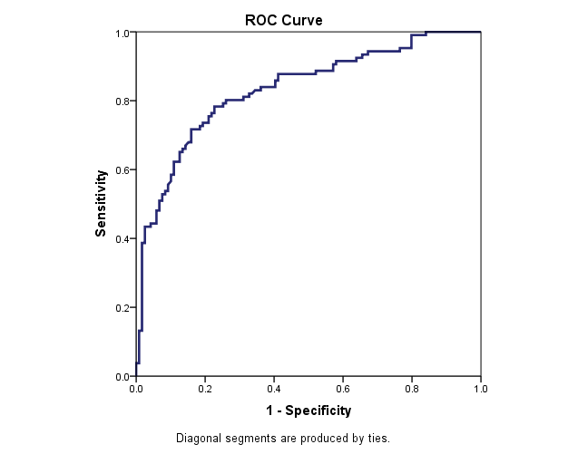
Supplementary Figure S1. Receiver operating characteristic (ROC) curve of the lipid accumulation product (LAP) for identifying metabolic syndrome. The ROC curve demonstrated good discriminatory performance of LAP, with an area under the curve (AUC) of 0.833 (95% CI: 0.779–0.887, P < 0.001). The optimal cutoff value, determined using the Youden index, was 49.23, yielding a sensitivity of 87.7% and a specificity of 55.5%

Supplementary Table S2. Receiver operating characteristic (ROC) analysis of LAP for identifying metabolic syndrome
Outcome | AUC (95% CI) | Optimal cutoff | Sensitivity (%) | Specificity (%) | Youden index | P-value
Metabolic syndrome | 0.833 (0.779–0.887) | 49.23 | 87.7 | 55.5 | 0.432 | <0.001
ROC, receiver operating characteristic; AUC, area under the curve; CI, confidence interval; LAP, lipid accumulation product.
Optimal cutoff was determined using the maximum Youden index (Sensitivity + Specificity − 1)

