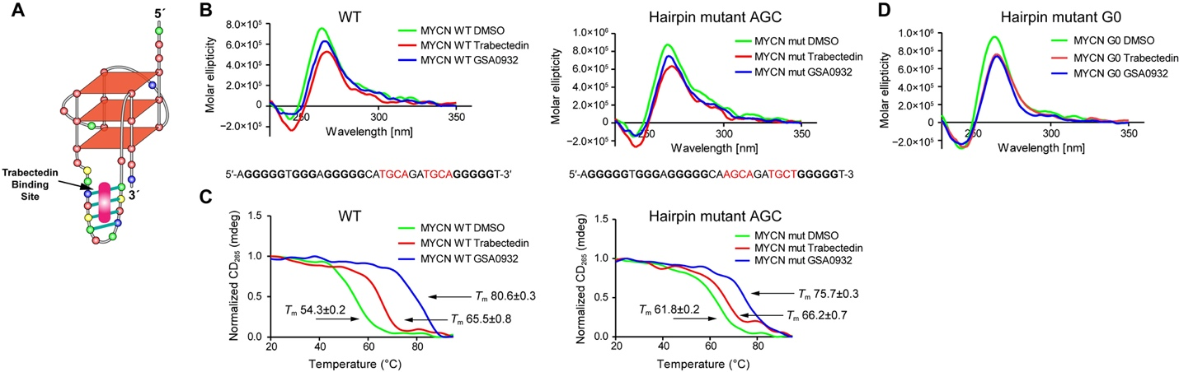
Supplementary Fig. 1. CD spectra and comparative melting points of MYCN G-quadruplexes in the presence of Trabectedin or GSA0932. (A) Model of the MYCN G4 folding. (B) CD spectra of the WT, hairpin mutant MYCN G4 and hairpin mutant NMYC G0 after addition of Trabectedin or GSA0932. (C) Melting points of the WT and hairpin mutant MYCN G4 and stabilization effects of Trabectedin and GSA0932.

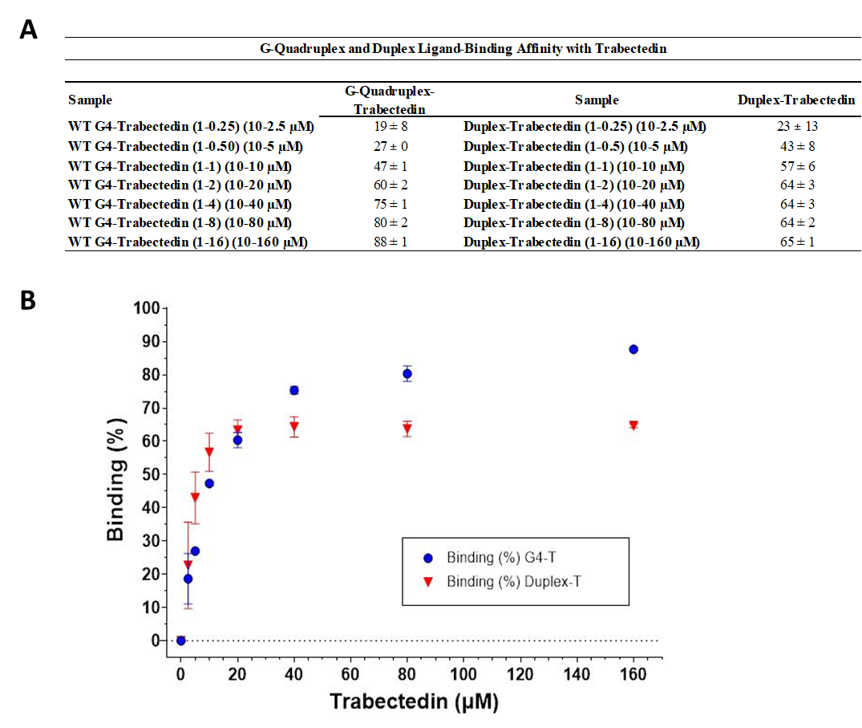
Supplementary Fig. 2. Trabectedin binding to duplex and G4 substrates. (A) LC-MS affinity assay comparing Trabectedin binding to duplex DNA and the G4-containing construct. (B) Red triangles represent the percentage of Trabectedin bound to the duplex substrate at increasing ligand concentrations. Binding to the duplex reaches a plateau at concentrations above 20 μM Trabectedin. Blue circles represent the percentage of Trabectedin bound to the G4-containing construct at increasing ligand concentrations. In contrast to the duplex substrate, the G4-containing construct does not reach saturation even at the highest concentration tested (160 μM), indicating weaker apparent engagement under these assay conditions.

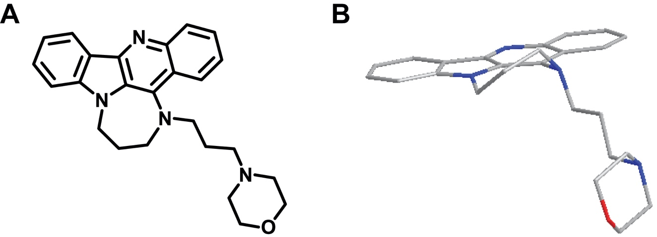
Supplementary Fig. 3. Structure of GSA0932 (A) and the Chembio3D model (B).

