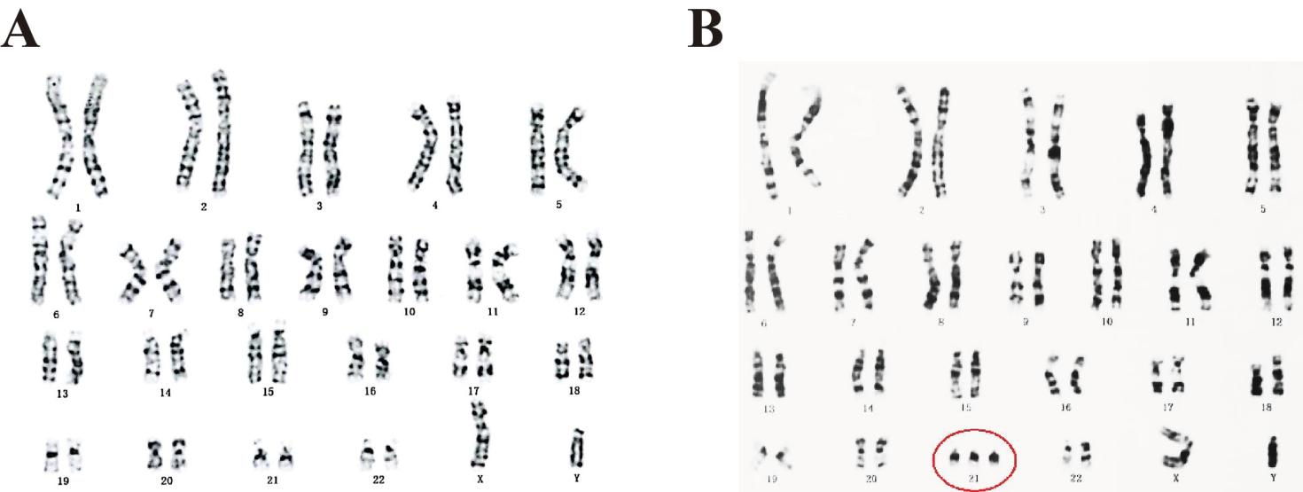
Supplementary Figure S1. Chromosome G banding of fetus. Non-DS fetus (A) and DS fetus (B).

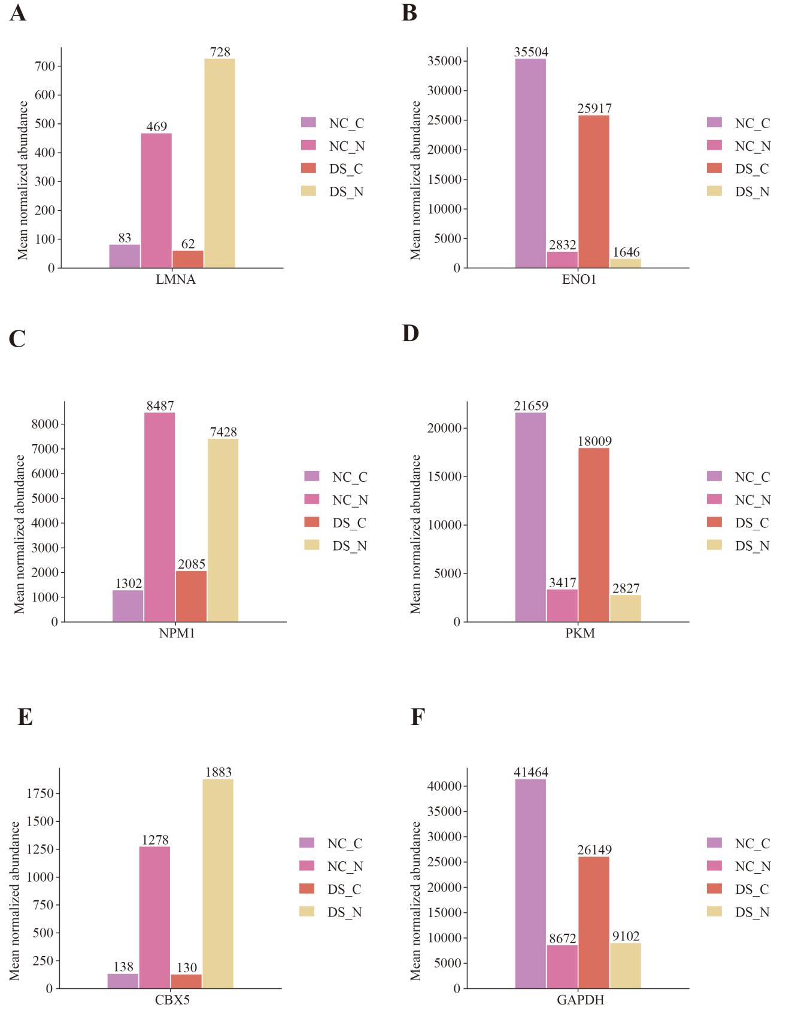
Supplementary Figure S2. Relative abundance of representative nuclear and cytoplasmic marker proteins across subcellular fractions. Representative nuclear marker proteins, including LMNA (A), NPM1 (C), and CBX5 (E), exhibited preferential enrichment in the nuclear fractions, whereas representative cytoplasmic marker proteins, including ENO1 (B), PKM (D), and GAPDH (F), showed higher abundance in the cytoplasmic fractions. Protein abundance values were obtained from the normalized proteomic expression matrix and are presented as the mean normalized abundance of three biological replicates per group.

