Appendix 1. Image collection dates.
12/04/2015 | 01/23/2016 | 03/20/2016 | 04/02/2016 | 07/11/2016 | 09/29/2016 | 10/09/2016
10/26/2016 | 11/15/2016 | 01/07/2017 | 01/24/2017 | 02/16/2017 | 02/23/2017 | 03/25/2017
04/07/2017 | 04/27/2017 | 05/04/2017 | 05/24/2017 | 09/09/2017 | 09/11/2017 | 10/01/2017
10/11/2017 | 10/24/2017 | 10/29/2017 | 11/23/2017 | 11/30/2017 | 01/14/2018 | 01/29/2018
03/13/2018 | 03/30/2018 | 04/17/2018 | 05/07/2018 | 05/09/2018 | 05/17/2018 | 07/01/2018
07/28/2018 | 08/22/2018 | 10/11/2018 | 11/15/2018 | 12/03/2018 | 01/04/2019 | 01/24/2019
01/29/2019 | 02/13/2019 | 04/02/2019 | 04/09/2019 | 04/14/2019 | 05/14/2019 | 06/06/2019
07/11/2019 | 09/14/2019 | 10/04/2019 | 11/03/2019 | 11/10/2019 | 11/15/2019 | 11/18/2019
11/23/2019 | 12/03/2019 | 12/18/2019 | 12/23/2019 | 12/30/2019 | 01/24/2020 | 02/21/2020
04/13/2020 | 04/26/2020 | 05/18/2020 | 06/12/2020 | 08/04/2020 | 08/19/2020 | 09/30/2020
10/03/2020 | 10/13/2020 | 11/17/2020 | 12/22/2020 | 04/01/2021 | 05/06/2021 | 09/10/2021
09/23/2021 | 04/01/2022 | 04/18/2022 | 05/26/2022 | 07/10/2022 | 09/23/2022 | 09/28/2022
10/08/2022 | 10/10/2022 | 07/17/2023 | 08/16/2023 | 08/19/2023

Appendix 2. Equations and formulas for Sentinel derived indices.
NDVI: ((NIR - Red) / (NIR + Red))
NDWI = (Green-NIR) / (Green+NIR)
NDMI = (NIR - SWIR1) / (NIR + SWIR1)
MNDWI = (Green – SWIR2) / (Green + SWIR2)
SAVI = ((NIR - Red) / (NIR + Red + L)) x (1 + L)
Note: False Color composite bands 8, 4, 3, Urban Index composite bands 12, 11, 4. In SAVI, the parameter L acts as a canopy background adjustment factor. A value of 0.5 for L in reflectance space was shown to reduce soil brightness variations and remove the need for extra calibration across different soils. This adjustment nearly eliminates soil-induced variations in vegetation indices.

Appendix 3. Detailed equations and descriptions of machine learning techniques used.

Polynomial regression is typically used for regression tasks, where the goal is to predict continuous output based on the input features. However, here we adapt it for our classification task by using it as part of a pipeline. The pipeline has two steps. Step 1 is polynomial feature transformation which generates polynomial features of the input data. Step 2 is applying logistic regression on the transformed features to predict class probabilities. In the experiment, we set the degree of polynomial regression from 2 to 5 and found that degree is 2 achieves the best accuracy.
k-Nearest Neighbors (KNN) classifier works by finding the k closest data points (neighbors) to a given input data point and making predictions based on the characteristics of those neighbors. In the experiment, we compute the Minkowski Distance [6] between the data points to catch their characteristics. We set the k from 2 to 8 and found that k = 7 has the best classification performance.
Multilayer Perceptron (MLP) is a neural-network-based classifier. We built a four-layer neural network with an input layer, two hidden layers, each with 10 neurons, and an output layer with 4 neurons. The activation function is Rectified Linear Unit (ReLU) where ReLU(x) = max (0, x). For training, we set optimization algorithms as Adam [3], learning rate as 0.001, momentum as 0.9, and number of epochs as 10.
Random Forest (RF) is an ensemble learning method by constructing a multitude of decision trees during training and output the classification of the individual trees. We built 100 trees in our forest with bootstrap samples, and we set split measurement criterion as Gini [5].
eXtreme Gradient Boosting (XGBoost) is an optimized implementation of Gradient Boosting [1] algorithm known for its speed, efficiency, and ability to handle large datasets. Gradient Boosting builds an ensemble of decision trees sequentially, where each tree attempts to correct the errors of the previous trees. The concept relies on the idea of boosting weak learners (shallow trees) into strong learners by minimizing a loss function using gradient descent. In this paper, we use the cross-entropy loss [4] function combined with the softmax [2] activation.
The loss function is defined as follows:
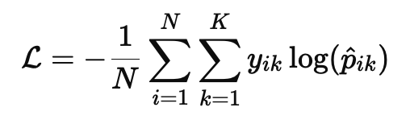
where:
- N is the total number of collected trap records.
- K is the number of classes, here we set it to 4.
- y_{ik} is a binary indicator (0 or 1) if class label k is the correct classification for record i.
- p_{ik} is the predicted probability of record i belonging to class k, computed using the softmax function:
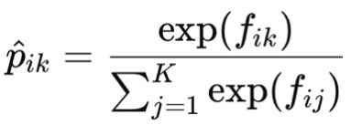
Here, f_{ik} is the raw score for class k from the model for record i.
In our experiment, we set the maximal tree depth as 4, and the learning rate as 0.3. As indicated in Table 1, XGBoost achieves the highest prediction accuracy compared to the other four methods. Feature importance for XGBoost was calculated using the built-in gain-based importance metric, which quantifies the relative contribution of each predictor to reducing the model’s loss function across all decision trees. Gain values were extracted from the final XGBoost classifier fit on the 70% training partition for each study period (i.e., the model used to produce the test-set accuracy reported in Table 1); the held-out 30% test partition was not used to compute or rescale importance values. We report gain-based importance because it is computed during training as an intrinsic by-product of the boosting procedure and is therefore not subject to permutation-noise on small samples. We acknowledge, however, that gain-based importance can be sensitive to correlated predictors and to the relative cardinality of variables, and should be interpreted as a measure of relative contribution to predictive performance within this specific model rather than as a measure of ecological causation. These importance values reflect relative contribution to predictive performance within the modeling framework and should not be interpreted as direct measures of ecological causation.

Appendix 4. Feature combinations considered for model selection.

- Feature combination 1 = group 1
- Feature combination 2 = group 1 + group 2
- Feature combination 3 = group 1 + group 2 + 1 day of group 3 before trapping
- Feature combination 4 = group 1 + group 2 + 2 days of group 3 before trapping
- Feature combination 5 = group 1 + group 2 + 3 days of group 3 before trapping
- Feature combination 6 = group 1 + group 2 + 4 days of group 3 before trapping
- Feature combination 7 = group 1 + group 2 + 5 days of group 3 before trapping
- Feature combination 8 = group 1 + group 2 + 6 days of group 3 before trapping
- Feature combination 9 = group 1 + group 2 + 7 days of group 3 before trapping
- Feature combination 10 = group 1 + group 2 + 1 day of group 4 before trapping
- Feature combination 11 = group 1 + group 2 + 2 days of group 4 before trapping
- Feature combination 12 = group 1 + group 2 + 3 days of group 4 before trapping
- Feature combination 13 = group 1 + group 2 + 4 days of group 4 before trapping
- Feature combination 14 = group 1 + group 2 + 5 days of group 4 before trapping
- Feature combination 15 = group 1 + group 2 + 6 days of group 4 before trapping
- Feature combination 16 = group 1 + group 2 + 7 days of group 4 before trapping

Appendix 5. Empirical semivariogram and cross validation of Ordinary Kriging
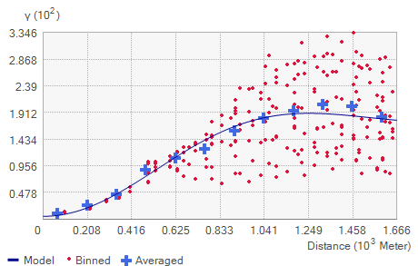
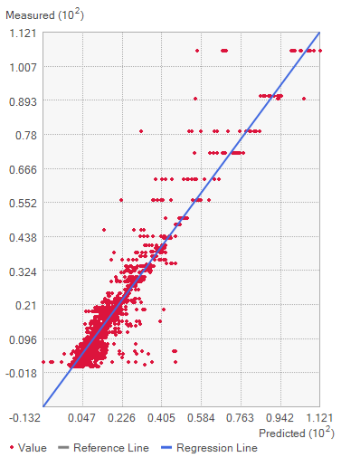

Reference
- Friedman, J. H. (2002). Stochastic gradient boosting. Computational Statistics & Data Analysis, 38(4), 367–378.
- Goodfellow, I., Bengio, Y., & Courville, A. (2018). Softmax units for multinoulli output distributions. Deep Learning. p.
- Kingma, D. P. (2014). Adam: A method for stochastic optimization. arXiv preprint arXiv:1412.6980.
- Mao, A., Mohri, M., & Zhong, Y. (2023). Cross-entropy loss functions: Theoretical analysis and applications. In International conference on Machine learning (pp. 23803-23828). PMLR.
- Nembrini, S., König, I. R., & Wright, M. N. (2018). The revival of the Gini importance? Bioinformatics, 34(21), 3711–3718.
- Şuhubi, E. S. (2003). Metric spaces. In Functional Analysis (pp. 261–356). Springer, Dordrecht.

