Supplementary Figures

- Original Agarose Gel Image (Figure 1C)

M 1 2 3 4 M
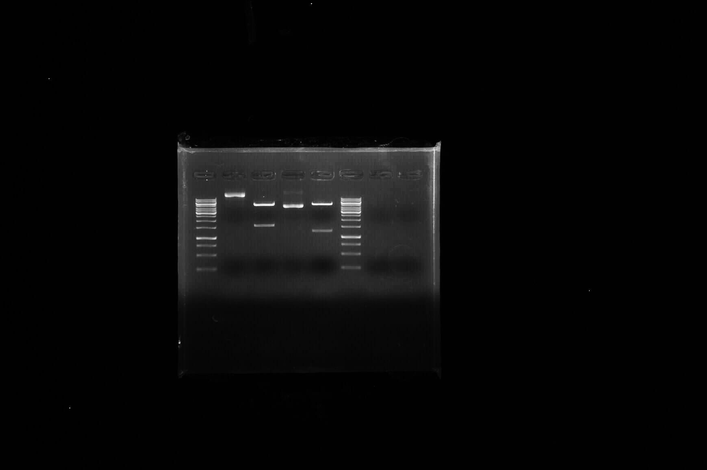
Lane: M, DNA standard marker;
Lane: 1, Uncut plasmid /vector -pET28a (pN-NiV);
Lane: 2, RE digested plasmid (pN-NiV) releasing target N gene (~1599 bp).

Note: Yellow dotted line denotes the area of cropping used for final presentation in the manuscript.

- Original Gel Image of SDS-PAGE (Figure 2A)

1 2 M 3 4
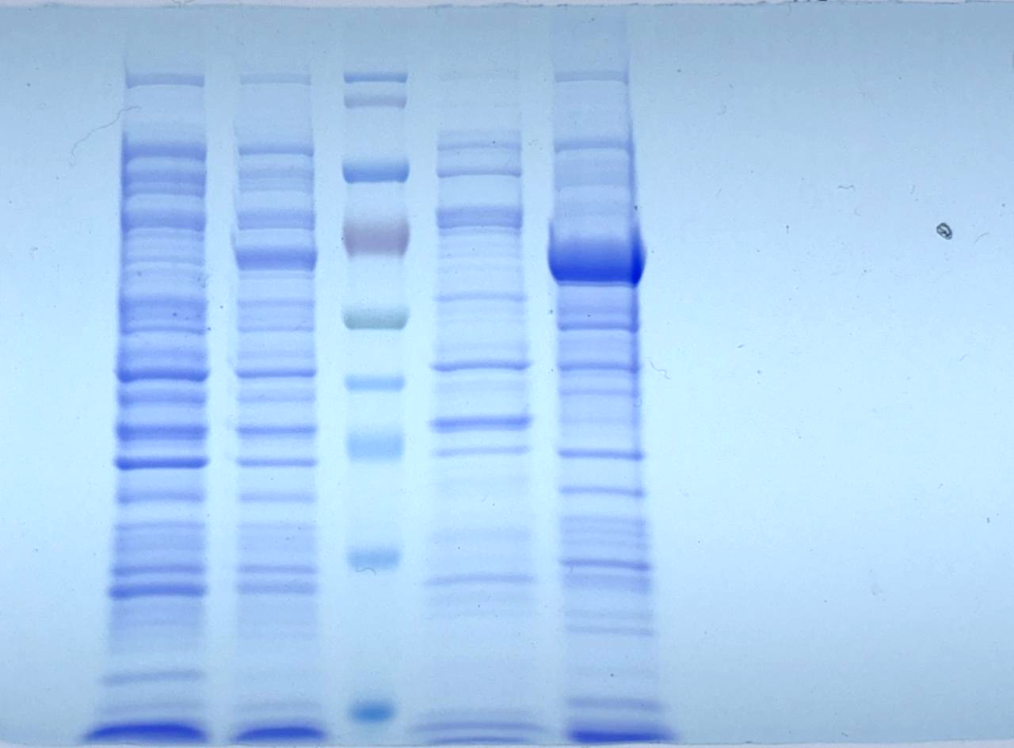

Lane M: Pre-stained protein ladder (Puregene, Genetix Biotech, India);
Lane 1 and 3: Uninduced E. coli cell lysates
Lane 2: Induced E. coli cell lysates after 30 min post-induction
Lane 4: Induced E. coli cell lysates after 4-hour post-induction, showing rN protein of NiV

Note: Red dotted line denotes the area of cropping used for final presentation in the manuscript.

- Original Gel Image of SDS-PAGE (Figure 2A)

1 2 3 4 M 5 6
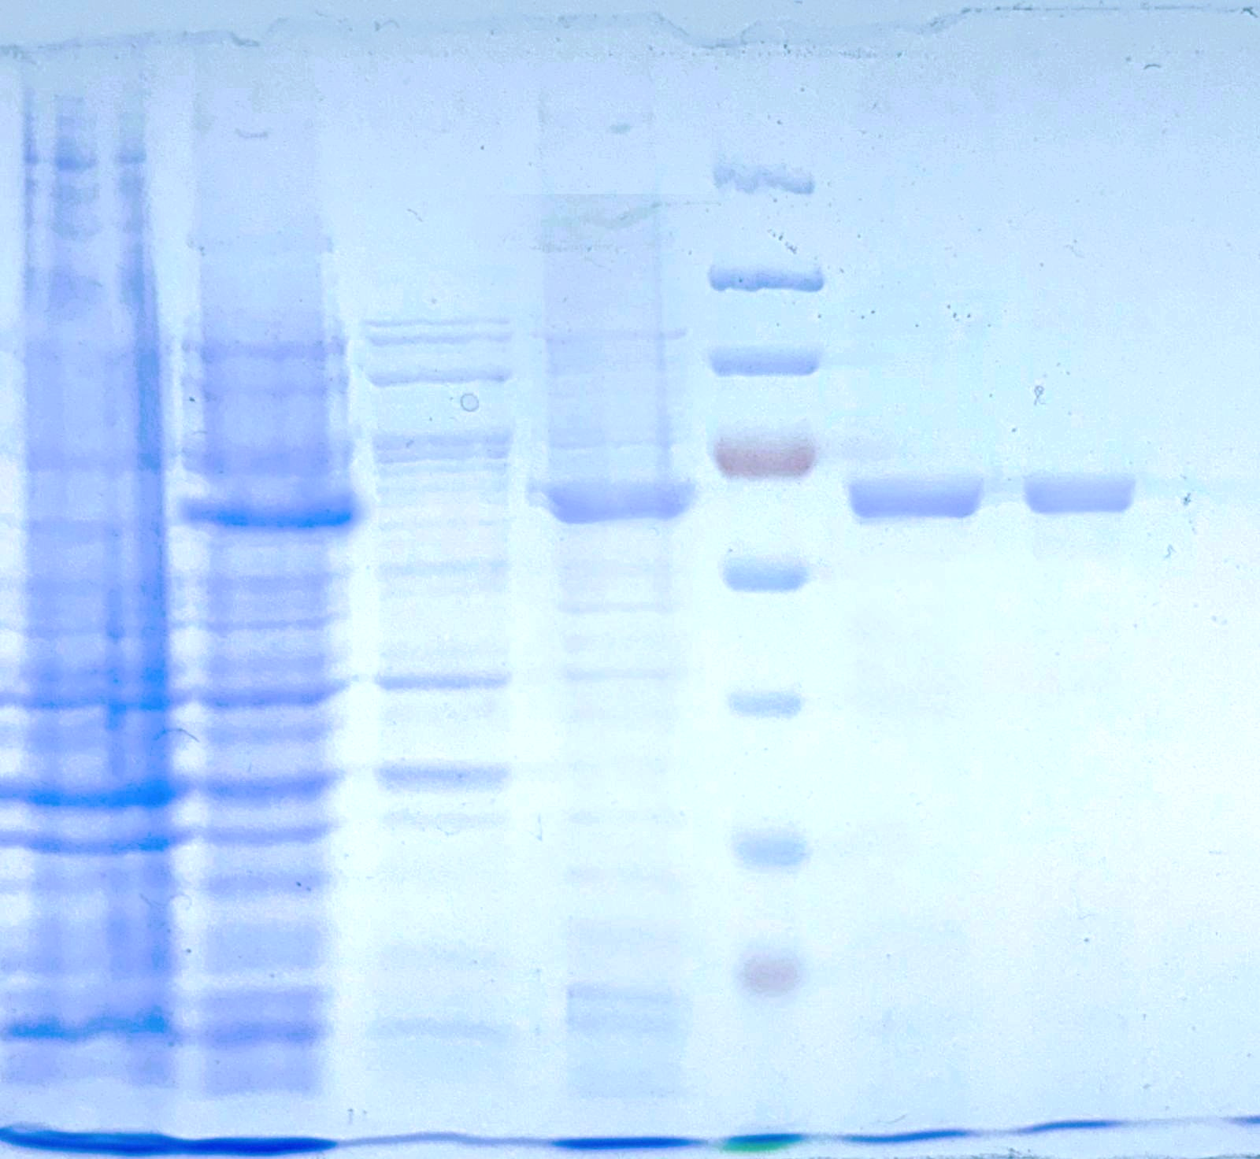
Lane M: Pre-stained protein ladder (Puregene, Genetix Biotech, India);
Lane 1: Uninduced E. coli cell lysates
Lane 2: Induced E. coli cell lysates after 3 hour post-induction, showing rN protein
Lane 3: Soluble fraction of induced E. coli cell lysates
Lane 4: Insoluble fraction of induced E. coli cell lysates showing rN protein
Lanes 5 and 6: Purified fractions of recombinant N protein of NiV

Note: Red dotted line denotes the area of cropping used for final presentation in the manuscript.

- Original Membrane Images of Western blot (Figure 2A)

M 5 M 6
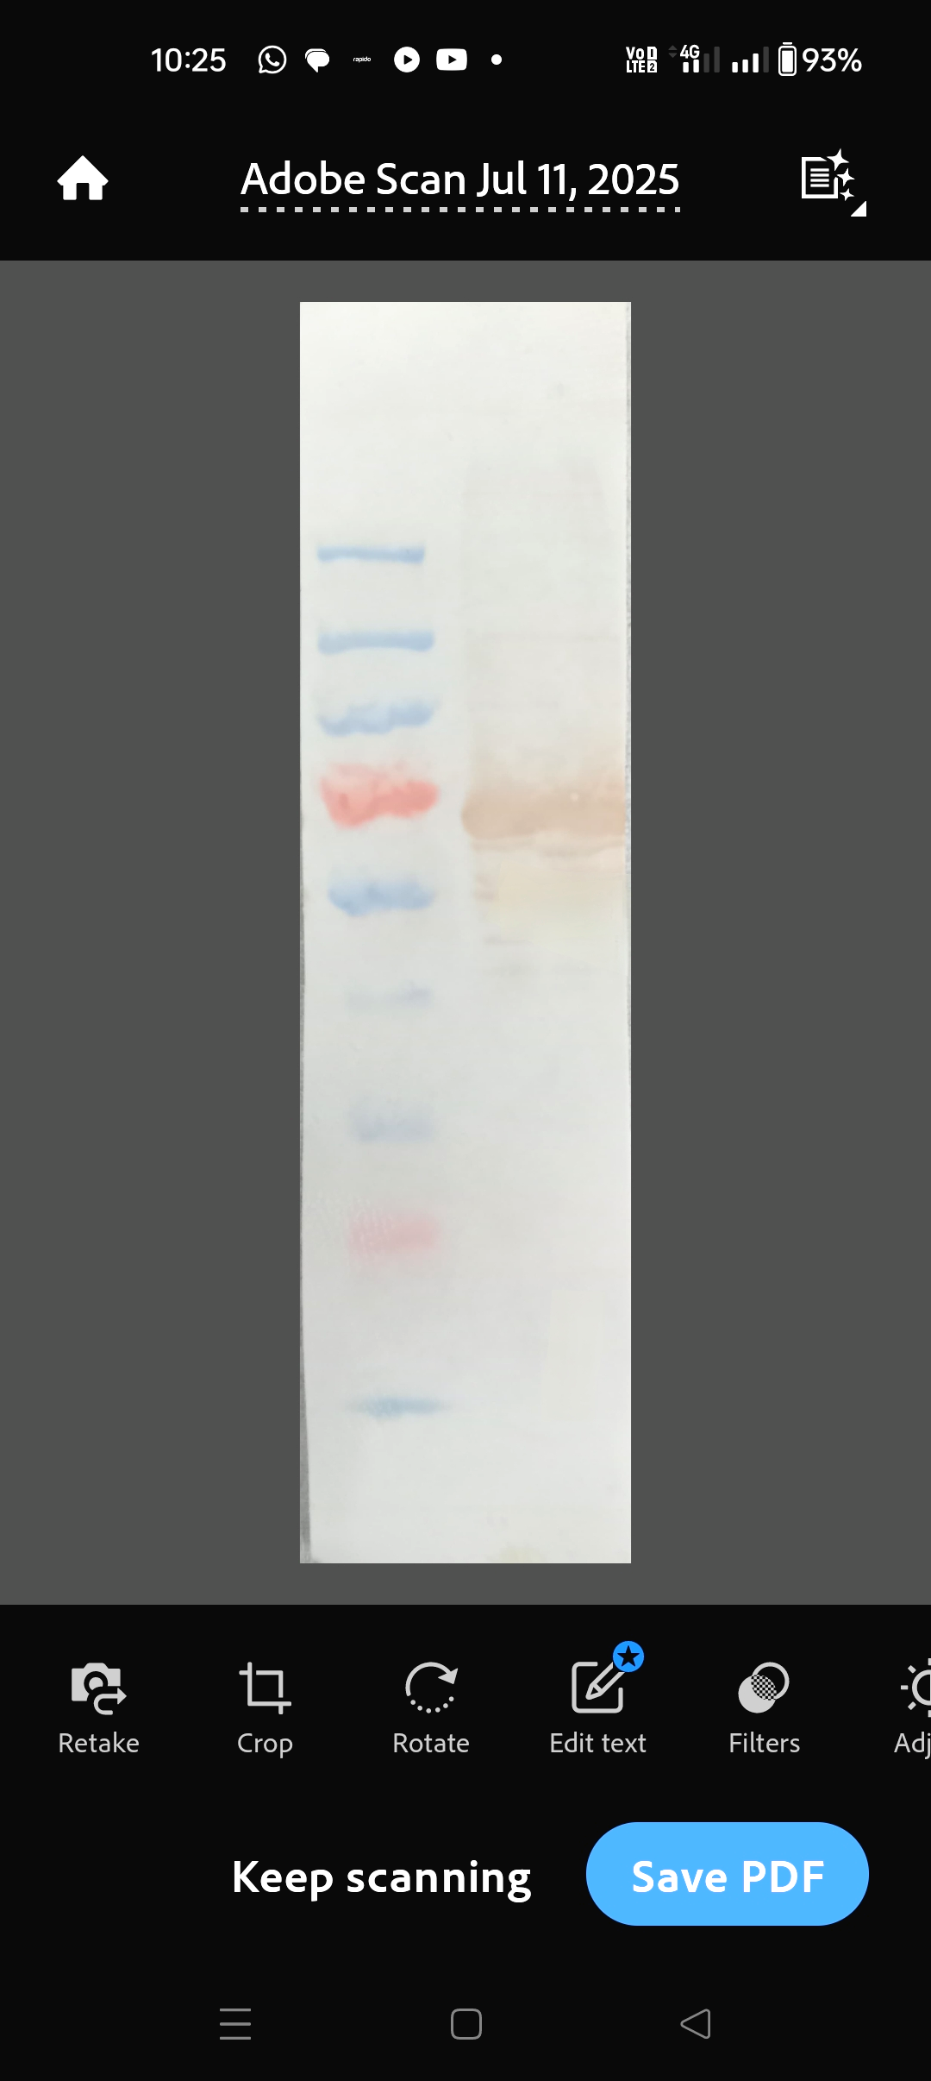
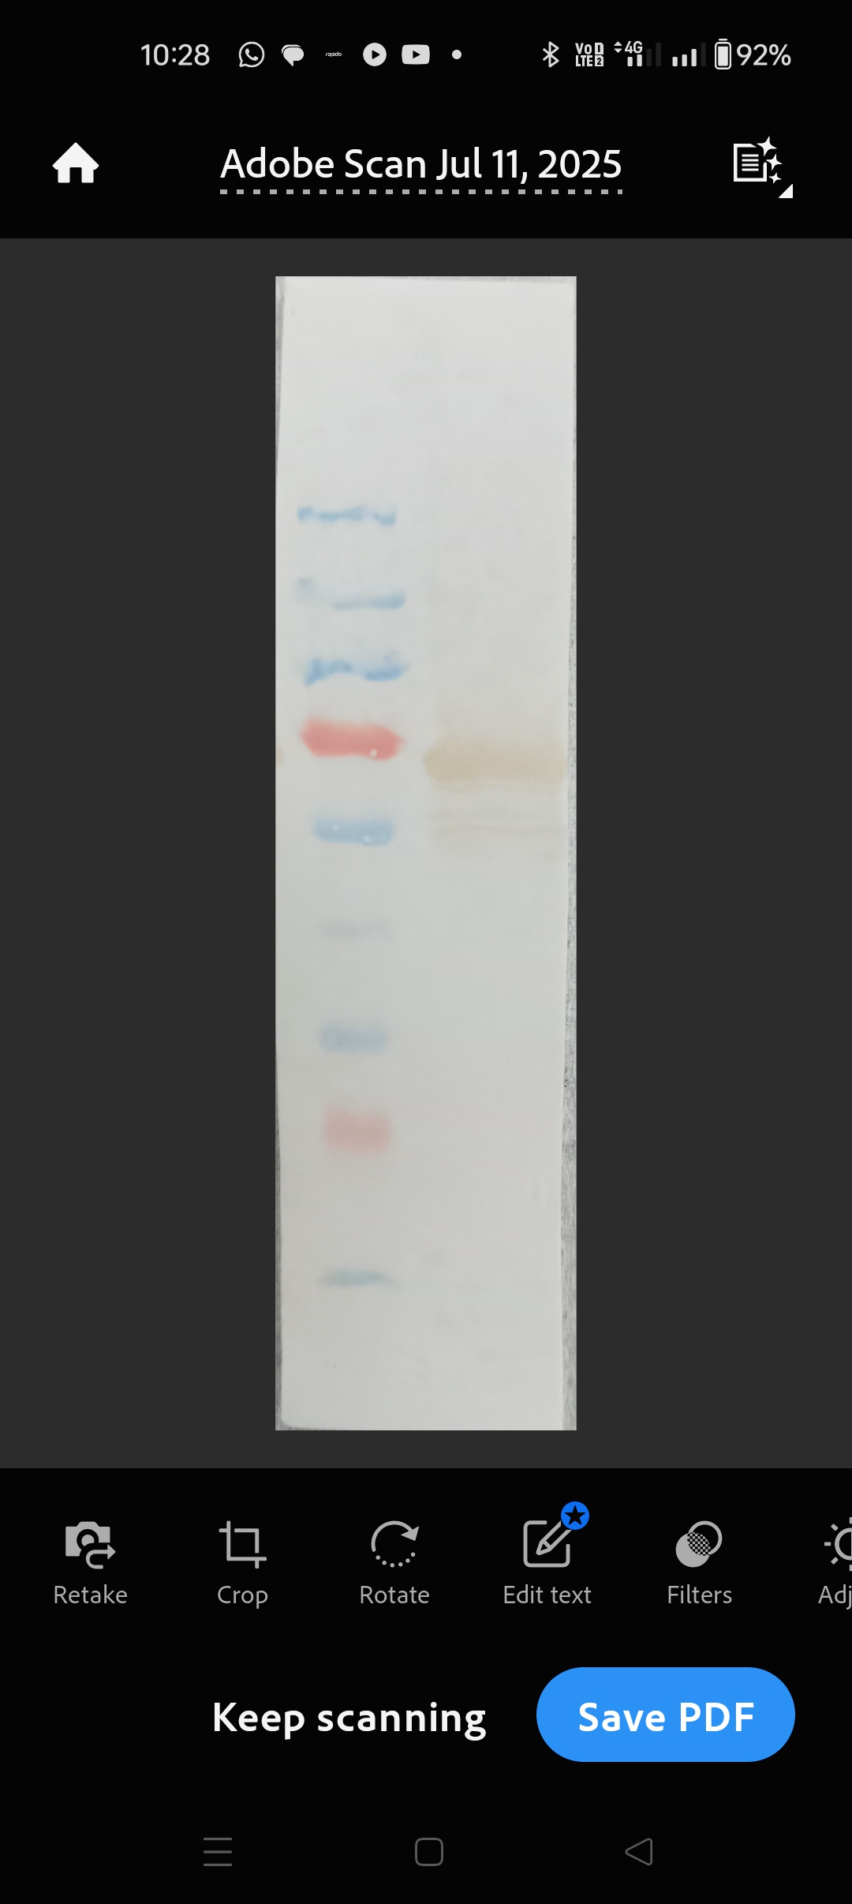

M: Pre-stained protein ladder (Puregene, Genetix Biotech, India);
Lane 5: Western blot using Polyclonal antibodies raised against rN protein in rabbit,
showing the immunoreactive specific band at ~62 kDa
Lane 6: Western blot using Polyclonal antibodies raised against rN protein in Guinea
pig, showing the immunoreactive specific band at ~62 kDa.
Note: Yellow dotted line denotes the area of cropping used for final presentation in the manuscript.

- Additional /Replicates Western blot membrane images
M 1 2
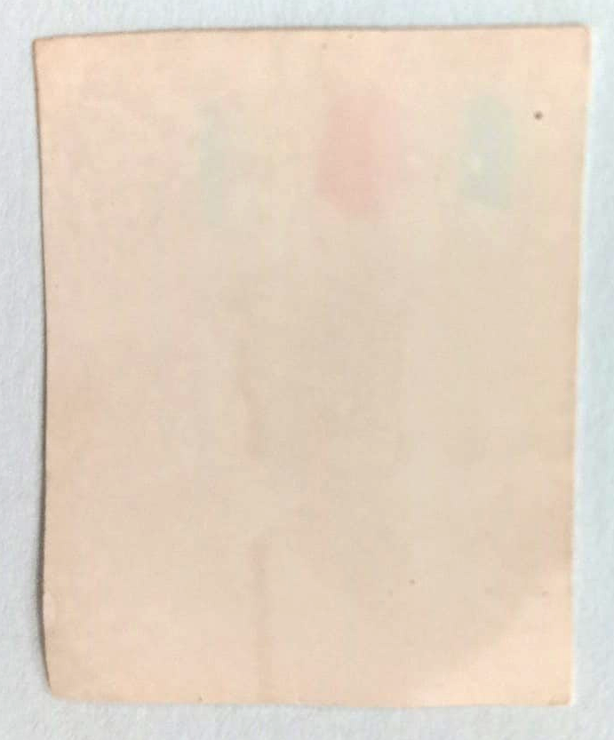

Lane M: Pre-stained protein ladder (Puregene, Genetix Biotech, India);
Lane 1: Western blot using Polyclonal antibodies raised against rN protein in rabbit,
showing the immunoreactive specific band at ~62 kDa
Lane 2: Western blot using Polyclonal antibodies raised against rN protein in Guinea
pig, showing the immunoreactive specific band at ~62 kDa.

***

