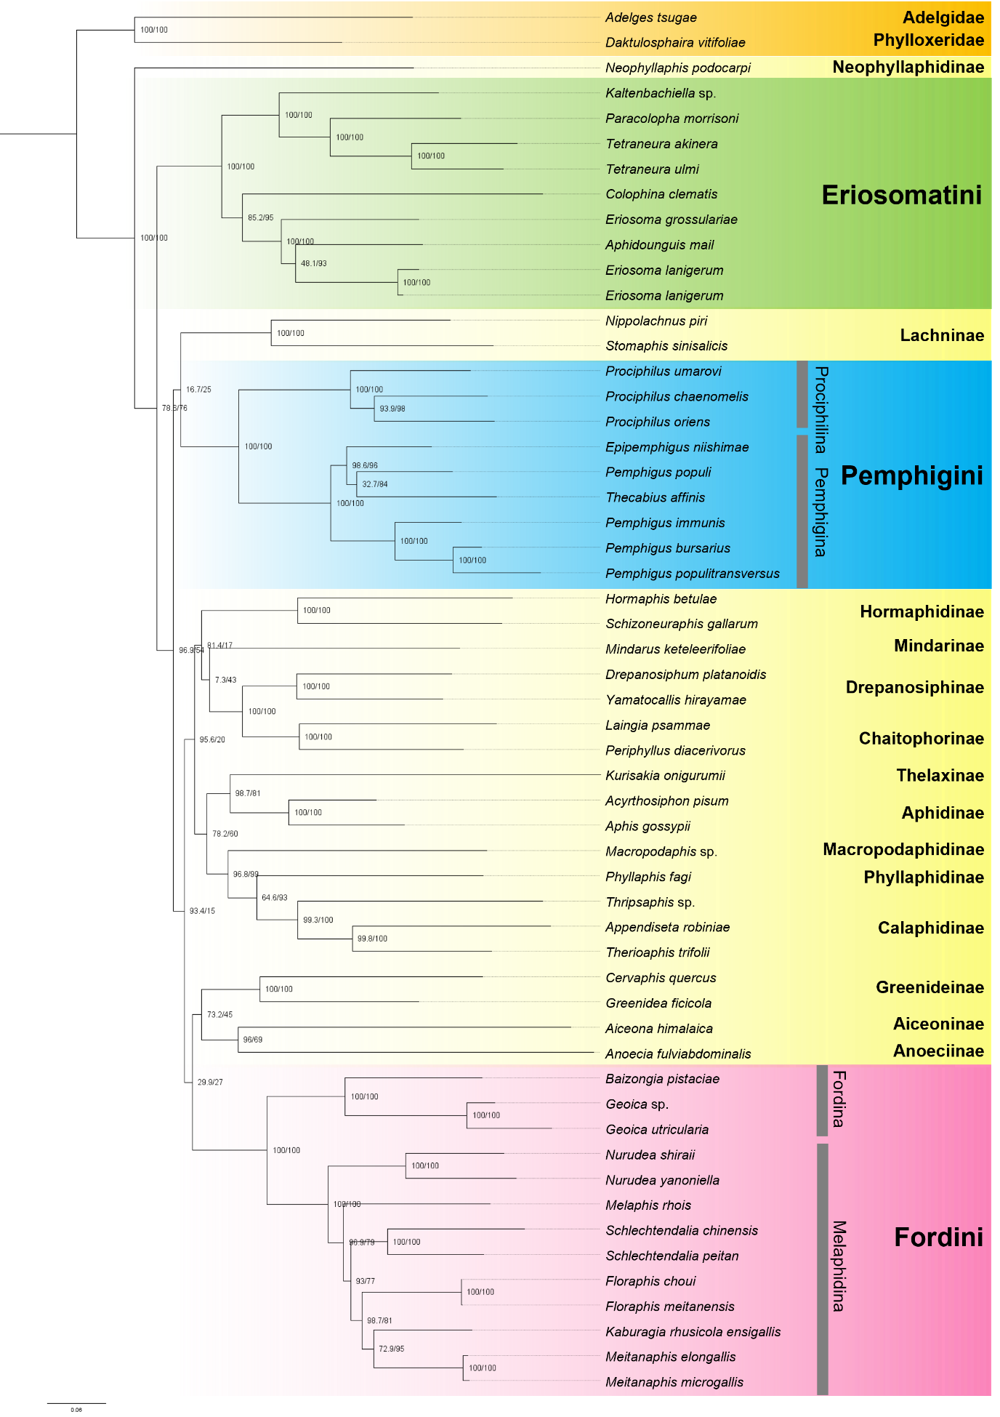
Supporting figure 1. Phylogram of Maximum likelihood (ML) analysis. All bootstrap values are shown close to each node (Shimodaira–Hasegawa approximate likelihood ratio test (SH- aLRT): left/ Ultrafast (UF) bootstrap pseudoreplicates: right.
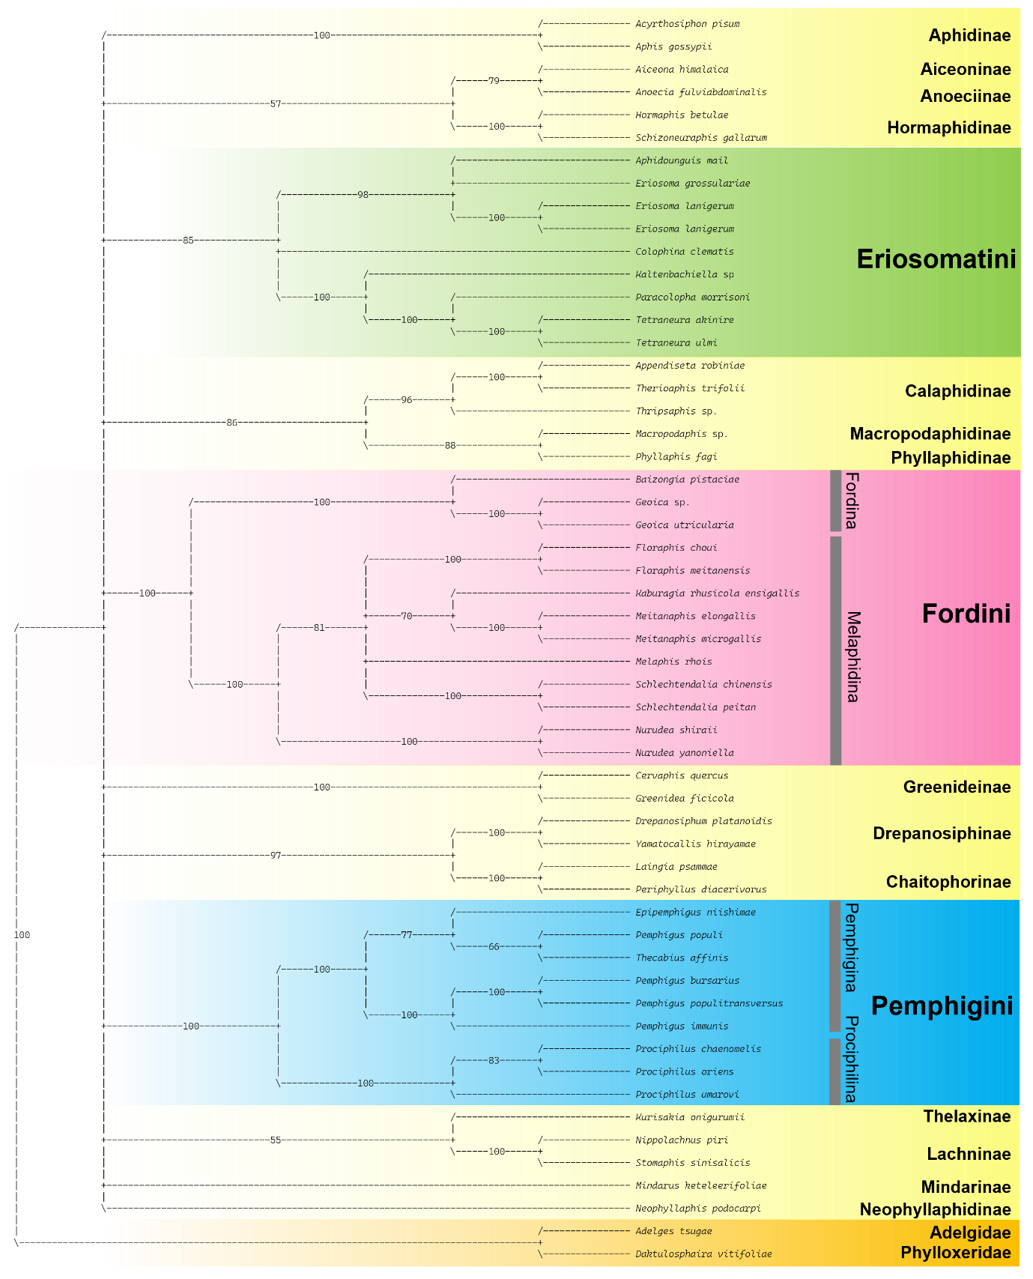
Supporting figure 2. Phylogram of Maximum Parsimony (MP) analysis. All jackknife resampling are shown close to each node.
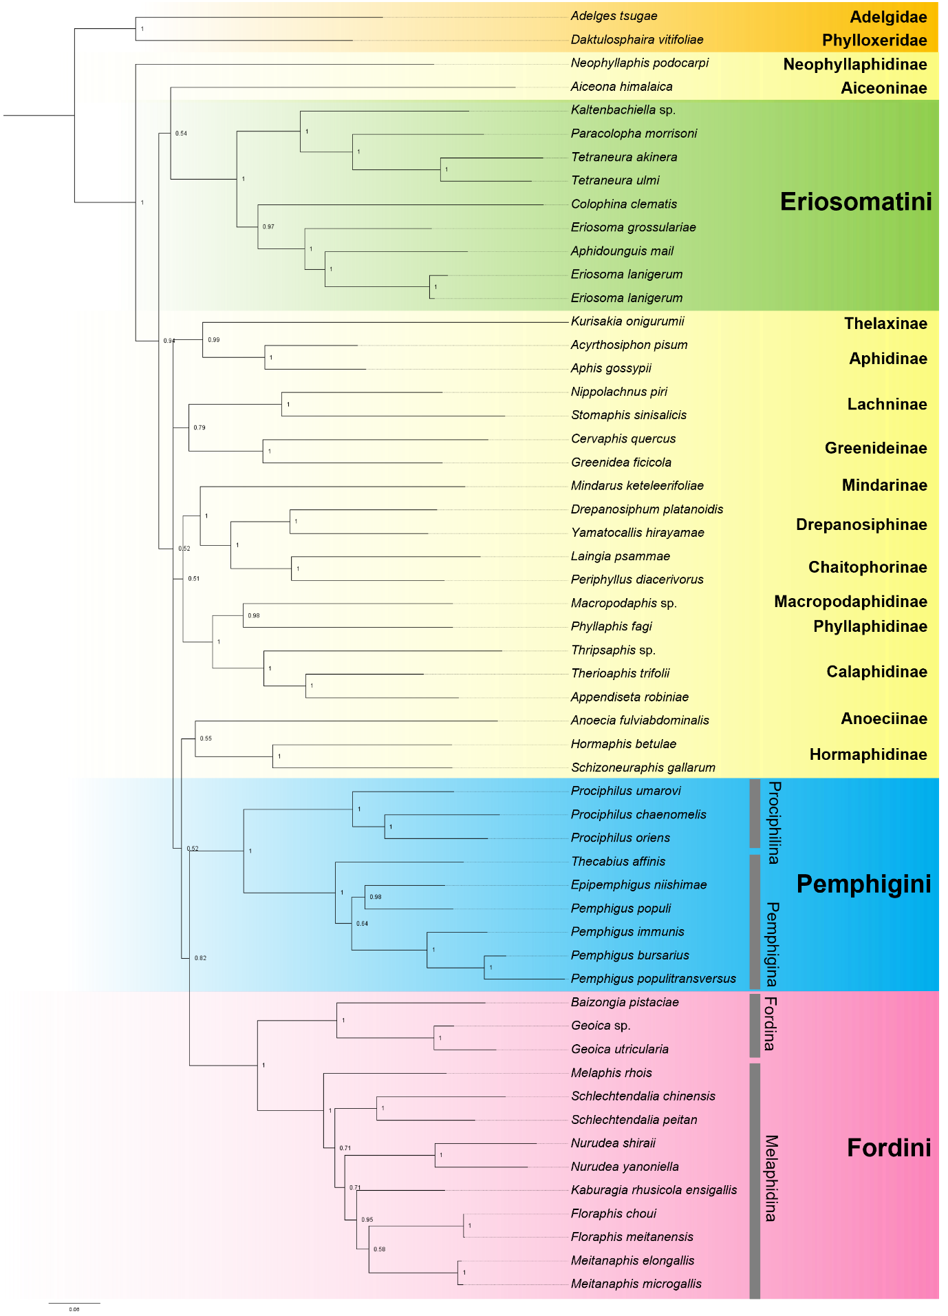
Supporting figure 3. Phylogram of Bayesian inference (BI) analysis. All posterior probabilities are shown close to each node.
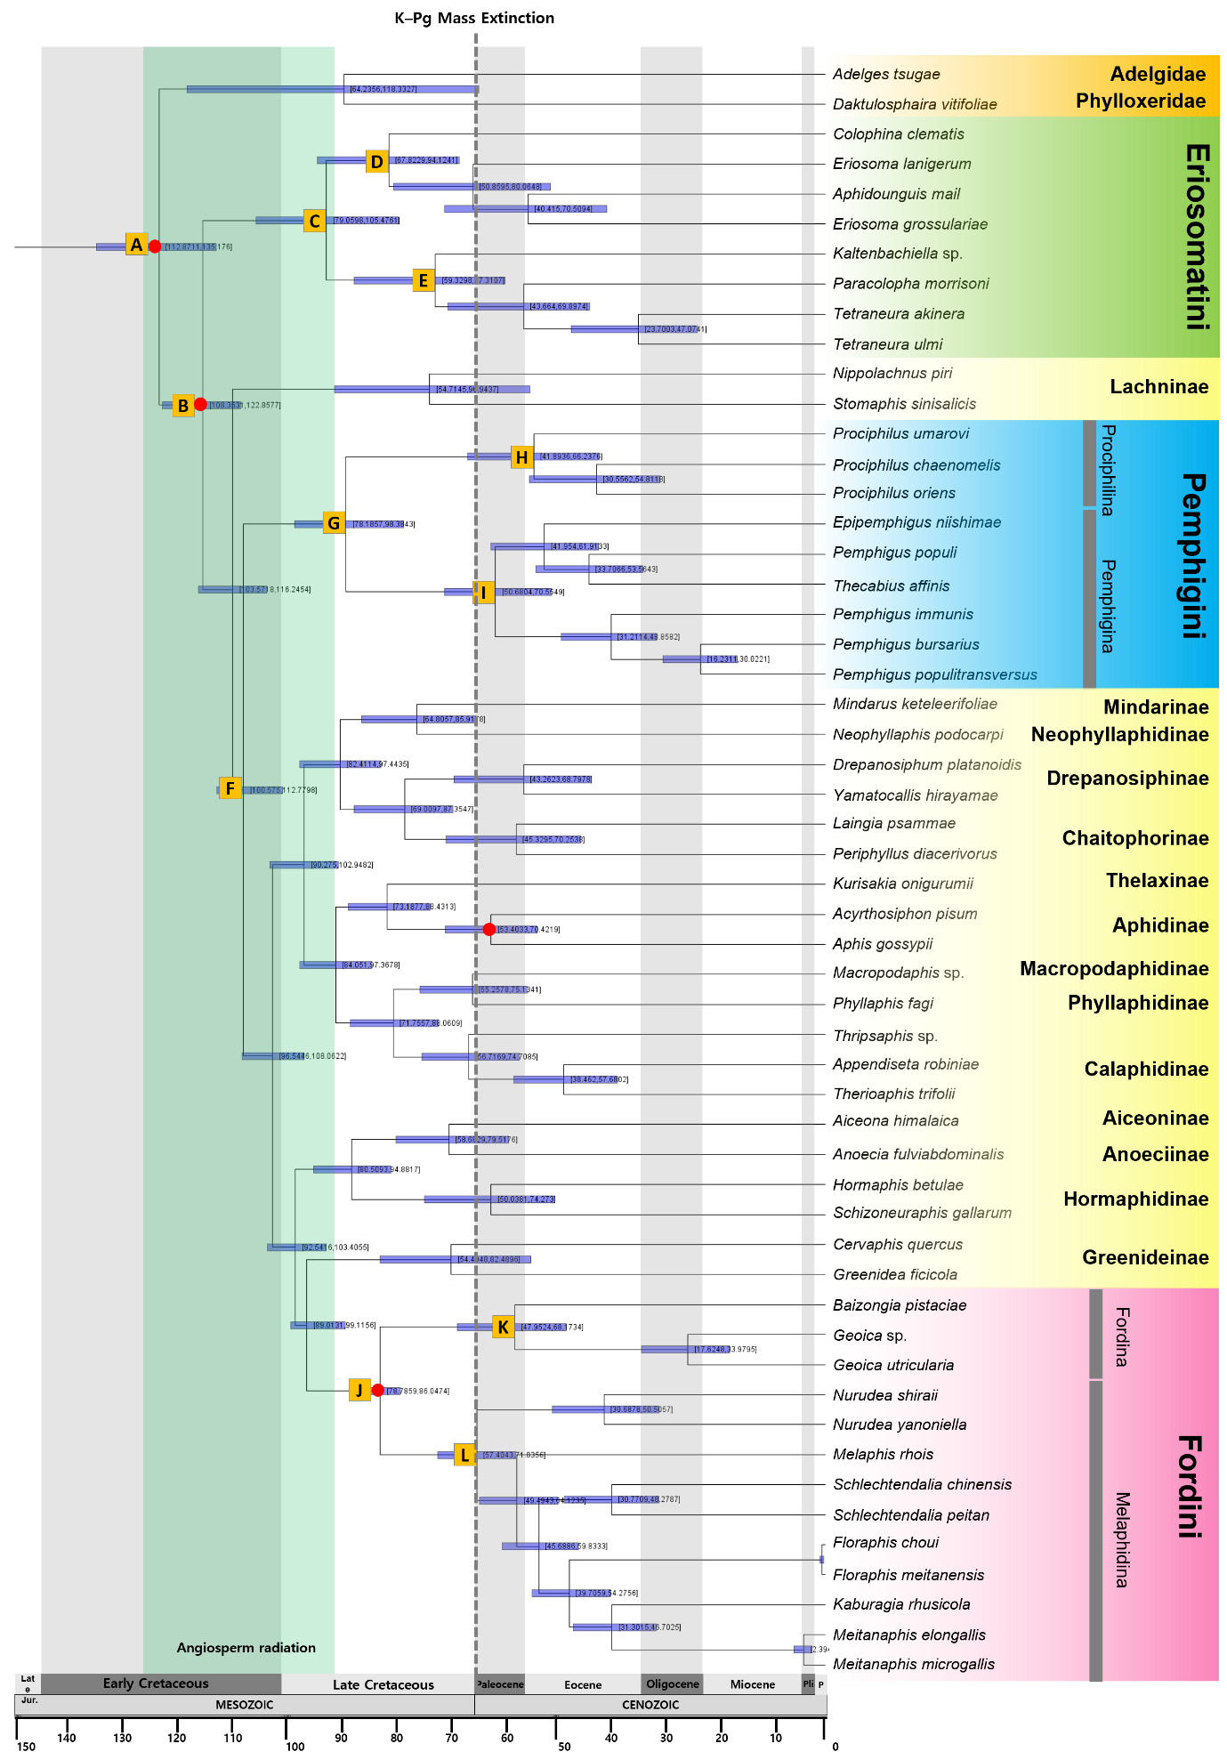
Supporting figure 4. Maximum clade credibility (MCC) tree inferred from BEAST analysis, showing range divergence times and 95% highest posterior density (HPD) intervals for Eriosomatinae and outgroup taxa. Node bars represent 95% HPD credible intervals, and red dots indicate fossil calibration points.

