Supporting Information
Reflux Ratio Modulates Algal and Bacterial Metabolic Balance to Enhance Refractory Pollutant Removal
Shuangnan Li^{1,2}, Haoyu Zhang¹, Jiayi Chen¹, Xinran Qi¹, Peilong Du¹, Aoqi Shen¹, Peng Cao^{1,2*}
Affiliation
¹ School of Chemical Engineering, Shandong Institute of Petroleum and Chemical Technology, Dongying, Shandong, 257000, China
² Shandong key Laboratory of Green Electricity&Hydrogen Science and Technology, Dongying, Shandong, 257000, China
Authors Email address: 2019021@sdipct.edu.cn, 2019020@sdipct.edu.cn, 320788416@qq.com, 1241560308@qq.com, 2878419417@qq.com,2544991336@qq.com
*Corresponding author: E-mail address: caopeng@sdipct.edu.cn

Table S1. Macro- and Micronutrient Components of BG-11 Medium
Number | Chemical | Stock Solution(g/L) | Volume(mL/L)
1 | Na₂CO₃ | 2 | 10
2 | Anhydrous citric acid | 0.66 | 10
3 | K₂HPO₄∙3H₂O | 5.2 | 22.5
4 | MgSO₄∙7H₂O | 7.5 | 16
5 | CaCl₂ | 2.7 | 10
6 | EDTA | 0.11 | 11
7 | Ammonium ferric citrate | 0.6 | 10
8 | NaHCO₃ | 23.4 | 100
9 | NaNO₃ | 15 | 55.3
10 | A5 | - | 0.2

Table S2. Composition of A5 Trace Elements Solution
Number | Chemical | Concentration (g/L)
1 | H₃BO₃ | 2.86
2 | MnCl₂·4H₂O | 1.86
3 | ZnSO₄·7H₂O | 0.22
4 | Na₂MoO₄·2H₂O | 0.39
5 | Co(NO₃)₂·6H₂O | 0.05
6 | CuSO₄·5H₂O | 0.08

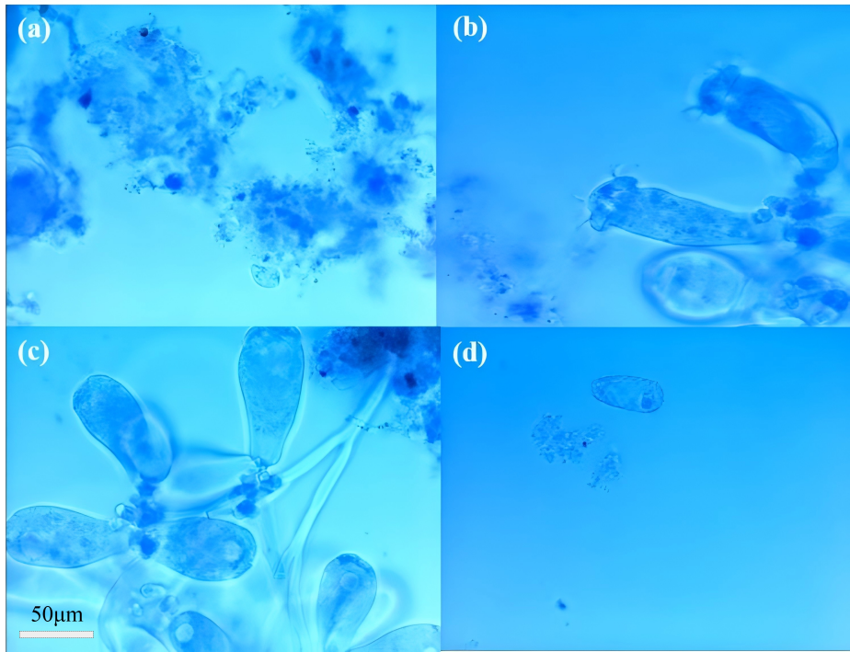
Fig. S1 Activated sludge microscopy: (a) zoogloea (floc), (b) Vorticella (bell-shaped ciliate), (c) Epistylis, and (d) Paramecium.

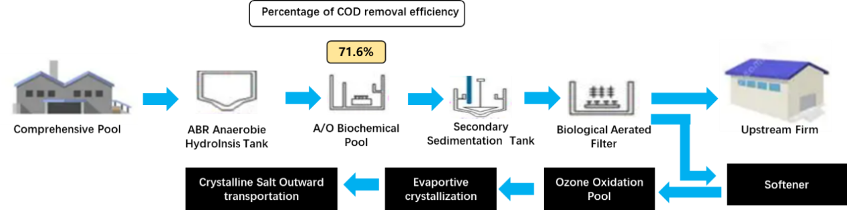
Fig. S2 Printing and Dyeing Factory Process Drawing.

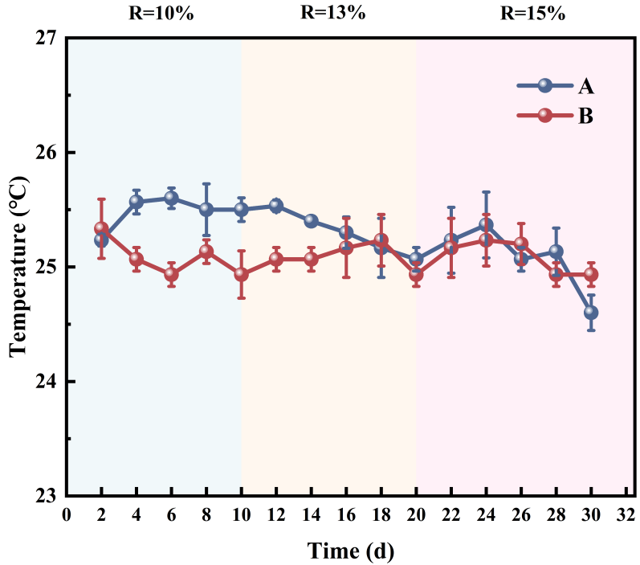
Fig. S3 Variation of temperature at different aeration in two systems
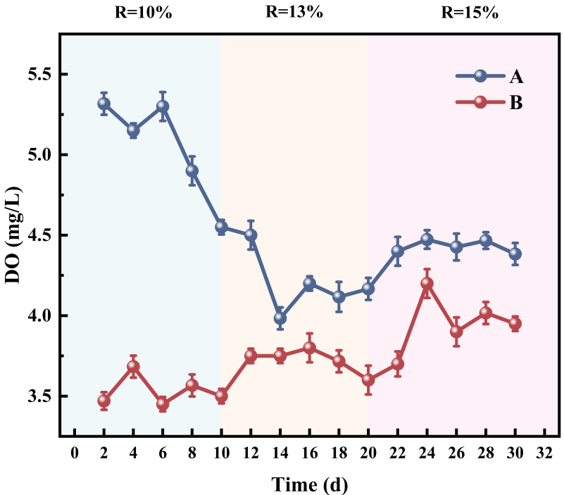
Fig.S4 Variation of DO at different aeration in two systems

Table S3. Analysis of degradation products of Disperse Red 3B by LC-MS
Peaks | Rt (min) | QMI (m/z) | Molecular Formula | structure of matter
Disperse Red | 1.58 | [M+H]⁺ (331.33) | C₂₀H₁₃NO₄ | 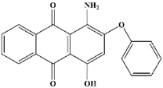
TP278 | 1.68 | [M+H]⁺ (278.15) | C₁₆H₂₂O₄ | 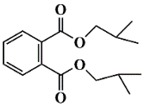
TP255 | 1.88 | [M+H]⁺ (255.05) | C₁₄H₁₀NO₄ | 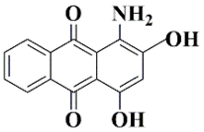
TP142 | 2.17 | [M+H]⁺ (142.04) | C₆H₇NO₃ | 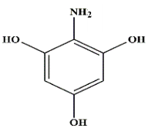
TP151 | 3.21 | [M+H]⁺ (151) | C₈H₈O₂ | 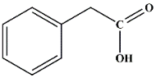
TP122 | 2.64 | [M+H]⁺ (122.04) | C₇H₆O₂ | 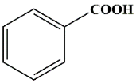
TP94 | 2.92 | [M+H]⁺ (94.04) | C₆H₆O | 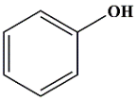
TP88 | 1.59 | [M+H]⁺ (88.11) | C₄H₈O₂ | 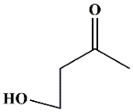
TP60 | 1.35 | [M+H]⁺ (60.06) | C₃H₈O | 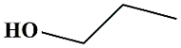
TP58 | 5.19 | [M+H]⁺ (58.08) | C₄H₁₀ | 
*All structural assignments are tentative and based on accurate mass and literature comparison. Authentic standards were not used for confirmation, and MS/MS data were not available.

