Supplementary Files
Contents
Item | Title
Supplementary Figures
Figure S1 | Search Strategy
Figure S2 | Baujat plot for the propensity-score-matched relative-effect synthesis
Figure S3 | Exploratory within-study postmenopausal-to-premenopausal HR ratio plot
Figure S4 | Contour-enhanced funnel plot of bariatric surgery versus no-surgery for breast cancer incidence, with shaded regions at p < 0.10, p < 0.05, and p < 0.01
Supplementary Tables
Table S1 | Confounder adjustment and exclusion of women with prior breast cancer.
Table S2A | Sensitivity analyses of the primary hazard-ratio pool.
Table S2B | Leave-one-underlying-cohort-out sensitivity analysis of the primary hazard-ratio pool.
Table S3A | Raw event-count sensitivity analyses addressing overlapping cohorts.
Table S3B | Leave-one-underlying-cohort-out sensitivity analysis.
Table S4 | Propensity-score-matched influence and leave-one-out analysis.
Table S5 | Formal assessment of menopausal subgroup difference.
Table S6A | Node-splitting analysis of the primary network meta-analysis.
Table S6B | Node-splitting analysis of the exploratory network meta-analysis incorporating Stenberg 2025.
Table S7 | Procedure × era interaction meta-regression coefficients.
Table S8 | Procedure × era interaction meta-regression model fit and tests of moderators.
Table S9 | ROBINS-I risk of bias assessment of each included study
Table S10 | GRADE summary-of-findings: certainty of evidence per outcome.

Supplementary Figures
Supplementary Figure S1 - Search Strategy
Pubmed - 1 - 270 - March 25th, 2026
( ( "Bariatric Surgery"[Mesh] OR "Gastric Bypass"[Mesh] OR "Gastrectomy, Sleeve"[Mesh] OR bariatric surg*[tiab] OR metabolic surg*[tiab] OR obesity surg*[tiab] OR weight loss surg*[tiab] OR gastric bypass*[tiab] OR "roux-en-y gastric bypass"[tiab] OR "roux en y gastric bypass"[tiab] OR "roux-en-y bypass"[tiab] OR RYGB[tiab] OR sleeve gastrectom*[tiab] OR "vertical sleeve gastrectom*"[tiab] OR "laparoscopic sleeve gastrectom*"[tiab] OR "gastric sleeve"[tiab] OR LSG[tiab] ) AND ( "Breast Neoplasms"[Mesh] OR breast cancer*[tiab] OR breast neoplasm*[tiab] OR breast tumor*[tiab] OR breast tumour*[tiab] OR breast malignan*[tiab] OR breast carcinoma*[tiab] OR mammary cancer*[tiab] OR mammary neoplasm*[tiab] OR mammary carcinoma*[tiab] ) ) NOT (animals[mh] NOT humans[mh])
OVIDSP (Embase / Medline) - 2 - 800 - March 25th, 2026
1. exp Bariatric Surgery/
2. exp Gastric Bypass/
3. Gastrectomy, Sleeve/
4. (bariatric surg* or metabolic surg* or obesity surg* or weight loss surg*).ti,ab,kf.
5. (gastric bypass* or "roux-en-y gastric bypass" or "roux en y gastric bypass" or "roux-en-y bypass" or RYGB).ti,ab,kf.
6. (sleeve gastrectom* or vertical sleeve gastrectom* or laparoscopic sleeve gastrectom* or gastric sleeve or LSG).ti,ab,kf.
7. 1 or 2 or 3 or 4 or 5 or 6
8. exp Breast Neoplasms/
9. (breast cancer* or breast neoplasm* or breast tumor* or breast tumour* or breast malignan* or breast carcinoma* or mammary cancer* or mammary neoplasm* or mammary carcinoma*).ti,ab,kf.
10. 8 or 9
11. 7 and 10
12. limit 11 to humans
Scopus - 3 - 449 - March 25th, 2026
TITLE-ABS-KEY( "bariatric surg*" OR "metabolic surg*" OR "obesity surg*" OR "weight loss surg*" OR "gastric bypass*" OR "roux-en-y gastric bypass" OR "roux en y gastric bypass" OR "roux-en-y bypass" OR RYGB OR "sleeve gastrectom*" OR "vertical sleeve gastrectom*" OR "laparoscopic sleeve gastrectom*" OR "gastric sleeve" OR LSG )
TITLE-ABS-KEY( "breast cancer*" OR "breast neoplasm*" OR "breast tumor*" OR "breast tumour*" OR "breast malignan*" OR "breast carcinoma*" OR "mammary cancer*" OR "mammary neoplasm*" OR "mammary carcinoma*" )

Supplementary Figure S2 - Baujat plot for the propensity-score-matched relative-effect synthesis.
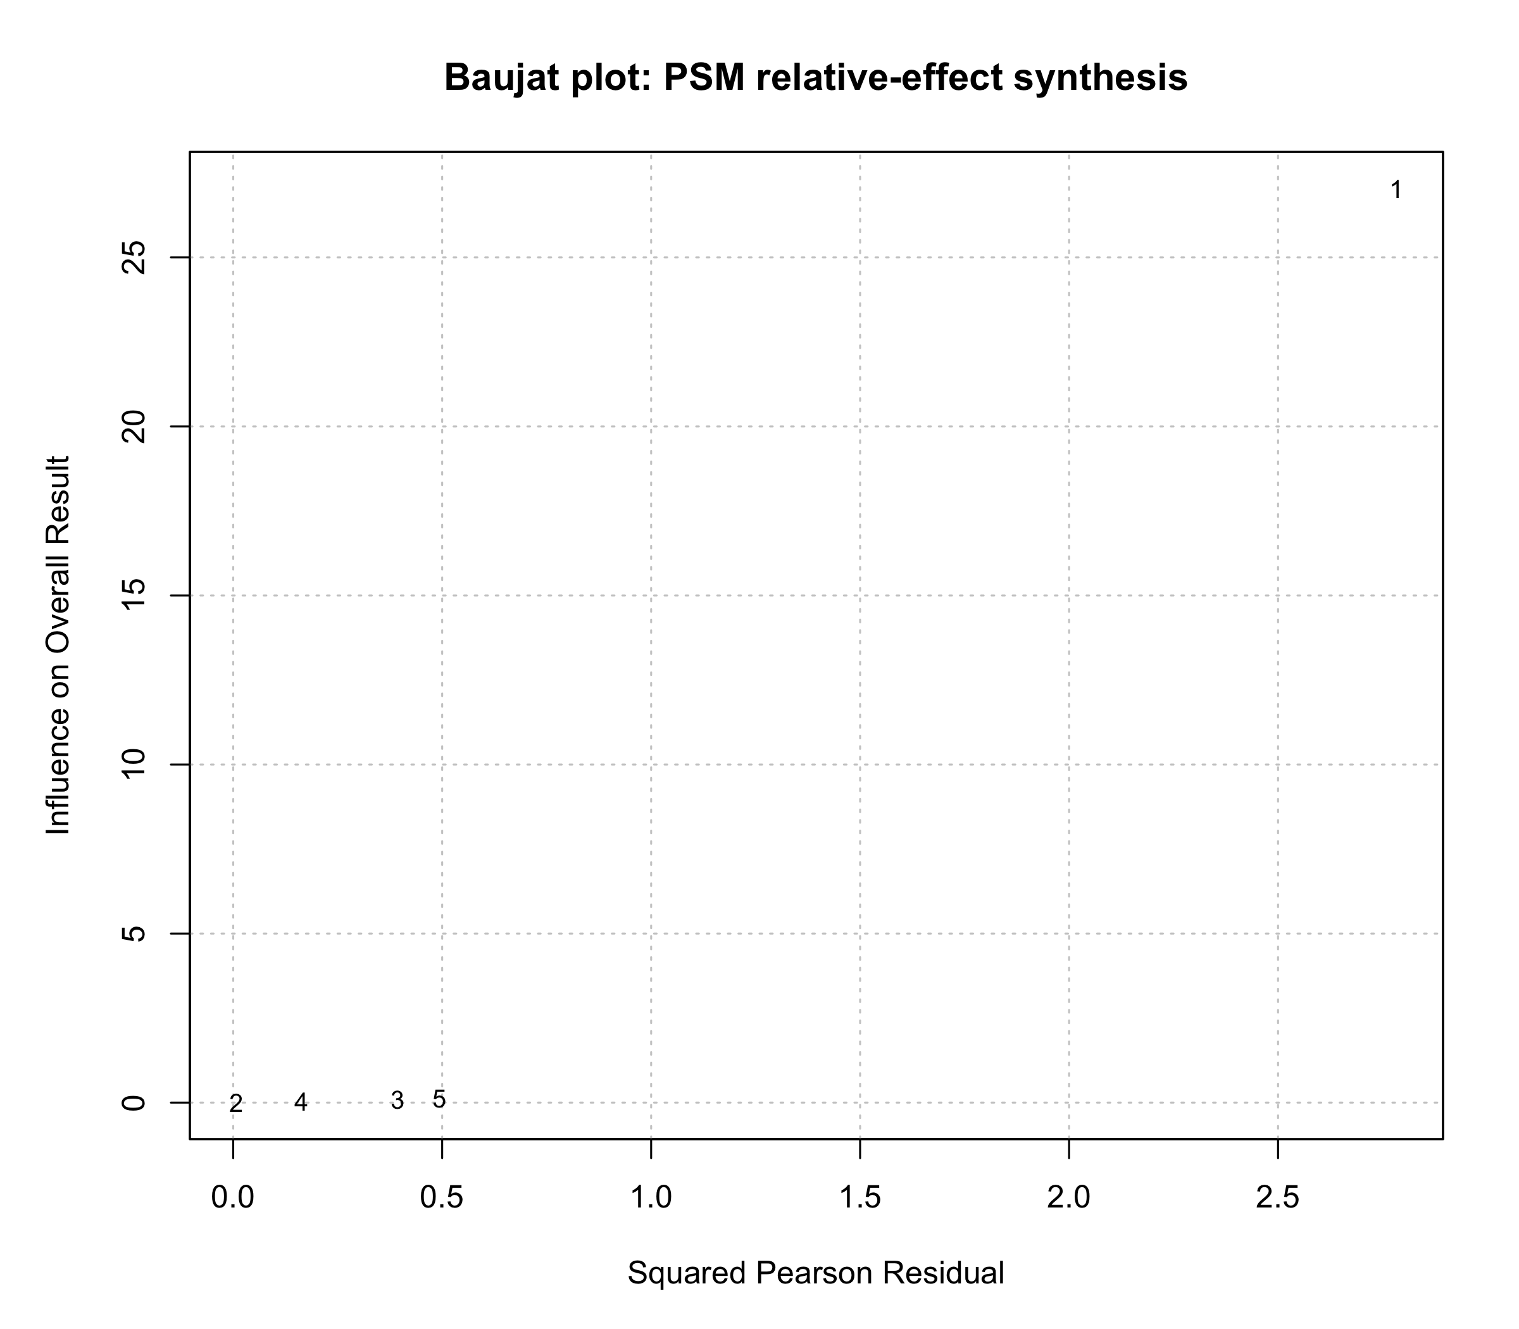

Supplementary Figure S3 Exploratory within-study postmenopausal-to-premenopausal HR ratio plot.
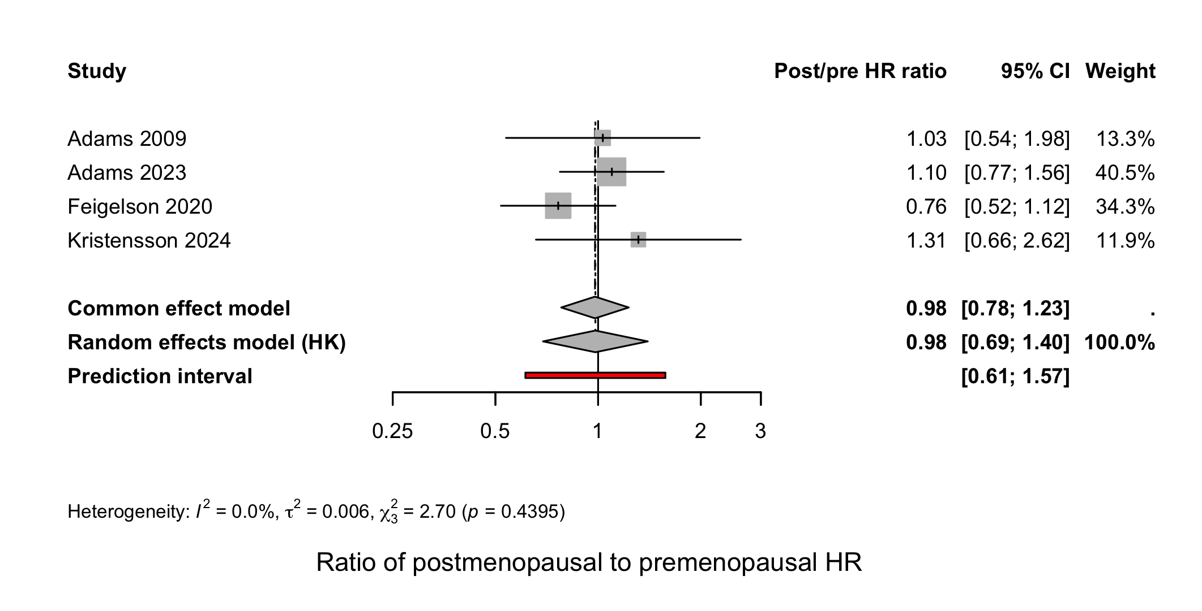

Supplementary Figure S4. Contour-enhanced funnel plot of bariatric surgery versus no-surgery for breast cancer incidence, with shaded regions at p < 0.10, p < 0.05, and p < 0.01.
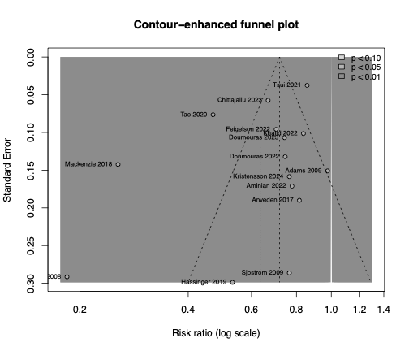

Supplementary Tables
Supplementary Table S1: Confounder adjustment and exclusion of women with prior breast cancer.
Author (Year) | Adjusted confounders / matching variables | Excluded prior breast cancer
Christou (2008) | Age, sex, duration since obesity diagnosis (matched; 6 controls each). No BMI. | Yes (all cancer)
Adams (2009) | Sex, age, BMI (group-matched); Cox adjusted for sex, age, baseline BMI. | Yes (all cancer)
Sjöström (2009) | 18-variable group-level matching (SOS); multivariable Cox adjusted for age, smoking, sagittal trunk diameter, social interaction. No BMI (visceral/sagittal adiposity used instead). | Yes (all cancer)
Anveden (2017) | SOS cohort (same as Sjöström 2009 / Kristensson 2024); 18-variable group-level matching. Cox adjusted for age, BMI and smoking status (per-protocol approach). | No (previous cancer present at baseline: 7.4% surgery, 5.9% control)
Mackenzie (2018) | Sex, age, Charlson comorbidity index, follow-up (propensity matched) | Yes (all cancer)
Hassinger (2019) | Age, BMI, race, diabetes, hypertension, GERD, smoking, CHF/CAD, insurance, follow-up (propensity matched). | Yes (breast cancer)
Feigelson (2020) | Age, BMI, study site, comorbidity index (matched); adjusted for race/ethnicity, diabetes, smoking, alcohol, hormone therapy. | Yes (all cancer)
Tao (2020) | Age, sex, country, calendar year, follow-up, diabetes (adjusted). No BMI. | Yes (all cancer)
Tsui (2021) | Age, race, ethnicity (matched); adjusted for insurance. No BMI. | Yes (all cancer)
Aminian (2022) | Age, sex, race, BMI category, smoking, type 2 diabetes, Elixhauser and Charlson indices, state (1:5 propensity matched, doubly robust); model further adjusted for income, laboratory values, menopausal hormone therapy and cancer screening. | Yes (all cancer)
Doumouras (2022) | Age, breast cancer screening history (matched; screening also time-varying in model); propensity score on income quintile, diabetes, smoking, healthcare utilisation. No BMI (administrative data). | Yes (breast cancer)
Khalid (2022) | Age, sex, hypertension, coronary artery disease, congestive heart failure, type 2 diabetes, chronic kidney disease, non-alcoholic fatty liver disease, osteoarthritis, obstructive sleep apnoea, COPD, smoking (1:1:1 exact matched). No BMI value (bariatric eligibility used). | Not stated
Adams (2023) | Sex, BMI, age, year (matched; control BMI corrected self-report); Cox adjusted for age, index year, BMI, sex, Caucasian, Hispanic. No hormone therapy, parity or smoking (Utah low-smoking population). | Yes (all cancer)
Chittajallu (2023) | Demographics, Elixhauser comorbidities, smoking, hormone therapy, cancer screening (mammography) (1:1 propensity matched). No BMI in matching (BMI >35 kg/m² used as inclusion criterion). | Yes (all cancer)
Doumouras (2023) | Age, breast cancer screening (matched; screening time-varying in model), diabetes, income, healthcare utilisation. No BMI in surgical arm (post-operative BMI not available). General-population / BMI-stratified comparator. | Yes (breast cancer)
Kristensson (2024) | 18-variable group-level matching (SOS); Cox adjusted for age, BMI, alcohol and smoking. No parity. Same cohort as Sjöström 2009 / Anveden 2017. | Yes (breast cancer)
Stenberg (2025) | Age, sex, area of residence (matched); general-population comparator | Yes (all cancer)

Confounders adjusted for or used as matching variables in each included study, and whether women with prior breast cancer (or any prior cancer) were excluded at baseline. "No BMI" indicates body mass index was not available for adjustment or matching, with the reason given where stated. Where prior-cancer exclusion was not explicitly reported, exclusion was not assumed. Abbreviations: BMI, body mass index; CAD, coronary artery disease; CHF, congestive heart failure; COPD, chronic obstructive pulmonary disease; GERD, gastro-oesophageal reflux disease; RYGB, Roux-en-Y gastric bypass; SOS, Swedish Obese Subjects study.

Supplementary Table S2A. Sensitivity analyses of the primary hazard-ratio pool.
Analysis | k | HR | 95% CI | I² (%) | τ² | Q (p)
Primary HR pool | 9 | 0.75 | 0.70-0.81 | 0.0 | 0.000 | 6.0 (0.5369)
+ Stenberg 2025 (women, IRR as approx. HR) | 10 | 0.76 | 0.72-0.80 | 0.0 | 0.000 | 7.4 (0.5973)
Obese/bariatric-eligible comparators only | 8 | 0.76 | 0.70-0.82 | 0.0 | 0.000 | 6.5 (0.4810)
SOS cohort de-duplicated (1 report) | 7 | 0.75 | 0.69-0.82 | 13.8 | 0.013 | 7.0 (0.3242)
Ontario cohort de-duplicated (1 report) | 8 | 0.74 | 0.69-0.80 | 0.0 | 0.000 | 6.0 (0.5345)
One estimate per distinct cohort | 6 | 0.74 | 0.67-0.82 | 16.9 | 0.019 | 6.0 (0.3044)
Random-effects meta-analysis on the log scale (REML estimator, Hartung-Knapp). The reference row shows the primary nine-study hazard-ratio pool. Subsequent rows add the Stenberg 2025 women-only estimate (incidence rate ratio as an approximation of the hazard ratio); restrict the pool to obese or bariatric-eligible comparators; and de-duplicate overlapping cohorts (the Swedish Obese Subjects and Ontario cohorts each contributing multiple reports), retaining one estimate per distinct cohort. k, number of estimates; tau-squared, between-study variance; Q, Cochran heterogeneity statistic with p-value.

Supplementary Table S2B. Leave-one-underlying-cohort-out sensitivity analysis of the primary hazard-ratio pool.
Cohort omitted | k | HR | 95% CI | I² (%) | τ² | Q (p) | Notable shift
None (full pool) | 9 | 0.75 | 0.70-0.81 | 0.0 | 0.000 | 7.0 (0.5362) | -
Feigelson | 8 | 0.77 | 0.73-0.81 | 0.0 | 0.000 | 3.2 (0.8630) | -
Ontario (Doumouras) | 7 | 0.75 | 0.68-0.82 | 0.0 | 0.000 | 5.7 (0.4526) | -
SOS | 6 | 0.75 | 0.68-0.83 | 27.4 | 0.000 | 6.9 (0.2291) | I² ↑ (still low)
Chittajallu | 8 | 0.75 | 0.69-0.83 | 0.0 | 0.001 | 7.0 (0.4290) | -
Nordic (Tao) | 8 | 0.74 | 0.69-0.80 | 0.0 | 0.000 | 6.0 (0.5345) | -
Utah (Adams) | 8 | 0.75 | 0.70-0.80 | 0.0 | 0.000 | 5.5 (0.6019) | -
Each row removes all reports from one underlying cohort from the primary nine-study hazard-ratio pool. The pooled estimate remained stable (HR 0.74-0.77) throughout; heterogeneity remained at 0% except when the Swedish Obese Subjects cohort was removed entirely, where it rose modestly but remained low. HR, hazard ratio; k, number of estimates; tau-squared, between-study variance; Q, Cochran heterogeneity statistic with p-value.

Supplementary Table S3A. Raw event-count sensitivity analyses addressing overlapping cohorts.
Analysis | k | RR | 95% CI | I² (%) | τ² | Q (p)
Full raw event-count pool | 15 | 0.64 | 0.50-0.81 | 89.8 | 0.154 | 137.8 (< 0.0001)
One estimate per underlying cohort | 12 | 0.60 | 0.44-0.82 | 92.0 | 0.196 | 137.1 (< 0.0001)
Random-effects meta-analyses on the log-RR scale (REML estimator). The reference row (light blue) shows the full pool of 15 raw event-count estimates; the second-row collapses studies sharing an underlying cohort to a single estimate per cohort. k, number of estimates contributing to the model; τ², between-study variance; Q, Cochran's heterogeneity statistic with associated p-value.
Supplementary Table S3B. Leave-one-underlying-cohort-out sensitivity analysis.
Cohort omitted | k | RR | 95% CI | I² (%) | τ² | Q (p) | Notable shift
None (full pool) | 15 | 0.64 | 0.50-0.81 | 89.8 | 0.154 | 137.8 (< 0.0001) | -
Christou | 14 | 0.68 | 0.56-0.83 | 88.8 | 0.096 | 115.8 (< 0.0001) | I² ↓, RR ↑
Utah (Adams) | 14 | 0.62 | 0.48-0.79 | 90.3 | 0.153 | 133.5 (< 0.0001) | -
Mackenzie | 14 | 0.69 | 0.56-0.84 | 84.4 | 0.069 | 83.5 (< 0.0001) | I² ↓, RR ↑
Hassinger | 14 | 0.64 | 0.49-0.83 | 90.5 | 0.164 | 136.7 (< 0.0001) | -
Feigelson | 14 | 0.63 | 0.48-0.82 | 90.6 | 0.171 | 137.7 (< 0.0001) | -
Nordic (Tao) | 14 | 0.65 | 0.50-0.84 | 87.4 | 0.159 | 103.5 (< 0.0001) | -
New York (Tsui) | 14 | 0.62 | 0.48-0.80 | 87.1 | 0.162 | 100.8 (< 0.0001) | -
Ontario | 13 | 0.62 | 0.46-0.82 | 91.3 | 0.186 | 137.6 (< 0.0001) | CI widens
Chittajallu | 14 | 0.63 | 0.48-0.83 | 90.4 | 0.172 | 135.8 (< 0.0001) | -
SOS | 12 | 0.60 | 0.44-0.82 | 92.0 | 0.194 | 137.1 (< 0.0001) | RR ↓, CI widens
Aminian | 14 | 0.63 | 0.48-0.81 | 90.5 | 0.167 | 137.5 (< 0.0001) | -
Khalid | 14 | 0.62 | 0.48-0.81 | 90.4 | 0.164 | 135.3 (< 0.0001) | -
Random-effects meta-analyses (REML) re-fitted after removing all studies belonging to each underlying cohort in turn. The reference row (light blue) shows the full 15-study pool. Rows shaded pink mark cohorts whose omission produces a notable shift in the pooled estimate, residual heterogeneity, or confidence-interval width. k, number of estimates contributing to the model after omission; τ², between-study variance; Q, Cochran's heterogeneity statistic with associated p-value.

Supplementary Table S4. Propensity-score-matched influence and leave-one-out analysis.
Study omitted | RR | 95% CI | p-value | τ² | I² (%) | Crosses null
None (full pool, k = 5) | 0.56 | 0.31 - 0.99 | 0.048 | 0.198 | 91.0 | No
Mackenzie 2018 | 0.68 | 0.60 - 0.77 | 0.0023 | 0.000 | 0.0 | No
Hassinger 2019 | 0.56 | 0.24 - 1.29 | 0.115 | 0.255 | 95.0 | Yes
Doumouras 2022 | 0.51 | 0.23 - 1.15 | 0.078 | 0.235 | 92.5 | Yes
Chittajallu 2023 | 0.53 | 0.23 - 1.22 | 0.094 | 0.259 | 90.1 | Yes
Aminian 2022 | 0.51 | 0.23 - 1.12 | 0.072 | 0.226 | 93.4 | Yes
Leave-one-out influence analysis of the five propensity-score-matched cohorts, each pooled as a risk ratio by the Mantel–Haenszel method. Each row shows the pooled estimate with one study omitted; the reference row (italic) shows the full five-study pool. "Crosses null" indicates whether the 95% confidence interval includes 1.00. Omitting Mackenzie 2018 removes the heterogeneity (I² 91.0% → 0.0%) without altering the direction of effect. Abbreviations: CI, confidence interval; RR, risk ratio; I², proportion of variation due to heterogeneity; τ², between-study variance.
Supplementary Table S5. Formal assessment of menopausal subgroup difference.
Analysis | Estimate / test statistic | 95% CI | p-value
Random-effects subgroup difference | Q = 0.01, df = 1 | - | 0.9321
Common-effect subgroup difference | Q = 0.06, df = 1 | - | 0.8051
Meta-regression on menopausal indicator | β = -0.0268 | -0.357 to 0.303 | 0.8493
Postmenopausal vs premenopausal within-study HR ratio | HR = 0.98 | 0.69 to 1.40 | 0.8792
Formal tests of the difference between pre- and postmenopausal subgroup estimates. The random-effects and common-effect rows report Cochran's Q for the subgroup difference; the meta-regression row models menopausal status as a moderator on the log scale; and the final row gives the pooled within-study postmenopausal-to-premenopausal hazard-ratio ratio. None reached statistical significance, indicating no evidence of effect modification by menopausal status. Abbreviations: CI, confidence interval; df, degrees of freedom; HR, hazard ratio; β, meta-regression coefficient (log scale).

Supplemental Table S6A. Node-splitting analysis of direct versus indirect evidence in the breast cancer incidence network meta-analysis
Comparison | k | Direct prop. | NMA RR | Direct RR | Indirect RR | RoR | p (disagree)
AGB:Control | 1 | 0.48 | 0.50 | 0.31 | 0.79 | 0.39 | 0.35
RYGB:Control | 3 | 0.77 | 0.53 | 0.58 | 0.40 | 1.47 | 0.65
SG:Control | 2 | 0.63 | 0.42 | 0.48 | 0.34 | 1.41 | 0.71
AGB:RYGB | 1 | 0.57 | 0.94 | 1.35 | 0.58 | 2.30 | 0.44
AGB:SG | 1 | 0.62 | 1.20 | 1.68 | 0.70 | 2.41 | 0.45
RYGB:SG | 1 | 0.49 | 1.27 | 1.25 | 1.30 | 0.96 | 0.97

Node-splitting comparison of direct and indirect evidence for each contrast in the procedure network. Direct prop. is the proportion of network information contributed by direct evidence; NMA RR is the pooled network estimate; RoR is the ratio of direct to indirect relative risks; and p (disagree) tests inconsistency between direct and indirect evidence. No comparison showed significant disagreement (all p ≥ 0.35). Abbreviations: AGB, adjustable gastric banding; NMA, network meta-analysis; RoR, ratio of relative risks; RR, relative risk; RYGB, Roux-en-Y gastric bypass; SG, sleeve gastrectomy.

Supplementary Table S6B. Node-splitting analysis of the exploratory network meta-analysis incorporating Stenberg 2025.
Comparison | k | Direct prop. | NMA RR | Direct RR | Indirect RR | RoR | p (disagree)
AGB:Control | 1 | 0.36 | 0.66 | 0.31 | 1.01 | 0.31 | 0.034
RYGB:Control | 4 | 0.72 | 0.60 | 0.64 | 0.51 | 1.25 | 0.576
Sleeve:Control | 3 | 0.57 | 0.62 | 0.74 | 0.49 | 1.50 | 0.325
RYGB:Sleeve | 2 | 0.50 | 0.96 | 0.95 | 0.98 | 0.97 | 0.940
AGB:RYGB | 1 | 0.43 | 1.10 | 1.35 | 0.94 | 1.43 | 0.506
AGB:Sleeve | 1 | 0.42 | 1.06 | 1.68 | 0.76 | 2.21 | 0.154

Node-splitting comparison of direct and indirect evidence in the exploratory network incorporating Stenberg 2025. Columns are as defined for Supplementary Table S6A. Direct and indirect evidence remained concordant for all contrasts after augmentation. Abbreviations: AGB, adjustable gastric banding; NMA, network meta-analysis; RoR, ratio of relative risks; RR, relative risk; RYGB, Roux-en-Y gastric bypass; SG, sleeve gastrectomy.
Supplementary Table S7. Procedure × era interaction meta-regression coefficients.
Term | β | SE | p-value | 95% CI
Intercept (mean RYGB%, mean era) | -0.512 | 0.232 | 0.078 | -1.108 to 0.085
RYGB share (centred, per 1%) | 0.0028 | 0.0142 | 0.852 | -0.0338 to 0.0394
Recruitment midpoint (centred, per yr) | 0.0148 | 0.0269 | 0.606 | -0.0544 to 0.0839
RYGB% × era (interaction) | 0.00026 | 0.00147 | 0.869 | -0.00351 to 0.00402
Bivariate random-effects meta-regression (REML) of the log relative effect on RYGB share, recruitment midpoint, and their interaction, across the nine procedure-contributing studies. Covariates are mean-centred; coefficients are on the log-RR scale. The non-significant interaction term indicates no evidence that procedure-specific differences are confounded by recruitment era. Abbreviations: CI, confidence interval; RR, relative risk; RYGB, Roux-en-Y gastric bypass; SE, standard error; β, regression coefficient (log scale).

Supplementary Table S8. Procedure × era interaction meta-regression model fit and tests of moderators.
Statistic | Value
Number of studies (k) | 9
Residual heterogeneity (τ²) | 0.434
Residual I² | 96.5%
R² (heterogeneity explained by moderators) | 0.0%
Test of residual heterogeneity (QE) | Q(5) = 78.03, p < 0.0001
Omnibus test of moderators (QM) | F(3, 5) = 0.13, p = 0.941

Model-fit statistics and omnibus tests for the procedure × era meta-regression in Supplementary Table S7. Residual heterogeneity remained high with R² = 0%, and the omnibus test of moderators was non-significant, indicating that RYGB share, recruitment era, and their interaction jointly explained none of the between-study variance. Abbreviations: k, number of studies; QE, test of residual heterogeneity; QM, omnibus test of moderators; R², proportion of heterogeneity explained by moderators; I², residual heterogeneity; τ², residual between-study variance.
Supplementary Table S9. ROBINS-I risk of bias assessment of each included study
Study | Confounding | Selection | Classification | Deviations | Missing data | Outcome meas. | Reporting | Overall RoB
Christou 2008 | Serious | Serious | Moderate | Low | Serious | Serious | Moderate | Serious
Adams 2009 | Serious | Moderate | Low | Low | Moderate | Low | Low | Moderate
Mackenzie 2018 | Serious | Moderate | Moderate | Low | Moderate | Moderate | Low | Serious
Tsui 2021 | Serious | Moderate | Moderate | Low | Serious | Moderate | Low | Serious
Chittajallu 2023 | Moderate | Moderate | Moderate | Low | Serious | Moderate | Low | Serious
Adams 2023 | Moderate | Moderate | Low | Low | Moderate | Low | Low | Moderate
Doumouras 2023 | Moderate | Low | Low | Low | Moderate | Low | Low | Low
Stenberg 2025 | Serious | Low | Low | Low | Low | Low | Low | Moderate
Sjöström 2009 | Moderate | Low | Low | Low | Low | Low | Moderate | Moderate
Anveden 2017 | Moderate | Low | Low | Low | Low | Low | Moderate | Moderate
Hassinger 2019 | Serious | Moderate | Moderate | Low | Serious | Moderate | Moderate | Serious
Feigelson 2020 | Moderate | Low | Low | Low | Moderate | Low | Low | Moderate
Tao 2020 | Serious | Low | Low | Low | Low | Low | Low | Moderate
Doumouras 2022 | Moderate | Moderate | Low | Low | Moderate | Low | Low | Moderate
Aminian 2022 | Moderate | Low | Low | Low | Moderate | Low | Low | Moderate
Khalid 2022 | Serious | Moderate | Moderate | Low | Serious | Serious | Moderate | Serious
Kristensson 2024 | Moderate | Low | Low | Low | Low | Low | Moderate | Moderate

Risk of bias for each included study across the seven ROBINS-I domains, with an overall judgement. Ratings are Low, Moderate, or Serious; the overall rating reflects the most severe domain. Abbreviations: RoB, risk of bias; ROBINS-I, Risk Of Bias In Non-randomised Studies of Interventions.

Supplementary Table S10. GRADE assessments of quality of each included study
Outcome | k | Pooled effect (95% CI) | Risk of Bias | Inconsistency | Indirectness | Imprecision | Overall (GRADE certainty)
Primary HR analysis (MBS vs no surgery) | 9 | HR 0.75 (0.70-0.81); I² = 0% | Not serious | Not serious | Not serious | Not serious | ⊕⊕⊕○ Moderate*
Women-only cohorts | 7 | HR 0.74 (0.67-0.81); I² = 0% | Not serious | Not serious | Not serious | Not serious | ⊕⊕○○ Low
Propensity-score-matched | 5 | RR 0.56 (0.31-0.99); 0.68 (0.62-0.75) excl. Mackenzie; I² 91% → 0% | Serious | Serious | Not serious | Not serious | ⊕⊕○○ Low
Premenopausal women | 4 | HR 0.74 (0.60-0.91); I² = 0% | Serious | Not serious | Not serious | Serious | ⊕⊕○○ Low
Postmenopausal women | 4 | HR 0.73 (0.50-1.07); I² = 50.5% | Serious | Serious | Not serious | Serious | ⊕○○○ Very low
Procedure network (NMA) | 6 | SG 0.42 (0.18-1.00); RYGB 0.53 (0.26-1.08); AGB 0.50 (0.19-1.35) | Serious | Serious | Serious | Serious | ⊕○○○ Very low
*Upgraded one level (low → moderate) for a large, consistent effect: a 25% hazard reduction with I² = 0%, a prediction interval lying entirely below 1.00, and approximately 1.86 million participants, supported by a dominance of BMI-adjusted, registry-outcome, time-to-event studies. A dose-response gradient (Kristensson insulin strata; Doumouras BMI strata) was noted but not applied as a second upgrade, to remain conservative. No other outcome was upgraded.
Abbreviations: AGB, adjustable gastric banding; CI, confidence interval; HR, hazard ratio; I², heterogeneity statistic; k, number of contributing studies/nodes; MBS, metabolic and bariatric surgery; NMA, network meta-analysis; RR, risk ratio; RYGB, Roux-en-Y gastric bypass; SG, sleeve gastrectomy.

