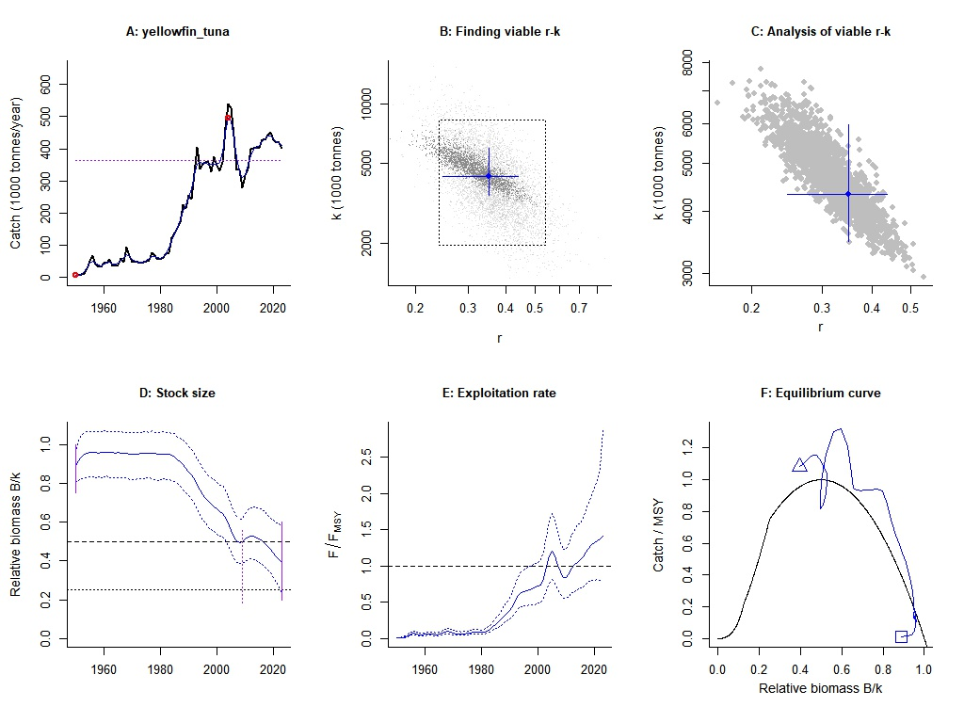
Supplementary Figure 1. CMSY model construction diagnostics for yellowfin tuna in the Indian Ocean area. The black curve in A shows the time series of catches and the blue curve shows the smoothed data with indication of highest and lowest catch in red, as used in the estimation of prior biomass by the default rules. Panel B and C shows the explored log r-k space, with the grey and black dots are the viable r-k pairs found by CMSY. The point in the center of the blue cross is the most likely r-k pair predicted by CMSY, and horizontal and vertical error bars approximate 95% confidence limits for r and k, respectively. The dotted rectangle indicates the range of the provided priors. The blue curve in D shows the median of the biomass trajectories estimated by CMSY , with the dotted lines indicate the 2.5th and 97.5th percentiles. The blue curves in panel E show the CMSY predictions for exploitation. Panel F shows the Schaefer equilibrium curve of catch/MSY relative to B/k, indented at B/k < 0.25 to account for reduced recruitment at low stock sizes. The blue curve shows the predictions by CMSY , from first year (square) to last years (triangle).

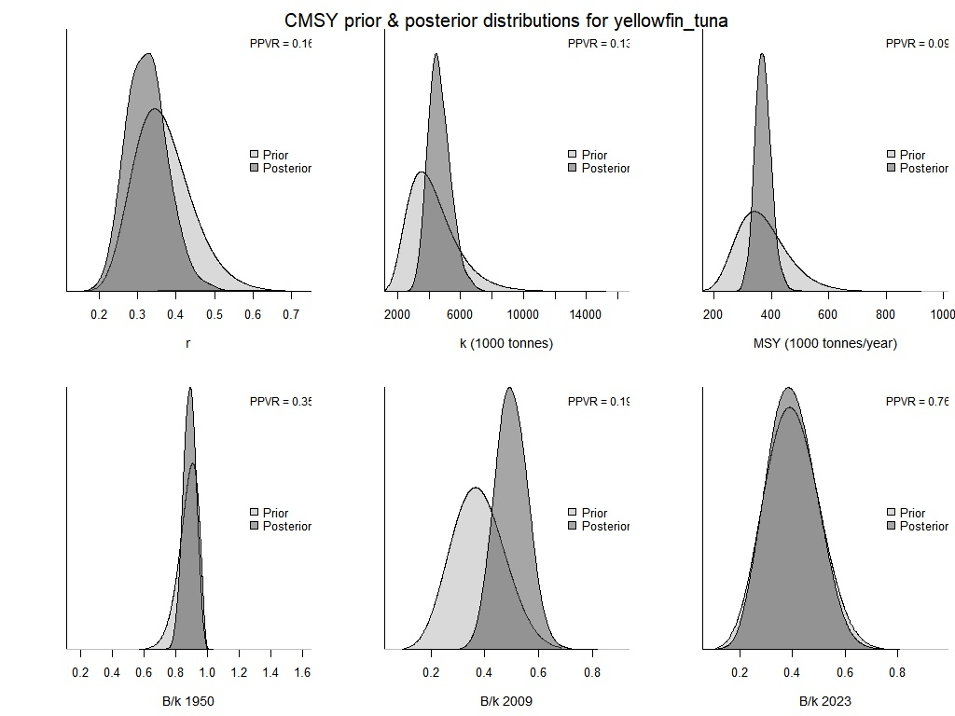
Supplementary Figure 2. Comparison of prior and posterior densities (same area under curves, PPVR) for productivity (r), maximum stock size (k), maximum sustainably yield (MSY) by CMSY and BSM

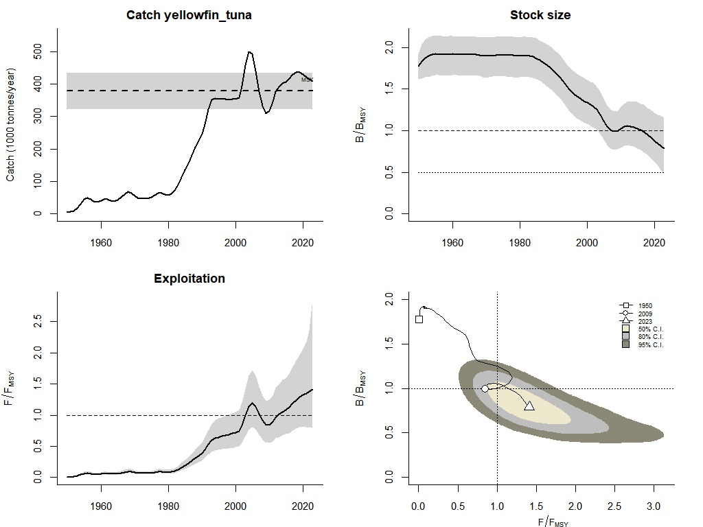
Supplementary Figure 3. The CMSY model outputs to inform management about the stock status. The upper left panel shows catches relative to MSY, with indication of 95% confidence limits in grey. The upper right panel shows the development of predicted relative total biomass (B/B_{msy}), with the grey area indicating uncertainty. The lower left graph shows relative exploitation (F/F_{msy}). The lower-right panel shows the trajectory of relative stock size (B/B_{msy}) as a function of fishing pressure (F/F_{msy}). The “banana” shape around the assessment of the final year triangle indicates uncertainty with different confidence levels.

Supplementary Table 1.​ Sensitivity of CMSY estimates to alternative prior assumptions.
Scenario | r prior | B_{end}/k prior | B/B_{msy} | F/F_{msy} | MSY (10³ t)
Baseline | 0.24–0.54 | Medium (0.2–0.6) | 0.79 | 1.41 | 378
S1 | 0.24–0.54 | Strong (0.01–0.4) | 0.71 | 1.52 | 362
S2 | 0.24–0.54 | Low (0.4–0.8) | 0.86 | 1.28 | 395
S3 | 0.30–0.60 | Medium (0.2–0.6) | 0.82 | 1.35 | 401
S4 | 0.15–0.40 | Medium (0.2–0.6) | 0.75 | 1.48 | 352

