Appendix

- Contrast in dB
The microwave (MW) magnetic field from the antenna in this work is linearly polarized, as the incident electric field is also linearly polarized. A simplified expression for the ODMR contrast of a single NV⁻ center in diamond is given by [1]

$$C\left(P\right)=\frac{P}{P+υ^{2}},$$ | (A1)

where C is the optical contrast between the $\left|m_{s}=±1〉\right.$ and $\left|m_{s}=0〉\right.$ spin sublevels, P the effective microwave driving power, υ is the offset between MW frequency and zero field splitting parameter D. In the continuous-wave ODMR regime, the effective driving strength is determined by the Rabi frequency Ω, which is proportional to the transverse component of the microwave magnetic field relative to the NV quantization axis:

$$Ω∝B_{⊥}.$$ | (A2)

Since the microwave power is proportional to the square of the driving field, it follows that

$$P∝Ω^{2}∝{B_{⊥}}^{2}.$$ | (A3)

Therefore, the ODMR contrast is ultimately governed by the square of the transverse microwave magnetic-field amplitude, consistent with standard Rabi driving behavior in NV systems [2]. This relationship provides the physical basis for using ODMR contrast as a measure of the local microwave magnetic-field strength in the quasi-linear regime. As indicated above, the fluorescence exhibits a minimum when the microwave frequency matches the NV resonance frequency, and the frequency-dependent ODMR spectrum could be described with a double-Lorentzian functions where the splitting is due to the strain-induced splitting as the E parameter. The microwave power in decibel units $P_{dB}$ is defined as

$$P=\exp\left(\frac{P_{dB}}{{10log}_{10}e}\right),$$ | (A4)

so the Contrast as a function of $P_{dB}$ is
$$C\left(P_{dB}\right)=\frac{1}{1+P_{μ}exp\left(-\frac{P_{dB}}{{10log}_{10}e}\right)},$$ | (A5)

If we set $P_{0}≡10\log_{10}(P_{μ})$ and $k≡ln⁡(10)/10$, then the contrast is reduced to a sigmoidal form:

$$C\left(P_{dB}\right)=\frac{1}{1+e^{-αk(P_{dB}-P_{0})}},$$ | (A6)

where $α$ is an ideal factor. The exponent 𝛼 quantifies the sharpness of the saturation transition on a logarithmic power scale. In the ideal case of uniform microwave driving across all NV centers, $α=1$ and the contrast follows the canonical single-site saturation curve Eq. (3). In practice, $α<1$ reflects a broadened, ensemble‐averaged saturation behaviour [2]. $P_{0}$ reflects the effective saturation power of the NV ensemble, as determined by the local microwave magnetic field amplitude $B_{mwp}^{i}$, optical pump rate, spin-lattice relaxation times $T_{1}$, and spin-spin relaxation times $T_{2}$ [3]. Measuring contrast as a function of $P_{dB}$ allows these probe-DUT specific constants to be extracted, thereby providing a quantitative calibration of the measurement system. This calibration procedure is analogous to the standard routine performed prior to MW measurements with a conventional vector network analyzer.

- Linear regime
Given the contrast is in the form

$$f\left(x\right)=\frac{1}{1+e^{-k(x-x_{0})}}$$ | (B1)

Expanding f(x) around $x_{0}$​ using a Taylor series:

$$f\left(x\right)≈\frac{1}{2}+\frac{k}{4}\left(x-x_{0}\right)-\frac{k^{3}}{48}{\left(x-x_{0}\right)}^{3}+O({(x-x_{0})}^{5}),$$ | (B2)

So the first nonlinear term is cubic:

$$ε\left(x\right)≈\frac{k^{3}}{48}{|x-x_{0}|}^{3},$$ | (B3)

We require that the nonlinearity remains below a specified tolerance (e.g., 1% of the full range), say 1% of the full range:

$$ε\left(x\right)≈\frac{k^{3}}{48}{\left|x-x_{0}\right|}^{3}≤0.01$$ | (B4)

Solve for $|x-x_{0}|$, we get
$|x-x_{0}|≤\frac{{0.48}^{1/3}}{k}$. | (B5)

With experimental parameters $k=α∙\frac{\log\left(10\right)}{10}≈0.1267$, we get the 1% linear regime for contrast as a function of power in dB:
$$|P_{dB}-P_{0}|≤6.18$$ | (B6)

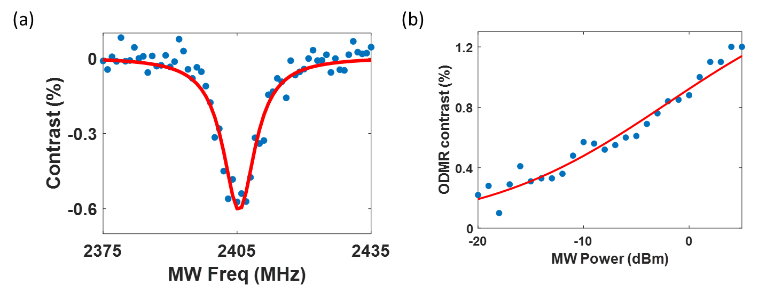
Fig. S1 ODMR spectrum of the diamond probe at 2.4 GHz excited by a PCB straight microstrip transmission line. (a) Fluorescence contrast versus swept frequency with a power input of -5 dBm from synthesizer. The spectrum was fitted with a single Lorentzian curve. (b) Contrast plotted against mw input power at 2.405 GHz. The power spectrum is fitted with the sigmoidal form derived previously.

Note that when $|P_{dB}-P_{0}|≤6$ dB across a 12 dB range with the proposed diamond probe, the difference of the sigmoidal function to a linear function is less than 1% and the contrast in dB unit could be well-approximated by a linear function.

- Frequency tuning
The ODMR spectra of diamond probe at 2.4 GHz is show in Fig. S1. This spectrum serves as the basis for subsequent measurements for all the antenna excited at 2.4 GHz.

Fig. S2 Spatial resolution of the diamond probe. The measured ODMR contrast was plotted against position of the probe from a microstrip transmission line.
- Spatial scanning profile of the diamond probe
In order to quantify the spatial sensitivity of the diamond probe, it was placed above a 2 mm wide microstrip transmission line and scanned across it, as shown in Fig. S2. With a diamond width of 2 mm, the spatial resolution of the probe is on the order of the diamond size.

- Angular Projection Model for Polarization-Selective NV Response
Building on the ground-state Hamiltonian introduced in the main text, the interaction between the microwave magnetic field and the NV spin is described by the magnetic dipole term

$$H_{mw}=γ_{B}B·S.$$ | (E1)

For a given NV quantization axis $\hat{n}$, only the transverse components of the magnetic field contribute to spin transitions. Introducing a local orthonormal frame $( \hat{x^{'}}, {\hat{y}}^{'}, \hat{n})$, the transverse field is written as

$$\overset{⃑}{B_{⊥}}=B_{x'}\hat{x^{'}}+B_{y'}\hat{y^{'}}.$$ | (E2)
To expose the selection rules, we express the transverse field in the circular basis

$$\hat{e_{±}}=\frac{1}{\sqrt{2}}\left(\hat{x^{'}}±i\hat{y^{'}}\right).$$ | (E3)
Using the spin-1 ladder operators $S_{±}=S_{x'}±iS_{y'}$​, the interaction Hamiltonian becomes

$$H_{mw}^{(⊥)}=\frac{γ_{B}}{2}[\left(B_{x^{'}}-iB_{y^{'}}\right)S_{+}+\left(B_{x^{'}}+iB_{y^{'}}\right)S_{-}].$$ | (E4)

This expression shows that the two transitions,∣0⟩ ↔∣+1⟩,∣0⟩ ↔∣−1⟩, are driven by the circular components of the magnetic field. Defining

$$B_{σ^{±}}={\hat{e_{±}}}^{†}\overset{⃑}{B}=\frac{1}{\sqrt{2}}(B_{x^{'}}∓iB_{y^{'}}).$$ | (E5)

and the transition strengths scale as

$$W_{±}∝{{\left|B_{σ^{±}}\right|}^{2}=\left|{\hat{e_{±}}}^{†}\overset{⃑}{B}\right|}^{2}.$$ | (E6)

Thus, the ODMR response is not determined by the magnitude of the total magnetic field, but by its projection onto the circular basis defined by the NV quantization axis.

We now evaluate this projection for a circularly polarized field whose rotation axis is not aligned with the NV axis. We consider a microwave magnetic field that is purely circularly polarized about an axis $\hat{k}$,

$$\overset{⃑}{B}=\frac{B_{0}}{\sqrt{2}}(\hat{u}+i\hat{v})$$ | (E7)

where $\hat{u}$ and $\hat{v}$ are transverse unit vectors, and $\hat{k}=\hat{u}×\hat{v}$. The relative orientation between the polarization axis and the NV axis is given by

$$\cos{θ}=\hat{k}∙\hat{n}.$$ | (E8)
Without loss of generality, we choose the NV quantization axis as the reference axis, $\hat{z}=\hat{n}$, and let the microwave polarization axis $\hat{k}$ be tilted by an angle θ in the xz-plane,
$$\hat{k}=cosθ\hat{z}+sinθ\hat{x}.$$ | (E9)

A corresponding transverse basis can be constructed as

$$\hat{u}=cosθ\hat{x}-sinθ\hat{z},$$ | (E10)

and $\hat{v}=\hat{y}$, such that $( \hat{u}, \hat{v}, \hat{k})$ form an orthonormal right-handed basis. The field then becomes

$$\overset{⃑}{B}=\frac{B_{0}}{\sqrt{2}}\left(cosθ\hat{x}-sinθ\hat{z}+i\hat{y}\right).$$ | (E11)

Projecting this field onto the NV circular basis , we obtain

$$\overset{⃑}{B}=\frac{B_{0}}{2}\left[\left(1+cosθ\right)\hat{e_{+}}+\left(1-cosθ\right)\hat{e_{-}}\right]-\frac{B_{0}}{\sqrt{2}}\left(sinθ\hat{z}\right).$$ | (E12)

The last term is parallel to the NV quantization axis and therefore does not contribute to the ∣0⟩↔∣±1⟩ transitions. From the above decomposition, the transition-driving strengths satisfy

$$W_{±}∝{\left|B_{σ^{±}}\right|}^{2}=B_{0}^{2}{(\frac{1±cosθ}{2})}^{2}.$$ | (E13)

For comparison, a linearly polarized microwave magnetic field tilted by an angle θ relative to the NV quantization axis produces a transverse component $B_{⊥}=B_{0}sinθ$,
so that the transition-driving strength scales as

$$W(θ)∝B_{⊥}^{2}=B_{0}^{2}\sin^{2}θ.$$ | (E14)

This dependence reflects the fact that only the transverse component of the magnetic field contributes to the spin transition.

- Simulation of Ensemble NV Response
The ODMR response of the NV ensemble is modeled by combining the spin Hamiltonian described in the main text with a numerical evaluation of microwave-driven transitions and spin-dependent fluorescence. The present formulation focuses on how the local frame of each NV orientation, together with the applied magnetic field and microwave polarization, determines the observable contrast. For each NV orientation k, a local coordinate system is defined such that the quantization axis aligns with the NV axis $\hat{n_{k}}∈\{[111],[1\overline{1}\overline{1}],[\overline{1}1\overline{1}],[\overline{1}\overline{1}1]\}.$​ The transformation from the laboratory frame to the local frame is performed using a rotation matrix $R_{k}$​, such that the static magnetic field $B_{0}^{k}$ and microwave field $B_{1}^{k}$ are expressed as

$B_{0, local}^{k}=R_{k}^{T}B_{0, lab}^{k},$ $B_{1, local}^{k}=R_{k}^{T}B_{1, lab}^{k}$ | (F1)

The spin Hamiltonian is then diagonalized in this local frame to obtain eigenstates $\left|\left.ψ_{n}^{(k)}\right\rangle \right.$ and eigenvalues, which generally correspond to mixtures of the $\left|m_{s}=0〉\right.$ and $\left|m_{s}=±1〉\right.$ basis under an applied magnetic field.

The microwave-driven transition strength between eigenstates is evaluated through the interaction Hamiltonian, which defines an effective Rabi frequency $Ω_{mn}$ via

$$Ω_{mn}^{2}∝M_{mn}^{(k)}={\left|\left\langle ψ_{m}^{\left(k\right)} | H_{mw} | ψ_{n}^{\left(k\right)}\right\rangle \right|}^{2}.$$ | (F2)

This formulation inherently captures the projection of the microwave field onto the transverse spin components and includes the effects of state mixing under off-axis magnetic fields. While the numerical implementation uses the full matrix element, it is instructive to express the microwave field in the circular basis defined with respect to the NV axis. In the local frame, the transverse field components may be written as

$$B_{σ^{±}}^{(k)}=\frac{1}{\sqrt{2}}(B_{x}^{(k)}∓iB_{y}^{(k)}).$$ | (F3)

which selectively drive the $\left|m_{s}=0〉\right.$ to $\left|m_{s}=±1〉\right.$transitions. The corresponding transition strengths scale with ${\left|B_{σ^{±}}^{(k)}\right|}^{2}$, providing a direct physical interpretation of polarization selectivity. Linear polarization corresponds to equal contributions from $B_{σ^{+}}$ and $B_{σ^{-}}$​, whereas circular polarization corresponds to an imbalance between these components.

The optical readout is modeled through spin-dependent fluorescence. Each eigenstate $\left|\left.ψ_{n}^{(k)}\right\rangle \right.$ is assigned a brightness determined by its projection onto the $\left|m_{s}〉\right.$ basis,

$$F_{n}^{(k)}=F_{0}p_{0}+F_{1}(p_{+1}+p_{-1}).$$ | (F4)

where $p_{m_{s}}={\left|\left\langle m_{s} | ψ_{n}^{(k)}\right\rangle \right|}^{2},$ and $F_{0}>F_{1}$reflects the higher fluorescence associated with the $\left|m_{s}=0〉\right.$ component. The fluorescence contrast for a transition between states n and m is then defined as

$$C_{mn}^{(k)}=\left|F_{m}^{(k)}-F_{n}^{(k)}\right|.$$ | (F5)

To account for saturation of the ODMR response at finite microwave power, the observable transition amplitude is modeled as

$$A_{mn}^{(k)}=\frac{Ω_{mn}^{2}}{Ω_{mn}^{2}+Ω_{sat}^{2}}C_{mn}^{(k)}.$$ | (F6)

where $Ω_{sat}$​ is a phenomenological saturation parameter that sets the scale for nonlinear response. In this expression, $Ω_{mn}$​ captures the geometry-dependent microwave coupling, while $C_{mn}^{(k)}$​ encodes the optical readout contrast, and their combination determines the measurable ODMR signal. Each transition contributes a Lorentzian lineshape:

$$L\left(f;f_{mn},Γ\right)=\frac{Γ^{2}}{{\left(f-f_{mn}\right)}^{2}+Γ^{2}},$$ | (F7)

where $f_{mn}=f_{m}-f_{n}$ is the frequency offset between sublevels and $Γ$ is the half-width at half-maximum. The ODMR spectrum for a single NV orientation is

$$S^{\left(k\right)}\left(f\right)=\sum_{m>n}{A_{mn}^{(k)}}L\left(f;f_{mn},Γ\right).$$ | (F8)

The measured signal is the incoherent sum over the four NV orientations:

$$S_{total}\left(f\right)=\sum_{k=1}^{4}{S^{\left(k\right)}\left(f\right)}.$$ | (F9)

The ODMR simulation employs experimentally motivated parameters describing the NV spin system, microwave driving, and fluorescence response. The values are chosen to reproduce typical ensemble ODMR behavior while preserving the relative scaling between transition strengths and polarization-dependent effects. All parameters used in the simulation are summarized in Table F1.

Table F1. Simulation parameters used in ODMR modeling
Parameter | Symbol | Value | Description
Zero-field splitting | D | 2.87 GHz | Ground-state spin splitting
Gyromagnetic ratio | $$γ_{B}$$ | 2.8025 MHz/G | Zeeman coupling strength
Linewidth (FWHM) | $$∆f$$ | 4 MHz | Ensemble broadening (Lorentzian)
MW field scale | $$B_{1}$$ | 0.5 G | Effective microwave field used to define saturation
Saturation scale | $$Ω_{sat}$$ | 1.401 MHz | Onset of ODMR saturation. Set to $γ_{B}B_{1}$
Bright-state fluorescence | $$F_{0}$$ | 1 | Fluorescence of $\left|m_{s}=0〉\right.$
Dark-state fluorescence | $$F_{1}$$ | 0.7 | Fluorescence of $\left|m_{s}=±1〉\right.$
Zero-field contrast | $$-$$ | 6% | Used for global normalization

- Probe-Frame Helicity and Measurement Mapping Under Inversion
In the near field, circular polarization cannot be uniquely defined by a propagation direction, and therefore quantities such as Bx±iBy ​ represent axis-dependent basis decompositions rather than intrinsic field properties. In NV-based measurements, the relevant quantity is instead the transition-selective coupling of the microwave magnetic field to the spin, which is determined by the projection of the field onto circular components defined with respect to the effective quantization axis of the NV center. This quantization axis is set by the eigenstates of the NV spin Hamiltonian, resulting from the combined effects of the zero-field splitting and the applied static magnetic field. As a result, it is generally not aligned with either the crystallographic NV axis or the external magnetic field alone. The measured ODMR contrast therefore reflects coupling to circular components defined in this eigenstate-dependent frame, rather than to a fixed laboratory-frame definition of circular polarization.

To facilitate interpretation, we introduce a probe-frame helicity label, defined with respect to the physical axis of the device (from cable to diamond, taken as +x). This label provides a consistent operational reference across measurements at a fixed transition frequency. However, it does not directly correspond to the intrinsic rotational sense of the electromagnetic field in space. Under inversion operations, the relationship between the measured signal and the underlying field component can change in two distinct ways. Inversion of the diamond or the applied magnetic field modifies the effective quantization axis and the transition selection, thereby reversing the mapping between the measured transition and the sampled circular component, while leaving the probe axis unchanged. In contrast, inversion of the probe reverses the probe axis itself, so that the probe-frame helicity label follows the device, even though the sampled spatial rotation of the field is reversed. These effects are summarized in Table G1.

Table G1. Mapping between probe-frame helicity and sampled field rotation under inversion
Operation | Probe-Frame CP | Sampled Spatial Rotation
Original | RHCP (+x) | Original direction
Flip diamond | LHCP (+x) | Opposite direction
Flip magnet | LHCP (+x) | Opposite direction
Flip probe | RHCP (-x) | Opposite direction

- HFSS-Derived Circular Components and Relation to Measurements
Full-wave HFSS simulations are used to obtain the microwave magnetic field, which is decomposed into circular components with respect to locally chosen coordinate axes. For the baseplate region, circular components are defined about the surface-normal (z-axis) as Hx±iHy ​, while for the side of the helical conductor they are defined about the axial direction (x-axis) as Hy±iHz​. These definitions correspond to axis-dependent circular bases and are selected to reflect the local field geometry. The resulting circular component maps, shown in Fig. S3, show distinct behavior in different regions. Along the antenna axis (z-direction), the helical structure supports a preferred rotational sense, leading to unequal circular components. In contrast, for transverse axes (e.g., x-direction along the helix side), no preferred rotation is expected, and the corresponding
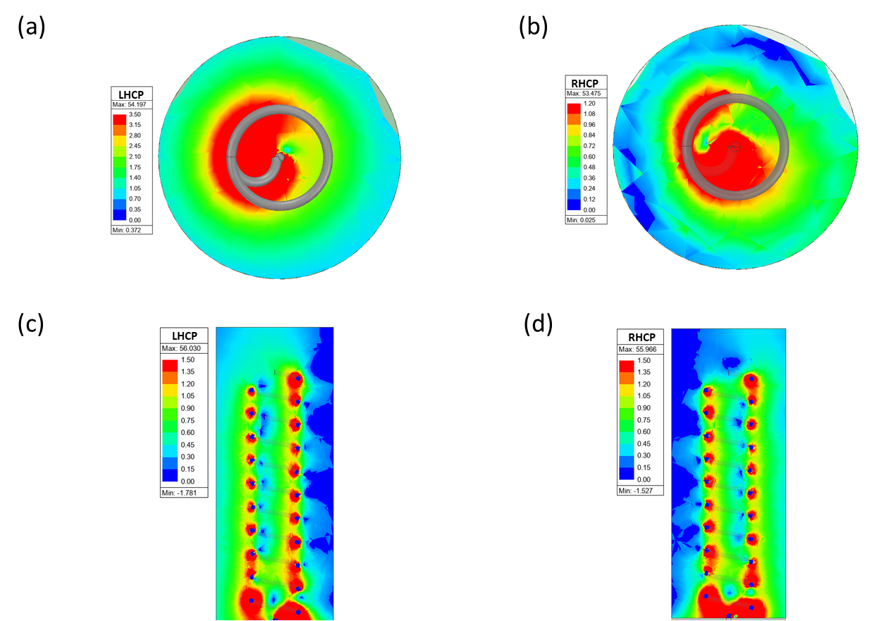
Fig. S3 HFSS simulation of the helical antenna. (a,b) Circular components of the magnetic field near the baseplate, defined with respect to the z-axis as Hx∓iHy ​ (LHCP/RHCP). (c,d) Circular components near the side of the helical conductor, defined with respect to the x-axis as Hy∓iHz (LHCP/RHCP). All circular components are axis-dependent basis decompositions and do not represent intrinsic helicity in the near field.

components are approximately balanced. This is consistent with the known polarization characteristics of helical antennas.

The NV probe measures the projection of the microwave magnetic field onto circular components defined with respect to its effective quantization axis. Accordingly, agreement between simulation and experiment occurs only when the local field is predominantly transverse to this axis and the simulation basis is aligned. In general, these conditions are not satisfied in the near field, and the simulated circular components should be interpreted as describing the underlying field distribution rather than the directly measured helicity.

REFERENCE
1. Jensen, K., Acosta, V. M., Jarmola, A. & Budker, D. Light narrowing of magnetic resonances in ensembles of nitrogen-vacancy centers in diamond. Phys. Rev. B 87, 014115 (2013).
2. Barry, J. F. et al. Sensitivity optimization for NV-diamond magnetometry. Reviews of Modern Physics 92, (2020).
3. Kehayias, P. et al. Microwave saturation spectroscopy of nitrogen-vacancy ensembles in diamond. Phys. Rev. B 89, 245202 (2014).

