Supplementary Materials

Table S1. Pearson correlation coefficients (r) among conditioning factors based on WoE contrast values.
Factor | Slope | TWI | Curvature | DTS | SD | Lithology | Rb | LD | LSID | Rainfall
Slope | 1.00
TWI | -0.82* | 1.00
Curvature | 0.23 | -0.19 | 1.00
DTS | 0.67 | -0.63 | 0.08 | 1.00
SD | 0.58 | -0.54 | 0.11 | 0.71 | 1.00
Lithology | 0.41 | -0.38 | 0.06 | 0.44 | 0.47 | 1.00
Rb | 0.73 | -0.68 | 0.15 | 0.59 | 0.52 | 0.49 | 1.00
LD | 0.35 | -0.32 | 0.04 | 0.38 | 0.41 | 0.43 | 0.39 | 1.00
LSID | 0.33 | -0.30 | 0.03 | 0.42 | 0.45 | 0.40 | 0.38 | 0.86 | 1.00
Rainfall | 0.28 | -0.26 | 0.05 | 0.31 | 0.33 | 0.24 | 0.29 | 0.34 | 0.32 | 1.00
*Values in bold indicate strong correlation (|r| > 0.7) [81]
Table S2. Variance Inflation Factor (VIF) for each conditioning factor.
Factor | R² | VIF | Interpretation
Slope | 0.78 | 4.55 | Moderate (acceptable)
TWI | 0.74 | 3.85 | Moderate (acceptable)
Curvature | 0.08 | 1.09 | Low (independent)
DTS | 0.69 | 3.23 | Moderate (acceptable)
SD | 0.66 | 2.94 | Moderate (acceptable)
Lithology | 0.51 | 2.04 | Low
Rb | 0.71 | 3.45 | Moderate (acceptable)
LD | 0.77 | 4.35 | Moderate (acceptable)
LSID | 0.81 | 5.26 | Moderate-High (exceeds threshold)
Rainfall | 0.18 | 1.22 | Low (independent)
*VIF > 5 indicates moderate-to-severe multicollinearity; VIF > 10 indicates severe multicollinearity requiring correction [83]

Table 3S: Comparison between the aquifer parameters from resistivity soundings (VES), GWp values from WOF, EBF models, and the available borehole information.
VES | Locations |  | Aquifer parameters from VES |  |  |  |  | groundwater potentiality (GwP). |  |  | Borehole information
 | East | North | Resistivity (Ω.m) | Thickness (m) | Depth (m) | Lithology | WOE- |  | EBF | Well depth (m) |  | TDS (ppm)
1 | 34' 42' 42.' | 23' 18' 44.' | 177/550 | 14.2 | 3 | Nubian Sandstone / fractured basement | High |  | High
2 | 34' 42' 24' | 23' 18' 53' | 46 | 22 | 17.8 | Nubian sandstone | High |  | High
3 | 34' 42' 18' | 23' 19' 50' | 78.8 | 75 | 31.5 | Nubian sandstone | V. High |  | V. High
4 | 34' 42' 9' | 23' 19' 1' | 111 | 65 | 30 | Nubian sandstone | V. High |  | V. High
5 | 34' 42' 14' | 23' 18' 32' | 119/371 | 85 | 7.8 | Nubian Sandstone / fractured basement | V. High |  | V. High | 50
6 | 34°48'32 | 23°17' 57 | 120 | 30 | 30.4 | Nubian sandstone | V. High |  | V. High | 90.53 |  | 824
7 | 34' 42' 34' | 23' 17' 44' | 151 | 10 | 2.3 | Nubian sandstone | High |  | High
8 | 34' 42' 55' | 23' 17' 53' | 165 | 65 | 58.5 | Nubian sandstone | V. High |  | V. High | 155 |  | 915
9 | 34°44'55 | 23°18'47 | 560 | 21 | 5.6 | Fractured basement | High |  | High
10 | 34' 46' 56' | 23' 17' 48' | 83.5 | 10.8 | 2.9 | Nubian sandstone | High |  | High | Spring |  | 800
11 | 34' 49' 15' | 23' 18' 34' | 17.5 | 29.7 | 31.6 | Nubian sandstone | V. High |  | High | 83 |  | 2120
12 | 34' 55' 43 | 23' 15' 8' | 227 | 110 | 31.5 | Nubian sandstone | V. High |  | High | 134 |  | 568
13 | 34' 56' 6' | 23' 15' 50' | 76.8 | 65 | 48.5 | Nubian sandstone | High |  | High | 90 |  | 1061
14 | 34' 53' 36.' | 23' 18' 40' | 71.4 | 21 | 12.5 | Fractured Metamorphic | Medium |  | Medium |  |  | 7931
15 | 34°51'37 | 23°22'36 | 275 | 10.2 | 2.3 | Fractured Granite | Medium |  | Low |  |  | 713
16 | 34°55'03 | 23°22'42 | 556 | 10.2 | 1.5 | Fractured basement | low |  | low |  |  | 2237
17 | 34' 52' 18.' | 23' 25' 23' | 246 | 28 | 3.3 | Nubian sandstone | High |  | High | Spring |  | 412

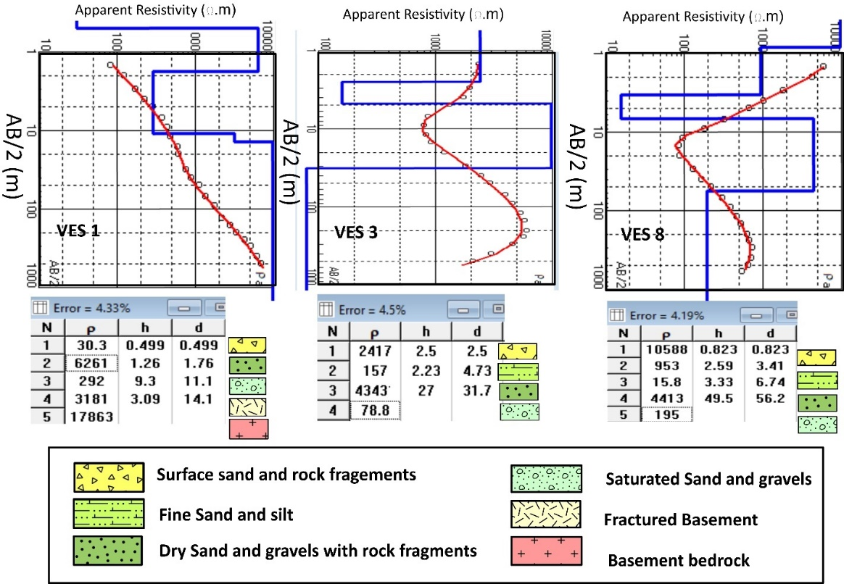
Fig. S1: Representative resistivity curves with their interpretations and corresponding RMS% errors. The curves display substantial variability in curve shapes, resistivity values, and layer thicknesses, consistent with the local geological complexity influenced by subsurface faults and basement relief. For the locations of the corresponding VESs, see Fig. 5.

