Figure 3: The ordination plots of distinct separation of samples collected at Week 1, Week 2, Week 4, Week 12, and Month 12
Distance based redundancy analysis (db-RDA) of infant gut microbiome. Subjects belonging to the study groups, CS-Control, CS-Test, and the VD-Reference are indicated by the red, purple, and green circles respectively. The db-RDA axes describe the percentage of the fitted and total variation explained by each axis while being constrained on groups. Black arrow vectors indicate the weight and direction of 10 bacterial genera that most explain the variation. The labels for the groups, CS-Control, CS-Test, and the VD-Reference are located at the geometrical centre of each feeding group. * p<0.05, **p< 0.01, *** p<0.001 (PERMANOVA test to compare differences between the centroids of the groups).
- Week 1
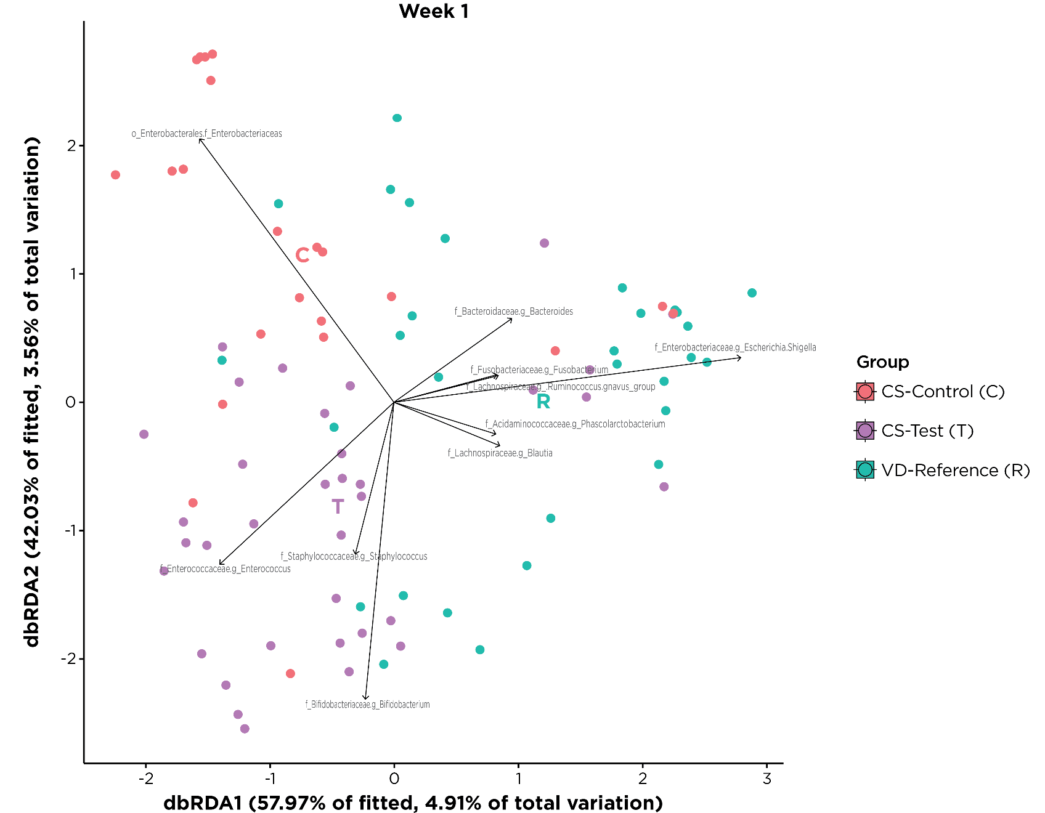
PERMANOVA (FDR)
T vs C: 0.001
T vs R: 0.001
C vs R: 0.001
Dispersion p = 0.573

PERMANOVA test to compare differences between the centroids of the groups at Week 1:
CS-Control vs CS-Test | p=0.001**
CS-Control vs VD-Reference | p=0.001**
CS-Test vs VD-Reference | p=0.001**

- Week 2
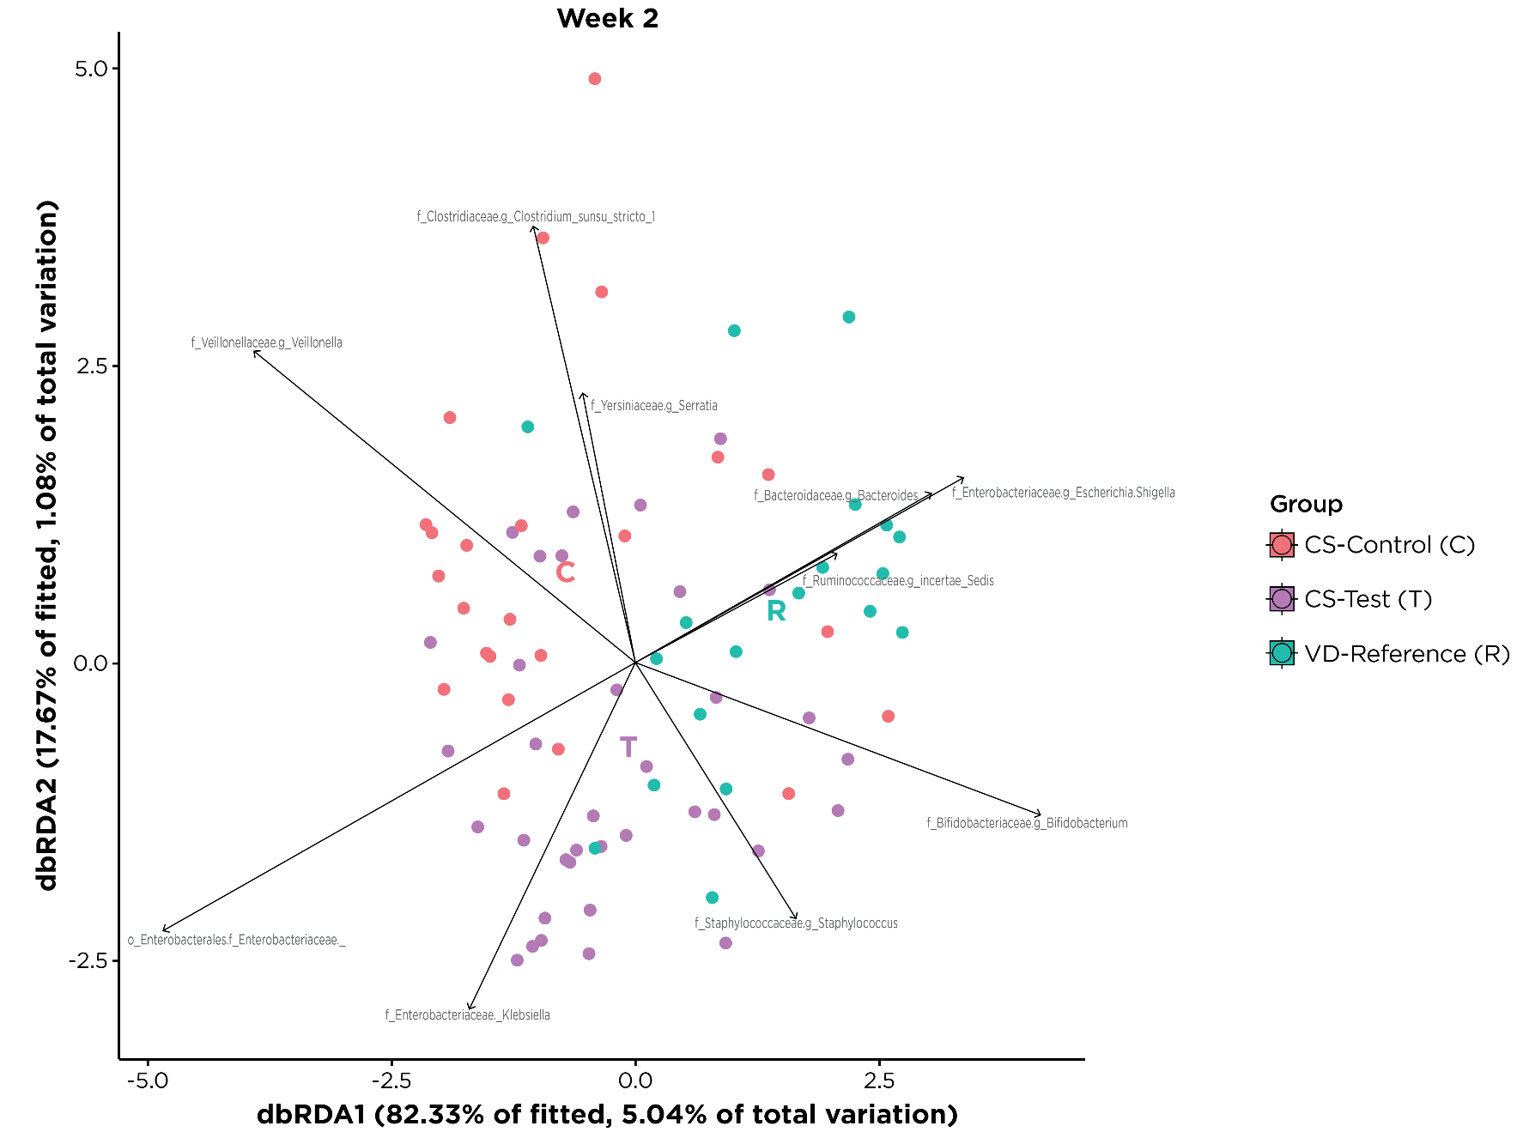
PERMANOVA (FDR)
T vs C: 0.251
T vs R: 0.0045
C vs R: 0.0045
Dispersion p = 0.275
PERMANOVA test to compare differences between the centroids of the groups at Week 2:
CS-Control vs CS-Test | p=0.247
CS-Control vs VD-Reference | p=0.001**
CS-Test vs VD-Reference | p=0.004**
- Week 4
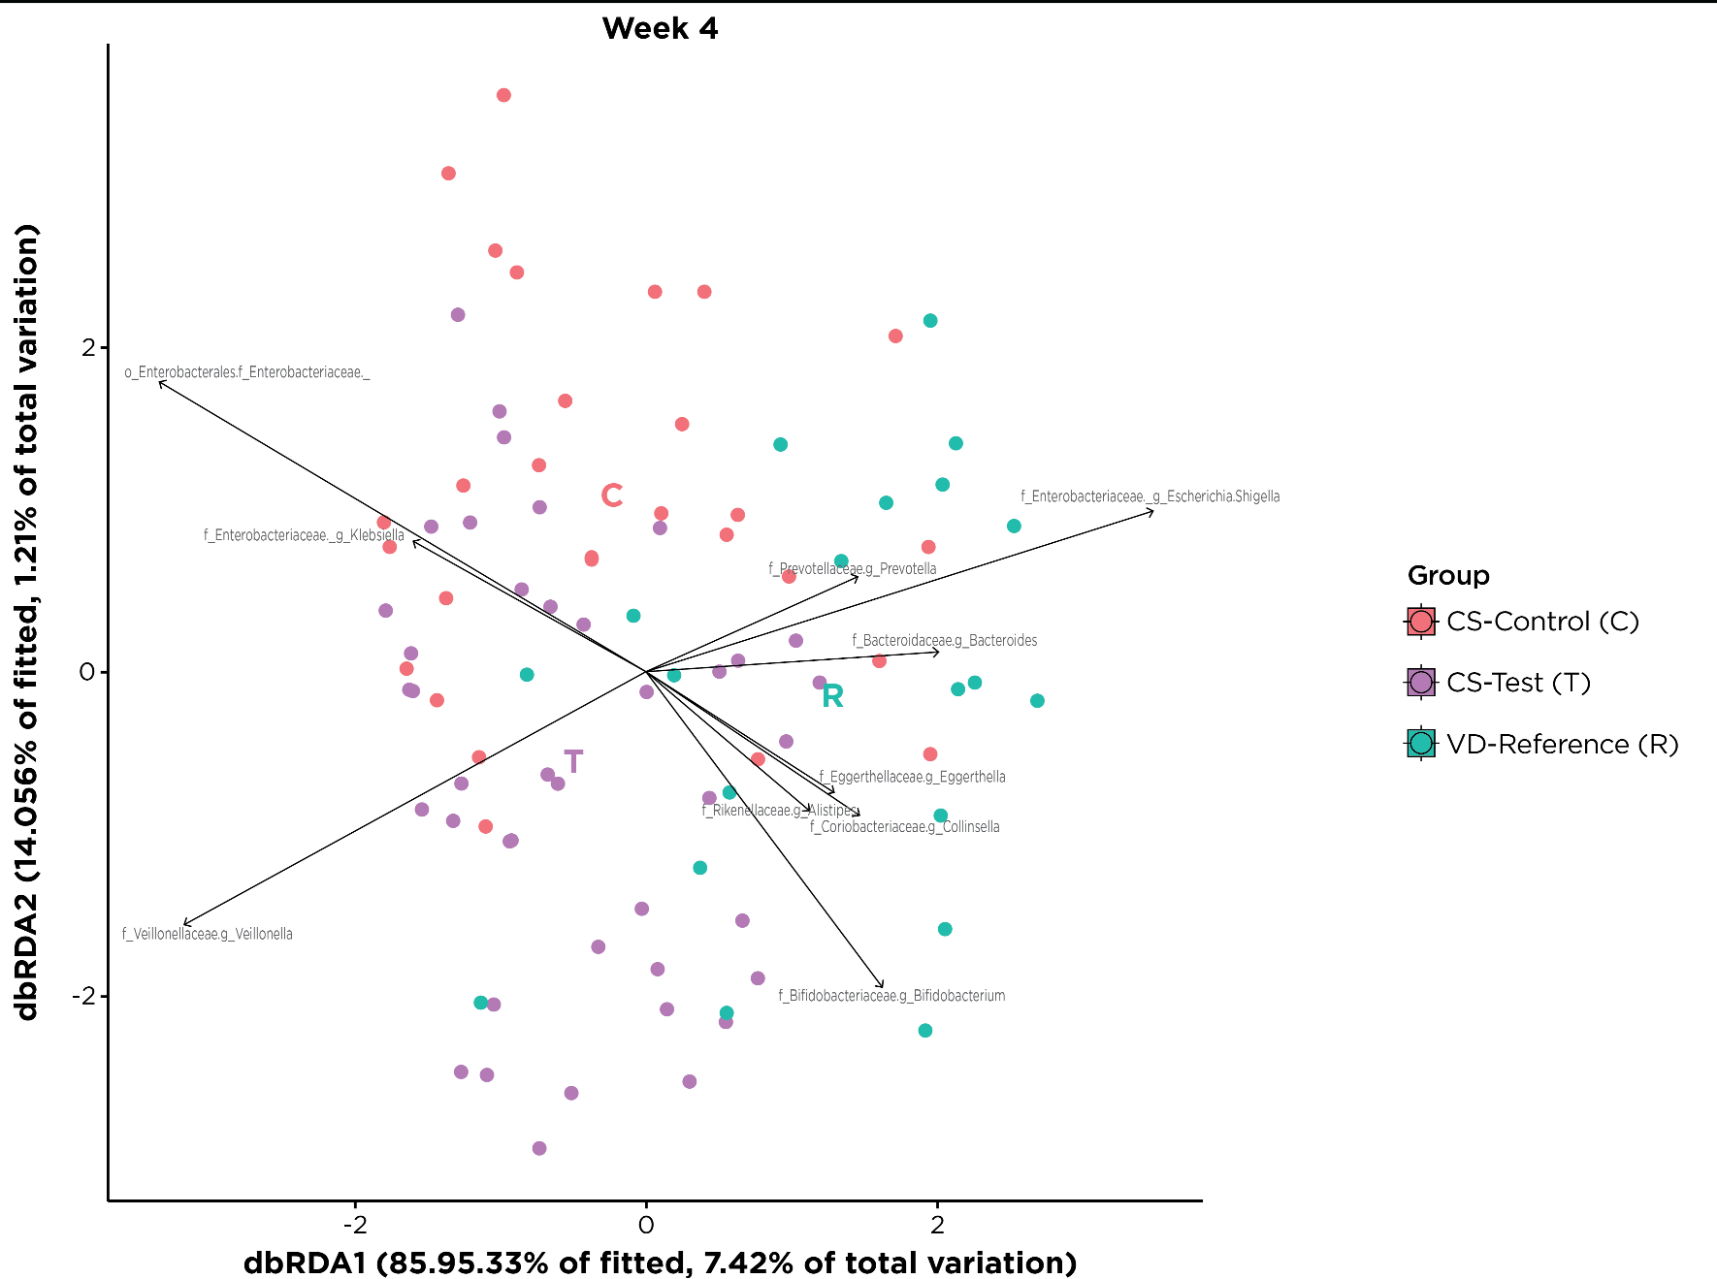
PERMANOVA (FDR)
T vs C: 0.246
T vs R: 0.003
C vs R: 0.003
Dispersion p = 0.0155
PERMANOVA test to compare differences between the centroids of the groups at Week 4:
CS-Control vs CS-Test | p=0.172
CS-Control vs VD-Reference | p=0.001**
CS-Test vs VD-Reference | p=0.001**
- Week 12
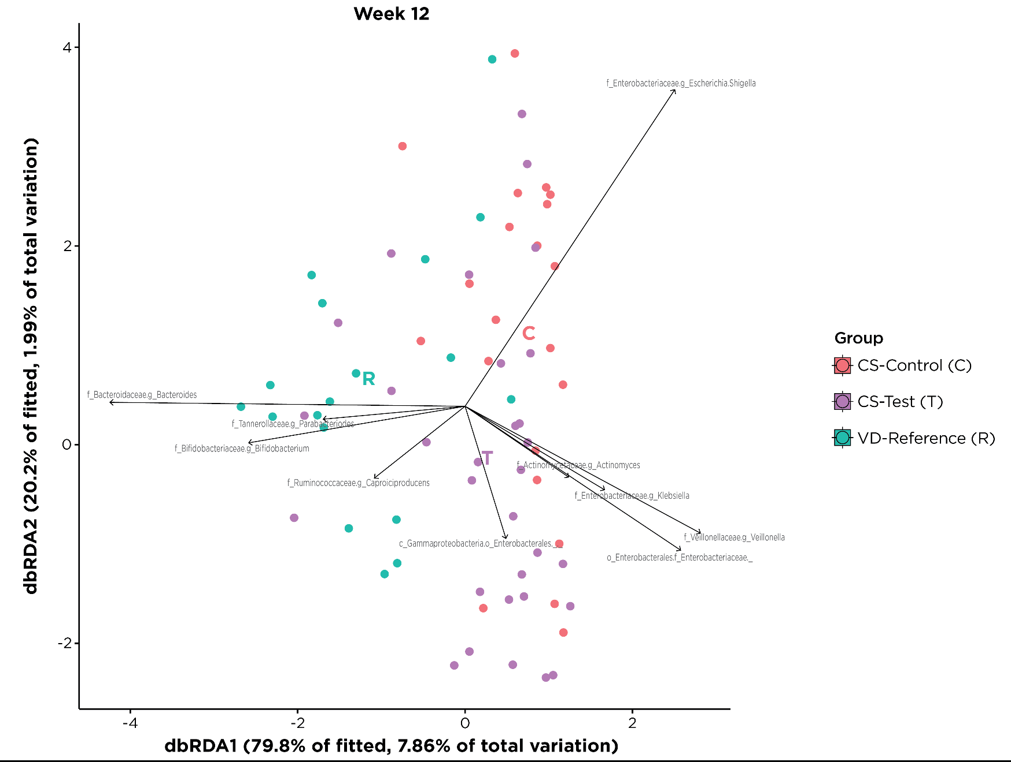
PERMANOVA (FDR)
T vs C: 0.075
T vs R: 0.0015
C vs R: 0.0015
Dispersion p = 0.616
PERMANOVA test to compare differences between the centroids of the groups at Week 12:
CS-Control vs CS-Test | p=0.063
CS-Control vs VD-Reference | p=0.001**
CS-Test vs VD-Reference | p=0.001**
- Month 12
- 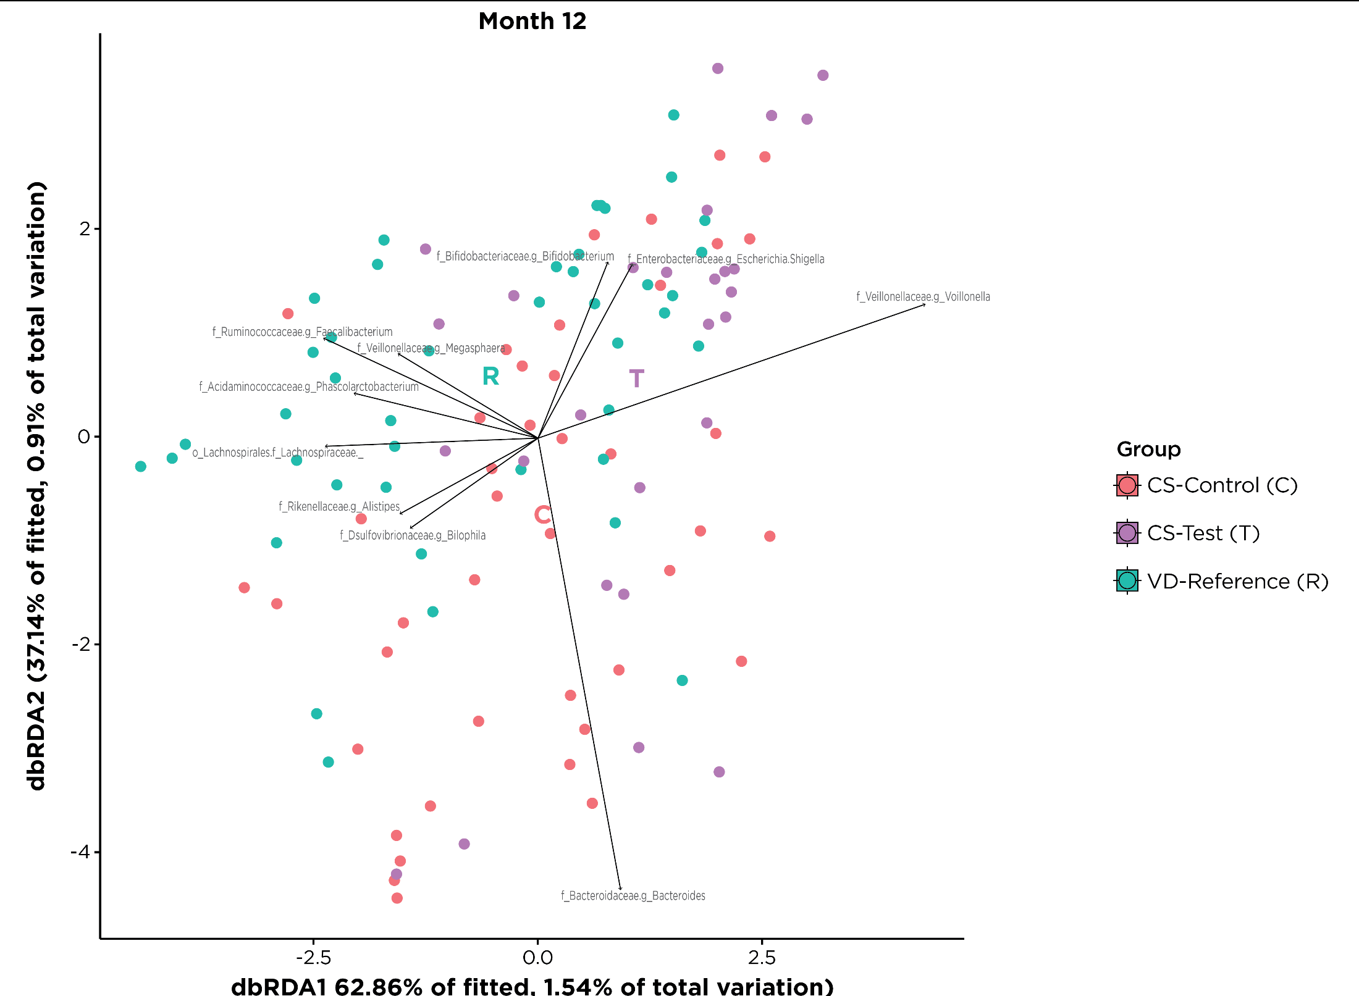
PERMANOVA (FDR)
T vs C: 0.243
T vs R: 0.147
C vs R: 0.243
Dispersion p = 0.237

ERMANOVA test to compare differences between the centroids of the groups at Month 12:
CS-Control vs CS-Test | p=0.184
CS-Control vs VD-Reference | p=0.320
CS-Test vs VD-Reference | p=0.049*

