Supporting Information

Sustainable synthesis of Ag/UiO-66 composites using recycled silver for efficient adsorption of methylene blue and crystal violet

Hazem Ibrahem*, Hassanien Gomaa*, Ahmed A. Gahlan, Adham M.Nagiub*

Department of Chemistry, Faculty of Science, Al-Azhar University, Assiut, 71524, Egypt.
* Corresponding authors: (Hazem Ibrahem: Ghazx1611@gmail.com); Hassanien Gomaa (h.gomaa@azhar.edu.eg); Adham M. Nagiub (adham.nagiub@azhar.edu.eg)

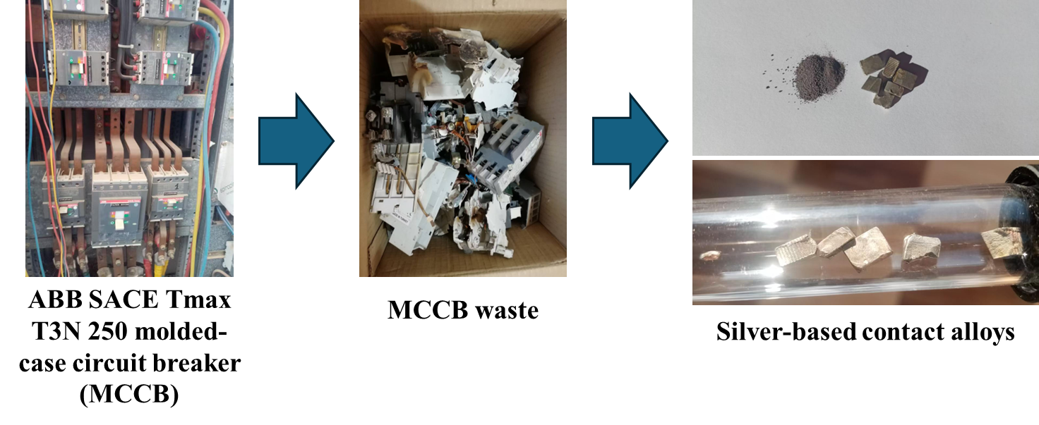
Fig. S1 Real images of MCCB waste and Silver-based contact alloys.

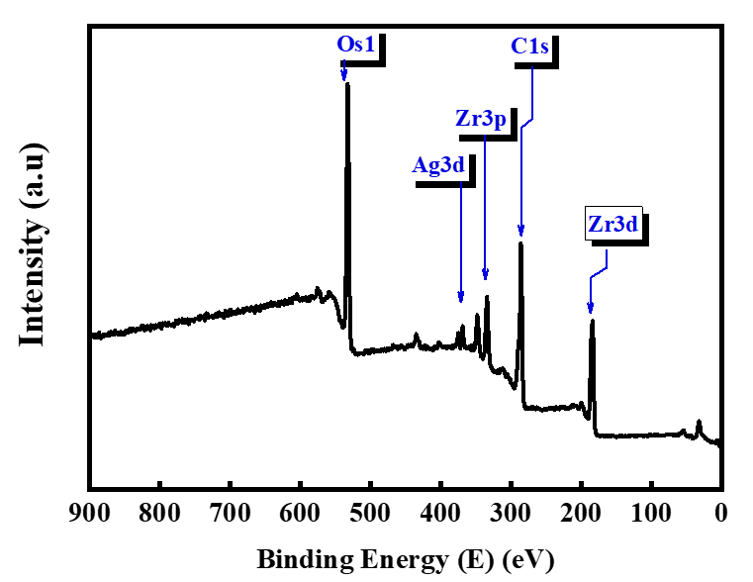
Fig. S2 XPS survey spectrum of the Ag/UiO-66 composite, showing the O 1s, Zr 3p, Ag 3d, C 1s, and Zr 3d core-level peaks.

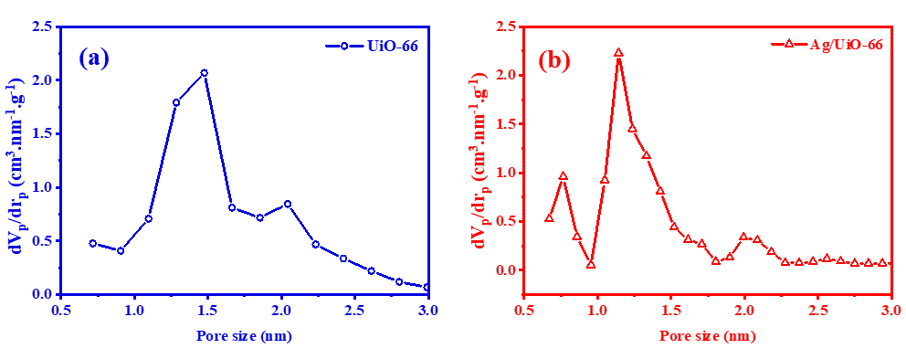
Fig. S3 BJH pore-size distributions of (a) UiO-66 and (b) Ag/UiO-66 samples.

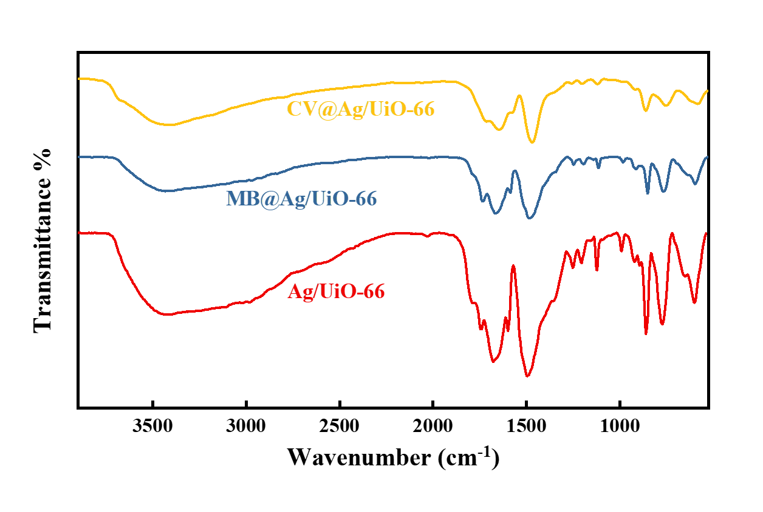
Fig. S4 FTIR spectra of Ag/UiO-66 before adsorption and after adsorption of MB (MB@Ag/UiO-66) and CV (CV@Ag/UiO-66).

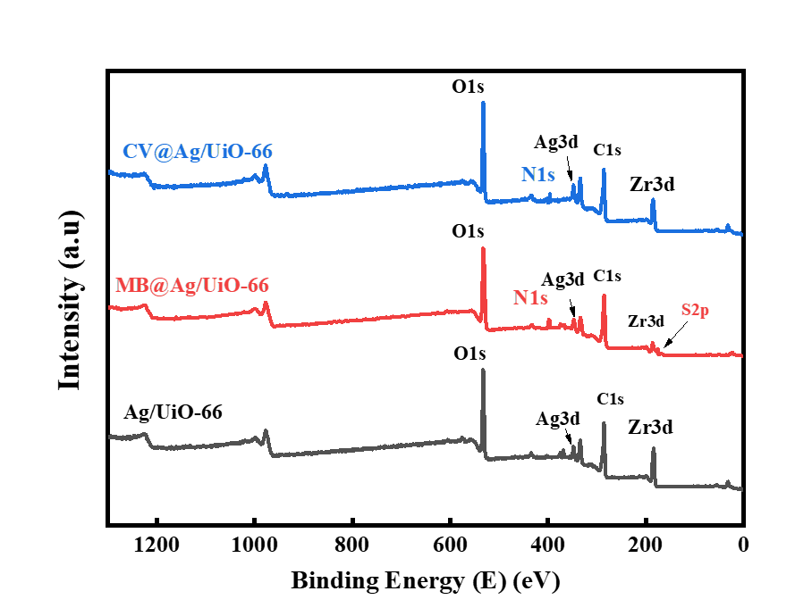
Fig. S5 XPS survey spectra of Ag/UiO-66 before adsorption and after adsorption of MB (MB@Ag/UiO-66) and CV (CV@Ag/UiO-66).

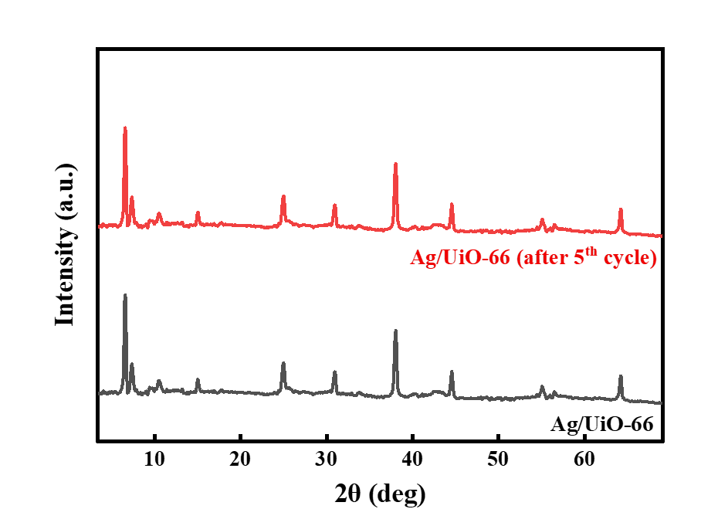
Fig. S6 PXRD patterns of Ag/UiO-66 before use (as-synthesized) and after the 5th adsorption–desorption cycle.

