Supplementary Methods
Image Acquisition
The initial 10 participants obtained MR images using the General Electric 3T MRI Discovery 750 HD (MR console version DV26.0_R05_2008) and a 24-channel head coil. The remaining 18 participants received images using the General Electric SIGNA Ultra High Performance (UHP) 3.0 T MRI (MR console version MR30.1_R01_2322.c) and a 48-channel head coil.

T1-weighted images were collected using a BRAVO 3D inversion recovery-prepared fast spoiled echo gradient (FSPGR) sequence. Acquisition parameters included a repetition time (TR) = 8.4 ms, echo time (TE) = 3.2 ms, inversion time (TI) = 650 ms, flip angle 10˚, field of view of 256 mm x 256 mm x 188 mm, matrix size of 256 x 256 x 188, GRAPPA (ARC) factor of two in the phase-encoded direction, and sagittal-oblique orientation to approximate alignment with anterior commissure (AC)-posterior commissure (PC).

T2-weighted images used a 3D fast-spin echo (FSE) sequence. Parameters were as follows: TR = 3000 ms, TE = 60-90 ms, echo train length of 130, a field of view measuring 256 mm x 225 mm x 188 mm, matrix size of 256 x 256 x 188, a sagittal-oblique orientation approximating alignment with the AC-PC axis, and GRAPPA (ARC) factor of two utilized in the phase-encoded and slice direction.

The initial 10 participants obtained isotropic 3D ZTE images with the following parameters: TR = 698 ms, TE = 16 µs, flip angle = 1˚, receiver bandwidth ± 62.5 kHz, number of averages = 3.5, field of view measuring 256 mm x 256 mm x 256 mm, matrix size of 256 x 256 x 256. The remaining 18 participants obtained isotropic 3D ZTE images with the parameters TR = 531 ms, TE = 16 µs, flip angle = 1˚, receiver bandwidth ± 62.5 kHz, number of averages = 3.5, field of view measuring 256 mm x 256 mm x 256 mm, matrix size of 256 x 256 x 256.

Supplementary Figures

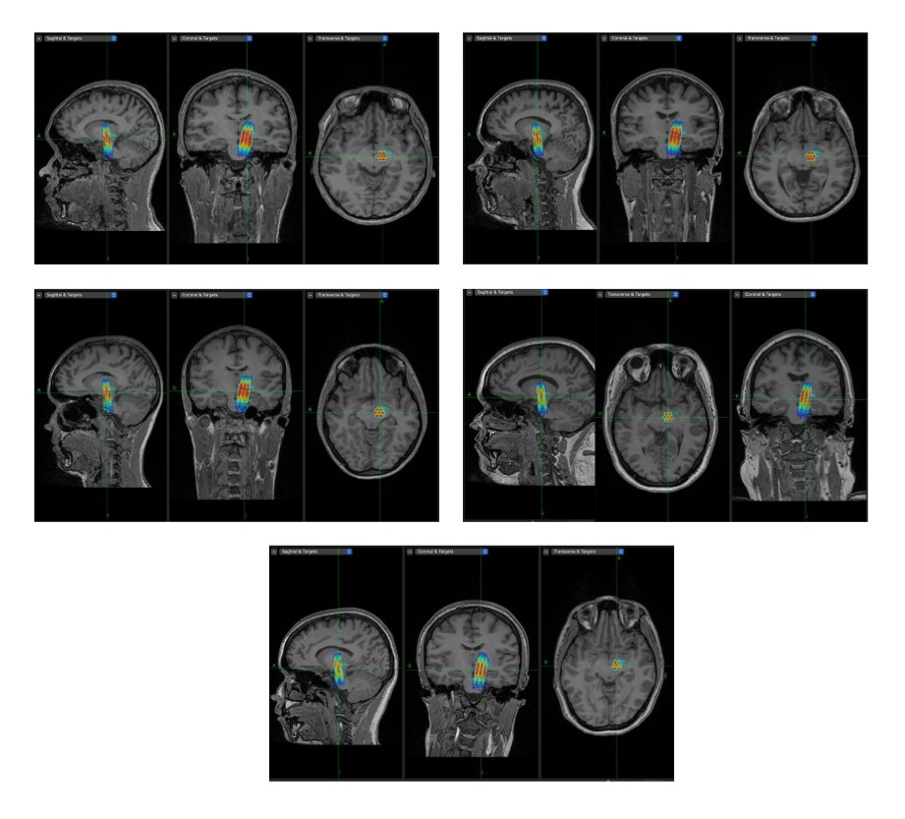
Supplementary Figure 1. Multifocal normalized acoustic intensity profiles in the brain using BabelBrain for 5 representative participants, showing reliable targeting of multiple focal spots. In situ I_{SPPA} of 10 W/cm² and I_{SPTA} of 1 W/cm².
Supplementary Tables
Supplementary Table 1. Post-sonication questionnaire on interoceptive experience. Number of reported sensations at baseline and post-TUS or -sham in unifocal and multifocal groups.

 | Unifocal |  |  |  | Multifocal
 | Sham |  | TUS |  | Sham |  | TUS
 | Baseline | Post-Sonication | Baseline | Post-Sonication | Baseline | Post-Sonication | Baseline |  | Post-Sonication | Area Targeted
Skin numbness, tingling, or itching? | 1 | 1 | 1 | 2 | 1 | 1 | 0 |  | 0 | Medial Lemniscus
Unusual muscle twitches, movements, tightness, or contraction? | 1 | 0 | 1 | 1 | 1 | 1 | 0 | 4 |  | Cerebral Peduncle
Changes in hearing or vision (double vision)? | 0 | 0 | 0 | 0 | 0 | 0 | 0 |  | 0 | CN III and IV
Weakness in the face, hand, arm, leg, or foot? | 1 | 0 | 0 | 0 | 0 | 0 | 0 |  | 0 | Cerebral Peduncle
Difficulty speaking? | 0 | 0 | 0 | 0 | 0 | 0 | 0 |  | 0 | Cerebral Peduncle
Decreased coordination? | 0 | 0 | 0 | 0 | 0 | 0 | 0 |  | 0 | Cerebral Peduncle
Feelings of anxiousness or nervousness? | 0 | 0 | 0 | 0 | 1 | 0 | 1 |  | 0 | Medial Lemniscus

Note: Participants were asked to focus on changes on the right side of their body as TUS was applied to the left STN.

Supplementary Table 2. Post-procedure safety questionnaire⁴¹

Rate the following, based on how you feel right now | Value:  - (1) absent  - (2) mild  - (3) moderate  - (4) severe | Related to stimulation?  - (1) definitely not related  - (2) unlikely to be related  - (3) possibly related  - (4) definitely related
Weakness in face, hand, arm, leg, or foot
Difficulty speaking or swallowing
Decreased coordination
Headache
Skin numbness, tingling, itching
Muscle pain
Fatigue
Difficulty paying attention
Tooth pain
Change in hearing or vision
Nausea
Unusual twitches or muscle movements
Dizziness
Feeling anxious or nervous
Feeling forgetful
Difficulty with balance/walking
Other/Comments:
Note: Participants were asked to rate each side effect and indicate whether they thought it was related to stimulation.

Supplementary Table 3. Comparison of baseline values in unifocal and multifocal groups.

 | Unifocal |  |  |  | Multifocal
Outcome | Sham | TUS | Test statistic | p-value | Sham | TUS | Test statistic | p-value
Congruent response time (ms) | 630.79 ± 90.53 | 610.92 ± 108.91 | -1.07 | .286 | 631.61 ± 106.63 | 628.84 ± 98.18 | .11 | .915
Incongruent response time (ms) | 692.94 ± 112.34 | 668.28 ± 125.98 | .79 | .441 | 679.96 ± 131.17 | 670.22 ± 125.21 | .32 | .759
Stroop effect (ms) | 62.15 ± 41.71 | 57.36 ± 34.95 | -.07 | .948 | 48.35 ± 34.86 | 41.38 ± 34.58 | -.87 | .386
Congruent accuracy (%) | 99.11 ± 1.11 | 99.11 ± 1.32 | -.22 | .823 | 99.03 ± 1.05 | 97.64 ± 3.21 | -1.43 | .152
Incongruent accuracy (%) | 98.50 ± 2.35 | 98.61 ± 1.49 | -.25 | .805 | 98.68 ± 1.24 | 98.13 ± 2.54 | -.48 | .633
Finger tapping frequency (Hz) | 5.53 ± .65 | 5.61 ± .54 | -.95 | .354 | 5.56 ± .54 | 5.56 ± .55 | .06 | .952

Supplementary Table 4. Two-way repeated measures ANOVA results in combined Unifocal x Multifocal groups.

 | F-statistic | p-value | Conditional Result
Congruent Response Time
Condition | 1.289 | .267 | Sham: 595.97  (± 93.78) ms | TUS: 581.57  (± 79.68) ms
Method | .241 | .628 | Sham: 595.97  (± 93.78) ms | TUS: 581.57  (± 79.68) ms
Interaction | .003 | .958 | Sham: 595.97  (± 93.78) ms | TUS: 581.57  (± 79.68) ms
Incongruent Response Time
Condition | 2.401 | .133 | Sham: 650.51  (± 119.34) ms | TUS: 625.44  (± 103.22) ms
Method | .004 | .953 | Sham: 650.51  (± 119.34) ms | TUS: 625.44  (± 103.22) ms
Interaction | .016 | .900 | Sham: 650.51  (± 119.34) ms | TUS: 625.44  (± 103.22) ms
Stroop Effect
Condition | 4.235 | .050 | Sham: 54.55  (± 40.32) ms | TUS: 43.87  (± 37.03) ms
Method | .872 | .359 | Sham: 54.55  (± 40.32) ms | TUS: 43.87  (± 37.03) ms
Interaction | .069 | .794 | Sham: 54.55  (± 40.32) ms | TUS: 43.87  (± 37.03) ms
Congruent Accuracy
Condition | .256 | .617 | Sham: 98.66  (± 1.24) % | TUS: 98.54  (± 2.00) %
Method | .111 | .742 | Sham: 98.66  (± 1.24) % | TUS: 98.54  (± 2.00) %
Interaction | .147 | .705 | Sham: 98.66  (± 1.24) % | TUS: 98.54  (± 2.00) %
Incongruent Accuracy
Condition | .001 | .981 | Sham: 97.87  (± 2.13) % | TUS: 97.82  (± 2.24) %
Method | .655 | .426 | Sham: 97.87  (± 2.13) % | TUS: 97.82  (± 2.24) %
Interaction | .218 | .644 | Sham: 97.87  (± 2.13) % | TUS: 97.82  (± 2.24) %
Finger Tapping Frequency
Condition | .386 | .540 | Sham: 5.46  (± .58) Hz | TUS: 5.49  (± .42) Hz
Method | .102 | .752 | Sham: 5.46  (± .58) Hz | TUS: 5.49  (± .42) Hz
Interaction | .921 | .346 | Sham: 5.46  (± .58) Hz | TUS: 5.49  (± .42) Hz

Supplementary Table 5. Comparison between sham and TUS separately in unifocal and multifocal groups.

 | Unifocal (n = 18) |  |  |  | Multifocal (n = 10)
Outcome | Sham | TUS | Test statistic | p-value | Sham | TUS | Test statistic | p-value
Congruent response time (ms) | 590.05 ± 94.33 | 576.14 ± 80.92 | -1.11 | .267 | 606.61 ± 96.85 | 591.34 ± 80.69 | 1.04 | .327
Incongruent response time (ms) | 648.88 ± 117.31 | 625.30 ± 103.15 | 1.05 | .310 | 653.45 ± 129.29 | 625.68 ± 108.92 | 1.56 | .153
Stroop effect (ms) | 58.83 ± 37.97 | 49.16 ± 35.19 | 1.31 | .208 | 46.84 ± 45.30 | 34.34 ± 40.24 | -1.99 | .047
Congruent accuracy (%) | 98.69 ± 1.16 | 98.65 ± 1.57 | -.32 | .752 | 98.61 ± 1.43 | 98.33 ± 2.70 | -.68 | .497
Incongruent accuracy (%) | 97.69 ± 2.41 | 97.53 ± 2.31 | -.40 | .686 | 98.19 ± 1.58 | 98.33 ± 2.13 | -.56 | .574
Finger tapping frequency (Hz) | 5.51 ± .64 | 5.48 ± .40 | .25 | .810 | 5.38 ± .49 | 5.49 ± .48 | -1.64 | .136

Supplementary Table 6. Statistical comparison of average scores of side effects following sham and TUS.

 | Sham | TUS | p-value
Weakness in face, hand, arm, leg, or foot | 1.04 ± .19 | 1.00 ± .00 | .322
Difficulty speaking | 1.00 ± .00 | 1.00 ± .00 | N/A
Decreased coordination | 1.04 ± .19 | 1.00 ± .00 | .326
Headache | 1.04 ± .19 | 1.04 ± .19 | 1.00
Skin numbness, tingling, itching | 1.07 ± .26 | 1.07 ± .26 | 1.00
Muscle pain | 1.00 ± .00 | 1.04 ± .19 | .326
Fatigue | 1.54 ± .64 | 1.25 ± .44 | .057
Difficulty paying attention | 1.32 ± .55 | 1.25 ± .44 | .593
Tooth pain | 1.11 ± .57 | 1.00 ± .00 | .326
Change in hearing or vision | 1.00 ± .00 | 1.07 ± .26 | .161
Nausea | 1.00 ± .00 | 1.00 ± .00 | N/A
Unusual twitches or muscle movements | 1.00 ± .00 | 1.00 ± .00 | N/A
Dizziness | 1.00 ± .00 | 1.00 ± .00 | N/A
Feeling anxious or nervous | 1.04 ± .19 | 1.04 ± .19 | 1.00
Feeling forgetful | 1.00 ± .00 | 1.00 ± .00 | N/A
Difficulty with balance/walking | 1.00 ± .00 | 1.00 ± .00 | N/A

