Supplementary Figures (S1 Fig and S2 Fig)
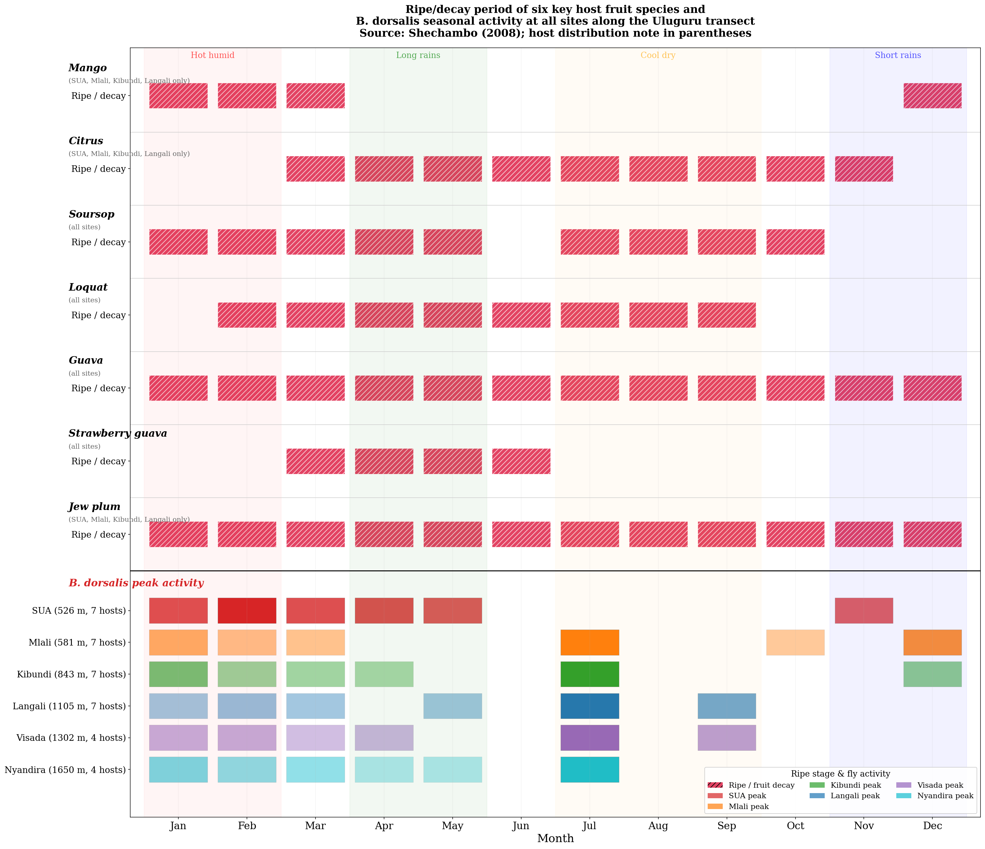
S1 Fig. Phenological stages of six key host fruit species and B. dorsalis seasonal activity at all sites along the Uluguru transect. Source: adapted from Shechambo (2008).

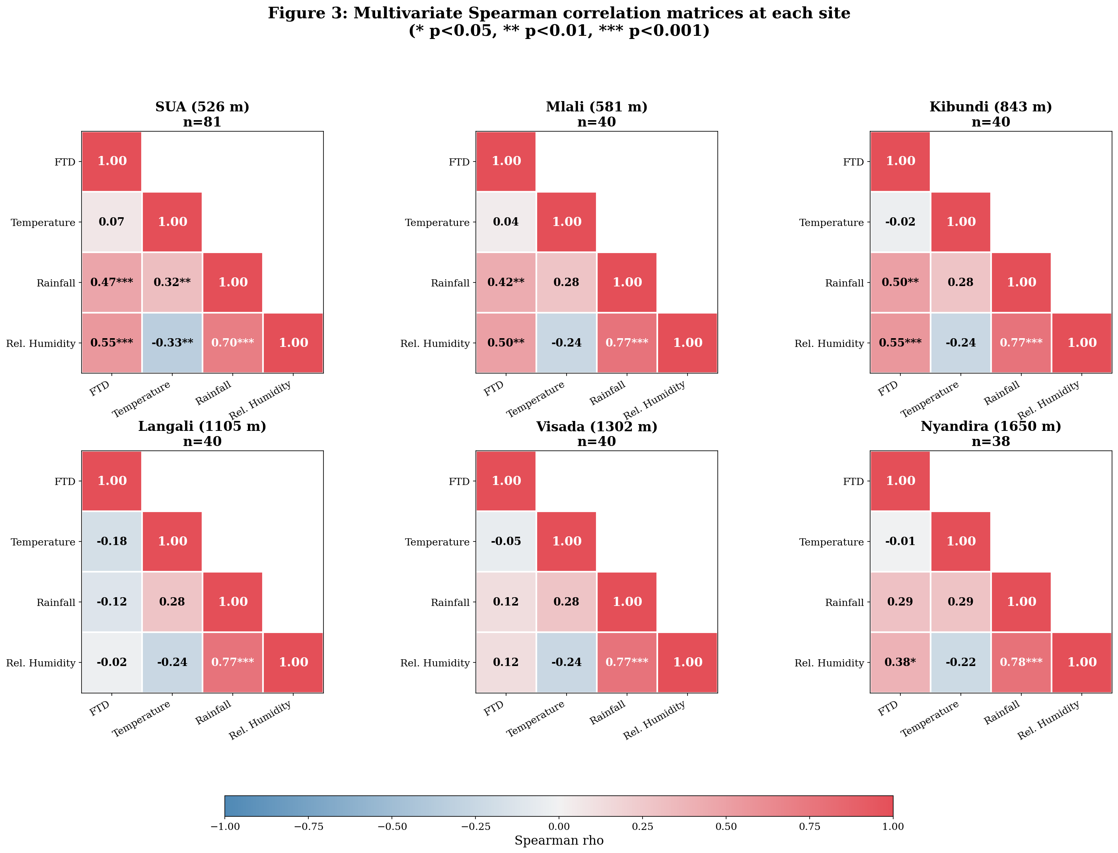
S2 Fig. Multivariate Spearman correlation matrices between FTD and weather variables at each site separately (n = 38–81 per site).

