Supplementary Material
Table S1 Cohort-specific identification and operational definition of severe heart failure
Dataset |  | HF ascertainment |  | Operational definition of severe HF |  | Supporting clinical information
The Affiliated Hospital of Qingdao University |  | ICU admission diagnosis, discharge diagnosis, and clinical records documented by the treating physicians |  | Documented HF or acute decompensated HF constituting the primary reason for ICU admission |  | Physician documentation and, when available, compatible clinical symptoms and signs, echocardiographic findings, and BNP or NT-proBNP measurements
Qingdao Municipal Hospital |  | ICU admission diagnosis, discharge diagnosis, and clinical records documented by the treating physicians |  | Documented HF or acute decompensated HF constituting the primary reason for ICU admission |  | Physician documentation and, when available, compatible clinical symptoms and signs, echocardiographic findings, and BNP or NT-proBNP measurements
MIMIC-IV |  | Prespecified ICD-9 and ICD-10 diagnosis codes for HF |  | Documented HF considered the principal ICU-related condition rather than a secondary comorbidity alone |  | ICU admission diagnosis and available clinical documentation were used, when available, to support HF as the principal ICU-related condition

Table S2 Distribution and timing of glucose measurements during ICU stay
Variable |  |  | Overall
Number of glucose measurements within the first 48 h, median (IQR) |  |  | 8 (5-13)
Minimum number of glucose measurements |  |  | 3
Maximum number of glucose measurements |  |  | 168
Time from ICU admission to first glucose measurement, h, median (IQR) |  |  | 0.8 (0.3-2.0)

Table S3A Baseline characteristics according to the combined SHR and GV categories in the MIMIC-IV cohort (G1-G3)
Variable | Overall  (N = 1854) | G1  (N = 407) | G2  (N = 279) | G3  (N = 243) | p
Demographics
Age (years) | 75.00 (68.00 - 82.00) | 76.00 (69.00 - 84.00) | 75.00 (68.00 - 83.00) | 74.00 (67.00 - 81.00) | 0.002
Female, n (%) | 749.00 (40.40) | 156.00 (38.33) | 115.00 (41.22) | 104.00 (42.80) | 0.826
Vital signs
HR (bpm) | 85.00 (72.00 - 100.00) | 79.00 (68.00 - 94.00) | 84.00 (72.00 - 97.00) | 86.00 (73.00 - 101.00) | <0.001
RR (bpm) | 20.00 (16.00 - 24.00) | 19.00 (16.00 - 22.00) | 19.00 (16.00 - 23.00) | 20.00 (17.00 - 24.00) | <0.001
MAP (mmHg) | 84.00 (72.00 - 96.00) | 88.00 (76.00 - 100.00) | 84.00 (73.00 - 96.00) | 83.00 (71.00 - 95.00) | <0.001
Comorbidities
HTN, n (%) | 684.00 (36.89) | 192.00 (47.17) | 98.00 (35.13) | 72.00 (29.63) | <0.001
CVA, n (%) | 271.00 (14.62) | 64.00 (15.72) | 42.00 (15.05) | 35.00 (14.40) | 0.976
CS, n (%) | 310.00 (16.72) | 36.00 (8.85) | 48.00 (17.20) | 36.00 (14.81) | <0.001
COPD, n (%) | 356.00 (19.20) | 64.00 (15.72) | 60.00 (21.51) | 50.00 (20.58) | 0.089
MI, n (%) | 546.00 (29.45) | 107.00 (26.29) | 73.00 (26.16) | 57.00 (23.46) | 0.011
CKD, n (%) | 601.00 (32.42) | 98.00 (24.08) | 89.00 (31.90) | 102.00 (41.98) | <0.001
Glucose metabolism state
NGR, n (%) | 482.00 (26.00) | 128.00 (31.45) | 66.00 (23.66) | 26.00 (10.70) | <0.001
Pre-DM, n (%) | 729.00 (39.32) | 199.00 (48.89) | 121.00 (43.37) | 61.00 (25.10)
DM, n (%) | 643.00 (34.68) | 80.00 (19.66) | 92.00 (32.97) | 156.00 (64.20)
Laboratory measurements
Hb(g/dL) | 11.30 (9.61 - 12.91) | 11.90 (10.39 - 13.36) | 11.40 (9.59 - 12.78) | 10.80 (9.22 - 12.26) | <0.001
Plt(10⁹/L) | 201.47 (155.97 - 259.21) | 204.65 (164.63 - 252.91) | 193.27 (148.32 - 255.79) | 201.43 (151.14 - 267.93) | 0.013
RBC(m/Ul) | 3.80 (3.27 - 4.35) | 4.01 (3.48 - 4.47) | 3.81 (3.31 - 4.39) | 3.70 (3.19 - 4.28) | <0.001
WBC(K/Ul) | 10.47 (7.82 - 13.85) | 9.11 (7.21 - 11.45) | 9.47 (7.09 - 12.36) | 9.99 (7.45 - 13.30) | <0.001
Potassium(mEq/L) | 4.20 (3.79 - 4.60) | 4.11 (3.80 - 4.42) | 4.12 (3.71 - 4.51) | 4.11 (3.80 - 4.69) | <0.001
Sodium(mEq/L) | 137.91 (134.87 - 140.92) | 138.78 (136.67 - 140.85) | 138.91 (136.65 - 141.01) | 138.77 (135.86 - 141.76) | <0.001
PT (s) | 13.53 (12.07 - 15.67) | 13.16 (12.03 - 15.00) | 13.53 (12.29 - 15.82) | 13.62 (12.08 - 16.35) | <0.001
PTT (s) | 31.67 (27.41 - 43.35) | 31.07 (27.60 - 40.66) | 31.56 (27.37 - 39.82) | 31.08 (27.31 - 39.54) | 0.039
Treatment
ACEI, n (%) | 592.00 (31.93) | 134.00 (32.92) | 88.00 (31.54) | 62.00 (25.51) | 0.216
ARB, n (%) | 258.00 (13.92) | 58.00 (14.25) | 35.00 (12.54) | 42.00 (17.28) | 0.689
β-blocker, n (%) | 1383.00 (74.60) | 297.00 (72.97) | 215.00 (77.06) | 175.00 (72.02) | 0.415
Spironolactone, n (%) | 137.00 (7.39) | 21.00 (5.16) | 26.00 (9.32) | 20.00 (8.23) | 0.246
VP, n (%) | 962.00 (51.89) | 200.00 (49.14) | 151.00 (54.12) | 117.00 (48.15) | 0.002
Statin, n (%) | 468.00 (25.24) | 97.00 (23.83) | 71.00 (25.45) | 72.00 (29.63) | 0.439
CRRT, n (%) | 96.00 (5.18) | 6.00 (1.47) | 20.00 (7.17) | 13.00 (5.35) | <0.001
Ventilation, n (%) | 1441.00 (77.72) | 272.00 (66.83) | 229.00 (82.08) | 186.00 (76.54) | <0.001
Clinical scores
SOFA | 4.00 (2.00 - 7.00) | 2.00 (1.00 - 4.00) | 4.00 (2.00 - 6.00) | 4.00 (2.00 - 6.00) | <0.001
APACHE II score | 17.00 (13.00 - 22.00) | 14.00 (11.00 - 19.00) | 17.00 (13.00 - 21.00) | 18.00 (14.00 - 23.00) | <0.001
CCI | 7.00 (5.00 - 10.00) | 6.00 (5.00 - 8.00) | 7.00 (5.00 - 9.00) | 8.00 (6.00 - 9.00) | <0.001
SHR: stress hyperglycemia ratio; GV: glycemic variability; HR: heart rate; RR: respiratory rate; MAP: mean arterial pressure; HTN: hypertension; CVA: cerebrovascular accident; CS: cardiogenic shock; COPD: chronic obstructive pulmonary disease; MI: myocardial infarction; CKD: chronic kidney disease; NGR: normal glucose regulation; Pre-DM: pre-diabetes mellitus; DM: diabetes mellitus; Hb: hemoglobin; Plt: platelet; RBC: red blood cell; WBC: white blood cell; PT: prothrombin time; PTT: partial thromboplastin time

Table S3B Baseline characteristics according to the combined SHR and GV categories in the MIMIC-IV cohort (G4-G6)
Variable | Overall  (N = 1854) | G4  (N = 211) | G5  (N = 339) | G6  (N = 375) | p
Demographics
Age (years) | 75.00 (68.00 - 82.00) | 75.00 (67.00 - 83.00) | 74.00 (68.00 - 81.00) | 74.00 (67.00 - 81.00) | 0.002
Female, n (%) | 749.00 (40.40) | 82.00 (38.86) | 134.00 (39.53) | 158.00 (42.13) | 0.826
Vital signs
HR (bpm) | 85.00 (72.00 - 100.00) | 83.00 (72.00 - 96.00) | 88.00 (74.00 - 103.00) | 90.00 (76.00 - 105.00) | <0.001
RR (bpm) | 20.00 (16.00 - 24.00) | 19.00 (16.00 - 23.00) | 20.00 (17.00 - 24.00) | 21.00 (17.00 - 25.00) | <0.001
MAP (mmHg) | 84.00 (72.00 - 96.00) | 86.00 (76.00 - 98.00) | 83.00 (71.00 - 95.00) | 81.00 (69.00 - 92.00) | <0.001
Comorbidities
HTN, n (%) | 684.00 (36.89) | 83.00 (39.34) | 120.00 (35.40) | 119.00 (31.73) | <0.001
CVA, n (%) | 271.00 (14.62) | 31.00 (14.69) | 48.00 (14.16) | 51.00 (13.60) | 0.976
CS, n (%) | 310.00 (16.72) | 28.00 (13.27) | 80.00 (23.60) | 82.00 (21.87) | <0.001
COPD, n (%) | 356.00 (19.20) | 32.00 (15.17) | 65.00 (19.17) | 85.00 (22.67) | 0.089
MI, n (%) | 546.00 (29.45) | 68.00 (32.23) | 114.00 (33.63) | 127.00 (33.87) | 0.011
CKD, n (%) | 601.00 (32.42) | 53.00 (25.12) | 112.00 (33.04) | 147.00 (39.20) | <0.001
Glucose metabolism state
NGR, n (%) | 482.00 (26.00) | 99.00 (46.92) | 107.00 (31.56) | 56.00 (14.93) | <0.001
Pre-DM, n (%) | 729.00 (39.32) | 75.00 (35.55) | 148.00 (43.66) | 125.00 (33.33)
DM, n (%) | 643.00 (34.68) | 37.00 (17.54) | 84.00 (24.78) | 194.00 (51.73)
Laboratory measurements
Hb (g/dL) | 11.30 (9.61 - 12.91) | 11.57 (9.83 - 13.10) | 11.41 (9.75 - 13.07) | 11.01 (9.27 - 12.70) | <0.001
Plt (10⁹/L) | 201.47 (155.97 - 259.21) | 196.14 (152.22 - 246.91) | 205.95 (158.69 - 264.90) | 206.65 (159.07 - 268.10) | 0.013
RBC (m/µL) | 3.80 (3.27 - 4.35) | 3.86 (3.33 - 4.31) | 3.77 (3.25 - 4.33) | 3.67 (3.11 - 4.27) | <0.001
WBC (K/µL) | 10.47 (7.82 - 13.85) | 10.66 (8.20 - 13.50) | 11.53 (8.76 - 15.36) | 11.52 (8.61 - 15.65) | <0.001
Potassium (mEq/L) | 4.20 (3.79 - 4.60) | 4.11 (3.81 - 4.51) | 4.21 (3.80 - 4.69) | 4.30 (3.90 - 4.78) | <0.001
Sodium (mEq/L) | 137.91 (134.87 - 140.92) | 138.90 (136.00 - 140.99) | 138.06 (134.96 - 141.01) | 137.01 (134.07 - 140.17) | <0.001
PT (s) | 13.53 (12.07 - 15.67) | 13.06 (12.00 - 15.06) | 13.62 (12.18 - 15.96) | 13.50 (12.21 - 15.74) | <0.001
PTT (s) | 31.67 (27.41 - 43.35) | 31.54 (26.98 - 43.36) | 32.30 (27.92 - 47.28) | 31.28 (27.07 - 48.12) | 0.039
Treatment
ACEI, n (%) | 592.00 (31.93) | 71.00 (33.65) | 120.00 (35.40) | 117.00 (31.20) | 0.216
ARB, n (%) | 258.00 (13.92) | 28.00 (13.27) | 45.00 (13.27) | 50.00 (13.33) | 0.689
β-blocker, n (%) | 1383.00 (74.60) | 151.00 (71.56) | 263.00 (77.58) | 282.00 (75.20) | 0.415
Spironolactone, n (%) | 137.00 (7.39) | 12.00 (5.69) | 30.00 (8.85) | 28.00 (7.47) | 0.246
VP, n (%) | 962.00 (51.89) | 88.00 (41.71) | 195.00 (57.52) | 211.00 (56.27) | 0.002
Statin, n (%) | 468.00 (25.24) | 45.00 (21.33) | 89.00 (26.25) | 94.00 (25.07) | 0.439
CRRT, n (%) | 96.00 (5.18) | 8.00 (3.79) | 19.00 (5.60) | 30.00 (8.00) | <0.001
Ventilation, n (%) | 1441.00 (77.72) | 162.00 (76.78) | 284.00 (83.78) | 308.00 (82.13) | <0.001
Clinical scores
SOFA | 4.00 (2.00 - 7.00) | 3.00 (2.00 - 5.00) | 4.00 (2.00 - 7.00) | 5.00 (3.00 - 7.00) | <0.001
APACHE II score | 17.00 (13.00 - 22.00) | 16.00 (12.00 - 20.00) | 18.00 (13.00 - 23.00) | 19.00 (15.00 - 24.00) | <0.001
CCI | 7.00 (5.00 - 10.00) | 6.00 (5.00 - 8.00) | 7.00 (5.00 - 9.00) | 7.00 (6.00 - 9.00) | <0.001
SHR: stress hyperglycemia ratio; GV: glycemic variability; HR: heart rate; RR: respiratory rate; MAP: mean arterial pressure; HTN: hypertension; CS: cardiogenic shock; CVA: cerebrovascular accident; COPD: chronic obstructive pulmonary disease; MI: myocardial infarction; CKD: chronic kidney disease; NGR: normal glucose regulation; Pre-DM: pre-diabetes mellitus; DM: diabetes mellitus; Hb: hemoglobin; Plt: platelet; RBC: red blood cell; WBC: white blood cell; PT: prothrombin time; PTT: partial thromboplastin time

Table S4A Baseline characteristics according to the combined SHR and GV categories in the Chinese hospital-based cohort (G1-G3)
Variable | Overall  (N = 1348) | G1  (N = 296) | G2  (N = 202) | G3  (N = 176) | p
Demographics
Age (years) | 75.00 (68.00 - 82.00) | 75.76 (68.76 - 83.53) | 75.00 (68.00 - 82.76) | 74.24 (67.24 - 81.24) | 0.002
Female, n (%) | 546 (40.50) | 114 (38.51) | 83 (41.09) | 76 (43.18) | 0.906
Vital signs
Age (years) | 75.00 (68.00 - 82.00) | 75.76 (68.76 - 83.53) | 75.00 (68.00 - 82.76) | 74.24 (67.24 - 81.24) | 0.002
Female, n (%) | 546 (40.50) | 114 (38.51) | 83 (41.09) | 76 (43.18) | 0.906
Age (years) | 75.00 (68.00 - 82.00) | 75.76 (68.76 - 83.53) | 75.00 (68.00 - 82.76) | 74.24 (67.24 - 81.24) | 0.002
Comorbidities
HTN, n (%) | 496 (36.80) | 139 (46.96) | 71 (35.15) | 52 (29.55) | <0.001
CVA, n (%) | 197 (14.61) | 47 (15.88) | 30 (14.85) | 26 (14.77) | 0.983
CS, n (%) | 225 (16.69) | 26 (8.78) | 35 (17.33) | 26 (14.77) | <0.001
COPD, n (%) | 258 (19.14) | 46 (15.54) | 43 (21.29) | 36 (20.45) | 0.199
MI, n (%) | 397 (29.45) | 78 (26.35) | 52 (25.74) | 41 (23.30) | 0.043
CKD, n (%) | 436 (32.34) | 71 (23.99) | 64 (31.68) | 74 (42.05) | <0.001
Glucose metabolism state
NGR, n (%) | 351 (26.04) | 93 (31.42) | 48 (23.76) | 19 (10.80) | <0.001
Pre-DM, n (%) | 528 (39.17) | 145 (48.99) | 87 (43.07) | 44 (25.00)
DM, n (%) | 469 (34.79) | 58 (19.59) | 67 (33.17) | 113 (64.20)
Laboratory measurements
Hb(g/dL) | 11.30 (9.59 - 12.89) | 11.95 (10.39 - 13.31) | 11.38 (9.61 - 12.85) | 10.73 (9.29 - 12.31) | <0.001
Plt(10⁹/L) | 202.73 (156.04 - 258.71) | 206.67 (162.90 - 252.65) | 195.25 (145.65 - 255.10) | 201.83 (154.38 - 265.48) | 0.013
RBC(m/Ul) | 3.82 (3.27 - 4.33) | 3.99 (3.50 - 4.49) | 3.81 (3.31 - 4.37) | 3.68 (3.19 - 4.26) | <0.001
WBC(K/Ul) | 10.30 (7.77 - 13.73) | 9.04 (7.14 - 11.38) | 9.37 (7.11 - 12.43) | 9.92 (7.45 - 13.44) | <0.001
Potassium(mEq/L) | 4.20 (3.81 - 4.60) | 4.11 (3.80 - 4.42) | 4.10 (3.71 - 4.51) | 4.11 (3.80 - 4.69) | <0.001
Sodium(mEq/L) | 138.12 (135.18 - 141.11) | 139.06 (136.98 - 141.21) | 138.89 (137.01 - 140.99) | 139.08 (135.96 - 142.09) | <0.001
PT (s) | 13.46 (12.14 - 15.74) | 13.14 (11.98 - 15.00) | 13.46 (12.27 - 15.75) | 13.55 (12.13 - 16.47) | <0.001
PTT (s) | 31.50 (27.39 - 42.99) | 31.07 (27.74 - 40.64) | 31.66 (27.01 - 39.70) | 30.96 (27.52 - 39.44) | 0.039
Treatment
ACEI, n (%) | 431 (31.97) | 97 (32.77) | 63 (31.19) | 45 (25.57) | 0.388
ARB, n (%) | 187 (13.87) | 42 (14.19) | 26 (12.87) | 30 (17.05) | 0.854
β-blocker, n (%) | 1004 (74.48) | 216 (72.97) | 155 (76.73) | 126 (71.59) | 0.663
Spironolactone, n (%) | 98 (7.27) | 15 (5.07) | 19 (9.41) | 14 (7.95) | 0.388
VP, n (%) | 700 (51.93) | 146 (49.32) | 109 (53.96) | 85 (48.30) | 0.016
Statin, n (%) | 341 (25.30) | 71 (23.99) | 52 (25.74) | 52 (29.55) | 0.583
CRRT, n (%) | 71 (5.27) | 5 (1.69) | 15 (7.43) | 9 (5.11) | 0.013
Ventilation, n (%) | 1047 (77.67) | 197 (66.55) | 166 (82.18) | 134 (76.14) | <0.001
Clinical scores
SOFA | 4.00 (2.00 - 7.00) | 2.48 (1.24 - 4.95) | 4.00 (2.00 - 6.24) | 4.00 (2.00 - 6.24) | <0.001
APACHE II score | 17.00 (13.00 - 22.00) | 14.95 (11.47 - 17.81) | 17.00 (13.00 - 21.24) | 17.76 (13.76 - 22.76) | <0.001
CCI | 7.00 (5.00 - 10.00) | 6.24 (5.00 - 8.47) | 7.00 (5.00 - 9.24) | 7.76 (5.76 - 9.24) | <0.001
SHR: stress hyperglycemia ratio; GV: glycemic variability; HR: heart rate; RR: respiratory rate; MAP: mean arterial pressure; HTN: hypertension; CVA: cerebrovascular accident; CS: cardiogenic shock; COPD: chronic obstructive pulmonary disease; MI: myocardial infarction; CKD: chronic kidney disease; NGR: normal glucose regulation; Pre-DM: pre-diabetes mellitus; DM: diabetes mellitus; Hb: hemoglobin; Plt: platelet; RBC: red blood cell; WBC: white blood cell; PT: prothrombin time; PTT: partial thromboplastin time

Table S4B Baseline characteristics according to the combined SHR and GV categories in the Chinese hospital-based cohort (G4-G6)
Variable | Overall  (N = 1348) | G4  (N = 154) | G5  (N = 247) | G6  (N = 273) | p
Demographics
Age (years) | 75.00 (68.00 - 82.00) | 75.00 (67.24 - 82.76) | 74.24 (68.00 - 81.24) | 74.24 (67.24 - 81.24) | 0.002
Female, n (%) | 546 (40.50) | 60 (38.96) | 98 (39.68) | 115 (42.12) | 0.906
Vital signs
HR (bpm) | 85.00 (72.00 - 97.62) | 83.00 (72.00 - 93.63) | 85.63 (74.00 - 100.63) | 87.63 (76.00 - 102.63) | <0.001
RR (bpm) | 20.00 (16.00 - 24.00) | 19.00 (16.00 - 23.00) | 20.00 (17.00 - 24.00) | 21.00 (17.00 - 25.00) | <0.001
MAP (mmHg) | 84.00 (72.00 - 96.00) | 86.00 (76.00 - 98.00) | 83.00 (71.00 - 95.00) | 81.00 (69.00 - 92.00) | <0.001
Comorbidities
HTN, n (%) | 496 (36.80) | 61 (39.61) | 87 (35.22) | 86 (31.50) | <0.001
CVA, n (%) | 197 (14.61) | 22 (14.29) | 35 (14.17) | 37 (13.55) | 0.983
CS, n (%) | 225 (16.69) | 21 (13.64) | 58 (23.48) | 59 (21.61) | <0.001
COPD, n (%) | 258 (19.14) | 23 (14.94) | 48 (19.43) | 62 (22.71) | 0.199
MI, n (%) | 397 (29.45) | 50 (32.47) | 83 (33.60) | 93 (34.07) | 0.043
CKD, n (%) | 436 (32.34) | 39 (25.32) | 81 (32.79) | 107 (39.19) | <0.001
Glucose metabolism state
NGR, n (%) | 351 (26.04) | 73 (47.40) | 78 (31.58) | 40 (14.65) | <0.001
Pre-DM, n (%) | 528 (39.17) | 54 (35.06) | 107 (43.32) | 91 (33.33)
DM, n (%) | 469 (34.79) | 27 (17.53) | 62 (25.10) | 142 (52.01)
Laboratory measurements
Hb (g/dL) | 11.30 (9.59 - 12.89) | 11.55 (9.90 - 13.05) | 11.36 (9.82 - 13.09) | 11.08 (9.22 - 12.75) | <0.001
Plt (10⁹/L) | 202.73 (156.04 - 258.71) | 195.33 (150.75 - 248.55) | 207.97 (160.61 - 267.51) | 203.92 (157.95 - 265.25) | 0.013
RBC (m/µL) | 3.82 (3.27 - 4.33) | 3.84 (3.35 - 4.29) | 3.77 (3.23 - 4.31) | 3.69 (3.09 - 4.27) | <0.001
WBC (K/µL) | 10.30 (7.77 - 13.73) | 10.66 (8.29 - 13.59) | 11.46 (8.57 - 15.22) | 11.57 (8.56 - 15.65) | <0.001
Potassium (mEq/L) | 4.20 (3.81 - 4.60) | 4.11 (3.79 - 4.51) | 4.19 (3.80 - 4.69) | 4.28 (3.88 - 4.78) | <0.001
Sodium (mEq/L) | 138.12 (135.18 - 141.11) | 138.90 (135.76 - 141.01) | 137.92 (135.05 - 140.99) | 137.22 (134.14 - 140.00) | <0.001
PT (s) | 13.46 (12.14 - 15.74) | 13.06 (12.02 - 15.01) | 13.55 (12.20 - 15.96) | 13.50 (12.16 - 15.65) | <0.001
PTT (s) | 31.50 (27.39 - 42.99) | 31.37 (26.93 - 43.41) | 32.73 (27.73 - 47.00) | 31.83 (27.43 - 47.72) | 0.039
Treatment
ACEI, n (%) | 431 (31.97) | 52 (33.77) | 88 (35.63) | 86 (31.50) | 0.388
ARB, n (%) | 187 (13.87) | 21 (13.64) | 32 (12.96) | 36 (13.19) | 0.854
β-blocker, n (%) | 1004 (74.48) | 111 (72.08) | 191 (77.33) | 205 (75.09) | 0.663
Spironolactone, n (%) | 98 (7.27) | 8 (5.19) | 21 (8.50) | 21 (7.69) | 0.388
VP, n (%) | 700 (51.93) | 64 (41.56) | 142 (57.49) | 154 (56.41) | 0.016
Statin, n (%) | 341 (25.30) | 32 (20.78) | 65 (26.32) | 69 (25.27) | 0.583
CRRT, n (%) | 71 (5.27) | 6 (3.90) | 14 (5.67) | 22 (8.06) | 0.013
Ventilation, n (%) | 1047 (77.67) | 118 (76.62) | 207 (83.81) | 225 (82.42) | <0.00
Clinical scores
SOFA | 4.00 (2.00 - 7.00) | 3.24 (2.00 - 5.47) | 4.00 (2.00 - 7.00) | 4.76 (2.76 - 7.00) | <0.001
APACHE II score | 17.00 (13.00 - 22.00) | 16.24 (12.24 - 19.53) | 17.76 (13.00 - 22.76) | 18.53 (14.53 - 23.53) | <0.001
CCI | 7.00 (5.00 - 10.00) | 6.24 (5.00 - 8.47) | 7.00 (5.00 - 9.24) | 7.00 (5.76 - 9.24) | <0.001
SHR: stress hyperglycemia ratio; GV: glycemic variability; HR: heart rate; RR: respiratory rate; MAP: mean arterial pressure; HTN: hypertension; CS: cardiogenic shock; CVA: cerebrovascular accident; COPD: chronic obstructive pulmonary disease; MI: myocardial infarction; CKD: chronic kidney disease; NGR: normal glucose regulation; Pre-DM: pre-diabetes mellitus; DM: diabetes mellitus; Hb: hemoglobin; Plt: platelet; RBC: red blood cell; WBC: white blood cell; PT: prothrombin time; PTT: partial thromboplastin time

Table S5 Adjusted hazard ratios for the associations of SHR and GV with 30-day and 365-day all-cause mortality across the MIMIC-IV and Chinese hospital-based cohorts
Variables | MIMIC-IV cohort  Model 3 |  | Chinese hospital-based cohort  Model 3 |  | Overall cohort  Model 3
Variables | HR (95%CI) | P | HR (95%CI) | P | HR (95%CI) | P
SHR median
30-day mortality
Group 1 | 1.00 (Reference) |  | 1.00 (Reference) |  | 1.00 (Reference)
Group 2 | 1.462 (1.113 - 1.920) | 0.006 | 1.428 (1.017 - 2.005) | 0.040 | 1.437 (1.143 - 1.813) | 0.001
365-day mortality
Group 1 | 1.00 (Reference) |  | 1.00 (Reference) |  | 1.00 (Reference)
Group 2 | 1.356 (1.077 - 1.708) | 0.010 | 1.327 (1.001 - 1.760) | 0.049 | 1.382 (1.115 - 1.678) | 0.002
GV tertiles
30-day mortality
Group 1 | 1.00 (Reference) |  | 1.00 (Reference) |  | 1.00 (Reference)
Group 2 | 1.438 (1.054 - 1.962) | 0.022 | 1.386 (0.949 - 2.024) | 0.091 | 1.424 (1.092 - 1.871) | 0.012
Group 3 | 1.574 (1.125 - 2.202) | 0.008 | 1.518 (1.007 - 2.289) | 0.046 | 1.572 (1.202 - 2.072) | 0.002
365-day mortality
Group 1 | 1.00 (Reference) |  | 1.00 (Reference) |  | 1.00 (Reference)
Group 2 | 1.677 (1.247 - 2.256) | 0.001 | 1.628 (1.131 - 2.344) | 0.009 | 1.656 (1.293 - 2.121) | <0.001
Group 3 | 1.778 (1.326 - 2.384) | <0.001 | 1.724 (1.204 - 2.469) | 0.003 | 1.755 (1.374 - 2.242) | <0.001
Model 3: adjusted for age, sex, HR, MAP, RR, HTN, COPD, MI, CKD, ACEI, ARB, β-blocker, Spironolactone, Statin, mechanical ventilation, SOFA and CCI

Table S6 Baseline characteristics according to the combination of the SHR and GV (G4-G6)
Variable | Overall  (N = 3202) | G4  (N = 365) | G5  (N = 586) | G6  (N = 648) | p
SHR | 1.08 (0.89 - 1.38) | 1.23 (1.15 - 1.38) | 1.36 (1.21 - 1.59) | 1.53 (1.28 - 1.92) | <0.001
GV | 19.70 (13.10 - 28.80) | 12.20 (9.70 - 14.20) | 20.20 (17.80 - 23.10) | 33.40 (28.20 - 42.20) | <0.001
Demographics
Age (years) | 75.00 (68.00 - 82.00) | 75.00 (67.10 - 82.90) | 74.10 (68.00 - 81.10) | 74.10 (67.10 - 81.10) | 0.002
Female, n (%) | 1295.00 (40.44) | 142.00 (38.90) | 232.00 (39.59) | 273.00 (42.13) | 0.591
Vital signs
HR (bpm) | 85.00 (72.00 - 99.00) | 83.00 (72.00 - 95.00) | 87.00 (74.00 - 102.00) | 89.00 (76.00 - 104.00) | <0.001
RR (bpm) | 20.00 (16.00 - 24.00) | 19.00 (16.00 - 23.00) | 20.00 (17.00 - 24.00) | 21.00 (17.00 - 25.00) | <0.001
MAP (mmHg) | 84.00 (72.00 - 96.00) | 86.00 (76.00 - 98.00) | 83.00 (71.00 - 95.00) | 81.00 (69.00 - 92.00) | <0.001
Comorbidities
HTN, n (%) | 1180.00 (36.85) | 144.00 (39.45) | 207.00 (35.32) | 205.00 (31.64) | <0.001
CVA, n (%) | 468.00 (14.62) | 53.00 (14.52) | 83.00 (14.16) | 88.00 (13.58) | 0.915
CS | 535.00 (16.71) | 49.00 (13.42) | 138.00 (23.55) | 141.00 (21.76) | <0.001
COPD, n (%) | 614.00 (19.18) | 55.00 (15.07) | 113.00 (19.28) | 147.00 (22.69) | 0.005
MI, n (%) | 943.00 (29.45) | 118.00 (32.33) | 197.00 (33.62) | 220.00 (33.95) | <0.001
CKD, n (%) | 1037.00 (32.39) | 92.00 (25.21) | 193.00 (32.94) | 254.00 (39.20) | <0.001
Glucose metabolism state
NGR, n (%) | 833.00 (26.01) | 172.00 (47.12) | 185.00 (31.57) | 96.00 (14.81) | <0.001
Pre-DM, n (%) | 1257.00 (39.26) | 129.00 (35.34) | 255.00 (43.52) | 216.00 (33.33)
DM, n (%) | 1112.00 (34.73) | 64.00 (17.53) | 146.00 (24.91) | 336.00 (51.85)
Laboratory measurements
Hb(g/dL) | 11.30 (9.60 - 12.90) | 11.56 (9.86 - 13.08) | 11.39 (9.78 - 13.08) | 11.04 (9.25 - 12.72) | <0.001
Plt(10⁹/L) | 202.00 (156.00 - 259.00) | 195.80 (151.60 - 247.60) | 206.80 (159.50 - 266.00) | 205.50 (158.60 - 266.90) | 0.013
RBC(m/Ul) | 3.81 (3.27 - 4.34) | 3.85 (3.34 - 4.30) | 3.77 (3.24 - 4.32) | 3.68 (3.10 - 4.27) | <0.001
WBC(K/Ul) | 10.40 (7.80 - 13.80) | 10.66 (8.24 - 13.54) | 11.50 (8.68 - 15.30) | 11.54 (8.59 - 15.65) | <0.001
Potassium(mEq/L) | 4.20 (3.80 - 4.60) | 4.11 (3.80 - 4.51) | 4.20 (3.80 - 4.69) | 4.29 (3.89 - 4.78) | <0.001
Sodium(mEq/L) | 138.00 (135.00 - 141.00) | 138.90 (135.90 - 141.00) | 138.00 (135.00 - 141.00) | 137.10 (134.10 - 140.10) | <0.001
PT (s) | 13.50 (12.10 - 15.70) | 13.06 (12.01 - 15.04) | 13.59 (12.19 - 15.96) | 13.50 (12.19 - 15.70) | <0.001
PTT (s) | 31.60 (27.40 - 43.20) | 31.47 (26.96 - 43.38) | 32.48 (27.84 - 47.16) | 31.51 (27.22 - 47.95) | 0.039
Treatment
ACEI, n (%) | 1023.00 (31.95) | 123.00 (33.70) | 208.00 (35.49) | 203.00 (31.33) | 0.031
ARB, n (%) | 445.00 (13.90) | 49.00 (13.42) | 77.00 (13.14) | 86.00 (13.27) | 0.416
β-blocker, n (%) | 2387.00 (74.55) | 262.00 (71.78) | 454.00 (77.47) | 487.00 (75.15) | 0.145
Spironolactone, n (%) | 235.00 (7.34) | 20.00 (5.48) | 51.00 (8.70) | 49.00 (7.56) | 0.037
VP, n (%) | 1662.00 (51.91) | 152.00 (41.64) | 337.00 (57.51) | 365.00 (56.33) | <0.001
Statin, n (%) | 809.00 (25.27) | 77.00 (21.10) | 154.00 (26.28) | 163.00 (25.15) | 0.128
CRRT, n (%) | 167.00 (5.22) | 14.00 (3.84) | 33.00 (5.63) | 52.00 (8.02) | <0.001
Ventilation, n (%) | 2488.00 (77.70) | 280.00 (76.71) | 491.00 (83.79) | 533.00 (82.25) | <0.001
Clinical scores
SOFA | 4.00 (2.00 - 7.00) | 3.10 (2.00 - 5.20) | 4.00 (2.00 - 7.00) | 4.90 (2.90 - 7.00) | <0.001
APACHE II score | 17.00 (13.00 - 22.00) | 16.10 (12.10 - 19.80) | 17.90 (13.00 - 22.90) | 18.80 (14.80 - 23.80) | <0.001
CCI | 7.00 (5.00 - 10.00) | 6.10 (5.00 - 8.20) | 7.00 (5.00 - 9.10) | 7.00 (5.90 - 9.10) | <0.001
SHR: stress hyperglycemia ratio; GV: glycemic variability; HR: heart rate; RR: respiratory rate; MAP: mean arterial pressure; HTN: hypertension; CS: cardiogenic shock; CVA: cerebrovascular accident; COPD: chronic obstructive pulmonary disease; MI: myocardial infarction; CKD: chronic kidney disease; NGR: normal glucose regulation; Pre-DM: pre-diabetes mellitus; DM: diabetes mellitus; Hb: hemoglobin; Plt: platelet; RBC: red blood cell; WBC: white blood cell; PT: prothrombin time; PTT: partial thromboplastin time

Table S7 Baseline characteristics according to stratification of the SHR
Variable | Overall  (N = 3202) | Q1  (N = 1603) | Q2  (N = 1599) | p
SHR | 1.08 (0.89 - 1.38) | 0.89 (0.78 - 0.98) | 1.40 (1.22 - 1.68) | <0.001
GV | 19.70 (13.10 - 28.80) | 18.88 (15.61 - 22.59) | 23.72 (20.17 - 28.81) | <0.001
Demographics
Age (years) | 75.00 (68.00 - 82.00) | 75.00 (68.00 - 83.00) | 74.00 (67.00 - 82.00) | 0.024
Female, n (%) | 1295.00 (40.44) | 648.00 (40.42) | 647.00 (40.46) | 0.993
Vital signs
HR (bpm) | 85.00 (72.00 - 99.00) | 82.00 (71.00 - 96.00) | 87.00 (74.00 - 101.00) | <0.001
RR (bpm) | 20.00 (16.00 - 24.00) | 19.00 (16.00 - 23.00) | 20.00 (17.00 - 24.00) | <0.001
MAP (mmHg) | 84.00 (72.00 - 96.00) | 85.00 (74.00 - 97.00) | 83.00 (71.00 - 94.00) | <0.001
Comorbidities
HTN, n (%) | 1180.00 (36.85) | 624.00 (38.93) | 556.00 (34.77) | 0.016
CVA, n (%) | 468.00 (14.62) | 244.00 (15.22) | 224.00 (14.01) | 0.357
CS, n (%) | 535.00 (16.71) | 207.00 (12.91) | 328.00 (20.51) | <0.001
COPD, n (%) | 614.00 (19.18) | 299.00 (18.65) | 315.00 (19.70) | 0.479
MI, n (%) | 943.00 (29.45) | 408.00 (25.45) | 535.00 (33.46) | <0.001
CKD, n (%) | 1037.00 (32.39) | 498.00 (31.07) | 539.00 (33.71) | 0.119
Glucose metabolism state
NGR, n (%) | 833.00 (26.01) | 380.00 (23.71) | 453.00 (28.33) | 0.009
Pre-DM, n (%) | 1257.00 (39.26) | 657.00 (40.99) | 600.00 (37.52)
DM, n (%) | 1112.00 (34.73) | 566.00 (35.31) | 546.00 (34.15)
Laboratory measurements
Hb(g/dL) | 11.30 (9.60 - 12.90) | 11.46 (9.85 - 12.90) | 11.29 (9.58 - 12.93) | 0.041
Plt(10⁹/L) | 202.00 (156.00 - 259.00) | 201.06 (155.91 - 257.30) | 203.76 (157.33 - 262.16) | 0.320
RBC(m/Ul) | 3.81 (3.27 - 4.34) | 3.86 (3.36 - 4.40) | 3.75 (3.21 - 4.30) | <0.001
WBC(K/Ul) | 10.40 (7.80 - 13.80) | 9.42 (7.23 - 12.22) | 11.32 (8.54 - 15.04) | <0.001
Potassium(mEq/L) | 4.20 (3.80 - 4.60) | 4.11 (3.77 - 4.52) | 4.22 (3.84 - 4.69) | <0.001
Sodium(mEq/L) | 138.00 (135.00 - 141.00) | 138.90 (136.56 - 141.24) | 137.84 (134.84 - 140.64) | <0.001
PT (s) | 13.50 (12.10 - 15.70) | 13.37 (12.11 - 15.60) | 13.43 (12.15 - 15.64) | 0.499
PTT (s) | 31.60 (27.40 - 43.20) | 31.22 (27.46 - 40.09) | 31.86 (27.39 - 46.62) | 0.136
Treatment
ACEI, n (%) | 1023.00 (31.95) | 489.00 (30.51) | 534.00 (33.40) | 0.086
ARB, n (%) | 445.00 (13.90) | 233.00 (14.54) | 212.00 (13.26) | 0.321
β-blocker, n (%) | 2387.00 (74.55) | 1184.00 (73.86) | 1203.00 (75.23) | 0.395
Spironolactone, n (%) | 235.00 (7.34) | 115.00 (7.17) | 120.00 (7.50) | 0.771
VP, n (%) | 1662.00 (51.91) | 808.00 (50.41) | 854.00 (53.41) | 0.096
Statin, n (%) | 809.00 (25.27) | 415.00 (25.89) | 394.00 (24.64) | 0.440
CRRT, n (%) | 167.00 (5.22) | 68.00 (4.24) | 99.00 (6.19) | 0.016
Ventilation, n (%) | 2488.00 (77.70) | 1184.00 (73.86) | 1304.00 (81.55) | <0.001
Clinical scores
SOFA | 4.00 (2.00 - 7.00) | 3.00 (2.00 - 5.00) | 4.00 (2.00 - 7.00) | <0.001
APACHE II score | 17.00 (13.00 - 22.00) | 16.00 (12.00 - 20.00) | 18.00 (14.00 - 23.00) | <0.001
CCI | 7.00 (5.00 - 10.00) | 7.00 (5.00 - 9.00) | 7.00 (5.00 - 9.00) | 0.627

Table S8 Baseline characteristics according to stratification of the GV
Variable | Overall  (N = 3202) | T1  (N = 1068) | T2  (N = 1067) | T3  (N = 1067) | p
SHR | 1.08 (0.89 - 1.38) | 1.02 (0.94 - 1.12) | 1.14 (1.01 - 1.32) | 1.26 (1.05 - 1.54) | <0.001
GV | 19.70 (13.10 - 28.80) | 11.34 (8.25 - 13.81) | 19.79 (17.48 - 22.78) | 32.77 (27.93 - 40.51) | <0.001
Demographics
Age (years) | 75.00 (68.00 - 82.00) | 76.00 (68.00 - 83.00) | 75.00 (68.00 - 82.00) | 74.00 (67.00 - 81.00) | 0.004
Female, n (%) | 1295.00 (40.44) | 412.00 (38.58) | 430.00 (40.30) | 453.00 (42.46) | 0.188
Vital signs
HR (bpm) | 85.00 (72.00 - 99.00) | 80.00 (69.00 - 94.00) | 86.00 (73.00 - 99.00) | 88.00 (75.00 - 102.00) | <0.001
RR (bpm) | 20.00 (16.00 - 24.00) | 19.00 (16.00 - 22.00) | 20.00 (17.00 - 24.00) | 21.00 (17.00 - 24.00) | <0.001
MAP (mmHg) | 84.00 (72.00 - 96.00) | 87.00 (76.00 - 99.00) | 83.00 (72.00 - 95.00) | 82.00 (70.00 - 93.00) | <0.001
Comorbidities
HTN, n (%) | 1180.00 (36.85) | 475.00 (44.48) | 376.00 (35.24) | 329.00 (30.83) | <0.001
CVA, n (%) | 468.00 (14.62) | 164.00 (15.36) | 155.00 (14.53) | 149.00 (13.96) | 0.658
CS, n (%) | 535.00 (16.71) | 111.00 (10.39) | 221.00 (20.71) | 203.00 (19.03) | <0.001
COPD, n (%) | 614.00 (19.18) | 165.00 (15.45) | 216.00 (20.24) | 233.00 (21.84) | <0.001
MI, n (%) | 943.00 (29.45) | 303.00 (28.37) | 322.00 (30.18) | 318.00 (29.80) | 0.627
CKD, n (%) | 1037.00 (32.39) | 261.00 (24.44) | 346.00 (32.43) | 430.00 (40.30) | <0.001
Glucose metabolism state
NGR, n (%) | 833.00 (26.01) | 393.00 (36.80) | 299.00 (28.02) | 141.00 (13.21) | <0.001
Pre-DM, n (%) | 1257.00 (39.26) | 473.00 (44.29) | 463.00 (43.39) | 321.00 (30.08)
DM, n (%) | 1112.00 (34.73) | 202.00 (18.91) | 305.00 (28.58) | 605.00 (56.70)
Laboratory measurements
Hb(g/dL) | 11.30 (9.60 - 12.90) | 11.80 (10.21 - 13.25) | 11.39 (9.70 - 12.96) | 10.93 (9.25 - 12.55) | <0.001
Plt(10⁹/L) | 202.00 (156.00 - 259.00) | 202.18 (159.70 - 251.02) | 201.07 (153.96 - 261.27) | 203.97 (156.20 - 266.90) | 0.680
RBC(m/Ul) | 3.81 (3.27 - 4.34) | 3.95 (3.44 - 4.42) | 3.79 (3.27 - 4.35) | 3.68 (3.14 - 4.27) | <0.001
WBC(K/Ul) | 10.40 (7.80 - 13.80) | 9.62 (7.54 - 12.14) | 10.57 (7.97 - 13.99) | 10.92 (8.14 - 14.75) | <0.001
Potassium(mEq/L) | 4.20 (3.80 - 4.60) | 4.11 (3.80 - 4.45) | 4.16 (3.76 - 4.61) | 4.22 (3.85 - 4.74) | <0.001
Sodium(mEq/L) | 138.00 (135.00 - 141.00) | 138.90 (136.49 - 141.00) | 138.41 (135.81 - 141.00) | 137.81 (134.81 - 140.81) | <0.001
PT (s) | 13.50 (12.10 - 15.70) | 13.12 (12.01 - 15.01) | 13.55 (12.23 - 15.88) | 13.54 (12.15 - 15.97) | <0.001
PTT (s) | 31.60 (27.40 - 43.20) | 31.21 (27.42 - 41.58) | 32.08 (27.56 - 43.83) | 31.32 (27.29 - 44.63) | 0.191
Treatment
ACEI, n (%) | 1023.00 (31.95) | 354.00 (33.15) | 359.00 (33.65) | 310.00 (29.05) | 0.044
ARB, n (%) | 445.00 (13.90) | 149.00 (13.95) | 138.00 (12.93) | 158.00 (14.81) | 0.456
β-blocker, n (%) | 2387.00 (74.55) | 775.00 (72.57) | 824.00 (77.23) | 788.00 (73.85) | 0.038
Spironolactone, n (%) | 235.00 (7.34) | 56.00 (5.24) | 96.00 (9.00) | 83.00 (7.78) | 0.003
VP, n (%) | 1662.00 (51.91) | 498.00 (46.63) | 597.00 (55.95) | 567.00 (53.14) | <0.001
Statin, n (%) | 809.00 (25.27) | 245.00 (22.94) | 277.00 (25.96) | 287.00 (26.90) | 0.089
CRRT, n (%) | 167.00 (5.22) | 25.00 (2.34) | 68.00 (6.37) | 74.00 (6.94) | <0.001
Ventilation, n (%) | 2488.00 (77.70) | 749.00 (70.13) | 886.00 (83.04) | 853.00 (79.94) | <0.001
Clinical scores
a | 4.00 (2.00 - 7.00) | 3.00 (1.00 - 5.00) | 4.00 (2.00 - 7.00) | 5.00 (3.00 - 7.00) | <0.001
APACHE II score | 17.00 (13.00 - 22.00) | 15.00 (12.00 - 19.00) | 17.00 (13.00 - 22.00) | 18.00 (14.00 - 23.00) | <0.001
CCI | 7.00 (5.00 - 10.00) | 6.00 (5.00 - 8.00) | 7.00 (5.00 - 9.00) | 7.00 (6.00 - 9.00) | <0.001

Table S9 Comparisons between survivors and non-survivors based on 30-day outcomes
Variable | Overall  (N = 3202) | Survivors  (N = 2882) | Non-survivors  (N = 320) | p
SHR | 1.08 (0.89 - 1.38) | 1.06 (0.88 - 1.36) | 1.23 (0.97 - 1.61) | <0.001
GV | 19.70 (13.10 - 28.80) | 19.46 (12.93 - 28.49) | 21.82 (14.67 - 31.64) | 0.001
Demographics
Age (years) | 75.00 (68.00 - 82.00) | 75.00 (68.00 - 82.00) | 79.00 (72.00 - 85.00) | <0.001
Female, n (%) | 1295.00 (40.44) | 1164.00 (40.39) | 131.00 (40.94) | 0.897
Vital signs
HR (bpm) | 85.00 (72.00 - 99.00) | 85.00 (72.00 - 99.00) | 89.00 (75.00 - 103.00) | 0.001
RR(bpm) | 20.00 (16.00 - 24.00) | 20.00 (16.00 - 24.00) | 22.00 (16.00 - 26.00) | <0.001
MAP (mmHg) | 84.00 (72.00 - 96.00) | 84.00 (72.00 - 96.00) | 80.00 (68.00 - 93.00) | <0.001
Comorbidities
HTN, n (%) | 1180.00 (36.85) | 1076.00 (37.34) | 104.00 (32.50) | 0.101
CVA, n (%) | 468.00 (14.62) | 411.00 (14.26) | 57.00 (17.81) | 0.105
CS, n (%) | 535.00 (16.71) | 426.00 (14.78) | 109.00 (34.06) | <0.001
COPD, n (%) | 614.00 (19.18) | 548.00 (19.01) | 66.00 (20.62) | 0.536
MI, n (%) | 943.00 (29.45) | 830.00 (28.80) | 113.00 (35.31) | 0.018
CKD, n (%) | 1037.00 (32.39) | 911.00 (31.61) | 126.00 (39.38) | 0.006
Glucose metabolism state
NGR, n (%) | 833.00 (26.01) | 752.00 (26.09) | 81.00 (25.31) | 0.768
Pre-DM, n (%) | 1257.00 (39.26) | 1135.00 (39.38) | 122.00 (38.12)
DM, n (%) | 1112.00 (34.73) | 995.00 (34.52) | 117.00 (36.56)
Laboratory measurements
Hb(g/dL) | 11.30 (9.60 - 12.90) | 11.35 (9.67 - 12.94) | 10.85 (8.97 - 12.54) | 0.001
Plt(10⁹/L) | 202.00 (156.00 - 259.00) | 202.60 (157.50 - 258.70) | 196.60 (142.50 - 261.70) | 0.242
RBC(m/Ul) | 3.81 (3.27 - 4.34) | 3.83 (3.29 - 4.35) | 3.66 (3.06 - 4.24) | <0.001
WBC(K/Ul) | 10.40 (7.80 - 13.80) | 10.18 (7.63 - 13.43) | 12.38 (9.33 - 17.13) | <0.001
Potassium(mEq/L) | 4.20 (3.80 - 4.60) | 4.18 (3.79 - 4.58) | 4.38 (3.89 - 4.78) | <0.001
Sodium(mEq/L) | 138.00 (135.00 - 141.00) | 138.10 (135.10 - 141.00) | 137.10 (134.10 - 141.00) | <0.001
PT (s) | 13.50 (12.10 - 15.70) | 13.39 (12.03 - 15.44) | 14.49 (12.73 - 18.04) | <0.001
PTT (s) | 31.60 (27.40 - 43.20) | 31.58 (27.34 - 43.63) | 31.78 (27.94 - 39.33) | 0.702
Treatment
ACEI, n (%) | 1023.00 (31.95) | 979.00 (33.97) | 44.00 (13.75) | <0.001
ARB, n (%) | 445.00 (13.90) | 431.00 (14.95) | 14.00 (4.38) | <0.001
β-blocker, n (%) | 2387.00 (74.55) | 2197.00 (76.23) | 190.00 (59.38) | <0.001
Spironolactone, n (%) | 235.00 (7.34) | 226.00 (7.84) | 9.00 (2.81) | 0.002
VP, n (%) | 1662.00 (51.91) | 1401.00 (48.61) | 261.00 (81.56) | <0.001
Statin, n (%) | 809.00 (25.27) | 734.00 (25.47) | 75.00 (23.44) | 0.468
CRRT, n (%) | 167.00 (5.22) | 104.00 (3.61) | 63.00 (19.69) | <0.001
Ventilation, n (%) | 2488.00 (77.70) | 2199.00 (76.30) | 289.00 (90.31) | <0.001
Clinical scores
SOFA | 4.00 (2.00 - 7.00) | 4.00 (2.00 - 7.00) | 7.00 (4.00 - 9.00) | <0.001
APACHE II score | 17.00 (13.00 - 22.00) | 17.00 (13.00 - 21.00) | 22.00 (18.00 - 27.00) | <0.001
CCI | 7.00 (5.00 - 10.00) | 7.00 (5.00 - 10.00) | 8.00 (6.00 - 11.00) | <0.001

Table S10 Comparisons between survivors and non-survivors based on 365-day outcomes
Variable | Overall  (N = 3202) | Survivors  (N = 2754) | Non-survivors  (N =448) | p
SHR | 1.08 (0.89 - 1.38) | 1.06 (0.88 - 1.35) | 1.19 (0.94 - 1.53) | <0.001
GV | 19.70 (13.10 - 28.80) | 19.19 (12.69 - 28.34) | 22.86 (15.65 - 31.61) | <0.001
Demographics
Age (years) | 75.00 (68.00 - 82.00) | 75.00 (68.00 - 82.00) | 78.00 (71.00 - 83.00) | <0.001
Female, n (%) | 1295.00 (40.44) | 1108.00 (40.23) | 187.00 (41.74) | 0.581
Vital signs
HR (bpm) | 85.00 (72.00 - 99.00) | 84.00 (72.00 - 98.00) | 89.00 (75.00 - 103.00) | <0.001
RR (bpm) | 20.00 (16.00 - 24.00) | 20.00 (16.00 - 24.00) | 21.00 (16.00 - 25.00) | 0.003
MAP (mmHg) | 84.00 (72.00 - 96.00) | 85.00 (73.00 - 97.00) | 80.00 (69.00 - 93.00) | <0.001
Comorbidities
HTN, n (%) | 1180.00 (36.85) | 1047.00 (38.02) | 133.00 (29.69) | <0.001
CVA, n (%) | 468.00 (14.62) | 402.00 (14.60) | 66.00 (14.73) | 0.998
CS, n (%) | 535.00 (16.71) | 397.00 (14.42) | 138.00 (30.80) | <0.001
COPD, n (%) | 614.00 (19.18) | 519.00 (18.85) | 95.00 (21.21) | 0.266
MI, n (%) | 943.00 (29.45) | 797.00 (28.94) | 146.00 (32.59) | 0.130
CKD, n (%) | 1037.00 (32.39) | 851.00 (30.90) | 186.00 (41.52) | <0.001
Glucose metabolism state
NGR, n (%) | 833.00 (26.01) | 722.00 (26.22) | 111.00 (24.78) | 0.794
Pre-DM, n (%) | 1257.00 (39.26) | 1080.00 (39.22) | 177.00 (39.51)
DM, n (%) | 1112.00 (34.73) | 952.00 (34.57) | 160.00 (35.71)
Laboratory measurements
Hb(g/dL) | 11.30 (9.60 - 12.90) | 11.41 (9.73 - 13.00) | 10.61 (8.83 - 12.30) | <0.001
Plt(10⁹/L) | 202.00 (156.00 - 259.00) | 202.98 (158.38 - 258.44) | 195.98 (141.38 - 262.44) | 0.117
RBC(m/Ul) | 3.81 (3.27 - 4.34) | 3.84 (3.32 - 4.36) | 3.62 (2.99 - 4.21) | <0.001
WBC(K/Ul) | 10.40 (7.80 - 13.80) | 10.17 (7.63 - 13.35) | 11.82 (8.83 - 16.55) | <0.001
Potassium(mEq/L) | 4.20 (3.80 - 4.60) | 4.17 (3.79 - 4.57) | 4.37 (3.89 - 4.77) | <0.001
Sodium(mEq/L) | 138.00 (135.00 - 141.00) | 138.14 (135.28 - 141.00) | 137.14 (133.28 - 141.00) | <0.001
PT (s) | 13.50 (12.10 - 15.70) | 13.35 (12.02 - 15.35) | 14.45 (12.62 - 17.85) | <0.001
PTT (s) | 31.60 (27.40 - 43.20) | 31.61 (27.39 - 43.82) | 31.51 (27.49 - 39.42) | 0.834
Treatment
ACEI, n (%) | 1023.00 (31.95) | 943.00 (34.24) | 80.00 (17.86) | <0.001
ARB, n (%) | 445.00 (13.90) | 415.00 (15.07) | 30.00 (6.70) | <0.001
β-blocker, n (%) | 2387.00 (74.55) | 2105.00 (76.43) | 282.00 (62.95) | <0.001
Spironolactone, n (%) | 235.00 (7.34) | 211.00 (7.66) | 24.00 (5.36) | 0.102
VP, n (%) | 1662.00 (51.91) | 1299.00 (47.17) | 363.00 (81.03) | <0.001
Statin, n (%) | 809.00 (25.27) | 681.00 (24.73) | 128.00 (28.57) | 0.093
CRRT, n (%) | 167.00 (5.22) | 89.00 (3.23) | 78.00 (17.41) | <0.001
Ventilation, n (%) | 2488.00 (77.70) | 2089.00 (75.85) | 399.00 (89.06) | <0.001
Clinical scores
SOFA | 4.00 (2.00 - 7.00) | 4.00 (2.00 - 7.00) | 6.00 (3.00 - 9.00) | <0.001
APACHE II score | 17.00 (13.00 - 22.00) | 16.00 (12.00 - 21.00) | 21.00 (17.00 - 26.00) | <0.001
CCI | 7.00 (5.00 - 10.00) | 7.00 (5.00 - 10.00) | 8.00 (6.00 - 11.00) | <0.001

Table S11 Baseline characteristics between HF patients with and without new-onset rhythm related events
Variable | Overall  (N = 3039) | Without the composite event  (N = 1930) | With the composite event  (N =1109) | p
SHR | 1.09 (0.90 - 1.39) | 1.06 (0.89 - 1.36) | 1.14 (0.93 - 1.44) | <0.001
GV | 20.10 (13.40 - 29.30) | 19.67 (12.89 - 29.15) | 20.84 (14.28 - 29.55) | 0.007
Demographics
Age (years) | 75.00 (68.00 - 82.00) | 75.00 (68.00 - 82.00) | 76.00 (68.00 - 83.00) | 0.014
Female, n (%) | 1229.00 (40.44) | 787.00 (40.78) | 442.00 (39.86) | 0.646
Vital signs
HR (bpm) | 86.00 (73.00 - 100.00) | 86.00 (73.00 - 99.00) | 86.00 (72.00 - 102.00) | 0.845
RR (bpm) | 20.00 (16.00 - 25.00) | 20.00 (16.00 - 25.00) | 20.00 (16.00 - 25.00) | 0.446
MAP (mmHg) | 83.00 (71.00 - 95.00) | 84.00 (72.00 - 96.00) | 81.00 (68.00 - 94.00) | <0.001
Comorbidities
HTN, n (%) | 1120.00 (36.85) | 716.00 (37.10) | 404.00 (36.43) | 0.742
CVA, n (%) | 444.00 (14.61) | 262.00 (13.58) | 182.00 (16.41) | 0.038
CS, n (%) | 508.00 (16.72) | 173.00 (8.96) | 335.00 (30.21) | <0.001
COPD, n (%) | 583.00 (19.18) | 355.00 (18.39) | 228.00 (20.56) | 0.158
MI, n (%) | 895.00 (29.45) | 561.00 (29.07) | 334.00 (30.12) | 0.569
CKD, n (%) | 984.00 (32.38) | 626.00 (32.44) | 358.00 (32.28) | 0.962
Glucose metabolism state
NGR, n (%) | 791.00 (26.03) | 507.00 (26.27) | 284.00 (25.61) | <0.001
Pre-DM, n (%) | 1193.00 (39.26) | 709.00 (36.74) | 484.00 (43.64)
DM, n (%) | 1055.00 (34.72) | 714.00 (36.99) | 341.00 (30.75)
Laboratory measurements
Hb(g/dL) | 11.30 (9.60 - 12.90) | 11.30 (9.60 - 12.90) | 11.30 (9.60 - 12.90) | 0.789
Plt(10⁹/L) | 202.00 (156.00 - 259.00) | 202.18 (156.00 - 257.18) | 201.68 (156.00 - 262.18) | 0.864
RBC(m/Ul) | 3.81 (3.27 - 4.34) | 3.82 (3.28 - 4.36) | 3.80 (3.24 - 4.30) | 0.502
WBC(K/Ul) | 10.40 (7.80 - 13.80) | 10.25 (7.69 - 13.54) | 10.65 (7.99 - 14.24) | 0.019
Potassium(mEq/L) | 4.20 (3.80 - 4.60) | 4.24 (3.80 - 4.60) | 4.14 (3.80 - 4.60) | <0.001
Sodium(mEq/L) | 138.00 (135.00 - 141.00) | 138.36 (135.00 - 141.00) | 137.36 (135.00 - 141.00) | <0.001
PT (s) | 13.50 (12.10 - 15.70) | 13.21 (11.92 - 14.86) | 14.01 (12.42 - 17.16) | <0.001
PTT (s) | 31.60 (27.40 - 43.20) | 30.69 (26.93 - 41.30) | 33.19 (28.23 - 46.50) | <0.001
Treatment
ACEI, n (%) | 971.00 (31.95) | 590.00 (30.57) | 381.00 (34.36) | 0.035
ARB, n (%) | 422.00 (13.89) | 266.00 (13.78) | 156.00 (14.07) | 0.870
β-blocker, n (%) | 2265.00 (74.53) | 1376.00 (71.30) | 889.00 (80.16) | <0.001
Spironolactone, n (%) | 223.00 (7.34) | 129.00 (6.68) | 94.00 (8.48) | 0.080
VP, n (%) | 1577.00 (51.89) | 818.00 (42.38) | 759.00 (68.44) | <0.001
Statin, n (%) | 768.00 (25.27) | 467.00 (24.20) | 301.00 (27.14) | 0.079
CRRT, n (%) | 158.00 (5.20) | 57.00 (2.95) | 101.00 (9.11) | <0.001
Ventilation, n (%) | 2361.00 (77.69) | 1434.00 (74.30) | 927.00 (83.59) | <0.001
Clinical scores
SOFA | 5.00 (2.00 - 8.00) | 5.00 (2.00 - 8.00) | 5.00 (2.00 - 8.00) | <0.001
APACHE II score | 18.00 (13.00 - 23.00) | 18.00 (13.00 - 23.00) | 19.00 (14.00 - 24.00) | <0.001
CCI | 7.00 (5.00 - 10.00) | 7.00 (5.00 - 10.00) | 7.00 (5.00 - 10.00) | 0.486

Table S12 Logistic regression models for new-onset rhythm related events according to SHR categories and GV tertiles
Variables | Model 1 |  | Model 2 |  | Model 4
Variables | OR (95%CI) | P | OR (95%CI) | P | OR (95%CI) | P
SHR median
Overall
Group 1 | 1.00 (Reference) |  | 1.00 (Reference) |  | 1.00 (Reference)
Group 2 | 1.354 (1.169-1.569) | <0.001 | 1.362 (1.176-1.577) | <0.001 | 1.345 (1.159-1.560) | <0.001
P for trend |  | <0.001 |  | <0.001 |  | <0.001
Patients with NGR
Group 1 | 1.00 (Reference) |  | 1.00 (Reference) |  | 1.00 (Reference)
Group 2 | 1.702 (1.268-2.284) | <0.001 | 1.705 (1.269-2.290) | <0.001 | 1.679 (1.245-2.264) | <0.001
P for trend |  | <0.001 |  | <0.001 |  | <0.001
Patients with Pre-DM
Group 1 | 1.00 (Reference) |  | 1.00 (Reference) |  | 1.00 (Reference)
Group 2 | 1.217 (0.969-1.530) | 0.091 | 1.224 (0.973-1.539) | 0.084 | 1.187 (0.941-1.497) | 0.149
P for trend |  | 0.091 |  | 0.084 |  | 0.149
Patients with DM
Group 1 | 1.00 (Reference) |  | 1.00 (Reference) |  | 1.00 (Reference)
Group 2 | 1.340 (1.036-1.732) | 0.026 | 1.333 (1.031-1.724) | 0.028 | 1.335 (1.028-1.735) | 0.030
P for trend |  | 0.026 |  | 0.028 |  | 0.030
GV tertiles
Overall
Group 1 | 1.00 (Reference) |  | 1.00 (Reference) |  | 1.00 (Reference)
Group 2 | 1.291 (1.078-1.545) | 0.005 | 1.302 (1.087-1.560) | 0.004 | 1.292 (1.077-1.549) | 0.006
Group 3 | 1.212 (1.012-1.452) | 0.037 | 1.230 (1.026-1.474) | 0.025 | 1.214 (1.012-1.456) | 0.036
P for trend |  | 0.039 |  | 0.026 |  | 0.036
Patients with NGR
Group 1 | 1.00 (Reference) |  | 1.00 (Reference) |  | 1.00 (Reference)
Group 2 | 1.370 (1.000-1.878) | 0.050 | 1.375 (1.001-1.887) | 0.049 | 1.361 (0.989-1.872) | 0.058
Group 3 | 1.612 (1.059-2.455) | 0.026 | 1.628 (1.069-2.481) | 0.023 | 1.585 (1.037-2.424) | 0.033
P for trend |  | 0.011 |  | 0.011 |  | 0.016
Patients with Pre-DM
Group 1 | 1.00 (Reference) |  | 1.00 (Reference) |  | 1.00 (Reference)
Group 2 | 1.423 (1.092-1.854) | 0.009 | 1.427 (1.095-1.859) | 0.008 | 1.424 (1.093-1.854) | 0.009
Group 3 | 1.383 (1.028-1.861) | 0.032 | 1.389 (1.032-1.869) | 0.030 | 1.361 (1.010-1.834) | 0.043
P for trend |  | 0.018 |  | 0.017 |  | 0.024
Patients with DM
Group 1 | 1.00 (Reference) |  | 1.00 (Reference) |  | 1.00 (Reference)
Group 2 | 1.080 (0.714-1.634) | 0.716 | 1.085 (0.717-1.643) | 0.699 | 1.083 (0.715-1.640) | 0.706
Group 3 | 1.223 (0.845-1.769) | 0.286 | 1.242 (0.857-1.799) | 0.252 | 1.241 (0.856-1.798) | 0.255
P for trend |  | 0.232 |  | 0.200 |  | 0.201
Model 1: unadjusted;
Model 2: adjusted for age, sex;
Model 4: adjusted for age, sex, MAP, HTN, CVA, WBC, PT, PTT, ACEI, ARB, β-blocker, Spironolactone, Ventilation, SOFA, and CCI

Table S13 Logistic regression models for new-onset rhythm related events according to joint SHR–GV categories
Variables | Model 1 |  | Model 2 |  | Model 4
Variables | OR (95%CI) | P | OR (95%CI) | P | OR (95%CI) | P
Overall
Group 1 | 1.00 (Reference) |  | 1.00 (Reference) |  | 1.00 (Reference)
Group 2 | 1.291 (1.078-1.545) | 0.005 | 1.302 (1.087-1.560) | 0.004 | 1.292 (1.077-1.549) | 0.006
Group 3 | 1.212 (1.012-1.452) | 0.037 | 1.230 (1.026-1.474) | 0.025 | 1.214 (1.012-1.456) | 0.036
Group 4 | 1.354 (1.169-1.569) | <0.001 | 1.362 (1.176-1.577) | <0.001 | 1.345 (1.159-1.560) | <0.001
Group 5 | 1.692 (1.332–2.149) | <0.001 | 1.711 (1.347–2.173) | <0.001 | 1.674 (1.310–2.139) | <0.001
Group 6 | 1.581 (1.243–2.011) | <0.001 | 1.604 (1.261–2.041) | <0.001 | 1.563 (1.221–2.001) | <0.001
Patients with NGR
Group 1 | 1.00 (Reference) |  | 1.00 (Reference) |  | 1.00 (Reference)
Group 2 | 1.370 (1.000-1.878) | 0.050 | 1.375 (1.001-1.887) | 0.049 | 1.361 (0.989-1.872) | 0.058
Group 3 | 1.612 (1.059-2.455) | 0.026 | 1.628 (1.069-2.481) | 0.023 | 1.585 (1.037-2.424) | 0.033
Group 4 | 1.702 (1.268-2.284) | <0.001 | 1.705 (1.269-2.290) | <0.001 | 1.679 (1.245-2.264) | <0.001
Group 5 | 2.218 (1.425–3.452) | <0.001 | 2.224 (1.427–3.466) | <0.001 | 2.167 (1.377–3.410) | <0.001
Group 6 | 2.594 (1.529–4.401) | <0.001 | 2.617 (1.541–4.443) | <0.001 | 2.501 (1.455–4.299) | <0.001
Patients with Pre-DM
Group 1 | 1.00 (Reference) |  | 1.00 (Reference) |  | 1.00 (Reference)
Group 2 | 1.423 (1.092-1.854) | 0.009 | 1.427 (1.095-1.859) | 0.008 | 1.424 (1.093-1.854) | 0.009
Group 3 | 1.383 (1.028-1.861) | 0.032 | 1.389 (1.032-1.869) | 0.030 | 1.361 (1.010-1.834) | 0.043
Group 4 | 1.217 (0.969-1.530) | 0.091 | 1.224 (0.973-1.539) | 0.084 | 1.187 (0.941-1.497) | 0.149
Group 5 | 1.659 (1.160–2.373) | 0.006 | 1.666 (1.164–2.384) | 0.005 | 1.609 (1.116–2.321) | 0.010
Group 6 | 1.604 (1.093–2.354) | 0.016 | 1.612 (1.097–2.369) | 0.015 | 1.538 (1.037–2.281) | 0.032
Patients with DM
Group 1 | 1.00 (Reference) |  | 1.00 (Reference) |  | 1.00 (Reference)
Group 2 | 1.080 (0.714-1.634) | 0.716 | 1.085 (0.717-1.643) | 0.699 | 1.083 (0.715-1.640) | 0.706
Group 3 | 1.223 (0.845-1.769) | 0.286 | 1.242 (0.857-1.799) | 0.252 | 1.241 (0.856-1.798) | 0.255
Group 4 | 1.340 (1.036-1.732) | 0.026 | 1.333 (1.031-1.724) | 0.028 | 1.335 (1.028-1.735) | 0.030
Group 5 | 1.395 (0.848–2.295) | 0.189 | 1.389 (0.843–2.289) | 0.197 | 1.382 (0.833–2.293) | 0.210
Group 6 | 1.608 (1.032–2.481) | 0.031 | 1.679 (1.084-2.600) | 0.027 | 1.672 (1.052-2.509) | 0.029
Model 1: unadjusted;
Model 2: adjusted for age, sex;
Model 4: adjusted for age, sex, MAP, HTN, CVA, WBC, PT, PTT, ACEI, ARB, β-blocker, Spironolactone, Ventilation, SOFA, and CCI

Table S14 Subgroup analysis of the joint effect of the SHR and GV on 30-day all-cause mortality
A.
 | Cases/Total | G1 | G2 | G3 | P for interaction
Age |  |  |  |  | 0.775
≥78 | 1254/3202 | 1.000 | 1.510 (0.894-2.552) | 1.765 (1.026-3.034) *
<78 | 1948/3202 | 1.000 | 1.308 (0.718-2.381) | 1.362 (0.738-2.523)
Sex |  |  |  |  | 0.583
Male | 1907/3202 | 1.000 | 1.584 (0.947-2.652) | 1.886 (1.115-3.190) *
Female | 1295/3202 | 1.000 | 1.275 (0.690-2.356) | 1.292 (0.679-2.458)
HTN |  |  |  |  | 0.618
Yes | 1180/3202 | 1.000 | 1.622 (0.851-3.094) | 2.049 (1.047-4.013) *
No | 2022/3202 | 1.000 | 1.339 (0.808-2.218) | 1.408 (0.841-2.360)
CKD |  |  |  |  | 0.993
Yes | 1037/3202 | 1.000 | 1.439 (0.721-2.872) | 1.522 (0.775-2.990)
No | 2165/3202 | 1.000 | 1.430 (0.880-2.323) | 1.530 (0.899-2.603)
B.
 | Cases/Total | G4 | G5 | G6 | P for interaction
Age |  |  |  |  | 0.641
≥78 | 1254/3202 | 1.744 (1.042-2.920) * | 1.898 (1.169-3.085) ** | 2.564 (1.617-4.067) ***
<78 | 1948/3202 | 1.169 (0.616-2.218) | 2.131 (1.272-3.572) ** | 1.921 (1.146-3.221) *
Sex |  |  |  |  | 0.723
Male | 1907/3202 | 1.738 (1.047-2.885) * | 2.156 (1.360-3.420) ** | 2.428 (1.545-3.814) ***
Female | 1295/3202 | 1.122 (0.578-2.177) | 1.954 (1.136-3.356) * | 2.076 (1.223-3.525) **
HTN |  |  |  |  | 0.716
Yes | 1180/3202 | 1.100 (0.554-2.187) | 1.912 (1.073-3.406) * | 2.624 (1.510-4.561) ***
No | 2022/3202 | 1.674 (1.011-2.771) * | 2.107 (1.344-3.305) ** | 2.116 (1.359-3.299) ***
CKD |  |  |  |  | 0.782
Yes | 1037/3202 | 1.522 (0.726-3.195) | 2.420 (1.307-4.484) ** | 1.941 (1.052-3.583) *
No | 2165/3202 | 1.445 (0.897-2.327) | 1.765 (1.140-2.733) * | 2.463 (1.618-3.749) ***
Notes: G1: SHR < 1.08 & GV < 15.20; G2: SHR < 1.08 & 15.20 ≤ GV < 25.60; G3: SHR < 1.08 & GV ≥ 25.60; G4: SHR ≥ 1.08 & GV < 15.20; G5: SHR ≥ 1.08 & 15.20 ≤ GV < 25.60; G6: SHR ≥ 1.08 & GV ≥ 25.60. * p< 0.05, ** p< 0.01, *** p< 0.001.

Table S15 Subgroup analysis of the joint effect of the SHR and GV on 365-day all-cause mortality
A.
 | Cases/Total | G1 | G2 | G3 | P for interaction
Age |  |  |  |  | 0.525
≥78 | 1254/3202 | 1.000 | 1.407 (0.891-2.221) | 1.587 (0.978-2.574)
<78 | 1948/3202 | 1.000 | 1.952 (1.201-3.174) ** | 1.967 (1.186-3.264) **
Sex |  |  |  |  | 0.431
Male | 1907/3202 | 1.000 | 1.706 (1.094-2.656) * | 2.145 (1.365-3.368) ***
Female | 1295/3202 | 1.000 | 1.601 (0.979-2.620) | 1.352 (0.787-2.324)
HTN |  |  |  |  | 0.739
Yes | 1180/3202 | 1.000 | 1.758 (1.013-3.051) * | 2.064 (1.135-3.753) *
No | 2022/3202 | 1.000 | 1.566 (1.033-2.375) * | 1.583 (1.027-2.440) *
CKD |  |  |  |  | 0.401
Yes | 1037/3202 | 1.000 | 1.413 (0.811-2.459) | 1.264 (0.721-2.219)
No | 2165/3202 | 1.000 | 1.757 (1.166-2.647) ** | 1.963 (1.255-3.071) **
B.
 | Cases/Total | G4 | G5 | G6 | P for interaction
Age |  |  |  |  | 0.786
≥78 | 1254/3202 | 1.429 (0.893-2.288) | 1.951 (1.277-2.982) ** | 2.077 (1.371-3.148) ***
<78 | 1948/3202 | 1.293 (0.743-2.253) | 2.468 (1.562-3.898) *** | 2.555 (1.636-3.989) ***
Sex |  |  |  |  | 0.298
Male | 1907/3202 | 1.707 (1.085-2.687) * | 2.413 (1.608-3.621) *** | 2.490 (1.670-3.715) ***
Female | 1295/3202 | 0.904 (0.495-1.653) | 1.904 (1.187-3.053) ** | 2.049 (1.301-3.222) **
HTN |  |  |  |  | 0.477
Yes | 1180/3202 | 0.860 (0.443-1.669) | 2.073 (1.242-3.462) ** | 2.492 (1.515-4.100) ***
No | 2022/3202 | 1.584 (1.021-2.460) * | 2.162 (1.464-3.194) *** | 2.153 (1.471-3.150) ***
CKD |  |  |  |  | 0.767
Yes | 1037/3202 | 1.403 (0.760-2.589) | 2.116 (1.267-3.533) ** | 1.794 (1.088-2.957) *
No | 2165/3202 | 1.303 (0.836-2.030) | 2.018 (1.366-2.981) *** | 2.503 (1.716-3.652) ***
Notes: G1: SHR < 1.08 & GV < 15.20; G2: SHR < 1.08 & 15.20 ≤ GV < 25.60; G3: SHR < 1.08 & GV ≥ 25.60; G4: SHR ≥ 1.08 & GV < 15.20; G5: SHR ≥ 1.08 & 15.20 ≤ GV < 25.60; G6: SHR ≥ 1.08 & GV ≥ 25.60. * p< 0.05, ** p< 0.01, *** p< 0.001.

Table S16 The performance comparison of each ML model in predicting 365-day mortality
 | AUC | Specificity | Precision | Accuracy | F1
NGR
LR | 0.811 | 0.841 | 0.411 | 0.821 | 0.516
SVM | 0.793 | 0.824 | 0.351 | 0.792 | 0.441
XGBoost | 0.850 | 0.876 | 0.492 | 0.854 | 0.586
LightGBM | 0.838 | 0.858 | 0.447 | 0.837 | 0.548
CatBoost | 0.827 | 0.849 | 0.425 | 0.825 | 0.522
Pre-DM
LR | 0.746 | 0.802 | 0.375 | 0.774 | 0.469
SVM | 0.729 | 0.775 | 0.323 | 0.737 | 0.405
XGBoost | 0.781 | 0.837 | 0.446 | 0.817 | 0.548
LightGBM | 0.773 | 0.825 | 0.421 | 0.803 | 0.522
CatBoost | 0.761 | 0.811 | 0.390 | 0.784 | 0.485
DM
LR | 0.758 | 0.823 | 0.403 | 0.793 | 0.493
SVM | 0.741 | 0.803 | 0.352 | 0.766 | 0.435
XGBoost | 0.791 | 0.846 | 0.451 | 0.823 | 0.548
LightGBM | 0.802 | 0.857 | 0.479 | 0.838 | 0.579
CatBoost | 0.776 | 0.829 | 0.412 | 0.803 | 0.507
CatBoost: categorical boosting; LightGBM: light gradient boosting machine; LR: logistic regression; SVM: support vector machines; XGBoost: extreme gradient boosting.

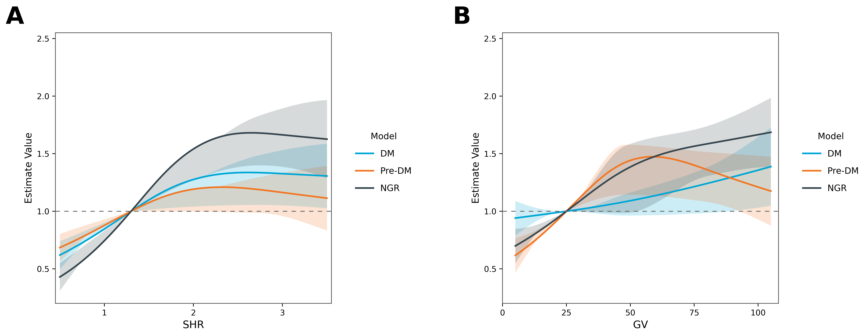
Figure S1 Multivariable-adjusted restricted cubic spline (RCS) analyses showed the associations of SHR and GV with new-onset rhythm related events across different glucose metabolic statuses. Covariates were adjusted as in Table S12. A: GV; B: SHR.

Figure S2 Kaplan-Meier plots of all-cause mortality by SHR and GV levels across different glucose metabolism subgroups. A: NGR; B: Pre-DM; C: DM.

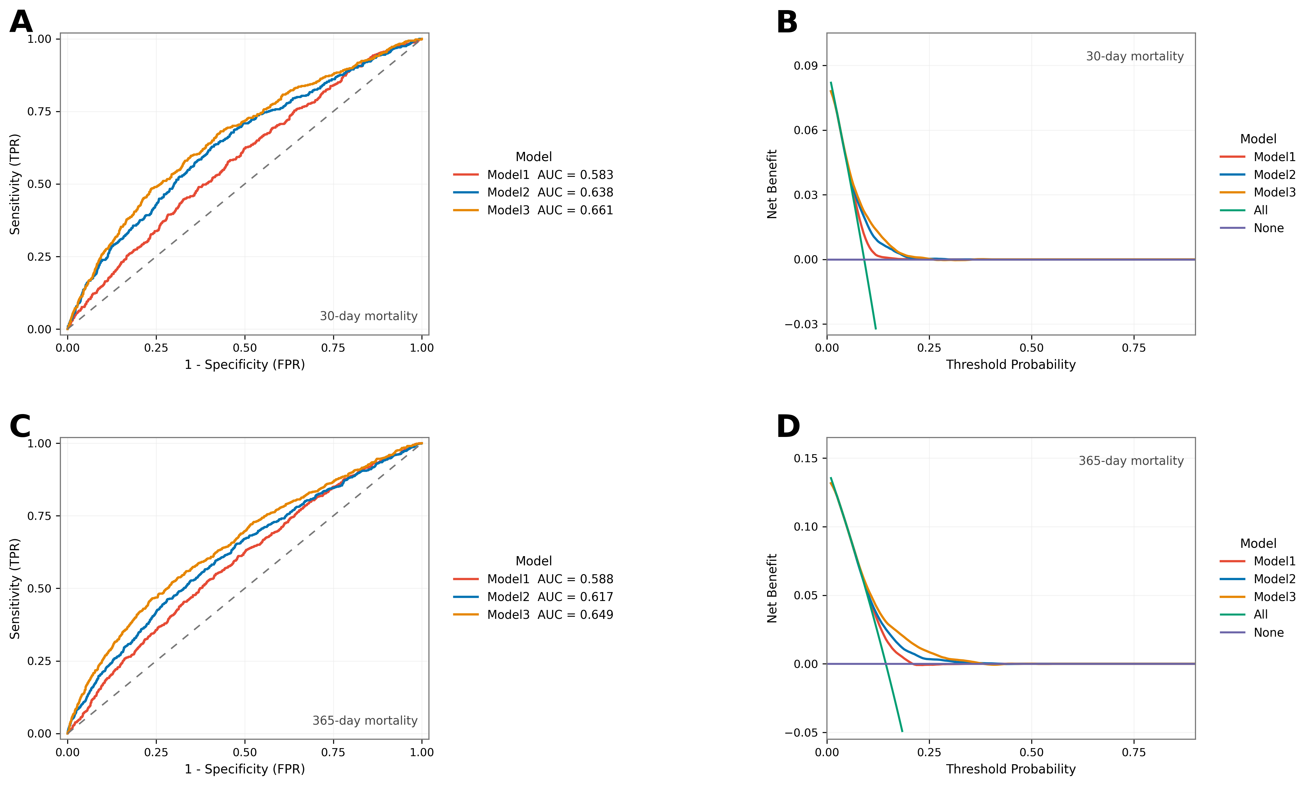
Figure S3 ROC curves of different Cox proportional hazards models and Decision curves for 30-day and for 365-day mortality. A: ROC curve of different Cox proportional hazard models exploring the association between combination of SHR and GV and the 30-day all-cause mortality of severe heart failure. B: Decision curve of different Cox proportional hazard models of 30-day all-cause mortality. C: ROC curve of different Cox proportional hazard models exploring the association between the combination of SHR and GV and the 365-day all-cause mortality of severe heart failure. D: Decision curve of different Cox proportional hazard models of 365-day all-cause mortality. Model 1: unadjusted crude model. Model 2: adjusted for sex, age. Model 3: adjusted for factors in Model 2 and HR, MAP, RR, HTN, COPD, MI, CKD, ACEI, ARB, β-blocker, Spironolactone, Statin, mechanical ventilation, SOFA, CCI.
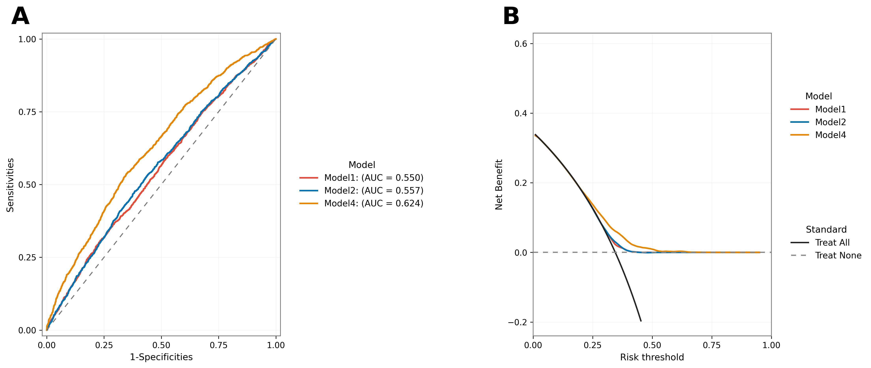
Figure S4 ROC curves and decision curve analyses of different logistic regression models for the prespecified composite of new-onset rhythm related events. A: ROC curves of different logistic regression models for the prespecified composite of new-onset rhythm related events in patients with severe heart failure. B: Decision curve analyses of different logistic regression models for the prespecified composite of new-onset rhythm related events. Model 1: unadjusted model. Model 2: adjusted for age and sex. Model 4: adjusted for the covariates specified in Model 2 and MAP, HTN, CVA, WBC, PT, PTT, ACEI, ARB, β-blocker, spironolactone, mechanical ventilation, SOFA, and CCI.
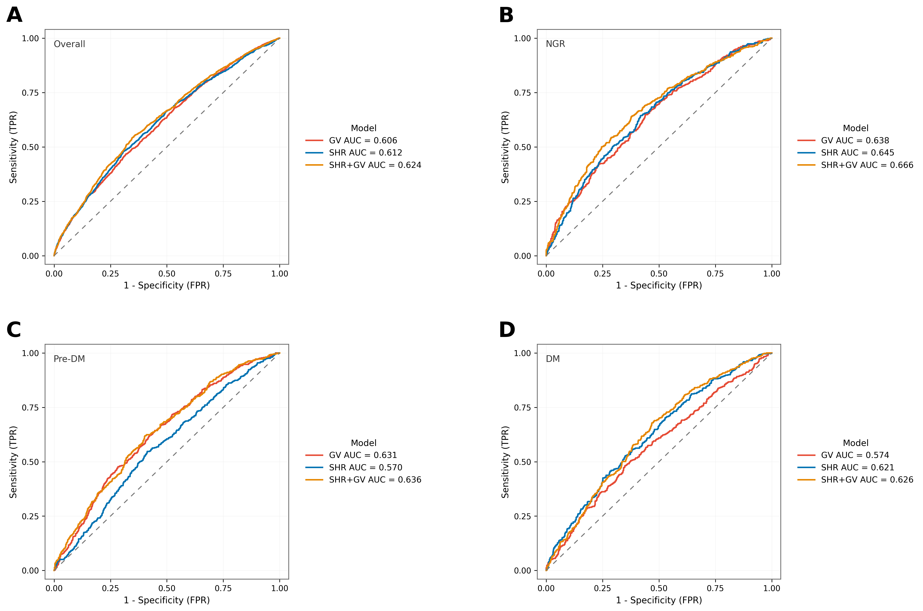
Figure S5 ROC curves for combined SHR/GV predicting new-onset rhythm related events, adjusted for model 4. A: Overall patients; B: patients with NGR; C: patients with Pre-DM; D: patients with DM

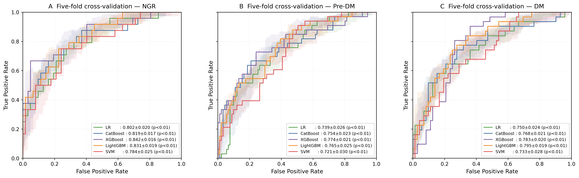
Figure S6 Five-fold cross-validation performance of five machine-learning models across different glucose metabolism groups. The mean ROC curves and corresponding variability of CatBoost, LightGBM, logistic regression (LR), support vector machine (SVM), and XGBoost were evaluated using five-fold cross-validation in the normal glucose regulation (NGR), prediabetes (Pre-DM), and diabetes mellitus (DM) groups. Solid lines represent the mean ROC curves, and shaded areas indicate the variability across the five folds. XGBoost achieved the highest mean AUC in the NGR and Pre-DM groups, whereas LightGBM showed the best predictive performance in the DM group. AUC, area under the receiver operating characteristic curve; ROC, receiver operating characteristic.
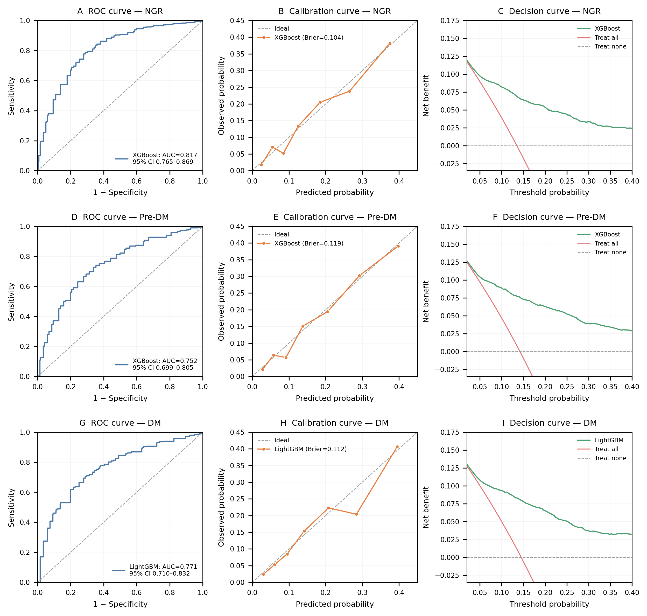
Figure S7 External validation of the final models for predicting 365-day all-cause mortality. ROC curves, calibration curves, and decision curve analyses are shown for XGBoost in the NGR and Pre-DM groups and LightGBM in the DM group using the Chinese hospital cohort. AUC, area under the curve; NGR, normal glucose regulation; Pre-DM, prediabetes; DM, diabetes mellitus.

