S1. Missing data description
For some experimental conditions, feature estimation was not possible because of irreducible artefacts in the physiological signals. Missing observations were therefore excluded on a feature-wise basis before statistical modelling. The missing data pattern for each signal domain is reported in Tables 1-4. Subjects 26 and 28 had missing respiratory data in all experimental conditions and were therefore fully excluded from the respiratory analyses. In all analyses, missing observations were not imputed. Linear mixed-effects models were fitted using the available observations for each feature, with subject included as a random intercept to account for repeated measurements.

Table 1. Missing data for HRV features.
Subject | Number of missing values | Missing condition(s)
14 | 1 | EO-2
15 | 2 | EC-2, EO-2
26 | 2 | EC-2, EO-2

Table 2. Missing data for EDA features.
Subject | Number of missing values | Missing condition(s)
13 | 1 | EO-2
14 | 2 | EC-2, EO-2
16 | 5 | C, LK, E, EC-2, EO-2
31 | 1 | EO

Table 3. Missing data for Respiratory features.
Subject | Number of missing values | Missing condition(s)
7 | 1 | EO
14 | 1 | EO-2
15 | 2 | EC-2, EO-2
26 | 7 | EO, EC, C, LK, E, EC-2, EO-2
28 | 7 | EO, EC, C, LK, E, EC-2, EO-2

Table 4. Missing data for EEG features.
Subject | Number of missing values | Missing condition(s)
3 | 1 | EO
5 | 2 | EC2, EO2
16 | 2 | EC2, EO2
S2. Condition contrasts vs reference condition analyses
Condition contrasts vs reference condition (EC) are reported for both peripheral indexes (Table 5) and EEG features (Table 6).
Table 5. Significant condition contrasts vs reference condition (EC) for peripheral indexes. Only contrasts with p<0.05 are shown.
Feature | Contrast | Estimate | SE | t | df | p | 95% CI
MeanNN | E − EC | 16.649 | 6.810 | 2.445 | 226 | 0.0153 | [3.231, 30.067]
MeanNN | EC-2 − EC | 24.375 | 6.936 | 3.514 | 226 | 0.000533 | [10.708, 38.042]
MeanNN | EO-2 − EC | 14.717 | 7.002 | 2.102 | 226 | 0.0367 | [0.919, 28.516]
RMSSD | EC-2 − EC | 17.326 | 7.029 | 2.465 | 226 | 0.0144 | [3.475, 31.177]
RMSSD | EO-2 − EC | 17.564 | 7.095 | 2.475 | 226 | 0.0140 | [3.582, 31.545]
SD1 | EC-2 − EC | 12.324 | 5.003 | 2.464 | 226 | 0.0145 | [2.467, 22.182]
SD1 | EO-2 − EC | 12.507 | 5.050 | 2.477 | 226 | 0.0140 | [2.556, 22.457]
SD2 | E − EC | 9.073 | 4.566 | 1.987 | 226 | 0.0481 | [0.076, 18.069]
SD2 | EC-2 − EC | 16.824 | 4.649 | 3.619 | 226 | 0.000365 | [7.663, 25.985]
SD2 | EO-2 − EC | 17.601 | 4.693 | 3.750 | 226 | 0.000224 | [8.353, 26.849]
SDNN | E − EC | 9.266 | 4.633 | 2.000 | 226 | 0.0467 | [0.137, 18.395]
SDNN | EC-2 − EC | 15.930 | 4.717 | 3.377 | 226 | 0.000863 | [6.635, 25.225]
SDNN | EO-2 − EC | 15.476 | 4.762 | 3.250 | 226 | 0.00133 | [6.092, 24.859]
Phasic Mean | C − EC | -0.130 | 0.056 | -2.304 | 201 | 0.0223 | [-0.241, -0.019]
Phasic Mean | LK − EC | -0.115 | 0.056 | -2.040 | 201 | 0.0427 | [-0.226, -0.004]
Phasic Std | EO − EC | 0.086 | 0.041 | 2.107 | 201 | 0.0364 | [0.005, 0.166]
BR | C − EC | -1.075 | 0.403 | -2.665 | 213 | 0.00828 | [-1.870, -0.280]
BR | LK − EC | -1.379 | 0.403 | -3.419 | 213 | 0.000754 | [-2.173, -0.584]
BR | E − EC | -1.106 | 0.403 | -2.743 | 213 | 0.00662 | [-1.901, -0.311]
Ampsum | C − EC | -0.098 | 0.044 | -2.248 | 201 | 0.0256 | [-0.184, -0.012]
Ampsum | LK − EC | -0.087 | 0.044 | -1.983 | 201 | 0.0487 | [-0.173, -0.001]
Tonic Mean | EO − EC | -0.553 | 0.216 | -2.556 | 201 | 0.0113 | [-0.979, -0.126]
Tonic Mean | C − EC | 0.507 | 0.216 | 2.347 | 201 | 0.0199 | [0.081, 0.934]
Tonic Mean | LK − EC | 0.908 | 0.216 | 4.197 | 201 | 4.053e-05 | [0.481, 1.334]
Tonic Mean | E − EC | 0.977 | 0.216 | 4.516 | 201 | 1.072e-05 | [0.550, 1.403]
Tonic Mean | EC-2 − EC | 1.003 | 0.218 | 4.598 | 201 | 7.550e-06 | [0.573, 1.433]
Tonic Mean | EO-2 − EC | 1.076 | 0.220 | 4.890 | 201 | 2.062e-06 | [0.642, 1.511]
Tonic Std | EO − EC | 0.096 | 0.043 | 2.251 | 201 | 0.0254 | [0.012, 0.181]
Tonic Std | C − EC | -0.089 | 0.043 | -2.080 | 201 | 0.0388 | [-0.174, -0.005]
EDASYMP | LK − EC | 1.118 | 0.390 | 2.869 | 201 | 0.00456 | [0.350, 1.886]
EDASYMP | E − EC | 0.871 | 0.390 | 2.237 | 201 | 0.0264 | [0.103, 1.640]
EDASYMP | EO-2 − EC | 0.914 | 0.398 | 2.299 | 201 | 0.0225 | [0.130, 1.698]
Table 6. Significant condition contrasts vs reference condition (EO) for EEG features. Only contrasts with p<0.05 are shown.
Feature | Contrast | Estimate | SE | t | df | p | 95% CI
PSDθ | EO − EC | 0.8378 | 0.3703 | 2.262 | 219 | 0.0247 | [0.1079, 1.5677]
PSDα | EO − EC | -4.3237 | 0.4809 | -8.991 | 219 | 1.176e-16 | [-5.2715, -3.3759]
PSDα | EO2 − EC | -2.8674 | 0.4857 | -5.904 | 219 | 1.339e-08 | [-3.8246, -1.9103]
PSDγ | EO − EC | 2.2856 | 0.4702 | 4.861 | 219 | 2.225e-06 | [1.3590, 3.2123]
PSDγ | LK − EC | 1.2749 | 0.4660 | 2.736 | 219 | 0.00673 | [0.3565, 2.1932]
PSDγ | E − EC | 0.9972 | 0.4660 | 2.140 | 219 | 0.0335 | [0.0788, 1.9156]
PSDγ | EC2 − EC | 1.1335 | 0.4748 | 2.387 | 219 | 0.0178 | [0.1976, 2.0693]
PSDγ | EO2 − EC | 2.4399 | 0.4748 | 5.138 | 219 | 6.125e-07 | [1.5041, 3.3757]
Cohδ | EO − EC | 0.0844 | 0.0126 | 6.714 | 219 | 1.606e-10 | [0.0596, 0.1092]
Cohδ | EO2 − EC | 0.0710 | 0.0127 | 5.589 | 219 | 6.753e-08 | [0.0460, 0.0960]
Cohθ | EO − EC | 0.0384 | 0.0102 | 3.758 | 219 | 0.000220 | [0.0183, 0.0586]
Cohθ | EO2 − EC | 0.0370 | 0.0103 | 3.582 | 219 | 0.000421 | [0.0166, 0.0573]
Cohα | EO − EC | -0.0642 | 0.0084 | -7.642 | 219 | 6.623e-13 | [-0.0807, -0.0476]
Cohα | EO2 − EC | -0.0434 | 0.0085 | -5.119 | 219 | 6.727e-07 | [-0.0601, -0.0267]
PLIα | EO − EC | -0.1078 | 0.0137 | -7.899 | 219 | 1.348e-13 | [-0.1347, -0.0809]
PLIα | EO2 − EC | -0.0931 | 0.0138 | -6.755 | 219 | 1.272e-10 | [-0.1203, -0.0659]
PLIβ | EO − EC | -0.0100 | 0.0029 | -3.441 | 219 | 0.000695 | [-0.0158, -0.0043]
PLIβ | EO2 − EC | -0.0147 | 0.0029 | -4.968 | 219 | 1.361e-06 | [-0.0205, -0.0088]
PLIγ | EC2 − EC | -0.0050 | 0.002 | -2.099 | 219 | 0.0370 | [-0.098, -0.0003]
S3. Sensitivity analysis for quality control of the gamma-band findings
Figures 1 and 2 report the results of the sensitivity analyses conducted for quality control of the gamma-band findings. First, we repeated the gamma-band analysis using only ICs classified as brain components at the standard ICLabel threshold of 0.5. Second, we repeated the analysis after excluding peripheral frontal and temporal electrodes that are more prone to ocular, facial, jaw, temporalis muscle, and movement-related artifacts. Specifically, we excluded Fp1, Fp2, F7, F8, T3/T7, T4/T8, T5/P7, and T6/P8, retaining only F3, Fz, F4, C3, Cz, C4, P3, Pz, P4, O1, and O2.
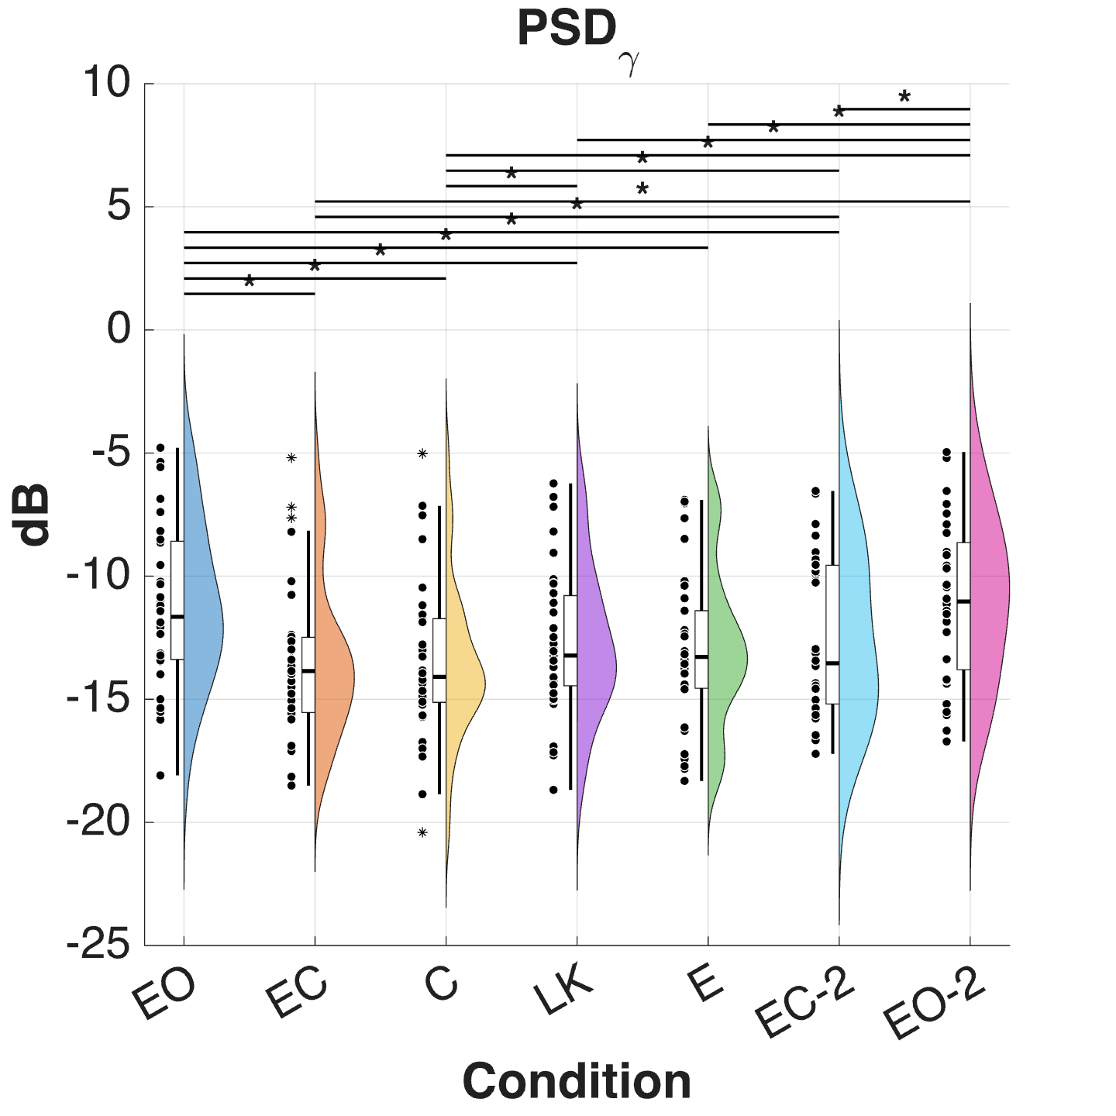
Figure 1. EEG-PSD changes in the gamma band after considering only “brain” components according to ICLabel. Post-hoc comparisons that were significant (p<0.05) are marked with an asterisk*.
Figure 2. EEG-PSD changes in the gamma band after considering only “brain” components according to ICLabel and considering only the following channels: F3, FZ, F4, C3, CZ, C4, P3, PZ, P4, O1, O2. Post-hoc comparisons that were significant (p<0.05) are marked with an asterisk*.

