Ancient terrestrial forests reborn as modern marine ecosystems under shifting sea levels

Mario Lebrato^{1,2,*}, Jack Shannon³, Theo Russell⁴, Alexandra Jordan^{5,6}, Mauro Jije-Goncalves^{1,2}, Maria da Graça^{1,2}, Michelle Caputo^{7,8}, and Ashlee Lillis⁸

¹ BCSS Ocean Observatory. Bazaruto Center for Scientific Studies (BCSS), Benguerra Island, Mozambique.
² Kisawa Sanctuary. Benguerra Island, Mozambique
³ University of Southampton, Southampton, UK.
⁴ University of Plymouth, Plymouth, UK.
⁵ Heriot-Watt University, Edinburgh, Scotland.
⁶ Newcastle University, Newcastle upon Tyne, UK.
⁷ School of Marine and Environmental Programs, University of New England, Maine, USA.
⁸ Sound Ocean Science, Canada.

Keyword: peatland, coral reef, coastal forest, sea level rise, nursery habitat, carbon

*Corresponding Author:
Address: BCSS Ocean Observatory. Bazaruto Center for Scientific Studies (BCSS), Benguerra Island, Mozambique.
E-mail: mario.lebrato@bcssmz.org
Telephone: +34 610 67 77 42

Supplementary materials

Figure S1. Calibrated radiocarbon age distributions of peat reef samples (examples). Each panel shows the calibration of a radiocarbon determination using the IntCal curve (one interpretation, and five examples). Red curves represent the measured radiocarbon age probability; blue lines with shaded envelopes indicate the calibration curve and its 68.3% uncertainty. Grey histograms show the resulting calendar age probability distributions. Horizontal brackets mark the 68.3% and 95.4% calibrated ranges. Calibrations were performed in OxCal v4.4.
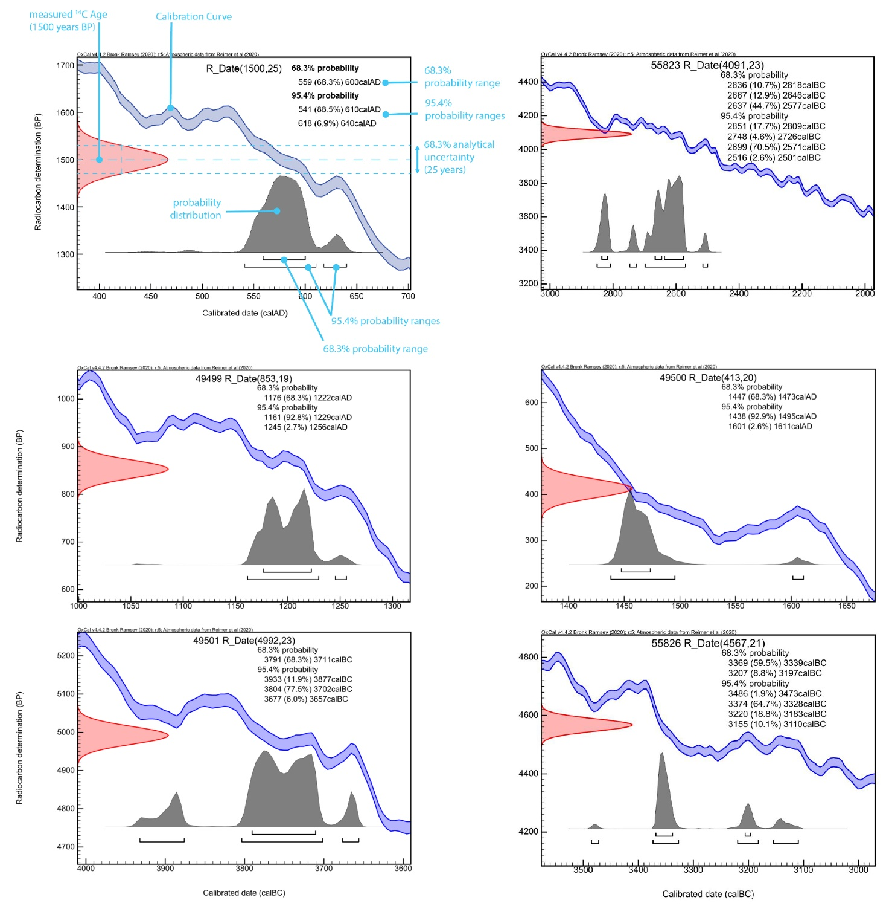

Figure S2. Multivariate differentiation of coral and peat reef communities. Principal Coordinates Analysis (PCoA) based on Bray-Curtis dissimilarity showing community separation between coral and peat reefs across habitat quadrats, invertebrates, small fish, and megafauna. Points represent quadrats or sites and are color-coded by reef type. Habitat quadrats were analyzed as benthic-cover composition, whereas invertebrates, small fish, and megafauna were analyzed at both species and family levels to test whether habitat differentiation was consistent across taxonomic resolutions. The accompanying table summarizes ANOSIM and PERMANOVA results for each dataset, including species-level and family-level tests where applicable. Significant values (p < 0.05) are shown in bold.
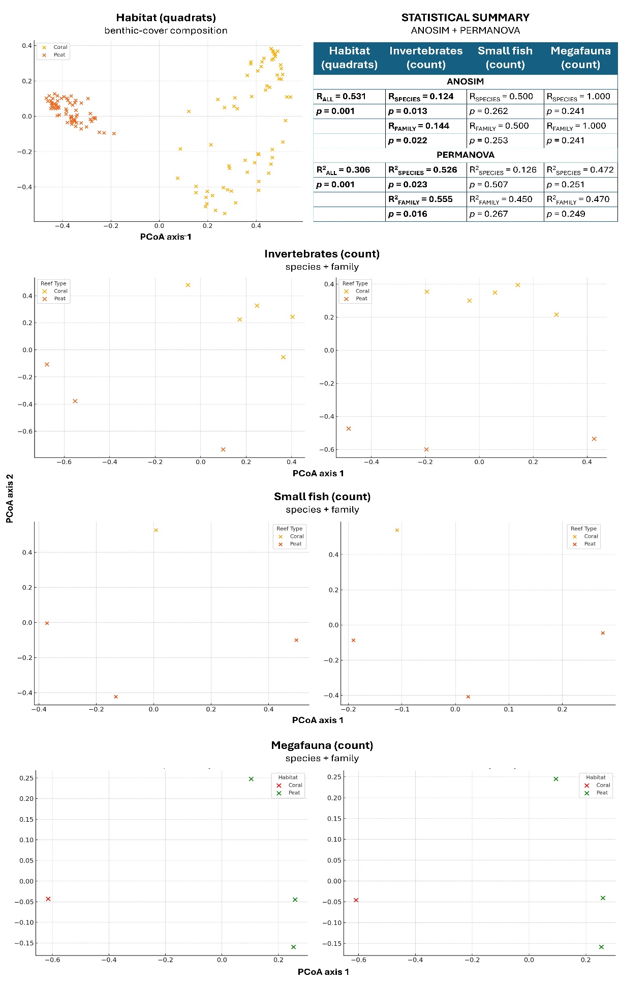

Figure S3. Habitat and taxa drivers of dissimilarity between coral and peat reef systems. SIMPER analysis shows the top 10 contributors to Bray-Curtis dissimilarity (%) between coral and peat reef habitats across four datasets: habitat quadrats, invertebrate counts, small fish counts, and megafauna counts. Bars indicate each habitat or taxon feature's percentage contribution to overall dissimilarity.
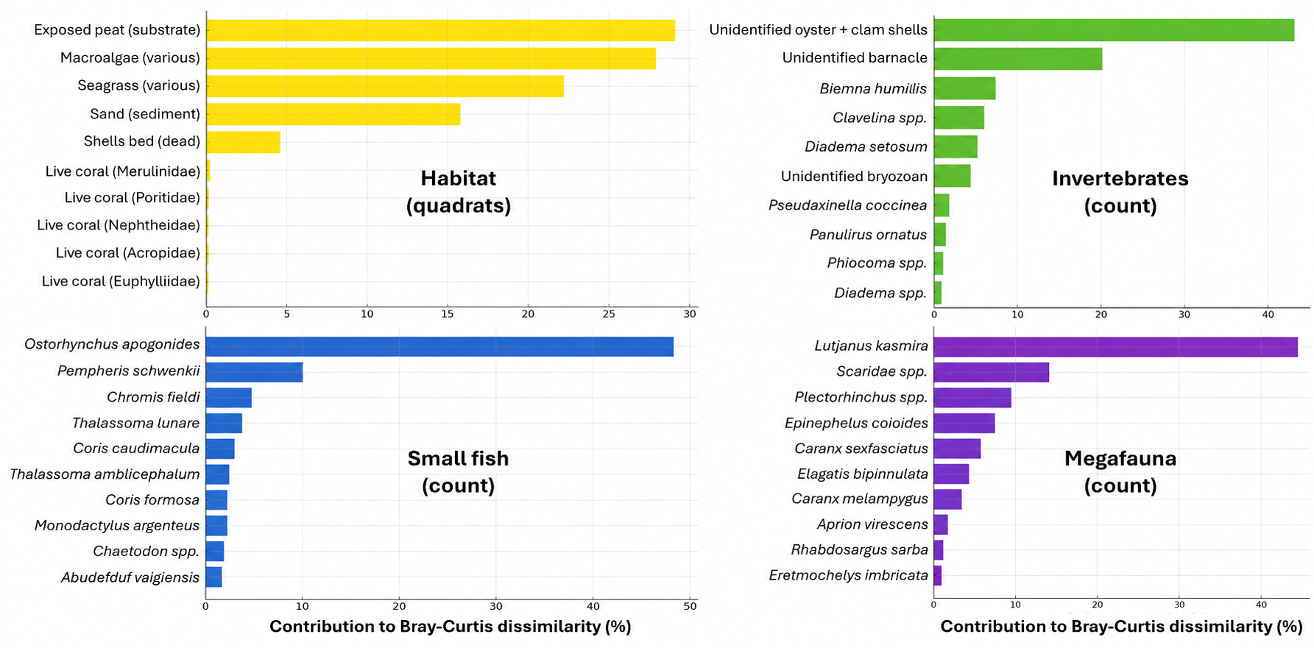

Table S1. Raw datasets corresponding to the work conducted in the peat reef systems. Snapshot tables of the full database used to understand the peat reef systems (sensor time-series, non-ecological data details, benthic quadrats, benthic invertebrates counts, small fish and megafauna surveys). All datasets are at the BCSS Ocean Observatory repository (https://bcssmz.org/) with DOI links https://doi.org/10.82174/bcssmz.ocean.observatory.data.access/ and https://doi.org/10.82174/bcssmz.ocean.observatory.data.repository/.
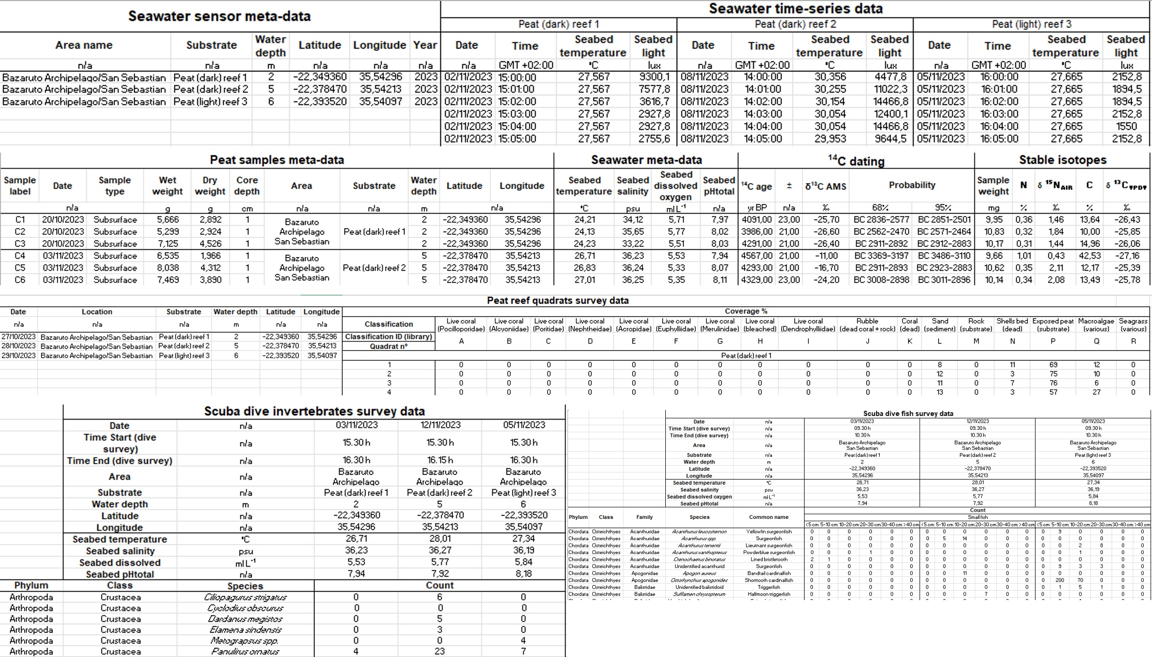

Table S2. Raw datasets corresponding to the work conducted in the coral reef system. Snapshot tables of the full database used to understand the coral reef system (sensor time-series, non-ecological data details, benthic quadrats, benthic invertebrates counts, small fish and megafauna surveys). All datasets are available at the BCSS Ocean Observatory repository (https://bcssmz.org/) with DOI links https://doi.org/10.82174/bcssmz.ocean.observatory.data.access/ and https://doi.org/10.82174/bcssmz.ocean.observatory.data.repository/.
